Thermodynamics parameters

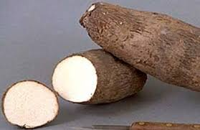
Partial
purification
Immobilization
Dioscorea alata (water yam)
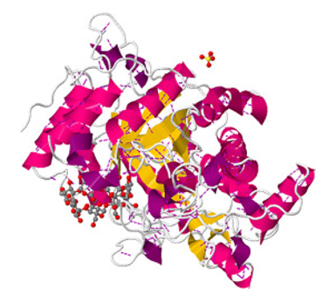
Catalysis
Characterization
Inactivation
Amino acid composition
C
Floresencing
β-amylase

