Supporting information

Expression and characterization of functional human vascular endothelial growth factor (VEGF₁₆₅) in Kluyveromyces lactis

Hülya Kuduğ Ceylan¹*, Seçil Erden Tayhan², İsa Gökçe³

*Corresponding author: Hülya Kuduğ Ceylan
Tel: +905064086148; Fax: +86-62344496;
E-mail: hulya.kudug@gop.edu.tr
ORCID: 0000-0003-0365-2760

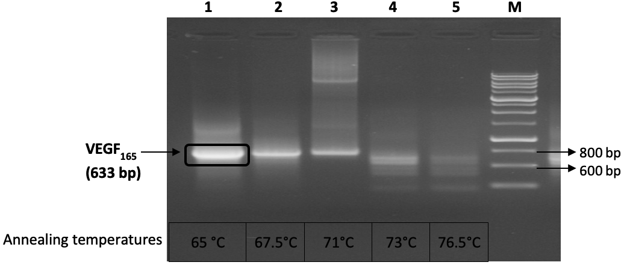
800 bç
600 bç
Figure S1. Gradient PCR analysis of the VEGF₁₆₅ specific primers.

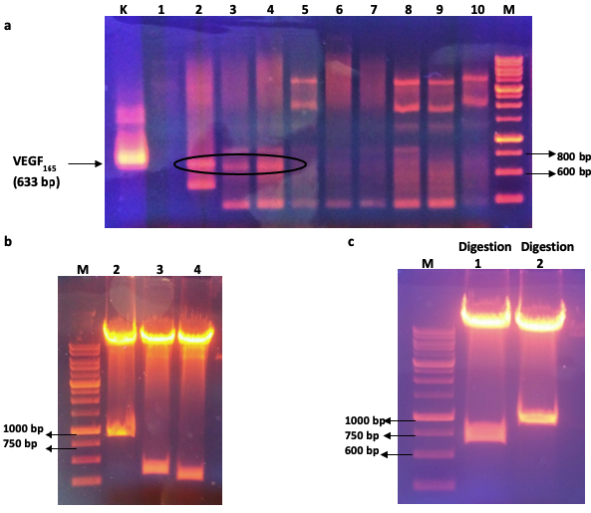
Figure S2. Confirmation analysis of the cloning VEGF₁₆₅ gene. a) PCR amplification of VEGF₁₆₅ gene of plasmid DNA of E. coli DH5α clones. 2,3 and 4 clones released the 633 bp VEGF₁₆₅ insert b) Restriction digestion analysis of clone 2,3 and 4 with XhoI-EcoRI enzymes. Clone 2 released the desired bands (8833 and 891 bp) c) Two restriction digestion analysis of clone 2 with XhoI-EcoRI and HindIII-EcoRI, separately. The small DNA strand of Digestion 1 (633 bp) and Digestion 2 (890 bp) were expected size. The clone 2 was decided as positive clone for expressing experiments.

a
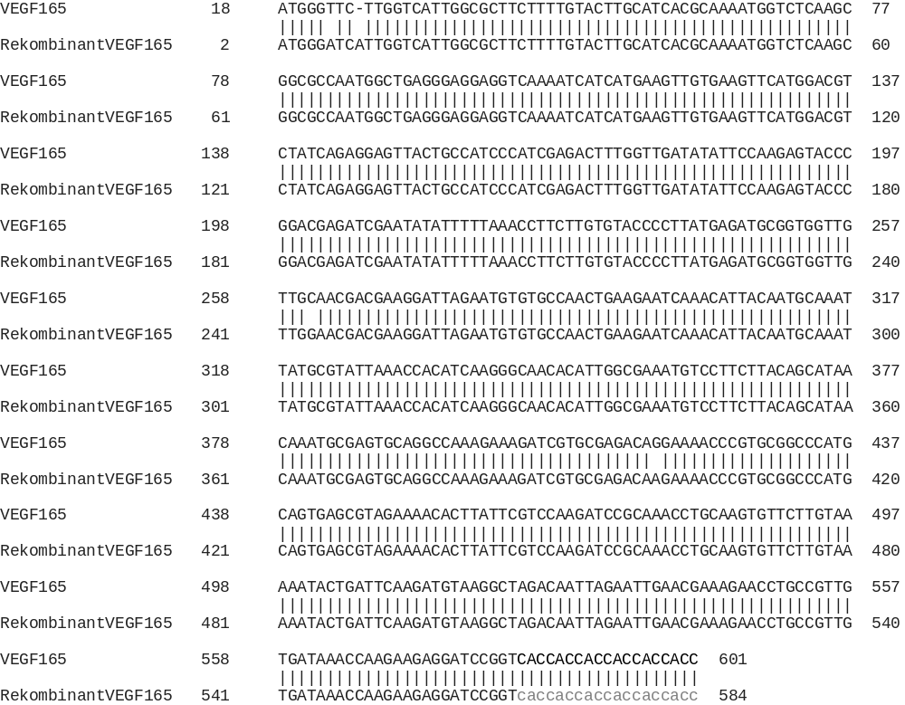

b
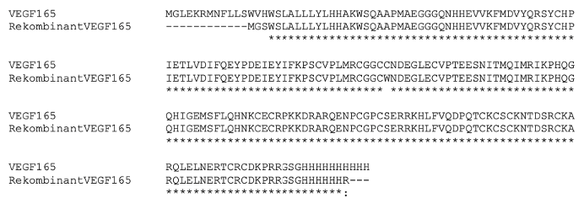
Figure S3. The nucleotide (a) and amino acid sequence (b) of the recombinant VEGF₁₆₅ and comparing with wild-type human VEGF₁₆₅

Table S1. Mean OD values of MTT assay at 570 nm for different concentrations of E. coli (as a positive control) VEGF₁₆₅ and K. lactis produced VEGF₁₆₅ in this study.
VEGF₁₆₅ concentration  (ng/mL) | Absorbance values (570 nm) (mean±SD)
VEGF₁₆₅ concentration  (ng/mL) | Negative control | Positive control  (E. coli derived VEGF₁₆₅) | Produced VEGF₁₆₅  (K. lactis derived)
20 | 1,626±0,053 | 1,563±0,276 | 1,599±0,096
10 | 1,442±0,153 | 1,715±0,038 | 1,464±0,194
5 | 1,505±0,156 | 1,525±0,153 | 1,549±0,074
2,5 | 1,558±0,038 | 1,47±0,216 | 1,732±0,042
1,25 | 1,377±0,112 | 1,576±0,121 | 1,502±0,194
0,625 | 1,355±0,154 | 1,562±0,131 | 1,602±0,098
0,312 | 1,556±0,032 | 1,715±0,118 | 1,567±0,047
0,156 | 1,314±0,119 | 1,575±0,221 | 1,63±0,054
0,078 | 1,522±0,016 | 1,555±0,079 | 1,685±0,072
0,039 | 1,276±0,053 | 1,51±0,077 | 1,707±0,040
0,019 | 1,319±0,011 | 1,465±0,120 | 1,388±0,048
Values are expressed as mean± SD using one-way ANOVA; n =3 in each group

Table S2. Percentage of cell viability relative to negative control of HUVEC cells after 48 h exposure to E. coli (as a positive control) VEGF₁₆₅ and K. lactis produced VEGF₁₆₅ in this study at different concentrations.
VEGF₁₆₅ concentration  (ng/mL) | Cell viability (%) relative to negative control
VEGF₁₆₅ concentration  (ng/mL) | Positive control  (E. coli derived VEGF₁₆₅) | Produced VEGF₁₆₅  (K. lactis derived)
20 | 2,35 | 2,65
10 | 2,33 | 2,58
5 | 2,51 | 2,67
2,5 | 2,64 | 2,83
1,25 | 2,02 | 2,51
0,625 | 2,11 | 2,59
0,312 | 2,05 | 2,36
0,156 | 2,18 | 2,28
0,078 | 1,81 | 1,84
0,039 | 1,47 | 1,85
0,019 | 1,37 | 1,73

Table S3. Percentage of wound closure after treatment with E. coli (as a positive control) VEGF₁₆₅ and K. lactis produced VEGF₁₆₅ with the incubation period of 24 hours and 48 hours.
 | Percentage of wound closure (%)
 | Cells control | Positive control  (E. coli derived VEGF₁₆₅) |  | Produced VEGF₁₆₅  (K. lactis derived)
 | Cells control | 5 ng/ml | 10 ng/ml | 5 ng/ml | 10 ng/ml
24 hours | 55,24 | 63,87 | 73,48 | 53,39 | 69,54
48 hours | 78,59 | 88,41 | 93,12 | 80,37 | 85,71

