Supplementary Materials

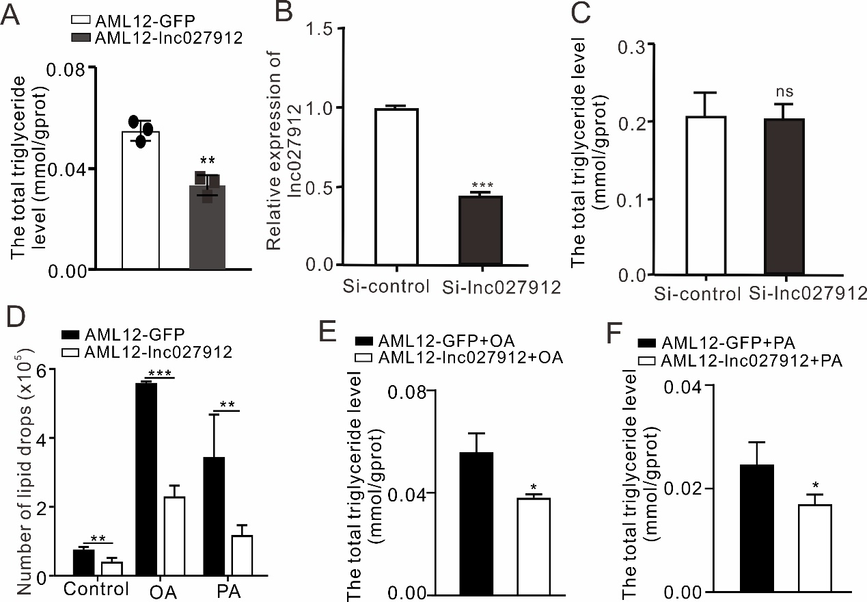
Fig. S1 The silencing of lnc027912 ability was analyzed by RT-PCR (A) and the TG level of cell was measured using TG kit under knockdown of lnc027912 AMl12- cells (B) or over-expression of lnc027912 cells (C). (D) The number of lipid drops was detected using Image-Pro Plus 6.0. Total triglyceride levels were analyzed under OA (E) and PA (F) treatment. OA, Oleic acid; PA, palmitic acid. (n=3, ns: no significantly, *P<0.05, **P<0.01, ***P<0.001).

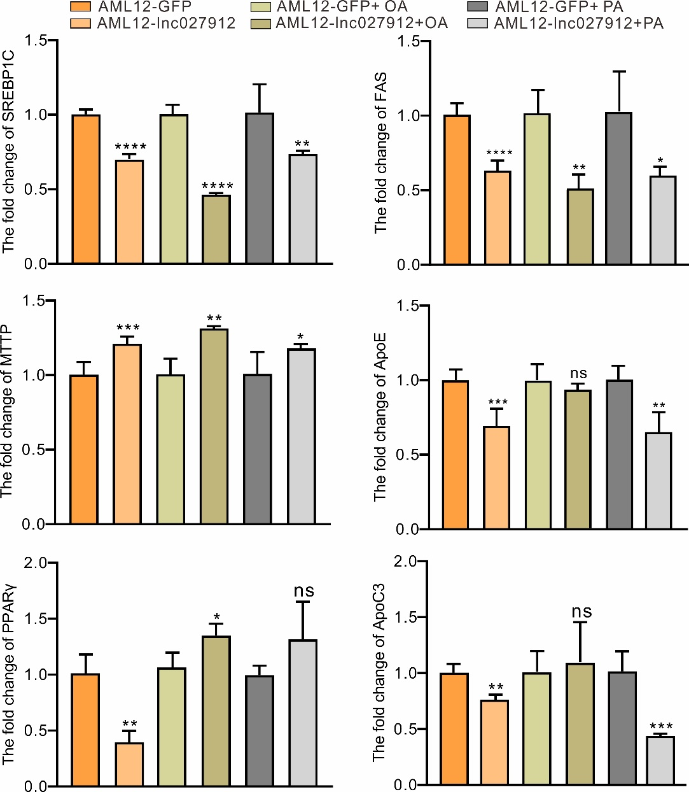
Fig. S2 RT-PCR analyze the change of lipid metabolism related genes, when these AML12-GFP and AML12-lnc027912 were treated with OA (A) and PA. (n≥3, ns: no significantly, * P<0.05, ** P<0.01, *** P<0.001, **** P<0.0001.)

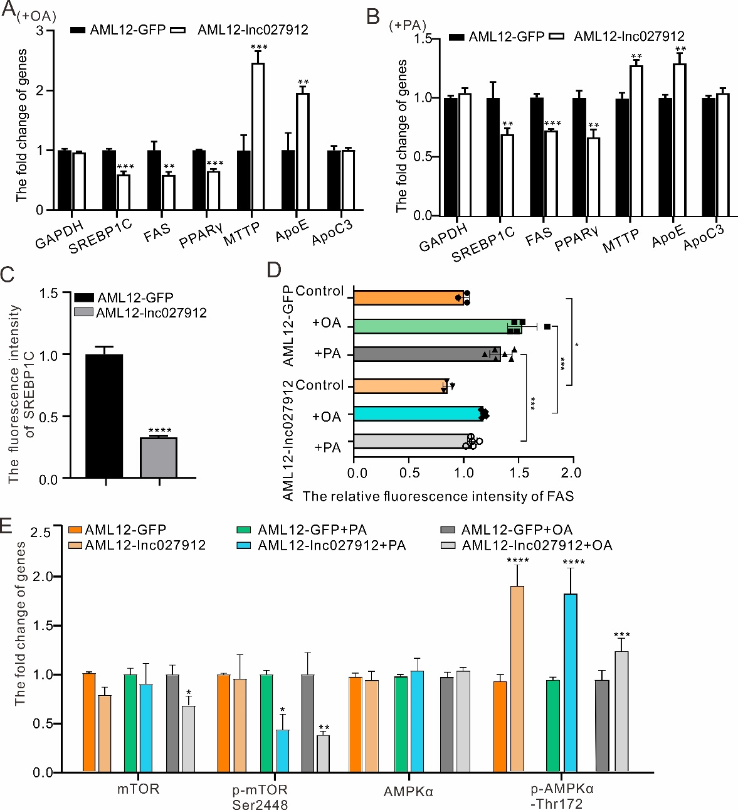
Fig. S3 Changes in key genes related to lipid metabolism were analyzed by Western blot after OA (A) and PA (B) treatments. (C) The SREBP1C fluorescence intensity was analyzed in AML12-GFP and AML12-lnc027912 cells. The immunofluorescence intensity of FAS was detected (D). The expression levels of AMPKα, p-AMPKα-Thr172, mTOR and p-mTOR-Ser2448 were analyzed by Image J (n=3). OA, Oleic acid; PA, palmitic acid. Data are presented as the mean ± SD, *P<0.05, **P<0.01, ***P<0.001, ****P<0.0001.

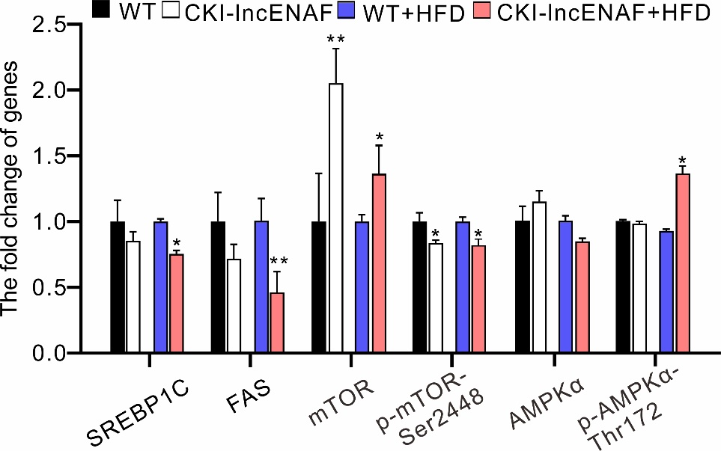
Fig. S4 The protein level of SREBP1C, FAS, mTOR, p-mTOR, AMPKα and p-AMPKα was analysis in wide type and CKI-lnc027912 liver tissue. Data are presented as the mean ± SD, *P<0.05, **P<0.01.

Table S1 Sequences of primers used for experiments in this manuscript.
Genes |  | Primer sequences (5’-3’)
GAPDH | Forward | GGGTTCCTATAAATACGGACTGC
Lnc027912 | Reverse  Forward | TACGGCCAAATCCGTTCACA  TAACATGTGGTACGTCTCTT
 | Reverse | AGACCAGTCTGGTCTTGAAC
SREBP-1C | Forward  Reverse | CTTTGGCCTCGCTTTTCGG  TGGGTCCAATTAGAGCCATCTC
FAS | Forward | GCGGGTTCGTGAAACTGATAA
PPARγ | Reverse  Forward | GCAAAATGGGCCTCCTTGATA  CGGCAGTTTCGCTACCAGG
 | Reverse | CACCAGCATCTCCACGATCTG
MTTP | Forward  Reverse | ATACAAGCTCACGTACTCCACT  TCTCTGTTGACCCGCATTTTC
ApoE | Forward | CTCCCAAGTCACACAAGAACTG
ApoC3 | Reverse  Forward | CCAGCTCCTTTTTGTAAGCCTTT  GCGTGCAGGAGTCCGATATAG
 | Reverse | CCAGTAGCCTTTCAGGGATCT

Table S2 Antibodies used in this study.
Antibody | Company | Cats# | Utilization | Dilution
Anti-SREBP-1C | Abcam  Proteintech | ab3259  66875-1 | Western blot  IF | 1:1000  1:200
Anti-FAS | Abcam  Abcam | ab82419  ab216991 | Western blot  IF | 1:1000  1:100
Anti-PPARγ | Abcam | ab178860 | Western blot | 1:1000
Anti-MTTP | Abcam | ab63467 | Western blot | 1:1000
Anti-ApoE | CST | 49285 | Western blot | 1:1000
Anti-ApoC3 | Abcam | ab21032 | Western blot | 1:1000
Anti-mTOR | CST | 2972S | Western blot | 1:1000
Anti-P_{ser2448}-mTOR | CST | 5536S | Western blot | 1:1000
Anti-GAPDH | CST | 8884S | Western blot | 1:1000
Anti-AMPKα | CST | 2532 | Western blot | 1:1000
Anti-P_{Thr172-}AMPKα | CST | 2535 | Western blot | 1:1000

