Supplementary information for
Tailoring Magnetic Exchange Interactions in Ferromagnet-Intercalated MnBi₂Te₄ Superlattices
Peng Chen^{1,2,3}, Qi Yao^{4,5*}, Qiang Sun^{6,7}, Alexander J. Grutter⁸, P. Quarterman⁸, Purnima P. Balakrishnan⁸, Christy J. Kinane⁹, Andrew J. Caruana⁹, Sean Langridge⁹, Baoshan Cui^{10,11}, Lun Li^{1,2,3}, Yuchen Ji⁵, Yong Zhang^{1,2,3}, Zhongkai Liu^{4,5}, Jin Zou^{6,7}, Guoqiang Yu^{10,11}, Yumeng Yang^{1*}, and Xufeng Kou^{1,4*}
¹School of Information Science and Technology, ShanghaiTech University, Shanghai, 201210, China
²Shanghai Institute of Microsystem and Information Technology, Chinese Academy of Sciences, Shanghai 200050, China
³University of Chinese Academy of Science, Beijing 101408, China
⁴ShanghaiTech Laboratory for Topological Physics, ShanghaiTech University, Shanghai 201210, China
⁵School of Physical Science and Technology, ShanghaiTech University, Shanghai, 201210, China
⁶School of Mechanical and Mining Engineering, The University of Queensland, St Lucia, QLD 4072, Australia
⁷Centre for Microscopy and Microanalysis, The University of Queensland, St Lucia, QLD 4072, Australia
⁸NIST Center for Neutron Research, National Institute of Standards and Technology, Gaithersburg, Maryland 20899-6102, USA
⁹ISIS-Neutron and Muon Source, Rutherford Appleton Laboratory, Didcot, Oxon OX11 0QX, United Kingdom
¹⁰Songshan Lake Materials Laboratory Dongguan, Guangdong 523808, China
¹¹Beijing National Laboratory for Condensed Matter Physics Institute of Physics Chinese Academy of Sciences Beijing 100190, China
* Corresponding author. Email: yaoqi@shanghaitech.edu.cn; yangym1@shanghaitech.edu.cn; kouxf@shanghaitech.edu.cn;
S1. XRD characterizations of the MBE-grown 5 SL MBT thin film
S2. Neutron reflectometry results of MBT and [MBT(MnTe)_{1.75}]₁₀ samples
S3. Magneto-resistance response of the MBT thin film
S4. Modified linear chain model of the MnTe-intercalated MBT system
S5. Determination of Néel temperatures of the MBT and [MBT(MnTe)_{m}]₅ samples
S6. XRR characterizations of the MBT and [MBT(MnTe)_{1.25}]_{N} samples

S1. XRD characterizations of the MBE-grown 5 SL MBT thin film
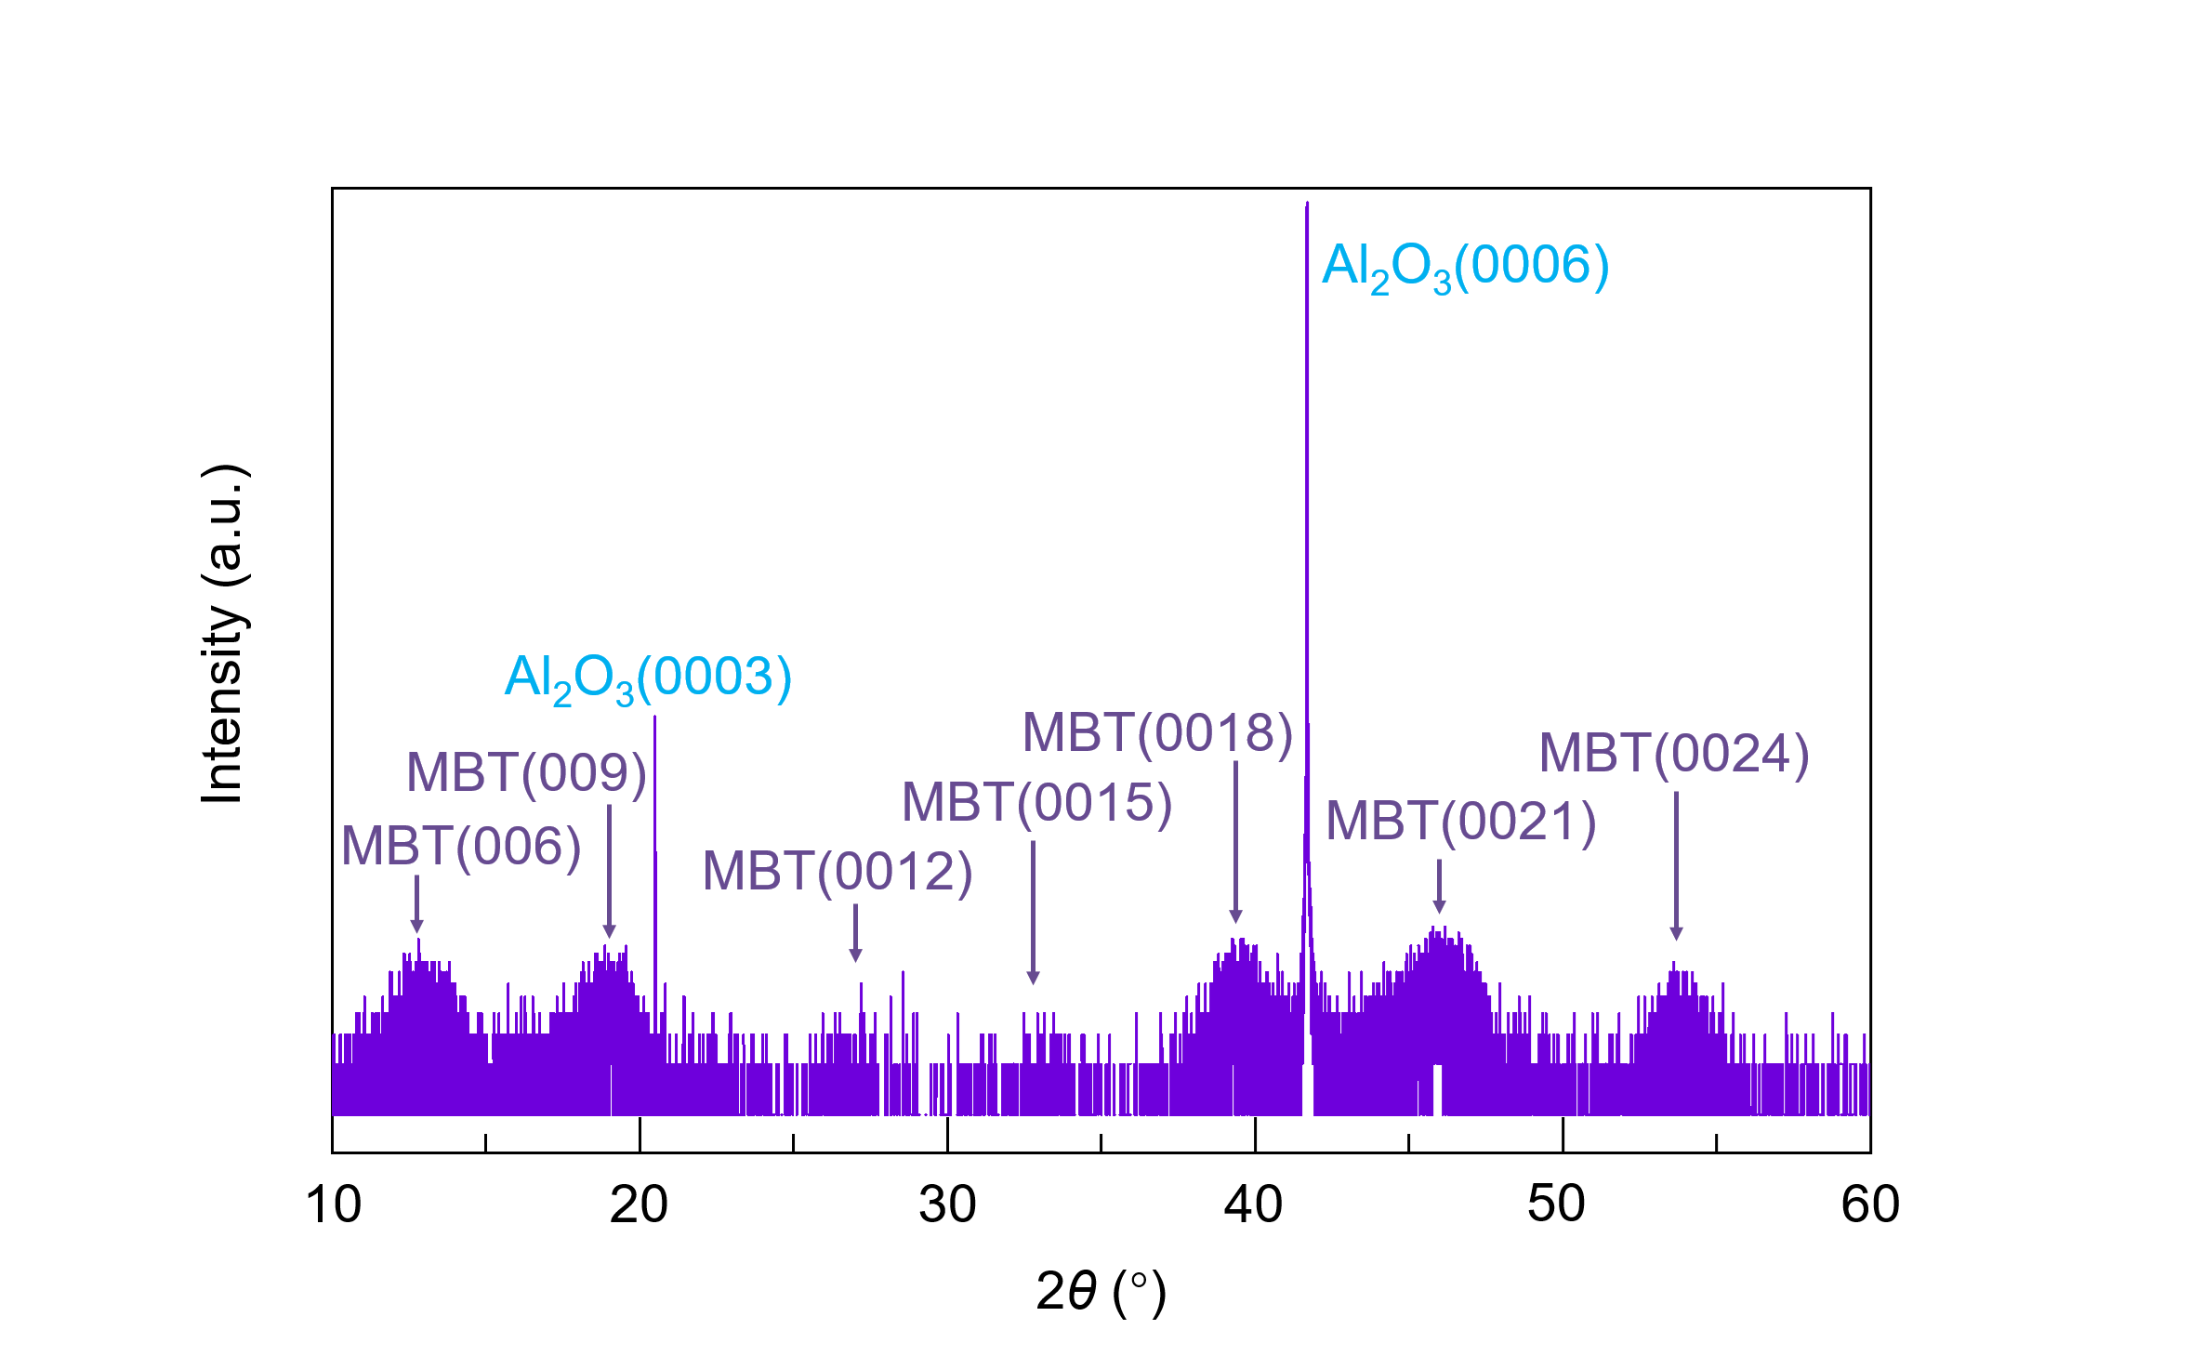
Figure S1. XRD patterns of the 5 SL MBT sample. Only (00n) series of MBT film peaks and the (000n*) Al₂O₃ substrate peaks are observed without any secondary phase.

To verify the crystal structure of the MBE-grown MnBi₂Te₄ (MBT) thin film, we conducted the X-ray diffraction (XRD) measurement on one 5 SL MBT sample with Cu K_{α} as the referring source. As shown in Fig. S1, only the (00n) series of MBT film peaks and the (000n*) Al₂O₃ substrate peaks are identified, hence confirming the single crystalline structure without detectable secondary phases.

S2. Neutron reflectometry results of MBT and [MBT(MnTe)_{1.75}]₁₀ samples
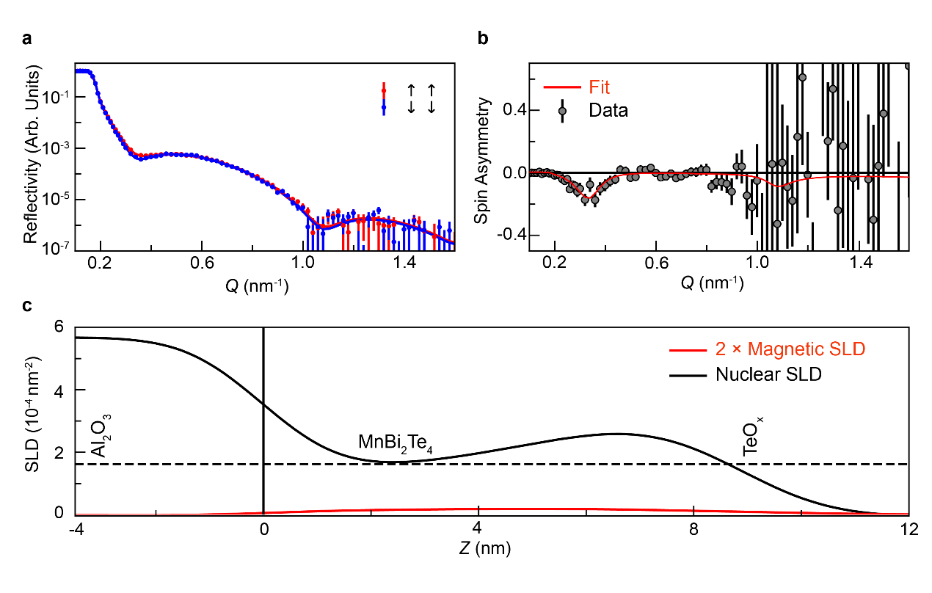
Figure S2-1. Polarized neutron reflectometry (PNR) measurements on the Te-capped MBT film. (a) Polarized neutron reflectometry and (b) spin asymmetry alongside best fit for the 6 SL MBT film (c) Scattering length density profile used to generate the fit shown. Error bars represent ±1 standard deviation. Measurements were performed at 6 K in a 3 T in-plane applied magnetic field. Dashed line represents the expected nuclear SLD value of bulk MBT.

To probe the compositional and magnetic depth profile of the MBE-grown MBT thin films, polarized neutron reflectometry from a Te-capped 6 SL MBT sample was performed at 6 K in a 3 T in-plane applied magnetic field. The spin-dependent reflectivities and spin asymmetry are plotted alongside theoretical fits in Figs. S2-1a-b respectively, with the nuclear and magnetic scattering length density (SLD) profiles used to generate those fits shown in Fig. S2-1c. The nuclear SLD profile is consistent with the bulk-like MBT diagram except for some oxidation of the Te capping layer. Despite surface oxidation, the magnetic SLD profile shows a uniform magnetization distribution across the film thickness, with a magnitude in excellent agreement with that expected from MBT in an in-plane magnetic field, supporting high-quality growth of the intended phase.
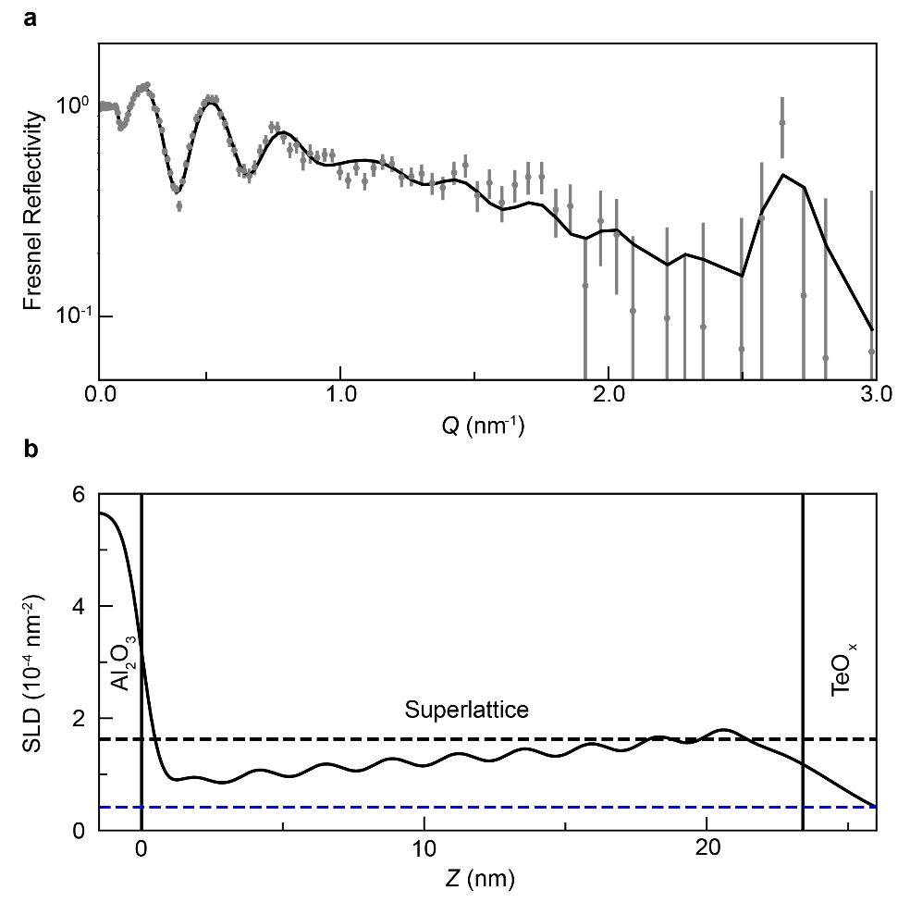
Figure S2-2. Polarized neutron reflectometry measurements on the Te-capped [(MBT)(MnTe)_{1.75}]₁₀ superlattice sample. (a) Unpolarized neutron reflectometry and fit for a [(MBT)(MnTe)_{1.75}]₁₀ superlattice (b) Scattering length density profile used to generate the fit shown in (a). Error bars denote the ±1 standard deviation. Black dashed line represents the expected bulk nuclear SLD of MBT while the blue dashed line corresponds to the ideal bulk nuclear SLD of MnTe.

In the meanwhile, we also performed PNR measurements on the MnTe-intercalated MBT superlattices. It is noted that the vast majority of neutron reflectometry studies on van der Waals (vdW) systems, such as MBT, would reveal rough surfaces which are apparently at odds with the atomically sharp interfaces visualized through electron microscopy approaches. This effect may be understood by considering the probing distance associated with neutron reflectometry, in which the entire sample is examined simultaneously, and the neutron coherence length extends for hundreds of μm if not mm over the surface of the sample. In this case, neutron reflectometry is sensitive not only to the intermixing, which would be evident in microscopy, but also to long range thickness variations or conformal roughness. Considering such conformal roughness is a common feature in vdW materials with large terrace structures forming on the surface of films and interfaces between layers. The values reported by imaging techniques must therefore be treated as a lower bound on the expected roughness values to be reported by PNR, rather than a predicted value.
In this regard, we may understand Fig. 2 in the main text as well as Fig. S2-2, which shows the unpolarized reflectivity associated with a [MBT(MnTe)_{1.75}]₁₀ (m = 1.75, N = 10) sample. Given the extremely thin superlattice repeat distance of approximately 2 nm, the expected location of the first order Bragg reflection for this sample is at a very high reciprocal lattice vector of Q ≈ 2.7 nm⁻¹. Despite the high Q, relatively small nuclear contrast, and conformal roughness inherent to terraced vdW heterostructures, a Bragg reflection does appear in the expected location, demonstrating large area, highly periodicity of [(MBT)(MnTe)_{m}]_{N} superlattices of the desired geometry, as shown in Fig. S2-2a. Furthermore, the average SLD oscillates between the expected bulk SLD values for MBT and MnTe, highlighted by the dashed black and blue lines, respectively. Yet we should also point out that an upturn in the nuclear SLD is also observed, likely indicating surface oxidation of the Te capping layer and the upper regions of the MBT. Nevertheless, the above neutron reflectometry data justify the realization of periodic [(MBT)(MnTe)_{m}]_{N} superlattices of the desired geometry in this work.

S3. Magneto-resistance response of the MBT thin film
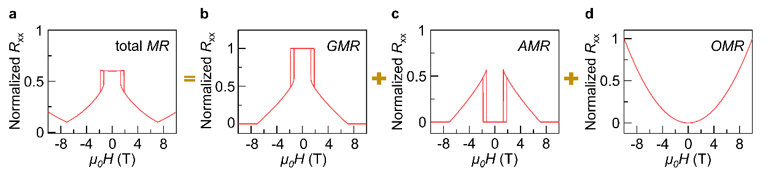
Figure S3. (a) Overall MR response of the MBT system composed of (b) GMR, (c) AMR and (d) OMR components.

To have a better understanding of the MR line-shape observed in the MBT sample (Fig. 1d), we recall that the MR signal in a multi-layer magnetic system can be interpreted as the sum of the giant MR (GMR), anisotropic MR (AMR), and ordinary MR (OMR) components. Specifically, the GMR effect depends on the angle between neighboring MBT layers $m_{i}^{MBT}$ and $m_{i+1}^{MBT}$, and its magnitude is proportional to $\sin^{2}\left(\frac{θ_{i}-θ_{i+1}}{2}\right)$;¹ the AMR term has a $\cos^{2}{φ}$ dependence where φ is defined as the angle between $m_{i}^{MBT}$ (or $m_{i+1}^{MBT}$) and the applied current direction; and the OMR component is resulted from the Lorentz force that follows the H² correlation. Here, we have calculated the GMR, AMR and OMR contributions based on the modified linear chain model (see S4), and the normalized MR response is shown in Fig. S3. It is seen that the overall contour of the simulated result agrees reasonably well with the experimental data, hence validating the physical origin of the AFM-type GMR feature in the MBT system.

S4. Modified linear chain model of the MnTe-intercalated MBT system
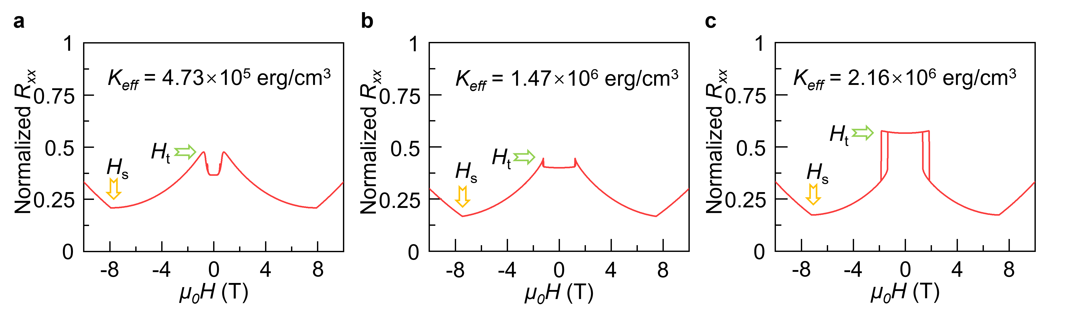
Figure S4. The simulated MR responses with respect to different ($K_{eff}^{MBT}$, $J_{eff}^{MBT}$) combinations. With a fixed $J_{eff}^{MBT}$ = 0.66 erg/cm² and varied $K_{eff}^{MBT}$ values of (a) 4.73 × 10⁵ erg/cm³, (b) 1.47 × 10⁶ erg/cm³, and (c) 2.16 × 10⁶ erg/cm³, the transition field H_{t} increases from 0.78 T to 1.84 T whereas the saturation field H_{s} remains at 7.4 T, consistent with the experimental results.

Generally, in a typical multilayered magnetic systems with versatile intra-/inter-layer exchange couplings, the total energy (i.e., ground magnetic/spin state) of the system can be described by the linear chain model which includes the exchange coupling term, anisotropy and field-induced Zeeman energy ²:
(1)

$$E_{N}\left(m_{i}^{MBT};H\right)\text{ =}\sum_{i=1}^{N-1}{\left[J_{i}m_{i}⋅m_{i+1}+\tilde{J_{i}}{\left(m_{i}⋅m_{i+1}\right)}^{2}\right]\text{ +}\sum_{i=1}^{N}{\left[K_{i}t_{i}{\left(m_{i}⋅z\right)}^{2}\right]}-}\sum_{i=1}^{N}{[M_{i}t_{i}m_{i}]∙H}$$
where N is the periodicity number, H is the applied magnetic field, $J_{i}$ and $\tilde{J_{i}}$ are the bilinear and biquadratic interlayer exchange coupling constants between adjacent magnetic layers, $K_{i}$, $t_{i}$, $M_{i}$, $m_{i}$ correspond to the uniaxial anisotropy constant, thickness, saturated magnetization, and the unit vector of magnetization direction of the ith layer, respectively.
In our case, the film stack of [(MBT)(MnTe)_{m}]_{N} superlattices can be considered as a combination of MBT and MnTe layers repeat in an alternating sequence. As illustrated in Fig. 5a, one macro-magnetic unit consists of two antiparallel-coupled MBT layers (i.e., denoted by $m_{i}^{MBT}$ and $m_{i+1}^{MBT}$) intercalated by two additional ferromagnetic MnTe spacer with magnetization $m_{i}^{MnTe}$and $m_{i+1}^{MnTe}$. According to the modified linear chain model, the total energy of the system can be written as:
(2)
(2)
$$E_{N}\left(m_{i}^{MBT}, m_{i}^{MnTe};{ }H\right)\text{ =}\sum_{i=1}^{N-1}{\left[J_{i}^{MBT}m_{i}^{MBT}⋅m_{i+1}^{MBT}+J_{i}^{MnTe}m_{i}^{MnTe}⋅m_{i+1}^{MnTe}+{\tilde{J}}_{i}^{MBT}{\left(m_{i}^{MBT}⋅m_{i+1}^{MBT}\right)}^{2}+{\tilde{J}}_{i}^{MnTe}{\left(m_{i}^{MnTe}⋅m_{i+1}^{MnTe}\right)}^{2}\right]} -\sum_{i=1}^{N}{J_{i}^{ex}m_{i}^{MBT}⋅m_{i}^{MnTe}}+\sum_{i=1}^{N}{\left[K_{i}^{MBT}t_{i}^{MBT}{\left(m_{i}^{MBT}⋅z\right)}^{2}+K_{i}^{MnTe}t_{i}^{MnTe}{\left(m_{i}^{MnTe}⋅z\right)}^{2}\right]} -\sum_{i=1}^{N}{\left(M_{i}^{MBT}t_{i}^{MBT}m_{i}^{MBT}+M_{i}^{MnTe}t_{i}^{MnTe}m_{i}^{MnTe}\right)⋅H}$$
where the energy of the ith and (i+1)th period is expressed as:
$$E_{i}\left(m_{i}^{MBT}, m_{i}^{MnTe};H\right)=J_{i}^{MBT}m_{i}^{MBT}⋅m_{i+1}^{MBT}+J_{i}^{MnTe}m_{i}^{MnTe}⋅m_{i+1}^{MnTe}$$
$$+ {\tilde{J}}_{i}^{MBT}{\left(m_{i}^{MBT}⋅m_{i+1}^{MBT}\right)}^{2}+{\tilde{J}}_{i}^{MnTe}{\left(m_{i}^{MnTe}⋅m_{i+1}^{MnTe}\right)}^{2}$$
$$-J_{i}^{ex}m_{i}^{MBT}⋅m_{i}^{MnTe}-J_{i+1}^{ex}m_{i+1}^{MBT}⋅m_{i+1}^{MnTe}$$
$$+K_{i}^{MBT}t_{i}^{MBT}{\left(m_{i}^{MBT}⋅z\right)}^{2}+K_{i}^{MnTe}t_{i}^{MnTe}{\left(m_{i}^{MnTe}⋅z\right)}^{2}$$
$$+K_{i+1}^{MBT}t_{i+1}^{MBT}{\left(m_{i+1}^{MBT}⋅z\right)}^{2}+K_{i+1}^{MnTe}t_{i+1}^{MnTe}{\left(m_{i+1}^{MnTe}⋅z\right)}^{2}$$
$$-{(M}_{i}^{MBT}t_{i}^{MBT}m_{i}^{MBT}+M_{i}^{MnTe}t_{i}^{MnTe}m_{i}^{MnTe})∙H$$
$$-{(M}_{i+1}^{MBT}t_{i+1}^{MBT}m_{i+1}^{MBT}+M_{i+1}^{MnTe}t_{i+1}^{MnTe}m_{i+1}^{MnTe})∙H$$
where $J_{i}^{MBT}$ and ${\tilde{J}}_{i}^{MBT}$ ($J_{i}^{MnTe}$ and ${\tilde{J}}_{i}^{MnTe}$) are the bilinear and biquadratic interlayer exchange coupling constants between adjacent MBT (MnTe) layers, $J_{i}^{ex}$ denotes the MBT/MnTe interfacial magnetic interaction, $K_{i}^{MBT}$($K_{i}^{MnTe}$), $t_{i}^{MBT}$ ($t_{i}^{MnTe}$), $M_{i}^{MBT}$ ($M_{i}^{MnTe}$), $m_{i}^{MBT}$($m_{i}^{MnTe}$) correspond to the uniaxial anisotropy constant, thickness, saturated magnetization, and the unit vector of magnetization direction of the ith MBT (MnTe) layer, respectively. The third term accounts for the anisotropy energy, and the fourth term represents the field-induced Zeeman energy from the uncompensated moments.
(3)
Based on the above elaborated expression, we can subsequently carry out the vector-to-scalar transformation, and Equation (3) can be converted into the following form^{3,4}:
$$E_{i}=J_{i}^{MBT}\cos{(}θ_{i}-θ_{i+1})+{\tilde{J}}_{i}^{MBT}\cos^{2}{(}θ_{i}-θ_{i+1})+J_{i}^{MnTe}\cos{(}θ_{i}^{'}-θ_{i+1}^{'})+{\tilde{J}}_{i}^{MnTe}\cos^{2}{(}θ_{i}^{'}-θ_{i+1}^{'})-J_{i}^{ex}\cos{(}θ_{i}^{'}-θ_{i}-α)-J_{i+1}^{ex}\cos{(}θ_{i+1}^{'}-θ_{i+1}-α^{'})+K_{i}^{MBT}t_{i}^{MBT}\sin^{2}{θ_{i}}+K_{i+1}^{MBT}t_{i+1}^{MBT}\sin^{2}{θ_{i+1}}+ K_{i}^{MnTe}t_{i}^{MnTe}\sin^{2}θ_{i}^{'}{+K_{i+1}^{MnTe}t_{i+1}^{MnTe}\sin^{2}{θ_{i+1}^{'}}}$$
$$-H_{z}M_{i}^{MBT}t_{i}^{MBT}{cosθ}_{i}-H_{z}M_{i+1}^{MBT}t_{i+1}^{MBT}\cos{θ_{i+1}}$$
$-H_{z}M_{i}^{MnTe}t_{i}^{MnTe}\cos{θ_{i}^{'}}-H_{z}M_{i+1}^{MnTe}t_{i+1}^{MnTe}\cos{θ_{i+1}^{'}}$ (4)
where $θ_{i}$($θ_{i+1}$) is the angle between the z-axis and $m_{i}^{MBT}$($m_{i+1}^{MBT}$), and $θ_{i}^{'}$($θ_{i+1}^{'}$) is the angle between the z-axis and $m_{i}^{MnTe}$($m_{i+1}^{MnTe}$); $J_{i}^{MBT}$($J_{i}^{MnTe}$) is the interlayer coupling between adjacent MBT (MnTe) layers; the higher order biquadratic coupling constant ${\tilde{J}}_{i}^{MBT}$(${\tilde{J}}_{i}^{MnTe}$), whose magnitude is usually a few times smaller than $J_{i}^{MBT}$($J_{i}^{MnTe}$), accounts for the effect of additional spacer microstructure and interface properties. In order to include the magnetic interactions between MBT and MnTe in the superlattice, we introduced additional bilinear coupling constant $J_{i}^{ex}$, which is the exchange coupling between neighboring MBT and MnTe layers. Here, a positive $J_{i}^{MBT}$(negative $J_{i}^{MnTe}$) favors antiparallel (parallel) alignment of MBT (MnTe) layers whereas a positive sign of $J_{i}^{ex}$ leads to the parallel alignment between MBT and MnTe. Besides, to comply with the experimental observation of an in-plane moment, angle α(α') is included to reflect the canting of MnTe magnetization from the MBT sublattices.
Consequently, by minimizing E at a given $H_{z}$, the ground magnetic state of the superlattice can be obtained, and the corresponding spin configuration (i.e., represented by $θ_{i}$, $θ_{i+1}$, $θ_{i}^{'}$ and $θ_{i+1}^{'}$), in principle, can be used for calculations of the magneto-electric response. To implement Equation (4), however, it turns out to be quite a difficult task to accomplish with multiple variables and fitting parameters. Fortunately, we notice that the thickness of the investigated MnTe spacer in this work is much thinner than that of MBT. Moreover, because of the mutual interaction nature of the magnetic exchange coupling, any influence of MnTe would be readily captured in the change of MBT’s magnetic behaviors. In other words, the effect of MnTe insertion can be reflected as the change of interlayer coupling ($J_{i}^{MBT}$) and intralayer coupling ($K_{i}^{MBT}$, $M_{i}^{MBT}$, $M_{i+1}^{MBT}$) of neighboring MBT. Therefore, to facilitate the calculation process without losing generality, it is reasonable to only include the MBT energy terms without explicitly invoking the MnTe ones. Likewise, the exchange coupling constant $J_{eff}^{MBT}$ and the lumped effective uniaxial anisotropy constant $K_{eff}^{MBT}$ are introduced to depict the influence from the MnTe insertion, as such strategy has been widely adopted in previous literatures^{2,5,6}. In this way, Equation (4) can be further simplified as follows:
$E=J_{eff}^{MBT}\left[\cos{(}θ_{i}-θ_{i+1})+β\cos^{2}{(}θ_{i}-θ_{i+1})\right]+K_{eff}^{MBT}t_{i}^{MBT}\left(\sin^{2}{θ_{i}}+{ξsin}^{2}{θ_{i+1}}\right)-H_{z}t_{i}^{MBT}\left(M_{i}^{MBT}{cosθ}_{i}{+}M_{i+1}^{MBT}{cosθ}_{i+1}\right)$ (5)
where β (0 < β < 1) is introduced as the scaling factors of the biquadratic coupling, different $M_{i}^{MBT}$and $M_{i+1}^{MBT}$ values are used since the presence of sizable MnTe moment would induce an uncompensated moment in MBT, which further lead to slightly different anisotropies (ξ is a scaler factor) among neighboring MBTs. During the model simulation process, $J_{eff}^{MBT}$and $K_{eff}^{MBT}$ are set to iterate among different rounds of calculations to compare with experimental data, while the other parameters are taken as $t_{i}^{MBT}$ = 1.36 nm, $M_{i}^{MBT}$ = 210 emu/cm³, $M_{i+1}^{MBT}$ = 260 emu/cm³, and β = 0.56.
Figures S4a-c display the final simulation results based on the modified linear chain model. To comply with the measured MR curves in Fig. 2, it is found that the fitted $J_{eff}^{MBT}$ remains almost unchanged while $K_{eff}^{MBT}$ varies in a wide range. Under this condition, the saturation field H_{s} of the simulated MR results stays around 7.4 T, while the transition field H_{t} monotonically increases from 0.78 T to 1.84 T with the incremented $K_{eff}^{MBT}$ values. On this basis, the lump sum effect of MnTe is interpreted as the decrease of $K_{eff}^{MBT}$ related to the intralayer MBT coupling, while the MnTe-insertion can preserve the interlayer MBT coupling $J_{eff}^{MBT}$. The former arises presumably from the magnetic proximity effect at the MnTe/MBT interfaces, which directly acts on the spin alignment of MBT within one layer. The latter is understood as the stabilization of inter MBT layer coupling by MnTe, which is similar to the exchange spring effect observed in other reports⁷⁻⁹.

S5. Determination of Néel temperatures the [MBT(MnTe)_{m}]₅ samples
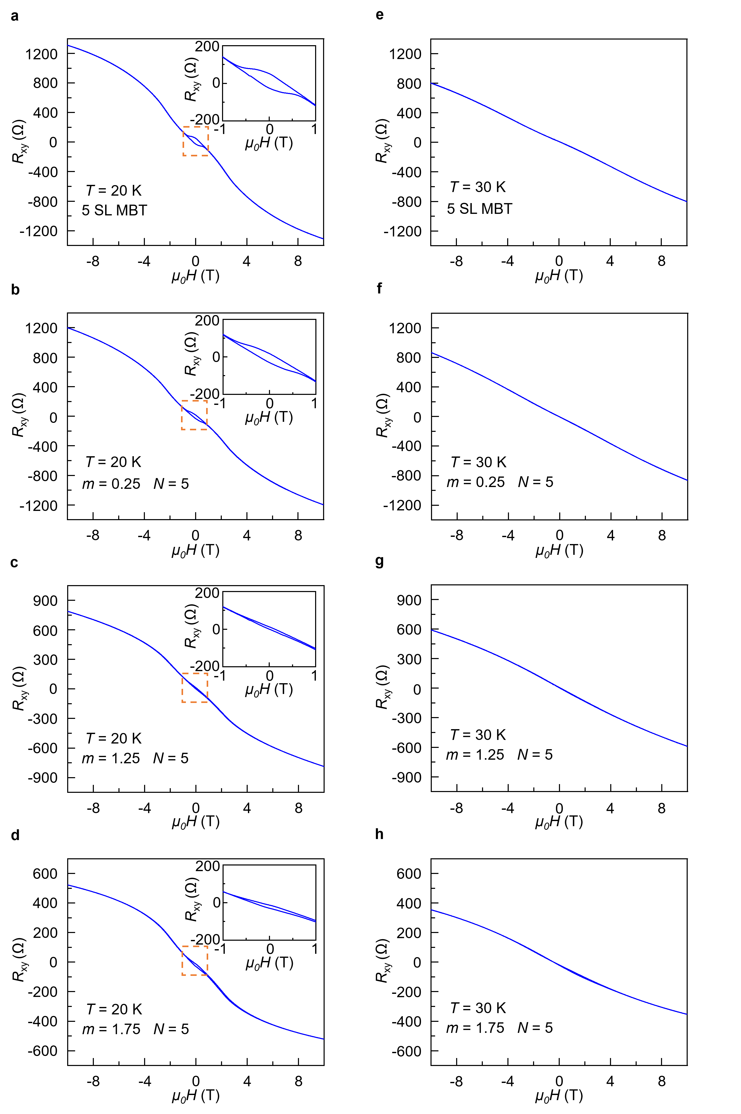
Figure S5. Determination of Néel temperatures of the [MBT(MnTe)_{m}]₅ (m = 0, 0.25, 1.25, 1.75) samples from the Hall resistance results. (a-d) Magnetic field-dependent Hall resistance at T = 20 K. The inset diagrams reveal the anomalous Hall effect with well-developed hysteresis R_{xy} loops in all samples. (e-h) Ordinary Hall effect with linear R_{xy} slopes observed in for the same samples at T = 30 K.

In MBT(Bi₂Te₃)_{n} (n≥1) series samples, the anti-ferromagnetic (AFM) coupling is dramatically weakened as the inserted Bi₂Te₃ layer thickness increases, leading to a sharp decrease of the Néel temperature T_{N} from 25 K to 13 K¹⁰⁻¹⁴. In contrast, in all [MBT(MnTe)_{m}]₅ samples, we have observed a pronounced anomalous Hall effect (AHE) with hysteresis R_{xy} loops at 20 K, as emphasized in Figs. S5a-d. This finding confirms the stabilization of the AFM-type interlayer coupling through the interfacial magnetic proximity effect and exchange spring effect with the inserted MnTe layer as discussed in the main text. On the other hand, the anomalous Hall effect vanishes in all samples as long as the base temperature is elevated above 30 K (Figs. S5e-h), from which we can estimate that Néel temperatures T_{N} of the ferromagnetically intercalated MBT superlattices are about the same as the pure 5 SL MBT control sample.

S6. XRR characterizations of the MBT and [MBT(MnTe)_{1.25}]_{N} samples
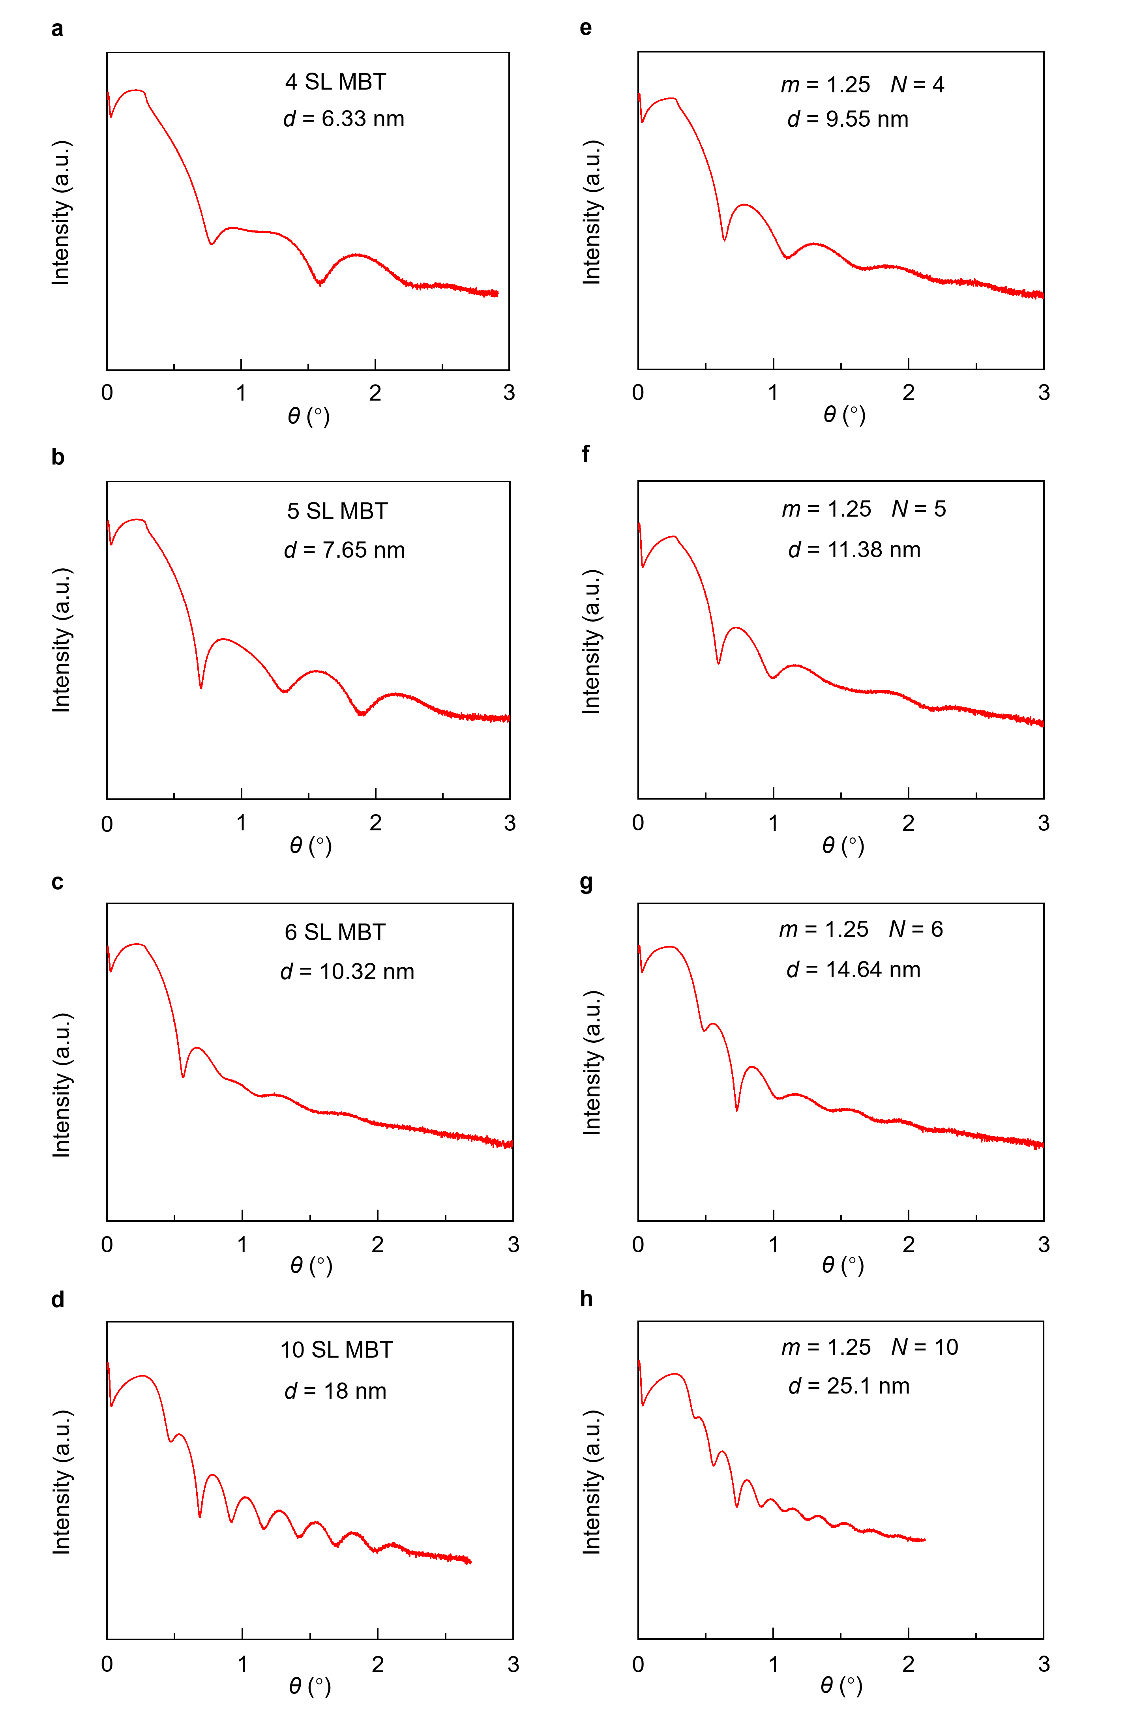
Figure S6. XRR characterizations of both the thickness-dependent MBT and [MBT(MnTe)_{1.25}]_{N} samples used in Fig. 5. The extracted thickness agrees well with our nominal growth period within the error range.
N

In order to validate the thickness of both MBT and [(MBT)(MnTe)_{1.25}]_{N} samples investigated in the manuscript, we have carried out additional X-ray reflection (XRR) measurements, and relevant results are summarized in Fig. S6. It is seen that all the XRR patterns of our MBE-grown thin films show continuous fringes, indicating atomically flat interfaces. More importantly, through standard XRR fitting procedure and film thickness calculations, we find that there is little disparity between the experimental data and expected values (which include both the as-grown film the Te capping layer thickness), as exhibited in Table S6.

N  Thickness | MBT (m = 0) | [MBT(MnTe)_{1.25}]_{N}
4 | 6.33 nm | 9.55 nm
5 | 7.65 nm | 11.38 nm
6 | 10.32 nm | 14.64 nm
10 | 18.00 nm | 25.10 nm
Table S6. Calibration of the [(MBT)(MnTe)_{m}]_{N} sample thickness from the XRR data. Here, the thickness-dependent MBT thin films are designated as [(MBT)(MnTe)₀]_{N} where m = 0 and N stands for the number of SL.

References

1 Nickel, J. Magnetoresistance overview. (Hewlett-Packard Laboratories, Technical Publications Department, 1995).
2 Rößler, U. & Bogdanov, A. Magnetic phases and reorientation transitions in antiferromagnetically coupled multilayers. Phys. Rev. B 69, 184420 (2004).
3 Zhang, Q. et al. Terahertz emission from CoFeB/Cr/Pt trilayers: The role of Cr as both a spin current transporter and generator. Appl. Phys. Lett. 118, 232401 (2021).
4 Zhang, Q. et al. Terahertz emission from an exchange-coupled synthetic antiferromagnet. Phys. Rev. Appl. 13, 054016 (2020).
5 Ustinov, V. V., Milyaev, M. A., Romashev, L. N., Krinitsina, T. P. & Kravtsov, E. A. In-plane magnetisation anisotropy of FeCr superlattices with biquadratic exchange coupling. J. Magn. Magn. Mater. 226, 1811-1813 (2001).
6 Wang, R., Mills, D., Fullerton, E. E., Mattson, J. & Bader, S. Surface spin-flop transition in Fe/Cr (211) superlattices: Experiment and theory. Phys. Rev. Lett. 72, 920 (1994).
7 Kneller, E. F. & Hawig, R. The exchange-spring magnet: a new material principle for permanent magnets. IEEE Trans. Magn. 27, 3588-3560 (1991).
8 Fullerton, E. E., Jiang, J. & Bader, S. Hard/soft magnetic heterostructures: model exchange-spring magnets. J. Magn. Magn. Mater. 200, 392-404 (1999).
9 Scholl, A., Liberati, M., Arenholz, E., Ohldag, H. & Stöhr, J. Creation of an antiferromagnetic exchange spring. Phys. Rev. Lett. 92, 247201 (2004).
10 Wu, J. et al. Toward 2D Magnets in the (MnBi₂Te₄)(Bi₂Te₃)_{n} Bulk Crystal. Adv. Mater. 32, 2001815 (2020).
11 Klimovskikh, I. I. et al. Tunable 3D/2D magnetism in the (MnBi₂Te₄)(Bi₂Te₃)_{m} topological insulators family. npj Quantum Mater. 5, 54 (2020).
12 Ding, L. et al. Crystal and magnetic structures of magnetic topological insulators MnBi₂Te₄ and MnBi₄Te₇. Phys. Rev. B 101, 020412 (2020).
13 Vidal, R. C. et al. Topological Electronic Structure and Intrinsic Magnetization in MnBi₄Te₇: A Bi₂Te₃ Derivative with a Periodic Mn Sublattice. Phys. Rev. X 9, 041065 (2019).
14 Shi, M. Z. et al. Magnetic and transport properties in the magnetic topological insulators MnBi₂Te₄(Bi₂Te₃)_{n} (n= 1, 2). Phys. Rev. B 100, 155144 (2019).

