Supporting Information
A reliable automated synthesis of 6-[¹⁸F]fluoro-L-DOPA and the clinical application on the imaging of congenital hyperinsulinism of infants

Zhengwei Zhang,^{1,2} Jingjie Ge,² Kai Jing,³ Yefeng Chen,³ Yihui Guan,² ✉ Hexin Xie,³ and ✉ Jianhua Zhu,¹
¹ Department of Radiopharmacy, School of Pharmacy, Fudan University, Shanghai 200232, China
² PET Center, Huashan Hospital, Fudan University, Shanghai 200235, China
³ School of Pharmacy, East China University of Science and Technology, Shanghai 200237, China
✉ Hexin Xie
xiehexin@ecust.edu.cn
✉ Jianhua Zhu
jhzhu@shmu.edu.cn

¹H, ¹³C NMR Spectra
¹H NMR of 2
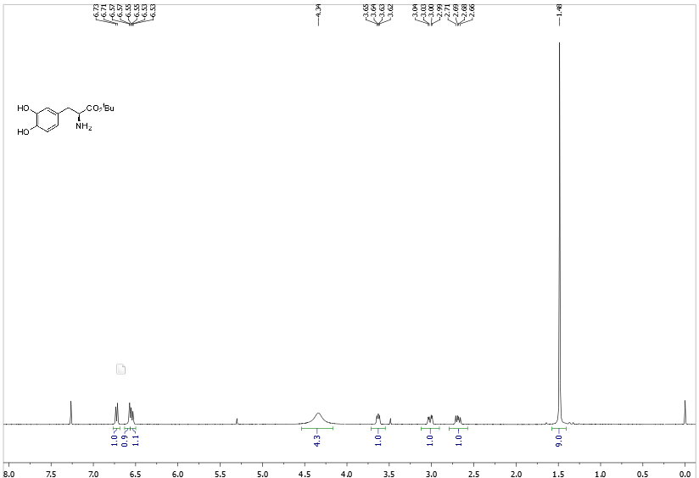
2

¹H NMR of 3
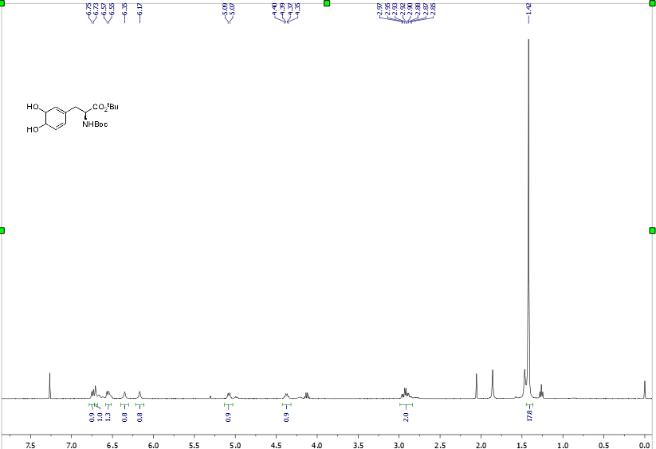
3
¹H NMR of 4
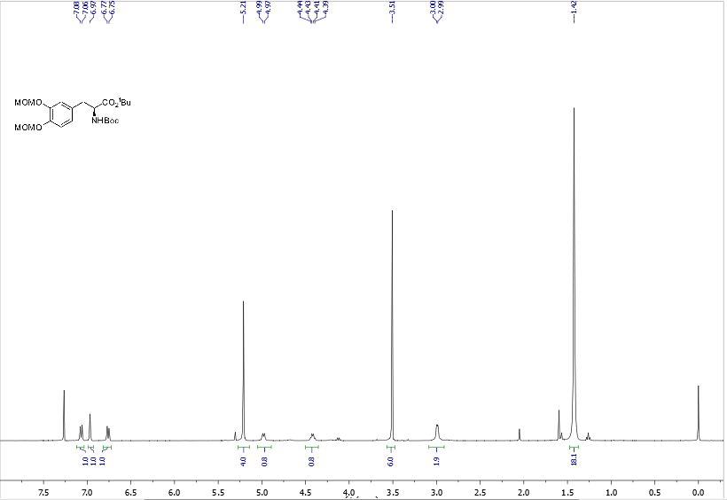
4

¹³C NMR of 4
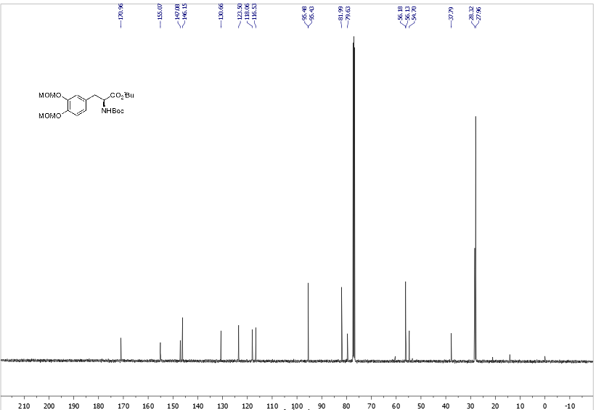
4

¹H NMR of 5
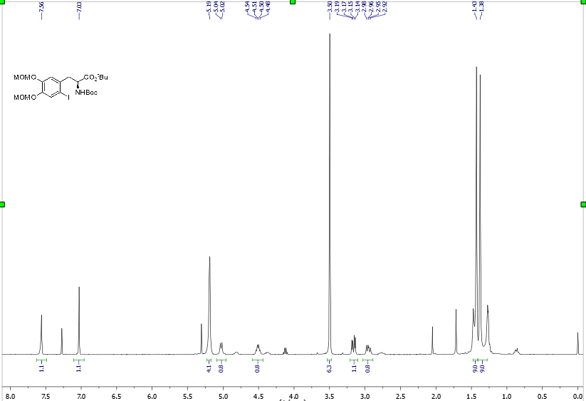
5

¹³C NMR of 5
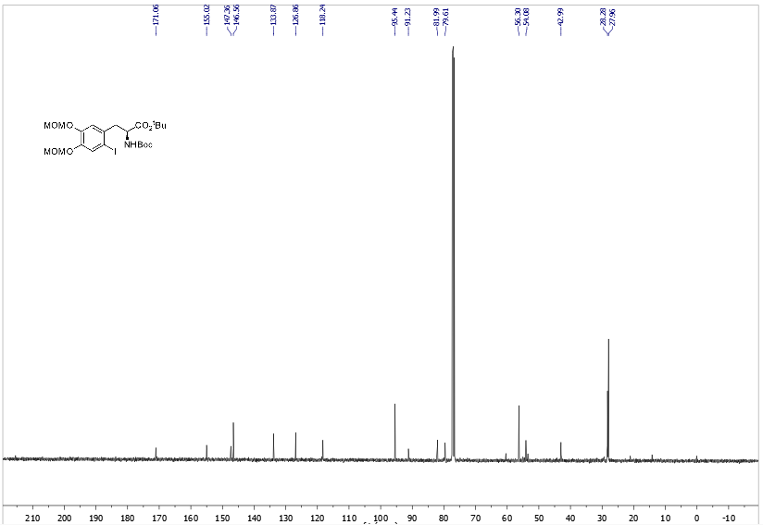
5
¹H NMR of 6
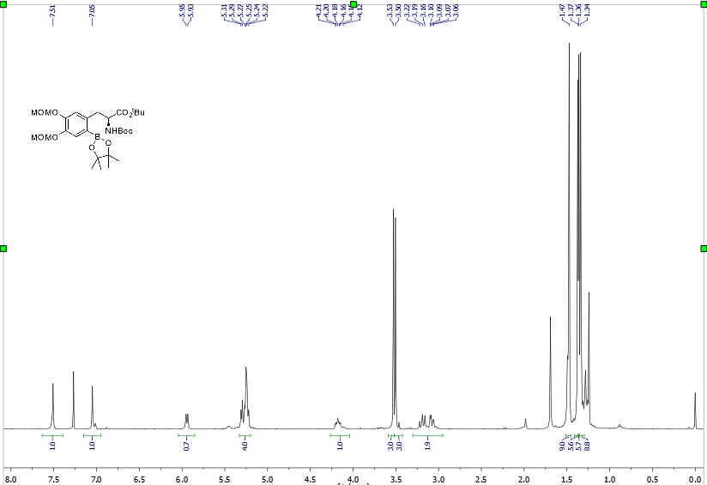
6

¹H NMR of 1b
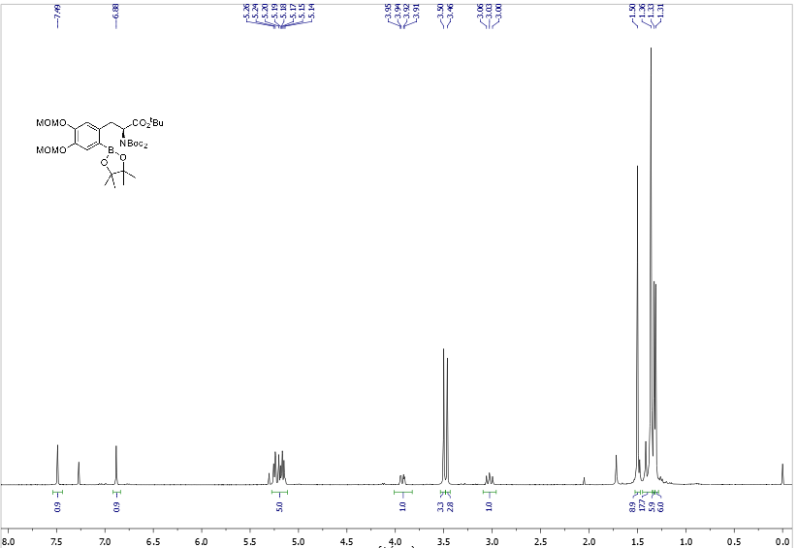
1b

¹³C NMR of 1b
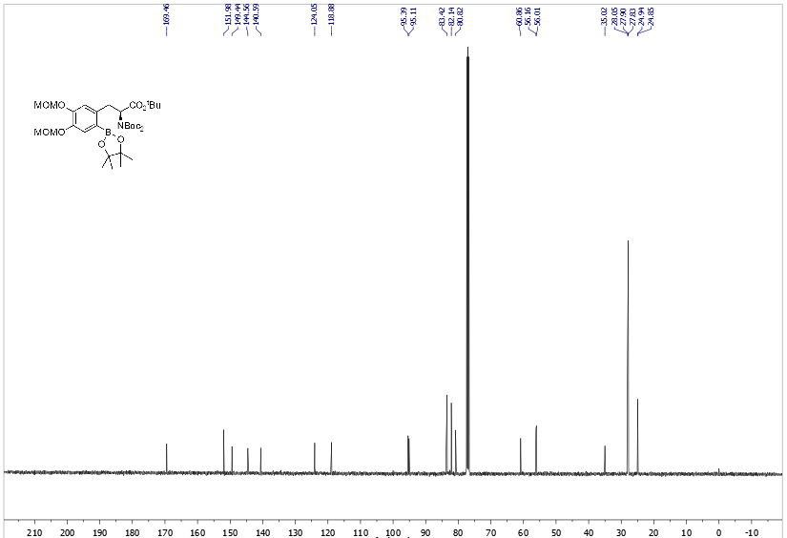
1b

