Supplementary Material

Table S1. Annual means of selected meteorological factors and annual cases of scrub typhus at provincial and country levels

 |  | 2001 | 2002 | 2003 | 2004 | 2005 | 2006 | 2007 | 2008 | 2009 | 2010 | 2011 | 2012 | 2013 | 2014 | 2015 | 2016 | 2017 | 2018 | 2019
Mean temperature (°C) |  | 13.3 | 13.2 | 13.1 | 13.6 | 12.8 | 13.4 | 13.6 | 13.4 | 13.4 | 13.1 | 12.9 | 12.5 | 13.5 | 13.6 | 13.9 | 14.0 | 13.5 | 13.1 | 13.7
Mean relative humidity (%) |  | 64 | 65.8 | 68.5 | 64.5 | 64.8 | 66.9 | 67.8 | 66.0 | 65.1 | 67.2 | 65.9 | 65.7 | 67.4 | 68.1 | 68.9 | 69.3 | 65.9 | 67.0 | 66.8
Scrub typhus cases | Country | 5.51 | 3.99 | 2.93 | 9.69 | 13.93 | 13.26 | 12.26 | 12.26 | 10.06 | 11.31 | 10.17 | 16.92 | 20.31 | 15.87 | 5.51 | 3.99 | 2.93 | 9.69 | 13.93
Scrub typhus cases | Seoul | 1.22 | 0.76 | 0.53 | 1.7 | 2.06 | 2.33 | 1.61 | 1.74 | 1.72 | 1.82 | 1.98 | 3.68 | 3.37 | 2.1 | 1.22 | 0.76 | 0.53 | 1.7 | 2.06
Scrub typhus cases | Busan | 4.02 | 2.11 | 1.4 | 6.88 | 12.29 | 13.93 | 12.45 | 9.9 | 11.65 | 15.38 | 13.29 | 21.33 | 22.28 | 14.79 | 4.02 | 2.11 | 1.4 | 6.88 | 12.29
Scrub typhus cases | Daegu | 3.76 | 2.34 | 0.99 | 7.12 | 19.22 | 13.86 | 11.3 | 11.03 | 5.58 | 6.56 | 5.98 | 9.54 | 17.37 | 8.17 | 3.76 | 2.34 | 0.99 | 7.12 | 19.22
Scrub typhus cases | Incheon | 1.21 | 0.27 | 0.51 | 1.79 | 2.05 | 3.33 | 2.57 | 2.54 | 3.15 | 2.82 | 2.73 | 4.32 | 3.46 | 2.01 | 1.21 | 0.27 | 0.51 | 1.79 | 2.05
Scrub typhus cases | Gwangju | 6.89 | 5.75 | 3.72 | 12.37 | 19.84 | 17.87 | 13.19 | 12.34 | 13.09 | 16.55 | 11.79 | 18.82 | 33.65 | 23.4 | 6.89 | 5.75 | 3.72 | 12.37 | 19.84
Scrub typhus cases | Daejeon | 10.26 | 2.83 | 2.17 | 15.86 | 16.98 | 18.83 | 19.44 | 25.23 | 10.19 | 22.89 | 12.06 | 29.21 | 33.82 | 19.58 | 10.26 | 2.83 | 2.17 | 15.86 | 16.98
Scrub typhus cases | Ulsan | 10.5 | 4.24 | 2.9 | 12.63 | 24.25 | 17.98 | 25.82 | 25.04 | 17.33 | 18.74 | 22.46 | 37.76 | 57.12 | 41.33 | 10.5 | 4.24 | 2.9 | 12.63 | 24.25
Scrub typhus cases | Gyeonggi-do | 1.39 | 1.23 | 1.26 | 4.71 | 5.78 | 6.33 | 4.62 | 4.54 | 3.83 | 4.61 | 4.75 | 8.45 | 6.57 | 6.6 | 1.39 | 1.23 | 1.26 | 4.71 | 5.78
Scrub typhus cases | Gangwon-do | 2.83 | 1.68 | 2.22 | 4.07 | 5.01 | 3.51 | 3.99 | 3.78 | 2.85 | 4.01 | 2.94 | 3.77 | 7.21 | 4.6 | 2.83 | 1.68 | 2.22 | 4.07 | 5.01
Scrub typhus cases | Chungcheong  buk-do | 8.82 | 9.97 | 4.49 | 19.14 | 21.22 | 20.92 | 18.99 | 24.19 | 13.26 | 17.09 | 15.04 | 23.14 | 25.3 | 16.31 | 8.82 | 9.97 | 4.49 | 19.14 | 21.22
Scrub typhus cases | Chungcheon  gnam-do | 19.27 | 10.93 | 11.94 | 30.47 | 37.54 | 37.79 | 30.33 | 46.64 | 34.47 | 38.56 | 32.56 | 35.74 | 49.55 | 39.85 | 19.27 | 10.93 | 11.94 | 30.47 | 37.54
Scrub typhus cases | Jeollabuk-do | 14.83 | 17.98 | 7.11 | 29.89 | 50.26 | 49.12 | 44.66 | 37.71 | 38.16 | 39.37 | 38.53 | 68.69 | 62.89 | 51.22 | 14.83 | 17.98 | 7.11 | 29.89 | 50.26
Scrub typhus cases | Jeollanam-do | 15.89 | 11.17 | 12.52 | 25.43 | 33.29 | 33.61 | 33.67 | 26.4 | 35.49 | 27.77 | 23.9 | 33.16 | 67.07 | 72.07 | 15.89 | 11.17 | 12.52 | 25.43 | 33.29
Scrub typhus cases | Gyeongsang  buk-do | 7.81 | 4.4 | 2.92 | 12.63 | 23.55 | 22.43 | 21.71 | 22.45 | 13.81 | 12.69 | 11.06 | 16.79 | 24.23 | 16.3 | 7.81 | 4.4 | 2.92 | 12.63 | 23.55
Scrub typhus cases | Gyeongsang  nam-do | 11.39 | 10.01 | 6.9 | 20.6 | 25 | 18.47 | 23.89 | 20.49 | 15.44 | 18.93 | 17.61 | 37.69 | 44.22 | 34.98 | 11.39 | 10.01 | 6.9 | 20.6 | 25
Scrub typhus cases | Jeju-do | 0.92 | 0.91 | 1.99 | 1.99 | 4.67 | 3.94 | 3.76 | 3.93 | 2.31 | 4.94 | 10.46 | 13.1 | 10.53 | 9.82 | 0.92 | 0.91 | 1.99 | 1.99 | 4.67

Figure S1. Seasonal variations of scrub typhus incidence and meteorological factors in the Republic of Korea from 2001 to 2019
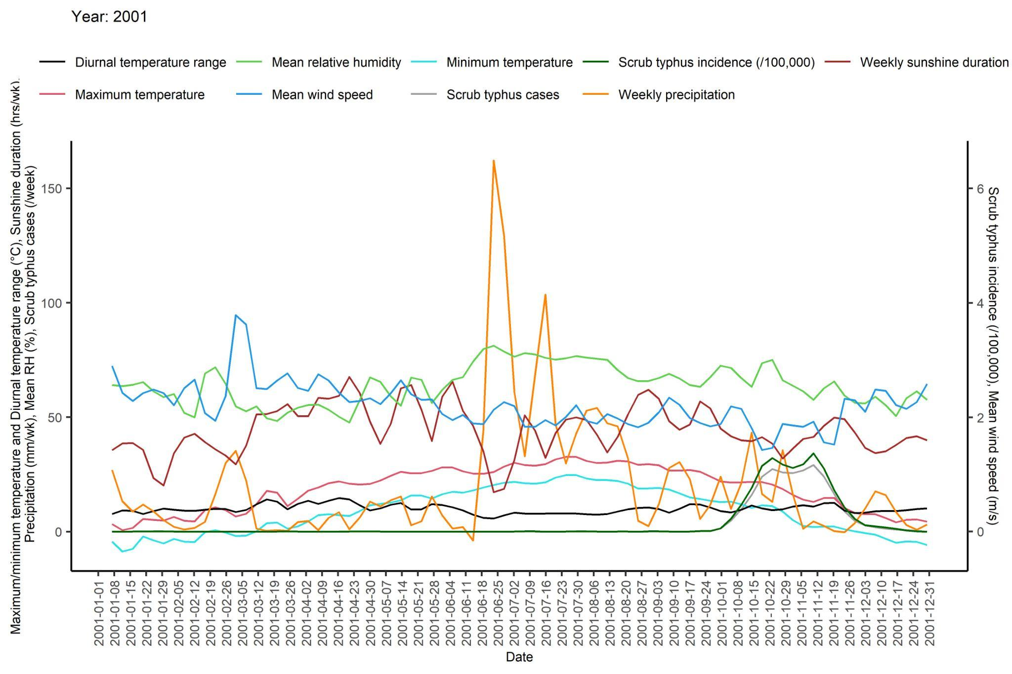 | 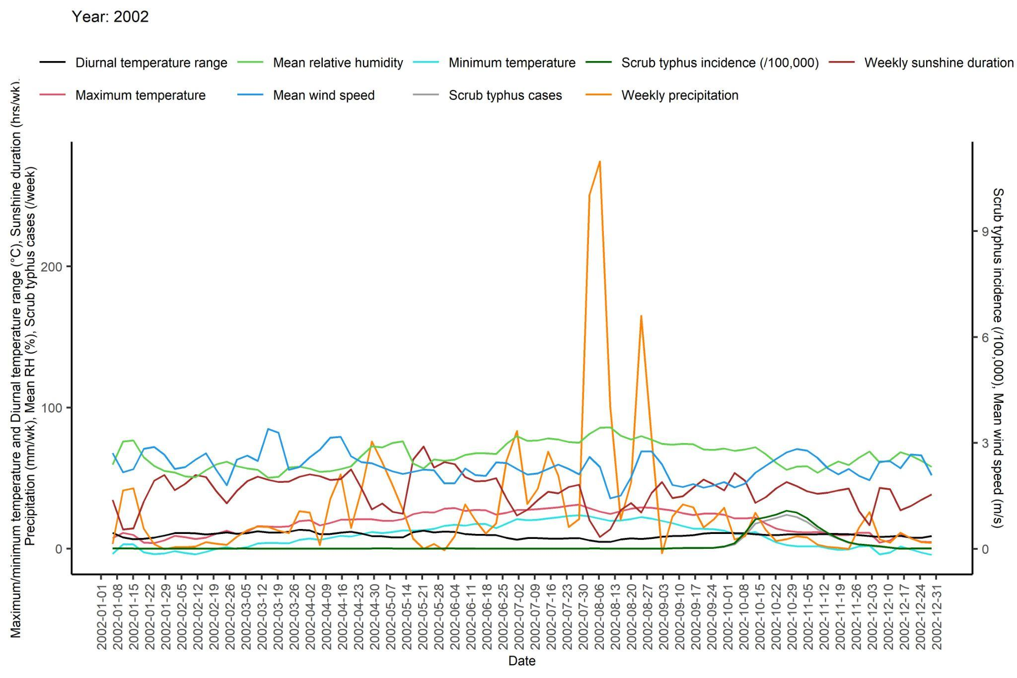
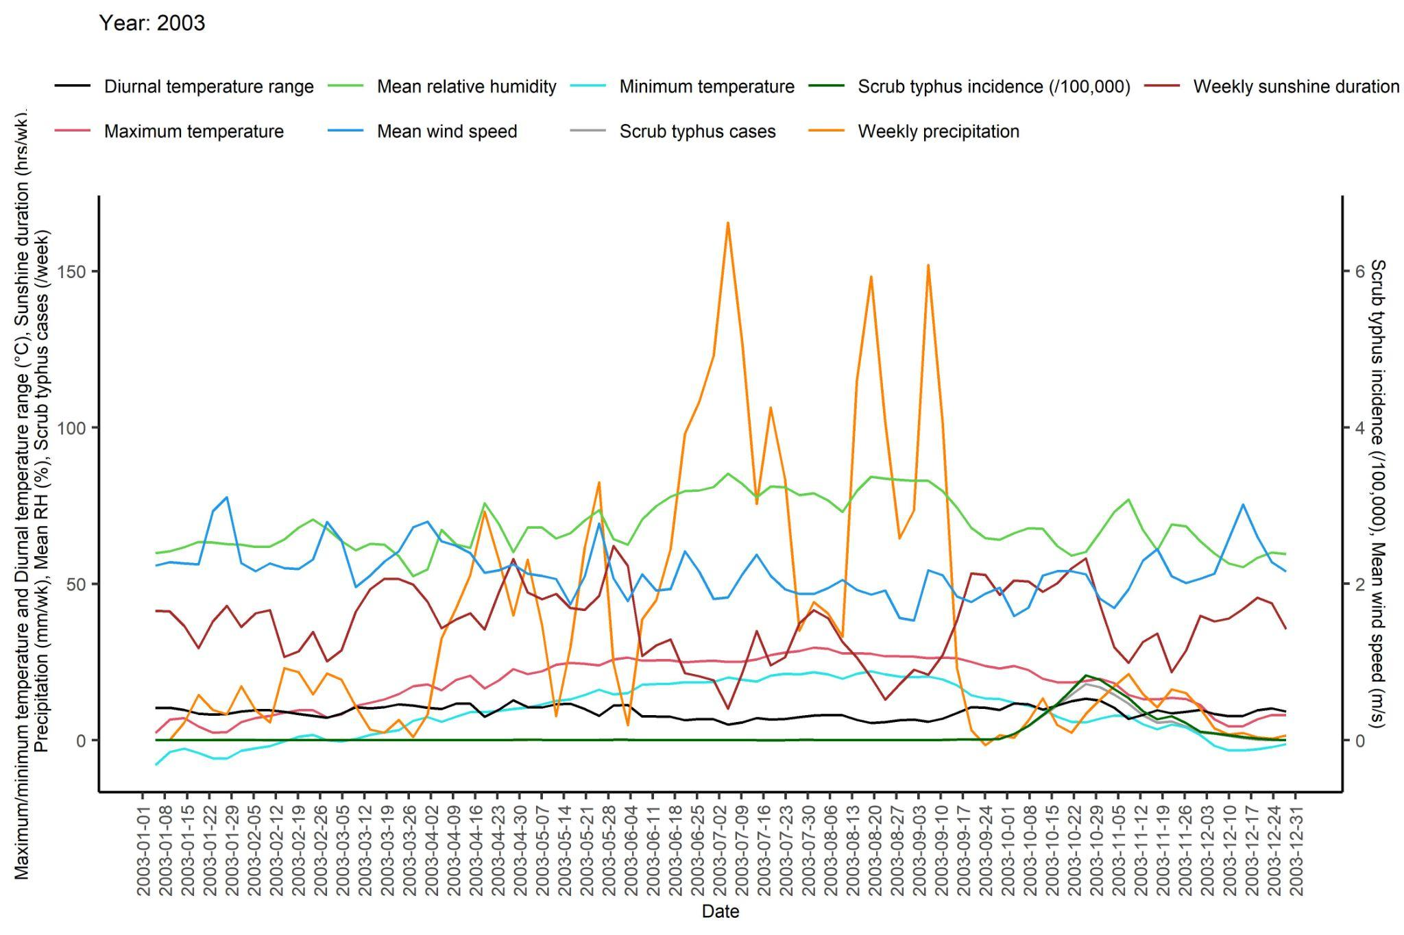 | 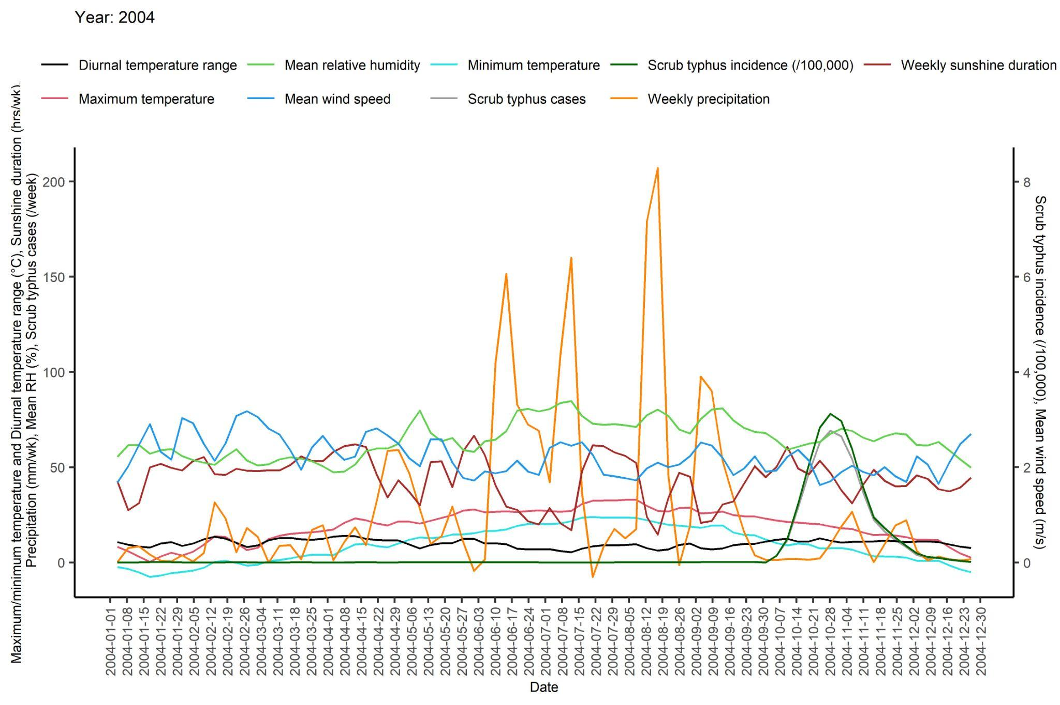
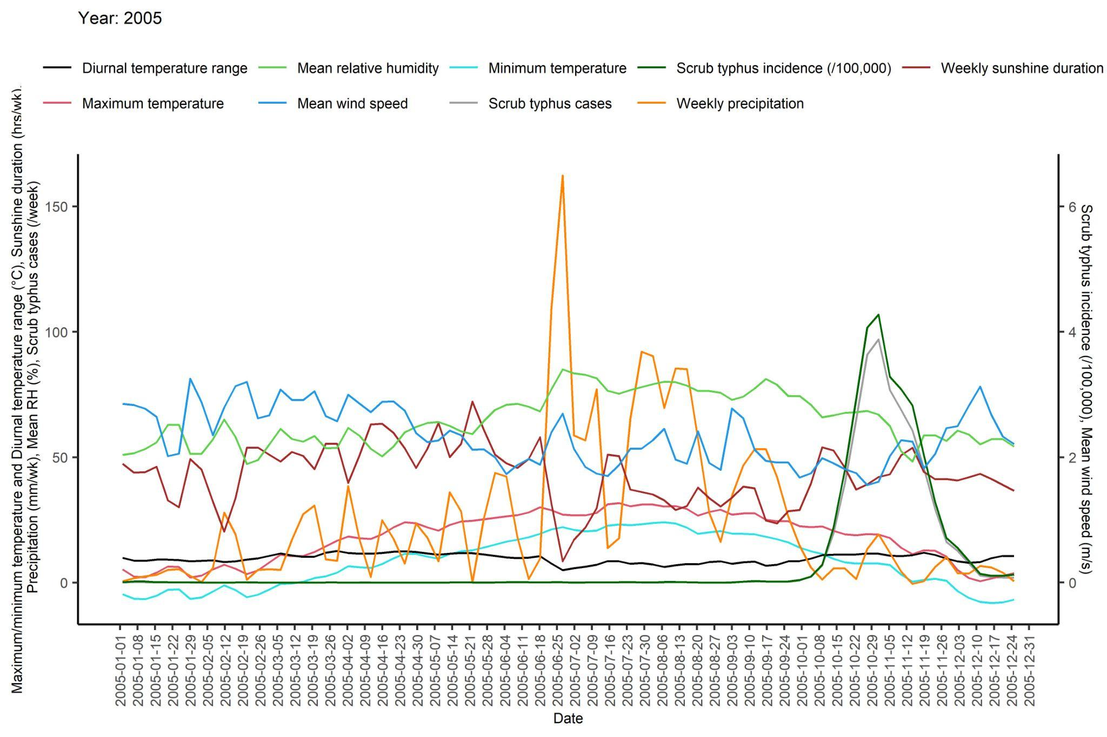 | 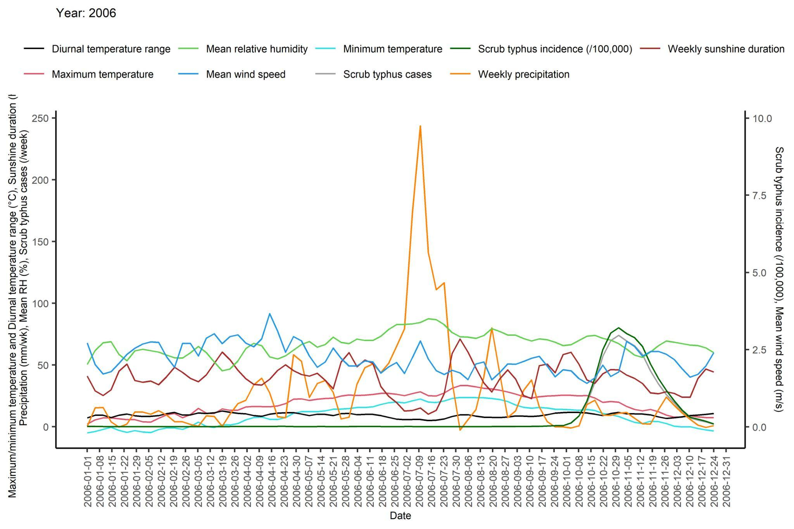
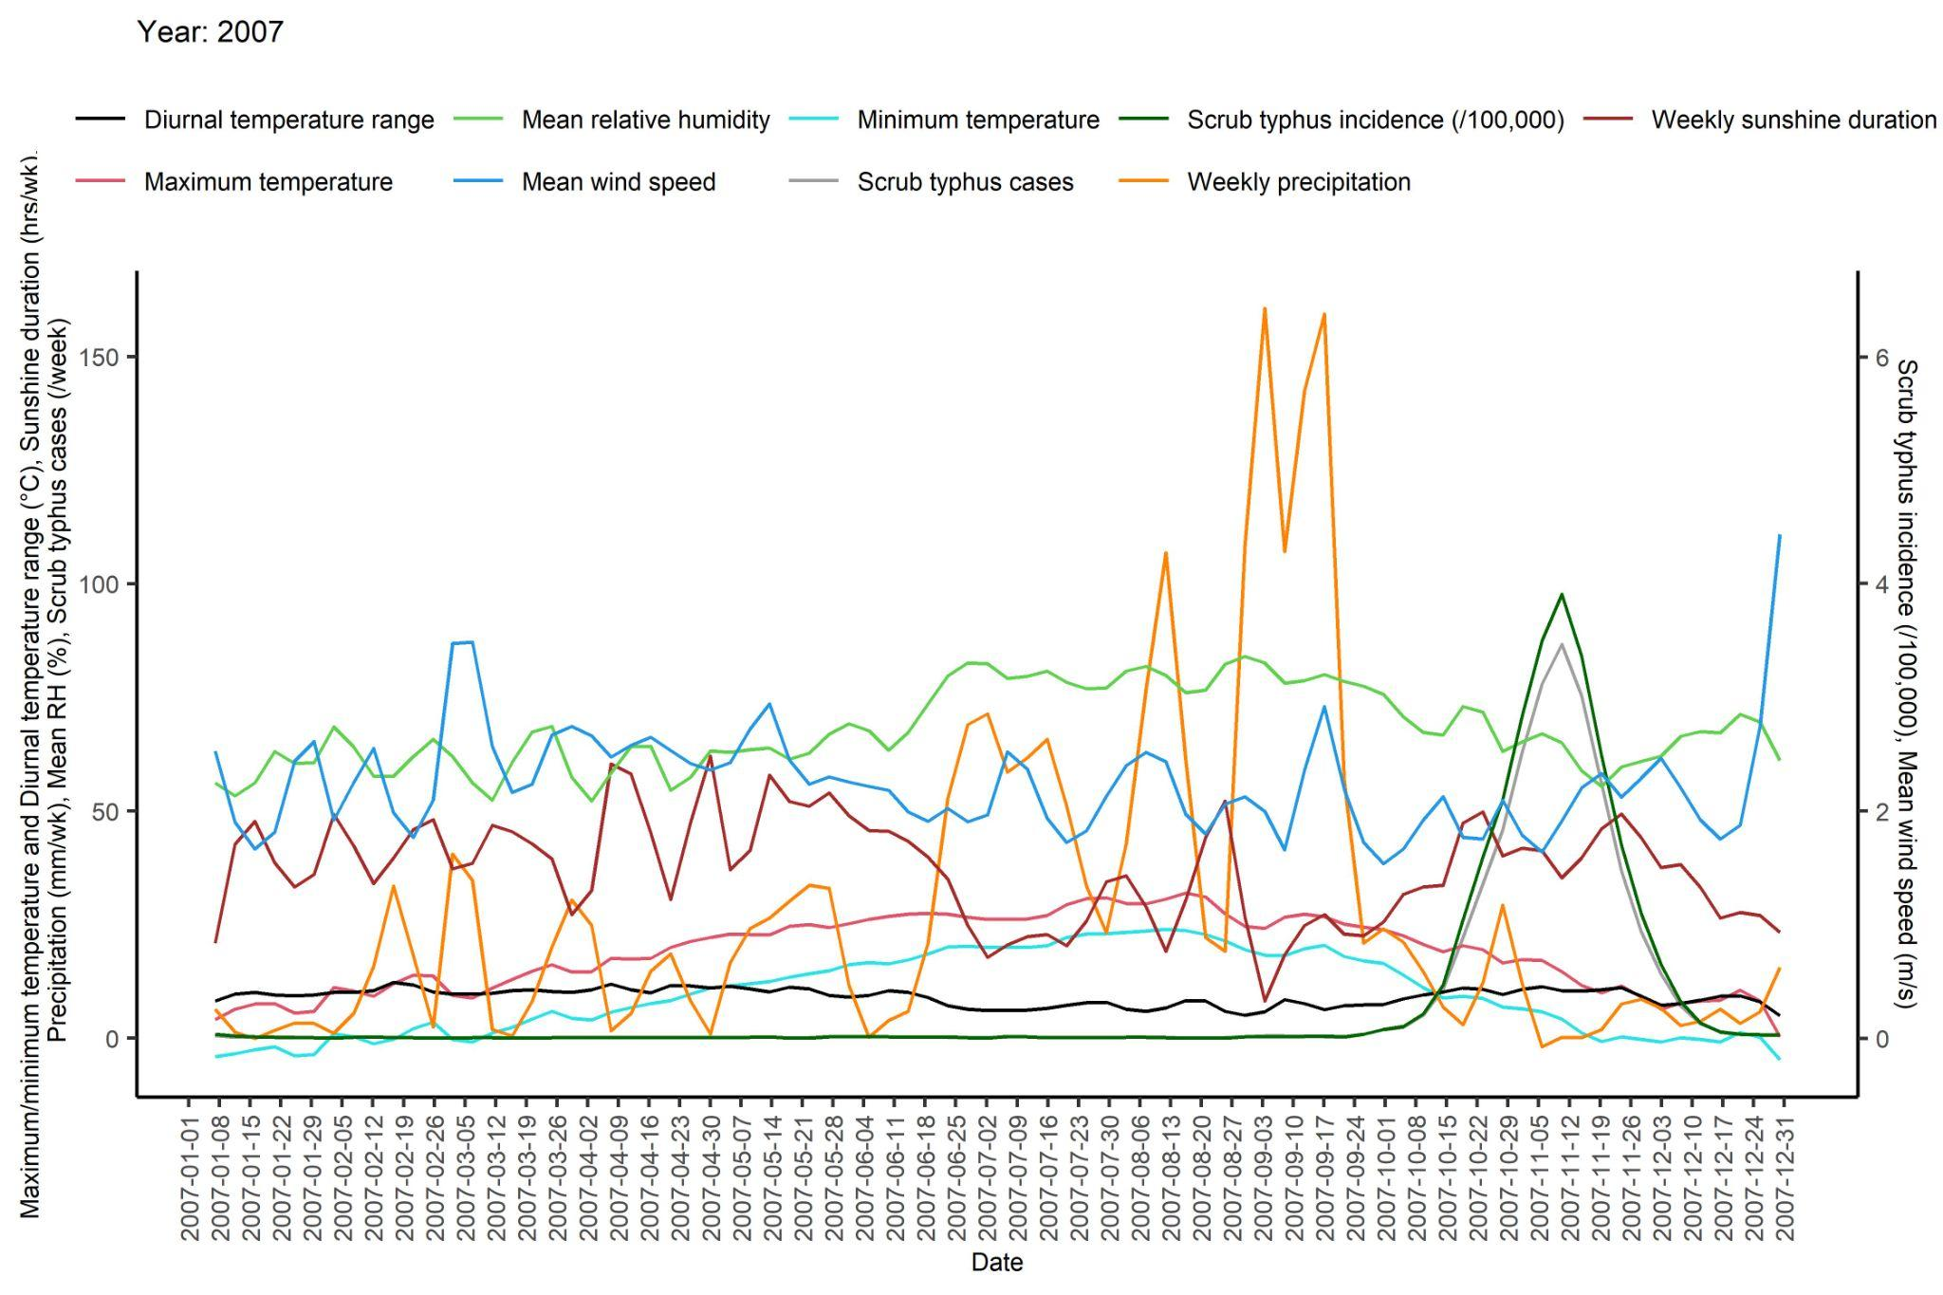 | 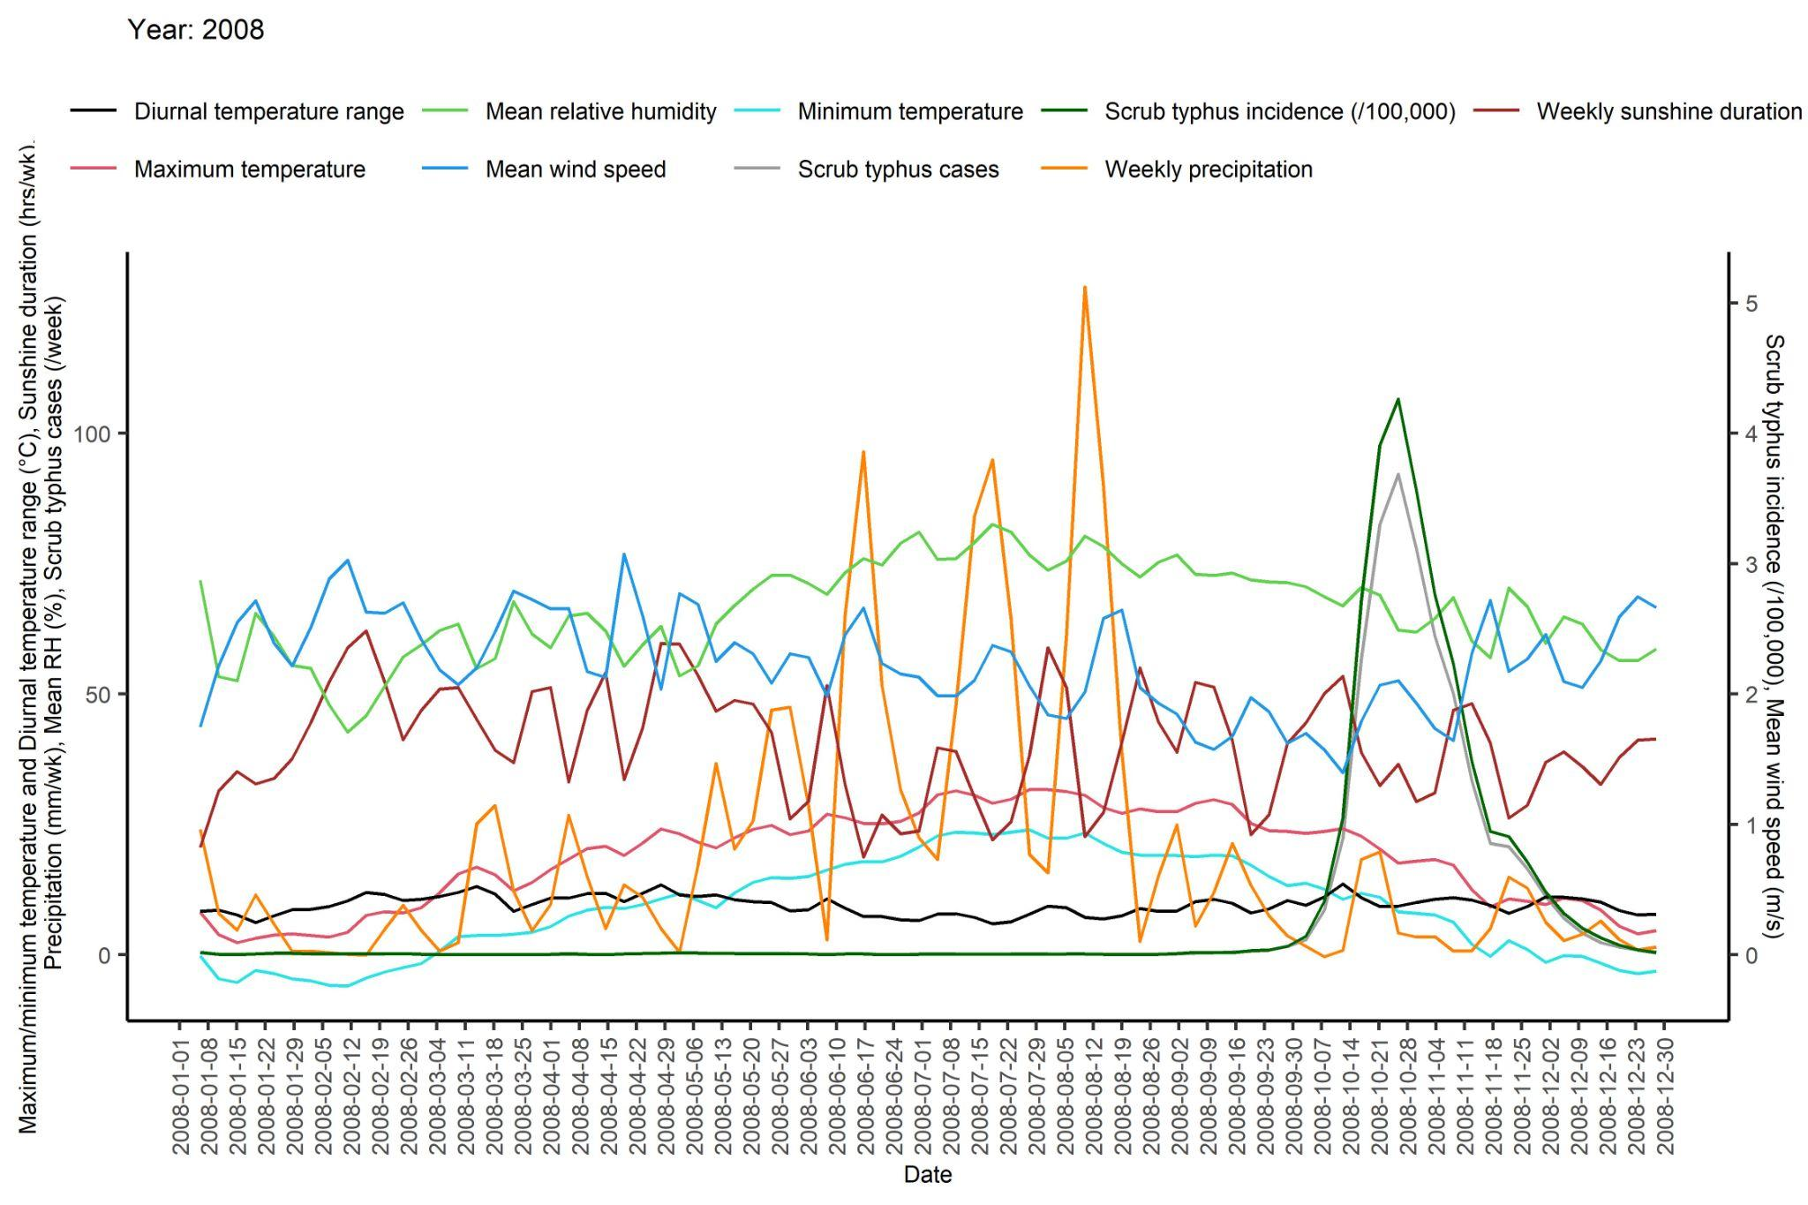

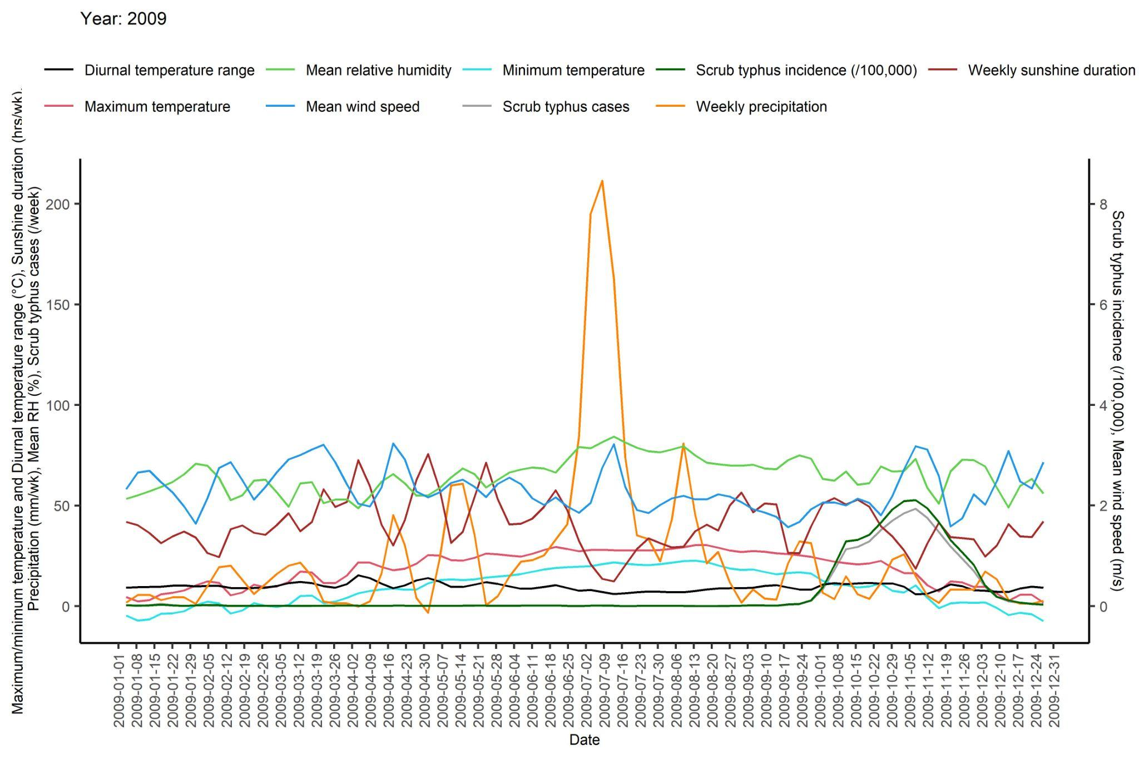 | 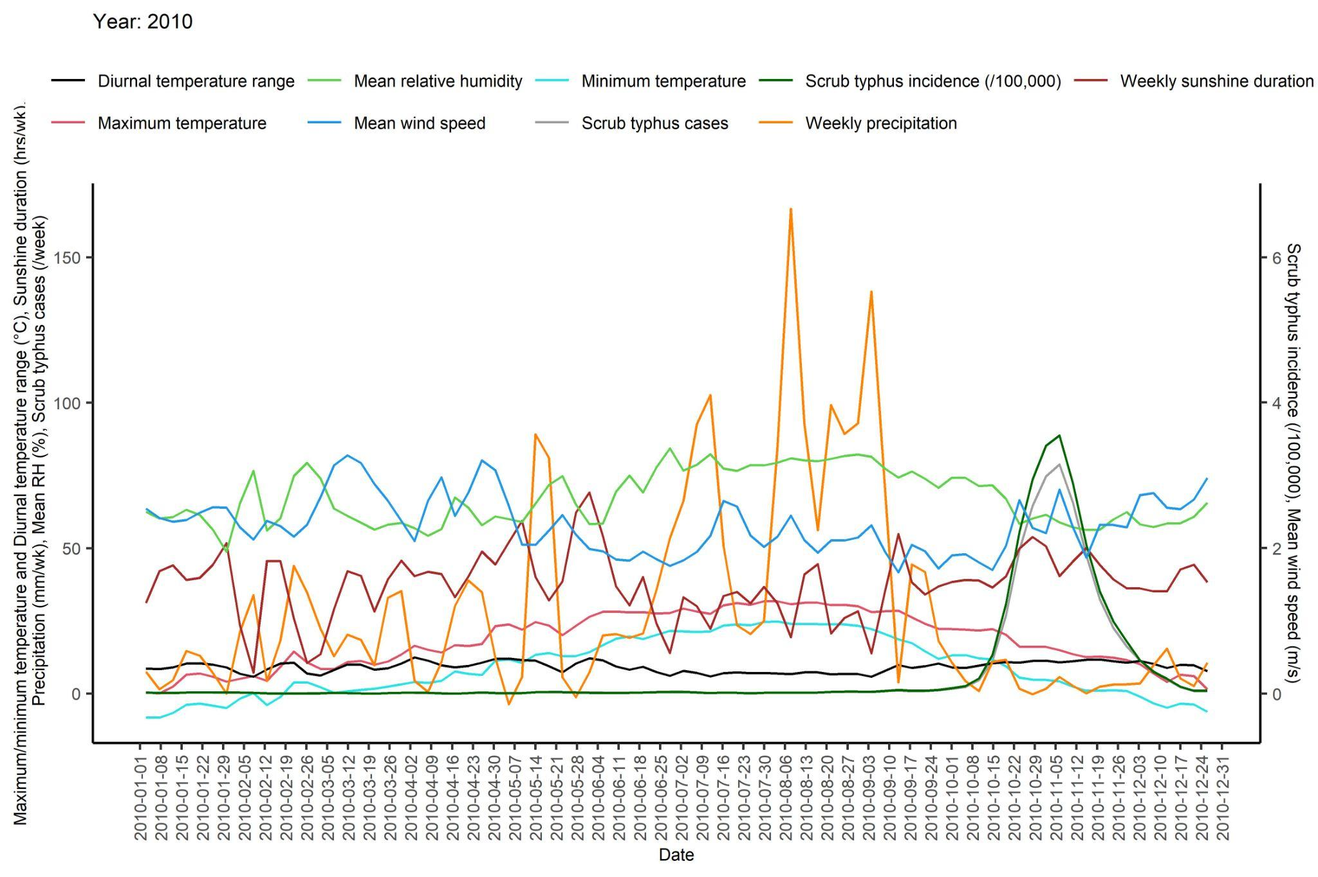
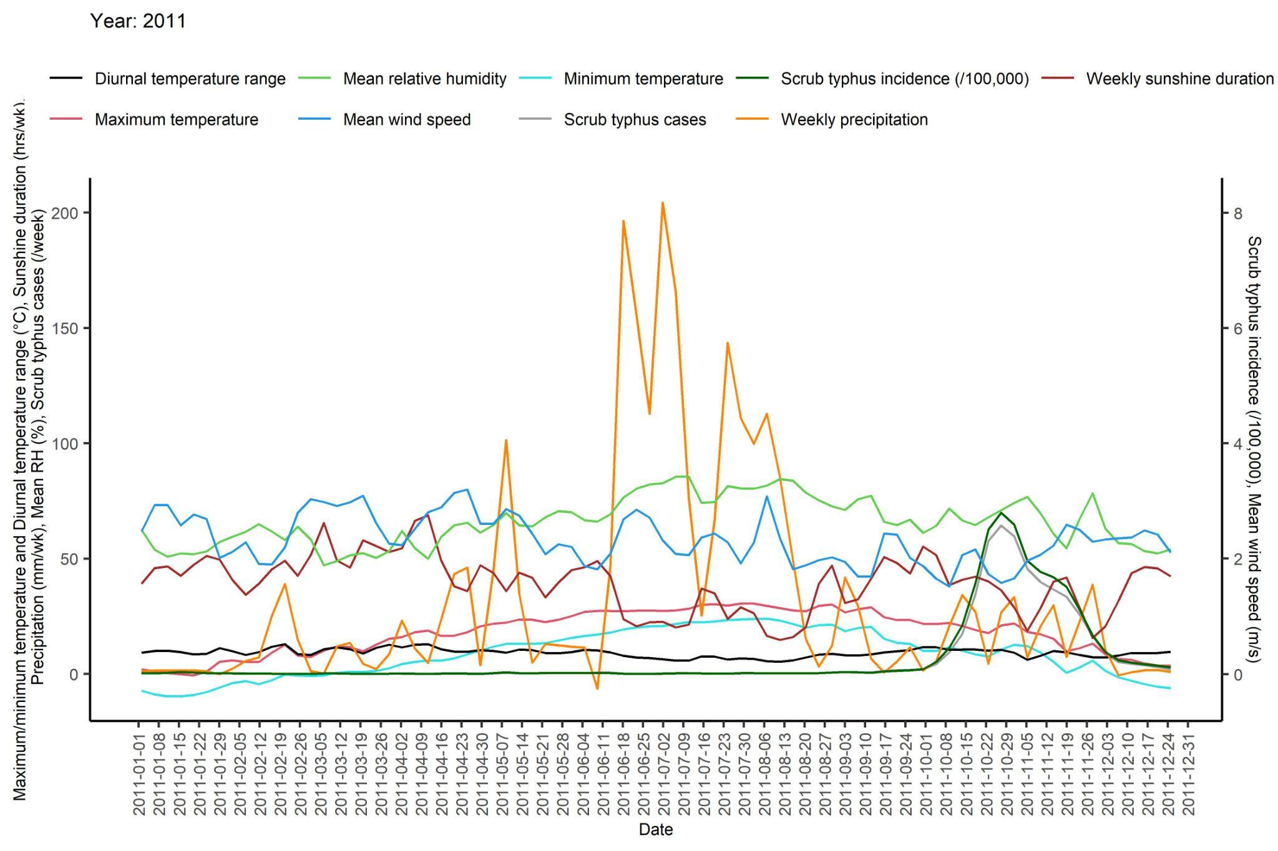 | 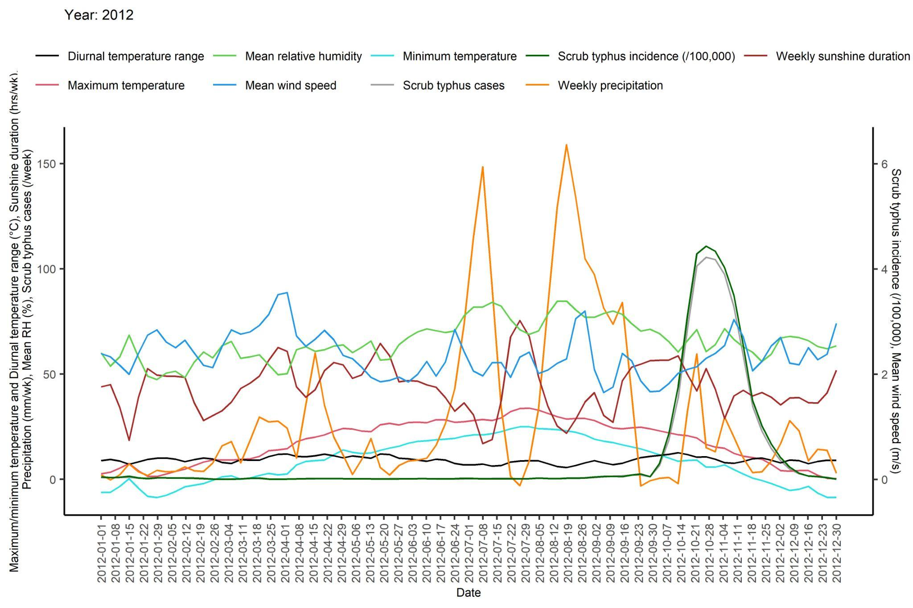
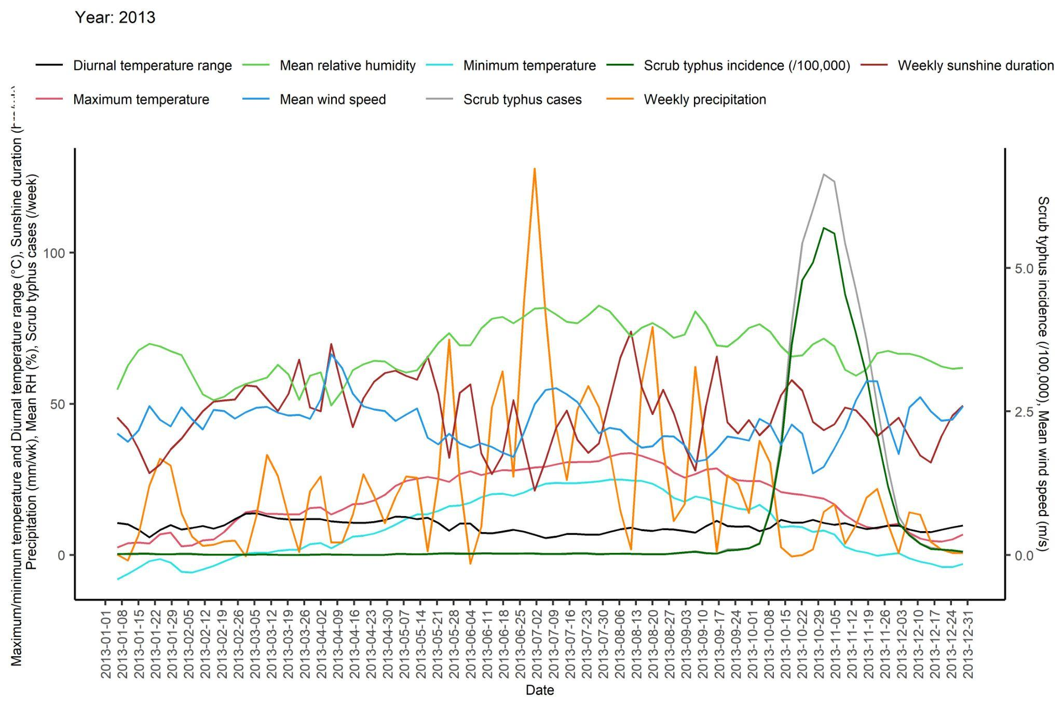 | 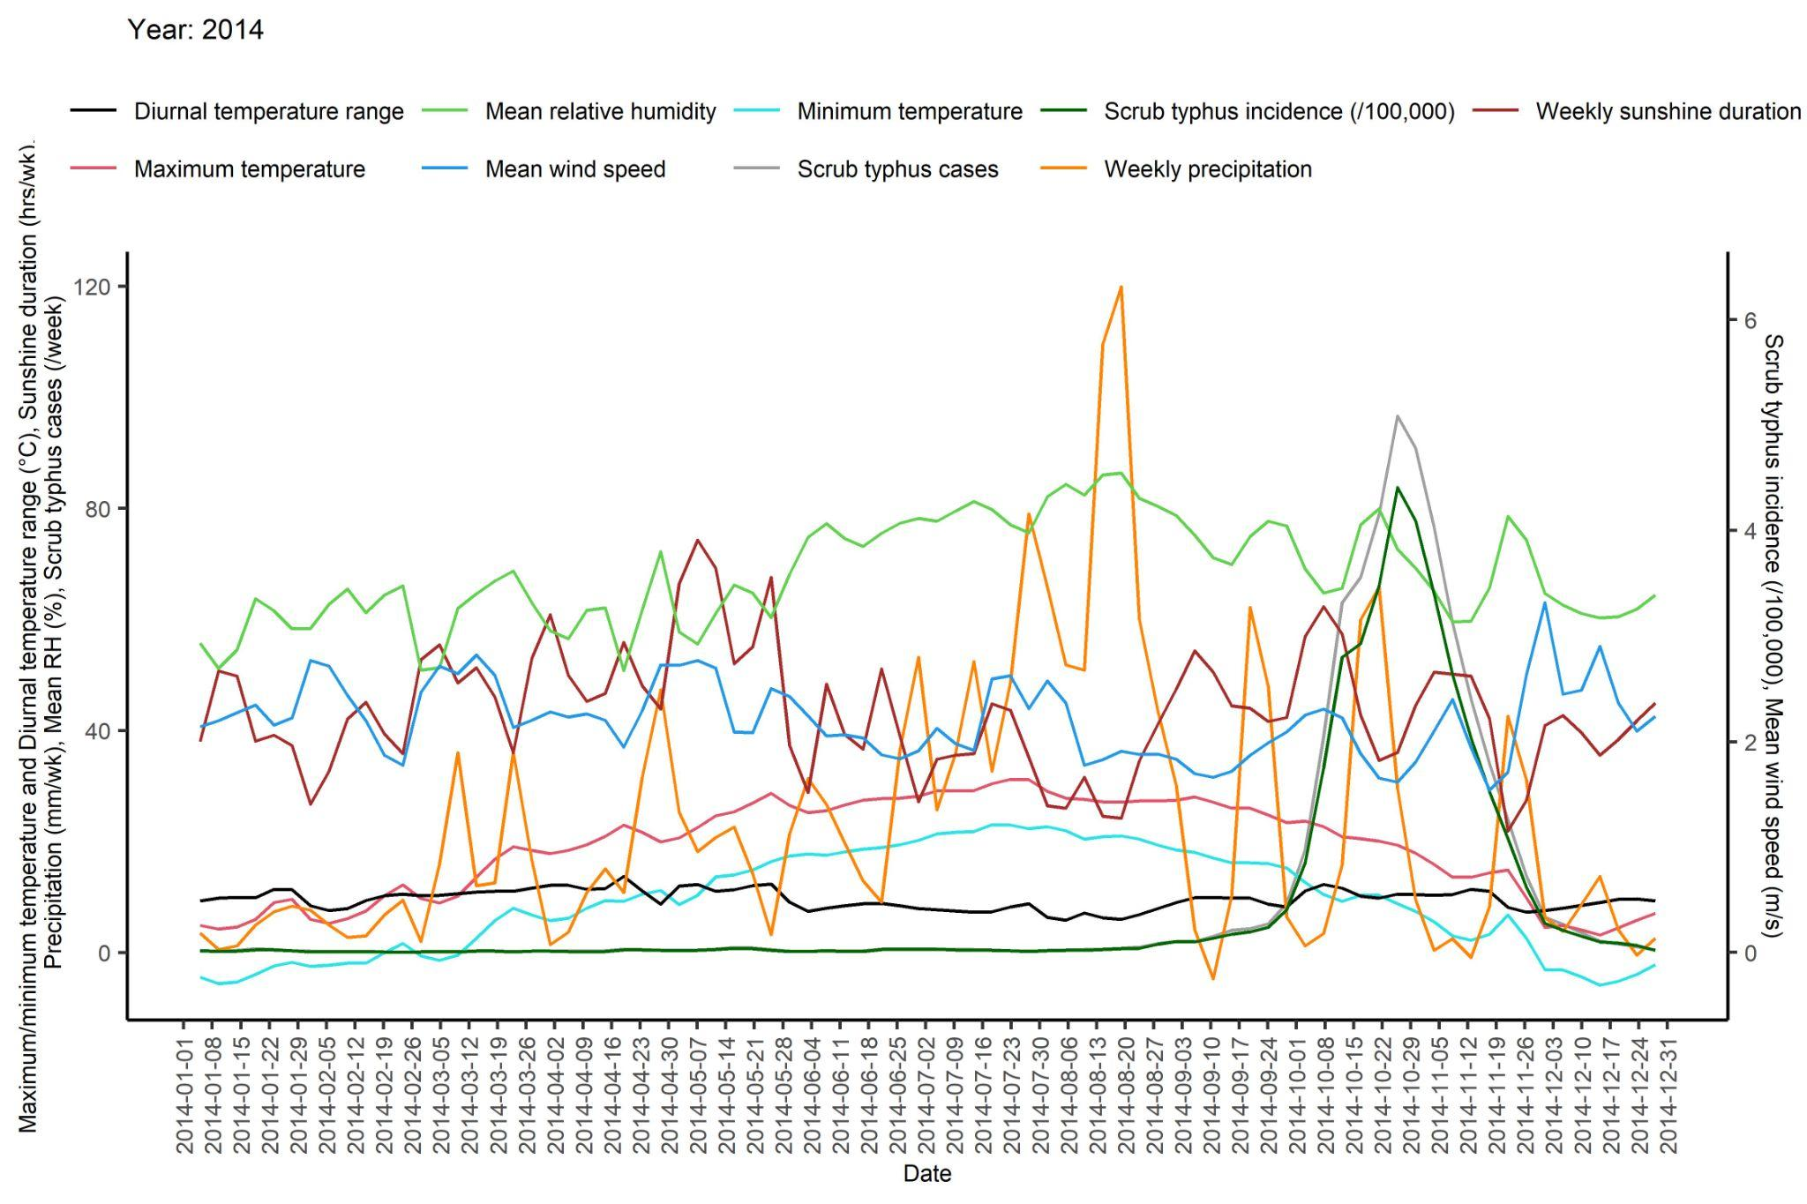
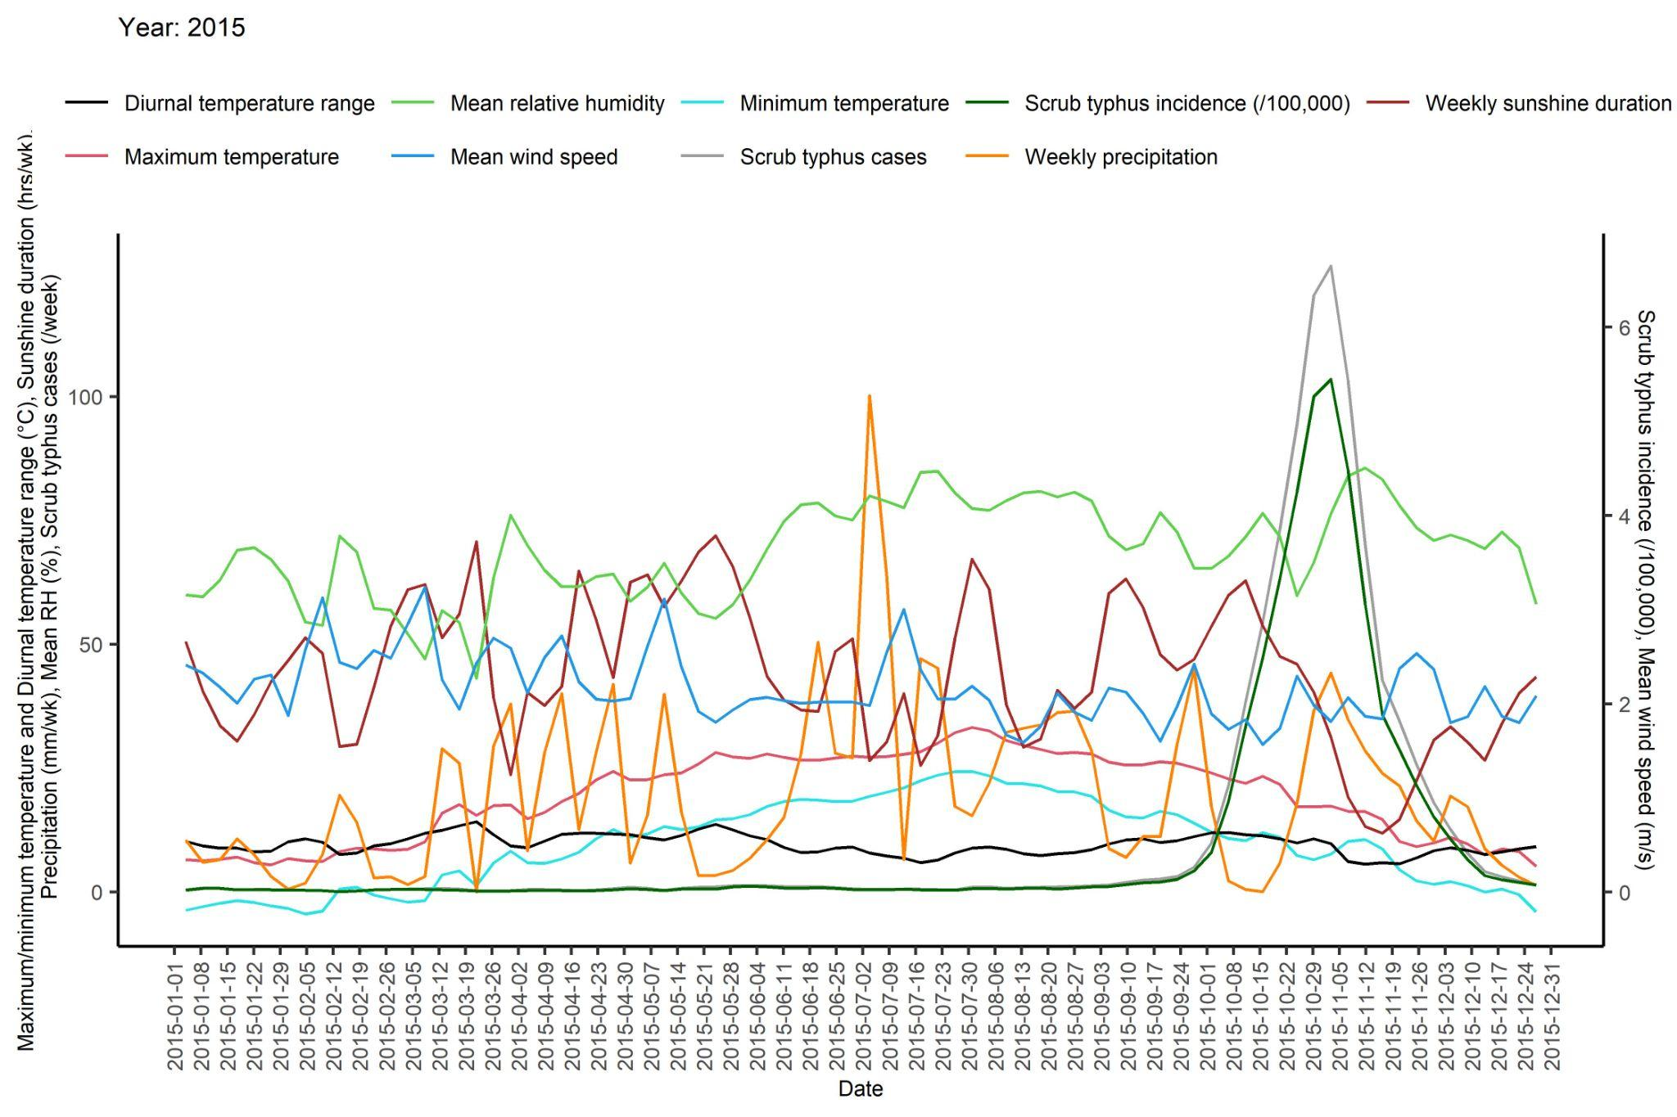 | 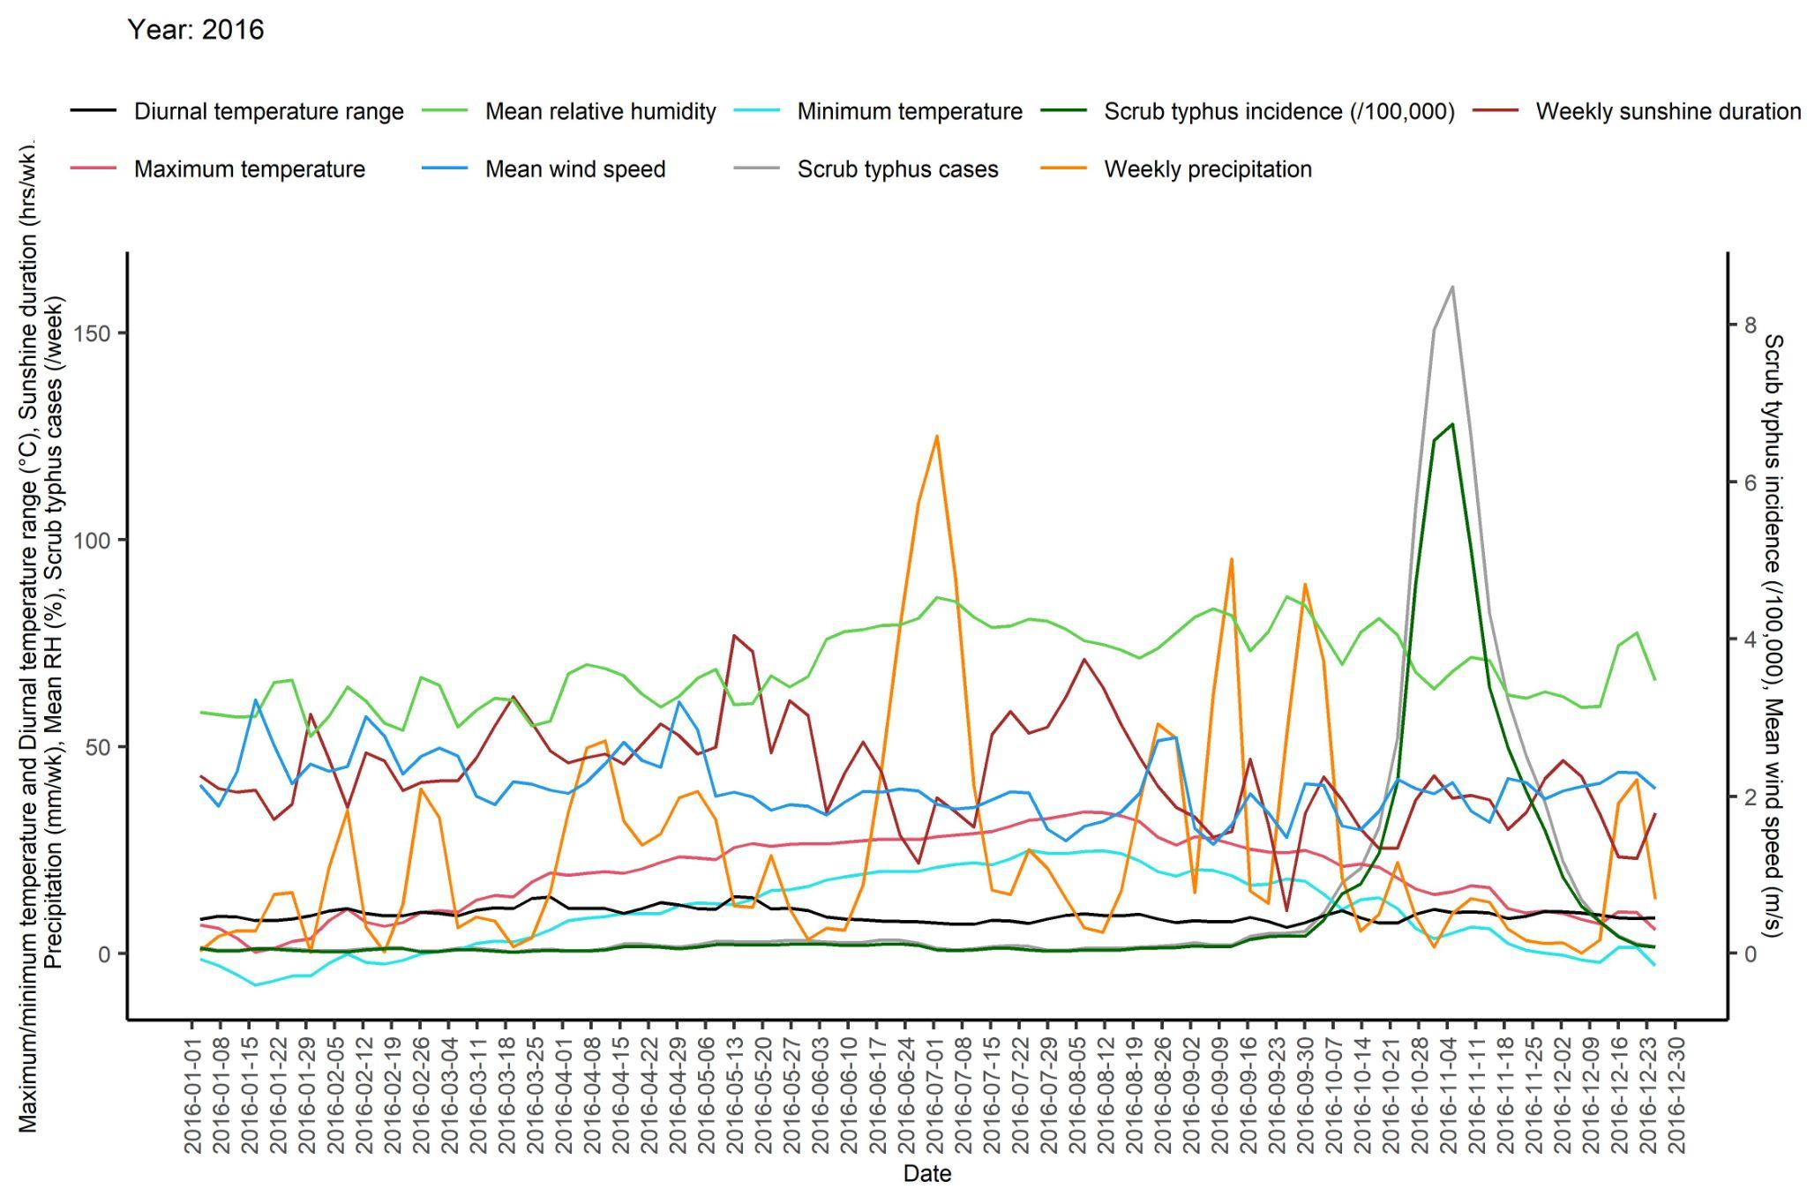

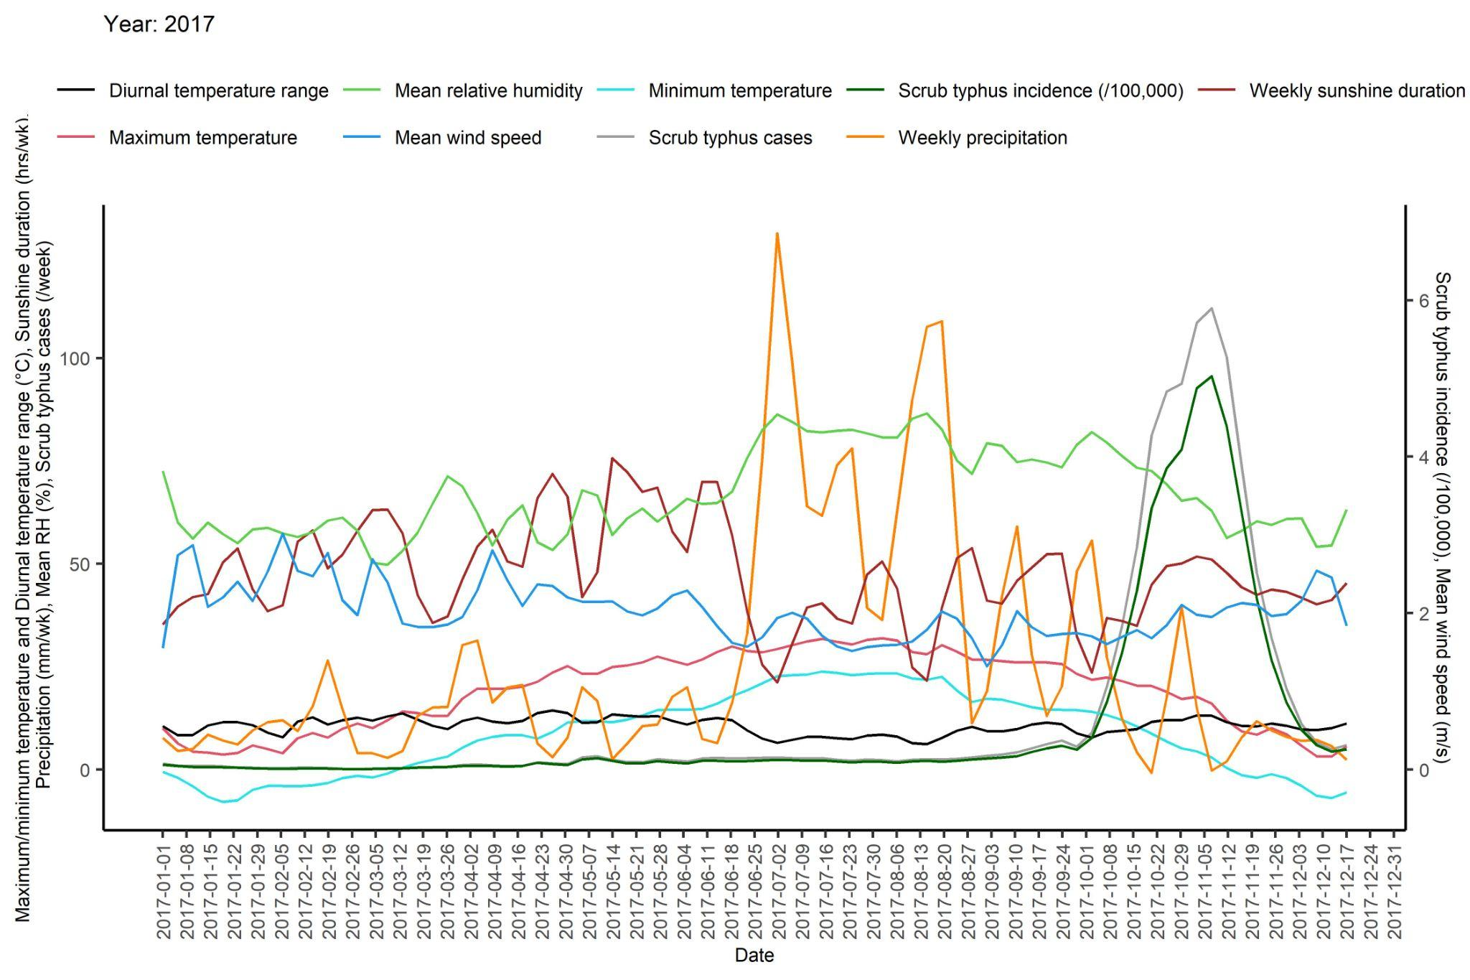 | 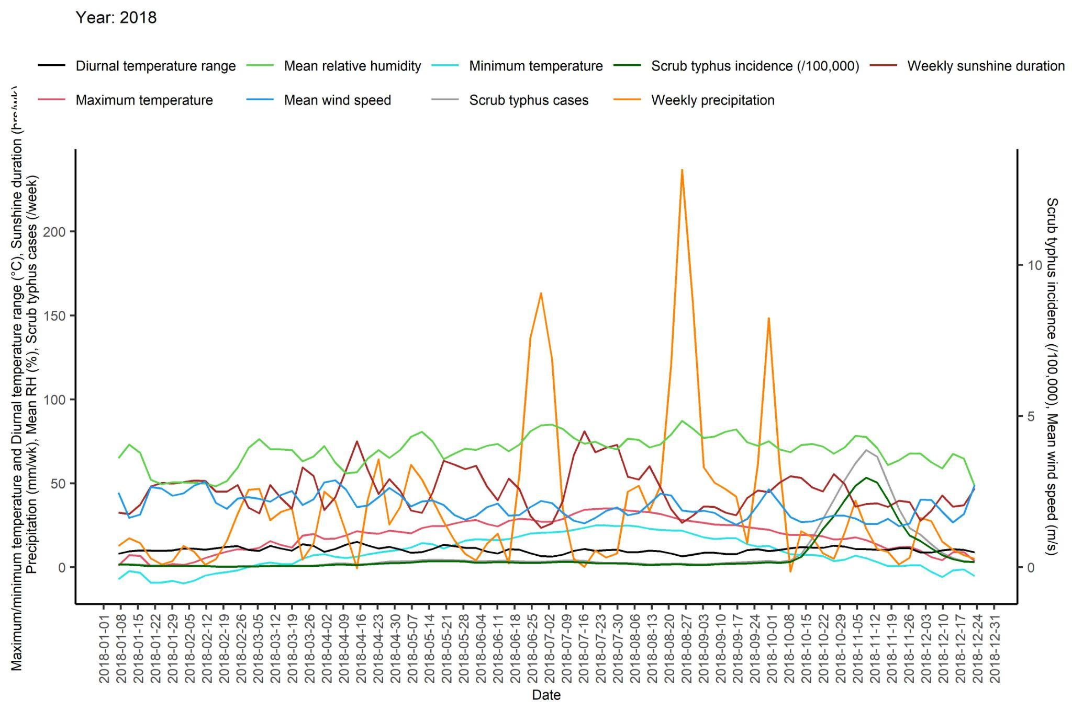
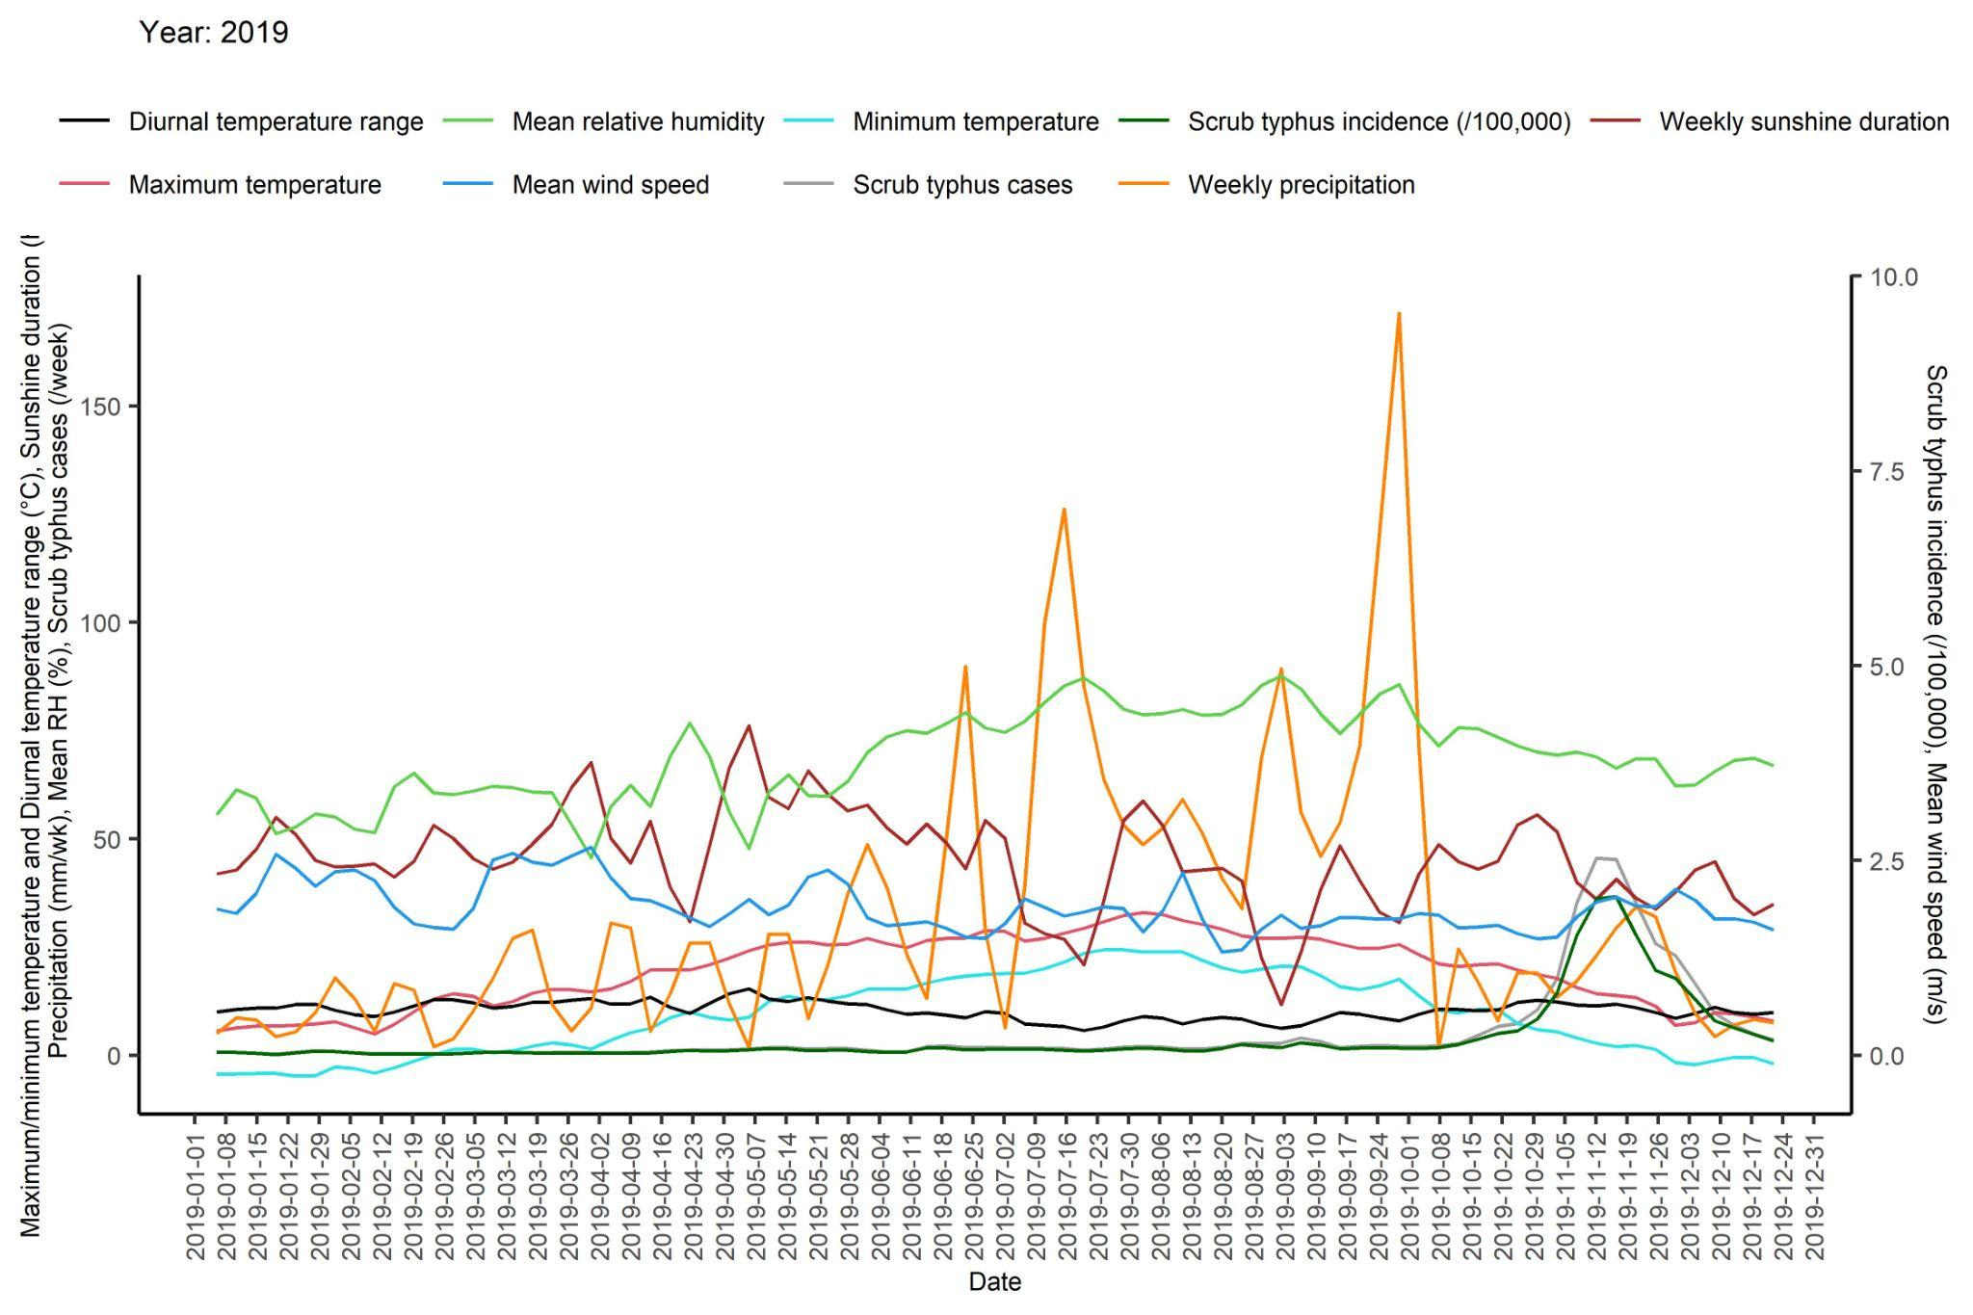

Figure S2. Bivariate association plots between meteorological variables and scrub typhus incidence using GAM
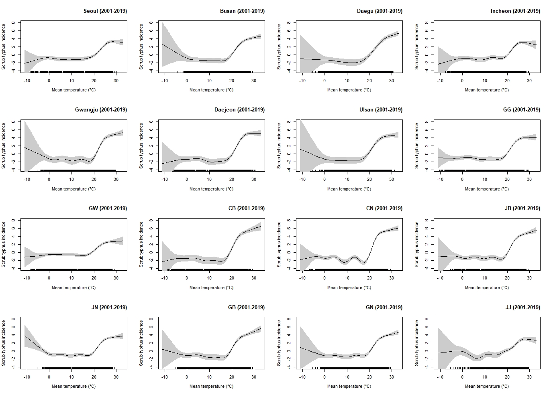
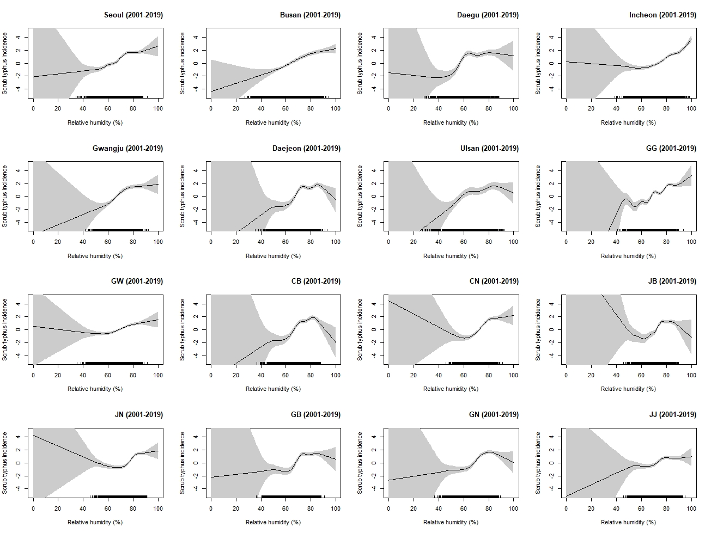
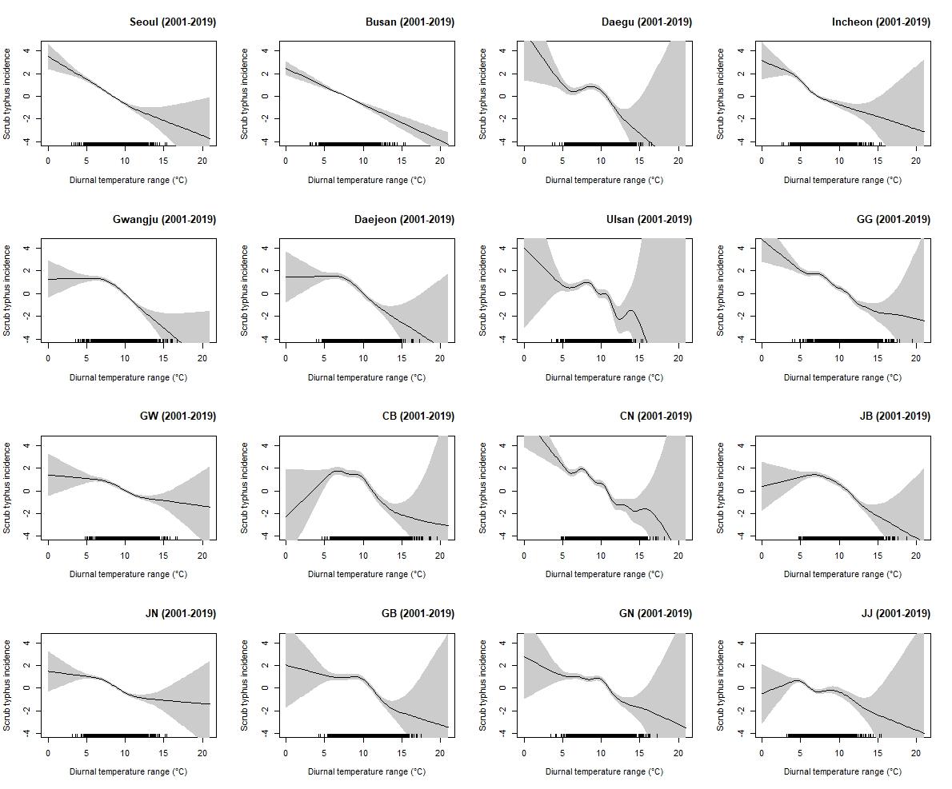
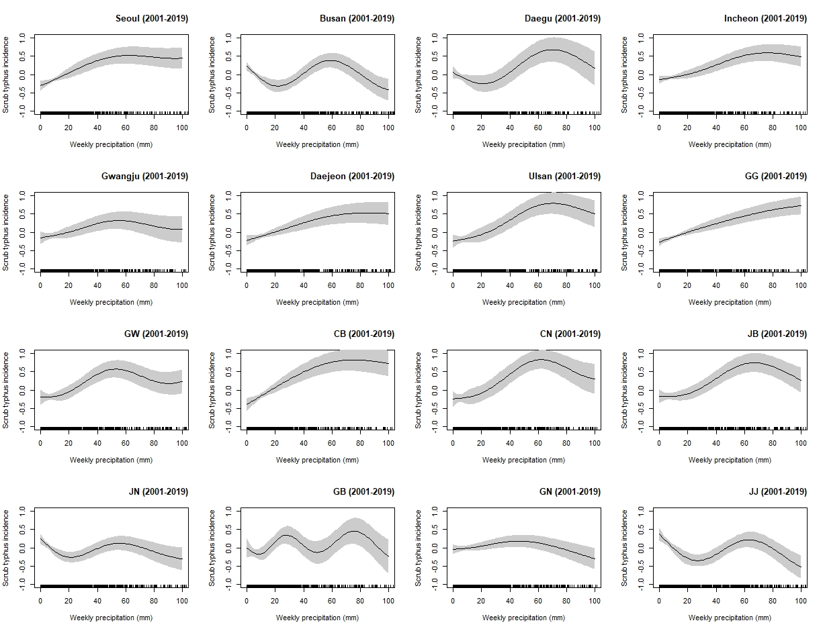
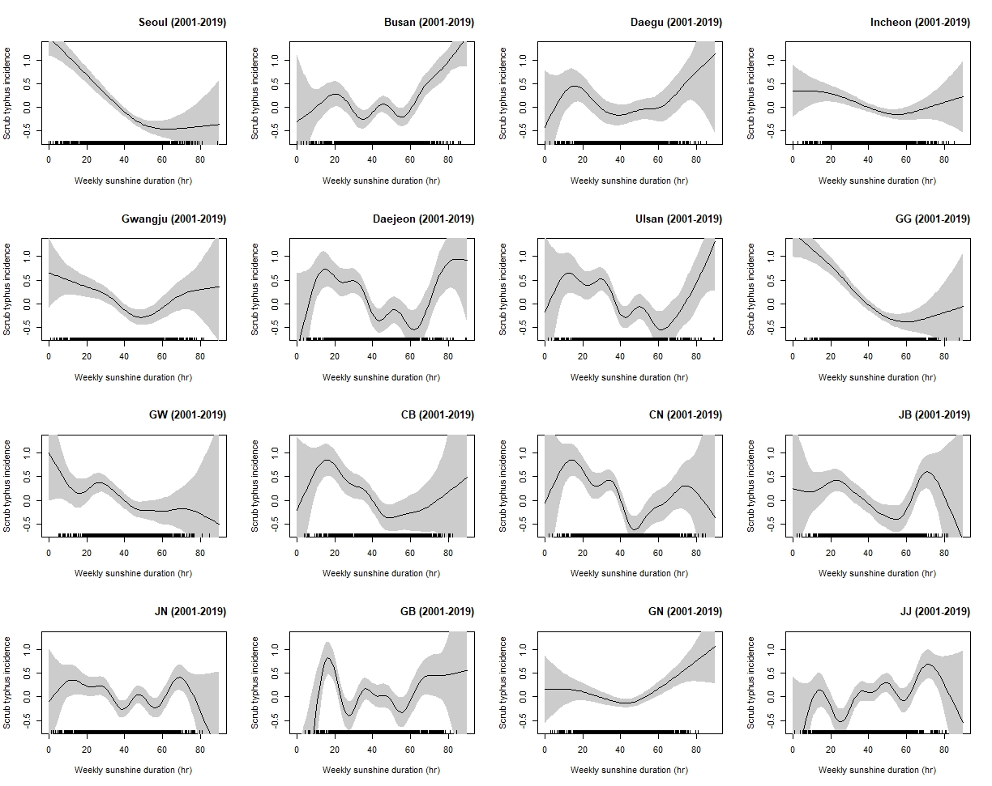
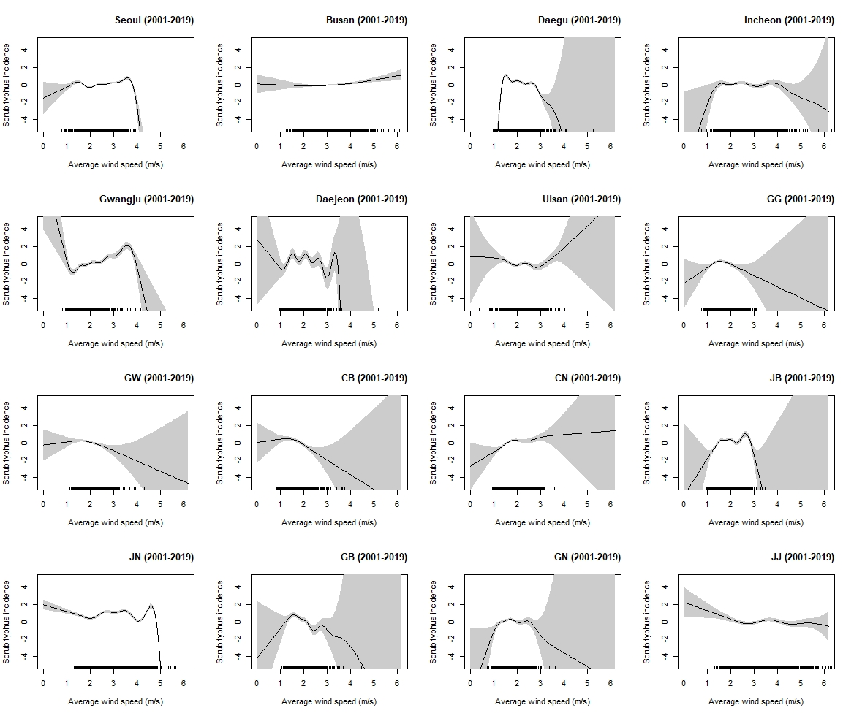

Figure S3. Degree of freedom in the generalized additive model was chosen when UBRE values of all provinces were minimized and plateaued afterward.
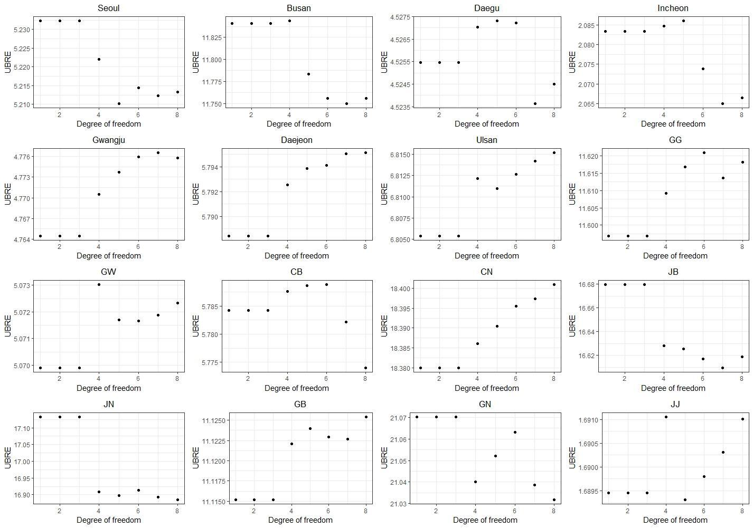

Figure S4. Degree of freedom in the generalized linear model was selected if both conditions were met that standardized regression coefficients (beta) remained nearly constant and Akaike Information Criteria (AIC) had a lowest value.
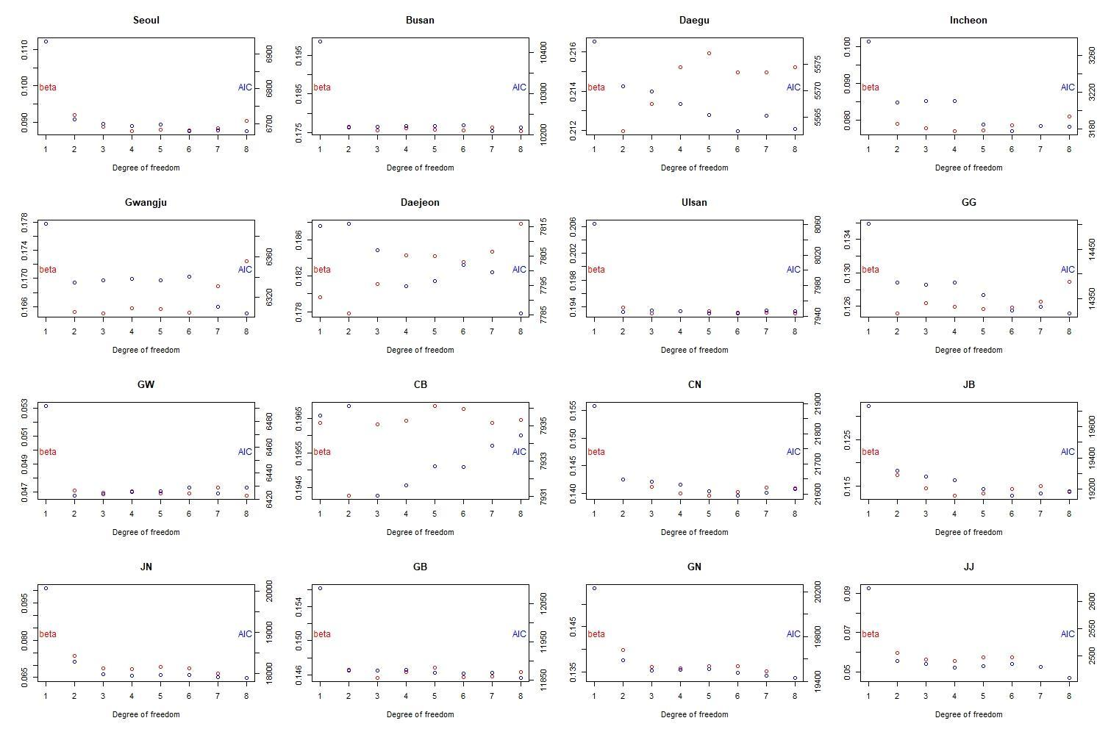

Figure S5. Comparison of association plots between mean ambient temperature (°C) or mean relative humidity and scrub typhus incidence (per 10,000,000) without a lag, with simple lags of 10-15 weeks and with moving average lags of 10-15 weeks for Seoul using generalized additive model
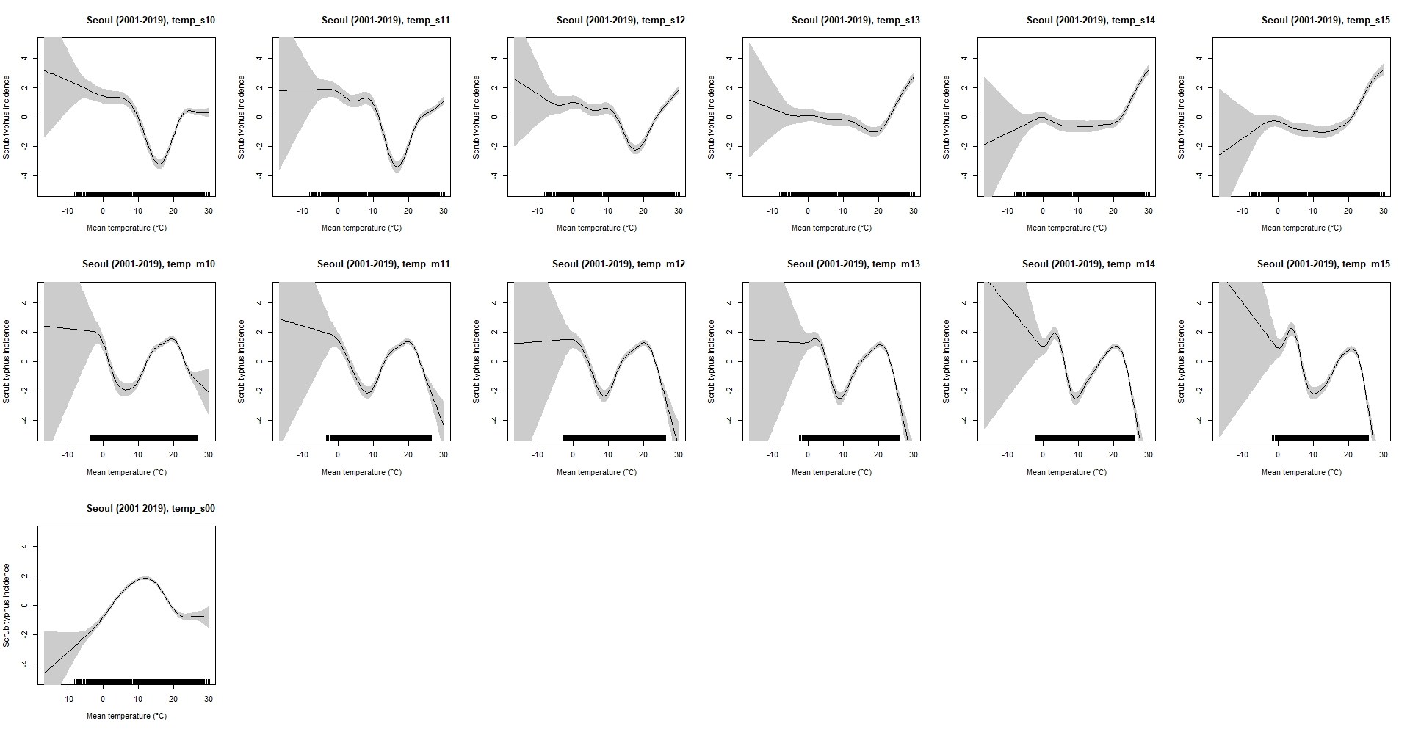

Figure S6. Association plots between mean ambient temperature (°C) and scrub typhus incidence (per 100,000) with a simple lag of 15 weeks for each province by applying generalized additive model
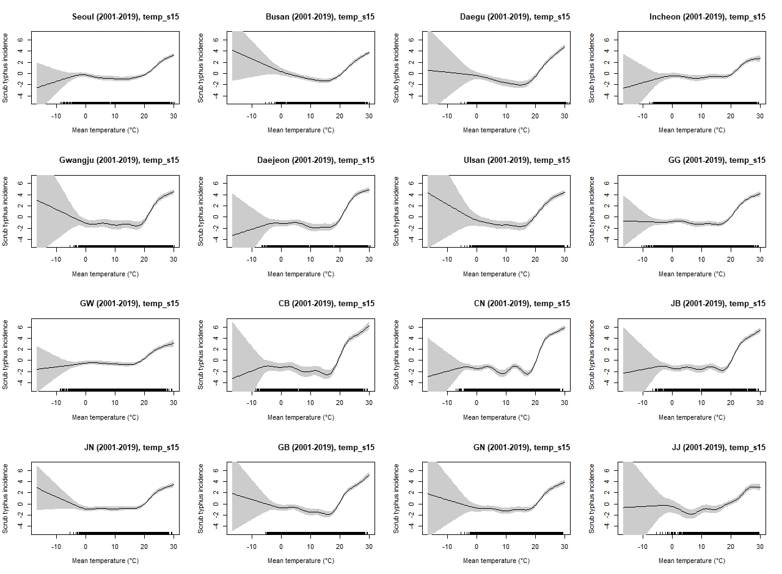
Figure S7. Association plots between mean relative humidity (%) and scrub typhus incidence (per 100,000) with a simple lag of 15 weeks for each province by applying generalized additive model
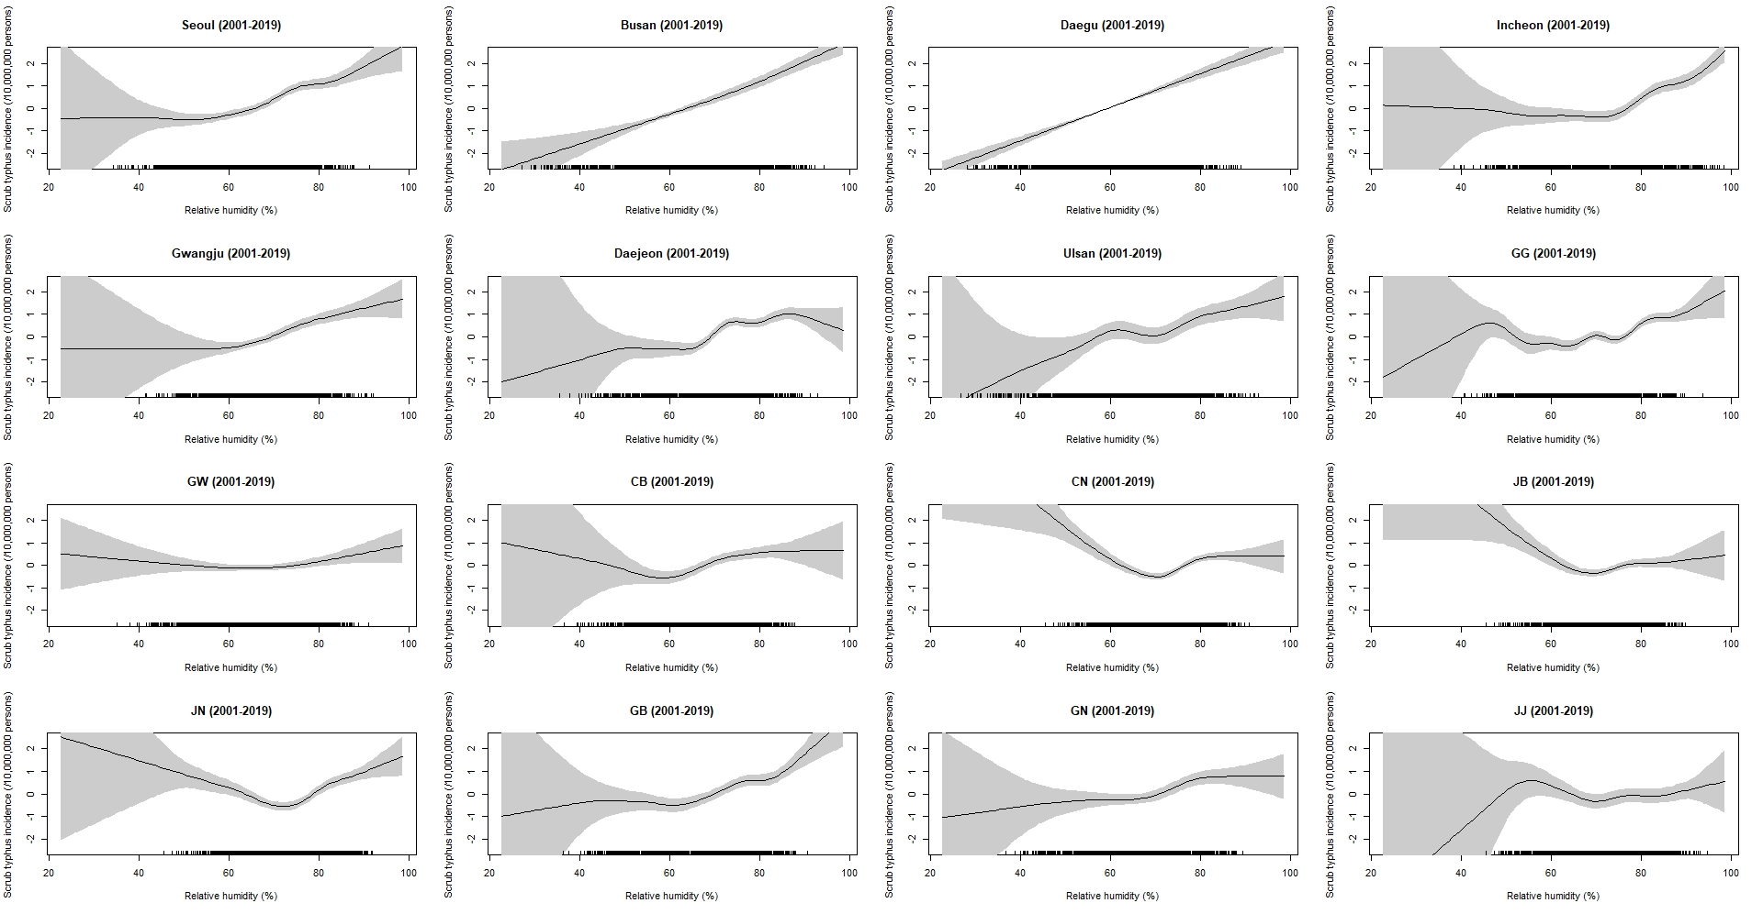
Figure S8. Association between mean ambient temperature and scrub typhus incidence for Seoul and Busan using GAM with or without harmonics (2, 4, 6, 8, 10) in the formula–
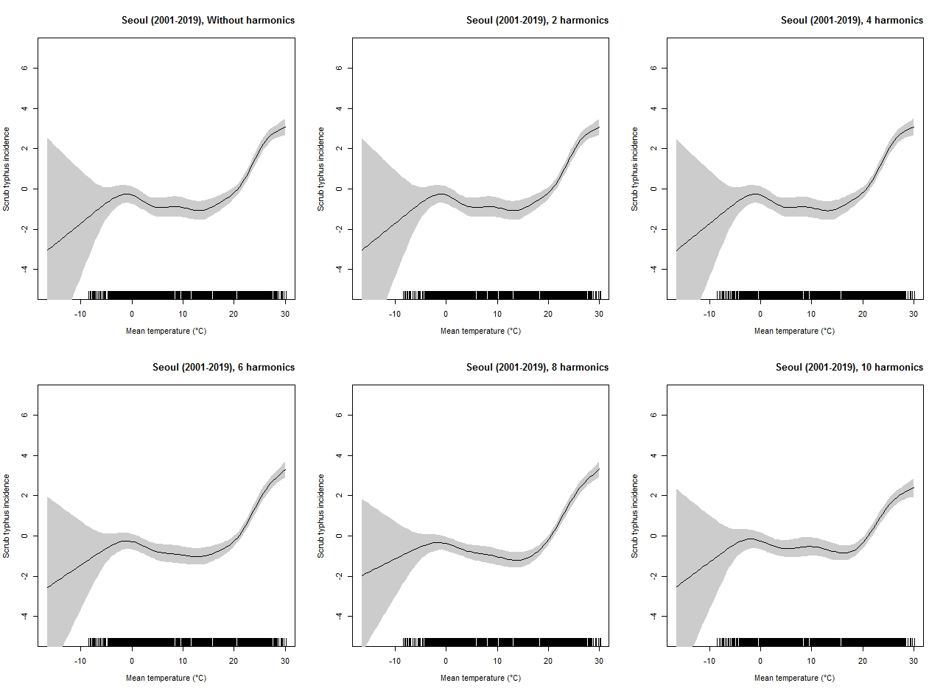
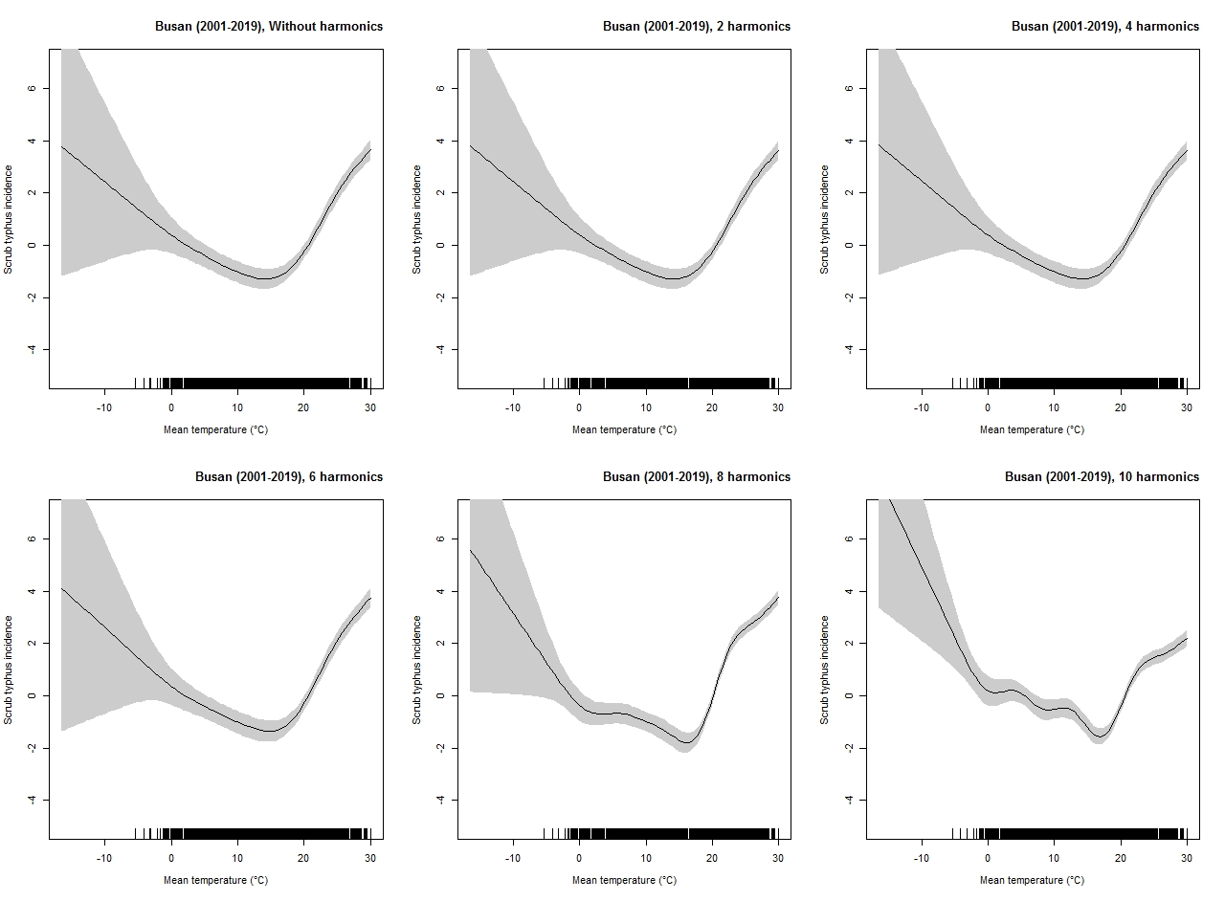

Figure S9. Association plots between mean ambient temperature (°C) and scrub typhus incidence in Seoul for 2001-2019 with a simple lag of 15 weeks - different degree of freedoms (dfs) was adopted to show a robustness of the model
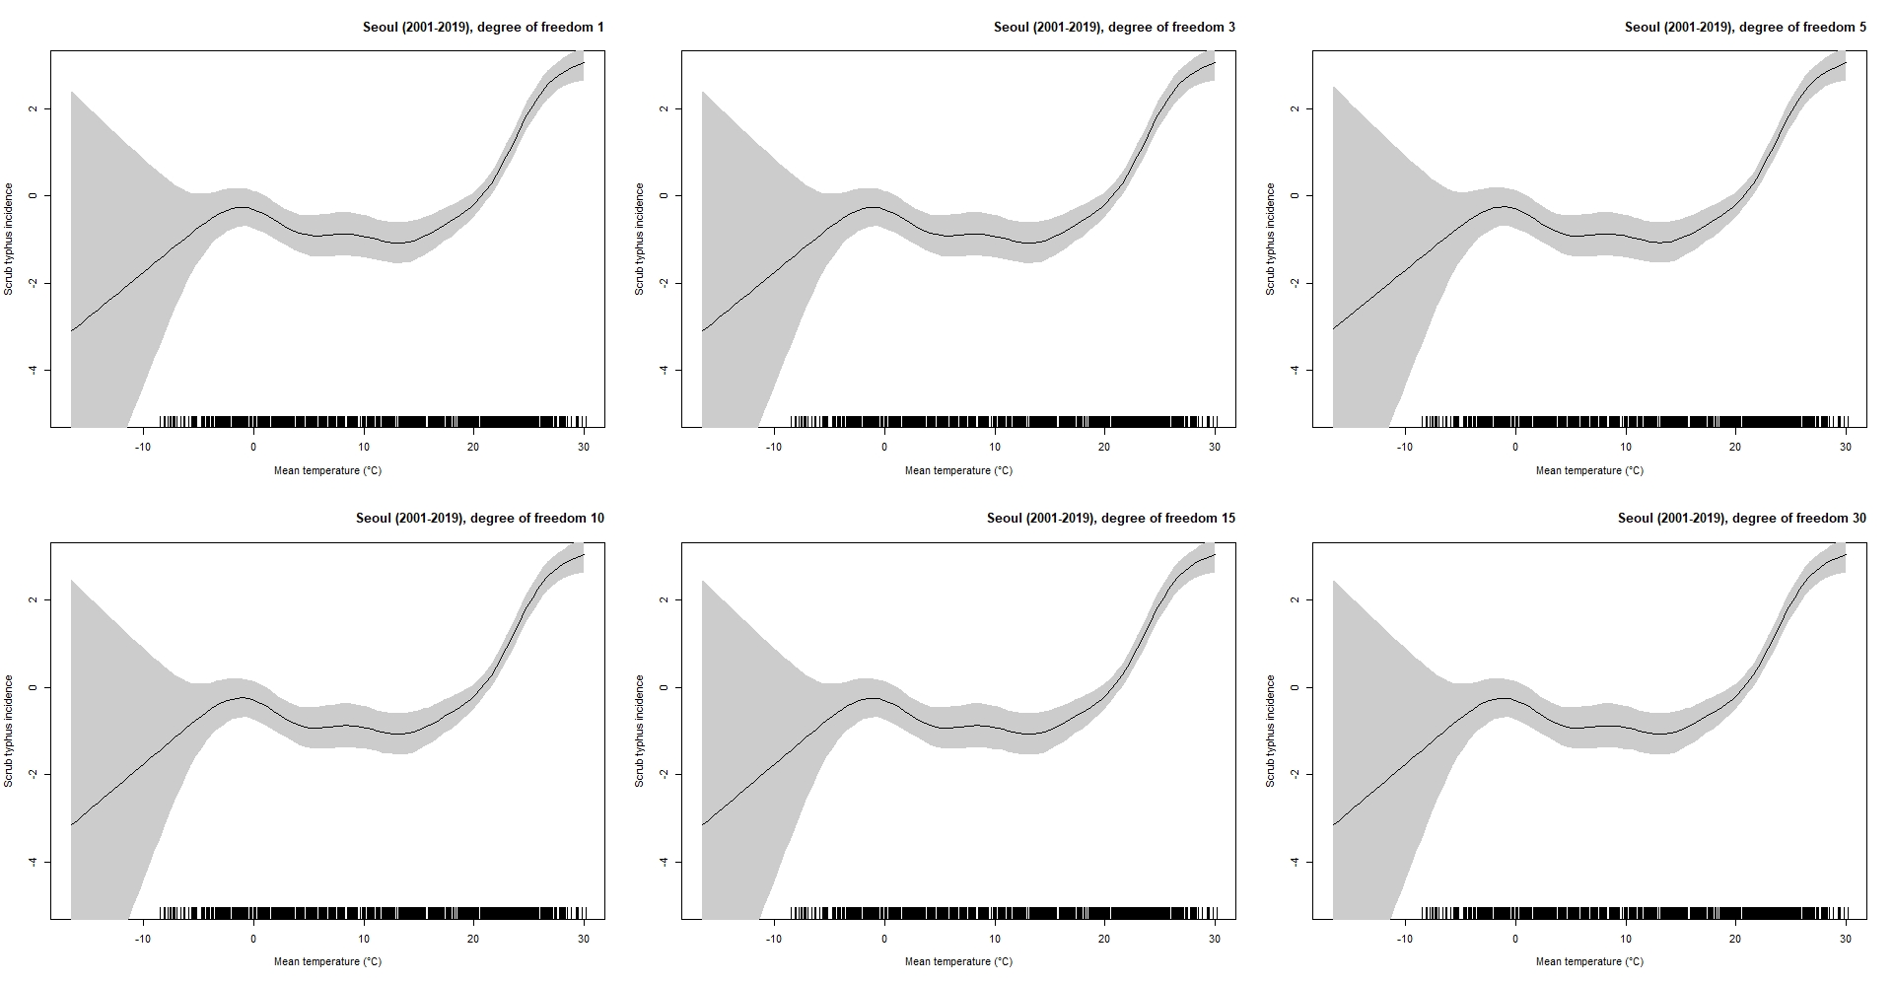

Figure S10. Draw and analyze causal diagrams (DAGitty) between mean ambient temperature, probable covariates and scrub typhus incidence
