(S1)
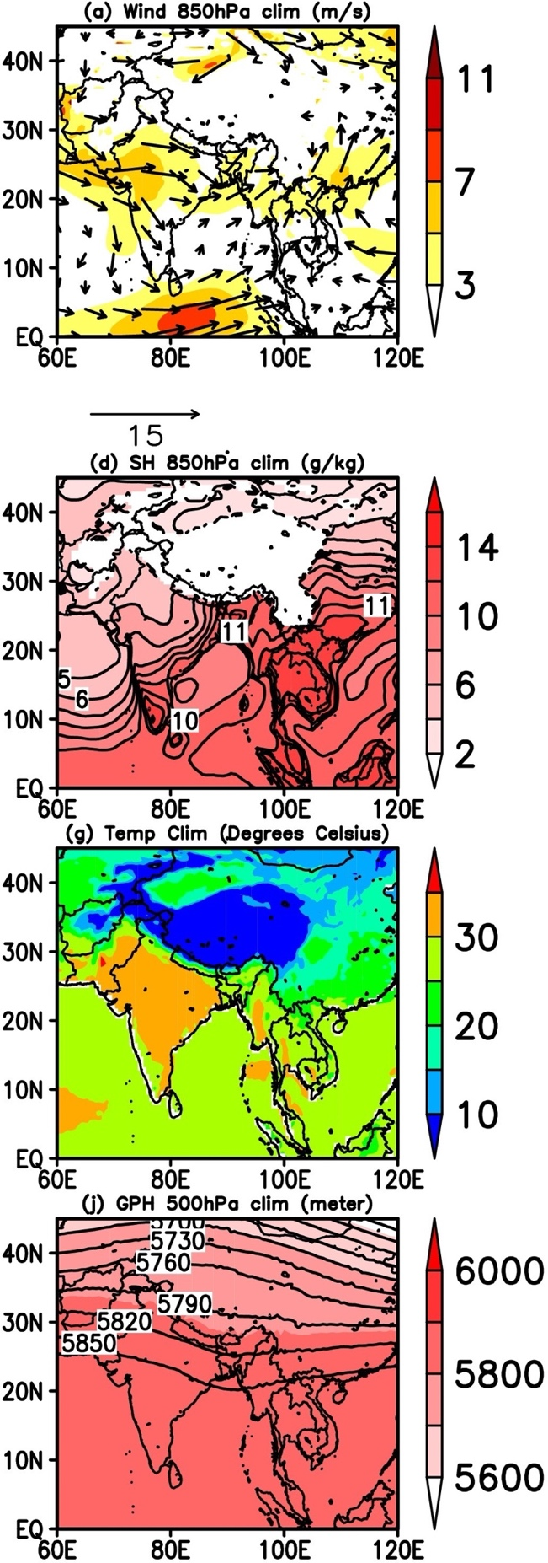

Figure S1. Climatological mean from year 1981 to 2016 for (a) Wind, (b) Specific Humidity, (c) Temperature, and (d) Geopotential height, respectively.

