Biosorption of hexavalent chromium from aqueous solution by pristine and CaCl₂-modified erythromycin production residues
Xining Sunª, Dongsheng Liª, Zengqiang Zhangª*
ªCollege of Natural Resources and Environment, Northwest A&F University, Yangling 712100, P R China

Fig. S1
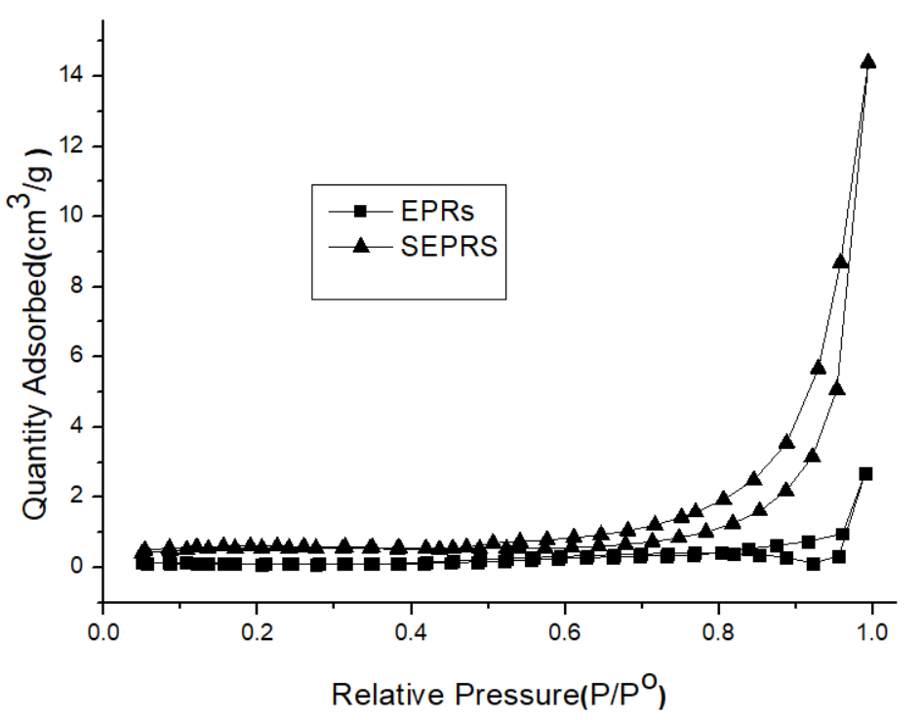
Fig. S1 Nitrogen adsorption/desorption isotherms of EPRs and SEPRs

