Supplementary Material

Newborn skin maturity model for gestational age prediction: a clinical trial for a novel medical device validation (Reis, ZSN et al., 2022)

Contents

Supplementary Appendix A 2
Procedures 2
Supplementary Table S1: Database of clinical variables collected from each newborn 2
Supplementary Table S2: Dataset of Preemie-Test skin acquisitions 5
Supplementary Appendix B 7
Gestational age data quality evaluation according to the existing references 7
Supplementary Figure S1: Histograms for the day-date of the month of the last menstrual period informed and adjusted 7
The reliability of the skin assessment with the photometer of the device 8
Supplementary Appendix C 9
Analytical pipeline 9
Supplementary Figure S2: Schematic representation of the analytical pipeline, which was executed 30 times with different random data divisions to make statistical analysis more robust. 9
XGBoost 10
Correlation between reference gestational age and predictor variables 11
Supplementary Figure S3: The measure of feature importance returned by the XGBoost classifier 11
Supplementary Table S3: Average results of regression models to predict R-gestational age at birth on the test sets when using a 10-fold cross-validation with 30 repetitions. For XGBoost, as it can handle missing values, N is always 781. For linear regression, N is indicated in the column “Covariates“ when different from 781. 12
Supplementary Appendix D 12
Supplementary Table S4: Accuracy for preterm newborn discrimination according to the methods of gestational age estimation 13
Supplementary Appendix E 14
Intent to preterm newborn discrimination according to simulated scenarios of care 15
Supplementary Table S5: Scenario-one: Absent or unreliable LMP (n = 451, 57.7%) 15
Supplementary Table S6: Scenario-two: Reliable LMP (n = 330, 42.3%) 15

Supplementary Appendix A

Procedures
The coordinator center trained 15 examiners following good clinical practice as set forth by the Brazilian regulatory health agency’s recommendations. Standard operating procedures were mandatory to advise enrollment, skin assessment, and data collection. Clinical information was collected in structured questionnaires using a software program dedicated to this project. The framework of clinical variables and skin acquisitions is available in Supplementary Table S1 and Supplementary Table S2. Textual information was saved in a tablet with internet access, individually associated with the respective skin assessment acquired with the medical device under validation.¹
An automated algorithm in the data collection system,² blinded to the examiner, calculated the reference gestational age. Established rules for redating gestational age at birth provided our reference for gestational age using data from the ultrasound report or prenatal care book/document.³ For data curation, the investigator's data entries were confronted with information from photographed digital images of clinical documents. In the case of multiple birth gestations with different ultrasonographic crown-rump-length values, the average of each embryo/fetal value was considered. A double-check system—paper-based and electronic—allowed the verification of the reliability and validity of clinical data as well as skin thickness acquisition. In addition, the data quality of antenatal pregnancy dating was evaluated by comparing the frequency of days in dates of LMP, as they should be random with no preference for digits. For this, in cases of multiple gestations, we retained only the first twin information for day-digit evaluation (Supplementary Appendix B).

Supplementary Table S1: Database of clinical variables collected from each newborn
Variables | Description | Types and categories
Identification
id_hospital | Hospital identification | Integer
id_user | Researcher Identification | Integer
nome_usuario | Researcher name | String
cod_sistema | Application registration code | Integer
ig_semanas | Gestational age (weeks) | Integer
ig_dias | Gestational Age (Days) | Integer
name_woman | Mother's name | String
age_woman | Mother's age | integer
prontuario_mulher | Women's medical record code | String
Pregnancy and birth data
data_parto | Delivery date and time | Datetime
us1_data | US1 - Date at the first ultrasound ( < 14 weeks) | date
us1_ig_sem | US1 - Gestational Age (GA) in weeks | integer
us1_ig_dias | US1 - GA (days) | integer
us1_cnn | US1 - CCN (mm) | integer
us2_data | US2 - Date at the second ultrasound | date
us2_ig_sem | US2 - GA (weeks) | integer
us2_ig_dias | US2 - GA (days) | integer
us2_bdp | US2 - Biparietal Diameter (BDP) | float
us2_femur | US2 - Femur | float
us2_cir_cefalica | US2 - Head circumference | float
us2_cir_abdominal | US2 - Abdominal circumference | float
dum_data | LMP - Last Menstrual Period | date
dum_confianca | LMP - Do you have confidence in LMP? | Yes / No
dum_cicloregulares | LMP - Are your menstrual cycles regular? | Yes / No
dum_concepcao_contracepcao | LMP - Did the current conception occur within 2 months of using hormonal contraceptives? | Yes / No
dum_concepcao_aborto | LMP - Did the current conception occur within 2 months of abortion or childbirth? | Yes / No
dum_ig_1visita | GA at the first prenatal care assessment (weeks) | integer
pront_altorisco | High-risk pregnancy | Yes / No
pront_diabetes | Diabetes | Yes / No
pront_hipertensao | Hypertensive disturb during pregnancy | Yes / No
pront_malformacao | Major malformation | Yes / No
pront_oligo | Oligohydramnios | Yes / No
pront_gemeos | Multiple gestations | Yes / No
pront_gemeos_ordem | Birth order of twins | integer
pront_outra_doencamaterna | Other maternal or fetal disease | String
cort_uso | Antenatal Corticosteroid Therapy for Fetal Maturation exposure (ACTFM) | Yes / No
cort_esquema | Corticotherapy scheme used | 2 doses / 4 doses
cort_doses | Number of doses ACTFM applied | integer
rn_sexo | Newborn sex | integer
rn_peso | Birthweight (g) | 300 - 6000
rn_apgar1 | 1-minute Apgar score | 0 - 10
rn_apgar5 | 5-minute Apgar score | 0 - 10
me_local | Accommodation | Ward / NICU / Birth-room
me_tipo_leito | Type of bed of the neonate | Incubator / incubators-radiant warmer / common crib / other
condrni_uso_foto | Phototherapy at the skin assessment | Yes / No
During 72h hours of life
diag_ictericia | Jaundice | Yes / No
alta_condicoes | Discharge Conditions | discharge / death / internal
alta_data | Discharge date and time | Datetime
obito_data | Neonatal death date and time | Datetime
obito_causa | Death cause | String
fcg1 | Prenatal care book photo - Side A | Image
fcg2 | Prenatal care book photo - Side B | Image
fus1 | US1 - Ultrasound report photo (<14 weeks) | Image
fus2 | US2 - Ultrasound report photo (>=14 weeks) | Image
Preemie-Test adverse events
preemie_aquecimento | Adverse events: equipment heating | Yes / No
preemie_choque | Adverse events: electric shock | Yes / No
preemie_marcaspele | Adverse events: neonate's skin marks or irritation | Integer
preemie_display_nao_indica | Device: display indicates nothing | Integer
preemie_nao_carrega | Device: equipment not charging | Integer
preemie_disparo | Device: trigger not fired | Integer
preemie_led_nao_acende | Device base: red LED does not light | Yes / No
preemie_outroevento | Other adverse events | String
preemietest_ processid | Equipment serial number and sequential number | Integer
preemietest_ dt | Exam date and time | Datetime
preemietest_json | JSON file - Preemie-Test reflection | File

Supplementary Table S2: Dataset of Preemie-Test skin acquisitions
Variables | Description | Types and categories
preemietest_ processid | Equipment serial number and sequential number | Integer
preemietest_ dt | Exam date and time | Datetime
preemietest_json | JSON file - Preemie-Test reflection | File
Duration | Duration [1..3] | Integer
Temperature | Temperature [1..3] | Integer
Gain | Gain [1..3] | Integer
Integration Time | Integration Time [1..3] | Integer
Current | Current [1..3] | Integer
SetupTime | SetupTime [1..3] | Integer
LedOffRaw | LedOffRaw [1..3] | Integer
LedOffRawMedian | LedOffRawMedian [1..3] | Integer
LedOffRawMean | LedOffRawMean [1..3] | Integer
LedOffRawStdDev | LedOffRawStdDev [1..3] | Integer
LedOffCal | LedOffCal [1..3] | Integer
LedOffCalMedian | LedOffCalMedian [1..3] | Integer
LedOffCalMean | LedOffCalMean [1..3] | Integer
LedOffCalStdDev | LedOffCalStdDev [1..3] | Integer
LedOnRaw | LedOnRaw [1..3] | Integer
LedOnRawMedian | LedOnRawMedian [1..3] | Integer
LedOnRawMean | LedOnRawMean [1..3] | Integer
LedOnRawStdDev | LedOnRawStdDev [1..3] | Integer
LedOnCal | LedOnCal [1..3] | Integer
LedOnCalMedian | LedOnCalMedian [1..3] | Integer
LedOnCalMean | LedOnCalMean [1..3] | Integer
LedOnCalStdDev | LedOnCalStdDev [1..3] | Integer

References

1. Reis, Z., Vitral, G. L. N., Guimarães, R. N., Aguiar, R. A. P. L. de & Romanelli, R. M. C. The Preemie-Test for the assessment of the newborn skin maturity. Protocols.io 2019. doi:dx.doi.org/10.17504/protocols.io.7ynhpve.
2. Reis, Z., Gaspar, J. de S., Elias, S. O. & Aguiar, R. A. L. P. D. Algorithm for gestational age assessment at birth. Protocols.io 2020. doi:dx.doi.org/10.17504/protocols.io.bawbifan.
3. ACOG. Committee Opinion No 700: Methods for Estimating the Due Date. Obstet Gynecol 2017. 129, e150–e154.

Supplementary Appendix B

Gestational age data quality evaluation according to the existing references
Digit preference was determined by comparing the observed to expected counts of each day of a month. Cochran Q test for k-related samples compared the last menstrual period (LMP) with the day adjusted to the reference gestational age (Figure S1). We removed duplicate data from twins, and observations on day 31 was removed during the statistical test. The hatched line corresponds to the frequency expected for each day among 30 days of a month.
Analyzing the day-digit of the last menstrual period informed by the woman, the most frequent digit preferences were for day-5 51 (8.3%), day-15 (6.7%), day-20 (7.2%), and day-25 (4.7%). Those frequencies had significant differences when compared to the day adjusted to the reference gestational age p < 0.008. Analyzing the day-digit of the LMP adjusted by the second ultrasound exam performed after 13 weeks and 6 days of gestation and before 22 weeks (comparator ultrasound US) data, there were no significant differences when compared to the day adjusted to the reference gestational age (p=0.195).
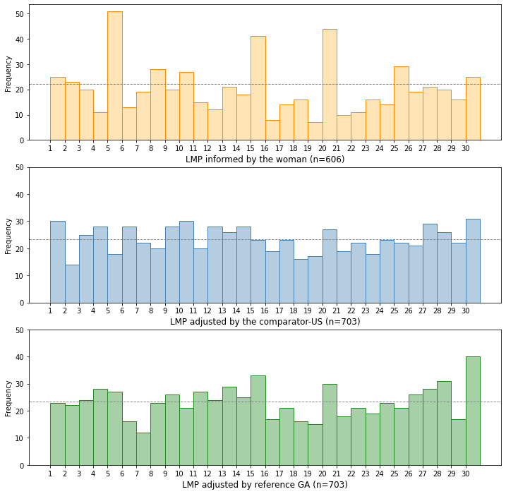

Supplementary Figure S1: Histograms for the day-date of the month of the last menstrual period informed and adjusted
Note: LMP: last menstrual period. GA: gestational age

The reliability of the skin assessment with the photometer of the device

The assessment of observer variability for the skin reflection acquisition with the novel device took into account the relative intra- and interobserver variability, taken in percentual, and accompanied by the 95% confidence interval (95% CI). ¹

$$(A-B)/[\frac{A+B}{2}]$$

The calculation of intraobserver variability used 90 sequential measurements taken in the same delimited skin region from eight individual observers totalizing 720 skin assessments. The observers' differences between repeat acquisitions had an average (standard deviation) of 1.97% (1.89%), 95% CI: 1.84% to 2.11%. It means that on 95% of occasions, the difference between one observers' assessment did not differ more than 1.84% to 2.11%.

The calculation of interobserver variability used a difference from 120 pairs of measurements taken in the same delimited skin region by two observers, using four different devices selected by random. The average (standard deviation) of relative differences was 2.6% (2.55%), 95% CI: 2.1% to 3.1%. It means that on 95% of occasions, the difference between two observers' assessments did not differ more than 1.6% to 3.5%.

References

- Popović, Z. B.; Thomas, J. D. Assessing observer variability: a user’s guide. Cardiovascular diagnosis and therapy. 7, 317-324, (2017).

Supplementary Appendix C

Analytical pipeline

Data analysis was performed using a k-fold cross-validation procedure,¹ with k=10, as illustrated in Supplementary Figure S2. This cross-validation procedure was repeated N times, where N=30. This means we have generated 30 different predictions for each example in the original dataset.

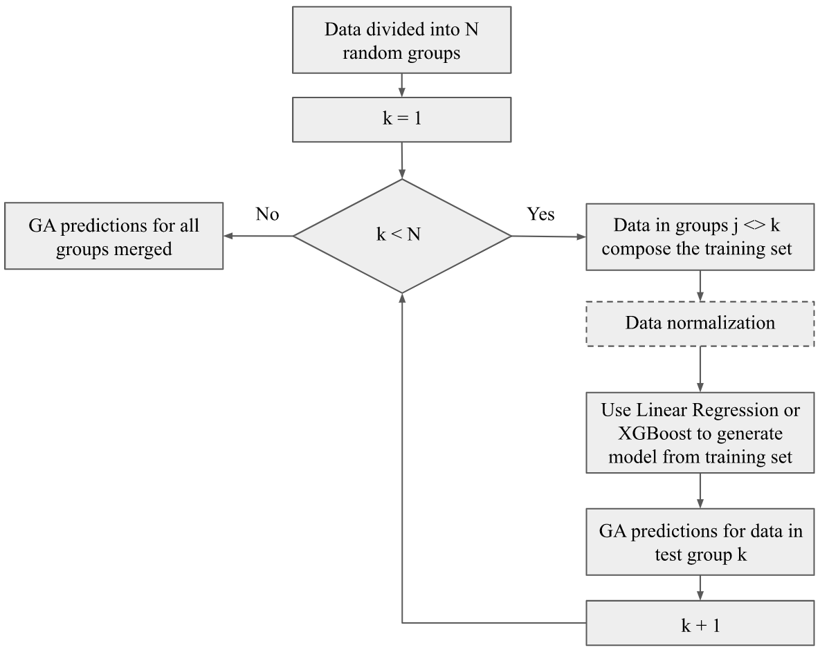

Supplementary Figure S2: Schematic representation of the analytical pipeline, which was executed 30 times with different random data divisions to make statistical analysis more robust.

XGBoost

XGBoost (Extreme Gradient Boosting)² is an efficient model that uses an ensemble of trees to make predictions. It combines the prediction of regression trees using the gradient tree boosting technique introduced by Friedeman.³ The main idea behind gradient boosting is to start with a very simple model, and allow subsequent models to “correct” the residuals in the predictions generated by previous models.
XGBoost uses regression trees as base models, i.e. the simple models that will be combined. A regression tree is a binary tree, where the root and internal nodes represent an input variable and a split point (in the case of continuous attributes) into that variable. Leaf nodes contain a continuous score w, used to make predictions.
Consider a supervised learning scenario, where we have a dataset D with n examples and m features, and each example i is represented by a pair D = {(x_{i}, y_{i})}, where xi m, yi .When we used the tree boosting method proposed by XX, the output yi of a model with k trees is given by:
yi = (xi) = k=1Kfk(xi), fk F, (1)
where F={ f(x) = wq(x)}, and q:mT, w t. q is the structure of the tree that maps an example to its leaf prediction (output variable), and T is the number of leaf nodes of the tree. Each fk corresponds to a tree structure q with leaf weights w. Given an example e, all decision trees (each represented by q) are used to find the corresponding leaf in the tree that classifies e. The final prediction is given by summing up the scores of the leaves associated with e in each tree (represented by w).
The set of functions (trees) are learnt by minimizing the regularized objective function Obj presented in Eq. 2.
L () = i=1nl(yi,yi)+k=1K(fk) (2)
(ft) = T + 12j=1Twj2 (3)
The first part of Eq. 2 is the loss function l(yi,yi), which measures the difference between the real value of the output variable yi and the predicted value yi. The second part is the regularization, given by the L2 norm of leaf scores, defined in Eq. 3. Its objective is to encourage leaf nodes to have smaller values (weights) and avoid overfitting.
The model described in Eq. 2 cannot be optimized using traditional optimization methods since it has functions as parameters. Hence, the model is trained in an additive way, using additive training (boosting). We start with a constant prediction and add a new function to it at each iteration, i.e., every time a new tree is generated. Let yi(t)be the prediction of the i instance in the t iteration. The process of learning the trees works as follows:
yi(0)= c
yi(1)= f1(x1) =yi(0)+f1(x1)
….
yi(t)=k=1Tfk(xi) =yi(t-1)+ft(xi)
The loss function we want to minimize can be rewritten as:
L(t)= i=1nl(yi,yi(t-1)+ft(xi))+(ft)
Observe that we add to the current model the function f_{t} that most improves the model according to Eq. 2. This loss function can be optimized using a second-order approximation. For more details on the mathematical setting, the reader is referred to Chen and Guestrin.²
Apart from this regularized objective function, XGBoost uses the shrinkage technique to help avoid overfitting. Shrinkage scales the weights predicted by the new trees by a factor $η,$ known as the learning rate. It also takes advantage of feature subsampling as a third mechanism to prevent overfitting.
XGBoost can handle missing values automatically. During the training phase, for each tree node split, two paths are generated: right and left. For each path, the algorithm calculates the values of the loss function assuming the instances with missing values will be assigned to that path. The algorithm then assigns as the default direction of the node the one that leads to the smallest loss. Each node in the tree is assigned a default path, regardless of missing data for the attribute tested by that node being present on the data. During prediction, an instance with a missing value will follow the default path for a node with missing values.

Correlation between reference gestational age and predictor variables

The choice of covariates for gestational age prediction machine learning models had the following criteria: already known to be influential in pregnancy dating, or to be influential in skin reflectance phenomenon. ⁴ All predictors were available at the time of the test, and they could be used in real scenarios with the user input into the medical device interface: birth weight, Antenatal corticosteroid therapy for fetal lung maturity (ACTFM), incubator-stay, gender, and jaundice. The importance of such variables by the XGBoost classifier is in Supplementary Figure S3.
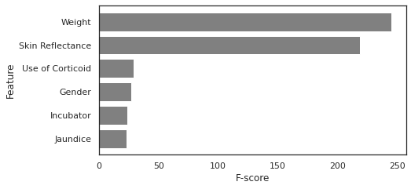

Supplementary Figure S3: The measure of feature importance returned by the XGBoost classifier

Comparing crude variables with bivariate modeling including birth weight, mean absolute error (MAE) between predicted gestational age and reference gestational age (R) accompanied by the coefficient of determination (R²) highlighted the advantage on the skin reflectance adjusted to birth weight, Supplementary Table S3. Concerning the models with more than two covariates to adjust the skin reflection, the coefficient of determination had differences only in the second decimal digit, being higher for the XGBoost model. MAE ranged from 1.08 to 1.16 weeks for linear regression models and 0.23 weeks with the machine learning approach, with differences in the third decimal case between models.
We choose the linear ridge regression (linear model with L2 regularization) skin reflectance algorithm as Model 1. For birth scenarios when the birth weight and ACTFM information are known, we choose the XGBOOST skin reflectance, birth weight, and ACTFM exposure as Model 2 due to the high coefficient of determination (R² = 0.986) and low mean absolute error (MAE = 0.232 weeks).

Supplementary Table S3: Average results of regression models to predict R-gestational age at birth on the test sets when using a 10-fold cross-validation with 30 repetitions.
 | Linear Regression |  | XGBoost
Covariates | Training |  | Training
Covariates | MAE  (SD) | R²  (SD) | MAE  (SD) | R²  (SD)
Birth weight (grams) | 1.259  (0.005) | 0.928 (0.001) | 0.495 (0.010) | 0.971  (0.001)
Skin reflectance raw model | 1.344  (0.004) | 0.923  (0.001) | 0.846  (0.016) | 0.951  (0.001)
Skin reflectance and birth weight | 1.150  (0.004) | 0.934  (0.01) | 0.295  (0.007) | 0.983  (0.001)
Skin reflectance, birth weight, ACTFM (n = 778) | 1.156  (0.005) | 0.934 (0.001) | 0.232  (0.004) | 0.986  (0.004)
Skin reflectance, birth weight, ACTFM, jaundice (n = 776) | 1.159  (0.005) | 0.934 (0.029) | 0.233  (0.005) | 0.986  (0.001)
Skin reflectance, birth weight, gender, jaundice, incubator (n=779) | 1.080  (0.004) | 0.938  (0.001) | 0.232  (0.005) | 0.986  (0.001)

ACTFM: Antenatal corticosteroid therapy for fetal lung maturity. MAE: Mean absolute error (weeks). R²: Coefficient of determination. SD: standard deviation. For XGBoost, as it can handle missing values, N is always 781. For linear regression, N is indicated in the column “Covariates“ when different from 781.

References
- Kohavi, R. A study of cross-validation and bootstrap for accuracy estimation and model selection. Ijcai. Montreal, Canada. 14, 1137-1145 (1995).
- Chen, T. & Guestrin, C. XGBoost: A Scalable Tree Boosting System. in the 22nd ACM SIGKDD International Conference 794 (2016). doi:10.1145/2939672.2939785
- Friedman, J. H. Stochastic gradient boosting. Computational statistics & data analysis. 38, 367-378 (2002).
- Reis, Z. S. N., Vitral, G. L. N., de Souza, I. M. F., Rego, M. A. S. & Guimaraes, R. N. Newborn skin reflection: Proof of concept for a new approach for predicting gestational age at birth. A cross-sectional study. PloS One 2017. 12, e0184734.

Supplementary Appendix D

Supplementary Table S4: Accuracy for preterm newborn discrimination according to the methods of gestational age estimation
 | Comparator US GA  (n=781) | Comparator LMP GA  (n=680) | Medical device - Test  (n=781)
Preterm <37 weeks (n=366) | Value (95% CI) | Value (95% CI) | Value (95% CI)
ACU (%) | 96.2 (94.6 to 97.4) | 92.8 (90.6 to 94.6) | 97.1 (95.6 to 98.1)
False - (%) | 3.8 (2.1 to 6.3) | 9.3 (6.4 to 13.1) | 0.5 (0.1 to 2.0)
SPE (%) | 96.1 (93.8 to 97.8) | 94.7 (91.9 to 96.8) | 94.9 (92.4 to 96.8)
VPP (%) | 95.7 (93.2 to 97.3) | 93.9 (90.8 to 96.0) | 94.5 (92.0 to 96.3)
VPN (%) | 96.6 (94.5 to 97.9) | 91.9 (89.0 to 94.1) | 99.5 (98.0 to 99.9)
LR+ | 25.0 (15.4 to 40.4) | 17.1 (11.0 to 26.6) | 19.7 (13.0 to 29.2)
LR- | 0.04 (0.02 to 0.07) | 0.10 (0.07 to 0.14) | 0.01 (0.00 to 0.02)
Preterm <32 weeks (n=131) | Value (95% CI) | Value (95% CI) | Value (95% CI)
ACU (%) | 98.5 (97.3 to 99.2) | 96.2 (94.5 to 97.5) | 98.1 (96.9 to 98.9)
False - (%) | 3.8 (1.3 to 8.7) | 10.0 (5.1 to 17.2) | 3.8 (1.3 to 8.7)
SPE (%) | 98.9 (97.8 to 99.6) | 97.4 (95.7 to 98.5) | 98.5 (97.2 to 99.3)
VPP (%) | 94.7 (89.6 to 97.4) | 86.8 (80.0 to 91.6) | 92.6 (87.2 to 95.9)
VPN (%) | 99.2 (98.2 to 99.7) | 98.1 (96.6 to 98.9) | 99.2 (98.2 to 99.7)
LR+ | 89.3 (42.7 to 186.8) | 34.2 (20.7 to 56.6) | 62.5 (33.8 to 115.8)
LR- | 0.04 (0.02 to 0.09) | 0.10 (0.06 to 0.18) | 0.04 (0.02 to 0.09)
Preterm <28 weeks (n=42) | Value (95% CI) | Value (95% CI) | Value (95% CI)
ACU (%) | 99.0 (98.0 to 99.6) | 98.5 (97.3 to 99.3) | 99.4 (98.5 to 99.8)
False - (%) | 11.9 (4.0 to 25.6) | 16.7 (6.4 to 32.8) | 0
SPE (%) | 99.6 (98.8 to 99.9) | 99.4 (98.4 to 99.8) | 99.3 (98.4 to 99.8)
VPP (%) | 92.5 (79.9 to 97.5) | 88.2 (73.6 to 95.3) | 89.4 (77.8 to 95.3)
VPN (%) | 99.3 (98.5 to 99.7) | 99.1 (97.3 to 99.3) | 100
LR+ | 217 (69.8 to 675) | 134 (50 to 360.3) | 147.8 (61.7 to 354.1)
LR- | 0.12 (0.05 to 0.27) | 0.17 (0.08 to 0.35) | 0

GA: gestational age. LR+: Likelihood ratio positive. Likelihood ratio negative: LR-. SEN: sensibility. SPE: Specificity. NPV: Negative Predictive Value. PPV: Positive Predictive Value. Comparator-US GA is the gestational age calculated with a second antenatal ultrasound exam after 13 weeks and 6 days of gestation and before 22 weeks. Comparator-LMP GA is the gestational age calculated with the last menstrual period. The new test is gestational age-predicted with the XGBoost algorithm, based on newborn skin reflectance values, birth weight, and ACTFM exposure information.

Supplementary Appendix E

Intent to preterm newborn discrimination according to simulated scenarios of care

Supplementary Table S5: Scenario-one: Absent or unreliable LMP (n = 451, 57.7%)

 | Medical device (Test) |  |  | Comparator-US GA |  |  | Comparator-LMP GA
 | Preterm newborn | Term newborn | Total | Preterm newborn | Term newborn | Total | Preterm newborn | Term newborn | Total
Test + | 199 | 16 | 215 | 190 | 11 | 201 | 131 | 13 | 144
Test - | 0 | 236 | 236 | 9 | 241 | 250 | 23 | 183 | 206
Missing | 0 | 0 | 0 | 0 | 0 | 0 | 45 | 56 | 101
Total | 199 | 252 | 451 | 199 | 252 | 451 | 199 | 252 | 451
 |  |  | 95% CI |  |  | 95% CI |  |  | 95% CI
Sensitivity % | 100 |  | 98.16 to 100.00 | 95.48 |  | 91.59 to 97.91 | 65.83 |  | 58.79 to 72.39
Specificity % | 93.65 |  | 89.89 to 96.33 | 95.63 |  | 92.32 to 97.80 | 72.62 |  | 66.67 to 78.03
Accuracy % | 96.45 |  | 94.30 to 97.96 | 95.57 |  | 93.23 to 97.27 | 69.62 |  | 65.15 to 73.84
PPV % | 92.56 |  | 88.56 to 95.23 | 94.53 |  | 90.64 to 96.86 | 90.97 |  | 85.58 to 94.48
NPV % | 100 |  | … | 96.40 |  | 93.39 to 98.07 | 88.83 |  | 84.49 to 92.08
LR+ | 15.75 |  | 9.80 to 25.31 | 21.873 |  | 12.26 to 39.02 | 12.83 |  | 7.55 to 21.78
LR- | 0 |  | … | 0.047 |  | 0.02 to 0.09 | 0.16 |  | 0.11 to 0.23

Notes: CI: confidence interval. GA: gestational age. US: ultrasound. LR+: Likelihood ratio positive. Likelihood ratio negative: LR-. SEN: sensibility. SPE: Specificity. NPV: Negative Predictive Value. PPV: Positive Predictive Value. The medical device is the new test is gestational age-predicted with the XGBoost algorithm, based on newborn skin reflectance values, birth weight, and ACTFM exposure information. Comparator-US GA: the gestational age calculated with a second antenatal ultrasound exam after 13 weeks and 6 days of gestation and before 22 weeks. Comparator-LMP GA: the gestational age calculated with the last menstrual period.

Supplementary Table S6: Scenario-two: Reliable LMP (n = 330, 42.3%)

 | Medical device |  |  | Comparator-US GA |  |  | Comparator-LMP GA
 | Preterm newborn | Term newborn | Total | Preterm newborn | Term newborn | Total | Preterm newborn | Term newborn | Total
Test + | 165 | 5 | 170 | 162 | 5 | 167 | 160 | 6 | 166
Test - | 2 | 158 | 160 | 5 | 158 | 163 | 7 | 157 | 164
Missing | 0 | 0 | 0 | 0 | 0 | 0 | 0 | 0 | 0
Total | 167 | 163 | 330 | 167 | 163 | 330 | 167 | 163 | 330
 |  |  | 95% CI |  |  | 95% CI |  |  | 95% CI
Sensitivity % | 98.80 |  | 95.74 to 99.85 | 97.01 |  | 93.15 to 99.02 | 95.81 |  | 91.55 to 98.30
Specificity % | 96.93 |  | 92.99 to 99.00 | 96.93 |  | 92.99 to 99.00 | 96.32 |  | 92.16 to 98.64
Accuracy % | 97.88 |  | 95.68 to 99.14 | 96.97 |  | 94.50 to 98.54 | 96.06 |  | 93.36 to 97.89
PPV % | 97.06 |  | 93.30 to 98.74 | 97.01 |  | 93.18 to 98.72 | 96.39 |  | 92.40 to 98.32
NPV % | 98.75 |  | 95.22 to 99.68 | 96.93 |  | 93.02 to 98.68 | 95.73 |  | 91.56 to 97.89
LR+ | 32.21 |  | 13.59 to 76.36 | 31.624 |  | 13.34 to 74.99 | 26.028 |  | 11.86 to 57.12
LR- | 0.03 |  | 0.00 to 0.05 | 0.031 |  | 0.01 to 0.07 | 0.044 |  | 0.02 to 0.09

Notes: CI: confidence interval. GA: gestational age. US: ultrasound. LR+: Likelihood ratio positive. Likelihood ratio negative: LR-. SEN: sensibility. SPE: Specificity. NPV: Negative Predictive Value. PPV: Positive Predictive Value. Medical device: test using the medical device is the gestational age predicted with skin reflectance, birth weight, and ACTFM exposure predictors with the XGBoost model. Comparator-US GA: the gestational age calculated with a second antenatal ultrasound exam after 13 weeks and 6 days of gestation and before 22 weeks. Comparator-LMP GA: the gestational age calculated with the last menstrual period.

