Newborns’ skin maturity models for gestational age prediction
Supplementary Information

Zilma Silveira Nogueira Reis^{1,2}*; Rodney Nascimento Guimarães¹; Roberta Maia de Castro Romanelli³; Juliano de Souza Gaspar¹; Gabriela Silveira Neves^{3,4}; Marynea Silva do Vale⁵; Paulo de Jesus H Nader⁶; Martha David Rocha de Moura⁷; Gabriela Luíza Nogueira Vitral³; Marconi Augusto Aguiar dos Reis³; Marcia Margarida Mendonça Pereira⁵, Patrícia Franco Marques⁵, Silvana Salgado Nader⁵, Augusta Luize Harff⁵, Ludmylla de Oliveira Beleza⁷, Maria Eduarda Canellas de Castro⁷, Rayner Guilherme Souza¹, Gisele Lobo Pappa^{2,8}; Regina Amélia Pessoa Lopes de Aguiar⁹

1 – Department of Gynecology and Obstetrics, Faculty of Medicine, Universidade Federal de Minas Gerais, Brazil.
2 – Center for Artificial Intelligence, Innovation and Health, Universidade Federal de Minas Gerais, Brazil.
3 - Department of Pediatrics, Faculty of Medicine, Universidade Federal de Minas Gerais, Brazil.
4 - Hospital Sofia Feldman, Brazil.
5 – Maternal and Child Unit, University Hospital, Universidade Federal do Maranhão, EBSERH, Brazil.
6. University Hospital of Canoas, Universidade Luterana do Brasil, Brazil.
7 - Hospital Materno Infantil de Brasília, Brazil.
8 - Computer Science Department, Universidade Federal de Minas Gerais, Brazil.
9 - State Health Department of Minas Gerais, Brazil

Supplementary Note 1: Gestational age data quality evaluation
Digit preference was determined by comparing the observed to expected counts of each day of a month. *Cochran Q test for k-related samples compared to the last menstrual period (LMP) adjusted to the standard reference day. The hatched line corresponds to the frequency expected for each day, excluding observations on day 31. We removed duplicate data from twins.
Analyzing the day-digit of the last menstrual period informed by the woman, the most frequent digit preferences were for day-5 51 (8.3%), day-15 (6.7%), day-20 (7.2%), and day-25 (4.7%), Supplementary Fig. in Note 3. Those frequencies had significant differences when compared to the day adjusted to the reference standard gestational age p < 0.008*. Analyzing the day-digit of the last menstrual period adjusted by Comparator 1, there were no significant differences when compared to the day adjusted to the reference standard gestational age p=0.195.
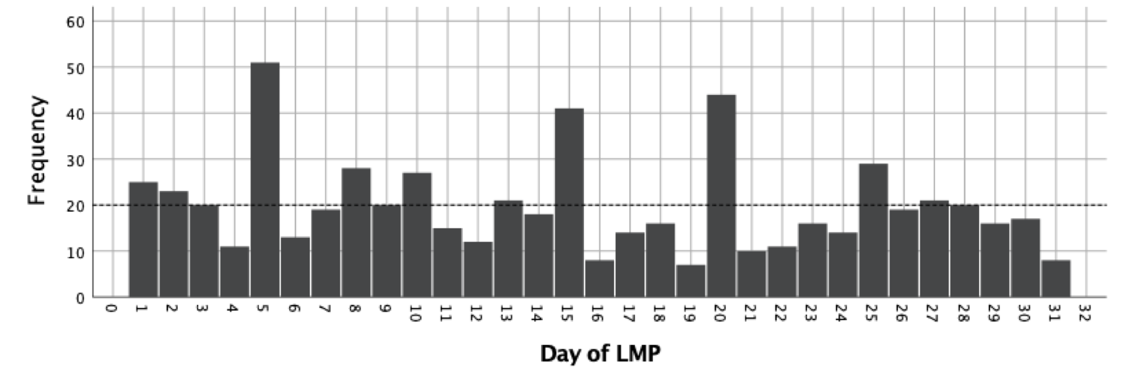
Digit preferences for the day of the last menstrual period informed by the woman (n=606)
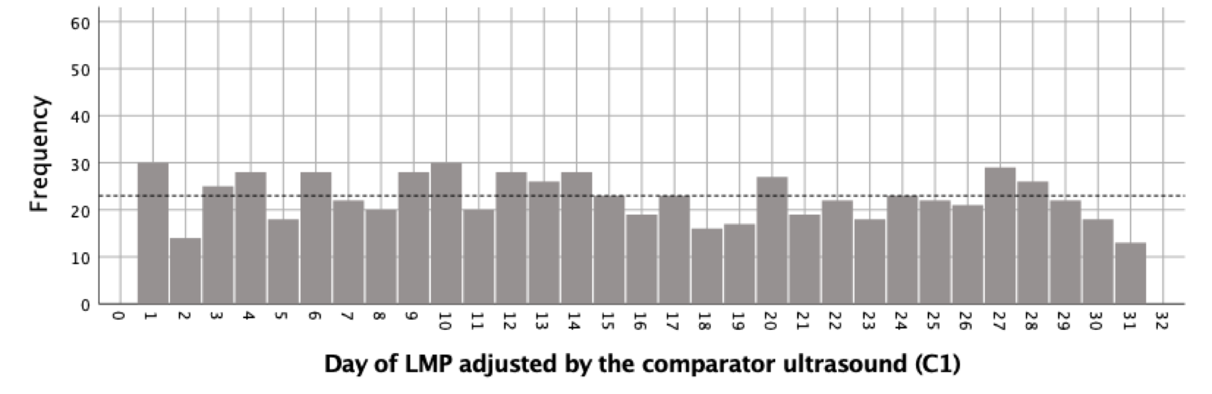
Digit preferences for the day of the last menstrual period adjusted by the Comparator 1 (n = 703)
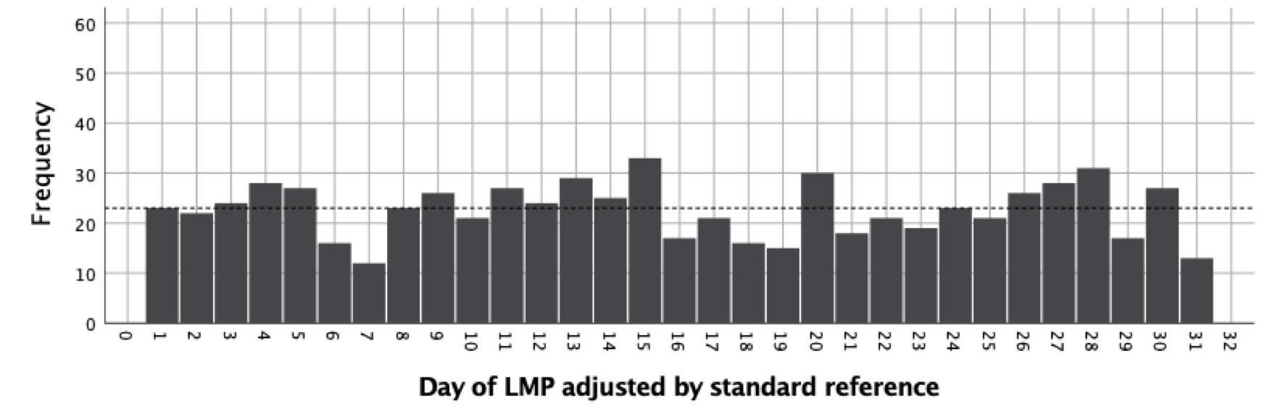
Digit preferences for the day of the last menstrual period adjusted by R-gestational age (n = 703)

Supplementary Fig. in Note 1. Histograms for the day-date of the month of the last menstrual period, adjusted or not by the other references for pregnancy dating

Note: LMP: last menstrual period.

Supplementary Note 2: Correlation between reference gestational age and predictor variables

The choice of covariates for gestational age prediction machine learning models had the following criteria: already known to be influential in pregnancy dating, or to be influential in skin reflectance phenomenon.¹⁹ All predictors were available at the time of the test, and they could be used in real scenarios with the user input into the medical device interface: birth weight, Antenatal corticosteroid therapy for fetal lung maturity (ACTFM), incubator-stay, gender, and jaundice. The importance of such variables by the XGBoost classifier is in Supplementary Fig. in Note 2.
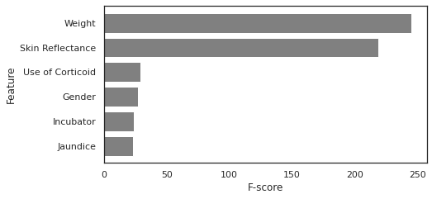
Supplementary Fig. in Note 2. The measure of feature importance returned by the XGBoost classifier

Comparing crude variables with bivariate modeling including birth weight, mean absolute error (MAE) between predicted gestational age and reference gestational age (R) accompanied by the coefficient of determination (R²) highlighted the advantage on the skin reflectance adjusted to birth weight, Supplementary Table in Note 2. Concerning the models with more than two covariates to adjust the skin reflection, the coefficient of determination had differences only in the second decimal digit. MAE ranged from 1.16 to 1.21 weeks for linear regression models and from 1.12 to 1.15 weeks with machine learning approach.
We choose the linear ridge regression (linear model with L2 regularization) skin reflectance and birth weight algorithm as Model 1 for birth scenarios when the birth weight is known and ACTFM exposition information is not. The reasons were the high coefficient of determination (R² = 0.846) with low mean absolute error (MAE = 1.249 weeks) in the test partition and simplicity for deployment into the device's firmware. However, for birth scenarios when the birth weight and ACTFM information are known, we choose the XGBOOST skin reflectance, birth weight, and ACTFM exposition as Model 2 due to the high coefficient of determination (R² = 0.881) and low mean absolute error (MAE = 1.140 weeks) in the test partition.
Supplementary Table in Note 2: Prediction results of regression models to predict R-gestational age at birth on the test set
 | Linear Regression |  |  |  | XGBoost
Covariates | Training |  | Test |  | Training |  | Test
Covariates | MAE (SD) | R²  (SD) | MAE  (SD) | R²  (SD) | MAE (SD) | R² (SD) | MAE (SD) | R² (SD)
Birth weight (grams) | 1.310 (0.013) | 0.835 (0.004) | 1.315 (0.114) | 0.829 (0.038) | 1.056 (0.011) | 0.899 (0.003) | 1.163 (0.100) | 0.872 (0.032)
Skin reflectance raw model (n = 781) | 2.069  (0.017) | 0.622  (0.008) | 2.075 (0.156) | 0.609 (0.073) | 1.816  (0.019) | 0.703  (0.008) | 2.008 (0.154) | 0.615 (0.091)
Skin reflectance and birth weight  (n = 781, 2 variables) | 1.243  (0.012) | 0.853  (0.004) | 1.249 (0.106) | 0.846 (0.036) | 1.112  (0.020) | 0.892  (0.004) | 1.250  (0.102) | 0.856 (0.034)
Skin reflectance, birth weight, ACTFM (n = 777) | 1.207 (0.012) | 0.863 (0.003) | 1.215 (0.110) | 0.857 (0.029) | 1.007  (0.011) | 0.911  (0.002) | 1.140  (0.094) | 0.881  (0.026)
Skin reflectance, birth weight, ACTFM, jaundice (n = 767) | 1.199  (0.011) | 0.863 (0.003) | 1.208(0.110) | 0.856 (0.029) | 0.987  (0.011) | 0.913  (0.002) | 1.126  (0.091) | 0.881  (0.026)
Skin reflectance, birth weight, gender, jaundice, incubator  (n=771) | 1.172  (0.011) | 0.868  (0.003) | 1.183  (0.104) | 0.862  (0.027) | 0.992  (0.010) | 0.911  (0.002) | 1.126  (0.095) | 0.882  (0.026)
ACTFM: Antenatal corticosteroid therapy for fetal lung maturity. MAE: Mean absolute error (weeks). R²: Coefficient of determination. SD: standard deviation.

Supplementary Table 1: Descriptive analysis of frequency for gestational age at birth, according to the methods of calculation.
 | Median (IQR) days | Min - Max, days
Reference gestational age (n=781) | 261 (44) | 155 to 294
Comparator 1 gestational age (n=781) | 260 (43) | 167 to 322
Comparator 2 gestational age (n=680) | 262 (48) | 165 to 319
Model 1 gestational age (n=781) | 258.9 (43) | 188.3 to 324.6
Model 1 gestational age (n=777) | 259.4 (43.6) | 168.6 to 287.7
Difference between Comparator 1 and reference gestational age (n=781) | 0 (4) | -27 to 50
Difference between Comparator 2 and reference gestational age (n=680) | -0.01 (4) | -72 to 72
Difference between Model 1 and reference gestational age (n=781) | 0.21 (14) | -48.6 to 48.6
Difference between Model 2 and reference gestational age (n=777) | -1.4 (-2.1) | -9.7 to 16.2
IQR: interquartile range.
Comparator 1 is the gestational age calculated with a second ultrasound exam after 13 weeks and 6 days of gestation and before 22 weeks.
Comparator 2 is the gestational age calculated with the last menstrual period.
Model 1: Linear-Ridge skin reflectance and birth weight predictors.
Model 2: XGBOOST skin reflectance, birth weight, and ACTFM exposition predictors.

Supplementary Fig. 1. Receiver Operating Characteristic of the skin reflection to discriminate term from preterm newborns
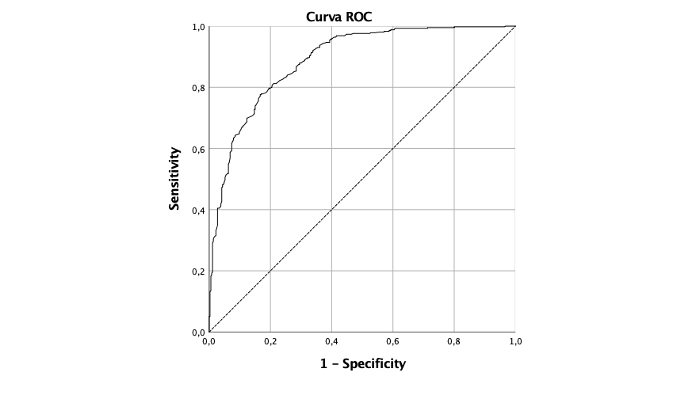
Preterm discrimination (37 weeks)
AUROC 0.956 (95%CI: 0.942, 0.970)
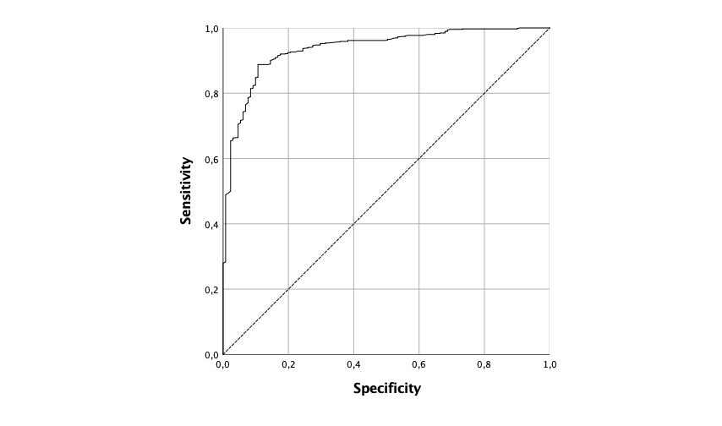
Preterm discrimination (32 weeks)
AUROC 0.937 (95%CI: 0.916, 0.958)
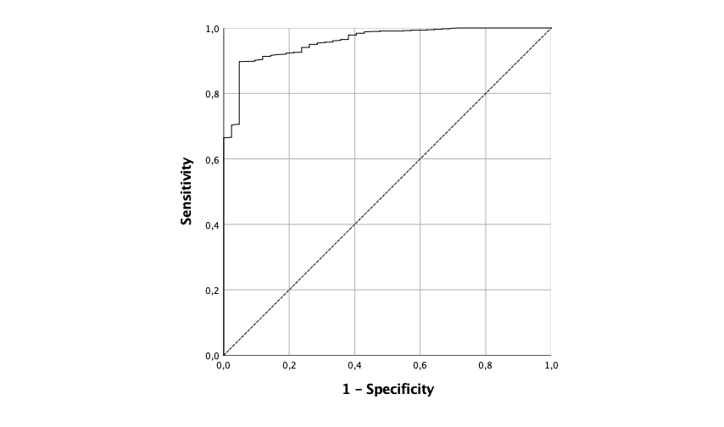
Preterm discrimination (28 weeks)
AUROC 0.959 (95%CI: 0.936, 0.981)

AUROC: the area under the receiver operating characteristic curve.

Supplementary Table 2: Prediction accuracy for preterm newborn by the methods of gestational age estimation
 | Comparator 1  gestational age  (n=781) | Comparator 2  gestational age  (n=680) | Model 1 gestational age  (n=781) | Model 2 gestational age  (n=777)
Preterm <37 weeks (n=366)
ACU (%) | 96.2 | 92.8 | 87.3 | 96.0
False - (%) | 3.8 | 9.4 | 10.1 | 1.9
SPE (%) | 96.1 | 94.7 | 85.1 | 94.2
VPP (%) | 95.7 | 93.9 | 84.1 | 93.7
VPN (%) | 96.6 | 91.9 | 90.5 | 98.2
LR+ | 25.0 | 17.1 | 6.0 | 16.8
LR- | 0.04 | 0.10 | 0.10 | 0.02
Preterm <32 weeks (n=131)
ACU (%) | 98.5 | 96.2 | 91.3 | 95.0
False - (%) | 3.8 | 10.0 | 23.7 | 11.5
SPE (%) | 98.9 | 97.4 | 94.3 | 96.3
VPP (%) | 94.7 | 86.8 | 73.0 | 82.9
VPN (%) | 99.2 | 98.1 | 95.2 | 97.6
LR+ | 89.3 | 34.2 | 13.4 | 23.8
LR- | 0.04 | 0.10 | 0.25 | 0.12
Preterm <28 weeks (n=42)
ACU (%) | 99.0 | 98.5 | 95.4 | 97.2
False - (%) | 11.9 | 16.7 | 71.4 | 19.0
SPE (%) | 99.6 | 99.4 | 99.2 | 98.1
VPP (%) | 92.5 | 88.2 | 66.7 | 70.8
VPN (%) | 99.3 | 99.1 | 96.1 | 98.9
LR+ | 217 | 134 | 35.2 | 42.5
LR- | 0.12 | 0.17 | 0.72 | 0.19
Model 1: Linear-Ridge skin reflectance and birth weight predictors. Model 2: XGBOOST skin reflectance, birth weight, and ACTFM exposition predictors. ACU: newborn correctly classified (accuracy). LR+: Likelihood ratio positive. Likelihood ratio negative: LR-. SEN: sensibility. SPE: Specificity.

Supplementary Note 3: The reliability of the skin assessment with the photometer of the device
The observer variability for the skin reflection acquisition with the novel device took into account the average and standard deviation of individual pairs of measurements.⁵¹ (POPOVIĆ; THOMAS, 2017) The calculation of intraobserver variability used 30 sequential measurements taken in the same delimited skin region from eight individual observers. The observers' differences between repeat acquisitions had an average (standard deviation) of 2.6% (1.34%). It means that on 95% of occasions, the difference between one observers' assessment did not differ more than 1.6% to 3.5%. The calculation of interobserver variability used a difference from 30 pairs of measurements taken in the same delimited skin region from two observers. The average (standard deviation) was 2.6% (1.34%). It means that on 95% of occasions, the difference between two observers' assessments did not differ more than 1.6% to 3.5%.

Supplementary Note 4: Framework of clinical variables collected from each newborn
Variables | Types and categories
Identification
Hospital identification | Integer
Researcher Identification | Integer
Researcher name | String
Application registration code | Integer
Gestational age (weeks) | Integer
Gestational Age (Days) | Integer
Mother's name | String
Mother's age | integer
Women's medical record code | String
Pregnancy and birth data
Delivery date and time | Datetime
US1 - Date at the first ultrasound ( < 14 weeks) | date
US1 - Gestational Age (GA) in weeks | integer
US1 - GA (days) | integer
US1 - CCN (mm) | integer
US2 - Date at the second ultrasound | date
US2 - GA (weeks) | integer
US2 - GA (days) | integer
US2 - Biparietal Diameter (BDP) | float
US2 - Femur | float
US2 - Head circumference | float
US2 - Abdominal circumference | float
LMP - Last Menstrual Period | date
LMP - Do you have confidence in LMP? | Yes / No
LMP - Are your menstrual cycles regular? | Yes / No
LMP - Did the current conception occur within 2 months of using hormonal contraceptives? | Yes / No
LMP - Did the current conception occur within 2 months of abortion or childbirth? | Yes / No
GA at the first prenatal care assessment (weeks) | integer
High-risk pregnancy | Yes / No
Diabetes | Yes / No
Hypertensive disturb during pregnancy | Yes / No
Major malformation | Yes / No
Oligohydramnios | Yes / No
Multiple gestations | Yes / No
Birth order of twins | integer
Other maternal or fetal disease | String
Antenatal Corticosteroid Therapy for Fetal Maturation exposition (ACTFM) | Yes / No
Corticotherapy scheme used | 2 doses / 4 doses
Number of doses ACTFM applied | integer
Newborn sex | integer
Birthweight (g) | 300 - 6000
1-minute Apgar score | 0 - 10
5-minute Apgar score | 0 - 10
Accommodation | Ward / NICU / Birth-room
Type of bed of the neonate | Incubator / incubators-radiant warmer / common crib / other
Phototherapy at the skin assessment | Yes / No
During 72h hours of life
Jaundice | Yes / No
Discharge Conditions | discharge / death / internal
Discharge date and time | Datetime
Neonatal death date and time | Datetime
Death cause | String
Prenatal care book photo - Side A | Image
Prenatal care book photo - Side B | Image
US1 - Ultrasound report photo (<14 weeks) | Image
US2 - Ultrasound report photo (>=14 weeks) | Image
Preemie-Test Exam Data
Skin abnormalities at the test site | String
Adverse events: equipment heating | Yes / No
Adverse events: electric shock | Yes / No
Adverse events: neonate's skin marks or irritation | Integer
Device: display indicates nothing | Integer
Device: equipment not charging | Integer
Device: trigger not fired | Integer
Device base: red LED does not light | Yes / No
Other adverse events | String
Equipment serial number and sequential number | Integer
Exam date and time | Datetime
JSON file - Preemie-Test reflection | File
Preemie-Test Exam Data - Examined 3 times
Duration [1..3] | Integer
Temperature [1..3] | Integer
Gain [1..3] | Integer
Integration Time [1..3] | Integer
Current [1..3] | Integer
SetupTime [1..3] | Integer
LedOffRaw [1..3] | Integer
LedOffRawMedian [1..3] | Integer
LedOffRawMean [1..3] | Integer
LedOffRawStdDev [1..3] | Integer
LedOffCal [1..3] | Integer
LedOffCalMedian [1..3] | Integer
LedOffCalMean [1..3] | Integer
LedOffCalStdDev [1..3] | Integer
LedOnRaw [1..3] | Integer
LedOnRawMedian [1..3] | Integer
LedOnRawMean [1..3] | Integer
LedOnRawStdDev [1..3] | Integer
LedOnCal [1..3] | Integer
LedOnCalMedian [1..3] | Integer
LedOnCalMean [1..3] | Integer
LedOnCalStdDev [1..3] | Integer

Supplementary note 5: Analytical pipeline

Data analysis was performed using a k-fold cross-validation procedure,⁵² (KOHAVI, 1995) with k=10, as illustrated in Supplementary Fig. in Note 5. This cross-validation procedure was repeated N times, where N=30. This means we have generated 30 different predictions for each example in the original dataset.

Data normalization
k = 1
k < N
Use Linear Regression or XGBoost to generate model from training set
Data in groups j<>k compose the training set
GA predicted for data in test group k
k+1
Data divided into N random groups
Yes
No
GA predictions for all groups merged

Supplementary Fig. in Note 5. Schematic representation of the analytical pipeline, which was executed 30 times with different random data divisions to make statistical analysis more robust.

XGBoost

XGBoost (Extreme Gradient Boosting)⁴⁹ is an efficient model that uses an ensemble of trees to make predictions. It combines the prediction of regression trees using the gradient tree boosting technique introduced by Friedeman.⁵³ The main idea behind gradient boosting is to start with a very simple model, and allow subsequent models to “correct” the residuals in the predictions generated by previous models.
XGBoost uses regression trees as base models, i.e. the simple models that will be combined. A regression tree is a binary tree, where the root and internal nodes represent an input variable and a split point (in the case of continuous attributes) into that variable. Leaf nodes contain a continuous score w, used to make predictions.
Consider a supervised learning scenario, where we have a dataset D with n examples and m features, and each example i is represented by a pair D = {(x_{i}, y_{i})}, wherexi m, yi .When we used the tree boosting method proposed by XX, the output yiof a model with k trees is given by:
yi = (xi) = k=1Kfk(xi), fk F, (1)
where F={ f(x) = wq(x)}, and q:mT, w t. q is the structure of the tree that maps an example to its leaf prediction (output variable), and T is the number of leaf nodes of the tree. Each fk corresponds to a tree structure q with leaf weights w. Given an example e, all decision trees (each represented by q) are used to find the corresponding leaf in the tree that classifies e. The final prediction is given by summing up the scores of the leaves associated with e in each tree (represented by w).
The set of functions (trees) are learnt by minimizing the regularized objective function Obj presented in Eq. 2.
L () = i=1nl(yi,yi)+k=1K(fk) (2)
(ft) = T + 12j=1Twj2 (3)
The first part of Eq. 2 is the loss function l(yi,yi), which measures the difference between the real value of the output variable yi and the predicted value yi. The second part is the regularization, given by the L2 norm of leaf scores, defined in Eq. 3. Its objective is to encourage leaf nodes to have smaller values (weights) and avoid overfitting.
The model described in Eq. 2 cannot be optimized using traditional optimization methods since it has functions as parameters. Hence, the model is trained in an additive way, using additive training (boosting). We start with a constant prediction and add a new function to it at each iteration, i.e., every time a new tree is generated. Let yi(t)be the prediction of the i instance in the t iteration. The process of learning the trees works as follows:
yi(0)= c
yi(1)= f1(x1) =yi(0)+f1(x1)
….
yi(t)=k=1Tfk(xi) =yi(t-1)+ft(xi)
The loss function we want to minimize can be rewritten as:
L(t)= i=1nl(yi,yi(t-1)+ft(xi))+(ft)
Observe that we add to the current model the function f_{t} that most improves the model according to Eq. 2. This loss function can be optimized using second order approximation. For more details on the mathematical setting the reader is referred to Chen and Guestrin.⁴⁹
Apart from this regularized objective function, XGBoost uses the shrinkage technique to help avoid overfitting. Shrinkage scales the weights predicted by the new trees by a factor $η,$ known as the learning rate. It also takes advantage of feature subsampling as a third mechanism to prevent overfitting.

