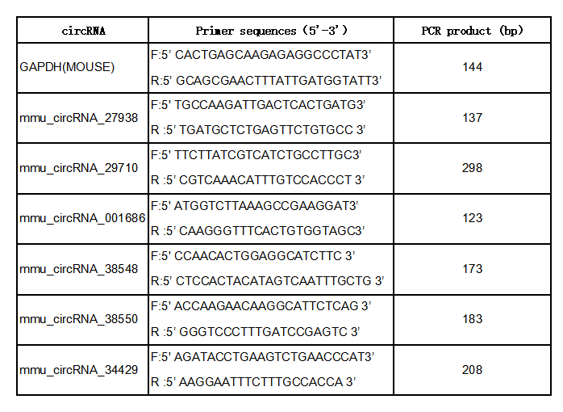
TABLE 1 List of qRT‐PCR primers
Note. circRNA: circular RNA; F: forward; PCR: polymerase chain reaction; qRT‐PCR: quantitative reverse transcription polymerase chain reaction; R: reverse.

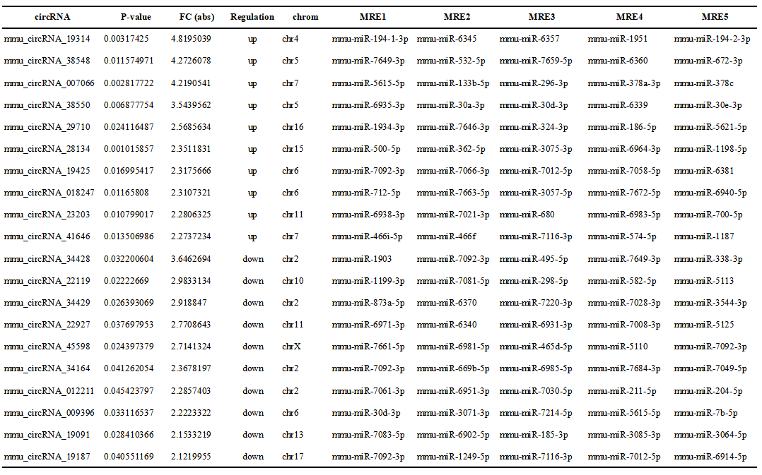
Table 2 List of top 10 significantly upregulated and downregulated circular RNAs

