Supporting information
Study on Hydrogenation Performance of Organo-Molybdenum Catalyst Based on Model Compounds
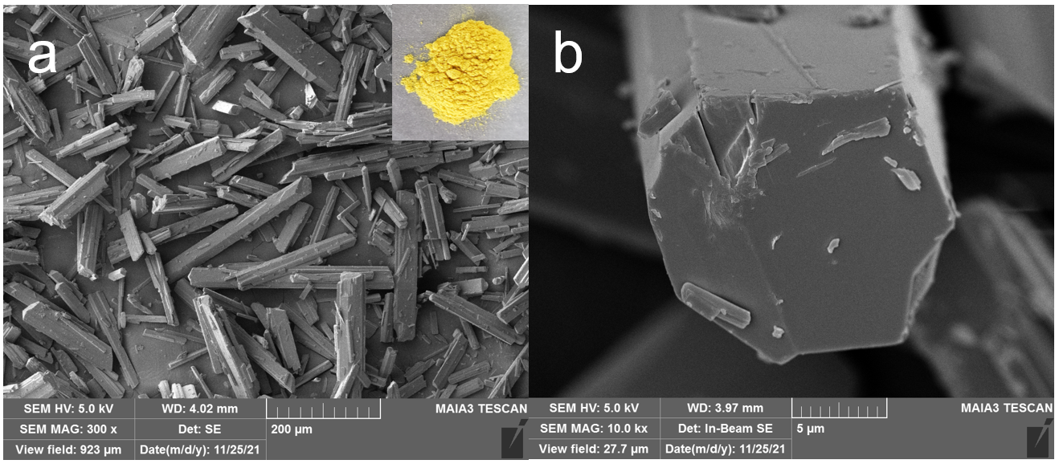
Figure S1. SEM photos of catalyst precursor. The illustration is photograph of catalyst precursor.

Table S1. The quality of catalyst before and after calcining
 | Before calcining | After calcining
1 | 0.4994 g | 0.2086 g
2 | 0.5014 g | 0.2091 g

Table S2. Hydrocracking gas product weight percent of model compounds at different reaction temperature.
Items | Weight percent (%)
Items | 445℃ | 435℃ | 425℃ | 415℃ | 405℃
CH₄ | 0.0847 | 0.0348 | 0.0162 | 0.0091 | 0.0051
C₂H₆ | 0.1809 | 0.0623 | 0.0250 | 0.0106 | 0.0034
C₂H₄ | 0.0023 | 0.0010 | 0 | 0 | 0
C₃H₈ | 0.1799 | 0.0614 | 0.0254 | 0.0108 | 0.0033
C₃H₆ | 0.0187 | 0.0079 | 0.0035 | 0.0015 | 0
C₄H₁₀ | 0.0638 | 0.0223 | 0.0106 | 0.0053 | 0.0022
H₂ | 99.47 | 99.81 | 99.92 | 99.96 | 99.99

Table S3. Hydrocracking liquid product unit injection peak area of GC-MS of model compounds at different reaction temperature.
Items | Unit injection peak area
Items | 445℃ | 435℃ | 425℃ | 415℃ | 405℃
hexane | 1114.087 | 521.1741 | 160.3591 | 66.41389 | 25.24264
heptane | 1455.146 | 671.9083 | 251.0662 | 90.95912 | 38.70875
octane | 1985.749 | 892.7796 | 360.4474 | 157.7145 | 49.04214
nonane | 2456.161 | 1074.033 | 468.8823 | 230.4395 | 73.25951
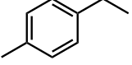 | 450.8109 | 339.1264 | 245.7933 | 194.2745 | 188.2669
decane | 2727.665 | 1349.992 | 486.2615 | 292.4667 | 93.23596
hendecane | 3241.352 | 1497.574 | 589.6356 | 328.2653 | 123.7935
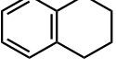 | 1036.472 | 497.0592 | 201.3156 | 67.20375 | 0
dodecane | 1728.772 | 1053.253 | 498.4987 | 227.1647 | 0
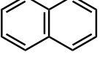 | 1882.863 | 0 | 0 | 0 | 0
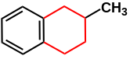 | 5942.562 | 6403.562 | 7128.648 | 7137.806 | 7497.354
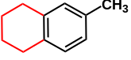 | 10662.18 | 11163.54 | 11900.33 | 11647.66 | 11453.06
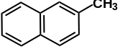 | 6626.227 | 6105.595 | 5663.206 | 4612.242 | 5375.998
tetradecane | 36394.02 | 35568.79 | 35573.85 | 37009.91 | 35846.87

Table S4. Hydrocracking gas product weight percent of model compounds with different concentrations of catalyst addition
Items | Weight percent (%)
Items | 10 mg/g | 5 mg/g | 2.5 mg/g | 0.65 mg/g
CH₄ | 0.0091 | 0.0077 | 0.0077 | 0.0068
C₂H₆ | 0.0106 | 0.0102 | 0.0112 | 0.0105
C₃H₈ | 0.0108 | 0.0102 | 0.0111 | 0.0103
C₃H₆ | 0.0015 | 0.0013 | 0.0017 | 0.0021
C₄H₁₀ | 0.0053 | 0.0041 | 0.0040 | 0.0035
H₂ | 99.96 | 99.97 | 99.96 | 99.97

Table 4. Hydrocracking liquid product unit injection peak area of GC-MS of model compounds with different concentrations of catalyst addition.
Items | Unit injection peak area
Items | 10 mg/g |  | 5 mg/g |  | 2.5 mg/g |  | 0.65 mg/g
hexane | 66.41389 |  | 69.17689 |  | 72.28036 |  | 64.09543
heptane | 90.95912 |  | 96.69368 |  | 112.1827 |  | 98.03091
octane | 157.7145 |  | 148.8119 |  | 169.1999 |  | 146.7047
nonane | 230.4395 |  | 218.6167 |  | 237.0231 |  | 198.3453
 | 194.2745 |  | 191.4022 |  | 164.3077 |  | 175.8289
decane | 292.4667 |  | 275.4528 |  | 287.2715 |  | 252.6946
hendecane | 328.2653 |  | 318.1921 |  | 339.4984 |  | 314.663
 | 67.20375 |  | 0 |  | 0 |  | 0
dodecane | 227.1647 |  | 216.2114 |  | 212.7417 |  | 178.0834
 | 0 |  | 0 |  | 0 |  | 0
 | 7137.806 |  | 7377.324 |  | 7267.637 |  | 6284.792
 | 11647.66 |  | 11745.44 |  | 11745.38 |  | 10559.26
 | 4612.242 | 4114.084 |  | 3897.035 |  | 5502.117
tetradecane | 37009.91 | 38021.96 |  | 35441.97 |  | 31596.76

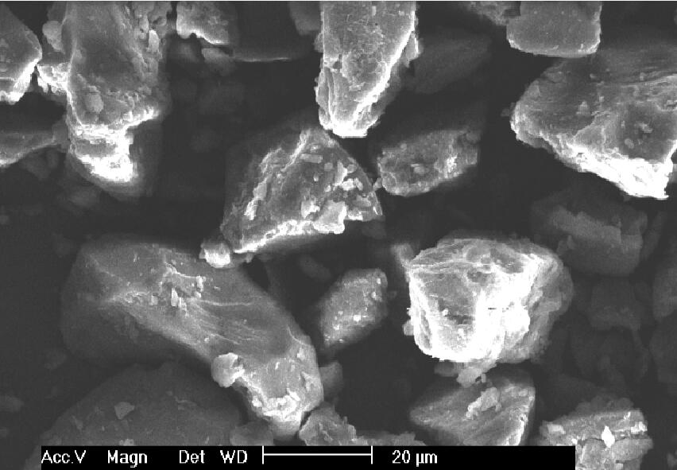
Figure S2. SEM image of raw coal.

