Supplementary Information

Wildfires disproportionately affected jaguars in the Pantanal
Alan Eduardo de Barros et al.

SI_notes

Complementary analysis (Results)

Real-time fire occurrence in jaguar home ranges (HRs)
In addition to the analyses considering the impacts of fire on HRs across multiple years, we analysed real-time fire impacts on jaguar home ranges (HR) (SI_Fig.S3). This analysis considered fires that occurred within jaguar HRs only during the individual monitoring period (2008–2016 in Brazil and 2005, 2006, and 2010 in Paraguay/Bolivia; SI_Figs.S3, S4). Our real-time investigation allowed us to find that the effects of fire were negligible in the area used by the four non-resident individuals (SI_Fig.S3b). While this might be just an anecdotal observation (given the small sample size), it may also be that fires caused more impacts on high-quality habitats within the HRs of the resident jaguars.

Relationship of the year and project region with fire occurrence
We used a two-way ANOVA to evaluate the effect of year, project region, and ID on real-time fire occurrence within jaguar HRs (during real-time monitoring) and jaguar HRs (HRs compared across all years). The interaction between year and project region on fire occurrence was the most plausible model, since it generated the smallest residuals (SI_Tab.S2, SI_Fig. S3c). However, a major limitation in the real-time analysis was the unequal distribution of jaguar HRs in space and time. Years without monitoring (2007, 2017–2020) or with sparse or clustered monitoring ( 2005–2006, 2008–2009, and 2016) seemed to neglect or underestimate the impact of fires on the overall jaguar HRs (SI_Fig. S3c). Conversely, the main approach used here (using 48 home ranges of resident jaguars across multiple years Figs. 2, 3) was more representative in space and time.

Additional details about the impacts of fires in the UPRB and Pantanal (Discussion)

Cumulative impacts in the Pantanal
An assessment of the integrity risk of aquatic ecosystems identified hydroelectric power plants, urbanization, and agribusiness as the top three stressors among 13 anthropic activities impacting the Upper Paraguay River Basin¹⁰². Environmental degradation (e.g., deforestation, erosion, sewage), economic activities (e.g., agriculture, mining), and infrastructure (e.g., dams, hydroelectric power plants, waterways, gas pipelines) are associated with the demand and pressure of an increasing human population in the UPRB. These environmental damages can interfere with drainage dynamics, flood pulses, and drought extent and, consequently, impact ecological richness, biodiversity, and ecosystem services^{42,61,102–105}.
The Pantanal occupies 38% of the UPRB⁸⁰, and the water that drains into the lowlands and floods in the Pantanal comes from springs in the highlands^{103,104}. Thus, the removal of the vegetation cover that protects these springs in the neighbouring biomes within the UPRB (Cerrado, Amazonia, Atlantic Forest, and Chaco)⁷³ impacts the drainage, water quality, and hydrological regime of the Pantanal^{61,80,102–105}. Deforestation, mining activities^{9,42}, and hydroelectric power plants (total ≈ 180, 47 of them installed or in operation and 133 planned)^{81,82} change water quality and flow, causing erosion, river sedimentation^{42,73,81}, and reduction of outflow (up to 100% in drier years) and nutrient transport to the Pantanal floodplains^{81,106,107}. Additional problems include reduced light, which is causing a decline or disappearance of aquatic plants and photosynthetic algae¹⁰², hypoxia and a consequent cascade effect, such as reduced food availability for fish¹⁰² and bioaccumulation of toxic mercury^{9,108}.
The implementation of a waterway on the Paraguay River, hydroelectric power plants, railroads, and highways have long been debated in academia, legal courts, and by stakeholders^{42,81,109–114}. Overwhelming evidence of negative impacts has barred or reduced the development of large enterprises, such as the construction of a 3,440 km² north-south waterway from Cáceres (Brazil) to Nueva Palmira (Uruguay) and large hydroelectric power plants^{42,111–114}. However, a subterfuge often used by stakeholders in many new enterprises is to propose several small hydroelectric plants, ports, or relatively short canalization projects as low-impact alternatives, without considering their cumulative impacts¹¹⁵. In addition, the supposed small individual impact is often used as an excuse to limit the decision-making to a smaller group of stakeholders^{112,116}, the so-called “tyranny of small decisions”^{112,117}. The impact of the cumulative effects of small ventures can be only avoided by adopting a holistic perspective in a process involving scientists with relevant subject matter expertise, planners, politicians, and other social actors^{112,117} in in-depth studies, with impartial evaluation and discussions (e.g., using a Strategic (or Integrated) Environmental Assessments (SEA) or equivalent approaches^{82,115,118,119}). Successful regulation based on laws¹²⁰ and updated SEAs for the Pantanal^{81,82,102}, through a transparent and plural engagement of civil society, could bring invaluable advances for conservation and provide science-based guidance to attain sustainability^{42,82,121,122}.

The increase in fires in the Pantanal
The high number of human-induced fires^{14–16} combined with the hottest and driest conditions since 1980¹⁹ led 2020 to record the highest daily severity rating (DSR) index of fires for this time period¹⁴, with tragic consequences for jaguars and Pantanal biota^{14,16}. Along with the fires, the severity of the 2020 drought¹⁹ (with minimum river depths estimated at around 86% below normal^{24,135} (Fig.2, SI_Figs.S2) has been demonstrated by several records of animal starvation, dehydration, and death^{14,16}. In addition to deaths from the direct impact of fire, clearing vegetation removal may increase erosion, and the resulting charcoal and ash can contaminate rivers¹⁴. Many reasons may have contributed to the intensity of the 2020 drought in the Pantanal, from climate¹⁹ to direct and indirect human impacts in the Upper Paraguay River Basin (UPRB)^{61,73}. The shortage of rain throughout the UPRB is among the main factors, as the basin water balance controls the hydroclimatological dynamics in the Pantanal (Fig.2, SI_Figs.S2)⁸⁷. The shortage of rain may also be a consequence of increased deforestation in the Amazon rainforest^{123, 124}, as summer rainfall in the Pantanal is strongly associated with the climate of the Amazon¹⁰⁵. In addition, the lack of governmental and human resources and delayed response at federal and local levels^{124,125,126} amplified the negative effects of water shortage^{14,16,124}.
The reduction in wetland flooded areas is historically correlated with the spread of fires (Fig.2, SI_Fig.S2)^{19,28,29}. Low water levels led to the absence of flooding and reduced wetland areas, and the remaining dry vegetation provided flammable material and created favourable conditions for fires to occur^{19–21}. Savanna-like vegetation, the predominant vegetation type in the Pantanal, usually recovers from the effects of fires in relatively short periods (months to a few years)²⁰, depending on the severity and frequency of fires and climate conditions in the subsequent years^{20,28,29}. Thus, human interventions to prevent sequential fire events in the same area are paramount^{16,20,75}. Although historical hydrological series show that extreme drought events occurred in the past^{19,35,89,91} (e.g., from the late 1960s to early 1970s SI_Fig.S2)²⁴, they also show that the recovery of the Pantanal was conditioned to the subsequent 15 years of regular to exceptional floods (1974 to early 1990s, SI_Figs.S2). In this context, researchers have emphasized that the dynamics of fires do not follow the intensity of extreme drought years³¹, as the resilience of many species may decrease with the annual repetition of extreme fire events^{28–30}.
Moreover, changes in the climate^{19,21,34–36}, landscape and water use in the UPRB over the last four decades^{15,25,42,73} are cumulative threats that may interfere with water recharge and vegetation resilience in the Pantanal. Global temperatures may increase up to 1.5 °C over the next five years³⁴, in addition to the 2 °C already recorded since 1980. By the end of the 21st century, scientists estimate increases of 5−7 °C in the temperature and the frequency of climatic extremes and a 30% reduction in average rainfall^{34–36}. Until 2019, pastures covered 15.5% of the Brazilian Pantanal and agriculture about 0.14%²⁵. However, agriculture and pastures occupied 60–65% of the surrounding Cerrado uplands within the UPRB^{42,61,73}, an occupation similar to the adjacent Paraguayan Chaco and Bolivian Chiquitano Forest^{42,127,128}. Consequently, this land occupation impacted the main headwaters of the Pantanal rivers and ultimately the entire Pantanal^{73,80,102,103}. Furthermore, by 2019, 47 hydroelectric power plants were installed or in operation, and another 133 were planned, totalling about 180 potential dam projects in the Brazilian UPRB^{81,82}. These economic and infrastructure activities in the surrounding highlands affect the Pantanal in different ways (SI_Fig.S1), including its drainage dynamics and flood pulses, with consequent impacts on drought duration and fire spread^{14,16,19–21}(Fig.1,2; SI_Figs.S1, S2). This combination of factors probably intensifies the Pantanal droughts, particularly the periodic sequence of dry years. Therefore, a critical point is how human actions can exacerbate such extreme events^{42,61,102} and make fire control even more difficult^{16,20,75} or, on the opposite, contribute to minimize the overall impacts of drought and fires and promote biodiversity conservation (SI_Fig.S1). Given that the rainfall remained below average in the last wet season²³ (SI_Fig.S2b) and that a severe drought persists in 2021¹²⁹, a surveillance protocol for rapid response and programs for fire management and mitigation of human impacts are urgently needed^{16,20,75}. If such measures keep lacking, a tragedy similar to the 2020 fires may be repeated in the coming years (SI_Fig.S1). To make matters worse, the government budget allocated for fire control and firefighting for 2021 was reduced to 65.5% of the 2019 budget¹²⁶, and all funds allocated to the environment were reduced to the lowest level in 20 years^{126,130}, with serious complaints of misuse¹³¹, embezzlement¹³² and wood-smuggling probe¹³³.

SI_Extra References
102. Petry et al. Ecological Risk Assessment for the Paraguay River Basin. Argentina, Bolivia, Brazil and Paraguay. Executive Summary, 16 p. (TNC, WWF, 2012).
103. Bergier, I. Effects of highland land-use over lowlands of the Brazilian Pantanal. Science of The Total Environment 463–464, 1060–1066 (2013).
104. Ioris, A., Irigaray, C. & Girard, P. Institutional responses to climate change: opportunities and barriers for adaptation in the Pantanal and the Upper Paraguay River Basin. Climatic Change 127, 139–151 (2014).
105. Bergier, I. et al. Amazon rainforest modulation of water security in the Pantanal wetland. Science of The Total Environment 619–620, 1116–1125 (2018).
106. Jardim, P. F.et al. Modeling Assessment of Large-Scale Hydrologic Alteration in South American Pantanal Due to Upstream Dam Operation. Front. Environ. Sci. 8, (2020); https://doi.org/10.3389/fenvs.2020.567450 (2020).
107. Oliveira, M. D. et al. Further Development of Small Hydropower Facilities May Alter Nutrient Transport to the Pantanal Wetland of Brazil. Front. Environ. Sci. 8, (2020); https://doi.org/10.3389/fenvs.2020.577793
108. Nogueira, F., Silva, E. C. E. & Junk, W. Mercury from gold minings in the Pantanal of Pocone (Mato Grosso, Brazil). International Journal of Environmental Health Research 7, 181–192 (1997).
109. MPF - Ministério Público Federal. Usinas hidrelétricas: MPF defende estudo na bacia hidrográfica do Pantanal Mato-Grossense para concessão de licença (2020); http://www.mpf.mp.br/pgr/noticias-pgr/usinas-hidreletricas-mpf-defende-estudo-na-bacia-hidrografica-do-pantanal-mato-grossense-para-concessao-de-licenca
110. MPF/MS - Ministério Público Federal do Mato Grosso do Sul. Suspensa instalação de novas hidrelétricas no Pantanal. Jusbrasil (2013); https://mpf.jusbrasil.com.br/noticias/100039926/mpf-ms-suspensa-instalacao-de-novas-hidreletricas-no-pantanal
111. Bucher, E. H. & Huszar, P. C. Critical environmental costs of the Paraguay-Paraná waterway project in South America. Ecological Economics 15, 3–9 (1995).
112. Gottgens, J. F. et al. The Paraguay-Paraná Hidrovia: Protecting the Pantanal with Lessons from the Past. BioScience 51, 301–308 (2001).112.
113. Hamilton, S. K. Potential effects of a major navigation project (Paraguay–Paraná Hidrovía) on inundation in the Pantanal floodplains. Regulated Rivers: Research & Management 15, 289–299 (1999).
114. Sousa Júnior et al. Nova Hidrovia Paraguai-Paraná: uma análise abrangente: análise de conjuntura e factibilidade política, econômica, social e ambiental da “nova” proposta da hidrovia Paraguai-Paraná (2019); https://mupan.org.br/_files/200001170-653776537a/20191021_Nova-Hidrovia-Paraguai-Parana_uma-analise-abrangente_e-book-3.pdf
115. Habets, F., Molénat, J., Carluer, N., Douez, O. & Leenhardt, D. The cumulative impacts of small reservoirs on hydrology: A review. Science of The Total Environment 643, 850–867 (2018).
116. Ioris, A. Rethinking Brazil’s Pantanal Wetland: Beyond Narrow Development and Conservation Debates. The Journal of Environment & Development 22, 239–260 (2013).
117. Odum, W. E. Environmental Degradation and the Tyranny of Small Decisions. BioScience 32, 728–729 (1982).
118. MMA - Ministério do Meio Ambiente. Livro Verde da Avaliação Ambiental Estratégica do Pantanal. (2008).
119. ANA - Agência Nacional de Águas. Strategic action program for the integrated management of the Pantanal and the Upper Paraguay River Basin, report, Brasília, DF: ANA/GEF/PNUMA/OEA. 315 p (2004); https://arquivos.ana.gov.br/projetos/gefpantanal/PAE_Pantanal_EN.pdf
120. Neide, R. Comissão Externa destinada a acompanhar e promover a estratégia nacional para enfrentar as queimadas em biomas brasileiros – CEXQUEI, Bioma Pantanal, Relatório, 298 p, (Câmara dos Deputados, 2020); https://www.camara.leg.br/proposicoesWeb/prop_mostrarintegra?codteor=1949330&filename=REL+1/2020+CEXQUE
121. Azevedo-Santos, V. M. et al. Removing the abyss between conservation science and policy decisions in Brazil. Biodivers Conserv 26, 1745–1752 (2017).
122. Pardini, R. et al. COVID-19 pandemic as a learning path for grounding conservation policies in science. Perspectives in Ecology and Conservation (2021); doi:10.1016/j.pecon.2021.02.009.
123. Silva Junior, C. H. L. et al. The Brazilian Amazon deforestation rate in 2020 is the greatest of the decade. Nat Ecol Evol 5, 144–145 (2021).
124. Feng, X. et al. How deregulation, drought and increasing fire impact Amazonian biodiversity. Nature 1–6 (2021) doi:10.1038/s41586-021-03876-7.
125. Abessa, D., Famá, A. & Buruaem, L. The systematic dismantling of Brazilian environmental laws risks losses on all fronts. Nat Ecol Evol 3, 510–511 (2019). https://doi.org/10.1038/s41559-019-0855-9
126. Werneck, F., Sordi, J., Araújo, S. & Angelo, C. Passando a boiada, report, (2021); https://www.oc.eco.br/wp-content/uploads/2021/01/Passando-a-boiada-1.pdf
127. Caldas, M., Goodin, D., Sherwood, S., Campos Krauer, J. & Wisely, S. Land-cover change in the Paraguayan Chaco: 2000–2011. Journal of Land Use Science 10, 1–18 (2013).
128. Le Polain de Waroux, Y., Lambin, E., Garrett, R. & Heilmayr, R. Land-use policies and corporate investments in agriculture in the Gran Chaco and Chiquitano. Proceedings of the National Academy of Sciences 113, (2016).
129. CPRM/SGB - Serviço Geológico do Brasil. Boletim de monitoramento hidrológico da estiagem na Bacia do Rio Paraguai, Boletim 29, (2021); https://www.cprm.gov.br/sace/boletins/Paraguai/20210723_07-20210723%20-%20181908.pdf
130. Pereira et al. Policy in Brazil (2016–2019) threaten conservation of the Amazon rainforest. Environmental Science & Policy 100, 8–12 (2019).
131. Potter, H. Forças Armadas recebem orçamento 10 vezes maior que Ibama para não fiscalizar Amazônia. The Intercept Brasil (2020); https://theintercept.com/2020/07/09/militares-recebem-mais-ibama-nao-fiscalizar-amazonia/
132. Amaral, A. C. Comandado por militares, Ibama destina R$ 19 milhões à Polícia Militar de SP. Folha de S.Paulo (2021); https://www1.folha.uol.com.br/ambiente/2021/02/comandado-por-militares-ibama-destina-r-19-milhoes-a-policia-militar-de-sp.shtml
133. Brazil’s environment minister faces second probe linked to illegal timber. Mongabay Environmental News (2021); https://news.mongabay.com/2021/06/brazils-environment-minister-faces-second-probe-linked-to-illegal-timber/
134. IBGE – Instituto Brasileiro de Geografia e Estatística. SIDRA - Sistema IBGE de Recuperação Automática, Statistical data, Table 3939: Efetivo dos rebanhos, por tipo de rebanho (bovino) (2021); https://sidra.ibge.gov.br/tabela/3939
135. ANA - Agência Nacional de Águas. HIDROWEB, version 3.1.1 (accessed 31 October 2020); http://www.snirh.gov.br/hidroweb/apresentacao

SI_Figures

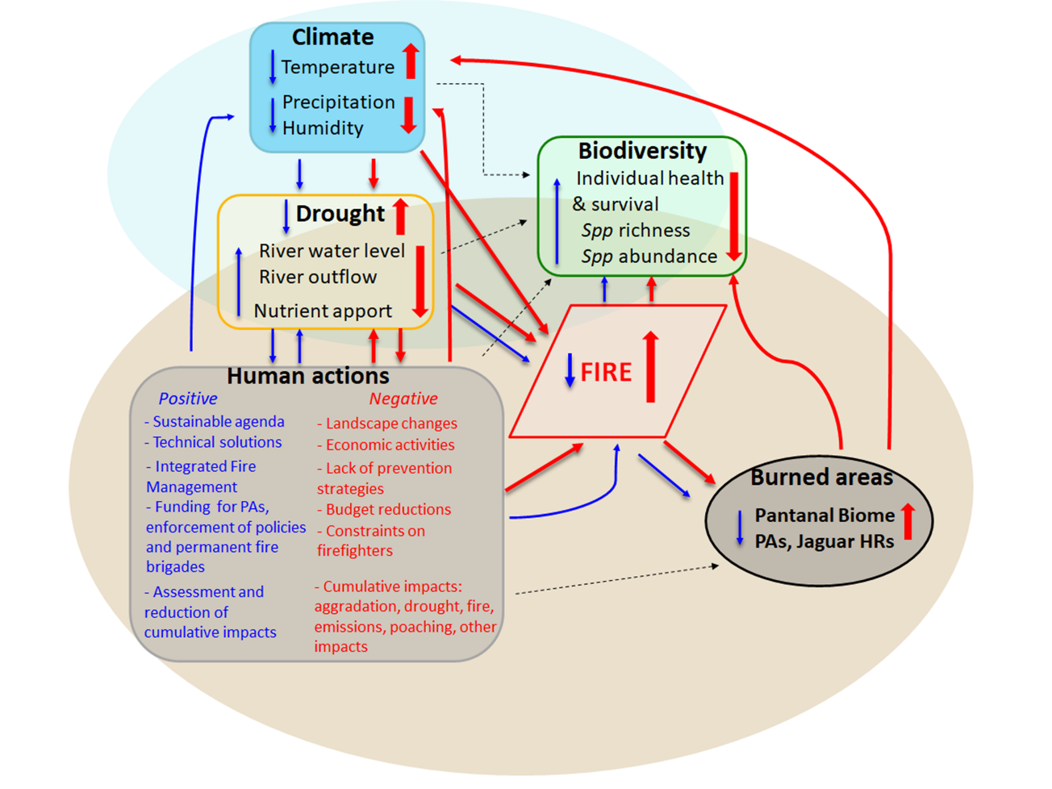
Fig. S1. Scheme summarizing the main impacts of fires in the Pantanal. The red arrows are intentionally larger and show a feedback loop linking increased negative human impacts, climate change, and drought to increased fires and burned areas, with a consequent negative impact on biodiversity. The blue arrows describe a feedback loop for fire control and impact mitigation. The dashed arrows denote other relevant effects in the biome (e.g., cumulative effects from infrastructure such as hydroelectric power plants, river waterways, water and soil pollution from legal and illegal mining and agriculture, poaching and illegal wildlife trade, opportunistic exploitation of burned areas, as well as natural climate constraints).

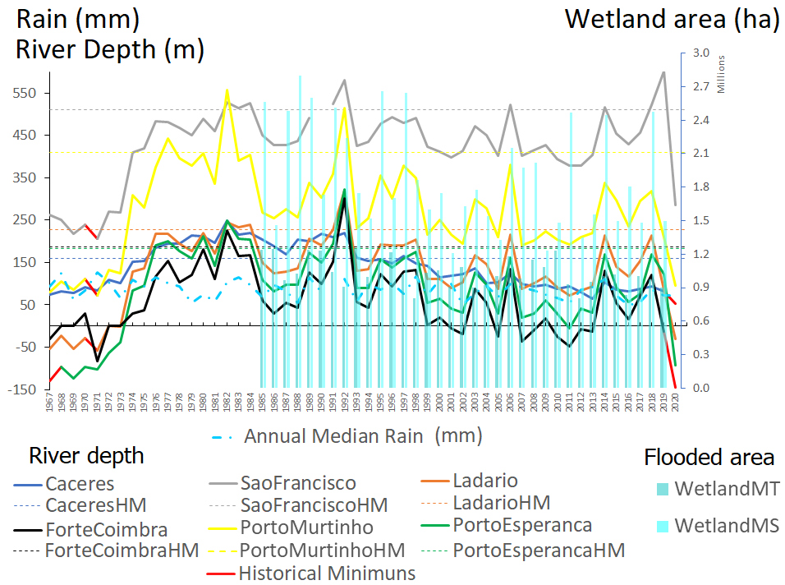
Fig. S2a. The continuous lines correspond to the minimum annual river depths (minimum quotas in meters from 1967 to 2020) at six Pantanal gauge stations in the Paraguay River. The dashed lines in the same colours correspond to the respective historical medians (HM) at each station^{24,135}. The histograms correspond to the MapBiomas 5.0²⁵ annual wetland estimated area (ha) in the Pantanal areas of Mato Grosso (MT) and Mato Grosso do Sul (MS) from 1985 to 2019. The dashed-dotted blue line corresponds to the median annual rainfall (1967 to 2019).

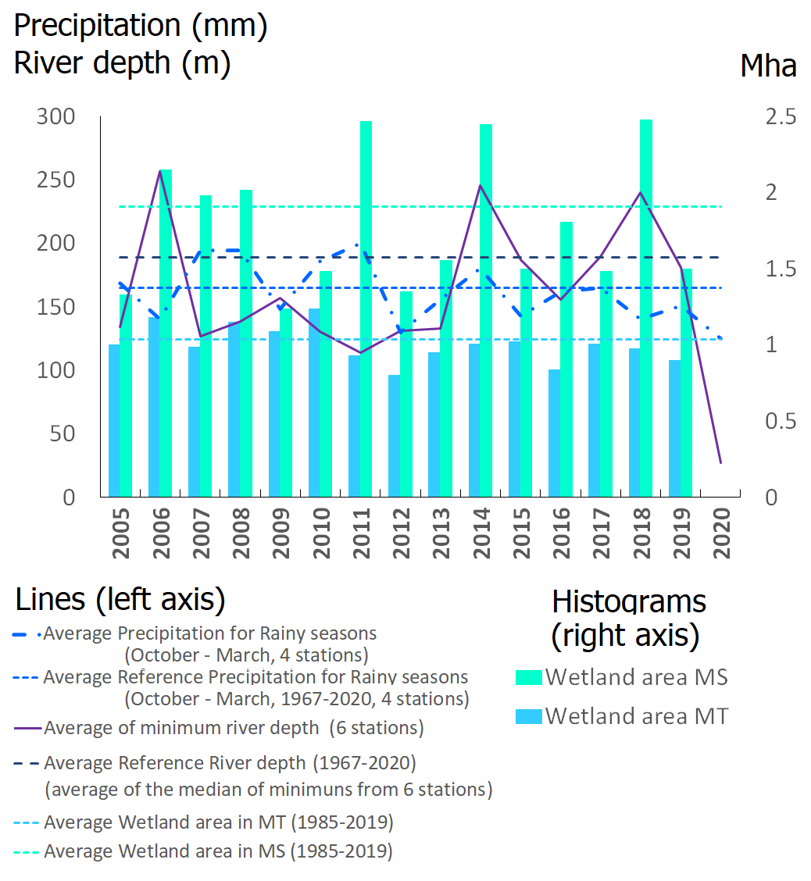
Fig.S2b. Hydrological conditions during the jaguar monitoring period (2005–2016) and in subsequent years. The continuous lines correspond to minimum annual river depths (minimum quotas in meters from 2005 to 2020) at six Pantanal gauge stations in the Paraguay River^{24,135}, and the dashed lines with the same colours correspond to the respective averaged references (average, from six stations, of medians of yearly minimums of each station during the monitoring period). The dashed-dotted line corresponds to median annual rainfall (reference 1967 to 2019)²². The histograms correspond to the MapBiomas 5.0²⁵ annual wetland estimated area (ha) in the Pantanal areas of Mato Grosso (MT) and Mato Grosso do Sul (MS) from 2005 to 2019. The dashed lines in the same colours correspond to the respective averages (1985 to 2019).
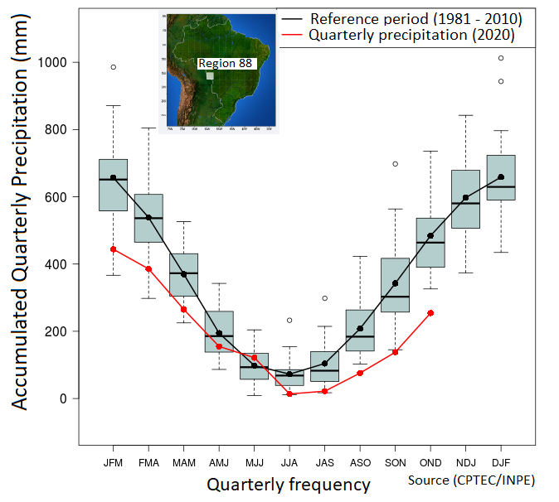
Fig.S2c. Quarterly rainfall in 2020 in comparison with rainfall in the reference period (1981–2010)²³.

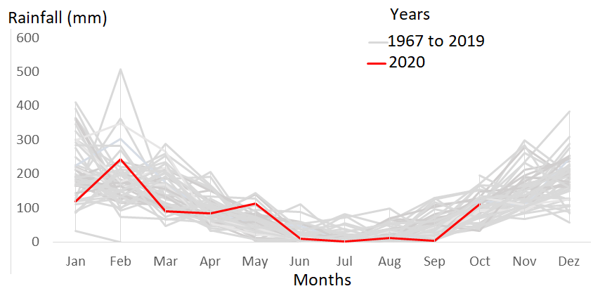
Fig.S2d. Monthly rainfall per year (considering the median of 4 stations in the UPRB: Cáceres, Corumbá, Cuiabá, and Campo Grande)²², with 2020 in red. Data acquired for 2020 was limited until October.
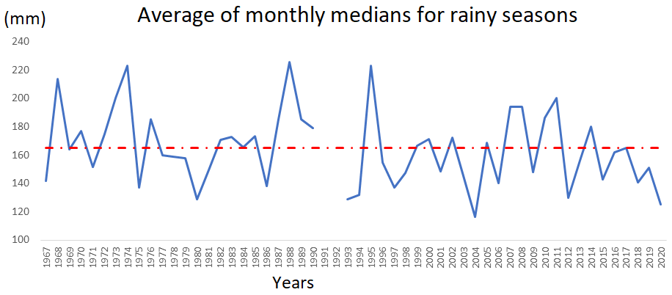
Fig.S2e. Average monthly medians for the wet seasons (considering four stations in the UPRB: Cáceres, Corumbá, Cuiabá, and Campo Grande)²². Note that 28 years had estimates below the historical average, with five years (1980, 1993, 1994, 2004, 2012) having estimates more than 20% below the historical average²². Data acquired for 2020 was limited until October.
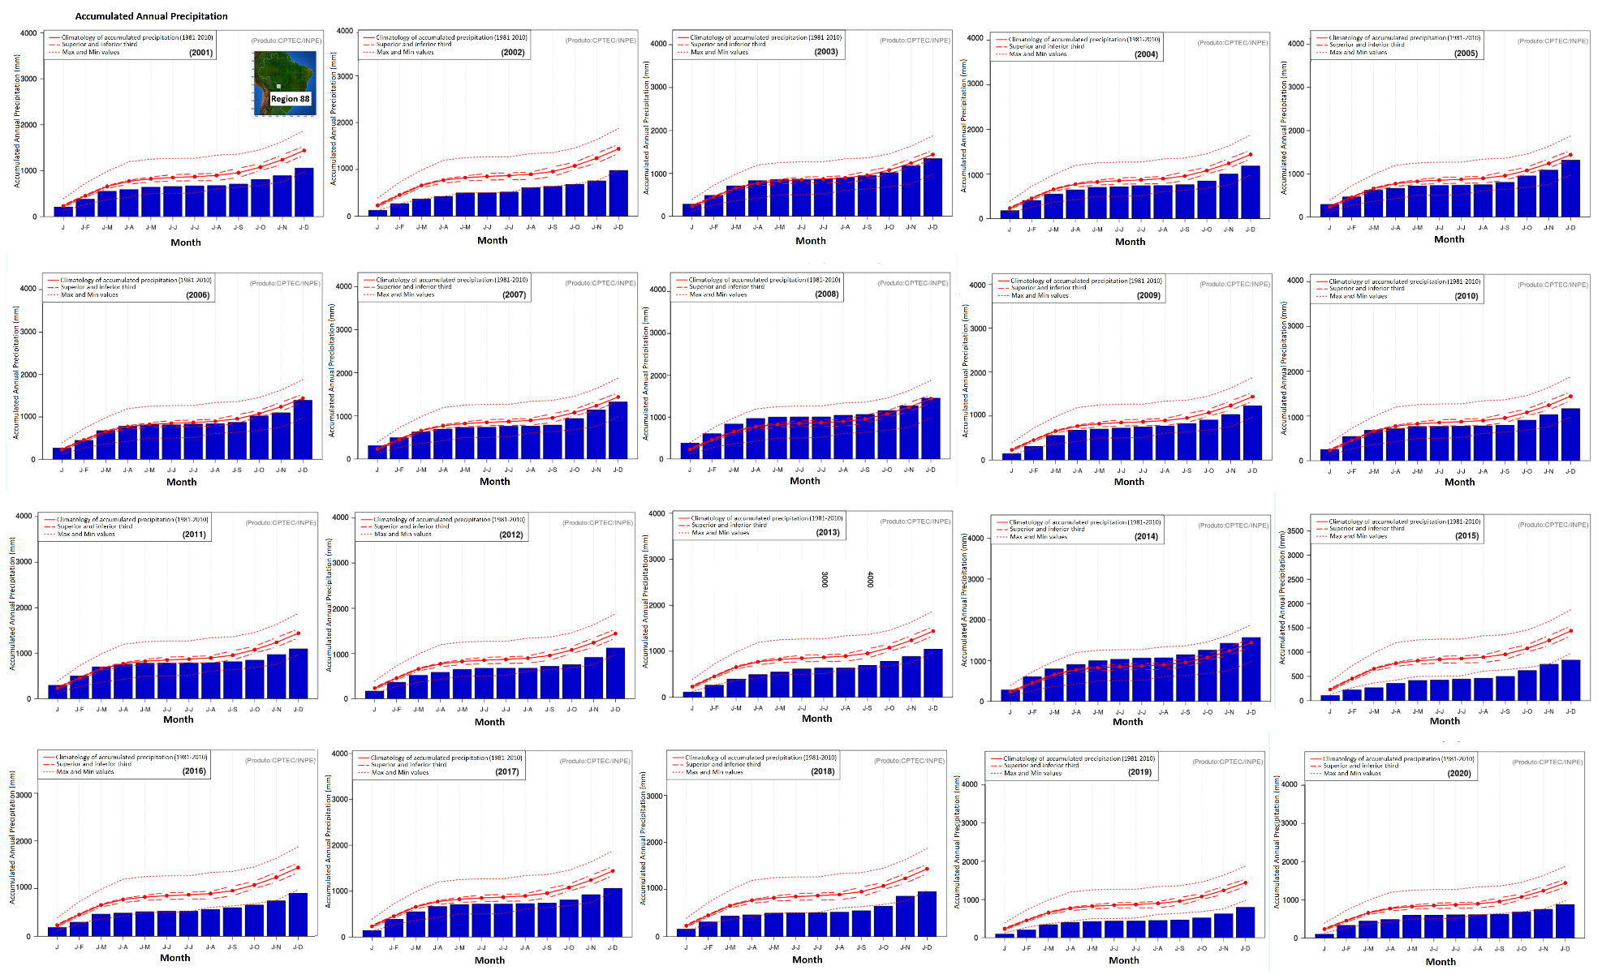
Fig.S2f. Annual rainfall from 2001 to 2020 in the Pantanal. Note that after 2014, accumulated rainfall often falls below the minimums (reference period 1981–2010; translated and adapted from CPTEC/INPE)²³.
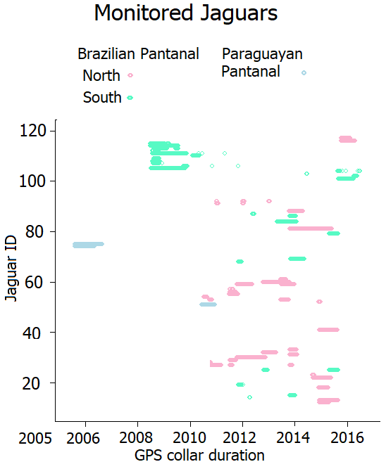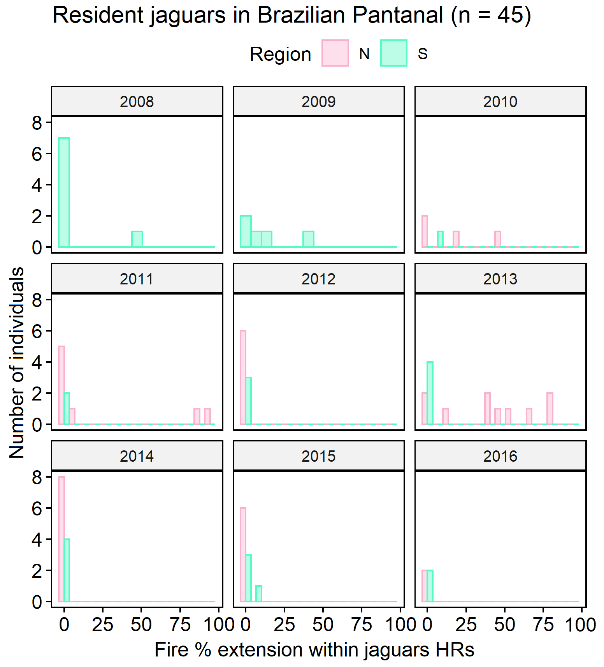 Fig.S3a. The left panel shows the monitoring period for GPS-collared jaguars³⁹. The right panel presents the percentage of fire impacting jaguar HRs during the individual monitoring period in the Brazilian Pantanal.
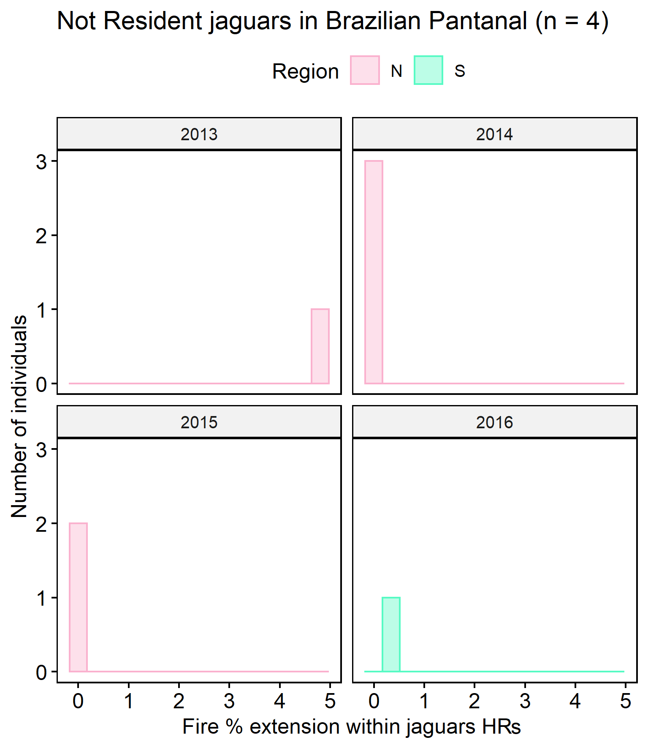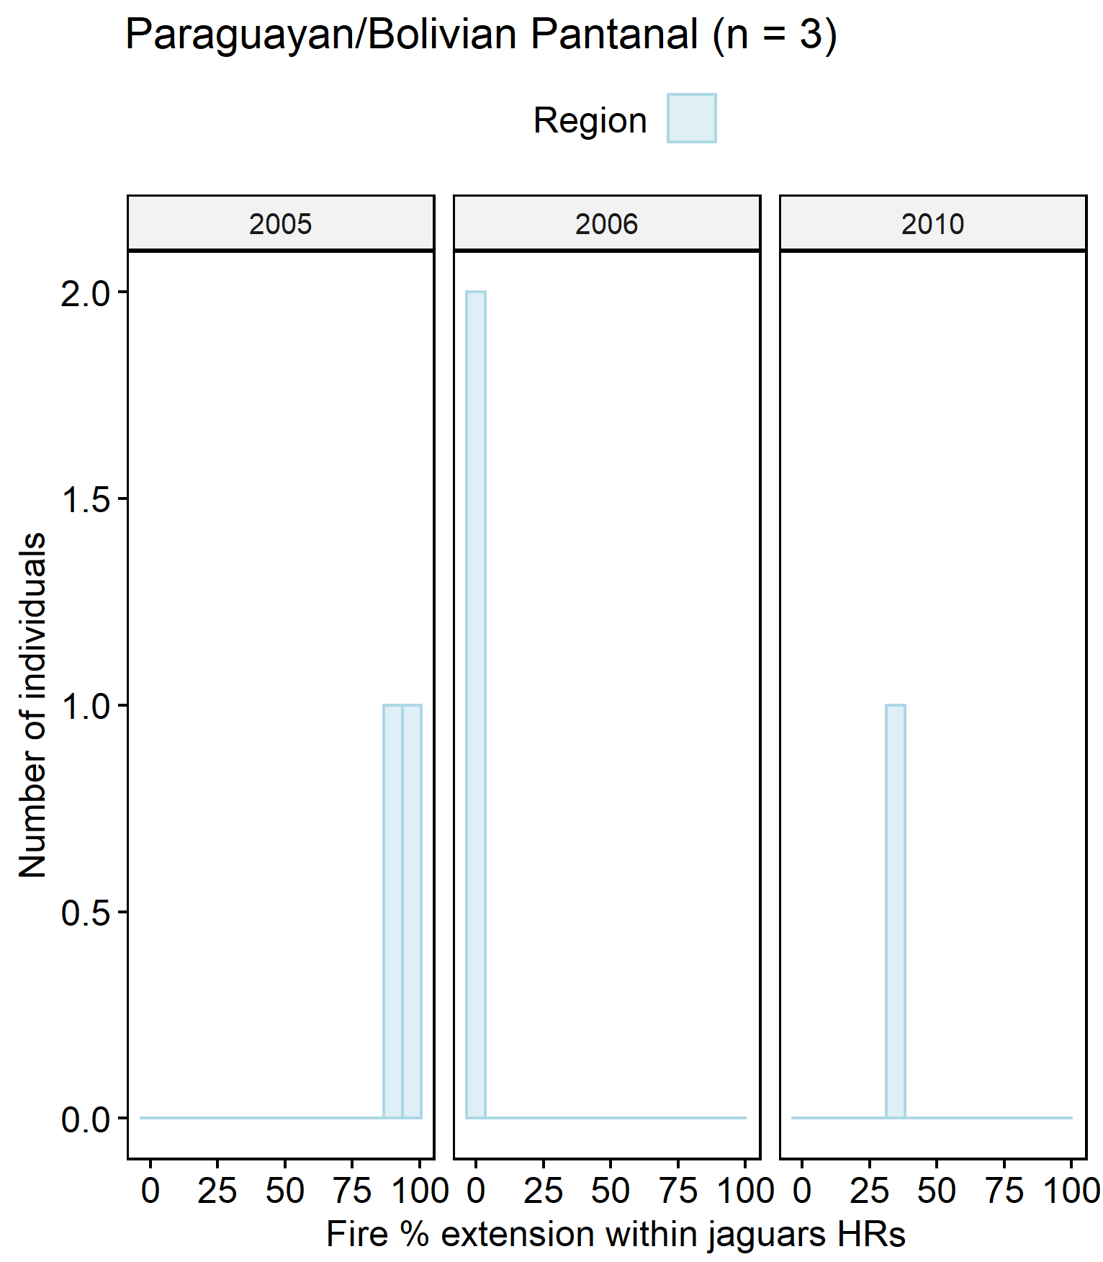Fig.S3b. Percentage of fire occurrence matching individual jaguar areas during the monitoring period. Non-resident jaguars in Brazil (left) and resident jaguars from Paraguay/Bolivia (right). Note the low fire occurrence within the areas used by non-resident jaguars.

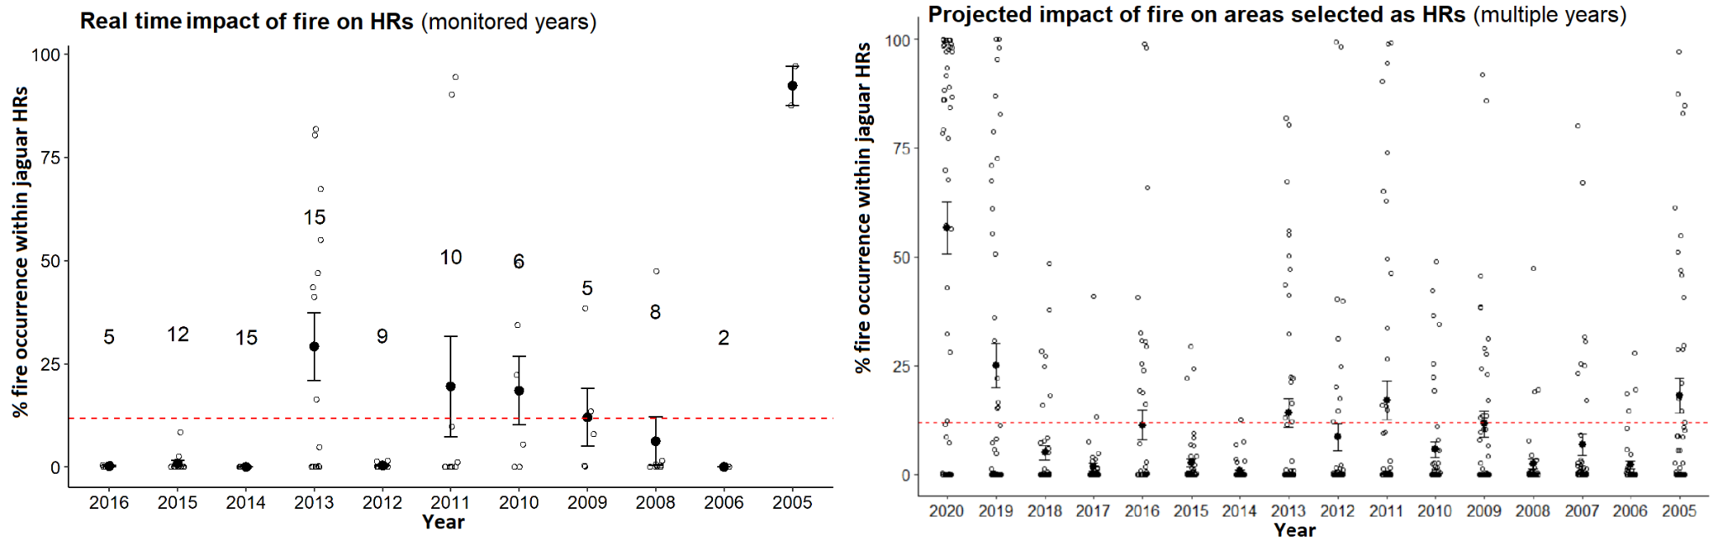
Fig. S3c. (Left) Real-time impact with the percentage of fire occurrence matching individual jaguar areas during the GPS monitoring period. This plot includes 52 individuals from the Brazilian Pantanal (45 residents and 4 non-residents) and the Paraguayan Pantanal (3 residents). The numbers in the plot represent the number of individuals monitored each year. (Right) Projected impact of fire on areas selected as home ranges (HRs) of 48 resident individuals from 2005 to 2020. This projection allowed us to explore the impacts of fire on jaguar HRs for years in which tracking data were unavailable (as was the case for 2020) (see SI_ Tab.S2).

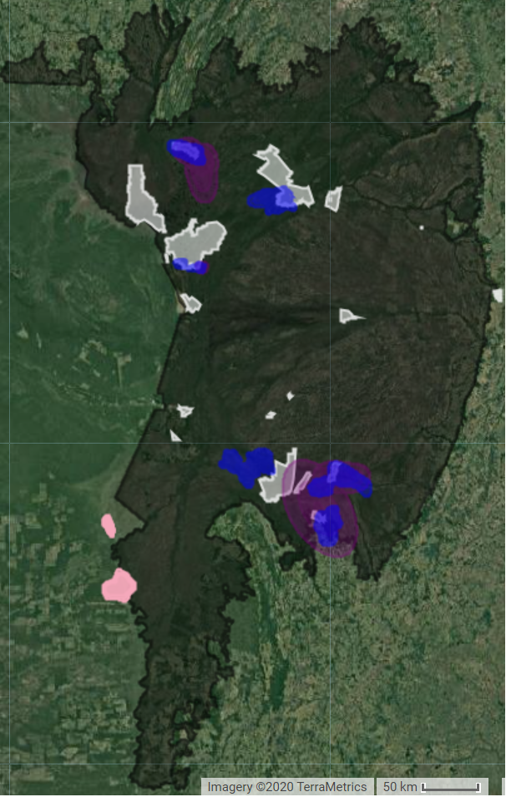 Fig. S4 Resident jaguars from the Brazilian (blue) and Paraguayan/Bolivian Pantanal (salmon colour) and non-residents jaguars (purple). Map source: Gorelick et al.⁹³.

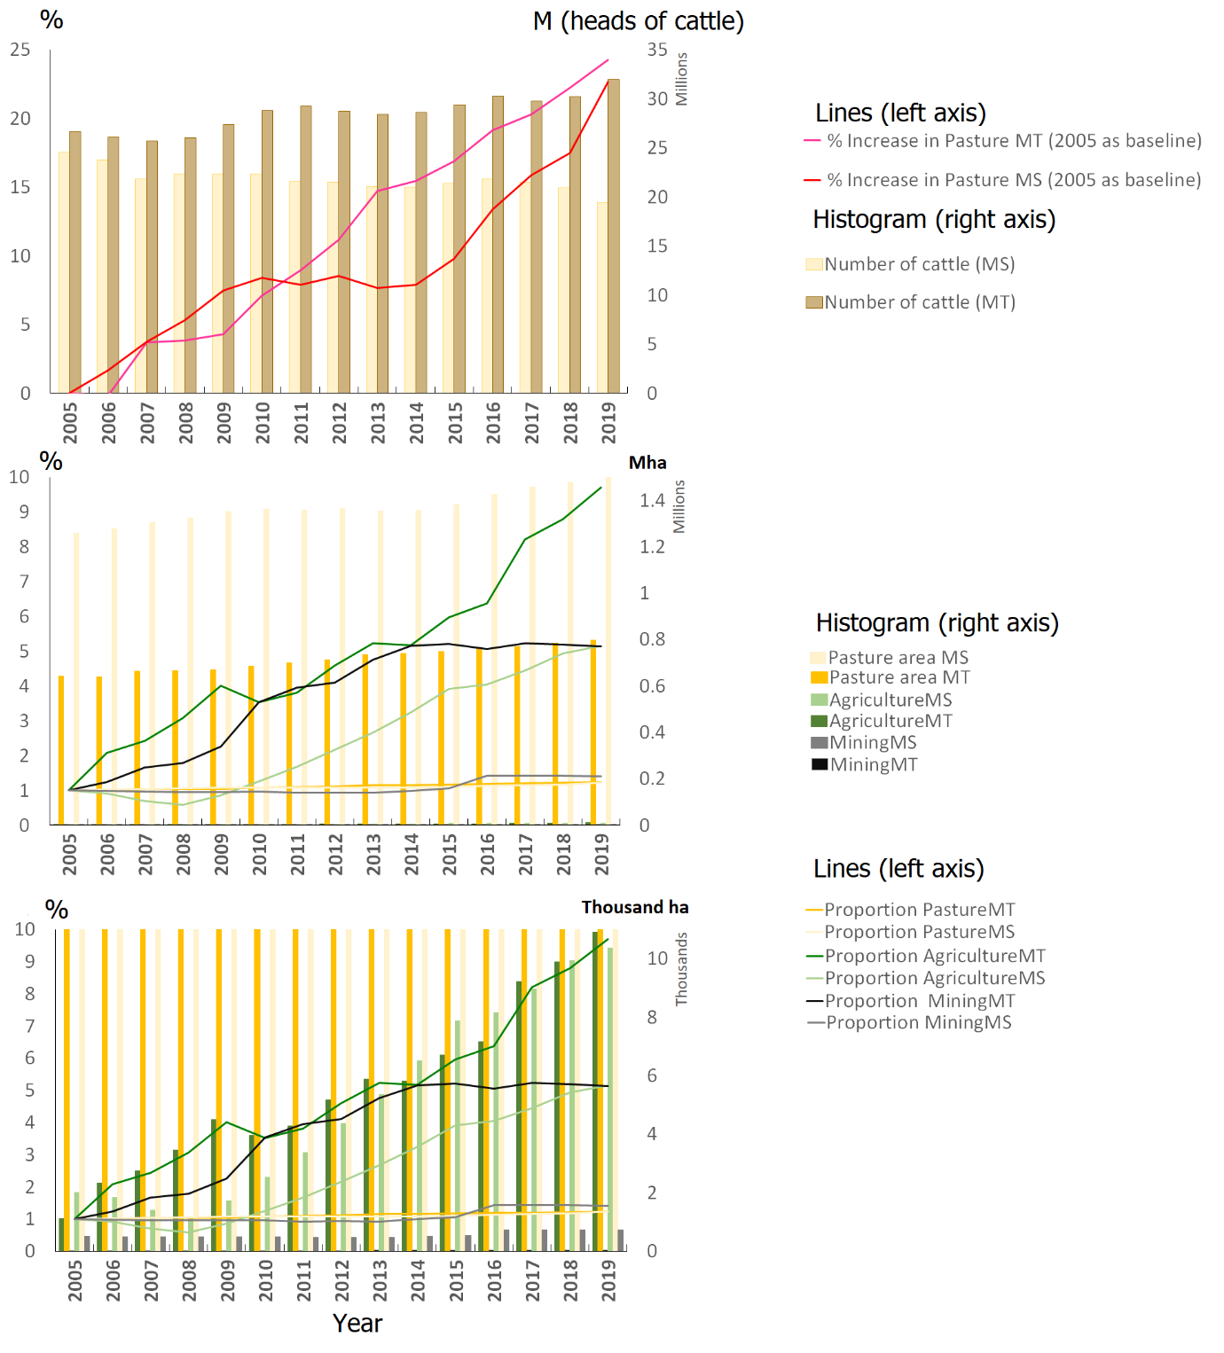

Fig. S5a Comparison of the main anthropic activities in the Brazilian Pantanal, states of Mato Grosso (MT) and Mato Grosso do Sul (MS)^{25,134}. Cattle livestock is the most abundant economic activity. It continues to increase in Pantanal areas of both states, although the number of cattle and pastures in the Cerrado has decreased (see Fig_S5b). Nonetheless, agriculture was the anthropic activity with the highest percentage growth (MapBiomas data)²⁹.

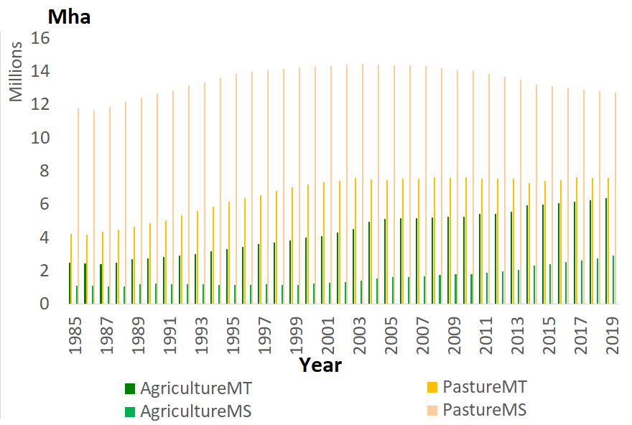
Fig. S5b. Main anthropic activities in the Brazilian Cerrado, states of Mato Grosso (MT) and Mato Grosso do Sul (MS) (MapBiomas data²⁵). Cattle livestock is still the most abundant economic activity, but the area occupied by agriculture (particularly soybean plantations) is increasing²⁵.
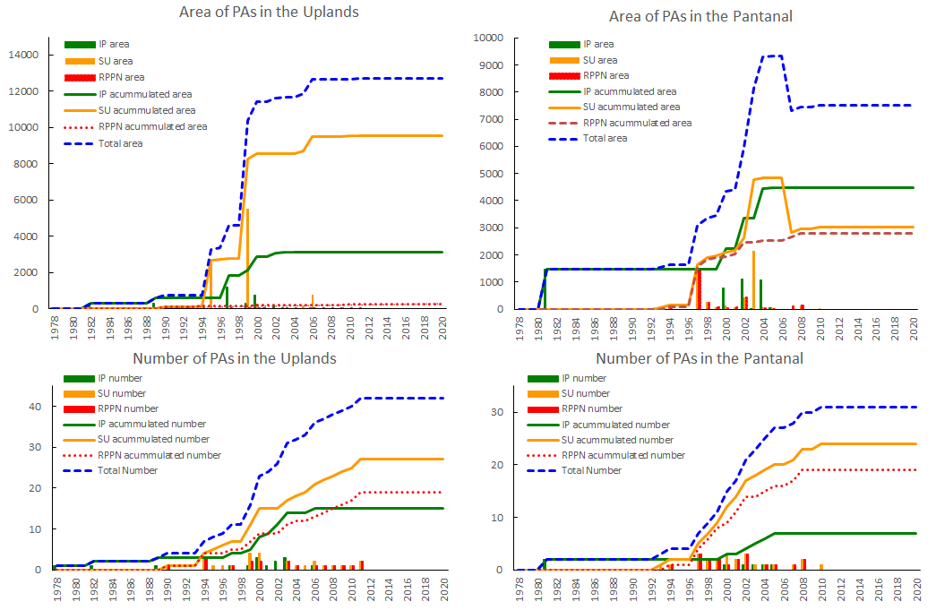

Fig. S5c. Creation and maintenance of protected areas in the Brazilian Pantanal and the surrounding Uplands within the Brazilian Upper Paraguay River Basin. The upper panels show the accumulated area. The bottom panel show the accumulated numbers. IP = PAs of Integral Protection. SU = PAs of Sustainable Use. RPPNs = Private Reserves. SU = PAs that include RPPNs, Park Roads, and other categories of sustainable use. RPPNs are shown in detail, considering that almost 95% of the Pantanal are on private land. IP areas and RPPNs form most of the PAs in the Pantanal but are a minority in the Uplands. The areas have remained stable since the creation of the last PAs in the Uplands in 2011 and since the revocation of the Environmental Protected Area of Pontal dos Rios Itiquira and Corrientes in 2006, reducing the total of PAs in Pantanal by almost 20%. Adapted from Tomas et al. 2019⁴² and Chaves & Silva 2018⁶⁸ using the following sources: MMA 2020⁶⁷; IMASUL 2019⁶⁹; ICMbio 2021⁷⁰; ICMbio - SIMRPPN 2021⁷¹. Data used to make the charts are shown in SI_Tab.S1c
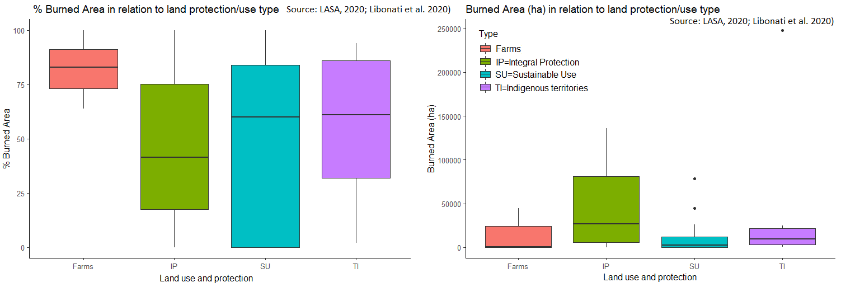Fig. S5d. Percentage variation (left) and burnt area (right) of the Brazilian Pantanal. Note that farms presented the highest medians for the percentage of burnt areas, while PAs of integral protection presented the highest absolute values of burnt areas. ANOVA applied to evaluate the effect of land protection/use type categories on the percentage and amount of burnt areas found no significant difference (p > 0.05) among the category types. Reference sources: LASA²⁷, Libonati et al.¹⁴. Data used in the analyses are shown in SI_Tab.S3.

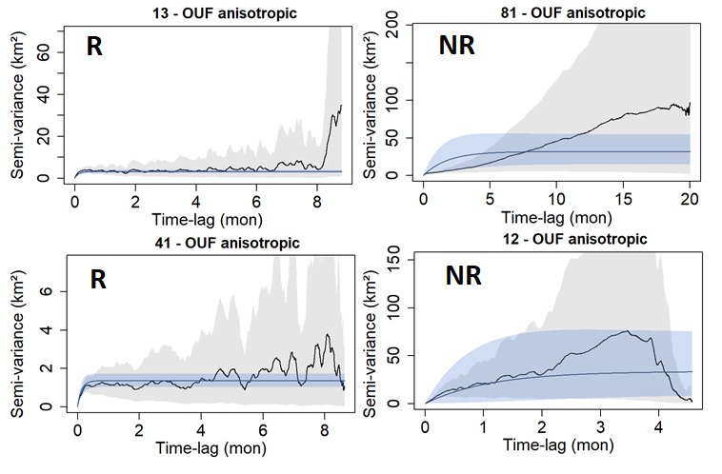
Fig. S6. Variograms of two resident (R, left) and two non-resident (NR, right) jaguars from the Pantanal. The best-fit models are represented by the blue line and their 95% CIs^{98,99}. Non-resident jaguars lack a clear asymptote despite the long monitoring time, also reflected by a low number of range crossings. Numbers at the top are individual identifiers. OUF anisotropic corresponds to the best-fit model (Ornstein-Uhlenbeck-F), capturing autocorrelated locations and velocities for all R and NR jaguars shown below (see SI_Tab.S4).
SI_Table
Tab. S1a. Areas and percentages of Brazilian protected areas (PAs) in the Pantanal, Uplands, and within Paraguay River Basin (UPRB). Brazilian UPRB corresponds to the basin area in Brazil. Total UPRB corresponds to the total basin area (multiple countries), and Total PRB corresponds to the entire Paraguay River Basin (PRB).
 | PAs in the Brazilian UPRB (2020)
REGION BOUNDARY AREA km² |  | PA area km² | % | number
Brazilian Pantanal | 150355 | 7506 | 5.0 | 31
Brazilian Uplands | 212025 | 12684 | 6.0 | 42
Brazilian UPRB | 362380 | 20190 | 5.6 | 73
Total UPRB | 600000 | 20190 | 3.4 | 73
Total PRB | 1100000 | 20190 | 1.8 | 73
Main sources: adapted from^{42,68-71}, Brazilian Pantanal boundary (IBGE)⁸⁶.

Tab. S1b. Comparative between Brazilian PAs in 2020 and the years in which the last area changes occurred. Note that PAs in the Brazilian Pantanal have decreased by almost 20% since 2007 and have remained the same in the Uplands since 2011.
Type of PA | Pantanal |  | Uplands
Year | 2006 | 2020 | 2011 | 2020
Integral Protection km² | 4491 | 4491 | 3140 | 3140
Sustainable Use km² | 4842 | 3014 | 9543 | 9543
Total km² | 9333 | 7506 | 12684 | 12684
Main sources: adapted from^{42,68-71}.

Tab. S1c. Protected areas (PAs) in the Pantanal and Uplands within the Brazilian boundaries of the Upper Paraguay River Basin (UPRB). Type: Split Protected Area classes in Integral Protection (IP) and Sustainable use (SU). Type II: Split the Protected Areas of Sustainable use in additional classes (APA = Environmental Protected Area with regulated sustainable use, RPPN = Private Protected Areas with restricted use, Park Road = buffer zone of restricted use along roads). Adapted from Tomas et al.⁴² and Chaves & Silva⁶⁸. Updated from^{69–71} (direct links on Source).
Type | Type II | Region | Protected Area Name | Area | Year | Modification | Source
IP | IP | Uplands | PE Águas do Cuiabá | 113.28 | 2002 |  | https://uc.socioambiental.org/arp/2311
SU | APA | Uplands | APA das Cabeceiras do Rio Cuiabá | 4734.11 | 1999 |  | https://uc.socioambiental.org/arp/1348?order=field_data_documento_value&sort=asc
SU | APA | Uplands | APA Nascentes do Rio Paraguai | 777.43 | 2006 |  | https://uc.socioambiental.org/pt-br/arp/5114
SU | RPPN | Uplands | RPPN Fazenda São Luiz | 2.04 | 1994 |  | https://sistemas.icmbio.gov.br/simrppn/publico/detalhe/606/
IP | IP | Uplands | PN da Chapada dos Guimarães | 330.00 | 1989 |  | https://uc.socioambiental.org/pt-br/arp/599
SU | RPPN | Uplands | RPPN Mata Fria | 0.10 | 2000 |  | https://sistemas.icmbio.gov.br/simrppn/publico/detalhe/594/
SU | APA | Uplands | APA da Chapada dos Guimarães | 2518.48 | 1995 |  | https://uc.socioambiental.org/pt-br/arp/1142
SU | RPPN | Uplands | RPPN Hotel Mirante | 0.20 | 2004 |  | https://sistemas.icmbio.gov.br/simrppn/publico/detalhe/599/
SU | APA | Uplands | APA Aricá-açu | 749.75 | 1999 |  | https://www.icmbio.gov.br/parnaguimaraes/images/stories/downloads/encarte_1_p1_a_7.pdf
IP | IP | Uplands | PE Águas Quentes | 14.87 | 1978 |  | https://uc.socioambiental.org/pt-br/arp/1175
IP | IP | Uplands | MN Morro de Santo Antônio | 2.58 | 2006 |  | https://uc.socioambiental.org/pt-br/arp/4870
IP | IP | Uplands | PE Zé Bolo Flô | 0.66 | 2000 |  | https://uc.socioambiental.org/pt-br/arp/3546
IP | IP | Uplands | PE Mãe Bonifácia | 0.77 | 2000 |  | https://uc.socioambiental.org/pt-br/arp/3456
IP | IP | Uplands | EE da Serra das Araras | 271.60 | 1982 |  | https://www.icmbio.gov.br/portal/unidadesdeconservacao/biomas-brasileiros/cerrado/unidades-de-conservacao-cerrado/2067-esec-serra-das-araras
IP | IP | Uplands | PE Serra Santa Bárbara | 1200.92 | 1997 |  | https://uc.socioambiental.org/pt-br/arp/1345
SU | RPPN | Pantanal | RPPN Jubran | 355.31 | 2002 |  | https://sistemas.icmbio.gov.br/simrppn/publico/detalhe/597/
IP | IP | Pantanal | EE de Taiamã | 112.00 | 1981 |  | https://uc.socioambiental.org/arp/612
SU | RPPN | Pantanal | RPPN Estância Ecológica SESC - Pantanal | 1079.96 | 1997 |  | https://sistemas.icmbio.gov.br/simrppn/publico/detalhe/619/ https://sistemas.icmbio.gov.br/simrppn/publico/detalhe/620/ https://www.sescpantanal.com.br/hotel.aspx?s=12
SU | RPPN | Uplands | RPPN Parque Ecológico João Basso | 36.25 | 1997 |  | https://sistemas.icmbio.gov.br/simrppn/publico/detalhe/589/
IP | IP | Uplands | PE Dom Osório Stoffel | 64.22 | 2002 |  | https://uc.socioambiental.org/arp/3451
IP | IP | Pantanal | PE do Guirá | 1102.26 | 2002 |  | https://uc.socioambiental.org/pt-br/arp/3439
SU | RPPN | Pantanal | RPPN Estância Dorochê | 265.18 | 1997 |  | https://sistemas.icmbio.gov.br/simrppn/publico/detalhe/613/
IP | IP | Pantanal | PE Encontro das Águas | 1089.60 | 2004 |  | https://uc.socioambiental.org/pt-br/arp/4253
SU | RPPN | Pantanal | RPPN Poleiro Grande | 165.30 | 1998 |  | https://www.imasul.ms.gov.br/reserva-particular-do-patrimonio-natural-rppn/
SU | APA | Pantanal | APA Pontal dos Rios Itiquira e Correntes | 2158.31 | 2003 | 2003, Revoked 2007 | Chaves & Silva 2018
SU | APA | Pantanal | APA Pontal dos Rios Itiquira e Correntes | -2158.31 | 2007 | 2003, Revoked 2007 | Chaves & Silva 2018
IP | IP | Pantanal | Monumento Natural Municipal da Serra do Pantanal | 41.60 | 2005 |  | https://sonora.ms.gov.br/v2/wp-content/uploads/2017/03/PLANO-DE-MANEJO_MONUMENTO-NATURAL-MUNICIPAL-DA-SERRA-DO-PANTANAL_OK.pdf
IP | IP | Pantanal | PN do Pantanal | 1350.00 | 1981 |  | https://uc.socioambiental.org/arp/600
SU | RPPN | Pantanal | RPPN Rumo ao Oeste | 9.90 | 2005 |  | https://www.imasul.ms.gov.br/reserva-particular-do-patrimonio-natural-rppn/
SU | RPPN | Pantanal | RPPN Fazenda Acurizal | 132.00 | 2007 |  | https://www.imasul.ms.gov.br/reserva-particular-do-patrimonio-natural-rppn/
SU | RPPN | Pantanal | RPPN Fazenda Penha | 131.00 | 1997 |  | https://www.imasul.ms.gov.br/reserva-particular-do-patrimonio-natural-rppn/
SU | RPPN | Pantanal | RPPN Engenheiro Eliezer Batista | 133.23 | 2008 |  | https://sistemas.icmbio.gov.br/simrppn/publico/detalhe/712/
SU | RPPN | Pantanal | RPPN Santa Cecília | 88.41 | 1998 | Additional area 2011 | https://www.imasul.ms.gov.br/reserva-particular-do-patrimonio-natural-rppn/
SU | RPPN | Uplands | RPPN Cachoeiras do São Bento | 30.37 | 2010 |  | https://www.imasul.ms.gov.br/reserva-particular-do-patrimonio-natural-rppn/
IP | IP | Uplands | MN Serra do Bom Jardim | 61.21 | 2003 |  | http://www.wikiaves.com.br/wiki/areas:mona_serra_bom_jardim:inicio http://www.semagro.ms.gov.br/wp-content/uploads/2019/01/Encarte-1_Plano-de-Manejo-PENT.pdf
IP | IP | Uplands | PNM Templo dos Pilares | 1.06 | 2003 |  | http://www.semagro.ms.gov.br/wp-content/uploads/2019/01/Encarte-1_Plano-de-Manejo-PENT.pdf
IP | IP | Uplands | PE Nascentes do Rio Taquari | 306.18 | 1999 |  | https://www.imasul.ms.gov.br/gestao-de-unidades-de-conservacao/unidades-de-conservacao-estaduais/parque-estadual-nascentes-do-rio-taquari/
SU | Park Road | Pantanal | Área de Especial Interesse Turístico (AEIT) Estrada Parque Pantanal | 68.00 | 1993 |  | https://www.imasul.ms.gov.br/estrada-parque-do-pantanal-2/
SU | Park Road | Pantanal | Estrada-Parque Santo Anténio de Leverger – Porto de Fora – Baráo de Melgaco | 44.70 | 2000 |  | Chaves & Silva 2018 https://documentacao.socioambiental.org/ato_normativo/UC/2498_20170130_171941.pdf
SU | Park Road | Pantanal | Estrada-Parque Rodovia MT 370 | 39.23 | 2000 |  | Chaves & Silva 2018
SU | RPPN | Pantanal | RPPN Arara Azul | 2.04 | 2002 |  | https://sistemas.icmbio.gov.br/simrppn/publico/detalhe/268/
SU | APA | Pantanal | APA da Baía Negra | 54.21 | 2010 |  | http://www.semagro.ms.gov.br/wp-content/uploads/2019/01/Encarte-1_Plano-de-Manejo-PENT.pdf
IP | IP | Pantanal | PNM de Piraputangas | 13.00 | 2003 |  | http://www.semagro.ms.gov.br/wp-content/uploads/2019/01/Encarte-1_Plano-de-Manejo-PENT.pdf
SU | RPPN | Pantanal | RPPN Paculândia | 82.32 | 2002 |  | https://www.imasul.ms.gov.br/reserva-particular-do-patrimonio-natural-rppn/
SU | RPPN | Pantanal | RPPN Fazenda Santa Helena | 42.95 | 2000 |  | https://sistemas.icmbio.gov.br/simrppn/publico/detalhe/622/
SU | RPPN | Pantanal | RPPN Fazendinha | 96.16 | 1994 |  | https://sistemas.icmbio.gov.br/simrppn/publico/detalhe/272/
SU | RPPN | Pantanal | RPPN Fazenda Alegria | 11.35 | 2008 |  | https://www.imasul.ms.gov.br/reserva-particular-do-patrimonio-natural-rppn/
SU | RPPN | Pantanal | RPPN Fazenda Nhumirim | 8.63 | 1999 |  | https://www.imasul.ms.gov.br/reserva-particular-do-patrimonio-natural-rppn/
IP | IP | Pantanal | PE do Pantanal do Rio Negro | 783.03 | 2000 |  | https://parquesnobrasil.org/arp/2933 http://www.servicos.ms.gov.br/imasuldownloads/PlanosdeManejo/planomanejoPEPRN.pdf
SU | RPPN | Pantanal | RPPN Pata da Onça (Faz. Santa Sophia) | 73.87 | 1999 |  | https://www.imasul.ms.gov.br/reserva-particular-do-patrimonio-natural-rppn/
SU | RPPN | Pantanal | RPPN Neivo Pires I and II | 4.39 | 2001 |  | https://www.imasul.ms.gov.br/reserva-particular-do-patrimonio-natural-rppn/
SU | RPPN | Pantanal | RPPN Estância Caiman | 56.03 | 2004 |  | https://sistemas.icmbio.gov.br/simrppn/publico/detalhe/253/
SU | RPPN | Pantanal | RPPN Fazenda Rio Negro | 70.00 | 2001 |  | https://www.imasul.ms.gov.br/reserva-particular-do-patrimonio-natural-rppn/
SU | APA | Uplands | APA Sete Quedas de Rio Verde | 188.25 | 2005 |  | https://www.rioverde.ms.gov.br/wp-content/uploads/2016/10/RESUMO-EXECUTIVO-APA-Sete-Quedas-do-Rio-Verde.pdf
SU | APA | Uplands | APA Rio Cênico Rotas Monçoeiras | 154.40 | 2000 |  | http://www.imasul.ms.gov.br/wp-content/uploads/2015/06/APA-Rio-C%C3%AAnico-Plano-Executivo.pdf
SU | RPPN | Uplands | RPPN Duas Pedras | 1.53 | 2008 |  | https://www.imasul.ms.gov.br/reserva-particular-do-patrimonio-natural-rppn/ https://www.imasul.ms.gov.br/wp-content/uploads/2019/08/Planilha-CNUC_para-o-site_atualiz.-Dez_-2018.pdf
SU | RPPN | Uplands | RPPN Cabeceira da Lagoa | 4.31 | 2011 |  | https://www.imasul.ms.gov.br/reserva-particular-do-patrimonio-natural-rppn/
SU | RPPN | Uplands | RPPN Vale do Bugio | 0.82 | 2003 |  | https://www.imasul.ms.gov.br/reserva-particular-do-patrimonio-natural-rppn/
SU | RPPN | Uplands | RPPN Fazenda Lageado | 125.50 | 1990 |  | https://www.imasul.ms.gov.br/reserva-particular-do-patrimonio-natural-rppn/
SU | APA | Uplands | APA Estrada Parque de Piraputanga | 101.08 | 2000 |  | https://www.imasul.ms.gov.br/wp-content/uploads/2019/08/Planilha-CNUC_para-o-site_atualiz.-Dez_-2018.pdf https://www.imasul.ms.gov.br/gestao-de-unidades-de-conservacao/unidades-de-conservacao-estaduais/estrada-parque-piraputanga/
SU | RPPN | Uplands | RPPN Cara da Onça | 0.12 | 2009 |  | https://www.imasul.ms.gov.br/wp-content/uploads/2019/08/Planilha-CNUC_para-o-site_atualiz.-Dez_-2018.pdf
IP | IP | Uplands | PN da Serra da Bodoquena | 770.22 | 2000 |  | https://www.icmbio.gov.br/portal/unidadesdeconservacao/biomas-brasileiros/cerrado/unidades-de-conservacao-cerrado/2082-parna-da-serra-da-bodoquena
SU | RPPN | Uplands | RPPN Fazenda Singapura | 4.56 | 1994 |  | https://sistemas.icmbio.gov.br/simrppn/publico/detalhe/251/
IP | IP | Uplands | MN da Gruta do Lago Azul | 2.74 | 2001 |  | https://www.imasul.ms.gov.br/wp-content/uploads/2019/08/Planilha-CNUC_para-o-site_atualiz.-Dez_-2018.pdf
SU | RPPN | Uplands | RPPN Rancho do Tucano | 0.30 | 2011 |  | https://www.imasul.ms.gov.br/reserva-particular-do-patrimonio-natural-rppn/
IP | IP | Uplands | MN do Rio Formoso | 0.18 | 2003 |  | https://www.imasul.ms.gov.br/wp-content/uploads/2019/08/Planilha-CNUC_para-o-site_atualiz.-Dez_-2018.pdf
SU | RPPN | Uplands | RPPN Fazenda São Pedro da Barra | 0.88 | 2003 |  | https://www.imasul.ms.gov.br/wp-content/uploads/2019/08/Planilha-CNUC_para-o-site_atualiz.-Dez_-2018.pdf
SU | RPPN | Uplands | RPPN Fazenda América | 4.01 | 1994 |  | https://sistemas.icmbio.gov.br/simrppn/publico/detalhe/263/
SU | RPPN | Uplands | RPPN Fazenda São Geraldo | 6.42 | 1999 |  | https://www.imasul.ms.gov.br/reserva-particular-do-patrimonio-natural-rppn/
SU | RPPN | Uplands | RPPN Cabeceira do Prata | 3.08 | 1999 |  | https://www.imasul.ms.gov.br/reserva-particular-do-patrimonio-natural-rppn/
SU | RPPN | Uplands | RPPN Buraco das Araras | 0.29 | 2007 |  | https://www.imasul.ms.gov.br/reserva-particular-do-patrimonio-natural-rppn/
SU | RPPN | Uplands | RPPN Xodó do Vô Ruy | 4.88 | 2006 |  | https://www.imasul.ms.gov.br/reserva-particular-do-patrimonio-natural-rppn/
SU | RPPN | Uplands | RPPN Fazenda Margarida | 19.99 | 2000 |  | https://sistemas.icmbio.gov.br/simrppn/publico/detalhe/266/
SU | Park Road | Uplands | Transpantaneira | 74.29 | 1996 |  | Chaves & Silva 2018

Tab. S2. Comparative ANOVAs considering the effect of years, location (project_region), and individuals (id) on fire occurrence within jaguar HRs during individual monitoring (monitoring time, HR in blue) or within the assumed home ranges (comparing all years, HR in red). The interaction between year and region exhibited the lowest residuals and the lowest AIC in both comparisons.
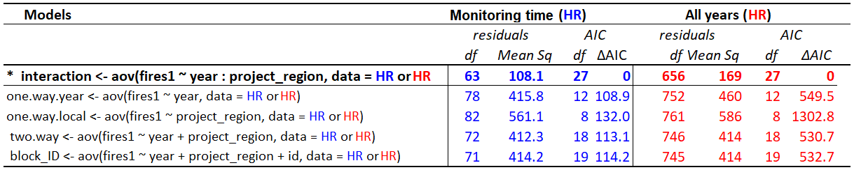

Tab. S3. Estimates of burned areas in the Pantanal in 2020. Reference sources: (LASA²⁷, Libonati et al.¹⁴).
Region | Type | Burned Area 2020 (%) | Burned Area (ha)
APA Baía Negra | SU | 74 | 45000
ESEC de Taiamã | IP | 40 | 4700
PARNA do Pantanal Matogrossense | IP | 100 | 136100
Parque Municipal de Piraputangas | IP | 0 | 0
PE Encontro das Águas | IP | 86 | 93300
PE do Guirá | IP | 43 | 45300
PE do Pantanal do Rio Negro | IP | 10 | 8200
RPPN Acurizal | SU | 85 | 10400
RPPN Arara Azul | SU | 90 | 1900
RPPN Dorochê | SU | 84 | 22600
RPPN Estância Caiman | SU | 0 | 0
RPPN Fazenda Nhumirim | SU | 0 | 0
RPPN Fazenda Paculândia | SU | 58 | 4800
RPPN Fazenda Rio Negro | SU | 0 | 0
RPPN Fazenda Santa Cecília II | SU | 29 | 2600
RPPN Fazenda Santa Sofia | SU | 0 | 0
RPPN Fazendinha | SU | 0 | 0
RPPN Jubran | SU | 78 | 26300
RPPN Neivo Pires | SU | 0 | 0
RPPN Penha | SU | 100 | 12900
RPPN Pioneira do Rio Piquiri | SU | 0 | 0
RPPN Poleiro Grande | SU | 68 | 11200
RPPN Reserva Natural Eng. Eliezer Batista | SU | 84 | 10600
RPPN Rumo ao Oeste | SU | 60 | 600
RPPN Sesc Pantanal | SU | 90 | 78800
TI Baía dos Guató | TI | 94 | 18100
TI Cachoeirinha | TI | 2 | 600
TI Guató | TI | 61 | 900
TI Kadiwéu | TI | 46 | 248000
TI Perigara | TI | 86 | 9300
TI Taunay/Ipegue | TI | 18 | 6000
TI Tereza Cristina | TI | 86 | 25000
Fazenda Jatobazinho | Farms | 89 | 300
Fazenda Morro Alegre | Farms | 85 | 1200
Fazenda Porto Jofre | Farms | 98 | 41500
Fazenda Santa Rosa | Farms | 64 | 100
Fazenda Santa Tereza | Farms | 75 | 44800
Fazenda São Bento | Farms | 68 | 18800
Fazenda São Gonçalo | Farms | 100 | 300
Fazenda Vale do Paraíso | Farms | 81 | 200

Tab. S4. Model selection and home range output used for status classification in combination with variograms (ctmm)^{98,99}.
N | data id | DOF _{area} | τ_{p} (days) | τ_{v} (h) | duration (months) | model | status | Total points | start | end | HR (km²) | area CI (km²) | project | country
1 | 13 | 68.9 | 3.4 | 0.3 | 8.8 | OUF_ani | R | 5039 | 07-12-14 | 24-08-15 | 52.8 | (41.1 - 66) | Taiama | Brazil
2 | 15 | 17.5 | 3.9 | 0.5 | 2.6 | OUF_ani | R | 1257 | 19-10-13 | 03-01-14 | 352.5 | (206.95 - 536.09) | Oncafari | Brazil
3 | 18 | 26.0 | 4.7 | 0.4 | 4.6 | OUF_ani | R | 2305 | 29-11-14 | 13-04-15 | 126.8 | (82.79 - 180.03) | Taiama | Brazil
4 | 19 | 53.6 | 0.9 | 0.3 | 2.5 | OUF_ani | R | 741 | 30-10-11 | 11-01-12 | 40.2 | (30.18 - 51.68) | Oncafari | Brazil
5 | 22 | 22.0 | 10.0 | 0.3 | 8.5 | OUF_ani | R | 4709 | 11-09-14 | 21-05-15 | 114.0 | (71.38 - 166.35) | Taiama | Brazil
6 | 25 | 102.5 | 1.6 | 0.2 | 35.3 | OUF_ani | R | 3074 | 22-10-12 | 30-08-15 | 46.2 | (37.69 - 55.56) | Oncafari | Brazil
7 | 27 | 57.7 | 3.7 | NA | 39.3 | OU_ani | R | 559 | 21-09-10 | 24-11-13 | 51.2 | (38.87 - 65.27) | Panthera2 | Brazil
8 | 28 | 40.5 | 2.1 | NA | 3.3 | OU_ani | R | 205 | 08-07-10 | 13-10-10 | 33.2 | (23.77 - 44.17) | Panthera1 | Brazil
9 | 29 | 27.0 | 1.7 | 2.8 | 2.8 | OUF_ani | R | 67 | 08-07-11 | 30-09-11 | 43.3 | (28.55 - 61.15) | Panthera1 | Brazil
10 | 30 | 123.1 | 2.9 | NA | 13.6 | OU_iso | R | 581 | 13-10-11 | 19-11-12 | 60.8 | (50.57 - 72.05) | Panthera2 | Brazil
11 | 31 | 33.2 | 2.2 | NA | 3.5 | OU ani | R | 103 | 21-10-13 | 01-02-14 | 31.7 | (21.84 - 43.33) | Panthera2 | Brazil
12 | 32 | 92.8 | 1.3 | NA | 6.1 | OU_ani | R | 240 | 15-10-12 | 12-04-13 | 100.0 | (80.7 - 121.36) | Panthera2 | Brazil
13 | 33 | 26.6 | 2.9 | NA | 3.4 | OU_ani | R | 133 | 22-10-13 | 29-01-14 | 88.8 | (58.33 - 125.62) | Panthera2 | Brazil
14 | 41 | 61.0 | 3.8 | 0.3 | 8.6 | OUF_ani | R | 4951 | 05-12-14 | 17-08-15 | 25.5 | (19.53 - 32.33) | Taiama | Brazil
15 | 52 | 6.5 | 3.6 | 0.3 | 0.9 | OUF_ani | R | 615 | 27-11-14 | 25-12-14 | 21.7 | (8.34 - 41.33) | Taiama | Brazil
16 | 53 | 24.9 | 6.1 | NA | 37.9 | OU_ani | R | 299 | 20-09-10 | 13-10-13 | 348.6 | (225.27 - 498.39) | Panthera2 | Brazil
17 | 54 | 7.3 | 5.1 | 1.6 | 1.5 | OUF_ani | R | 128 | 12-07-10 | 26-08-10 | 36.1 | (14.79 - 66.72) | Panthera1 | Brazil
18 | 55 | 38.3 | 1.9 | NA | 4.2 | OU_ani | R | 141 | 26-06-11 | 28-10-11 | 91.8 | (65.04 - 123.03) | Panthera2 | Brazil
19 | 56 | 28.1 | 2.3 | 1.4 | 3.0 | OUF_ani | R | 109 | 08-07-11 | 04-10-11 | 72.6 | (48.29 - 101.88) | Panthera1 | Brazil
20 | 59 | 118.0 | 2.5 | 1.9 | 27.1 | OUF_ani | R | 434 | 15-10-11 | 23-12-13 | 241.3 | (199.72 - 286.72) | Panthera2 | Brazil
21 | 60 | 235.5 | 1.2 | NA | 12.8 | OU_ani | R | 705 | 10-10-12 | 23-10-13 | 88.4 | (77.42 - 99.98) | Panthera2 | Brazil
22 | 61 | 8.6 | 7.0 | 2.3 | 2.4 | OUF_ani | R | 109 | 18-06-13 | 28-08-13 | 343.9 | (153.75 - 609.23) | Panthera2 | Brazil
23 | 68 | 14.0 | 3.0 | 0.4 | 1.8 | OUF_ani | R | 996 | 01-11-11 | 23-12-11 | 242.9 | (132.71 - 385.72) | Oncafari | Brazil
24 | 69 | 63.9 | 3.0 | 0.3 | 6.7 | OUF_ani | R | 3304 | 27-10-13 | 13-05-14 | 156.6 | (120.55 - 197.23) | Oncafari | Brazil
25 | 79 | 42.9 | 2.8 | 0.4 | 4.3 | OUF_ani | R | 2202 | 19-04-15 | 25-08-15 | 68.9 | (49.81 - 90.93) | Oncafari | Brazil
26 | 84 | 114.2 | 2.3 | 0.3 | 9.3 | OUF_ani | R | 4643 | 21-04-13 | 21-01-14 | 70.4 | (58.05 - 83.84) | Oncafari | Brazil
27 | 86 | 26.4 | 3.0 | 0.3 | 3.0 | OUF_ani | R | 1324 | 22-10-13 | 17-01-14 | 166.3 | (108.97 - 235.44) | Oncafari | Brazil
28 | 87 | 35.2 | 0.6 | 0.3 | 1.2 | OUF_ani | R | 398 | 15-05-12 | 18-06-12 | 37.4 | (26.05 - 50.65) | Oncafari | Brazil
29 | 88 | 18.7 | 8.8 | NA | 6.6 | OU_iso | R | 1289 | 08-10-13 | 20-04-14 | 80.2 | (48.1 - 120.48) | Taiama | Brazil
30 | 91 | 48.3 | 0.7 | 1.8 | 13.1 | OUF_ani | R | 85 | 01-01-11 | 24-01-12 | 66.8 | (49.33 - 86.96) | Taiama | Brazil
31 | 92 | 81.6 | 0.2 | NA | 25.3 | OU_ani | R | 95 | 01-01-11 | 18-01-13 | 130.8 | (103.97 - 160.67) | Taiama | Brazil
32 | 101 | 79.5 | 2.1 | 1.2 | 7.3 | OUF_ani | R | 404 | 26-08-15 | 29-03-16 | 302.1 | (239.34 - 371.98) | RioNegro | Brazil
33 | 104 | 15.4 | 3.3 | 0.6 | 10.4 | OUF_ani | R | 134 | 22-08-15 | 23-06-16 | 481.7 | (272.14 - 749.97) | RioNegro | Brazil
34 | 105 | 180.2 | 2.4 | NA | 16.1 | OU_ani | R | 2111 | 05-07-08 | 22-10-09 | 105.2 | (90.43 - 121.15) | SaoBento | Brazil
35 | 106 | 48.2 | 1.0 | 1.5 | 25.9 | OUF_ani | R | 227 | 24-09-09 | 29-10-11 | 244.4 | (180.32 - 318.01) | SaoBento | Brazil
36 | 107 | 19.9 | 3.8 | 0.8 | 4.5 | OUF_ani | R | 287 | 30-07-08 | 08-12-08 | 124.8 | (76.11 - 185.43) | SaoBento | Brazil
37 | 108 | 72.3 | 1.3 | 0.3 | 3.5 | OUF_ani | R | 481 | 25-07-08 | 06-11-08 | 142.8 | (111.77 - 177.54) | SaoBento | Brazil
38 | 109 | 69.6 | 0.6 | NA | 2.7 | OU_ani | R | 165 | 04-08-08 | 22-10-08 | 55.0 | (42.86 - 68.68) | SaoBento | Brazil
39 | 110 | 53.9 | 1.1 | NA | 3.4 | OU_ani | R | 166 | 02-02-10 | 13-05-10 | 265.8 | (199.62 - 341.33) | SaoBento | Brazil
40 | 111 | 104.4 | 4.5 | NA | 34.3 | OU_ani | R | 1757 | 17-07-08 | 26-04-11 | 58.4 | (47.73 - 70.11) | SaoBento | Brazil
41 | 112 | 9.5 | 7.5 | NA | 3.0 | OU_ani | R | 202 | 16-07-08 | 13-10-08 | 119.1 | (55.93 - 205.82) | SaoBento | Brazil
42 | 113 | 151.9 | 1.2 | NA | 11.5 | OU_ani | R | 707 | 11-08-08 | 15-07-09 | 40.6 | (34.4 - 47.31) | SaoBento | Brazil
43 | 115 | 58.0 | 3.9 | 0.9 | 8.9 | OUF_ani | R | 952 | 20-06-08 | 10-03-09 | 123.8 | (94.02 - 157.67) | SaoBento | Brazil
44 | 116 | 9.0 | 18.3 | 0.4 | 6.4 | OUF_ani | R | 3340 | 11-10-15 | 18-04-16 | 282.0 | (129.18 - 493.57) | Taiama | Brazil
45 | 117 | 25.2 | 4.5 | 0.4 | 4.3 | OUF_ani | R | 2820 | 11-10-15 | 14-02-16 | 47.8 | (30.95 - 68.13) | Taiama | Brazil
46 | 12 | 4.0 | 32.7 | 0.4 | 4.6 | OUF_ani | NR | 2681 | 05-12-14 | 18-04-15 | 619.7 | (169.85 - 1355.38) | Taiama | Brazil
47 | 23 | 3.3 | 8.6 | 0.2 | 0.9 | OUF_ani | NR | 572 | 01-09-14 | 26-09-14 | 44.8 | (10.23 - 104.34) | Taiama | Brazil
48 | 81 | 9.45* | 52.7 | 0.4 | 20.0 | OUF_ani | NR | 10617 | 15-10-13 | 29-05-15 | 591.1 | (276.34 - 1023.36) | Taiama | Brazil
49 | 102 | 4.6 | 12.2 | 1.1 | 1.9 | OUF_ani | NR | 151 | 29-03-16 | 23-05-16 | 567.4 | (172.2 - 1193.86) | RioNegro | Brazil
50 | 51 | 47.6 | 3.6 | 1.4 | 6.5 | OUF_ani | R | 727 | 05-06-10 | 14-12-10 | 535.7 | (394.46 - 698.22) | PantPy | Paraguay
51 | 74 | 98.6 | 2.6 | NA | 9.1 | OU_ani | R | 1300 | 09-08-05 | 06-05-06 | 75.4 | (61.24 - 90.97) | PantPy | Paraguay
52 | 75 | 74.7 | 4.4 | 1.1 | 12.7 | OUF_ani | R | 1694 | 09-08-05 | 18-08-06 | 115.9 | (91.13 - 143.64) | PantPy | Paraguay
N = individual id, data id = correspondent id in Morato et al. datapaper³⁹, DOF_{area} = effective number of range crossings, OUF_{ani} = anisotropic Ornstein-Uhlenbeck-F model, OUF_iso = isotropic Ornstein-Uhlenbeck-F model, R = resident jaguars, NR = non-resident jaguars. PantPy = Paraguayan Pantanal. Note that all non-resident jaguars had DOF area < 5, except for individual 81 (which had the largest amount of tracking locations in the dataset); however, observation of the variograms showed that this individual is a non-resident (see SI_Fig.S6).

