Supplementary Materials

Supplementary Figures
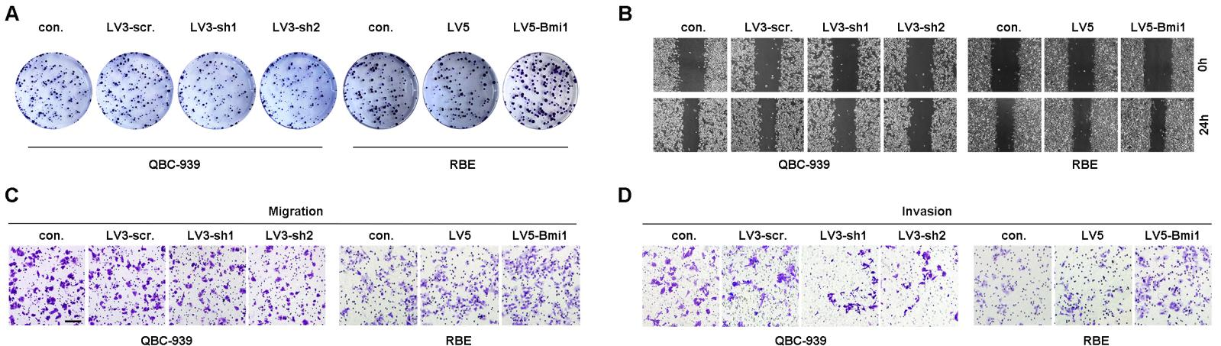
Supplementary Figure 1. (A) Representative images of colony formation in Figure 2E. (B) Representative images of wound healing assay in Figure 2F. (C and D) Representative images of transwell assay in Figure 2G and 2H.

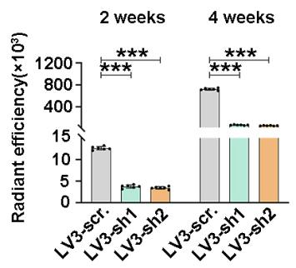

Supplementary Figure 2. Radiant efficiency of in vivo fluorescence was measured to quantify the tumor burden of nude mice in Figure 3A.

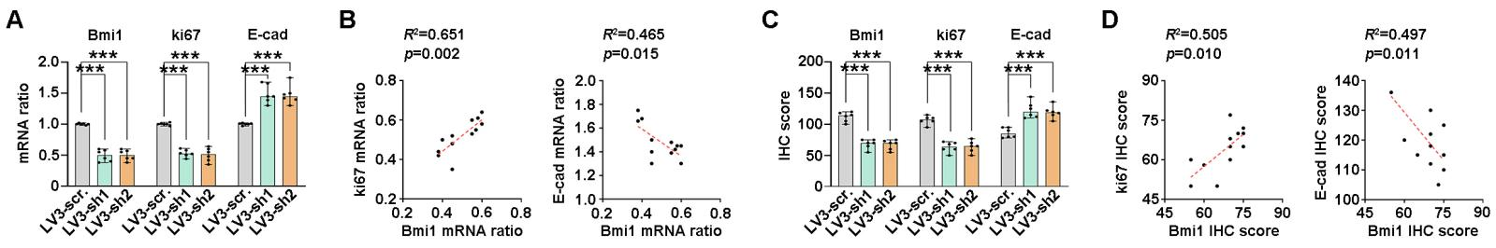

Supplementary Figure 3. (A) Ki67 and E-cad mRNA expression in Bmi1-silenced xenografts were detected with qPCR. (B) The mRNA ratio correlations between Bmi1 and ki67/E-cad in xenografts were subjected to Pearson correlation analysis. (C) Ki67 and E-cad expression were calculated by IHC score in Bmi1-silenced xenografts. (D) The IHC score correlations between Bmi1 and ki67/E-cad in xenografts were evaluated with Pearson correlation analysis
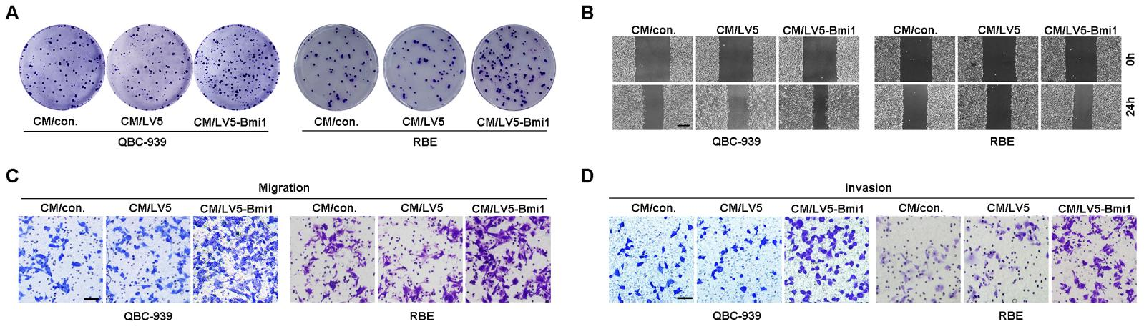
Supplementary Figure 4. (A) Representative images of colony formation in Figure 4E. (B) Representative images of wound healing assay in Figure 4F. (C and D) Representative images of transwell assay in Figure 4G and 4H.

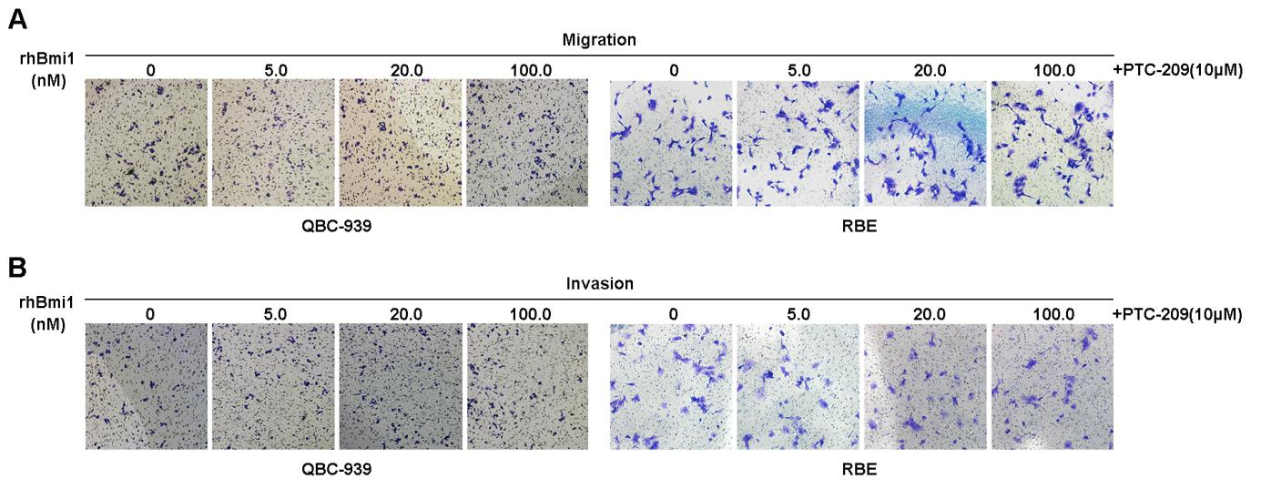
Supplementary Figure 5. Representative images of transwell assay in Figure 4J (A) and 4K(B).

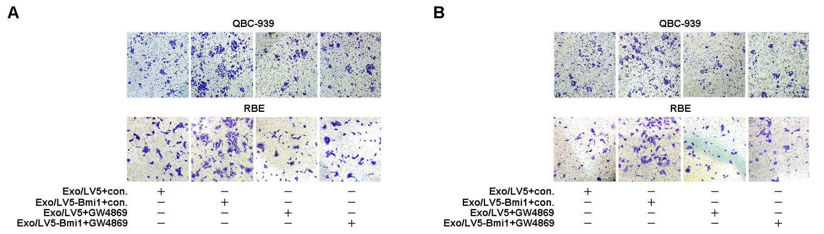
Supplementary Figure 6. Representative images of transwell assay in Figure 5I (A) and 5J(B).

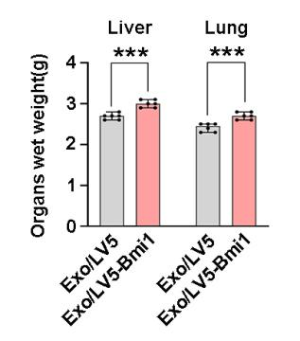
Supplementary Figure 7. Livers and lungs were weighed to assess the tumor burden of metastatic foci.

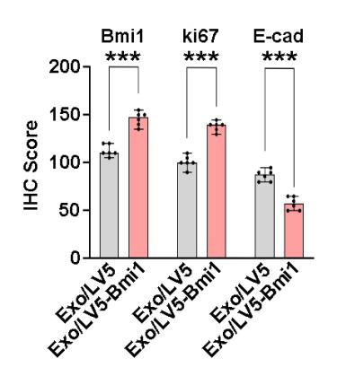
Supplementary Figure 8. Ki67 and E-cad expression were calculated by IHC score in xenografts.

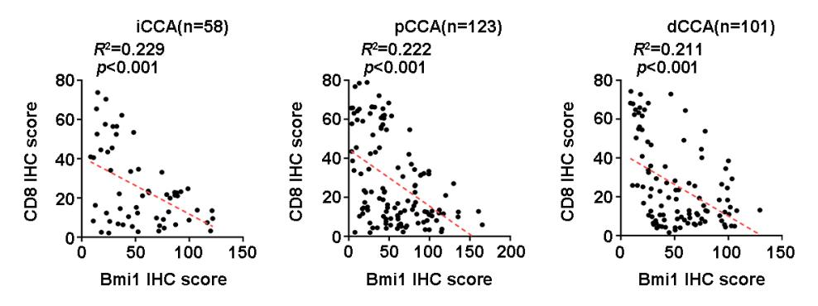
Supplementary Figure 9. The IHC scores of Bmi1 were negatively associated with CD8 in iCCA, pCCA, and dCCA.

Supplementary Tables

Supplementary Table 1. The information of reagents and antibodies

Antibodies | Source | Identifier
Bmi1 | Cell Signaling Technology(CST) | Cat. No. D20B7
E-cadherin | CST | Cat. No. 24E10
N-cad | CST | Cat. No. D4R1H
Snail | CST | Cat. No. C15D3
Ubiquityl-Histone H2A (Lys119) | CST | Cat. No. D27C4
Histone-H3 | CST | Cat. No. D1H2
p53 | Abcam | Cat. No. Ab26
ki-67 | Abcam | Cat. No. Ab15580
CD81 | Abcam | Cat. No. Ab79559
TSG101 | Abcam | Cat. No. Ab83
Calnexin | Abcam | Cat. No. Ab133615
β-actin | Abcam | Cat. No. Ab8226
CD8A | Proteintech | Cat. No. 65069-1-Ig
CCL5 | Immunoway | Cat. No. YT4002
CXCL9 | Immunoway | Cat. No. YT6008
Proteins and Chemicals | Source | Identifier
Recombinant human Bmi1 | Abcam | Cat. No. Ab114169
PTC-209 | Selleck Chemicals | Cat. No. 315704-66-6
GW4869 | Sigma-Aldrich | Cat. No. 6823-69-4

Supplementary Table 2. Correlations between Bmi1 expression and clinicopathological characteristics iCCA, pCCA, and dCCA.

Characteristics | iCCA |  |  | pCCA |  |  | dCCA
Characteristics | Bmi1-  (n=29) | Bmi1+  (n=29) | p | Bmi1-  (n=64) | Bmi1+  (n=59) | p | Bmi1-  (n=49) | Bmi1+  (n=52) | p
Age (years)
<65 | 25 | 14 | 0.005** | 38 | 31 | 0.472 | 27 | 29 | 1.000
≥65 | 4 | 15 | 0.005** | 26 | 28 | 0.472 | 22 | 23 | 1.000
Gender
female | 10 | 9 | 1.000 | 22 | 13 | 0.163 | 16 | 17 | 1.000
male | 19 | 20 | 1.000 | 42 | 46 | 0.163 | 33 | 35 | 1.000
Tumor size
<2.5cm | 15 | 6 | 0.028* | 41 | 26 | 0.031* | 31 | 29 | 0.544
≥2.5cm | 14 | 23 | 0.028* | 23 | 33 | 0.031* | 18 | 23 | 0.544
Differentiation
Well+Moderate | 14 | 17 | 0.599 | 40 | 43 | 0.251 | 28 | 28 | 0.842
Poor | 15 | 12 | 0.599 | 24 | 16 | 0.251 | 21 | 24 | 0.842
T stage
T1+T2 | 14 | 7 | 0.100 | 58 | 49 | 0.285 | 29 | 14 | 0.001**
T3+T4 | 15 | 22 | 0.100 | 6 | 10 | 0.285 | 20 | 38 | 0.001**
N stage
N0 | 16 | 13 | 0.600 | 42 | 35 | 0.576 | 39 | 34 | 0.125
N1+N2 | 13 | 16 | 0.600 | 22 | 24 | 0.576 | 10 | 18 | 0.125
M stage
M0 | 28 | 24 | 0.194 | 61 | 57 | 1.000 | 48 | 48 | 0.364
M1 | 1 | 5 | 0.194 | 3 | 2 | 1.000 | 1 | 4 | 0.364
TNM stage
I+II | 5 | 6 | 1.000 | 37 | 34 | 1.000 | 46 | 47 | 0.716
III+IV | 24 | 23 | 1.000 | 27 | 25 | 1.000 | 3 | 5 | 0.716

Abbreviations:
CCA = cholangiocarcinoma,
iCCA = intrahepatic cholangiocarcinoma,
pCCA = perihilar cholangiocarcinoma,
dCCA = distal cholangiocarcinoma.
p Calculated by Chi-square test；
*: p<0.05, **: p<0.01

Supplementary Table 3. The Primer sequences for qPCR

Target genes | Forward primer (5’-3’) | Reverse primer (5’-3’)
Bmi1 | GAGGGTACTTCATTGATGCCACAAC | GCTGGTCTCCAGGTAACGAACAATA
Ki67 | AGTACAACGACCCAACCCAA | GGCTGTGCCTTCCTACAGAC
E-cad | TCAGACTCCATGTGCCTGAGA | CACATTGTCCTCAGCCTTCTTTG
CD8A | CCTTACCAGTGACCGCCTT | AGGTTCCAGGTCCGATCCAG
CCL5 | CGAAAGAACCGCCAAGTGTG | CGGGTGGGGTAGGATAGTGA
CXCL9 | GGTGTTCTTTTCCTCTTGGGC | AACAGCGACCCTTTCTCACT
GAPDH | GAGTCAACGGATTTGGTCGT | GACAAGCTTCCCGTTCTCAG

Supplementary Table 4. The information of shRNA sequences
Name | The target sequence of shRNAs and siRNA (5’- 3’)
shBmi1-1 | CCTGGAGACCAGCAAGTAT
shBmi1-2 | GTTCTCCGAACGTGTCACGT
Name | The negative sequence of shRNAs and siRNA (5’- 3’)
sh-scramble -Bmi1 | TTCTCCGAACGTGTCACGT

Supplemental Table 5. The Primer sequences for ChIP-qPCR

Target genes | Forward primer | Reverse primer
CCL5 | (-215)CACCATTGGTGCTTGGTCA  AAGAGG | (+115)GCAGTAGCAATGAGGATGACAGCGA
CXCL9 | (-219)TGTGCCAAAGGCTATCAG  TG | (-117)CAGATCCAAGGGAATTTCT  GC

Supplementary Table 6. The prognostic significance of clinicopathological characteristics in in iCCA.
characteristics |  | 3-year OS | pª | HR | 95%CI | p^{b}
Age (years) | <65 | 34.0 | 0.340
Age (years) | ≥65 | 14.6
Gender | male | 22.4 | 0.358
Gender | female | 29.3
Tumor size | <2.5cm | 50.1 | 0.016 | 1
Tumor size | ≥2.5cm | 14.4 |  | 1.38 | 0.60-3.21 | 0.452
Differentiation | Well+Moderate | 24.2 | 0.510
Differentiation | Poor | 30.8
T stage | T1+T2 | 51.9 | 0.028 | 1
T stage | T3+T4 | 13.2 |  | 1.43 | 0.67-3.05 | 0.358
N stage | N0 | 43.5 | 0.022 | 1
N stage | N1+N2 | 11.3 |  | 2.14 | 1.11-4.10 | 0.022
M stage | M0 | 29.1 | 0.326
M stage | M1 | 0.00
TNM stage | I+II | 36.4 | 0.699 | -
TNM stage | III+IV | 22.6 |  | - | - | -
Bmi1 | Low | 47.9 | 0.003 | 1
Bmi1 | High | 8.8 |  | 2.68 | 1.36-5.29 | 0.004

Abbreviations:
OS = overall survival,
HR = hazard ratio,
CI= confidence interval,
pª Calculated by log-rank test.
p^{b} Calculated by Cox-regression Hazard model

Supplementary Table 7. The prognostic significance of clinicopathological characteristics in in pCCA.
characteristics |  | 3-year OS | pª | HR | 95%CI | p^{b}
Age (years) | <65 | 44.3 | 0.071
Age (years) | ≥65 | 26.0
Gender | male | 34.9 | 0.824
Gender | female | 39.0
Tumor size | <2.5cm | 47.8 | 0.014 | 1
Tumor size | ≥2.5cm | 39.4 |  | 1.544 | 0.85-2.80 | 0.152
Differentiation | Well+Moderate | 34.5 | 0.539
Differentiation | Poor | 36.5
T stage | T1+T2 | 39.0 | 0.012 | 1
T stage | T3+T4 | 25.7 |  | 2.627 | 1.29-5.36 | 0.008
N stage | N0 | 46.9 | 0.025 | 1
N stage | N1+N2 | 22.8 |  | 1.522 | 0.84-2.77 | 0.169
M stage | M0 | 35.2 | 0.948
M stage | M1 | 60.0
TNM stage | I+II | 48.7 | 0.011 | -
TNM stage | III+IV | 22.3 |  | - | - | -
Bmi1 | Low | 66.7 | ＜0.001 | 1
Bmi1 | High | 16.2 |  | 3.778 | 1.92-7.42 | ＜0.001

Abbreviations:
OS = overall survival,
HR = hazard ratio,
CI= confidence interval,
pª Calculated by log-rank test.
p^{b} Calculated by Cox-regression Hazard model

Supplementary Table 8. The prognostic significance of clinicopathological characteristics in in dCCA.
characteristics |  | 3-year OS | pª | HR | 95%CI | p^{b}
Age (years) | <65 | 26.0 | 0.901
Age (years) | ≥65 | 25.3
Gender | male | 33.9 | 0.709
Gender | female | 22.0
Tumor size | <2.5cm | 30.6 | 0.013 | 1
Tumor size | ≥2.5cm | 18.7 |  | 1.74 | 0.99-3.57 | 0.053
Differentiation | Well+Moderate | 36.8 | 0.015 | 1
Differentiation | Poor | 16.5 |  | 1.95 | 1.11-3.40 | 0.020
T stage | T1+T2 | 44.6 | 0.008 | 1
T stage | T3+T4 | 14.2 |  | 1.43 | 0.72-2.82 | 0.304
N stage | N0 | 28.7 | 0.112
N stage | N1+N2 | 17.5
M stage | M0 | 26.3 | 0.089
M stage | M1 | 0.00
TNM stage | I+II | 25.9 | 0.978 | -
TNM stage | III+IV | 21.9 |  | - | - | -
Bmi1 | Low | 42.8 | 0.002 | 1
Bmi1 | High | 12.6 |  | 2.14 | 1.18-3.89 | 0.013

Abbreviations:
OS = overall survival,
HR = hazard ratio,
CI= confidence interval,
pª Calculated by log-rank test.
p^{b} Calculated by Cox-regression Hazard model

