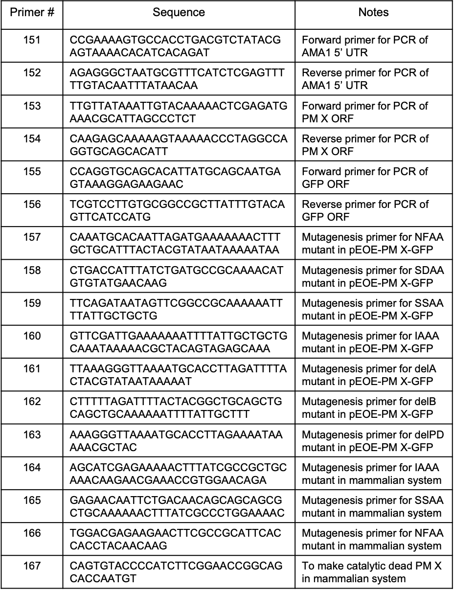
Table S1: List of primers used in this study.

PM X^{apt} + aTc
PM X^{apt} - aTc
WT+ aTc
WT - aTc
D266G+ aTc
D266G - aTc
Supplementary Fig. 1. A wild type (WT) but not a catalytic dead (D266G) form of second copy PM X could rescue the growth defect due to knockdown of endogenous PM X. PM X^{apt} parasites complemented with a second copy of the PM X gene, wild type (WT) or catalytic mutant (D266G) were grown in presence or absence of aTc. Parasitemia were determined at indicated times. Mean values from three independent experiments are shown and error bars represent standard deviations.

Supplementary Fig. 2. In vitro substrate cleavage activity of the wild type (WT) rPM X under different pH conditions. As substrate, a fluorogenic synthetic peptide that corresponds to the PM X cleavage site in Rh2N was used. 1 uM substrate peptide was incubated with 10 ng of rPM X at 37°C. The increase in relative fluorescence intensity (RFU) over time due to cleavage by PM X was measured. To inhibit PM X activity, 1 uM CWHM-117 was added to samples at pH 5.5. Neg: no rPM X added. Rh2N-mut: a mutated form that is not cleaved by PM X. Mean values from three independent experiments are shown and error bars represent standard deviations.

pH 5.5+CWHM-117

***
***
Supplementary Fig. 3. In vitro activity of prodomain (PD) mutant forms of parasite-derived PM X. Second copy PM X tagged with GFP was purified from schizonts using anti-GFP antibody. Isolated enzyme was then incubated with substrate as in fig. 3. Reaction was carried out for 1 h at 37°C. Mean values from three independent experiments are shown and error bars represent standard deviations. ***: p<0.001.

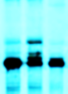
Supplementary Fig. 4. PM X processing is brefeldin A (BFA)-sensitive. 40-43 h schizonts expressing PM X-3xHA were pulse labelled with [³⁵S]methionine-cysteine for 5 min followed by chasing in unlabeled medium in the presence of cycloheximide (10 µg/ml). To one sample BFA (5 µg/ml) was added during chase. After 1 h, PM X was pulled down using anti-HA beads followed by autoradiography. The precursor and the processed forms of PM X are indicated.
BFA
No drug
0 min
1 h
unprocessed
processed

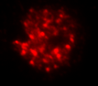
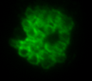
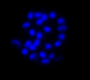
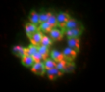
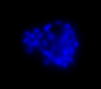
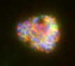
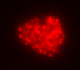
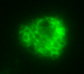
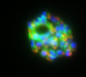
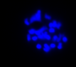
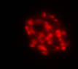
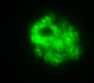
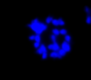
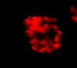
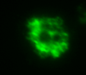
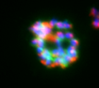
AMA1
MSP1
DAPI
Combined
-aTc+CWHM-117
+aTc+C1
2𝛍m
Supplementary Fig. 5. Unprocessed AMA1 accumulates in terminal organelles in
P. falciparum schizonts. Synchronized schizonts (44 h old) from PM X^{apt} parasites were treated with C1 in presence of aTc. To knock down PM X and suppress residual activity, an aliquot of the culture was grown in absence of aTc from invasion and at 24 h post invasion, 0.5 uM CWHM-117 was added. Samples were fixed and stained with indicated antibodies followed by IFA.

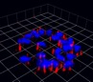
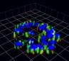
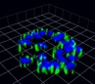
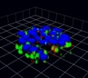
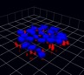
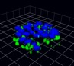
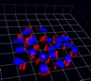
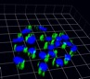
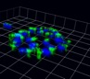
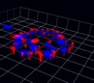
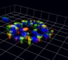
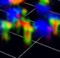
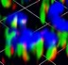
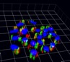
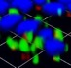
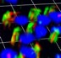
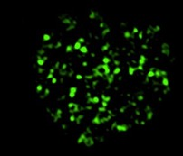
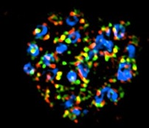
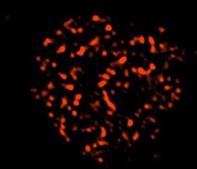
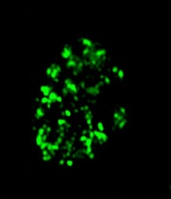
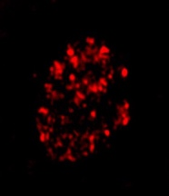
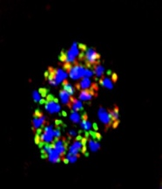
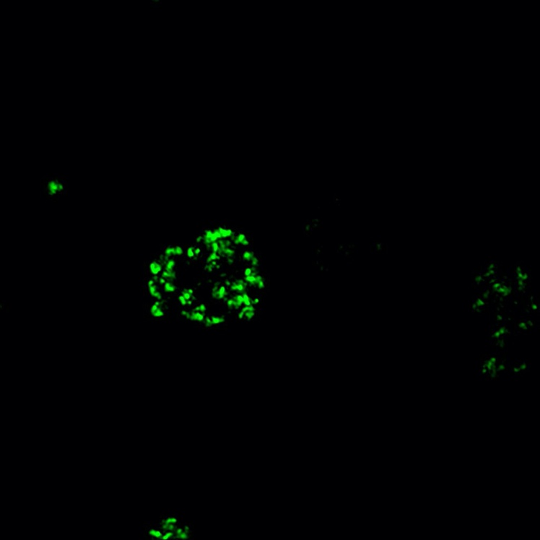
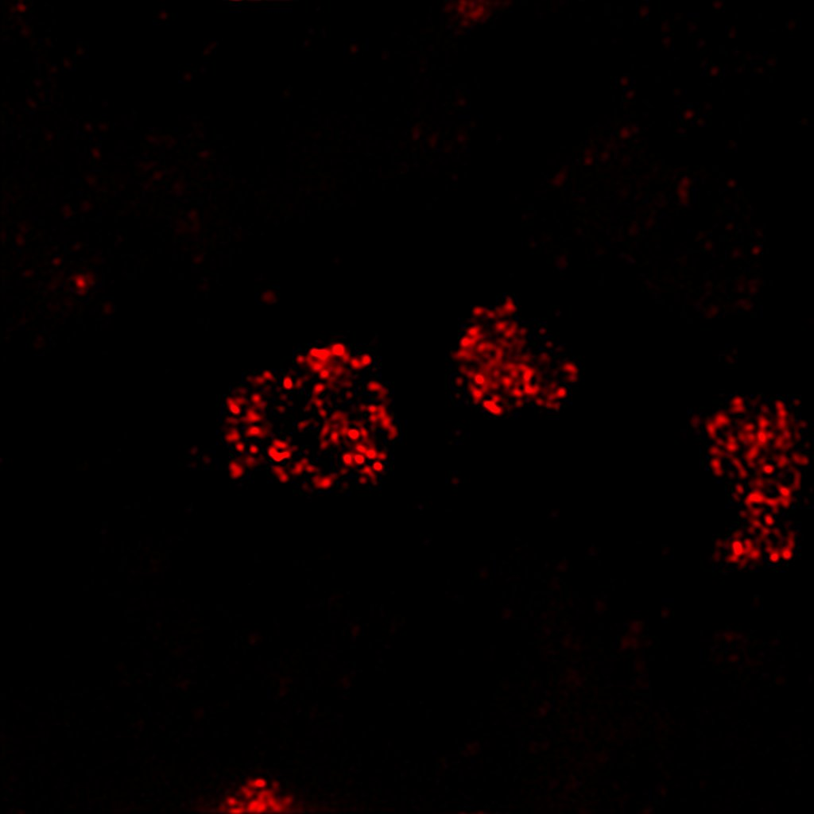
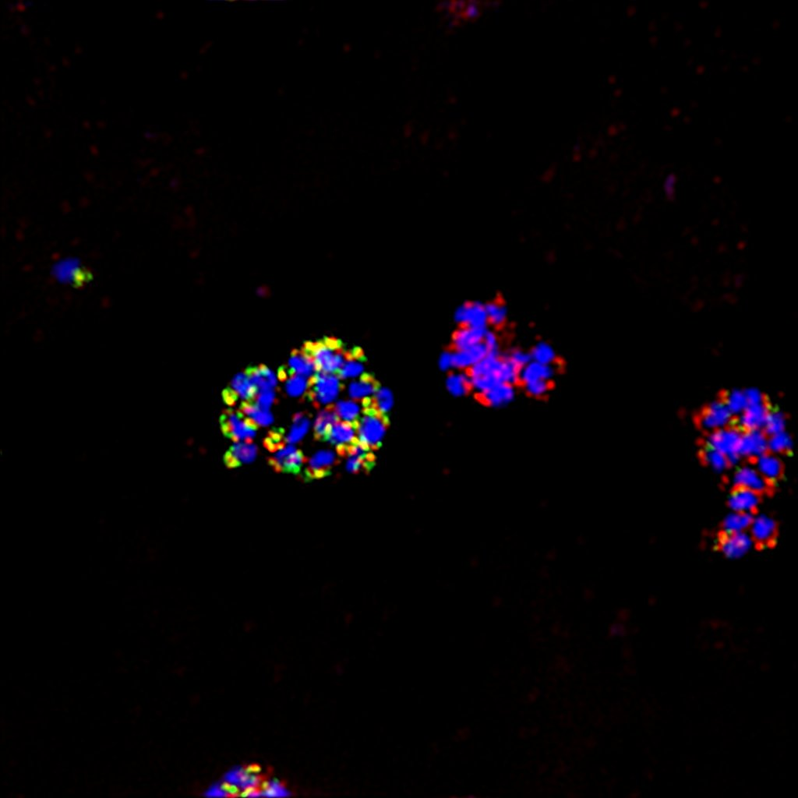
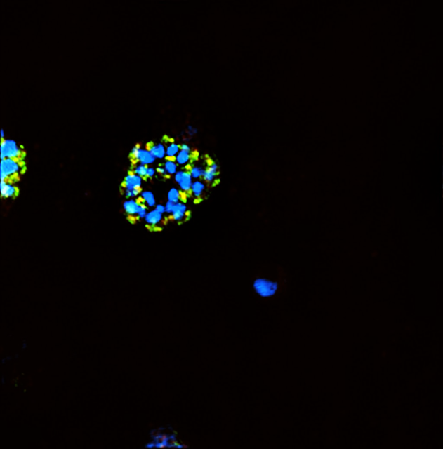
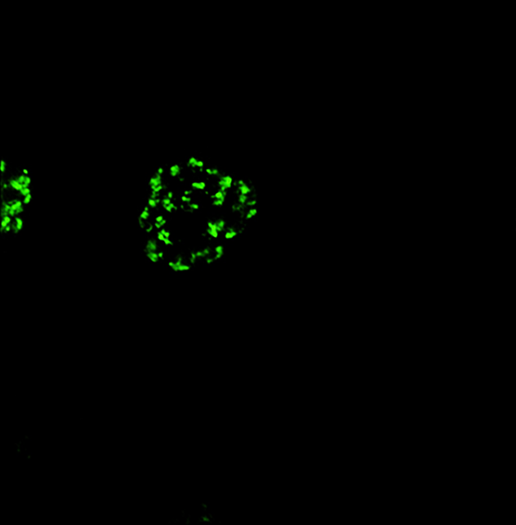
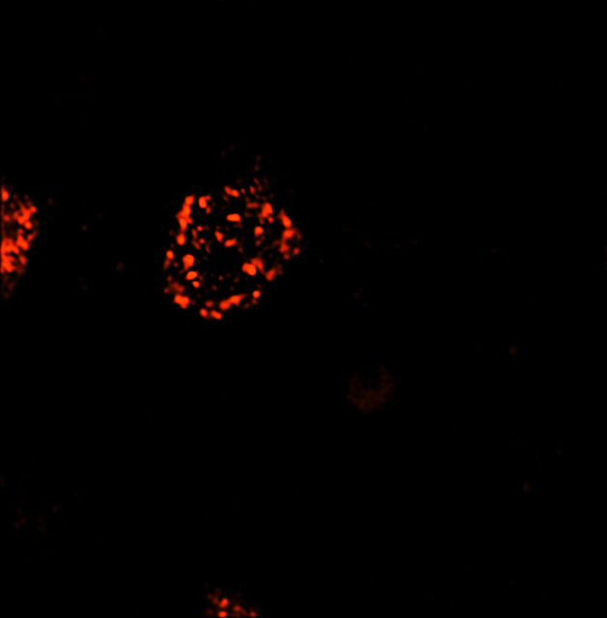
HA + DAPI
AMA1 + DAPI
Combined
HA + DAPI
EBA175 + DAPI
Combined
PM X
SUB1
a
b
c
PM X
SUB1
Supplementary Fig. 6. Both PM X and SUB1 partially colocalize with the microneme markers AMA1 and EBA175. a and b 3D reconstruction of Airyscan confocal images from the samples in fig 8c. Insets show regions of interest: either complete overlap or very close proximity of the two signals. Each unit of grid is 1.61 µm. c SR-SIM microscopy: 2D images of parasites expressing PM X-3xHA and labeled with the indicated antibodies.
AMA1
HA
Combined
with DAPI
5 μm
EBA175
HA
Combined
with DAPI

