Table 1: Medicinal plants, their uses, and preparation method
Nepali/common name | Scientific Name | Disease treated | Parts Used | Preparation Method | Associated photographs
Sikari laro | Peripioca calophylla | Bone fracture | Whole plant | Dried, powdered, and taken orally | 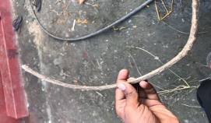
Gol kakri | Coccinia grandis | Bone fracture/ dislodge | Root | Dried, powdered, and taken orally | 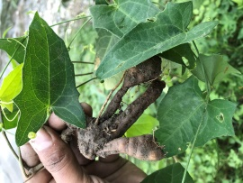
Bhaichapo |  | Bone/muscle dislodge | Leaves and stem | Paste applied
Bojho | Acorus calamus | Sore throat, cough | Root | Juice taken orally | 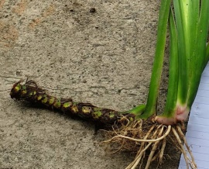
Mula pate | Elephantopus scaber | fever | Whole plant | Juice taken orally | 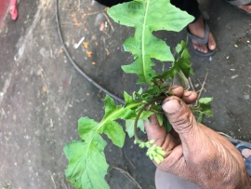
Gidari |  | Asthma | Bark | Dried, powdered, and taken orally | 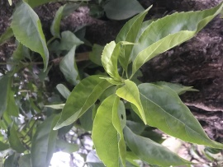
Gurjo | Tinospora sinensis | Jaundice | Root, leaves | Juice/ taken directly | 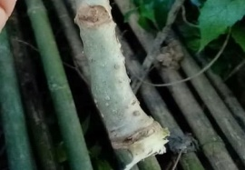
Ghodtapre | Centella asiatica | Jaundice | Leaves | Directly taken/ Juice taken orally | 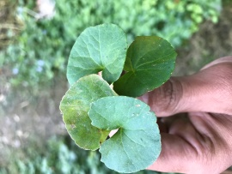
Gane Jhar |  | Jaundice | Leaves | Directly taken | 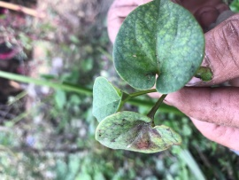
Kurkure |  | Jaundice | Leaves | Juice taken orally | 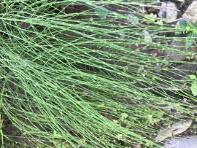
Bhakimlo | Semecarpus anacardium | Diarrhoea | Fruits | Dried, powdered, and taken orally | 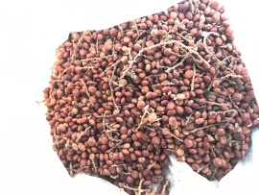
Kurilo | Asparagus racemosus | Milk increase, urinary infection | Stem | Juice taken orally | 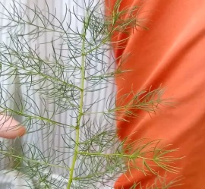
Asuro | Justica adhatoda | Cold cough | Leaves | Boiled and steam inhaled | 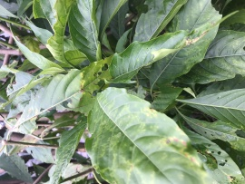
Kodo | Eleusine coracana | Infections | Grains | Powdered and paste applied | 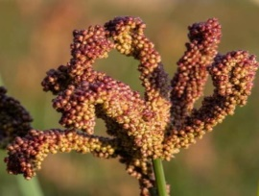
Beruwa |  | Abdominal pain, worms | Leaves, stem | Dried, powdered, and taken orally
Satuwa | Paris polyphylla | Worms | Root | Dried and taken orally | 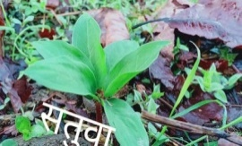
Jethi madhu | Glycyrrhiza glabra | Fever, abdominal pain | Leaves | Juice taken orally
Dhursul |  | Abdominal pain | Leaf bud | Powdered and taken orally | 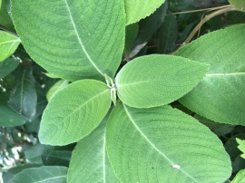
Tulsi | Ocimum sanctum | Fever | Whole plant | Paste/dried and powdered | 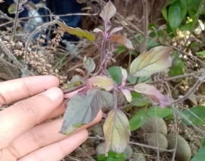
Akamaro | Achyranthes aspera | Abdominal pain | Stem | Juice taken orally | 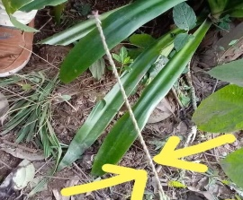
Bhede kuro | Xanthium strumarium | Abdominal pain | Seed | Powdered and taken orally | 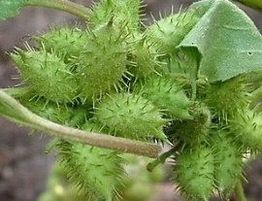
Chari amilo | Oxalis corniculata | Fever, dysentery | Whole plant | Taken directly, juice taken orally | 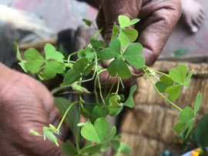
Jadela |  | Eye opacity | Stem | Watery fluid applied
Gurje gano/ Batul pate | Cissampelos pareira | Abdominal dislocation, bleeding | Stem, leaves | Juice taken orally | 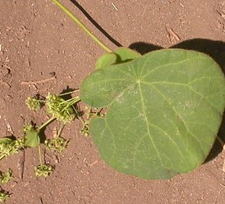
Tite karela | Momordica charantia | Blood pressure | Fruit | As vegetable | 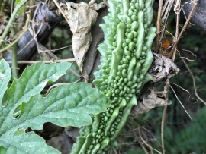
Kyauno |  | Mental disorder | Leaf and bark | Dried, powdered, and taken orally | 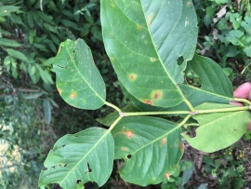
Aanp | Mangifera indica | Abdominal pain | Leaf bud, bark | Dried, powdered, and taken orally | 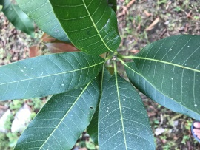
Jwano | Trachyspermum copticum | Cough, fever | Flowers, oil | Powdered/ boiled and taken orally | 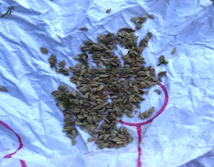
Siltimur | Lindera neesiana | Abdominal pain | Fruit | Dried and taken directly | 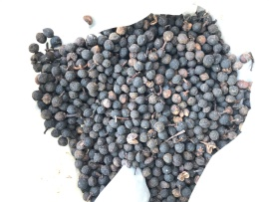
Raye timur | Zanthoxylum armatum | Common cold | Fruit | Dried and powdered taken orally | 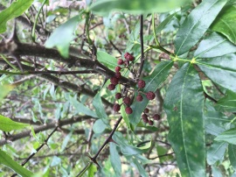
Bilaune | Maesa chisia | Scabies | Leaf | Paste applied | 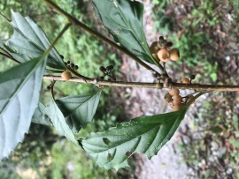
Gaaure |  | Tonsil | Shoot | Boiled and taken orally
Kalo angeri | Melastoma normale | Wounds, constipation | Fruit, Leaves | Powdered applied, Juice taken
Bhujetro | Butea minor | Worms | Seeds | Powdered and taken orally
Siru | Imperata cylindrica | Worms | Roots | Dried, Powdered, and taken orally | 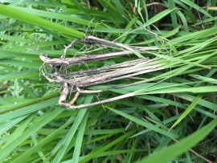
Kancho paat | Nicotiana tabacum | Mastitis in animals, joint ache | Leaves | Paste applied | 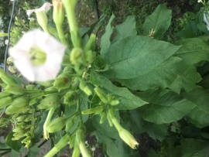
Ban marauti | Acmella oleraceae | Abdominal pain | Flowers, leaves | Powdered and taken orally | 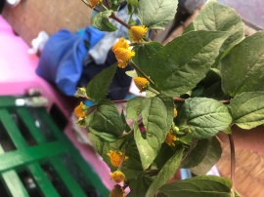
Abijalo | Drymaria diandra Blume | Dysentery | Shoot | Extracted juice taken orally | 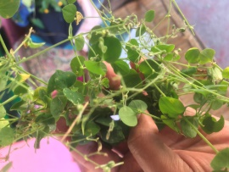
Dansinko |  | Abdominal pain | Leaves | Powdered taken orally | 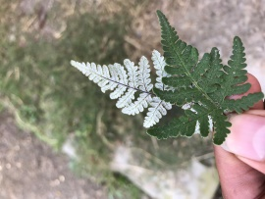
Tite pati | Artemisia indica | Abdominal pain, Joint ache | Leaves, oil | Dried, powdered, and taken orally. Oil massage | 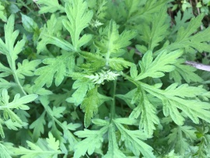
Neem | Azadiracta indica | Abdominal pain | Leaf | Dried and powdered/ Paste taken orally | 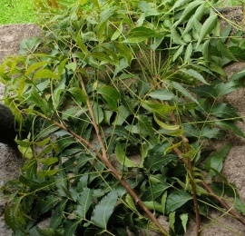
Bakaino | Melia azadirach | Abdominal pain | Leaf | Dried and powdered/ Paste taken orally | 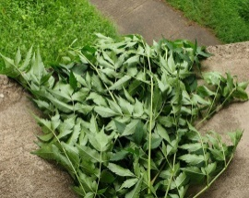
Ainselu | Rubus ellipticus | Abdominal pain | Root | Dried, powdered, and taken orally | 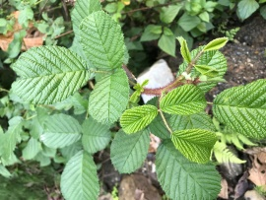
Amba | Psidium guajava | Abdominal pain | Shoot tip | Dried, powdered, and taken orally | 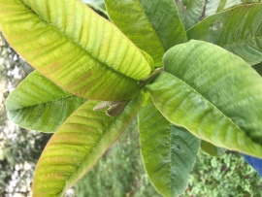
Lwang | Syzygium aromaticum | Abdominal pain | Fruit | Directly taken/ Powdered and taken orally | 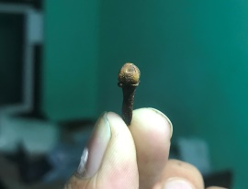
Ritha | Saoindus mukorossi | Excretion problem | Fruit | Dried, powdered, and taken orally
Asare phool |  | Abdominal dislocation | Rhizome | Taken directly | 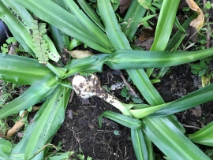
Sahur |  | Asthma | Bark | Powdered and taken orally
Rat pate |  | Fever | Leaves | Juice taken orally | 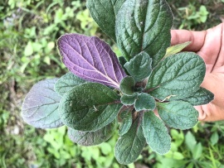
Amala | Phyllanthus emblica | Abdominal pain | Fruit | Dried, Powdered, and taken orally | 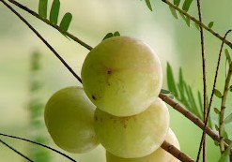
Harro | Terminalia chebula | Fever, skin disease | Fruit, Bark | Dried, Powdered, and taken orally | 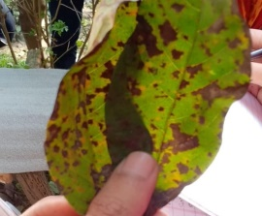
Sati phool |  | Skin diseases | Fruit | Paste applied
Charchare |  | Scabies | Shoot | Paste applied | 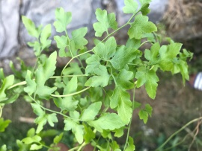
Ghiukumari | Aloe vera | Burn | Leaves | Juice applied over the burned wound | 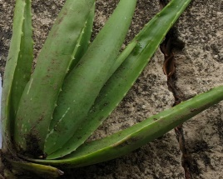
Kalo ningro | Dryoathyrium boryanum | Dysentery | Leaves and stem | Paste taken/ as vegetable | 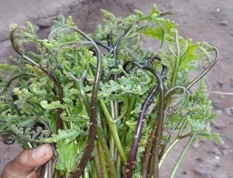
Dhairo | Woodfordia fruticosa | Dysentery | Flowers | Boiled in water | 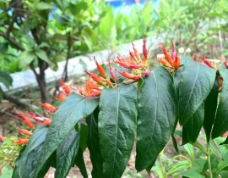
Sisno | Urtica dioca | Bone fracture | Root | Paste applied | 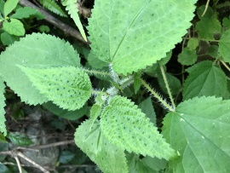
Jheu | Lichens sps | Wounds | Whole plant | Powdered applied | 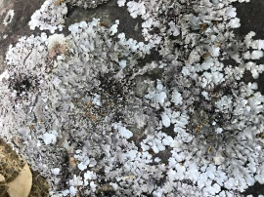
Pani amala | Nephrolepis cordifolia | Jaundice, Diabetes | Rhizome | Taken directly | 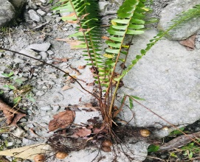
Banmara | Eupatorium cannabium | Wounds | Leaves | Juice applied | 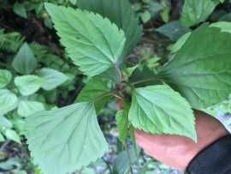
Pudina | Mentha viridis | Fever, asthma | Leaves | Paste taken orally | 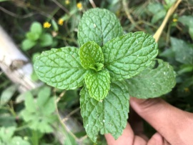
Amilo | Citrus aurantifolia | Mud burns of legs | Fruit | Juice applied | 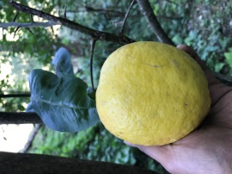
Dahi kamala | Callicarpa macrophylla | Fever | Root | Juice or powdered and taken orally | 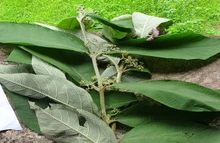
Ashwa ganda | Withania somnifera | Asthma, liver disease, depression | Root | Dried, powdered, and taken orally | 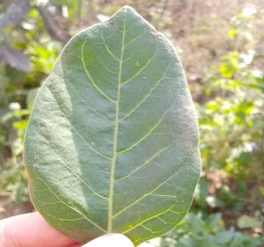
Sajiwan | Jathropa curcas | Infection, tooth ache | Leaf, seed | Paste applied | 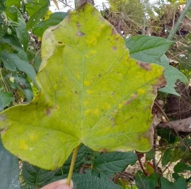
Tejpatta | Cinnamomum tamala | Heart problems, common cold, diarrhoea | Leaf, bark | Boiled with water or Powdered and taken orally | 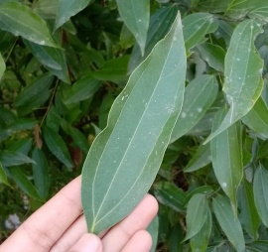
Amriso | Thysanolaena maxima | Typhoid | Root | Dried, powdered, and taken orally | 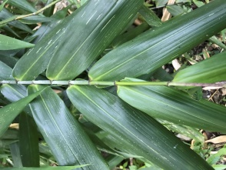
Sindhur | Bixa orellana | Digestion problems, headache | Seeds | Powdered and taken orally | 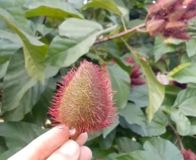
Aank | Calotropis procera | Asthma, constipation | Bark | Powdered and taken orally | 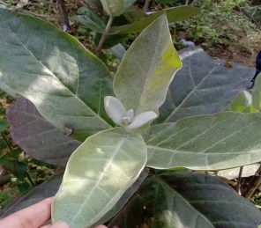
Patthar Chatta | Bryophyllum pinnatum | Kidney stone | Leaf | Juice taken orally | 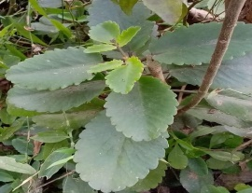
Others
Gadyaula | Lumbricus terrestris | Jaundice | Whole body | Juice extracted taken orally | 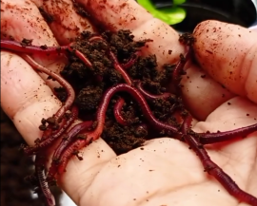
Chiple kira | Limax maximus | Bone fractures/  dislodge | Whole body | Taken directly
Dumsi | Porcupine | Asthma | Stomach | Cooked and Taken orally
Birenun | Himalayan black salt | Abdominal pain |  | Powdered and taken orally | 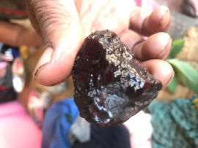
Fitkeri | Alum | Diarrhoea, scabies |  | Roasted and taken | 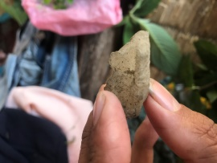
Source; (Field Survey, 2021)

