Intron retention coupled with nonsense-mediated decay is involved in cellulase biosynthesis in cellulolytic fungi
Yichen Gao,¹ Ai-Ping Pang,¹ Leyao Ma,¹ Haiyan Wang,¹ Samran Durrani,¹ Bingzhi Li,² Fu-Gen Wu,¹ Fengming Lin^{1*}

¹ State Key Laboratory of Bioelectronics, School of Biological Science and Medical Engineering, Southeast University, Nanjing, China
² Key Laboratory of Systems Bioengineering (Ministry of Education), School of Chemical Engineering and Technology, Tianjin University, Tianjin, China

*Correspondence: linfengming@seu.edu.cn

Table S1 The primers used for RT-qPCR in this study.
Primer | Sequence (5’ – 3’)
cel7a-i-F | GACGCTATCTTCTTGTTGGC
cel7a-i-R | CACTGGCTGTCACAGTACCC
cel7a-ii-F | TACTGCACAGCTGAGGAGGC
cel7a-ii-R | ACTCTTTGTCAACGCGCATG
cel7a-F | CGACTGTCGGCCAGGAGATC
cel7a-R | GTATGGGTTCCAGTCGCAGC
cel7b-i-F | GTGAGCCTGATGCCACTACT
cel7b-i-R | GTTGAACTGGGTGATGATGG
cel7b-ii-F | CAGTGCGGTGGCATTGGGTA
cel7b-ii-R | ATCACTCCCGTCAGGCATGG
cel7b-F | CTGGAACTACCGCTGGATGC
cel7b-R | GACGCCCTCGATGAAGCAGT
cel3a-i-F | GTATCCTGGAGACACCATGC
cel3a-i-R | GAGATTGAGCTTTGCCAATG
cel3a-ii-F | ACTATAAGCACTTCGACGAC
cel3a-ii-R | CTATCATTCCACAGTCATCC
cel3a-F | GGATCAGTACACGCTGCAGA
cel3a-R  sar1-F  sar1-R | CCGATTGTTACCGTTGAAGT  TGGATCGTCAACTGGTTCTACGA  GCATGTGTAGCAACGTGGTCTTT
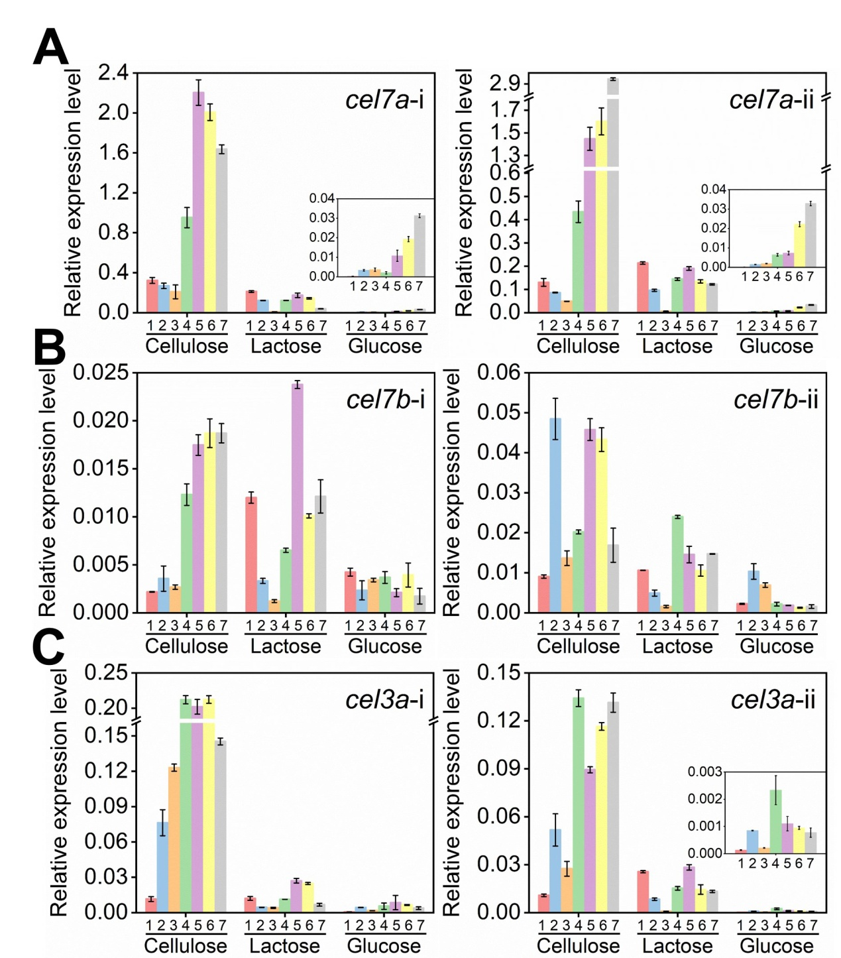
Fig. S1 The relative levels of introns in cel7a, cel7b, and cel3a in T. reesei RUT-C30 cultivated for 7 days in TMM containing 2% cellulose, 2% lactose or 2% glucose. Data are represented as the mean of three independent experiments and error bars express the standard.

