Supplementary Methods

Cell Picking
Each raft has a four-character alphanumeric coordinate (Raft ID). Fiduciary markers located at fixed locations on the raft plate (shown below) in conjunction with custom software (FIVTools > Cal Check, Calibration) were used to locate individual rafts for map generation (see Image Analysis and Quality Control).
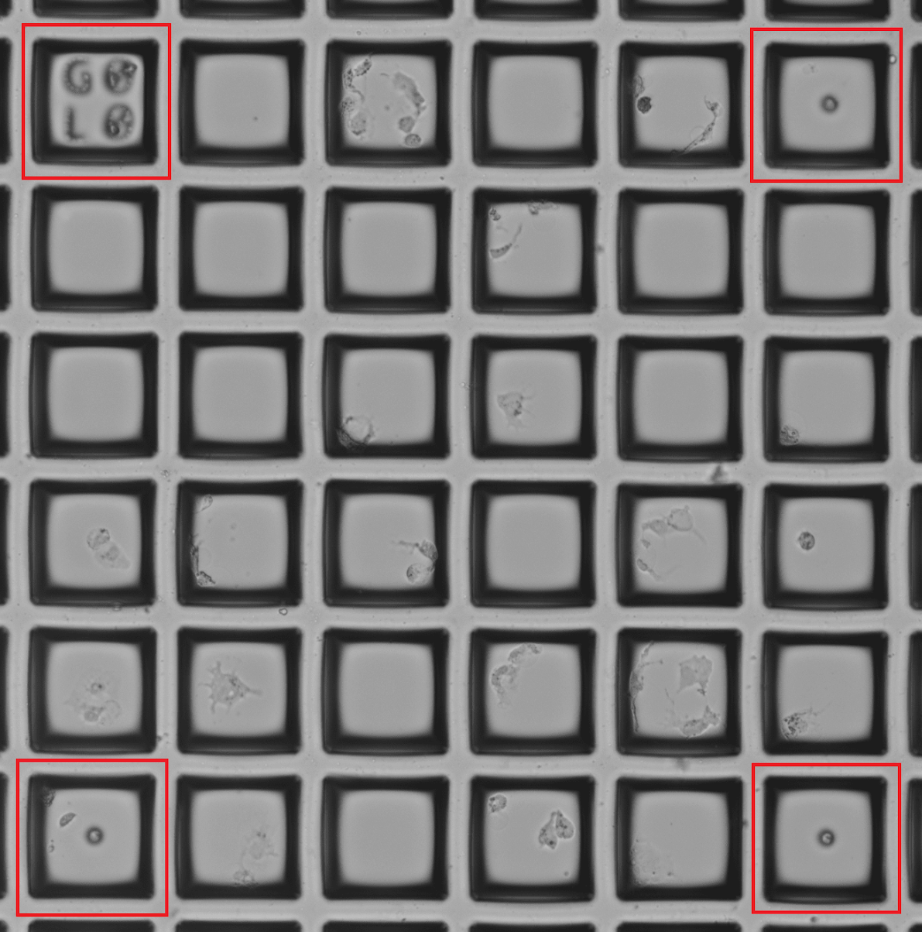 | Cropped example field of CytoSort raft plate: Alphanumeric fiduciary markers are etched on every 10 rafts (e.g. G0L0), and dot fiduciary markers are etched on every 5 rafts. Rafts with fiduciary markers are highlighted with red outlines.

HEK293 Cell Nucleofection
SF cell line solution stock was prepared from the Lonza SF Cell line 4D-Nucleofector LV Kit XL (V4LC-2520) kit by combining 82µL of SF Cell Line NucleofectorTM Solution with 18µL Supplement 1. 20µL of stock solution was then combined with 2µL 1mg/mL Cas9 protein (QB3 MacroLab) and 2µL 1mg/mL gRNA. The complexes were incubated on the benchtop for 10 minutes. Cell suspensions of 2x10⁵ cells were placed in 1.5 mL microcentrifuge tubes and spun down. Supernatant was carefully removed avoiding the cell pellet. The cells were rinsed in 1x PBS and centrifuged a second time. Supernatant was carefully removed, and the cells were resuspended in the final combined SF cell line solution and transferred to a nucleofector cuvette, found in the nucleofector kit. The cuvette was placed in the Lonza 4D-Nucleofector Unit. (Lonza AAF-1002X, AAF-1002B) and nucleofected with Pulse code CM130. Nucleofected material was added to a prewarmed 6 well plate with 5mL of DMEM media in each well. Nucleofected cells were incubated for 48 hours for recovery. The cell line solution is not healthy for the cells, so speed is a priority upon resuspension in cell line solution.

RFP-GFP Cell Perturbation and Isolation
A HEK293 cell line expressing both RFP and GFP (Gentarget #SC009) was used in this experiment. Cells were then nucleofected with a gRNA targeting GFP (TGCCCGAAGGCTACGTCCAG) or RFP (GGCCACGAGTTCGAGATCGA) and Cas9. All gRNAs were ordered from Synthego. Nucleofection was conducted using a Lonza 4D-Nucleofector Unit. (Lonza AAF-1002X, AAF-1002B). Following the Raft-Seq workflow, cells were imaged and the guide presence was predicted by a combination of RFP and GFP intensity features. Cells were selected and isolated into 96-well plates. Alternatively, cells were sorted using a Sony SH800S cell sorter individually by their RFP and GFP fluorescence. Cells were then genotyped and designated as being given the RFP or GFP guide if the locus that the respective guide targets had been altered.

Modeling Considerations
We implement several specific design criteria during the experimental setup and model selection. First, the ‘pure’ samples are split into testing wells and training wells so that we can decrease overfitting during model selection. For most of the experiments presented herein, our training datasets comprised two of the three labeled population wells of each type—the two wells must come from different plates—and use the remaining two labeled wells as “testing sets”. We split the data by well rather than randomly assigning cells from all pure population wells to mitigate the influence of batch effects during modeling. It is important to note that the actual data used for ultimate validation of the models will be the identities of the perturbagen in the unlabeled cell population. These are independent of the model scores of the pure populations, so we do not have to be concerned about hyperparameter overfitting from examining the testing data. Second, the testing wells are spread across different plates to hopefully account for batch effects. Since training data and testing data technically come from separate samples, we observed several odd phenomena such as prediction quality improving for testing data. These phenomena would most likely not be observed if the model-generating data were truly randomized, but we felt it was important to retain any variance caused by batch effects, since batch effects present a large and consistent obstacle to cell imaging analysis (Caicedo et al.).
Relatedly, we make sure not to create any artificial batch effects generated by inconsistencies in the screening process. All stains used are prepared as a single batch to be used across plates. All imaging and feature extraction settings are kept constant across each plate in a screening experiment.
Another aspect of model design that we consider is the exclusion of ‘leaky’ variables, or variables that happen to correlate with the data labels. Since our labeled data exists on specific positions of the plate, including a variable that is effectively a proxy for cell position would render the model useless on unlabeled data. We have found that several variables that are in the standard output of IN Carta feature extraction are leaky, such as features measured on a global basis, and we exclude them before starting the modeling process.
We also face a time constraint in our modeling pipeline. This time constraint is caused by the necessity of the locations of cells on the plate staying constant between imaging and isolation. Though we can fix the cells, a modeling pipeline based on that assumption would limit our ability to perform Raft-Seq for the isolation of live cells. Optimally, we complete feature selection, modeling, and raft selection within six hours of imaging, and continue on to isolation. This of course, requires a lot of computational power.

Supplementary Data

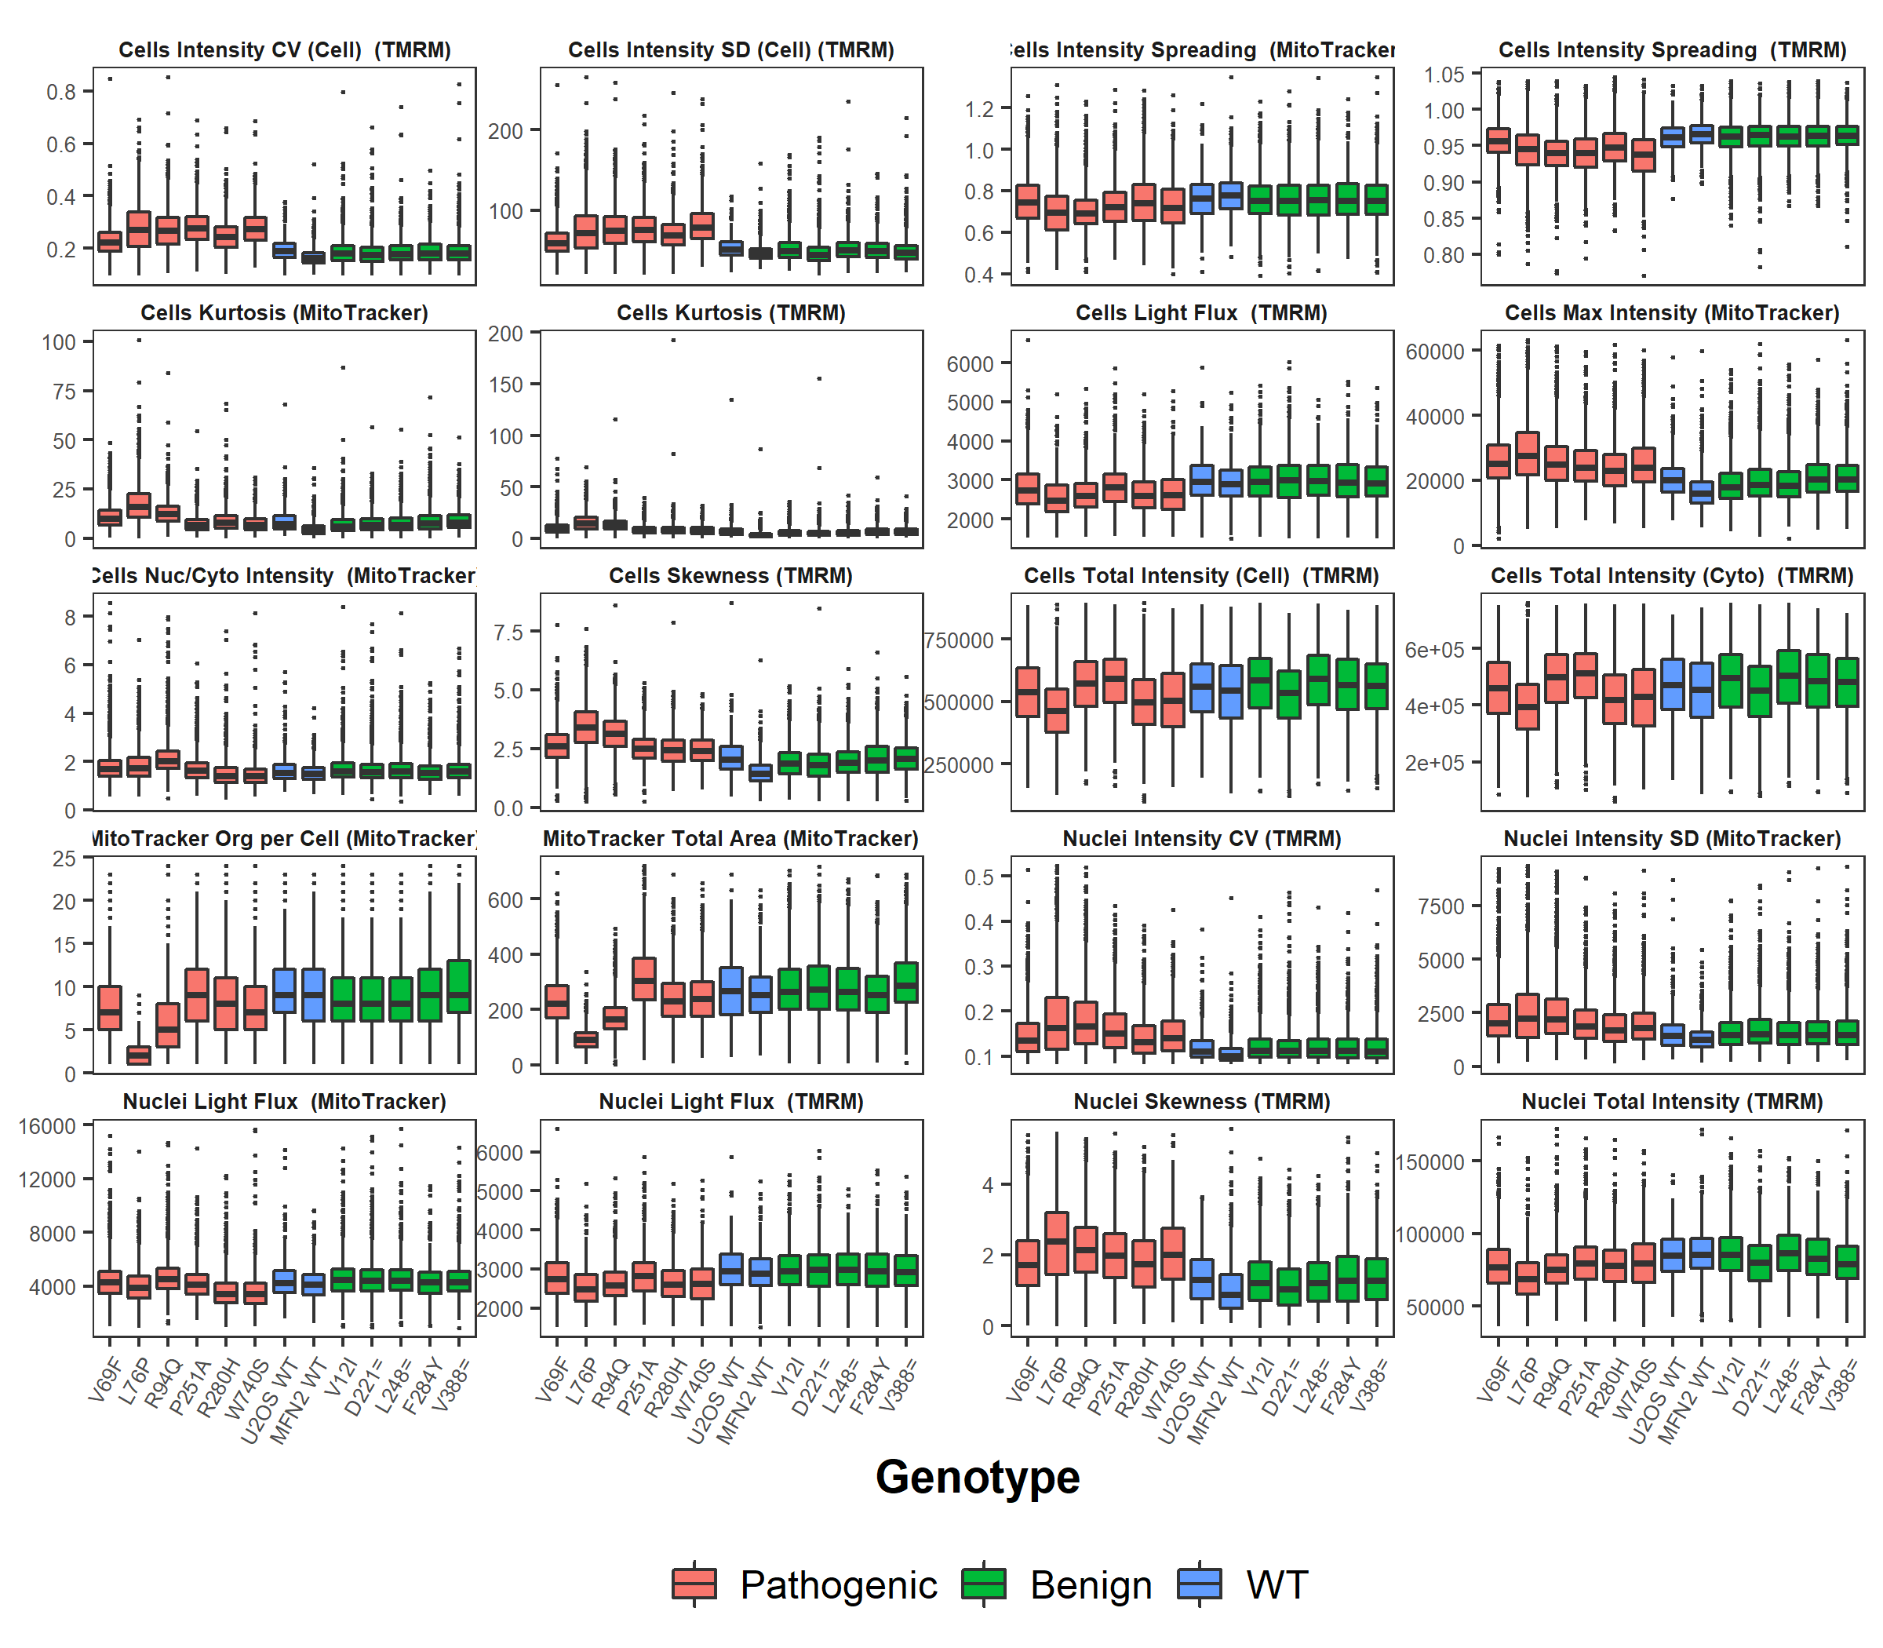
Figure S1: Box plots of important features extracted from TMRM and MitoTracker staining. Histograms are colored by whether the cell was wild type (unmodified wild type or modified with a wild type MFN2 cDNA), contained MFN2 cDNA containing a benign mutant, or contained MFN2 cDNA containing a pathogenic mutant. Features that showed no apparent difference between mutants were omitted.
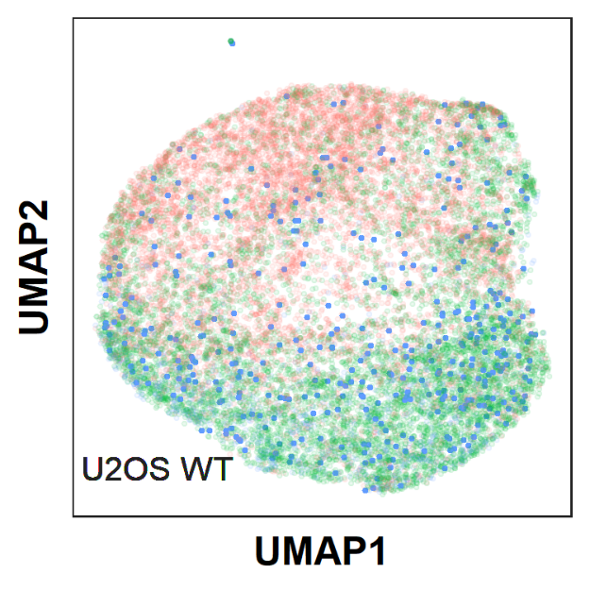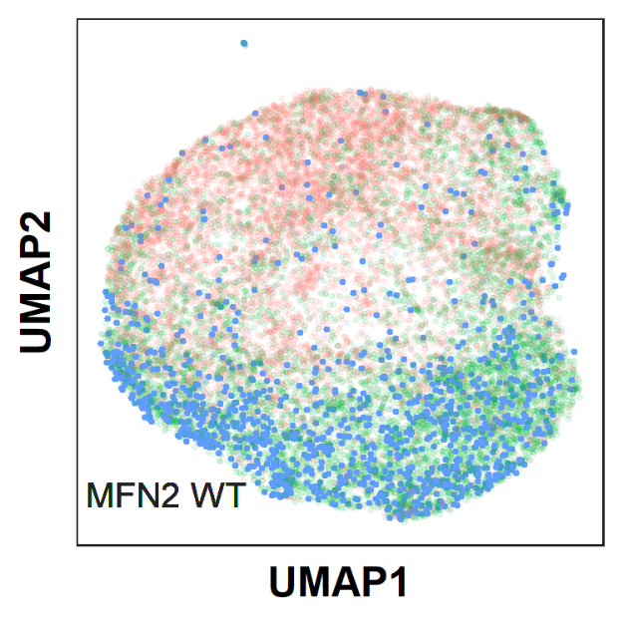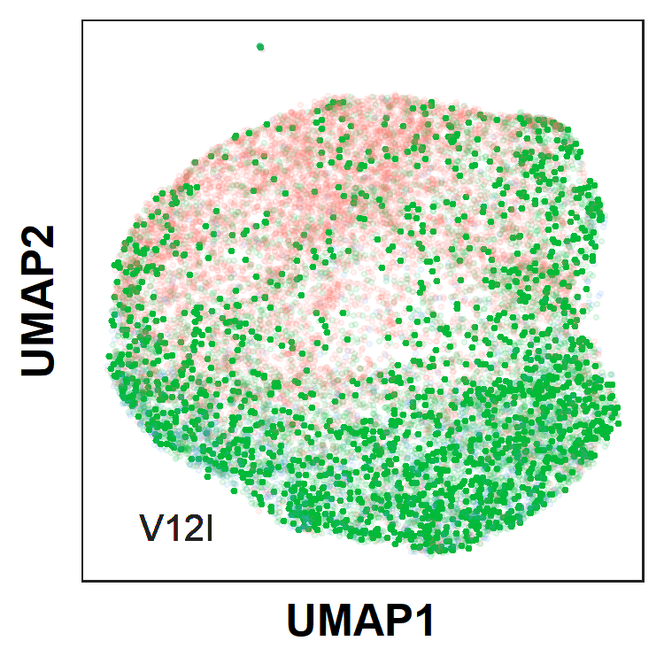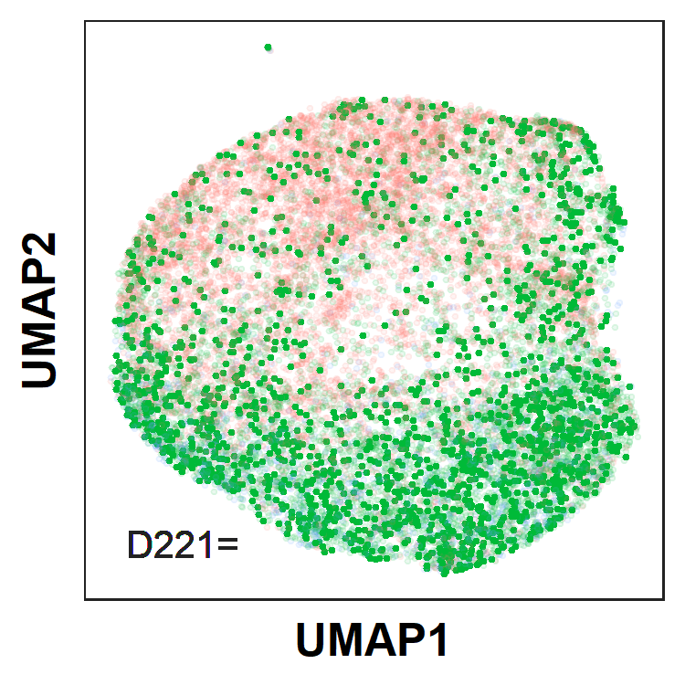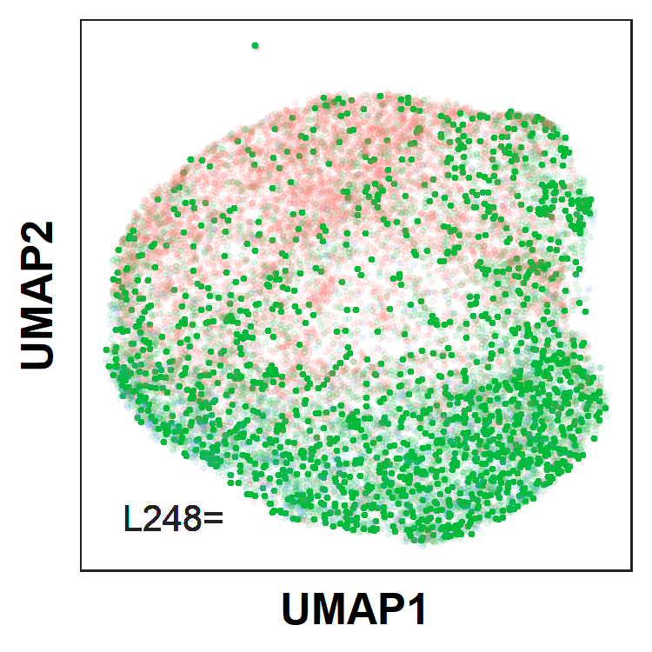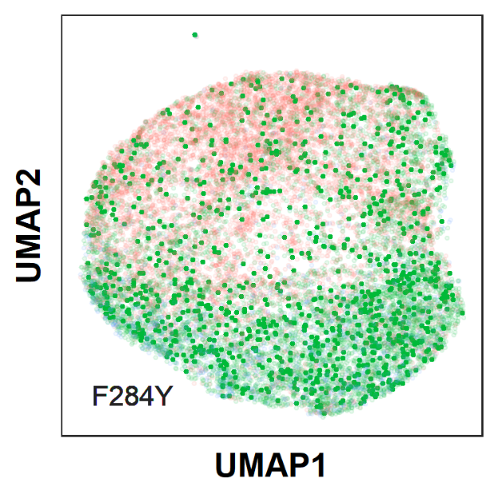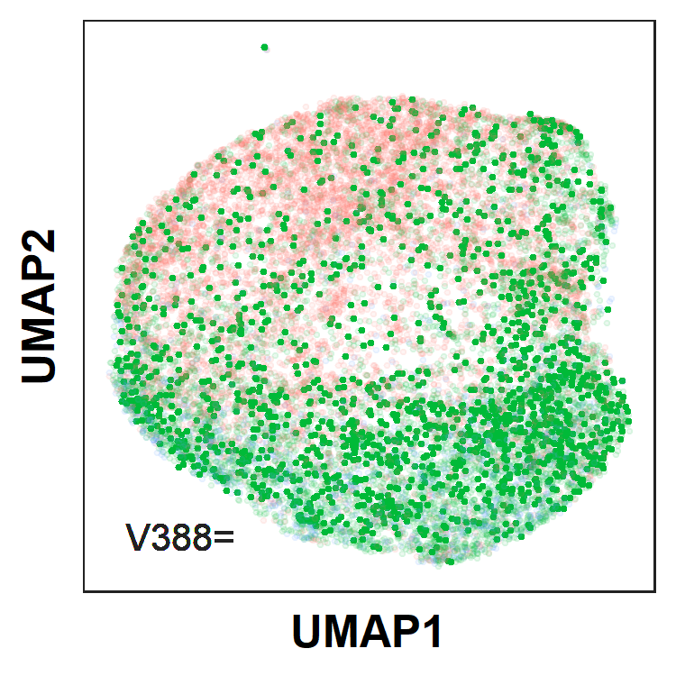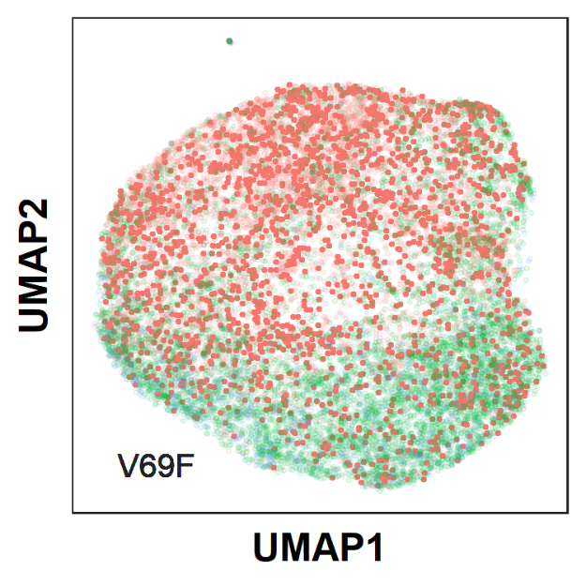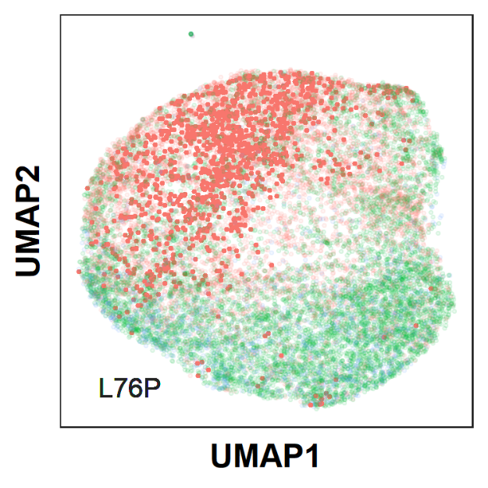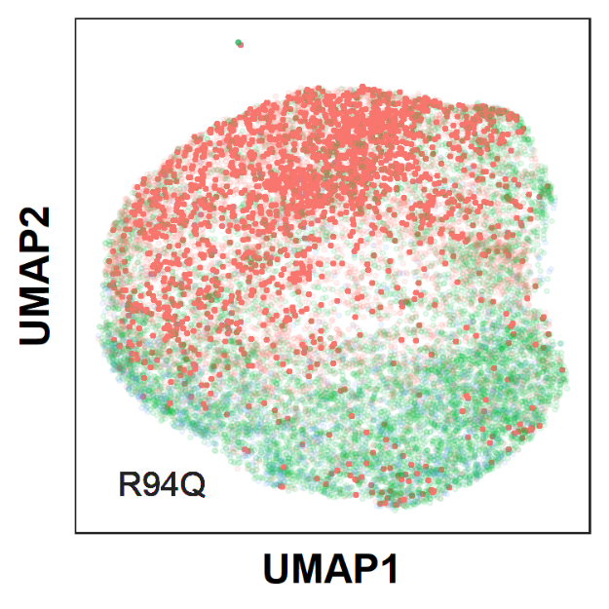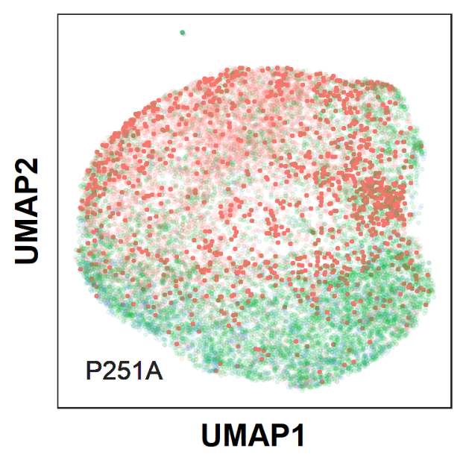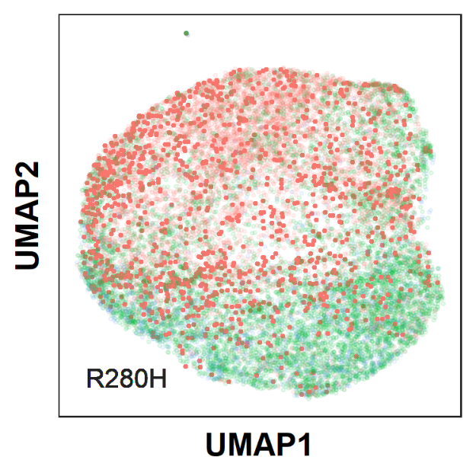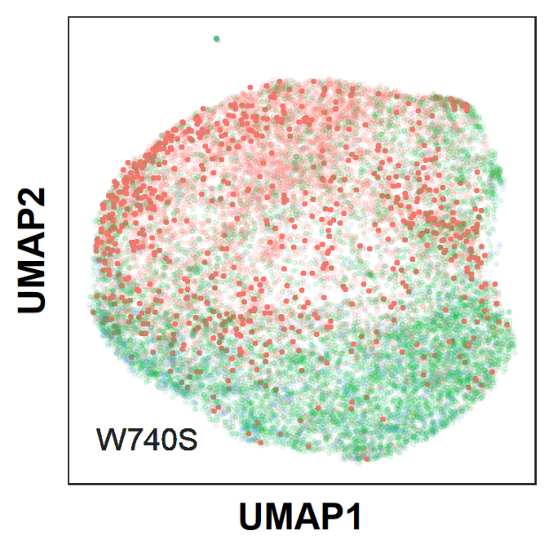
Figure S2: Scatter plot for cell feature data UMAPs, highlighted by cell genotype. In blue, U2OS WT refers to cells uninfected with lentivirus, while MFN2 WT refers to cells infected with lentivirus containing the wild type MFN2 gene. Otherwise, the highlighted genotype refers to the mutation present in the introduced MFN2 gene (red pathogenic, green benign).
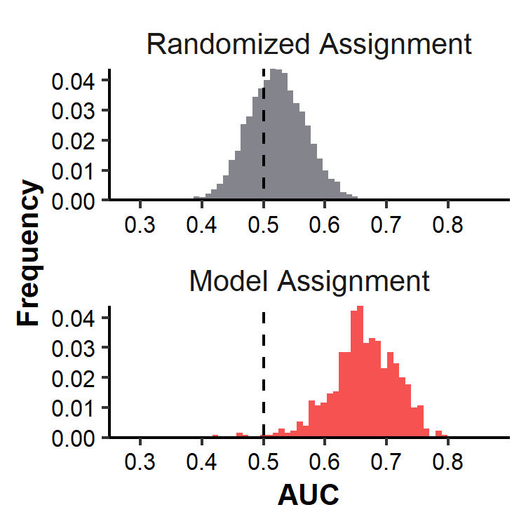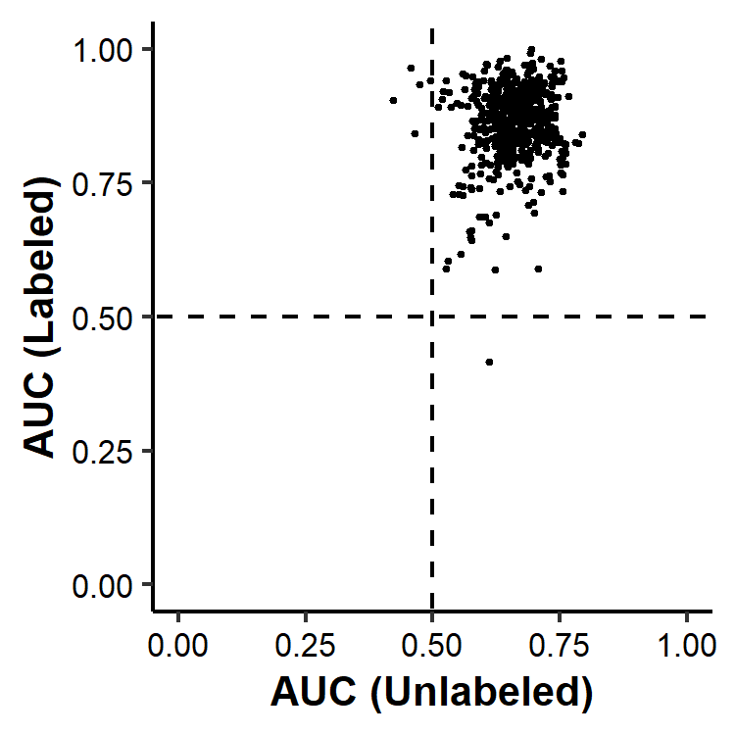
Figure S3 Model AUCs for identifying a mixture of wild type and six pathogenic mutant cell lines: Left: A histogram of AUCs for models detecting mutants in the unlabeled population of wild-type cells and mutants. On top, a histogram of AUCs generated from randomly assigning models is shown as a comparison. Right: A scatterplot showing the performance of 610 models in detecting mutants in a mixture of wild type cells and four pathogenic mutants. Each point represents a model and its position is determined by its ability to distinguish cells in the pure control wells and cells in the mixed wells.

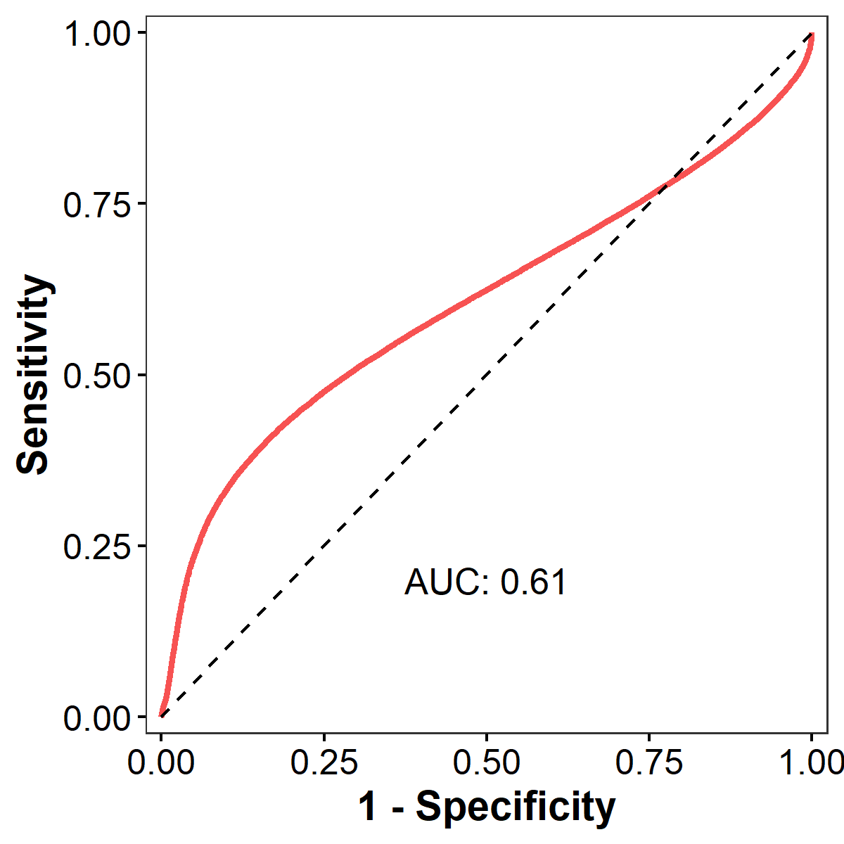

Figure S4 Modeled ROC from flow cytometry: ROC Curve based on flow data for MFN2 WT vs. MFN2 R280H mutants on the PerCP-Cy5.5-A-Compensated channel.

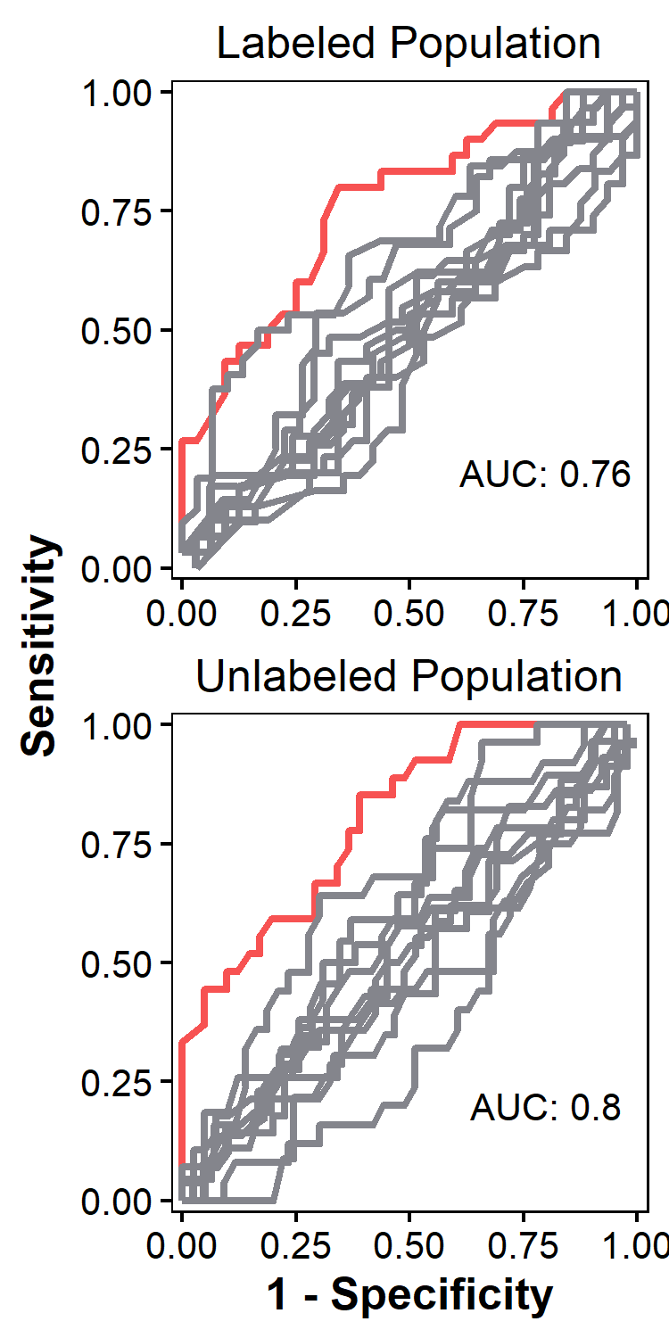
Figure S5 Results from Raft-Seq between P251A Pathogenic and D221= Benign: ROC Curves which were generated using the best model, separated by data that was generated from cells picked from wells in the labeled cell population (upper) and from the unlabeled cell population (lower). The red curves are for the models in question and the grey curves are those for control models generated by random shuffling of labels.

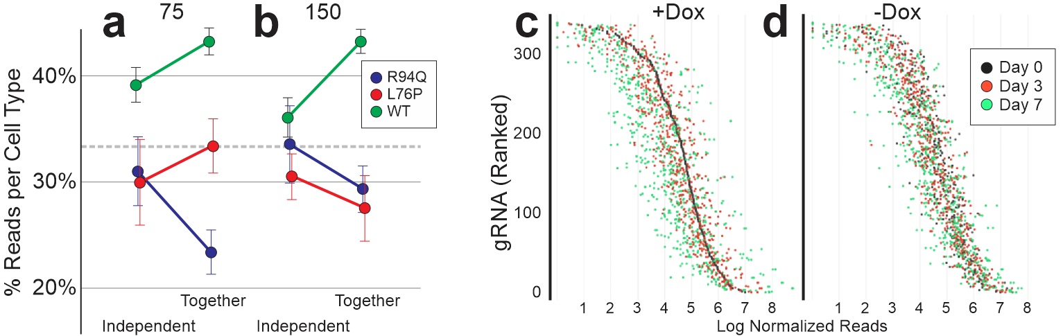
Figure S6 Fitness consequences of MFN2 mutations. a,b) U2OS stable lines containing R94Q, L76P, mutations, or the WT control line were grown in separate wells or evenly mixed together. This was done at 2 densities 75,000 (a) and 150,000 (b) cells / well of a 6-well plate and cells were allowed to grow for 4 days. Cells grown independently were harvested into the same tube (so all subsequent steps would be together). All cells were taken through the genotyping pipeline using the same primers as above, then the reads were counted, and the proportion of each cell type measured. c,d) A similar experiment was performed with the scanning MFN2-targeted gRNAs, under Dox (c) to induce Cas9 cutting, or under control conditions (d) with the gRNAs, but no Dox (and therefore no Cas9 cutting). Samples were taken initially, then at 3 and 7 days after Dox induction. Bulk timepoint samples were processed through the genotyping pipeline and reads were counted for each gRNA.

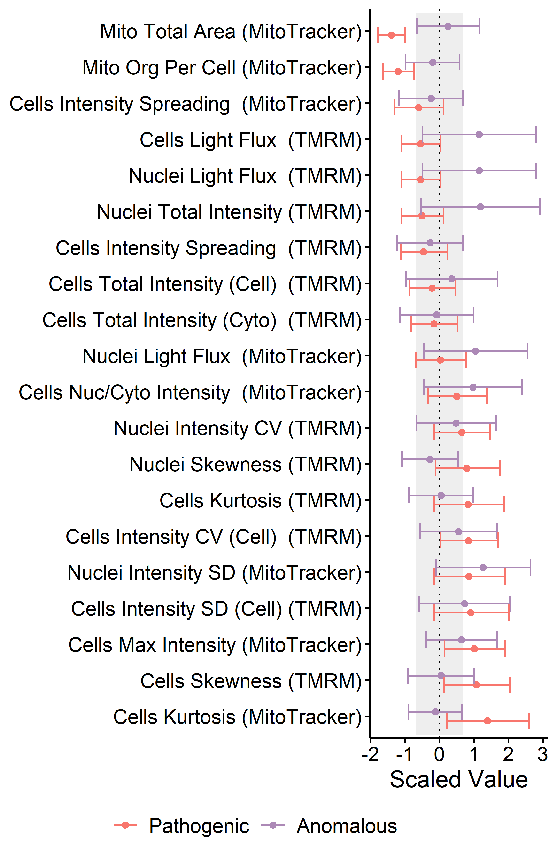
Figure S7. Isogenic Feature Comparison. We compared the distributions of the important features identified earlier for anomalous cells and strong pathogenic mutants (L76P & R94Q) by normalizing each to the distribution of the non-anomalous and benign mutants, respectively. Some of the features covaried between pathogenic and anomalous, and this pattern was stronger than in the non-anomalous (pathogenic vs. non-anomalous r² -0.02, vs anomalous r² 0.001, neither significant). Red is for the distribution in the pathogenic cells; purple is for the anomalous cells. Background grey shading indicates the base distribution for the non-anomalous/benign cells. Bar width and ranges correspond to 0.687σ in both directions, covering 50% of the data. Anomalous cells are the top 0.5% highest anomaly-detection scores from 152 models.
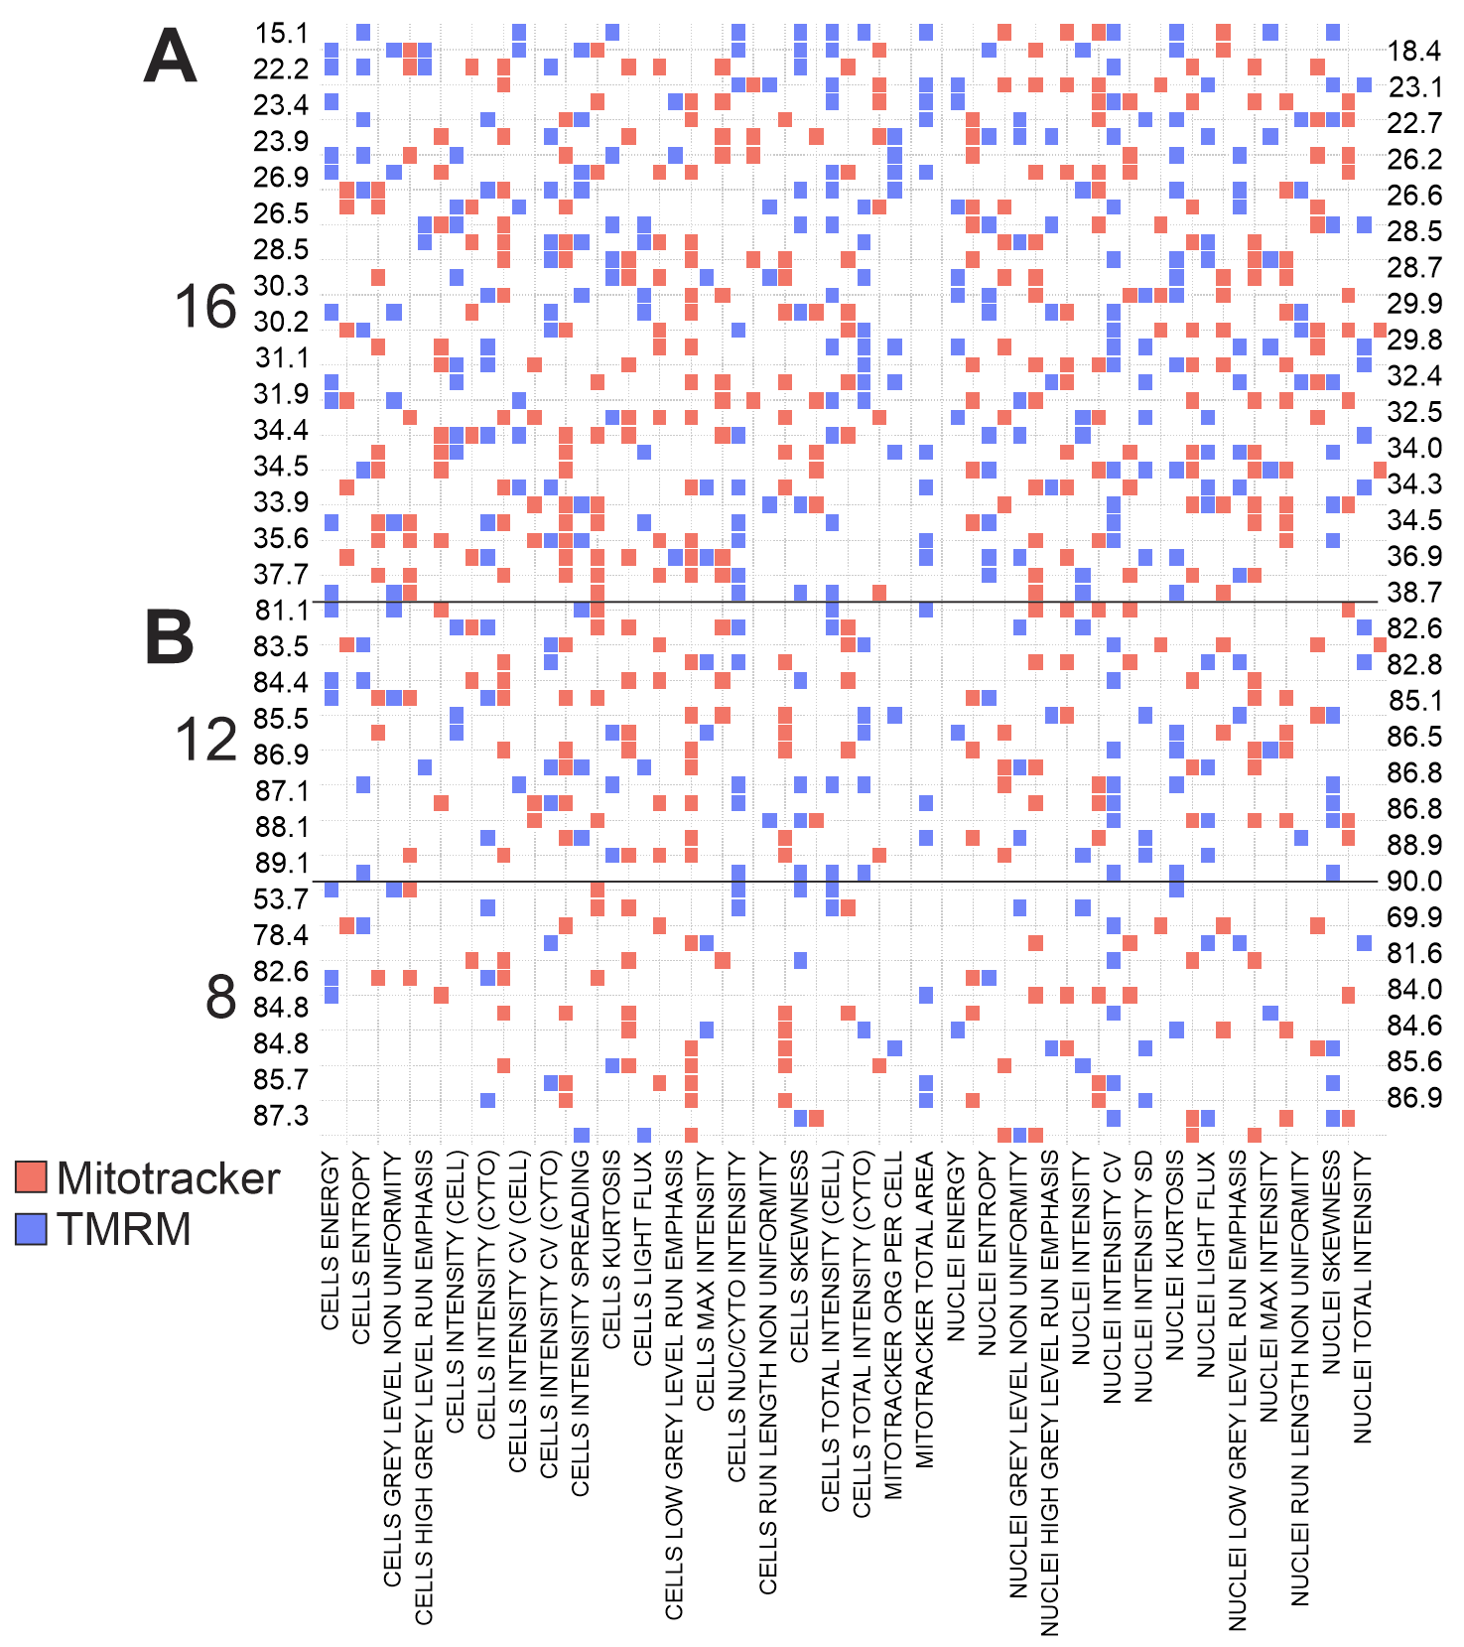
Figure S8: MFN2 Isogenic Lines carrying mutations are distinct from WT. Decision Jungles were trained on either WT vs. Known KO clones (A) or known mutants and known un-cut clones (B) with either 16, 12, or 8 features per model. Each model had a random set of features it could use in training. Then, the model was deployed and the Kruskall-Wallis p-Value comparing the model scores of the UTR/Coding mutants with the WT clones was assessed (these p-values are displayed as -log10 on either side of the graph).

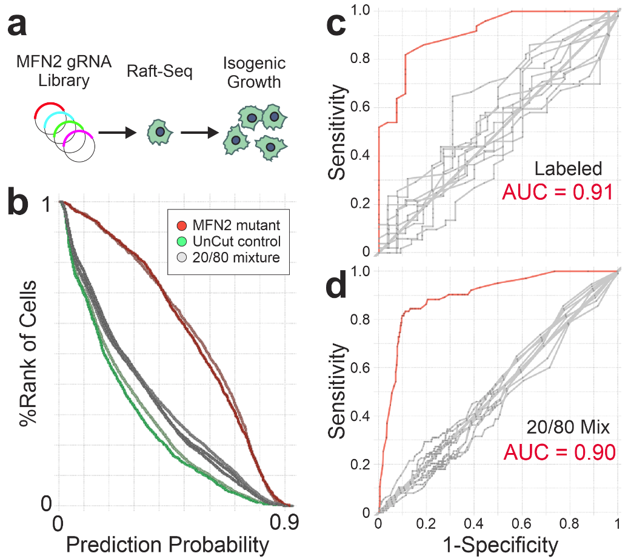

Figure S9. Endogenous MFN2 Mutant Line Can Be Effectively Separated from a Non-Cutting Control. a) U2OS cells with were screened against the MFN2 gRNA library using Raft-Seq, and single cells were picked for isogenic growth. One line, 5’ UTR Ins A04, was used here in a Raft-Seq experiment to compare its ability to separate against an un-cut control. The model was trained in AzureMLStudio (two class decision jungle) with 5 features (Nuclei Area, Mitotracker Intensity Kurtosis, Skewness, Energy and TMRM Intensity Entropy). b) Ranked histogram comparing single cells from labeled wells (where only the mutant or control were plated) against their prediction probabilities from the 5-feature model. Cells from the control (labeled) wells, and mixture well (20% mutant, 80% control) were picked and genotyped. c) ROC curves for the labeled (control) well (n=77). d) ROC curve from the wells with a mixture of the two cell types. The model performed with an AUC = 0.9, accuracy of 88%, precision 69% (n = 490 cells). Red curves are the real data while the gray curves were generated from sets of data where the link between the true genotype and the prediction probability were scrambled (noise models).

Feature | Stain
Mito Total Area | Mitotracker Red
Nuclei Low Grey Level Run Emphasis | Mitotracker Red
Mito Intensity | Mitotracker Red
Cells Entropy | Mitotracker Red
Nuclei Intensity CV | Mitotracker Red
Cells Skewness | Mitotracker Red
Cells Total Intensity (Cyto) | Mitotracker Red
Cells Intensity Spreading | Mitotracker Red

Table S1: Table of the 8 features used for cell isolation and random feature assembly with the corresponding stain.

Clone Name | Mutation | Type | DNA Cut | gRNA Sequence | Ex | I/I+C
H20fs/WT | H20 Frameshift / WT | Coding | g.chr1:11989226_11989232delCACATGG | AAATAAGAGACACATGGCTG | 2 | 0.376
V459fs/WT | V459 Frameshift / WT | Coding | g.chr1:12004594_12004595insC | CCCTTCTCCAGTAGTCCTCA | 12 | 0.46
P588fs/PQG590del/WT | P588fs / PQG590del / WT | Coding | g.chr1:12006581_12006608delCCCCACTGCCACAGGGCTCGCTCACCCA, g.chr1:12006588_12006596delGCCACAGGG | ACTGCCACAGGGCTCGCTCA/CACTGCCACAGGGCTCGCTC | 16 | 0.31
LEH710del/WT | LEH710del / 1+ WT | Coding | g.chr1:12009648_12009656delACCTGGAGC | CACCCGGGAGAACCTGGAGC | 18 | 0.24
VS507del/PV506del | Exon 15, VS507del/PV506del | Coding | g.chr1:12005732_12005737delCTGTGT,  g.chr1:12005731_12005736delCCTGTG | GTGTCTGTGCGGAGTCAGAT | 15 | 0
SRT612del/S615del/S615fs | Exon 16, SRT612del / S615del / S615fs | Coding | g.chr1:12006655_12006664delTCCAGGACC,  g.chr1:12006662_12006665delCCT,  g.chr1:12006662_12006672delCCTCCATGGG | GGACCTCCATGGGCATTCTT | 16 | 0
5'UTRdel A2P2-B05 | 5' UTR Deletion (3 var) | UTR | g.chr1:11980300_11980309delGAGGCGTAAG, g.chr1:11980302_11980332delGGCGTAAGGAGTAGGCGGGGCGAGCCGGCTG, g.chr1:11980312_11980340delGACTCGGGTCGGCCGAGCGGGGCGGATGA* | GCAGAGGCGTAAGGAGTAGG | 1 | 0
5'UTRdel/WT A3P1-E02 | 5' UTR Deletion / 2+ WT | UTR | g.chr1:11980421_11980431delCTGGGGTGGCG | CTGGGGTGGCGCTCGCTGGT | 1 | 0.38
5'UTRins A1P2-A04 | 5' UTR Insertion (3 var) | UTR | g.chr1:11980347_11980348insAAG, g.chr1:11980348_11980349insCCC, g.chr1:11980349_11980350insGGTC | CCAGCTCACCCGGGTCGAGG | 1 | 0
5'UTRdel/WT A1P1-F08 | 5' UTR Deletion / 2 WT | UTR | g.chr1:11980421_11980431delCTGGGGTGGCG | CCTGGGGTGGCGCTCGCTGG | 1 | 0.35
5'UTRdel/WT A2P1-D02 | 5' UTR Deletion / 2 WT | UTR | g.chr1:11980421_11980431delCTGGGGTGGCG | CCTGGGGTGGCGCTCGCTGG | 1 | 0.34
5'UTRdel/WT A3P2-A05 | 5' UTR Deletion / 2 WT | UTR | g.chr1:11980421_11980431delCTGGGGTGGCG | CCTGGGGTGGCGCTCGCTGG | 1 | 0.36
5'UTRdel A3P3-C09 | 5' UTR Deletion, No WT | UTR | g.chr1:11980286_11980288delGTC | AGTCGCGGGGCAGCAGAGGC | 1 | 0
5'UTRdel A3P3-D05 | 5' UTR Deletion, No WT | UTR | g.chr1:11980414_11980419delCCTCCC | CCCCCTGGGGTGGCGCTCGC | 1 | 0
3'UTRdel A2P3-E04 | 3' UTR Deletion | UTR | g.chr1:12012466_12012472delACACAGG, g.chr1:12012468_12012472delACAGG, g.chr1:12012689T>C | CACAGGACAGCTGGAGAATG | 19 | 0
3'UTRdel/WT A2P1-A08 | 3' UTR Deletion (2 different) / 1 WT | UTR | g.chr1:12013130_12013170delCCACTTCACAGCATGTCAGGGAAAATCACTGTCACACAATT, g.chr1:12013195delA | GGCCACTTCACAGCATGTCA/GGGCCACTTCACAGCATGTC | 19 | 0.09
3'UTRins A2P1-C06 | 3' UTR Indel (2 different, No WT) | UTR | g.chr1:12013045_12013046insT, g.chr1:12013195delA | TCAGTCTGTCCTGTTGTGTG | 19 | 0
3'UTRdel/WT A2P2-C04 | 3' UTR Deletion / 1 WT | UTR | g.chr1:12013094_12013104delTGTTCCCGGCG | ATGCTGTGGGTGGATGTTCC | 19 | 0.23
3'UTRdel A2P2-E05 | 3' UTR Deletion (2 different) No WT | UTR | g.chr1:12012811_12012828delGTGAGAAAAGCAGTTTGG, g.chr1:12012815_12012830delGAAAAGCAGTTTGGGT | CTGTGTGAGAAAAGCAGTTT | 19 | 0
3'UTRdel/WT A2P3-A04 | 3' UTR Deletion / WT | UTR | g.chr1:12012692_12012724delCCACCCTCCCTGATCTCCAGAACCTTCGACTGA | TCGACTGACCCCCTTGTCTT | 19 | 0.26
3'UTRdel/WT A1P1-C06 | Exon 19, 3' UTR Deletion (large) | UTR | g.chr1:12012447 [large del] | TCCACTTGGCCTCGTTCTGC | 19 | 0.32
WT A3P2-F10 | WT | WT |  | CCTGGGGTGGCGCTCGCTGG |  | 0.5
WT A2P3-G09 | WT | WT |  | CCTGGGGTGGCGCTCGCTGG |  | 0.48
WT A2P2-F12 | WT | WT |  | CCTGGGGTGGCGCTCGCTGG |  | 0.46
WT A3P3-C08 | WT | WT |  | CTGGGGTGGCGCTCGCTGGT |  | 0.51
WT A2P2-F05 | WT | WT |  | AAGGTGGGGACGTTGGTGGC |  | 0.52
WT A2P3-G12 | WT | WT |  | AGAAGAAGATCAATGGCATT |  | 0.49
WT A3P3-D08 | WT | WT |  | ATTGCTTCCTGCGGGTAGAG |  | 0.52
WT 3E5 | WT | WT | WT Parental Clone | N/A |  | 0.5

Table S2: MFN2 Isogenic mutant line information table. The U2OS isogenic lines were genotyped to determine the gRNA and the editing consequence of Cas9 cutting. The table shows the ‘Clone Name’ used in other parts of the paper as well as the longer mutation definition for the clone and the specific genomic mutation. Also listed is the sequence of the gRNA used, the exon where the cut was located, and the % of intact target reads as a ratio with a control (constant) sequence, where 0 = all alleles are mutant, and 0.5 = all alleles are WT. Variant calling was performed after paired end reads were merged using the fastq-join method from ea-tools (https://github.com/ExpressionAnalysis/ea-utils). Merged fastq files were then aligned using BWA-mem (DOI:10.1093/bioinformatics/btp324). Annotated variant call files were produced using Picard Tools (http://broadinstitute.github.io/picard/) and the Genome Analysis Tool Kit (DOI: 10.1101/201178).

Mitochondrial Feature | KW p-value
CELLS ENTROPY WVT | 2.72E-17
CELLS ENTROPY WVM | 4.40E-16
CELLS KURTOSIS WVT | 2.62E-15
CELLS ENERGY WVT | 8.06E-15
CELLS KURTOSIS WVM | 2.06E-13
CELLS SKEWNESS WVM | 3.11E-13
CELLS INTENSITY (CYTO) WVM | 3.10E-12
CELLS ENERGY WVM | 1.59E-10
CELLS INTENSITY (CELL) WVM | 1.64E-10
CELLS INTENSITY (CYTO) WVT | 2.42E-10
CELLS GREY LEVEL NON UNIFORMITY WVM | 2.60E-10
CELLS RUN LENGTH NON UNIFORMITY WVT | 3.41E-10
NUCLEI ENTROPY WVT | 4.33E-10
CELLS RUN LENGTH NON UNIFORMITY WVM | 4.78E-10
CELLS LOW GREY LEVEL RUN EMPHASIS WVT | 7.24E-10
CELLS INTENSITY (CELL) WVT | 2.49E-09
CELLS SKEWNESS WVT | 6.26E-09
NUCLEI ENERGY WVT | 9.21E-09
CELLS TOTAL INTENSITY (CYTO) WVT | 2.23E-08
CELLS TOTAL INTENSITY (CELL) WVT | 1.21E-07
NUCLEI ENTROPY WVM | 2.66E-07
CELLS TOTAL INTENSITY (CYTO) WVM | 9.80E-07
CELLS TOTAL INTENSITY (CELL) WVM | 3.76E-06
NUCLEI LOW GREY LEVEL RUN EMPHASIS WVT | 7.18E-06
CELLS GREY LEVEL NON UNIFORMITY WVT | 8.21E-06
NUCLEI RUN LENGTH NON UNIFORMITY WVT | 2.34E-05
CELLS MAX INTENSITY WVT | 3.08E-05
NUCLEI GREY LEVEL NON UNIFORMITY WVM | 5.76E-05
NUCLEI TOTAL INTENSITY WVT | 1.00E-04
NUCLEI SKEWNESS WVM | 2.04E-04
CELLS LOW GREY LEVEL RUN EMPHASIS WVM | 4.76E-04
NUCLEI INTENSITY WVT | 5.42E-04
NUCLEI TOTAL INTENSITY WVM | 5.72E-04
NUCLEI MAX INTENSITY WVT | 5.93E-04
NUCLEI INTENSITY WVM | 8.27E-04

Table S3: Individual mitochondrial features that distinguish the isogenic mutants from un-cut clones. The name of the engineered feature and the Kruskal-Wallis p-Value distinguishing the single feature’s mean difference between the cut isogenic clones (UTR or coding), and the WT isogenic clones. WVM refers to Mitotracker and WVT refers to TMRM. Features with Level in the name are texture-based features.

Clone | Baseline | FCCP | Oligomycin | ROT/AA
iCas9-3E5 | 1 (0.99/1) | 2.02 (2/2.04) | 0.39 (0.38/0.39) | 0.27 (0.27/0.27)
WT A2P2-F12 | 1.02 (1.01/1.03) | 1.5 (1.43/1.58) | 0.44 (0.42/0.46) | 0.25 (0.24/0.25)
WT A2P3-G12 | 0.8 (0.79/0.81) | 1.69 (1.66/1.72) | 0.34 (0.34/0.34) | 0.26 (0.26/0.27)
WT A3P3-C08 | 0.77 (0.77/0.78) | 1.52 (1.46/1.58) | 0.27 (0.27/0.27) | 0.21 (0.21/0.21)
WT A3P3-D08 | 1.02 (1.01/1.02) | 1.86 (1.78/1.95) | 0.42 (0.41/0.43) | 0.29 (0.29/0.3)
3'UTRdel/WT A2P3-A04 | 0.97 (0.95/0.98) | 2.02 (2/2.04) | 0.32 (0.32/0.32) | 0.21 (0.21/0.22)
5'UTRdel A2P2-B05 | 0.95 (0.93/0.97) | 2.11 (1.97/2.25) | 0.33 (0.33/0.33) | 0.22 (0.21/0.22)
5'UTRins A1P2 | 0.88 (0.88/0.89) | 1.77 (1.74/1.8) | 0.34 (0.34/0.34) | 0.25 (0.25/0.25)
3'UTRdel A2P3-E04 | 0.87 (0.86/0.88) | 1.99 (1.98/2.01) | 0.34 (0.34/0.35) | 0.2 (0.2/0.21)
3'UTRdel/WT A2P1-A08 | 0.74 (0.73/0.76) | 1.48 (1.45/1.5) | 0.29 (0.28/0.29) | 0.19 (0.19/0.2)
3'UTRdel A2P2-E05 | 0.72 (0.71/0.72) | 1.6 (1.58/1.62) | 0.26 (0.25/0.26) | 0.19 (0.18/0.19)
MFN2 L76P | 0.7 (0.7/0.71) | 1.2 (1.18/1.21) | 0.28 (0.28/0.28) | 0.2 (0.2/0.2)
H20fs/WT | 0.68 (0.67/0.68) | 1.29 (1.28/1.31) | 0.28 (0.28/0.28) | 0.21 (0.21/0.21)
V459fs/WT | 0.6 (0.59/0.61) | 1.05 (1.01/1.09) | 0.22 (0.21/0.22) | 0.15 (0.15/0.15)
VS507del/PV506del | 0.56 (0.55/0.58) | 1 (0.97/1.03) | 0.23 (0.23/0.24) | 0.17 (0.17/0.17)
3'UTRdel/WT A2P2-C04 | 0.55 (0.54/0.56) | 1.07 (1.05/1.08) | 0.18 (0.18/0.18) | 0.11 (0.11/0.11)
5'UTRdel A3P3-C09 | 0.44 (0.43/0.45) | 0.77 (0.73/0.8) | 0.15 (0.15/0.16) | 0.09 (0.09/0.1)
SRT612del/S615del/S615fs | 0.31 (0.31/0.32) | 0.53 (0.51/0.54) | 0.14 (0.14/0.14) | 0.1 (0.1/0.1)
3'UTRdel/WT A1P1-C06 | 0.2 (0.2/0.2) | 0.27 (0.26/0.28) | 0.09 (0.09/0.09) | 0.06 (0.05/0.06)
Table S4: Metabolic testing results on the U2OS MFN2 mutant isogenic cell lines. The ‘Clone Name’ for each isogenic line is given, the average and upper/lower 95% confidence intervals (in parentheses) of the OCR (pMoles/min) normalized to parental WT control (iCas9-3E5). The 4 columns indicate baseline OCR vs the OCR after adding the named toxins. Mutant clones are sorted so that normal basal activity is listed first with more disrupted activity listed further down, row borders are used as a visual aid only.

Table S5: Separate Excel File.

