Annex

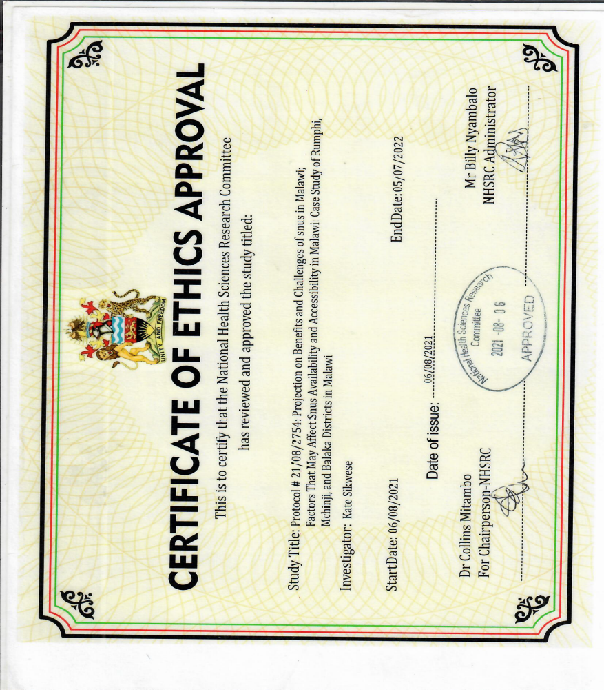
Figure 14: Certificate of ethics approval from National Health Sciences Research Committee

