Supplementary Data – Indian Covid19 Cases at Different Temperature
Jaydip Datta __________________________________________________________________________________
1. TABLE – I ( 11x 6 ) ( 6,7,8 )
H.P | 29330 | 1102 | 22161 | 0.0375 | 0.7557 | 21
Punjab | 140605 | 4428 | 130406 | 0.0314 | 0.927 | 22
Hariyana | 197952 | 2011 | 176403 | 0.0106 | 0.8911 | 20
Rajasthan | 223633 | 2056 | 203524 | 0.0092 | 0.91 | 18.5
UP | 509903 | 7354 | 479182 | 0.0144 | 0.939 | 18
MAHA | 1744698 | 46881 | 1612314 | 0.027 | 0.9241 | 25
GUJARAT | 187078 | 3794 | 170894 | 0.02 | 0.9135 | 27.5
ODISHA | 307906 | 1563 | 296516 | 0.00507 | 0.963 | 22
WB | 428498 | 7610 | 390096 | 0.01776 | 0.91 | 22
KARNATA | 860082 | 11527 | 820590 | 0.0134 | 0.954 | 22
AP | 852955 | 6854 | 826344 | 0.008 | 0.9688 | 27.5
2. CHART -III

3. Fig- III
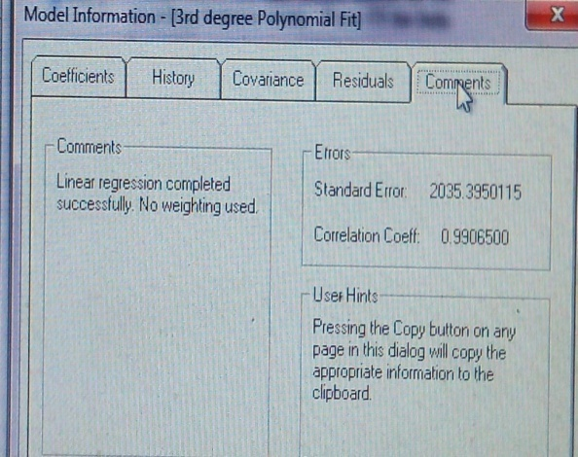
4. Fig – IV

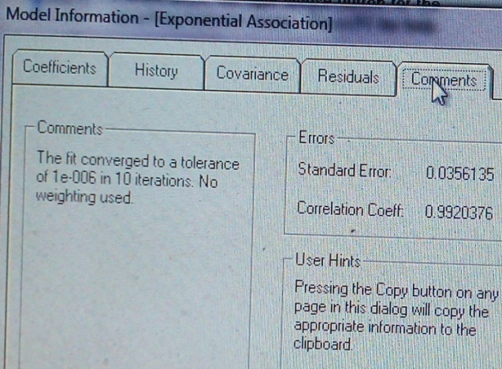

5. Jaydip Datta. A Statewise Statistical Analysis on Covid19 Cases in India at Different Temperature, 04 December 2020, PREPRINT (Version 1) available at Research Square [+https://doi.org/10.21203/rs.3.rs-121252/v1+] .
6. Link Data –

JAYDIP DATTA. (2020). Supplementary Data – Indian Covid19 Cases at Different Temperature (Version https://semver.org/spec/v1.0.0.html#semantic-versioning-100) [Data set]. Zenodo. http://doi.org/10.5281/zenodo.4362203 .

7. JSON EXPORT :

{
"files": [
{
"links": {
"self": "https://zenodo.org/api/files/20200ce5-320b-45e4-bf97-7836a42b071e/Supplimentary%20data%20%20on%20Indian%20Covid19%20Cases.docx"
},
"checksum": "md5:ed78514c817790e0fa1f4bd68b047e19",
"bucket": "20200ce5-320b-45e4-bf97-7836a42b071e",
"key": "Supplimentary data on Indian Covid19 Cases.docx",
"type": "docx",
"size": 290179
}
],
"owners": [
99235
],
"doi": "10.5281/zenodo.4362203",
"stats": {
"version_unique_downloads": 1.0,
"unique_views": 0.0,
"views": 0.0,
"version_views": 12.0,
"unique_downloads": 0.0,
"version_unique_views": 7.0,
"volume": 0.0,
"version_downloads": 1.0,
"downloads": 0.0,
"version_volume": 333494.0
},
"links": {
"doi": "https://doi.org/10.5281/zenodo.4362203",
"conceptdoi": "https://doi.org/10.5281/zenodo.4323138",
"bucket": "https://zenodo.org/api/files/20200ce5-320b-45e4-bf97-7836a42b071e",
"conceptbadge": "https://zenodo.org/badge/doi/10.5281/zenodo.4323138.svg",
"html": "https://zenodo.org/record/4362203",
"latest_html": "https://zenodo.org/record/4362203",
"badge": "https://zenodo.org/badge/doi/10.5281/zenodo.4362203.svg",
"latest": "https://zenodo.org/api/records/4362203"
},
"conceptdoi": "10.5281/zenodo.4323138",
"created": "2020-12-19T13:10:28.333399+00:00",
"updated": "2020-12-19T13:10:29.816754+00:00",
"conceptrecid": "4323138",
"revision": 1,
"id": 4362203,
"metadata": {
"access_right_category": "success",
"doi": "10.5281/zenodo.4362203",
"description": "<p>Supplimentary Datasets of&nbsp;A STATEWISE STATISTICAL ANALYSIS ON COVID19 CASES IN INDIA AT DIFFERENT TEMPERATURE derived from Curve Expert 1.4 and Excell Spreadsheet . &nbsp; &nbsp; &nbsp; &nbsp; &nbsp; &nbsp; &nbsp; &nbsp; &nbsp; &nbsp; &nbsp; &nbsp; &nbsp; &nbsp; &nbsp; &nbsp; &nbsp; &nbsp; &nbsp; &nbsp; &nbsp; &nbsp; &nbsp; &nbsp;&nbsp;</p>",
"language": "eng",
"title": "Supplementary Data \u2013 Indian Covid19 Cases at Different Temperature",
"license": {
"id": "CC-BY-4.0"
},
"relations": {
"version": [
{
"count": 2,
"index": 1,
"parent": {
"pid_type": "recid",
"pid_value": "4323138"
},
"is_last": true,
"last_child": {
"pid_type": "recid",
"pid_value": "4362203"
}
}
]
},
"version": "https://semver.org/spec/v1.0.0.html#semantic-versioning-100",
"references": [
"https://www.researchsquare.com/article/rs-121252/latest",
"https://covidindia.org/"
],
"keywords": [
"Covid19",
"Indian State",
"Best fit regression",
"Temperature"
],
"publication_date": "2020-12-15",
"creators": [
{
"name": "JAYDIP DATTA"
}
],
"access_right": "open",
"resource_type": {
"type": "dataset",
"title": "Dataset"
},
"related_identifiers": [
{
"scheme": "doi",
"identifier": "10.5281/zenodo.4323138",
"relation": "isVersionOf"
}
]
}
}

