Supplementary Data -
A STATEWISE STATISTICAL ANALYSIS ON COVID19 CASES IN INDIA AT DIFFERENT TEMPERATURE
1. TABLE – I ( 11x 6 ) ( 6,7,8 )
H.P | 29330 | 1102 | 22161 | 0.0375 | 0.7557 | 21
Punjab | 140605 | 4428 | 130406 | 0.0314 | 0.927 | 22
Hariyana | 197952 | 2011 | 176403 | 0.0106 | 0.8911 | 20
Rajasthan | 223633 | 2056 | 203524 | 0.0092 | 0.91 | 18.5
UP | 509903 | 7354 | 479182 | 0.0144 | 0.939 | 18
MAHA | 1744698 | 46881 | 1612314 | 0.027 | 0.9241 | 25
GUJARAT | 187078 | 3794 | 170894 | 0.02 | 0.9135 | 27.5
ODISHA | 307906 | 1563 | 296516 | 0.00507 | 0.963 | 22
WB | 428498 | 7610 | 390096 | 0.01776 | 0.91 | 22
KARNATA | 860082 | 11527 | 820590 | 0.0134 | 0.954 | 22
AP | 852955 | 6854 | 826344 | 0.008 | 0.9688 | 27.5
2. CHART -III

3. Fig- III
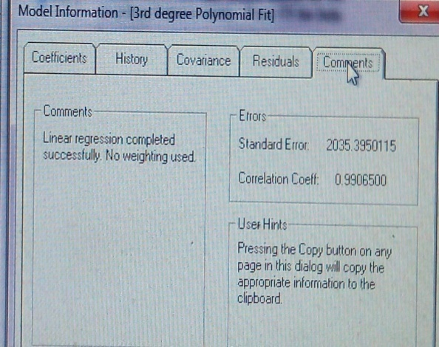

4. Fig – IV

