Supplementary Information for
Single Particle Hopping as an Indicator for Evaluating Electrocatalysts
Jun-Gang Wang,¹ Linjuan Zhang,² Jing Xie,³ and Di Li^{*1, 4}
¹ School of Chemistry and Molecular Engineering, East China Normal University, Shanghai 200241, China
² Key Laboratory of Interfacial Physics and Technology, Shanghai Institute of Applied Physics, Chinese Academy of Sciences, Shanghai 201800, China
³ Institute of Microelectronics, Chinese Academy of Sciences, Beijing 100029, China
⁴ Key Laboratory of Bioorganic Phosphorus Chemistry & Chemical Biology, Department of Chemistry, Tsinghua University, Beijing, 10084, China

Supplementary Note 1: Experimental Section
Chemicals
Copper sulfate (CuSO₄, ≥ 99.5 %) was purchased from J&K Scientific Ltd. (Shanghai, China). Potassium hydroxide (KOH, ≥ 85.0 %), sodium perchlorate monohydrate (NaClO₄ H₂O, ≥ 99.0 %), potassium ferricyanide (K₃[Fe(CN)₆], ≥ 99.5 %), potassium ferrocyanide (K₄[Fe(CN)₆], ≥ 99.5 %), acetone (analytical reagent), isopropanol (analytical reagent) and ethanol (analytical reagent) and hydrofluoric acid (analytical reagent) were purchased from Sinopharm Chemical Reagent Co., Ltd. (Shanghai, China). Rhodamine 6G (R6G), calcium nitrate tetrahydrate, cobalt nitrate hexahydrate, iron acetate, citric acid and urea were purchased from Sigma-Aldrich. All reagents were of analytical grade and used as received without any further purification. The solution was prepared using deionized water. Deionized water filtered by a Milli-Q system at a resistivity of > 18.2 MΩ cm and then re-filtered by 200 nm membrane filters was used throughout the experiments. ITO-coated glass (sheet resistance 20-30 Ω sp⁻¹; 1 mm and 0.13-0.17 mm thickness) was purchased from Shenzhen Laibao Technology Co. Ltd. (Shenzhen China). Coverslip (0.13-0.17 μm thickness) for total internal reflection microscope analysis was purchased from Thermo Fisher Scientific (Shanghai, China). Polydimethylsiloxane (PDMS) was fabricated from silicone elastomer from Dow Corning Corporation (Germany).
Electrochemical Deposition of Cu Planar Electrode
The ITO-coated glass was firstly cleaned with ethanol, and washed successively in acetone, isopropanol and water for at least 30 min under sonication, and dried under a flow of nitrogen gas. Then the ITO electrodes were incubated in 0.1 M HF for 30 s and rinsed three times with copious deionized water. Subsequently, the electrodes were treated with O₂ plasmon for 5 min (Harrick, PDC-32G-II, USA).¹⁻² A saturated calomel reference electrode (SCE) was used as reference electrode (RE), and a Pt wire was used as counter electrode (CE) for electrochemical deposition of Cu seeds and subsequent growth of Cu catalytic interface on the ITO electrode. For the electrodeposition of Cu interface, a deposition solution containing 1.0 mM CuSO₄ and 0.10 M NaClO₄ was used. First, a potential step from 0.20 to - 0.60 V was applied on the deposition solution, then the open circuit potential of the ITO working electrode was changed from 0.20 to - 0.01 V. Second, the as-prepared Cu seeds on ITO electrode (abbreviated to Cu seeds/ITO electrode) was served as the working electrode for subsequent growth of Cu interface in the same electrochemical cell. The growth process was performed by a cyclic voltammetry during a dynamic potential range from - 0.10 to - 0.30 V with 150 deposition cycles³, at a scan rate of 0.05 V s⁻¹. Then, the as-prepared electrode (abbreviated to Cu/ITO electrode) was removed from the deposition solution and rinsed copiously with deionized water. Last, the Cu/ITO electrode was dried under a gentle stream of nitrogen before its utilization for gas evolution reaction.
Synthesis of Electrocatalysts
Calcium cobaltite and Fe-doped calcium cobaltite were synthesized using simple sol-gel methodology. Briefly, 1.5 mM calcium nitrate tetrahydrate and 2.0 mM cobalt nitrate hexahydrate were dissolved in 40 mL deionized water, and vigorous stirred after the addition of citric acid and urea. Followed by a drying process at 80 °C (12 h) to form a gel, the gel was decomposed at 160 °C for 12 h and then annealed at 700 °C for another 12 h. Fe-doped Ca₃Co₄O₉ were prepared following a similar process, in which iron acetate were used to substitute cobalt nitrate hexahydrate. More detailed preparation procedure can be found in previous report.⁴ Pt-g-C₃N₄ and g-C₃N₄ were prepared according to previous work.⁵
Electrochemical Measurements
A CHI660E electrochemical station (CH Instruments, Shanghai, China) was used in all measurements. Electrochemical measurements were performed in a conventional one-compartment cell in conjunction with a standard three-electrode system and the micro-electrochemical cell, respectively. Linear sweep voltammetry (LSV) was performed at a scan rate of 0.10 V s⁻¹ to define the onset potential of surface gas evolution. Electrochemical impedance spectroscopy (EIS) analysis was conducted under open circuit potential with the frequencies ranging from 100 kHz to 0.1 Hz with an amplitude of 10 mV for iR correction of the uncompensated series resistance. Double-layer capacitance (C_{dl}) was used to measure the variation of the electrochemical active surface area (A_{ECSA} = C_{dI}/C_{s}) among various electrodes. The C_{dl} measurements were carried out in a non-faradaic potential range from 0.10 to 0.20 V (vs Pt quasi-reference electrode, QRE) by recording the current intensities as a function of potential scan rate (2, 4, 6, 8 and 10 mV s⁻¹). C_{s} is the specific capacitance of the sample, here, we used a typical reported value of 40 μF cm⁻² to calculate A_{ECSA}.⁶ On the basis of cyclic voltammetry curves in a 0.10 M KNO₃ solution containing 5.00 mM K₃[Fe(CN)₆] (Supplementary Figure 1), the ΔE₀^{1/2} was calculated as 0.286 V between using Pt QRE and saturated calomel electrode (SCE).
EC-TIRM measurements were performed in a homemade three-electrode microelectrochemical cell with a Pt wire counter electrode and a Pt wire QRE. In the micro-electrochemical cell, gas evolution reaction was carried out in potential range from - 0.50 to 1.20 V (vs Pt) at a scan rate of 0.10 V s⁻¹ and real time monitored by EC-TIRM. The electrolyte solution was bubbled with N₂ gas for 20 min prior to eject into the micro-electrochemical cell.
For electrochemical catalytic experiments, the catalyst inks were prepared by dispersing 5 mg each catalyst (IrO₂, Co₃O₄, Ca₃Co₄O₉, Ca₃Co_{3.2}Fe_{0.8}O₉, g-C₃N₄ and Pt-g-C₃N₄), 50 μL of 5 wt % Nafion solution and 150 μL of anhydrous alcohol in 800 μL of deionized water by at least 30 min ultrasonic processing to generate a relatively homogeneous suspension. Note that using a low concentration of Nafion can avoid a continuous thick film formation on the electrode and eliminate mass transfer perturbation on catalyst evaluation. The working electrode was prepared by drop-coating 20 μL catalyst ink onto the ITO electrode (0.6 cm²) that providing a mass loading of 8.33 mg cm⁻². During catalyst screening measurements, the measured potential values (vs Pt QRE) were converted to the reversible hydrogen electrode (RHE) scale by using the following equation at 25 ℃, note that we calibrated the potential to SCE reference electrode,
$E_{RHE}=E_{SCE}+E_{SCE}^{°}+0.059∙pH$ (1)
where E_{RHE} is the converted potential vs RHE, E_{SCE}° is the standard potential of SCE at 25 ℃, taken to 0.241 V and E_{SCE} is the measured polarization potential against the SCE. As the E_{Pt} = E_{SCE} – 0.286 V, we can obtain the calibrated potential versus the RHE: E_{RHE} = E_{Pt} + 1.30 V. The overpotential η was calculated following the equation η = E_{RHE} – 1.23 V. Tafel slope b of the catalysts was extracted by the equation, η = blogj + a, in which j is the polarization current density, b is the Tafel slope and a is a constant. The Tafel plot was used to describe the kinetic behavior of the electrode-electrolyte interface for OER. It was derived from the linear region of LSV curves that were plotted between the log of current density and polarization potential. The turnover frequency (TOF) was calculated to reveal the intrinsic OER performance of electrocatalysts. It was evaluated using the following equation:
$TOF=\frac{j∙A}{n∙F∙N} s^{-1}$ (2)
where j is the current density at a specific applied potential (1.20 V vs Pt), A is the electrochemical surface area of the electrode, F is the Faraday constant (96 485 C mol⁻¹), n is the number of transferred electrons for forming one oxygen molecule (n = 4), N is the number of moles of active metal on the electrode. It should be noted that the nature of the surface active sites was not yet understood and the exact number of binding sites was not known, we thus estimated the number of the active sites as the total number of the surface sites from the bulk electrodes, which may lead to an underestimation in evaluation of real TOF.
Finite Element Simulations
To track the oxygen and hydroxide distribution at the electrode-electrolyte interface during OER, one-dimension finite element modelling was established.³ Assuming the presence of sufficient supporting electrolyte to ensure the conductivity of the electrolyte without any perturbance on the interfacial electrochemical reaction.⁷ Hence, the resistance of the solution was relatively low and the induced concentration polarization was negligible. To describe the mass transport of both reactant and product species in the electrochemical reaction, Fick’s 2nd law was adopted to illustrate the mass transport of the electroactive species O₂ and OH⁻:⁸
$\frac{∂c_{i}}{∂t}=∇∙(D_{i}∇c_{i})$ (3)
At the initial stage, a uniform concentration distribution at the bulk electrolyte (x = L) and no product was present in bulk. At the electrode surface (x = 0), the reactant OH⁻ lost one electron to form 0.25 equivalent oxygen. The electrochemical interfacial reaction was expressed as the reductive form:
1/4 O₂ + 1/2 H₂O + e⁻→ OH⁻ (4)
The current density of this reaction was calculated based on the Bulter-Volmer equation for an oxidation:⁹
$i_{a}=nFk_{0}\left(c_{{OH}^{-}}exp\left(\frac{(n-α)Fη}{RT}\right)-c_{O_{2}}exp\left(\frac{-αFη}{RT}\right)\right)$ (5)
in which F is the Faraday’s constant (96485 C mol⁻¹), k₀ was the heterogeneous rate constant of the reaction (510⁻¹⁶ m s⁻¹, which was taken from the rate determining step for formation of the peroxide intermediate HOO during oxygen evolution reaction)¹⁰, α was the cathodic transfer coefficient (0.5) and η was the overpotential at the polarized electrode relative to the equilibrium potential of the redox couple of OH⁻ and O₂. Furthermore, the electrode surface boundary condition was drawn based on Faraday’s law, in which the flux of the reactant and product species (N_{i}) were proportional to their current density (i_{a}):
$-n∙N_{i}=\frac{ν_{i}i_{a}}{nF}$ (6)
Considering the oxygen evolution reaction at the Cu electrode was performed at relatively large overpotential under kinetic control, the polarized current density was assumed to be independent of the thermodynamic performance of electrocatalysts. Thereby, increasing the anodic polarization, a concentration field profile was established which exhibited a dynamic behavior as a function of distance from the electrode surface. Based on the numerical simulation, the dynamic oxygen and hydroxide concentration profile during dynamic potential was identified shown in Supplementary Figure 9. Note that the numerical simulation of the potential-dependent concentration profiles of both reactant (hydroxide) and products (oxygen) revealed that the conspicuous confinement for oxygen in diffusion layer at high potential scan rate (0.10 V s⁻¹) facilitated oxygen nanobubble nucleation and growth at the electrode-electrolyte interface.
Fabrication of the Microelectrochemical Cell
The total internal reflectance fluorescence compatible microelectrochemical cell was fabricated following the strategy presented in our previous publication with some necessary modifications.¹¹⁻¹² In brief, a liquid microchamber with a size of 6.0 × 6.0 × 2.0 mm³ (length × width × depth) was machined on a PDMS block. A standard three-electrode system was constructed, in which two Pt wires with 0.5 mm diameter served as CE and QRE electrode, respectively. The ITO working electrode (WE) was hermetically sealed with epoxy. Moreover, WE was connected to copper wires by conductive silver epoxy and then glued at bottom of the liquid chamber. The three electrodes were connected to an electrochemical workstation (CHI 660E) to complete the setup. This general setup procedure was used for all electrochemical total internal reflection microscopy experiments. The schematic of the detailed assembly of the microelectrochemical cell was shown in Supplementary Figure 1. The feasibility of microelectrochemical cell was verified by cyclic voltammetry in a 5 mM K₃[Fe(CN)₆] solution.

Supplementary Table S1. Comparison of Operando Techniques Employed in Energy Research.
 | In situ ToF-SIMS¹³ | In situ TEM¹⁴ | In situ X-ray spectroscopy¹⁵ | In situ Raman spectroscopy¹⁶ | In situ neutron reflectometry¹⁷⁻¹⁸ | In situ TIRM
Radiation | Ions | Electrons | X-rays | Light  (400-900 nm) | Neutrons | Light  (400-700 nm)
Lateral resolution | 50-100 nm | Atomic resolution | ~25 nm | 10-200 nm | 20-30 μm | 200 nm
Penetration depth | 1~5 nm | ~200 nm | 100 nm-5 μm | ~300 nm | 1-500 nm | 200 nm
Acquisition time | Seconds to minutes | Seconds to minutes | Seconds to minutes | Minutes | Minutes | Sub ms
Sampling requirements | Vacuum compatible in situ liquid cell | Vacuum compatible in situ liquid cell | Full electrode | Full electrode | Vacuum compatible in situ liquid cell | Full electrode
Beam energy | 20-30 keV | 10 keV-1 MeV | 250 eV-50 keV | 1-100 mW | 2-200 meV | <10 mW
Operation conditions | High vacuum | High vacuum | Ambient pressure | Ambient pressure | High vacuum | Ambient pressure
Acquired information | Secondary ion profiles provide molecular and elemental distribution in sample surface | It visualizes the detailed atomic arrangements and crystallographic information | It indicates the electron structure and elemental distribution in the surface. | Raman scattering provides specific vibrational modes of surface species | Reflectivity profiles reveal the structure and composition of the thin layer covered surface. | Scattering contrast is sensitive to the environment and location of the sample from focus plane.

Supplementary Note 2: Electrochemical Total Internal Reflectance Microscopy
Imaging of dynamic multi-phase interface evolution under polarization (operando imaging) is unachievable by conventional electrochemical approaches because of (i) severe interference from non-Faradaic processes and concomitant spectator interfacial reactions at the electrode surface; (ii) intrinsic limitations in high-temporal-spatial resolution acquisition caused by the heterogeneous potential gradient at the electrode interface, thereby multi-phase interface dynamics at the electrode-electrolyte interface cannot be uncovered in conventional electrochemical measurements. In order to precisely monitoring the multi-phase interface evolution processes on the electrode-electrolyte interface, it is imperative that the reference electrode provides stable and constant potential and exhibits a rapid response to changes in external conditions.¹⁹⁻²⁰ Considering the poor stability of the commonly used miniaturized Ag‐based “quasi‐reference/counter electrode” systems, in which AgCl wires, at alkaline pH values and at higher current densities results in a non-negligible drift in the working electrode potential making the microscale voltametric measurements instable.²¹ Here, we introduced a non‐interfering Pt wire as a pseudo-reference electrode located as close as possible to the working electrode, without making contact with the ITO electrode surface (Supplementary Figure 1, a), in order to reduce the effect of ohmic drop across the platinum wire and, thus, to improve charge transfer during dynamic potential scan. Moreover, the functionality of the Pt pseudo-reference electrode was evaluated by conduction cyclic voltammetry of the Fe³⁺/Fe²⁺ redox couple using three-electrode cell with a ITO working electrode, a platinum wire counter electrode, and either the Pt pseudo-reference electrode or the saturated calomel electrode (SCE). Supplementary Figure 1, b displays cyclic voltammograms obtained with the two reference electrode systems at a scan rate of 0.10 V s⁻¹. For the Pt pseudo-reference system, the dynamic equilibrium potential of the redox couple Fe³⁺/Fe²⁺ shifted ca. 0.286 V toward cathode polarized direction compared to the SCE reference electrode. Furthermore, in order to estimate the kinetics of the reduction and oxidation of redox probes on the ITO electrode surface, the CVs at different scan rates were recorded (Supplementary Figure 1, c). Both the cathodic and anodic peak currents were proportional to the square root of the scan rate, indicating a typical diffusion-controlled process with fast electron-transfer behavior. Moreover, during the consecutive 30 cycles, the Pt pseudo-reference electrode exhibited remarkable reproducibility and desirable stability which showed ca. 2 mV fluctuation during the dynamic potential scan (Supplementary Figure 1, e-g). The adopted Pt pseudo-reference system enabled the microminiaturization of the electrochemical cell for EC-TIRM in which it was impracticable to employ the conventional reference electrode in immediate vicinity of the working electrode. Meanwhile, it eliminated the interference induced by the electrolyte leakage from the conventional reference electrode. The established Pt pseudo-reference system will contribute to accurately monitoring redox reactions in specific electrochemical systems in which offer only limited access to conventional reference electrodes, and quantitatively describe these reactions in a less empirical manner.
During EC-TIRM analysis, the sharp raising indicated an adsorption of a single fluorophore R6G, and followed by a falling transition to the baseline associated with the departure of the fluorophore from the bubble surface. Based on statistics of these temporal fluorescence trajectories, the inhomogeneous diffusion patterns on single active sites and their quantitate distribution were effectively identified (Supplementary Figure 5): (i) 38% is drastic supersaturated region, where high stability and efficiency for OER was observed, which might be attributed to the surface defects introduced during electrochemical seed-mediated growth of Cu interface.²² (ii) 21% is moderate supersaturated regions, where only random catalytic events was observed during dynamic potential scan. (iii) 12% regions showed only higher initial stability then suffered a fast attenuation. The possible surface adsorbates blocked active sites beneath supersaturated regions and further induced the surface reorganization contributed to the irreversible deactivation. (iv) 29% regions revealed an obvious incubation time was needed before supersaturated regions appearance. Once supersaturated regions were appeared, they maintained high stability for oxygen bubble nucleation, which empowered the recovery of the activity or the generation of new active sites for formation of local supersaturated regions.²³⁻²⁴ These variability of supersaturated patterns across the electrode surface strongly correlated to local structure inhomogeneity. Therefore, the minute local structural heterogeneous such as crystal grains, corners, edges and nano-junctions could contribute to the heterogeneous supersaturated regions across the same electrode. The efficient spatial-temporal recognition fluctuations of local supersaturated regions without disturbance from time-average effect (static reactivity pattern) implied that one should pay more attention to introducing local stable catalytic sites and shortening the incubation time. It will benefit deeply to understand the fluctuation of catalytic activity and rationally improve the advanced electrocatalysts.
The nucleation rate of oxygen bubbles, as a function of applied potential, was further modeled by classical nucleation theory and shown as Arrhenius expression:²⁵⁻²⁶
$N_{0}=D_{0}C_{0}exp\left(-Φ(θ)\frac{16πσ^{3}V^{2}}{3k_{B}T{(nF(E-E_{0}))}^{2}}\right)$ (7)
where D₀ represents the flux of dissolved molecules into the bubble nuclei, C₀ denotes the molecule concentration in the nuclei, σ is the interfacial surface tension at the gas-liquid interface, V is the volume of the bubble nuclei, n is the number of transferred ion charge, F represents the Faraday’s constant (96485 C mol⁻¹), E is the applied potential, E₀ is the equilibrium potential of the gas evolution reaction, T is the temperature and k_{B} is Boltzmann’s constant (1.38×10⁻³² J K⁻¹). The geometric factor is shown as Φ(θ)=1/4(2+cosθ)(1-cosθ)².

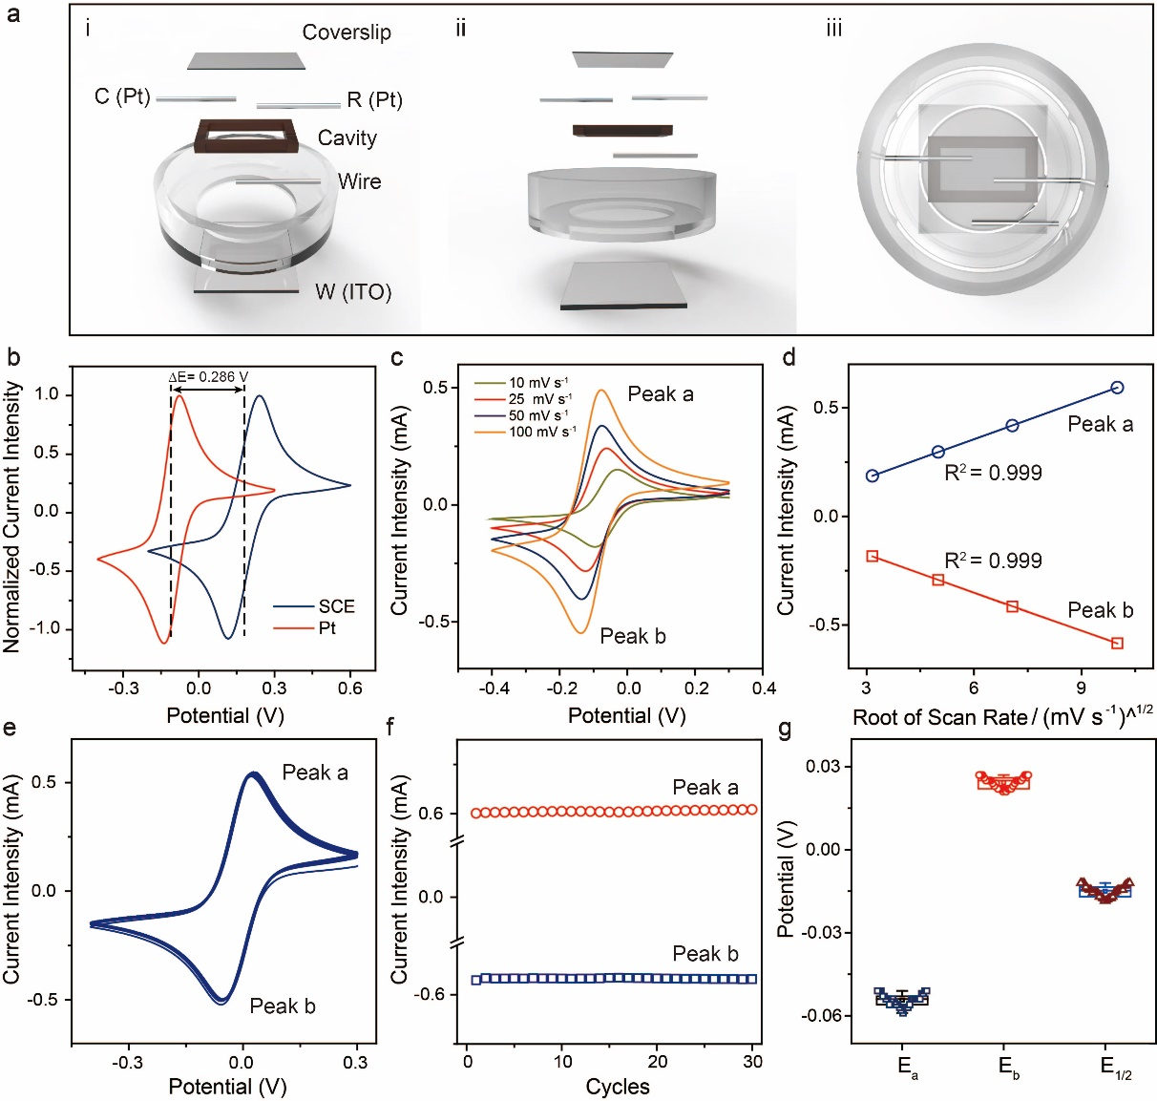
Supplementary Figure 1. (a) Schematic illustration of assembly of an electrochemical micro-device for total internal reflectance microscopy (i-iii). (b) Cyclic voltammograms (CV) in 0.10 M KNO₃ and 5.00 mM K₃[Fe(CN)₆] aqueous solution for a bare ITO electrode coupled with different reference electrode, Pt electrode (red line) and SCE (blue line), respectively. Scan rate: 0.10 V s⁻¹. The dynamic equilibrium potential (E_{1/2}) of the redox couple negatively shifted ca. 0.286 V in comparison with SCE. (c) Scan rate dependence of CV curves for an ITO electrode in 0.10 M KNO₃ and 5.00 mM K₃[Fe(CN)₆] aqueous solution. Scan rate: 0.010, 0.025, 0.050 and 0.100 V s⁻¹. (d) The dependence of the peak currents of a and b on the square root of the scan rate. (e) CV for consecutive 30 cycles for a homemade micro-electrochemical cell in 0.10 M KNO₃ and 5.00 mM K₃[Fe(CN)₆] aqueous solution. Scan rate: 0.10 V s⁻¹. (f) The fluctuations of polarized current intensity (peak a and b) during consecutive 30 potential scans. (g) The statistic of both anodic (E_{a}) and cathodic (E_{b}) polarized peak potential as well as dynamic equilibrium potential (E_{1/2}) during consecutive 30 potential scans.

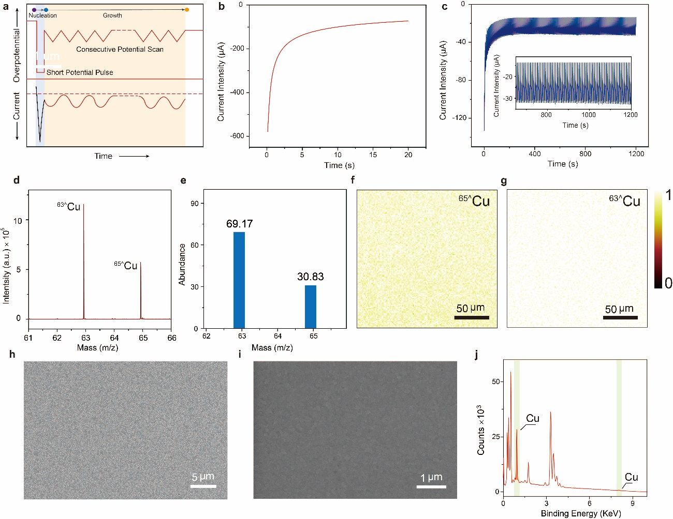
Supplementary Figure 2. (a) Schematic illustration of the electrochemical seed-mediated growth of Cu interface. The proposed overpotential and corresponding current for this electrochemical deposition method were demonstrated in top and bottom panel, respectively. (b) The experimental chronoamperometry profile for the seeding step at - 0.60 V (vs SCE), 20 s. (c) The experimental current intensity for the growth step within a potential scanned ranging from - 0.10 to - 0.30 V (vs SCE), at a scan rate of 0.05 V s⁻¹, 150 cycles. Inset showed the enlarged view of the current intensity. (d) Negative secondary ion mass spectra of Cu species on the Cu/ITO electrode. The as-synthesized platform was chemical identified and imaging via ToF-SIMS. The presence of Cu in the interface was confirmed by the isotope peaks of Copper on the ITO electrode (⁶³^Cu and ⁶⁵^Cu). It was same with the natural isotope distribution of copper (e). The chemical imaging of Cu isotopes (⁶³^Cu and ⁶⁵^Cu) revealed homogenous distribution of Cu isotopes and indicated the homogeneity for the electrochemical deposited Cu on the ITO electrode. (h) and (i) FE-SEM images of Cu/ITO electrode and bare ITO electrode, respectively. (j) EDX spectrum of the Cu/ITO electrode. The yellow region indicated the presence of copper species on the electrode.

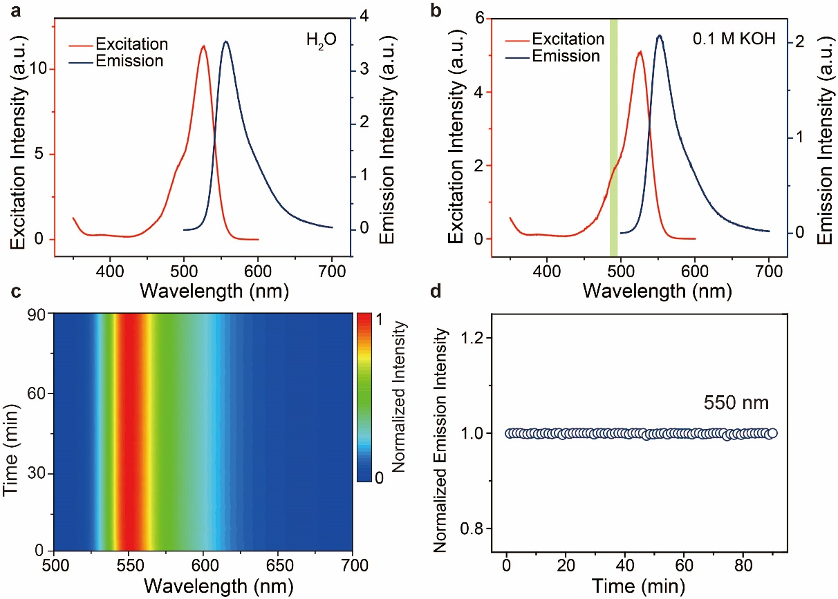
Supplementary Figure 3. The influence of hydroxyl ions concentrations on the photostability of R6G during consecutive total internal reflectance fluorescence microscopy analysis. The excitation and fluorescence emission spectra of R6G in H₂O (a) and 0.10 M KOH (b). The excitation laser (488 nm) was indicated by the light yellow region. (c) The full fluorescence emission spectra (contour plots) of R6G exposed to the electrolyte containing 0.10 M KOH for 90 min. (d) The fluctuation of the normalized excitation peak intensity at 550 nm of R6G in 0.10 M KOH during 90 min.

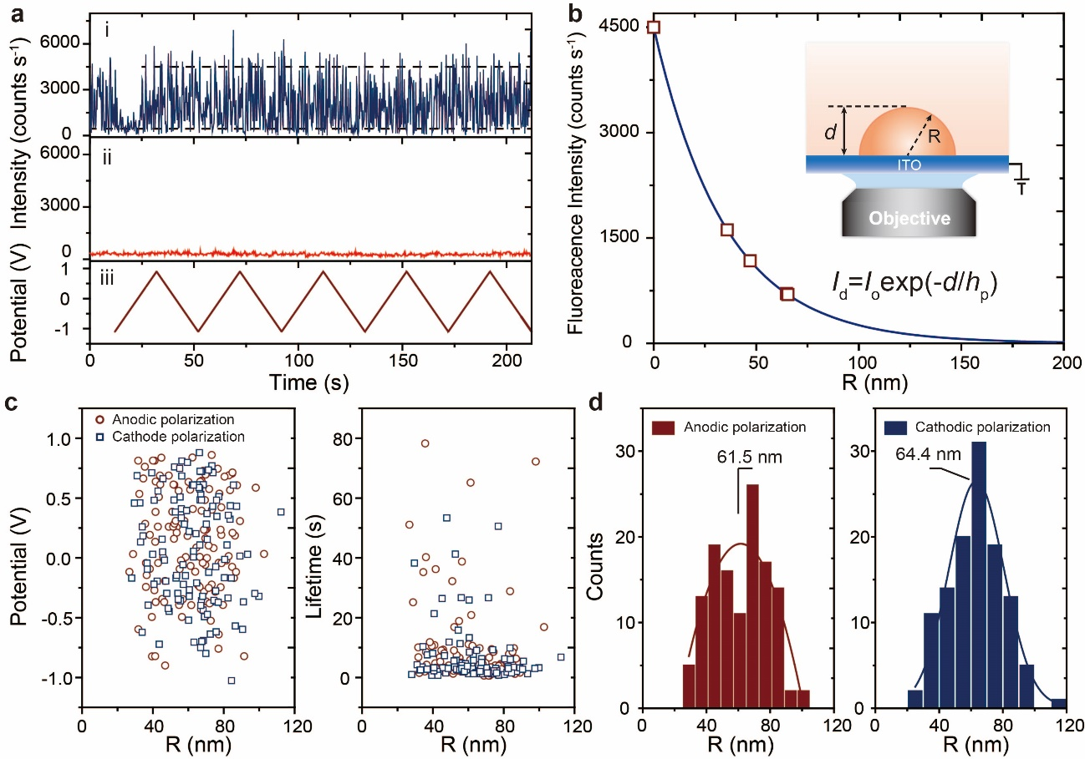
Supplementary Figure 4. (a) The representative fluorescence intensity time trajectory of a R6G molecule that adsorbed on the electrode surface (i) and a background site without R6G molecule adsorption (ii) during dynamic potential scan in potential range from - 1.10 to 0.90 V vs Pt, at a scan rate of 0.10 V s⁻¹, (iii) Consecutive CV curves (5 cycles) obtained in the homemade micro-electrochemical cell in 0.10 M KOH. (b) The correlation between the fluorescence emission intensity of single R6G molecule and its’ distance from the electrode-electrolyte interface. Four representative intensity-size relationships for surface gas bubbles were taken from Figure 2c in the main text. Inset showed schematic of the evanescent field induced by the total internal reflection at the electrode-electrolyte interface. The size of surface gas bubble was estimated from fluorescence intensity exponentially decay of labeled R6G molecules in evanescent field (I_{d} = I₀exp(-d/h_{p})). I₀ is the fluorescence intensity of a single R6G molecule that directly adsorbed on the electrode-electrolyte interface with distance d = 0 from the electrode surface. Here, the wavelength of the incident light is 488 nm, h_{p} is the penetration depth can be calculated based on the equation:²⁷
$$h_{p}=\frac{λ}{4π\sqrt{n_{1}^{2}{sinθ}^{2}-n_{2}^{2}}}$$
where n₁ and n₂ is the refractive index of ITO (n₁ = 1.515) and gas in the bubbles (n₂ = 1.000 for O₂), respectively, the incident angle θ = 80°, d is the distance between R6G molecule and the electrode surface and I_{d} is the fluorescence intensity measured during single bubble analysis. Assuming the surface gas bubble has a hemispherical shape and the adsorbed R6G located at the vertex of the gas bubble, hence, the radius R of the surface gas bubble is equal to the distance d. (c) The relationship between the size of surface gas bubbles and their evolution onset potential as well as bubble lifetime during anodic polarization (red circle) and cathodic polarization (blue square), respectively. (d) The distribution of the bubble radius during anodic polarization and cathodic polarization, respectively.

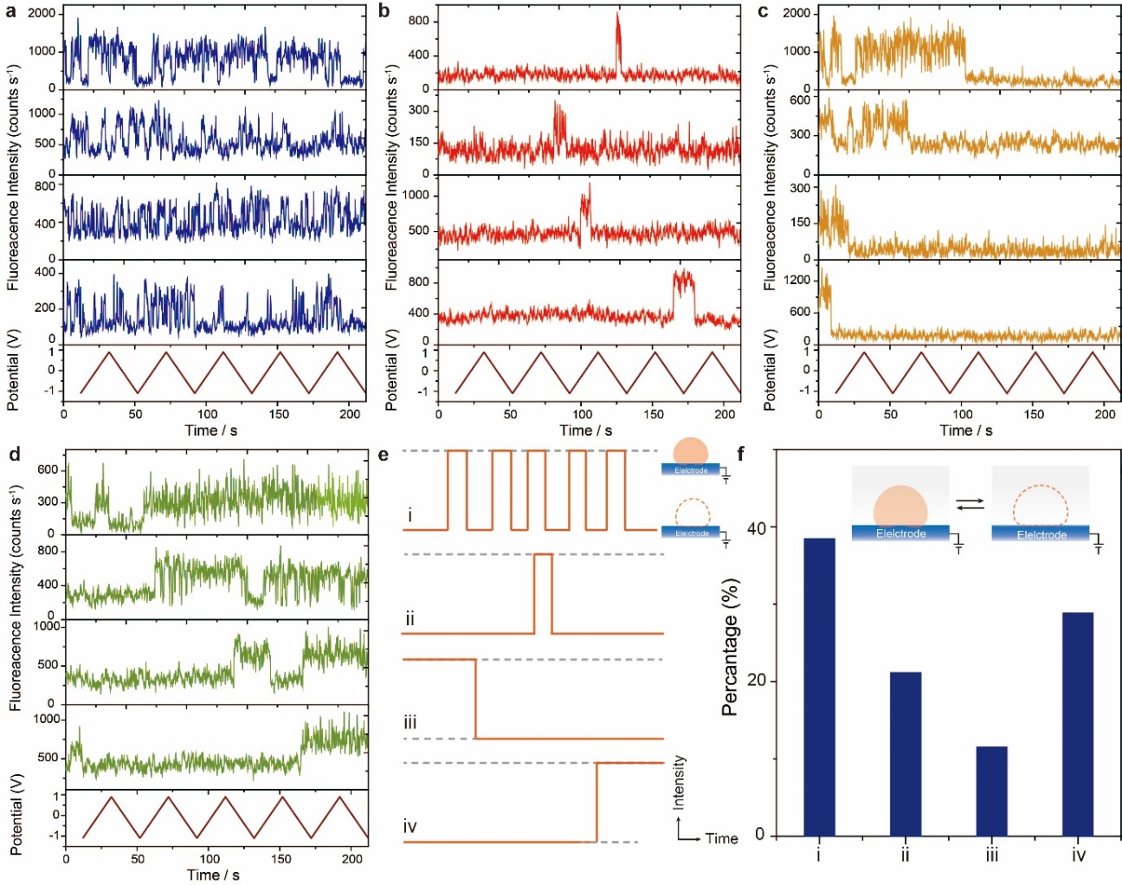
Supplementary Figure 5. Representative fluorescence intensity trajectories for four types catalytic active sites on the electrode surface. (a) Catalytic sites with high catalytic activity exhibited consecutive gas bubble evolution behavior during dynamic potential scan. (b) Catalytic sites with low catalytic activity exhibited single gas bubble evolution during dynamic potential scan. (c) Catalytic sites exhibited high catalytic activity at initial period and subsequently lose their activity during dynamic potential scan. (d) Catalytic sites exhibited low catalytic activity at initial period and generate high catalytic activity during dynamic potential scan. (e) Schematic of four types of catalytic sites during oxygen evolution reaction. (f) The distribution percentage of these different catalytic active sites. Inset showed the dynamics activity of catalytic sites during oxygen evolution reaction.

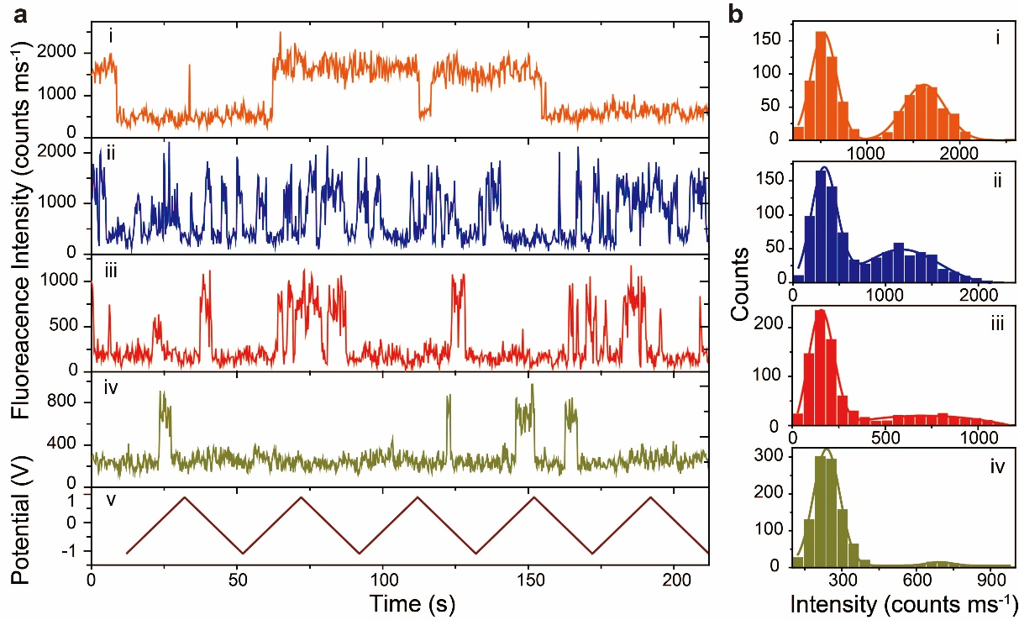
Supplementary Figure 6. (a) Representative fluorescence intensity trajectories on various catalytic active sites (i-iv) during consecutive potential scan (v) and corresponding intensity histograms (b).

Supplementary Note 3: The Relationship between Bubble Lifetime and Internal Mass Density
Based on the Epstein and Plesset theory, the derivation of the lifetime of an isolated spherical bubble with initial radius R₀ in oversaturated gas solution had been demonstrated. In their calculation, it is applicable for microscopic and nanoscopic gas bubbles.²⁸ However, for the surface gas bubbles which spherical bubble radius has been replaced by the radius of curvature, their lifetime cannot be estimated by Epstein and Plesset model. In order to reveal the relationship between the lifetime of surface gas bubble and the oversaturated concentration, the modified Epstein and Plesset model was developed.²⁹ We can consider that a surface gas bubble is attached on the electrode-electrolyte interface and the concentration of dissolved gas is uniform (C_{b}) at the initial time t = 0. The electrolyte is assumed to be at constant pressure and temperature. The dissolved saturated gas concentration at this temperature and pressure can be donated as C_{s}. With the enhancement of anodic polarization, the aggravated gas evolution around active catalytic sites enables the establishment local oversaturated gas concentration gradient field, which intrinsically contributes to the kinetic fluctuations of the surface gas bubbles (Supplementary Figure 6).
In general, the diffusion of gas can be illustrated by the diffusion equation:
$δ_{t}C+u∇C=D∇^{2}C$ (8)
where C is the mass concentration of electrochemical generated gas, u is the velocity field, D is the gas diffusion coefficient in the electrolyte. Assuming at the quasi-steady diffusion limited condition, the gas diffusion equation can be simplified to ▽²C = 0. In addition, considering the impermeable of electrode, there is no flux δC/δz = 0 at the electrode plane (z is vertical coordinate, here z = 0) and only the diffusive gas flux can be given by J=-D▽C.
The boundary condition of the surface gas bubble can be given by Henry’ law:
$C(R, t)=\frac{C_{0}}{P_{0}}P_{b}(t)$ (9)
where C₀ is the gas solubility, P₀ and P_{b}(t) are the ambient pressure in the electrolyte and the pressure in the surface gas bubble, respectively. Here, the gas concentration can be indicated by gas oversaturation terms:
$ξ(t)=\frac{C_{0}}{C_{b}}-1$ (10)
Considering the force equilibrium on the gas boundary and quasi-spherical cap shape, the pressure P_{b}(t) inside the gas bubble can be given by the Laplace pressure and ambient pressure:
$P_{b}(t)=\frac{2σ}{R(t)}+P_{0}$ (11)
$P_{b}(t)=\frac{4σsinθ}{L}+P_{0}$ (12)
Hence, the gas concentration at the electrolyte-gas interface is given by,
$C(R, t)=\frac{C_{0}}{P_{0}}(\frac{4σsinθ}{L}+P_{0})$ (13)
According to the Popov’s surface bubble model, the bubble mass change rate (dm/dt) can be given:³⁰
$\frac{dm}{dt}=-\frac{π}{2}DL\left[\frac{C_{0}}{P_{0}}(\frac{4σsinθ}{L}+P_{0})-C_{s}\right]f(θ)$ (14)
$m=ρ_{b}\frac{π}{8}L^{3}\frac{\cos^{3}θ-3cosθ+2}{3\sin^{3}θ}$ (15)
Based on these equations, the general differential equation for the contact angel θ of the surface gas bubble is given:²⁹
$\frac{dθ}{dt}=-\frac{4D}{L^{2}}\frac{C_{0}}{ρ_{b}}{(1+cosθ)}^{2}f(θ)\left[\frac{L_{c}}{L}sinθ-ξ(t)\right]$ (16)
For a stable equilibrium between Laplace pressure and oversaturated state, the corresponding equilibrium contact angle θ_{s} can be given:
$sinθ_{s}=ξ(t)\frac{L}{L_{c}}$ (17)
where L_{c} is the critical lateral extension in electrolyte under ambient conditions, which is a constant at general condition. Moreover, according to the Henry’ law, the balancing between the oversaturation pressure and Laplace pressure enables the equilibrium curvature of the gas bubble can be indicated as:
$R_{s}=\frac{L_{c}}{2ξ(t)}$ (18)
Based on the equation 16, the lifetime for the surface gas bubble can be deduced during the equilibrium as:
$t_{b}=\frac{L^{2}}{4D}\frac{ρ_{b}}{(ξ(t)+1)C_{b}}$ (19)
For simplifying at constant oversaturation ξ(t), the oxygen solubility in electrolyte C_{b} = 0.041 kg m⁻³, the diffusion of oxygen D = 2.0×10⁻⁹ m² s⁻¹, and the footprint diameter L can be
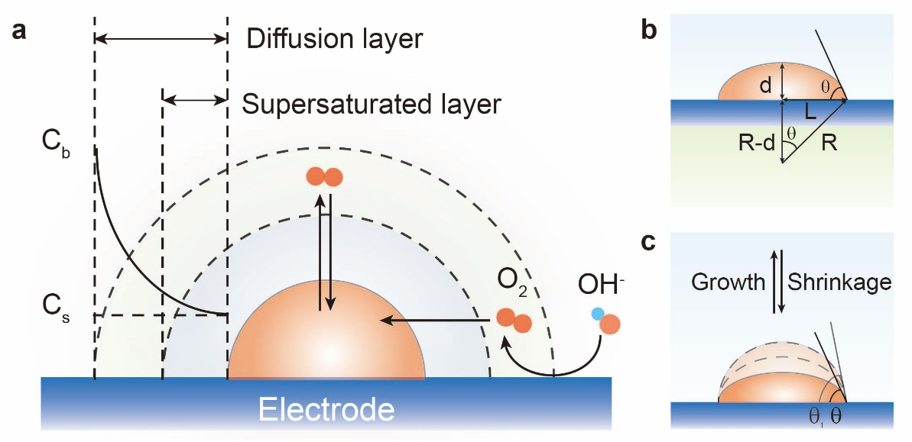
Supplementary Figure 7. (a) Schematic of the lateral concentration profile of dissolved gas bubble adhered on the electrode-electrolyte interface. (b) Illustration of the parameters for describing the geometry of surface gas bubble. Assuming a spherical cap shape for the surface gas bubble, for instance, the height d, the footprint lateral extension L, the contact angle θ, which can be estimated by the equation tan θ = (d/L)/[1/4-(d/L)²], and the radius of curvature R, which is written as R = (L² + 4d²)/8d. (c) Schematic of the evolution and shrinkage of the surface gas bubble during dynamic potential scan.
approximate to diameter of the surface gas bubble R, hence, it can be clearly identified that the lifetime of the surface gas bubble increase as the enhancement of the mass density in the gas bubble (Supplementary Figure 8). After the anodic dynamic potential scan, the oversaturation around the active catalytic sites reach to a stable equilibrium, hence, the ξ(t) can be consider a constant during the cathodic potential scan. Here, the mean lifetime of oxygen bubble during anodic and subsequent cathodic potential scan are t_{b}(anodic) = 3.85 s and t_{b}(cathodic) = 5.77 s, respectively. In addition, the relative mean radius of the oxygen bubble is R(anodic) = 61.55 nm and R(cathodic) = 63.40 nm, respectively. The mass density (ρ_{b}) in oxygen bubble during the subsequent cathodic scan increased ca. 41 % can be estimated based on the equation 17-19.

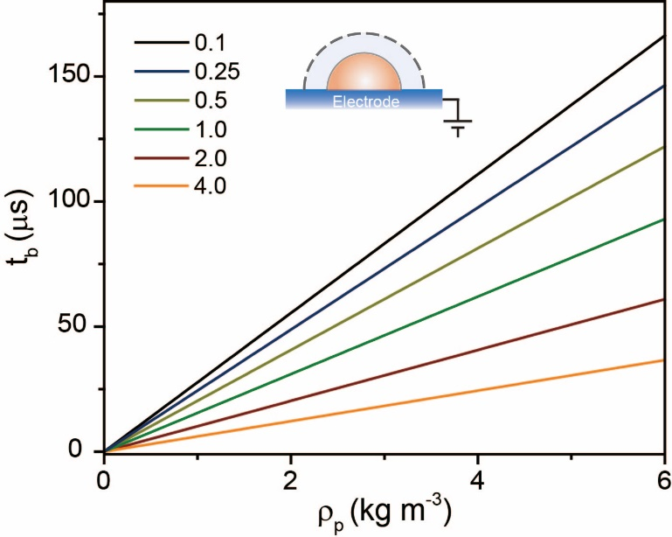
Supplementary Figure 8. The lifetime (t_{b}) of a surface oxygen bubble with radius 100 nm as a function of the mass density in the gas bubble under different oversaturation (ξ(t) = 0.1, 0.25, 0.5, 1.0, 2.0 and 4.0). Inset showed schematic of saturation layer around the electrochemical generated oxygen bubble at the electrode-electrolyte interface.

Supplementary Note 4: Numerical Simulation of Oxygen Diffusion
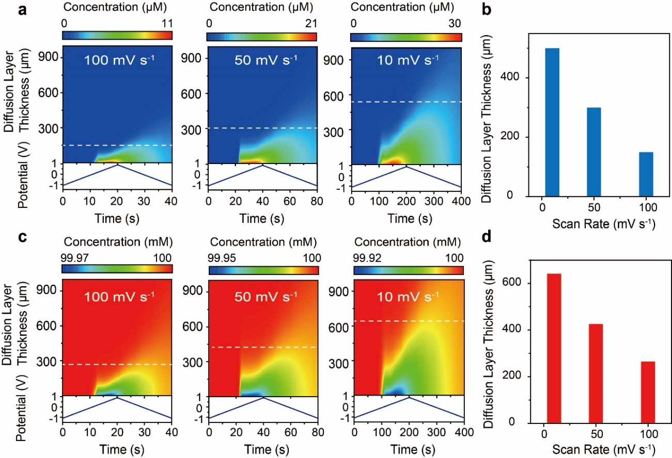
Supplementary Figure 9. Numerical simulation of potential dependent evolution of oxygen diffusion layer (contour plots) (a) and hydroxyl (c) along the axial direction of the EEIs in potential range from - 1.10 to 0.90 V vs Pt, at various scan rates 0.01, 0.05 and 0.10 V s⁻¹. The comparison of generated diffusion layer of oxygen (b) and hydroxyl (c) at various potential scan rate 0.01, 0.05 and 0.10 V s⁻¹. The diffusion layer evolution trend indicated that the generated oxygen was more inclined to confined at the electrode surface. Hence, the higher potential scan rate facilitated the formation of supersaturating region of oxygen and facilitate nanobubble nucleation and growth.
We further investigated the mass transfer of oxygen species at the electrode surface by performing finite element method (FEM) by combining Fick’s 2nd law and Bulter-Volmer equation. The numerical simulated concentration contour maps of the oxygen diffusion layer uncovered that the diffusion region of oxygen species (exhibited a shorter diffusion length, 150 μm) was more prone to confine at the electrode surface at a higher scan rate (0.10 V s⁻¹), and the thickness of diffusion region increased with decreasing scan rate, where a longer diffusion length (500 μm) was established at a slower scan rate (0.01 V s⁻¹) (Supplementary Figure 9). The shorter diffusion duration constrains oxygen diffusion efficaciously and leading remarkable confinement of oxygen at the electrode surface. These results further corroborated that the confinement of oxygen at the electrode-electrolyte interface was responsible for inducing a relative higher oxygen concentration gradient as well as conjectural local heterogeneous supersaturated regions readily for oxygen bubbles nucleation and growth.

Supplementary Note 5: Single Particle Hopping Mechanism
To correlate the multi-phase interface evolution with Faradaic transition from hydroxide ion to oxygen molecule, the electrochemical charge (Q, A s) was estimated by integrating the cell current (i, A) over the polarization duration (t, s) using the following equation:
$Q=\int{i(t)dt}$ (20)
The electrochemical charge based on Faradaic transition (oxygen evolution), was adopted to establish a direct quantitative correlation with oxygen evolution induced nanobubble volume (V, simplified as a hemisphere structure). The charge for oxygen evolution during dynamic potential scan could be estimated using the following equation:
$Q=\frac{8πr^{3}eN_{A}d_{O2}}{3M_{O2}}$ (21)
where r is the radius of oxygen nanobubble (the height of oxygen bubble (h) can be approximately as the same value of nanobubble radius, r), N_{A} is the Avogadro’s constant (6.02210²³ mol⁻¹), e is the elemental charge (1.60210⁻¹⁹ A s), M_{O2} is the molar mass of oxygen molecule (32 g mol⁻¹), and d_{O2} is the density of oxygen (1.429 g L⁻¹), respectively. Thus, single particle hopping driving by oxygen evolution along the vertical direction of the electrode surface, can directly correlate to charge transfer corresponding to OER process. Based on the fundamental correlation between multi-phase interface induced single particle hopping and OER, it enabled us to establish a direct relationship between catalytic activity of electrocatalysts and hopping behavior to effectively high throughput screening catalysts without perturbation from morphology diversity, non-Faradaic processes and concomitant spectator reactions, which cannot be precisely identified in traditional electrochemical methods. Note that the dependence of Faradaic charge on multi-phase (liquid-solid-gas) interface height (same with the oxygen nanobubble radius, r) power indicates that it is more sensitive to tracking the evolution of multi-phase interface evolution than electrochemical charge, and is sufficient to evaluate the catalytic activity of electrocatalysts in various gas evolving systems.
When the Faradaic transition occurred, a gas-evolving reaction concomitant with a corresponding multi-phase interface evolution was measured, provided direct information about the catalytic ability of individual nanoparticle. The motions of different particles were independent of each other as their diffusion was only caused by multi-phase interface evolution
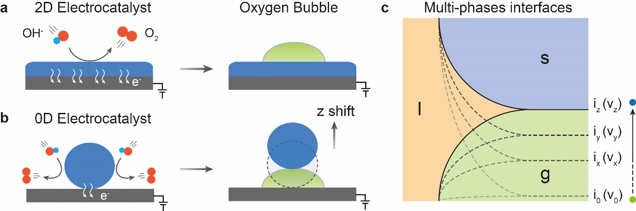
Supplementary Figure 10. (a) Schematic of oxygen evolution on two-dimensional catalytic interface and concomitant oxygen nanobubble nucleation and growth. (b) Schematic illustration of OER on quasi-zero-dimensional catalytic interface and concomitant oxygen nanobubble nucleation, growth and induced particle hopping at the electrode surface. (c) The potential dependent multi-phase (solid-liquid-gas) interface evolution processes (l: liquid; s: solid and g: gas). Here the interface height of solid-liquid-gas interface are correlated with oxygen bubble size and then directly associated with the intrinsic catalytic activity of particles based on the Faradaic transition from hydroxide ion to oxygen molecule.
during OER.³¹ According to this principle, it gives rise to an alternative pathway to reveal the probability of an individual particle desorption away from electrode surface which directly correlates with their intrinsic catalytic ability.

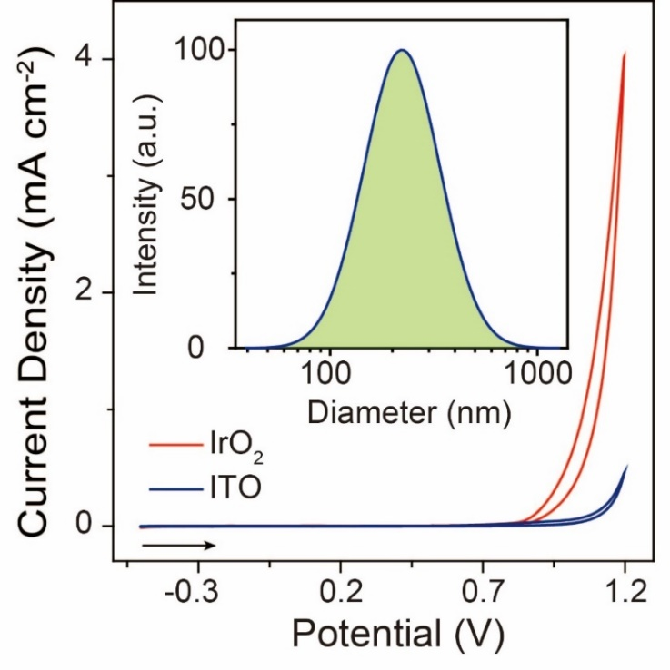
Supplementary Figure 11. Comparison of current density of IrO₂ nanoparticle modified ITO electrode and bare ITO electrode during dynamic potential scan from - 0.50 to 1.20 V vs Pt in 0.10 M KOH aqueous solution. Inset showed the hydraulic diameter of IrO₂ nanoparticles.

Supplementary Note 6: Control Experiments to Verify Particle Hopping
To verify the role of electron transport on the multi-phase evolution, we first lowered the hydroxide ion concentration through change to neutral environment, gas evolution behavior was severely constrained due to the limited reactant supply to the reactive particle surface. The catalytic current density decreased to ca. 7.5 %, from alkaline to neutral electrolyte environment, which was associated to the limited reactant supply to the reactive particle surface (Supplementary Figure 15). The scattering intensity of individual IrO₂ particles remained stable during OER under neutral environments.
We then changed the conductive metal oxide particle (IrO₂) to insulator (SiO₂, average size 400 and 800 nm). Intriguingly, during dynamic potential scan from - 0.50 to 1.20 V vs Pt, a different optical behavior was observed, where no obvious decay was observed during OER. The representative temporal intensity profiles of SiO₂ particles remained stable during consecutive potential scan (5 cycles), suggesting no chemical transition and new phase interface appeared on these particles because of the insulator cannot support the electron transfer to maintain reaction proceeding on particle surface (Supplementary Figure 17 and 18). Hence, it provided direct spectral evidence to confirm that constrained oxygen evolution contributed to eliminate single particle hopping caused by slowing down gas evolution efficiency under sluggish reaction conditions.
The phase interface transition from solid-liquid to solid-liquid-gas was further investigated in more detail. We further investigated the spatially resolved electron transport properties of the particles by using Fe(CN)₆⁴⁻ and Fe(CN)₆³⁻ coupled redox probe during dynamic potential cycle (Supplementary Figure 19-21). Distinguishing from the scattering intensity profiles during OER, the optical response exhibited reversible behavior during quasi-reversible redox reaction. The periodic recovery of the intensity was attributed to the consecutive transition between Fe(CN)₆⁴⁻ and Fe(CN)₆³⁻ around particles and caused the change of environmental refractive index.³² Sequential scattering images represented the spectral intensity change during - 0.50 to 0.30 V vs Pt, were extracted to tracking the subtle environmental change during redox probes conversion. The intensity changes initially occurred upon anodic polarization, the decay intensity was associated to the increased Fe(CN)₆³⁻ concentration gradient around particle (0 V). After subsequent cathodic polarization, the gradual rebuilding Fe(CN)₆⁴⁻ concentration field enabled the scattering intensity restored. To further evaluated the stability of redox probes optical properties under various illuminated laser wavelength and power, no obvious of accompanied side reaction occurred and the periodic optical profiles under polarization could only be accounted for by assignment to the subtle environment changes induced by the reversible adsorption of redox-active molecules on the particle surface (Supplementary Figure 22-24). These optical evolution behaviors exhibited excellent electron conduction properties of IrO₂ and uncover no new phase interface emerged on particle surface under weak polarization condition.
A series of scattering images under polarization was captured to further explore the diffusion mechanism of single particle hopping (Supplementary Figure 25). During potential linear scan from - 0.50 to 1.20 V vs Pt, the number of experimental and intelligent identified particles with bright feature both indicated a decreasing tendency, revealed that the oxygen evolution induced multi-phase interface fluctuation enabled particle desorption from the electrode surface and escaped out of the evanescent field. With increasing anodic polarization, the single-particle scattering intensity showed a steadily feature (0-10 s: at open circuit potential; 10-23 s, from - 0.50 to 0.74 V) where no oxygen evolution took place on the particle surface and a promptly attenuation (ca. 29.3 % in average intensity) during oxygen generation region (23 to 27 s, 0.74 to 1.20 V), following an irreversible optical response during the subsequent cathodic polarization (27 to 44 s, 1.20 to - 0.50 V). During single particle measurements, the intensity changes during the OER exhibited a rapid decay during first scan (under anodic polarization) and irreversible optical response during following scan (under cathodic polarization), revealed that phase interface progression was associated with particle hopping in which new phase nucleated at bottom of the particle and propagated to cause particle dislocation along perpendicular direction, as opposed to form around the upper surface of the particle. Because of gas nucleation and growth around particle surface could enhance the scattering intensity of particle by increasing the particle apparent diameter, which was not observed during particle imaging and only particle hopping behavior was recognized.³³
Moreover, the diffusion of particle at x-y lateral interface was examined by accurately tacking the particle location during dynamic potential scan. By extracting the MSD of particle at the electrode surface, it enabled to evaluate the diffusion behavior of particle during OER. The two-dimensional diffusion mechanism is Brownian movement driving and results in a random walk of particles at the electrode surface.³⁴⁻³⁶ In contrast, one-dimensional diffusion mechanism is multi-phase interface evolution driving and accompanied with directional movement along one orientation.³⁷ However, the previous work made no distinction between the mechanisms on one and two-dimensional diffusion mode. The particle diffusion mechanism-seen here on OER, is a consequence of multi-phase interface promoted one-dimensional dislocation of particles where oxygen evolution takes place, as compared to the small average displacement (ca. 5.1 nm) in lateral diffusion. Thereby, the possibility of two-dimensional diffusion mechanism under polarization at the electrode surface can be excluded during particle hopping.
By correlating scattering signals with electrochemical responses, we ruled out the possibility that the scattering intensity flips arose from solid phase transition and a change in charge density or environmental permittivity, as we did not observe these intensity flips in any other polarization conditions without multi-phase interface (solid-liquid-gas) evolution. We therefore attributed these scattering intensity flips to an emergence of nanobubble under operando condition. The scattering intensity followed an exponential damping on the height of the scattering particles with respect to the electrode-electrolyte interface, providing a measure of the diffusivity distribution of individual scatter along the optical axis (Figure 3c).
Based above knowledge, single particle hopping model was established to directly correlated the particle diffusion coefficient with intrinsic catalytic activity, by considering two aspects: (1) the multi-phase (liquid-solid-gas) interface dynamics is caused by Faradaic transition from hydroxide ion to oxygen molecule; (2) the diffusion coefficient of particle described the rate of multi-phase interface evolution (Supplementary Figure 10). Therefore, we attempted to extract the one-dimensional diffusion coefficient D of IrO₂ from mean square displacement (MSD) under polarization. As illustrated in Eq. I_{d} = I₀exp(-d/h_{p}), the diffusivity D for the particles could be modelled from the scattering intensity attenuation variance I² (corresponding to height variations h²) of the scattering profile with time t: 2Dt = h(t)²- h(0)². Therefore, the scattering intensity fluctuations of IrO₂ during OER could be converted to its distance change away from electrode. The achievable spatial precision Δh(t) < 5 nm for an exposure duration 100 ms was not limited by diffraction but rather by particle identification precision, which depended on the signal-to-noise ratio.³⁸ Furthermore, particle motion parallel to the electrodes and that perpendicular to the axis of the electrode was irrelevant since nanobubble evolution droved particles to desorb vertically from the electrode surface, whereas motion parallel to the electrode could be ignored for lacking external driving force. This allowed to extract one-dimensional diffusion coefficient of individual particles and correlate with their intrinsic OER performance.

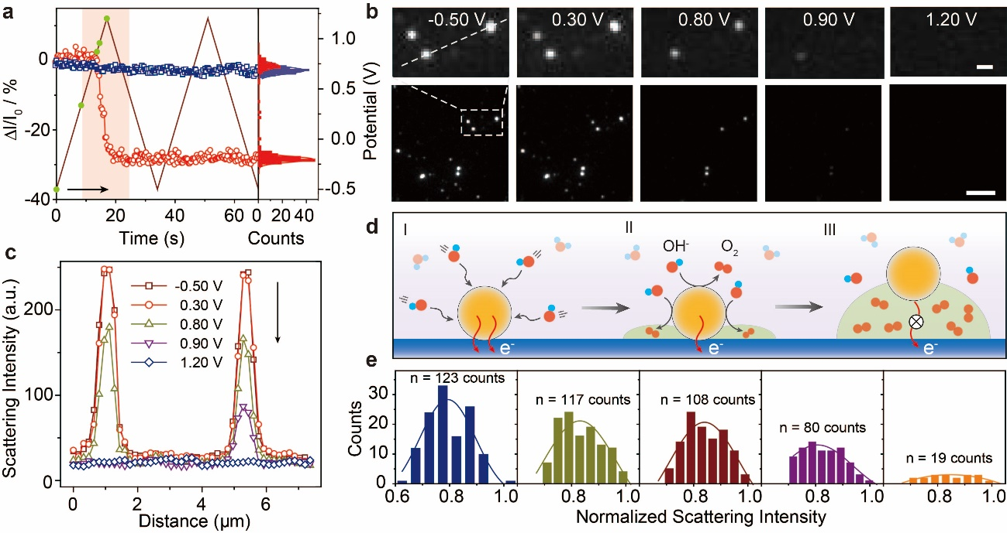
Supplementary Figure 12. OER on single electrocatalyst particle. (a) Optical response for individual IrO₂ particle (red dots) and corresponding background fluctuation during consecutive potential scan (solid line) from - 0.50 to 1.20 V vs Pt, at a scan rate of 0.10 V s⁻¹. All scattering intensity were generated by taking the differenec scattering intensity between the intensity at open circuit potential and that at specific polarization potential (ΔI), normalized to the intensity at open circuit potential (I₀), yielding ΔI/I₀ contrast optical signal. (b) Scattering images of IrO₂ particles under various polarization corresponding to green solid dots in (a). Upper panel was the magnifyed images of white dashed rectangle region. (c) The corresponding line scan of adjacent particles at under various polarization. As shown in Supplementary Figure 12 c, the scattering intensity of IrO₂ particles remained constant from - 0.50 to 0.30 V, but gradually decreased from 0.30 to 0.80 V. The normalized scattering intensity of single IrO₂ decreased about 30 % during OER, while that of adjacent background remained unchanged. Figure S12 c showed the potential-dependent scattering intensities changes of two adjacent particles in Figure S12 b, a similar fluctuation tendency was obtained. Importantly, the durations of these fluctuated features were aligned with the OER process and identified in electrochemical performance. (d) Schematic illustration of proposed single particle hopping mechanism (I-III). (e) The scattering intensity distribution and statics particle number on the electrode surface as a function of polarization corresponding to (b) and (c).

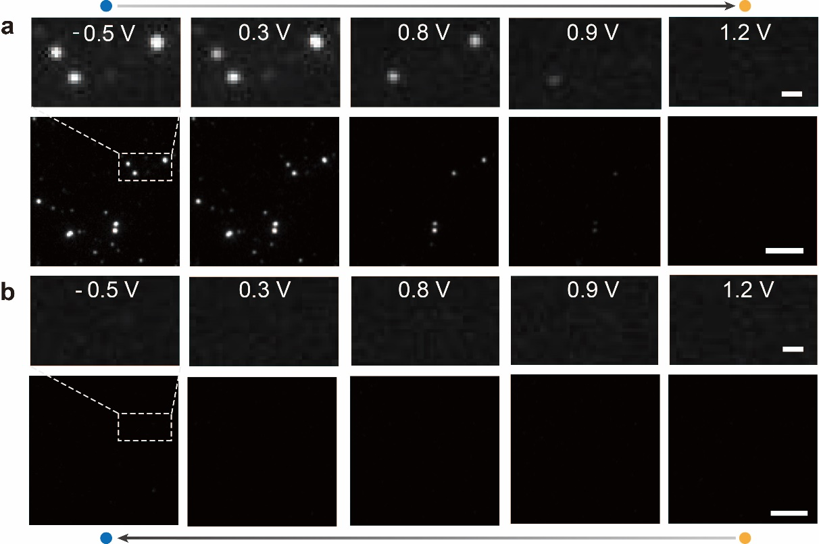
Supplementary Figure 13. Behavior of scattering images transitions upon OER. Sequential scattering images of IrO₂ particle in 0.10 M KOH solution during dynamic potential scan from - 0.50 to 1.20 V vs Pt (from left blue dot to right yellow dot, anodic polarization, a) and (from right yellow dot to left blue dot, cathodic polarization, b). The irreversible attenuation of scattering intensity under various polarization indicated that oxygen evolution induced the transient multi-phase interface fluctuation and enabled the particles desorption occurring at the electrode surface, further confirmed by the remarkable loss of identified particles. The white dashed lines are a guide for the eye, representing magnified region where representative IrO₂ particles located. (a) and (b) Upper panel scale bar, 1 μm; lower panel scale bar, 5 μm.

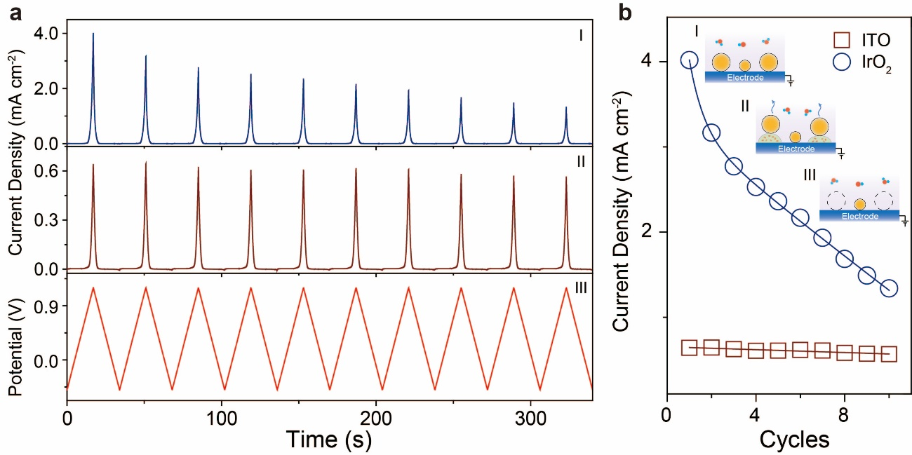
Supplementary Figure 14. (a) Consecutive electrochemical current density (i) during OER for IrO₂ modified ITO electrode and background current density of bare ITO electrode (ii) in 0.10 M KOH solution during dynamic potential scan from - 0.50 to 1.20 V vs Pt (iii). (b) Comparison between peak current for IrO₂ modified ITO electrode (blue dots) and bare ITO electrode (red squares). Inset showed schematic illustration of oxygen evolution induced particle hopping and desorption at the electrode surface, which decreased the effective active catalytic area and resulted in decay of catalytic current density under consecutive potential scan. At the preliminary stage, charge transfer occurred close to the juncture between particle and electrode, then oxygen gradient built up rapidly to saturation and led to oxygen nucleation and growth, breaking off the electron transfer pathway and shutting down this reaction. With the further enhancement of anodic polarization, the charge transfer reaction proceeding at bottom of particle was severely constrained, leading to particle desorption from electrode surface companied current density dramatic attenuation, as confirmed experimentally.

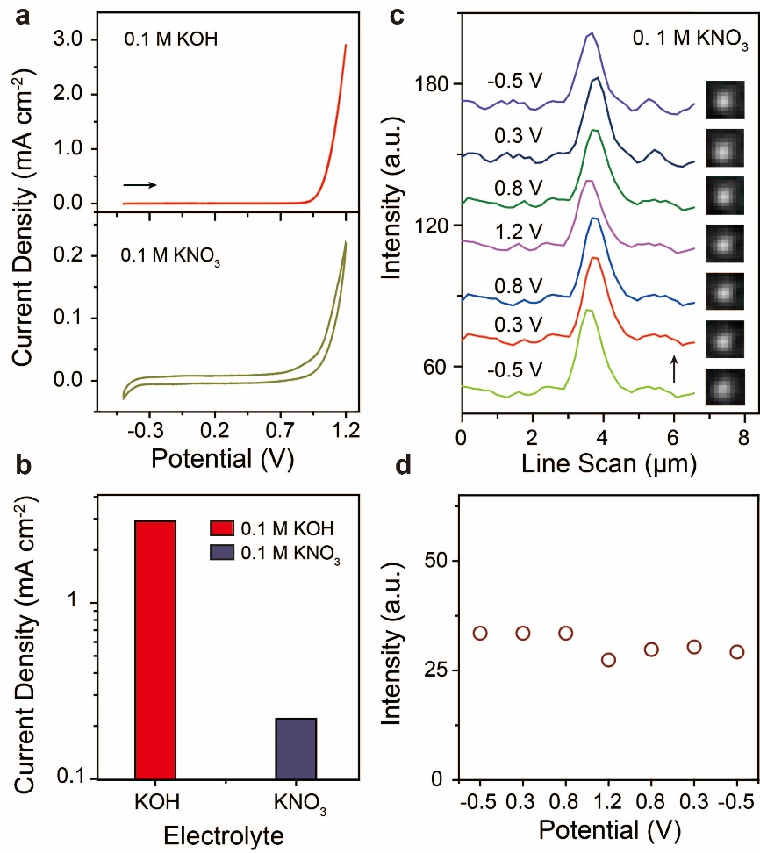
Supplementary Figure 15. (a) Current density of IrO₂ particles modified ITO electrode in different electrolyte, alkaline (0.10 M KOH) and neutral (0.10 M KNO₃) solution, respectively. The decrease of concentration of reactants resulted in effective attenuation in catalytic capability. (b) Comparison of current density for various electrolyte environment. (c) Scattering intensity line scan profiles across a representative IrO₂ particle under various polarization in 0.10 M KNO₃. Inset showed the corresponding scattering image. (d) The fluctuation of scattering intensity of a representative IrO₂ particle as a function of polarization potential in 0.10 M KNO₃.

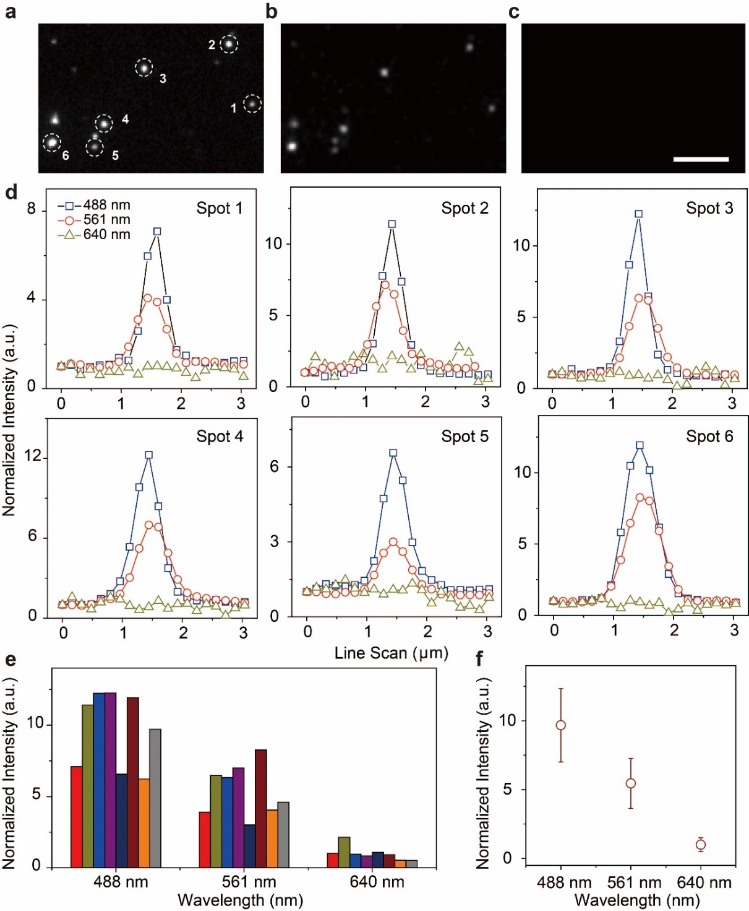
Supplementary Figure 16. Scattering images of representative IrO₂ particles under various illumination laser (a) 488 nm; (b) 561 nm and (c) 640 nm. Scale bar, 5 μm. (d) and (e) Comparison of scattering intensity of representative IrO₂ particles (spot 1-6, shown in a) under various illumination laser (a) 488 nm; (b) 561 nm and (c) 640 nm. (f) The influence of illumination laser wavelength on average scattering intensity of IrO₂ particles. With increasing of illumination laser wavelength from 488 to 640 nm, the average scattering intensity decayed ca. 43.7 % and 89.7 % at 561 nm and 640 nm, respectively. Thereby, we chose 488 nm for tracking single particle hopping during OER, because of the relative lower quantum efficiency of detector in near-infrared region.

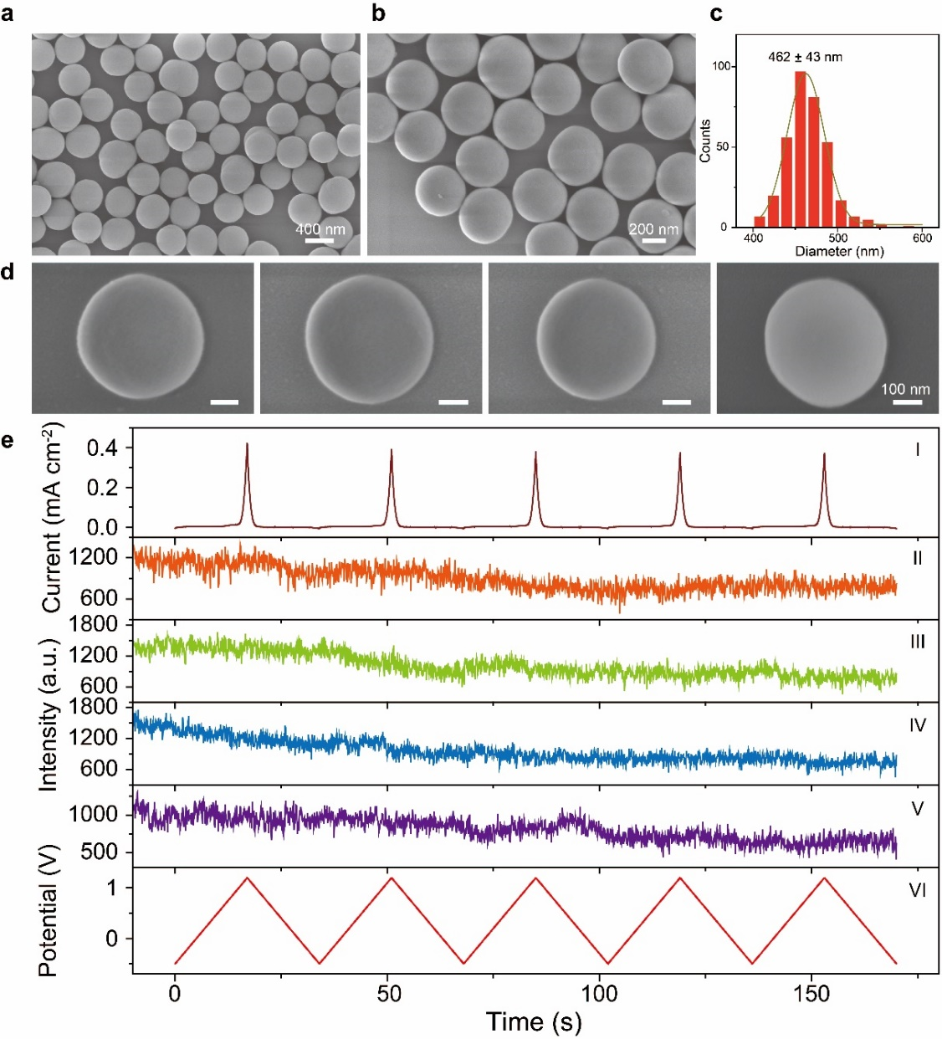
Supplementary Figure 17. (a) and (b) Representative SEM images of SiO₂ particles as insulator control with different magnification. (c) Size distribution of SiO₂ particles (average diameter 462 nm ± 43 nm). Representative individual SiO₂ particles were shown in (d). (e) The consecutive electrochemical current intensity (I) during OER for SiO₂ modified ITO electrode in 0.10 M KOH solution during dynamic potential scan from - 0.50 to 1.20 V vs Pt (VI) (five cycles). Scattering intensity profiles of representative SiO₂ particle modified on ITO electrode during dynamic potential scan (II-V).

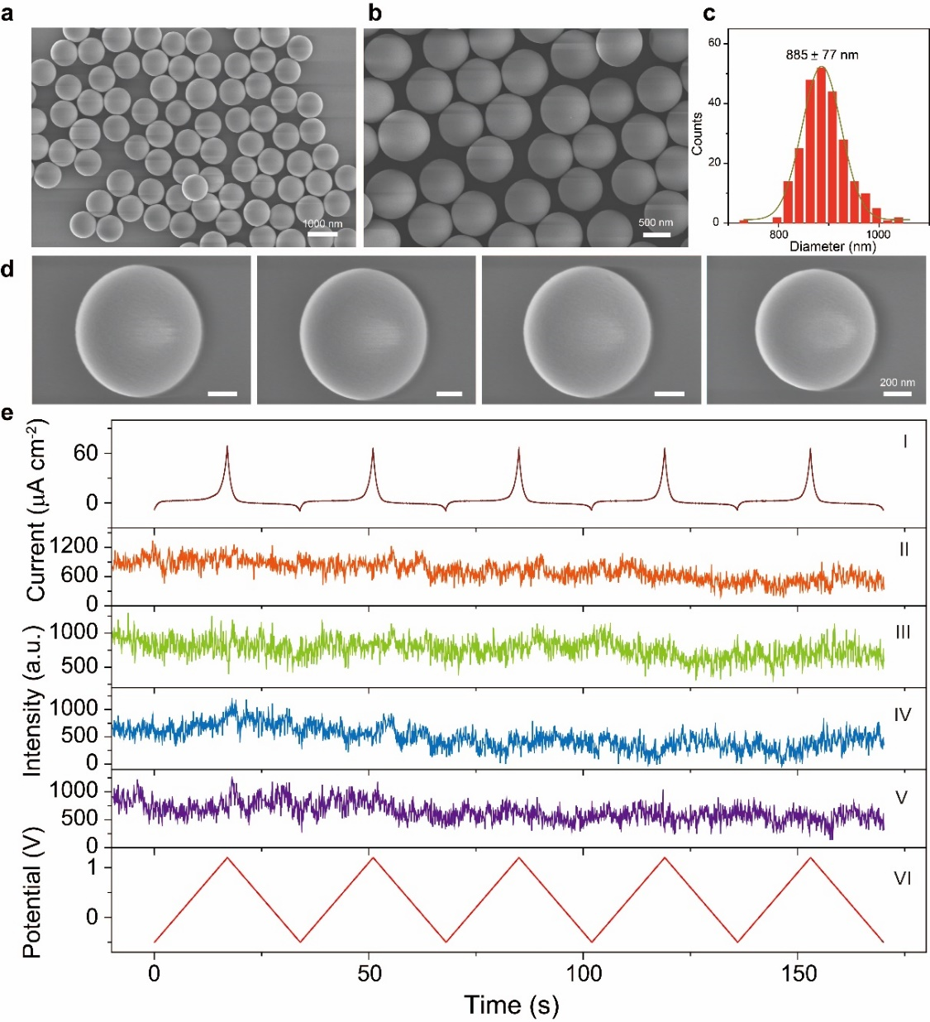
Supplementary Figure 18. (a) and (b) Representative SEM images of SiO₂ particles as insulator control with different magnification. (c) Size distribution of SiO₂ particles (average diameter 885 nm ± 77 nm). Representative individual SiO₂ particles were shown in (d). (e) The consecutive electrochemical current intensity (I) during OER for SiO₂ modified ITO electrode in 0.10 M KOH solution during dynamic potential scan from - 0.50 to 1.20 V vs Pt (VI) (five cycles). Scattering intensity profiles of representative SiO₂ particle modified on ITO electrode during dynamic potential scan (II-V).

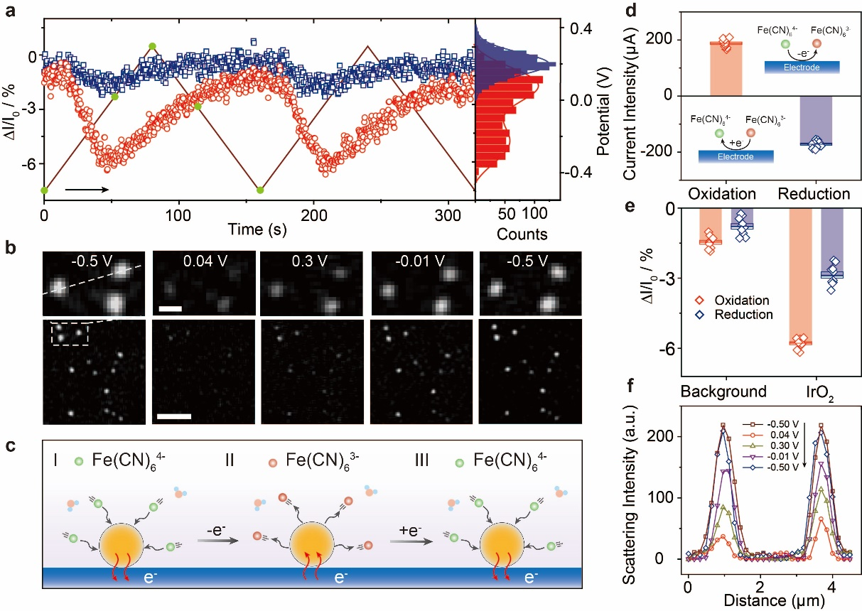
Supplementary Figure 19. Electron transfer at single electrocatalyst particle. (a) Optical response for individual IrO₂ particle (red dots) and corresponding background fluctuation (bule square) in 0.10 M KOH solution containing 2.5 mM both K₄[Fe(CN)₆] and K₃[Fe(CN)₆] during consecutive potential scan (solid line) from - 0.50 to 0.30 V vs Pt. All scattering intensity were generated by taking the differenec scattering intensity between the intensity at open circuit potential and that at specific polarization potential (ΔI), normalized to the intensity at open circuit potential (I₀), yielding ΔI/I₀ contrast optical signal. (b) Scattering images of IrO₂ particles under various polarization corresponding to green solid dots in (a). Upper panel was the magnifyed images of white dashed rectangle region. Upper panel scale bar, 1 μm; lower panel scale bar, 5 μm. (c) Schematic illustration of proposed electron transfer mechanism. With increasing of anodic polarization, excess positive charges were accumulated at particle surface firstly, and enhanced the adsorption of Fe(CN)₆⁴⁻ (I) by Coulombic force and improve Faradaic transition from Fe(CN)₆⁴⁻ to Fe(CN)₆³⁻ (II). During cathodic polarization, the enrichment of Fe(CN)₆³⁻ was gradual reduced to Fe(CN)₆⁴⁻ and recovery the initial concentration gradient of Fe(CN)₆⁴⁻ (III) around particles. (d) Comparison the anodic and cathodic peak current intensity in 0.10 M KOH solution containing 2.5 mM both K₄[Fe(CN)₆] and K₃[Fe(CN)₆] during dynamic potential scan from - 0.50 to 0.30 V vs Pt. The corresponding cyclic voltammetry curve was shown in Supplementary Figure 21. Inset showed the reducation and oxidation mechanism for redox reaction. (e) Comparison scattering intensity between IrO₂ and background under oxidation (0.30 V) and reduction (- 0.50 V) condition, respectively. (f) The corresponding line scan of adjacent particles under various polarization (the white dashed line scan shown in Supplementary Figure 19b).

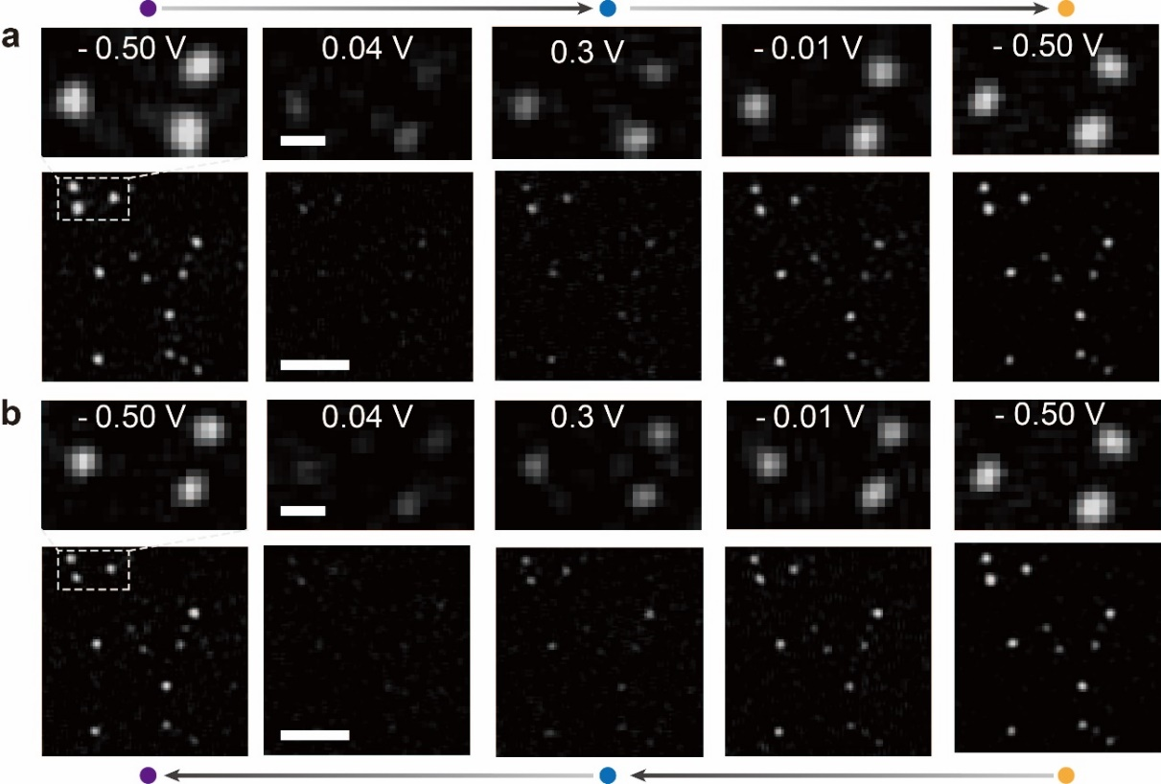
Supplementary Figure 20. Behavior of scattering images transitions upon redox reaction. (a) Sequential scattering images of IrO₂ particle during dynamic potential scan from - 0.50 to 0.30 V vs Pt (two cycles, from left to right). (b) Sequential scattering images of IrO₂ particle during dynamic potential scan from - 0.50 to 0.30 V vs Pt (two cycles, from right to left). The recovery of scattering intensity under various polarization indicated that the reversible redox chemical reaction occurred on individual particles resulted in the periodic fluctuation of redox probe (Fe(CN)₆⁴⁻ and Fe(CN)₆³⁻) concentration gradient near IrO₂ particles. The white dashed lines are a guide for the eye, representing magnified region where representative IrO₂ particles located. (a) and (b) Upper panel scale bar, 1 μm; lower panel scale bar, 5 μm.

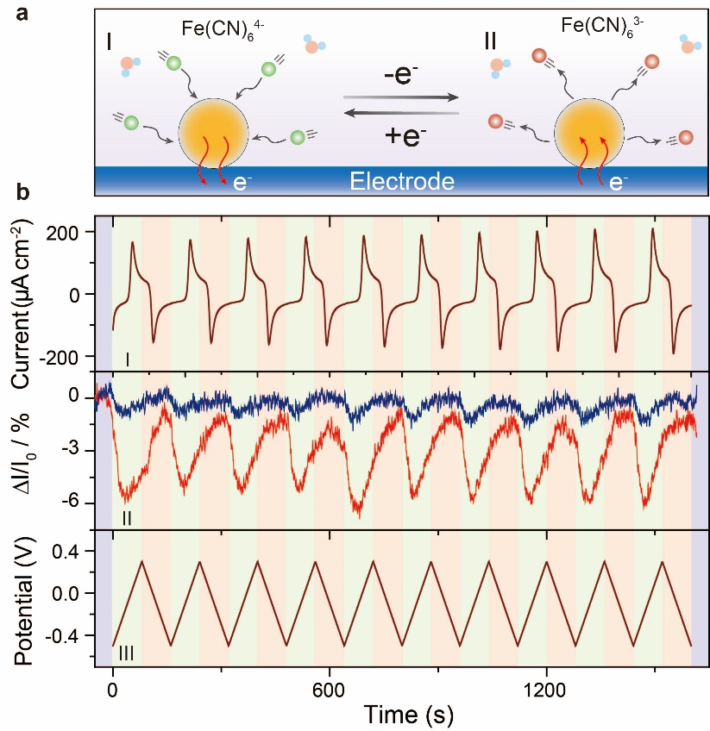
Supplementary Figure 21. (a) Schematic illustration of redox probe transition on representative IrO₂ nanoparticle under dynamic potential scan. (b) The consecutive electrochemical current density (I) during OER for IrO₂ modified ITO electrode in 0.10 M KOH solution containing 2.5 mM both K₄[Fe(CN)₆] and K₃[Fe(CN)₆] during dynamic potential scan from - 0.50 to 0.30 V vs Pt (III) (ten cycles). Comparison between scattering intensity of representative IrO₂ particle modified on ITO electrode (red line) and background signal from bare ITO electrode (blue line).

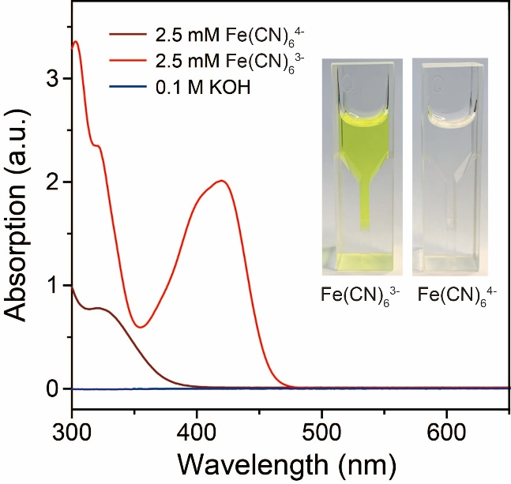
Supplementary Figure 22. The UV-Vis absorption spectrum of 0.10 M KOH (blue line) and containing 2.5 mM K₄[Fe(CN)₆] (dark red line) and K₃[Fe(CN)₆] (red line), respectively. Inset showed the images of 2.5 mM K₃[Fe(CN)₆] and K₄[Fe(CN)₆] in 0.10 M KOH solution, respectively.

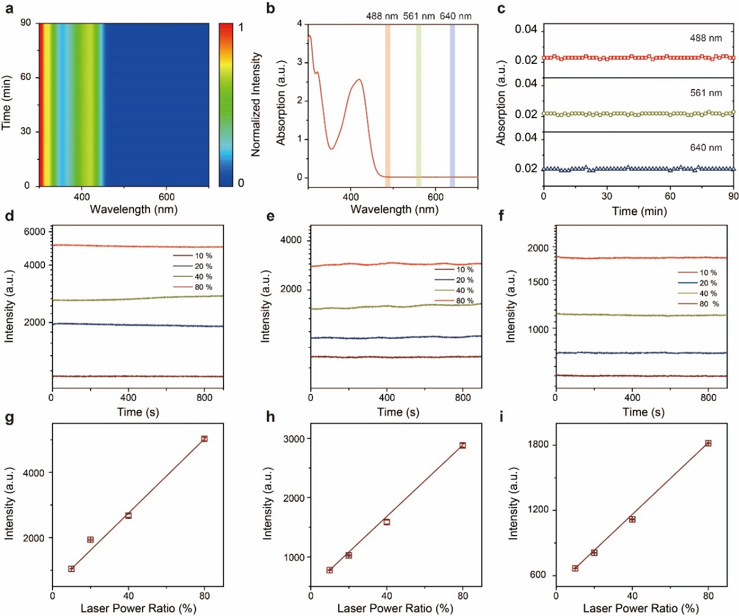
Supplementary Figure 23. (a) The stability of UV-Vis absorption spectrum of 2.5 mM K₃[Fe(CN)₆] in 0.10 M KOH solution at open circuit potential during 90 min. (b) The locations of different illumination laser wavelength (488, 561 and 640 nm) adopted for examining optical response of redox probe. (c) The comparison of the absorption intensity profiles at various monitoring wavelength (488, 561 and 640 nm) during 90 min. The comparison of the extinction intensity profiles at various monitoring wavelength (d 488, e 561 and f 640 nm) and different excitation laser power during 90 min. The average extinction intensity comparison at various monitoring wavelength (g 488, h 561 and i 640 nm) and different excitation laser power during 90 min.

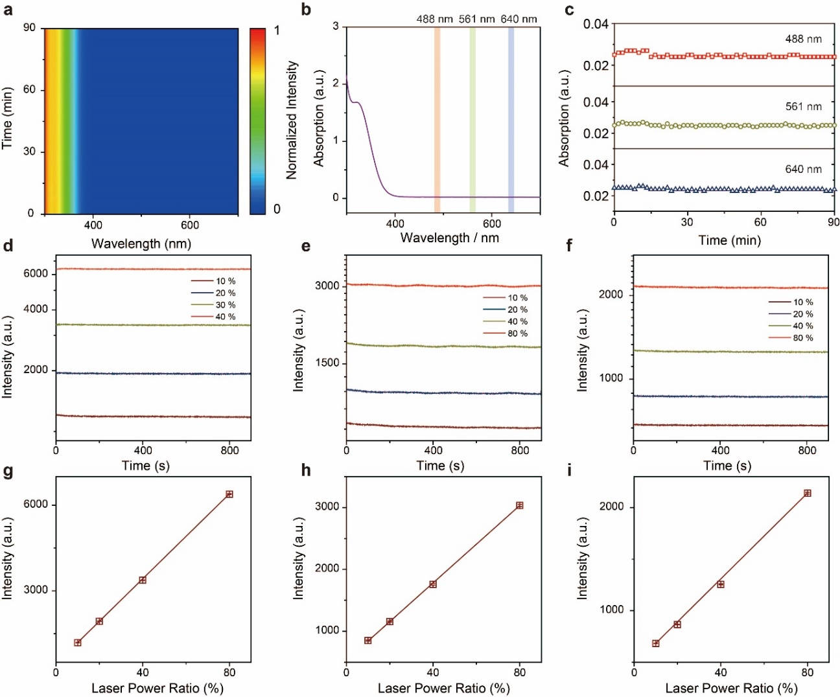
Supplementary Figure 24. (a) The stability of UV-Vis absorption spectrum of 2.5 mM K₄[Fe(CN)₆] in 0.10 M KOH aqueous solution at open circuit potential during 90 min. (b) The locations of different illumination laser wavelength (488, 561 and 640 nm) adopted for examining optical response of redox probe. (c) The comparison of the absorption intensity profiles at various monitoring wavelength (488, 561 and 640 nm) during 90 min. The comparison of the extinction intensity profiles at various monitoring wavelength (d 488, e 561 and f 640 nm) and different excitation laser power during 90 min. The comparison of average extinction intensity at various monitoring wavelength (g 488, h 561 and i 640 nm) and different excitation laser power during 90 min.

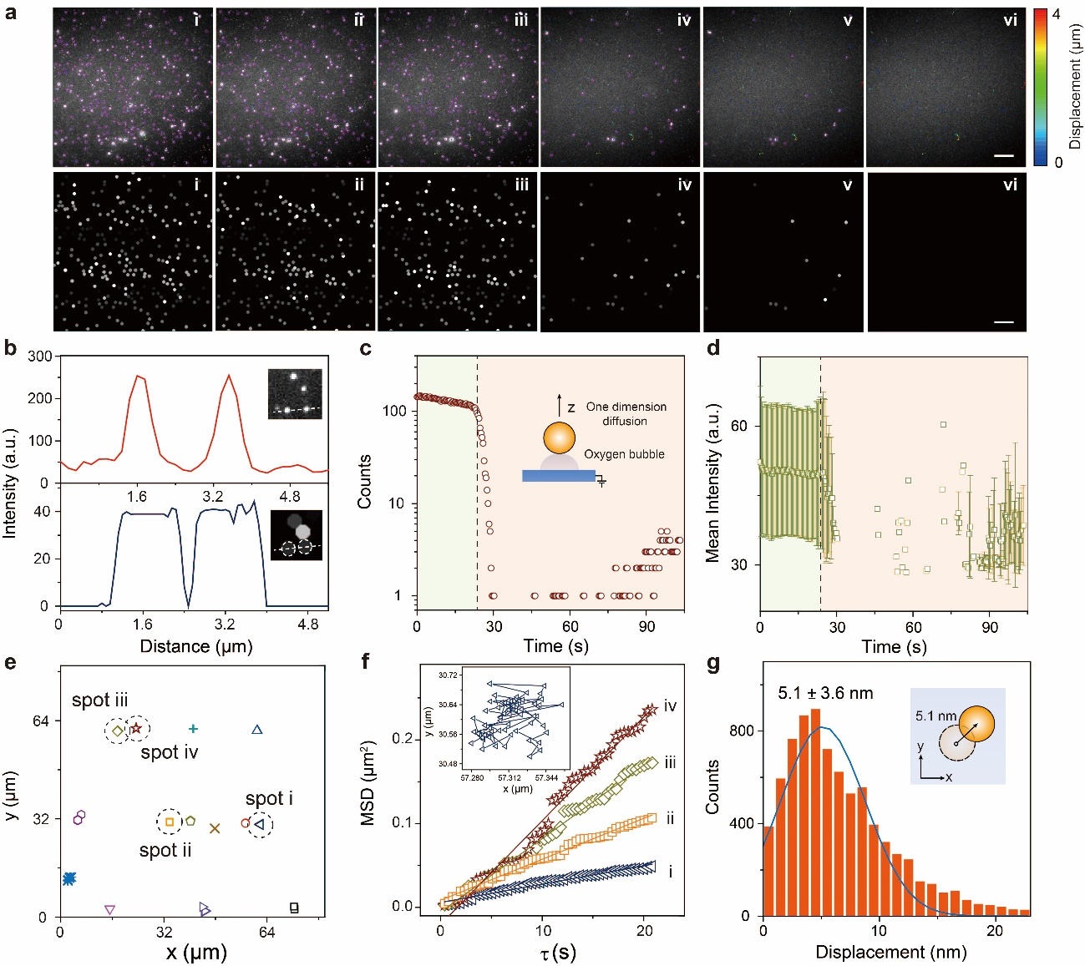
Supplementary Figure 25. (a) Sequential scattering images of IrO₂ particle during dynamic potential scan from - 0.50 to 1.20 V vs Pt. The i-vi frame corresponding to - 0.50, - 0.10, 0.30, 0.70, 0.90 and 1.20 V vs Pt, respectively. The color scale represented the xy-plane lateral diffusion distance which showed the degree of particle diffusion from its original location. Scale bar, 10 μm. EC-TIRM images of represented individual IrO₂ particles were acquired during OER under anodic polarization. Consecutive scattering images showed brightly scattering particles originating from Rayleigh scattering contribution from particles. The relative uniform spatial intensity among each particle indicates the particles were located at the electrode surface and was suited to investigate OER performance at the single particle level. (b) Comparison the scattering image of representative particles and scattering intensity line scan profile across adjacent particle and corresponding intelligent identified optical patterns of the same domain. (c) The recognized particle on the electrode surface as a function of time under polarization. Inset showed the oxygen evolution induced particle hopping along z direction. Dash line clarified the onset location where particle commenced to desorb from electrode surface. (d) The average scattering intensity of particle on the electrode as a function of time under polarization dash line clarified the onset location where particle commenced to desorb from the electrode surface. (e) Representative moving trajectories of particles on the electrode surface. The interval between the two data points is 393 ms. (f) Mean square displacement (MSD) of the represented IrO₂ nanoparticles enclosed in dashed circle (spot i-iv) in (e). Inset showed the enlarged view of single particle diffusion trajectory of spot i in (e). (g) The distribution of two-dimensional diffusion length for IrO₂ particle under polarization. Inset showed the schematic of particle diffusion at xy-plane.

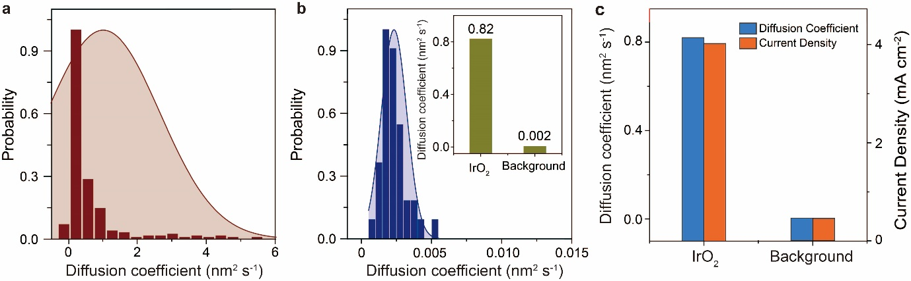
Supplementary Figure 26.The distribution of one-dimensional diffusion coefficient of (a) IrO₂ nanoparticle and (b) bare ITO region (served as background signal) during dynamic potential scan. Inset indicates the average diffusion coefficient of IrO₂ and background regions. (c) Comparison the diffusion coefficient and current density (at 1.20 V vs Pt) with the background signal. The scattering intensity collected from dark region close to IrO₂ particle was adopted as background diffusion coefficient, and current density obtained at bare ITO electrode at 1.20 V was served as the background current density.

Supplementary Note 7: Characterization of Series Electrocatalysts
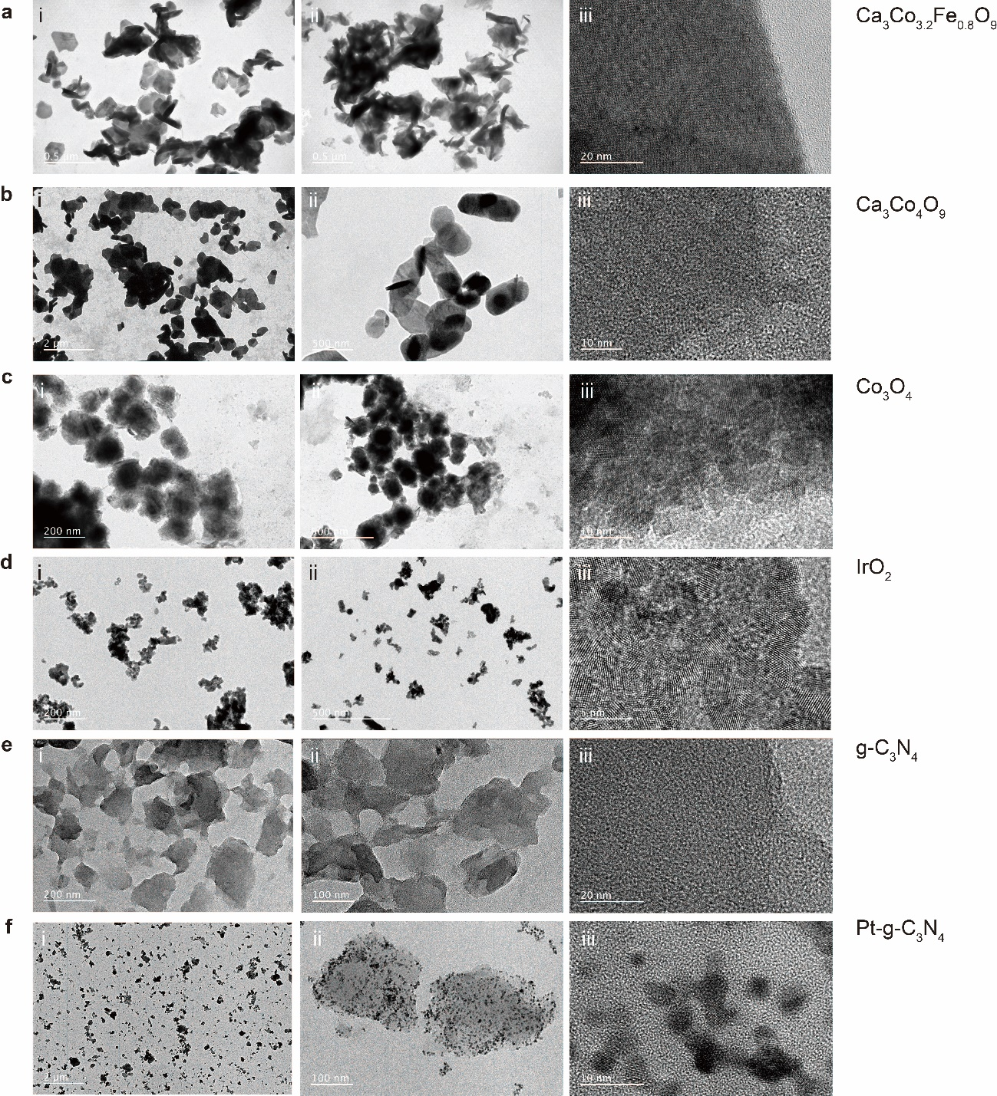
Supplementary Figure 27. TEM images of Ca₃Co_{3.2}Fe_{0.8}O₉ (a, i-ii), Ca₃Co₄O₉ (b, i-ii), Co₃O₄ (c, i-ii), IrO₂ (d, i-ii), g-C₃N₄ (e, i-ii) and Pt-g-C₃N₄ (f, i-ii). Corresponding HR-TEM images of the electrocatalysts were shown in (a-f, iii). The legible lattice planes in Ca₃Co₄O₉ and Ca₃Co_{3.2}Fe_{0.8}O₉ indicated the remarkable crystallization for these metallic oxides.

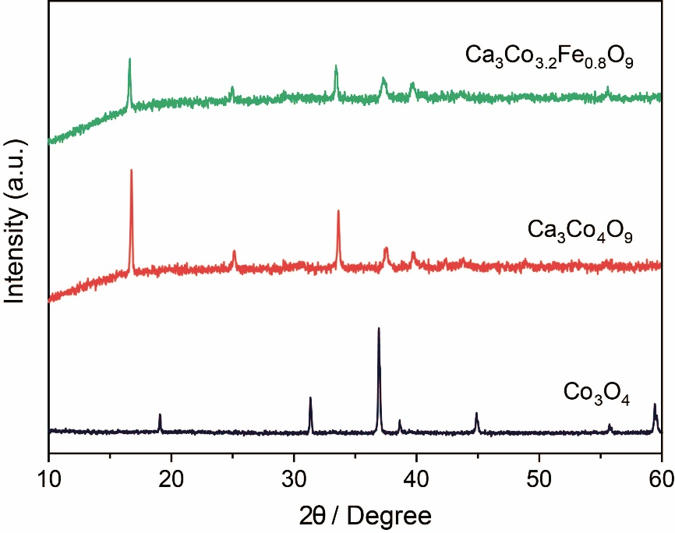
Supplementary Figure 28. X-ray diffraction patterns of prepared electrocatalyst Ca₃Co_{3.2}Fe_{0.8}O₉ and Ca₃Co₄O₉, and comparison with X-ray diffraction pattern of Co₃O₄. The XRD patterns of Ca₃Co₄O₉ exhibited the diffraction peaks same as the standard JCPDS card (23-0110) pattern. In contrast to pure Ca₃Co₄O₉, the XRD patterns of doping metal oxides (Fe) show same phase structure of Ca₃Co₄O₉.

Supplementary Note 8: Screening Electrocatalyst based on Single Particle Hopping Model
The primary difficulty in resolving the influence from morphological heterogeneity on screening catalysts lies in identifying how the catalytic impacts of morphological heterogeneity locally deviates from bulk-averaged metrics. To overcome this challenge, we tracked the vertical movements of single particle compared with bulk measurements. No remarkable scattering optical response for g-C₃N₄ hopping was observed, indicating phase interface evolution was severely constrained by the inferior charge transport ability under anodic polarization (Supplementary Figure 35). Whereas the corresponding scattering intensity change for Pt-g-C₃N₄ is correlated with particle hopping (D = 0.08 nm² s⁻¹) induced by multi-phase interface evolution, reaching a minimum strength at a polarization potential of 2.50 V vs RHE (Supplementary Figure 35). It should be noted that after loading Pt nanoparticles (with diameter ca. 5.5 nm) on g-C₃N₄ to form hybrid metal-metalloid composites, the OER performance is remarkably enhanced by providing abundant high active sites Pt atoms (Supplementary Figure 36).³⁹ By contrast, bare g-C₃N₄ nanosheets serve only as the platform for loading active components.⁴⁰ Further electrochemical characterizes including potential linear scan and electrochemical impedance spectroscopy provide more evidence and gain the same conclusion (Supplementary Figure 37).
To distinguish the mass transport properties for various electrode morphologies, we established a 2D axisymmetric domain surrounded by a concentric region in which infinite elements simulation can be used to extend the bulk solution in the model to infinity. Assuming the presence of a large quantity of supporting electrolyte to ensure the excellent conductivity. The mass transport equation of reactant and product species (here we used a redox couple: reduced reactant A and oxidized products B; A - e ↔ B) was implemented on the electrode interface. We use the Fick’s 2nd law (diffusion equation) to describe the mass transport of species A and B. At steady-state, this equation can be simplified as:
$∇∙(D_{i}∇c_{i})= 0$ (19)
The current density under polarization can be obtained by the electroanalytical Butler-Volmer equation:
$i_{a}=nFk_{0}\left(c_{A}exp\left(\frac{(n-α)Fη}{RT}\right)-c_{B}exp\left(\frac{-αFη}{RT}\right)\right)$ (20)
where k₀ is the heterogeneous rate constant for the oxidation reaction, here we set as 1 m s⁻¹. α is the cathodic transfer coefficient (0.5), and η is the overpotential at the polarized electrode. The diffusion coefficient for species A and B are set as 110⁻⁹ m² s⁻¹.
We simulated the reactants concentration distribution evolution in a 2D potential field following dynamic potential scan. To obtain reasonable agreement with experiments, we chose 1) single nanorod structure (diameter 40 nm, length 100 nm and aspect ratio 2.5) as the single particle electrode model; 2) a coupled electrode in which the planar electrode (radius 50 μm) modified with a same nanorod structure in single particle system served as the bulk electrode model to simulate and identify their corresponding mass diffusion pattern. Supplementary Figure 41 displayed the resulting reactants distribution under anodic polarization (0.4 V). In contrast to the quasi-plane diffusion mode identified in bulk electrode system, sphere diffusion pattern emerged around single particle electrode, explained the enhanced mass transport capability for single particle system than bulk case. Meanwhile, the concomitant current density exhibited a four orders of magnitude in single particle system (12.5 A cm⁻²) than bulk case (1.810⁻⁴ A cm⁻²), and exceeded industrial current densities (0.5 A cm⁻²) by about twenty times⁴¹, further confirmed high reaction efficiency in single particle system. The combination of experiments and simulations thus enabled a semi-quantitative evaluation of the morphological heterogeneity on catalytic performance.

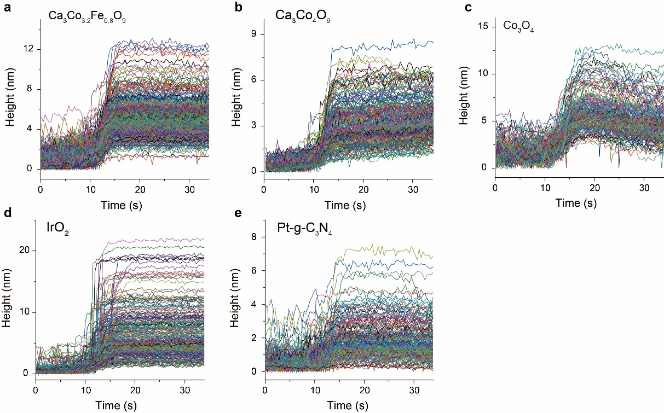
Supplementary Figure 29. Representative height profiles of various particles (a Ca₃Co_{3.2}Fe_{0.8}O₉, b Ca₃Co₄O₉, c Co₃O₄, d IrO₂, and e Pt-g-C₃N₄) as a function of time under dynamic potential scan (from 0.70 to 2.50 then to 0.70 V vs RHE, at a scan rate 0.10 V s⁻¹).

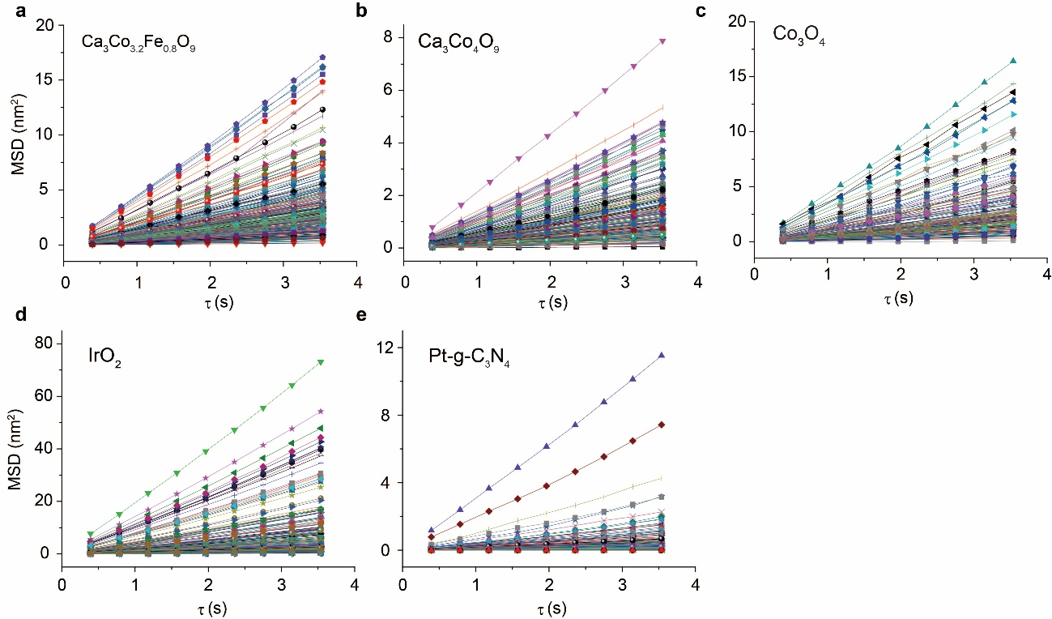
Supplementary Figure 30. The extracted representative MSD curves along z-axis from representive catalysts particles (a Ca₃Co_{3.2}Fe_{0.8}O₉, b Ca₃Co₄O₉, c Co₃O₄, d IrO₂, and e Pt-g-C₃N₄) based on the one-dimensional diffusion equation.

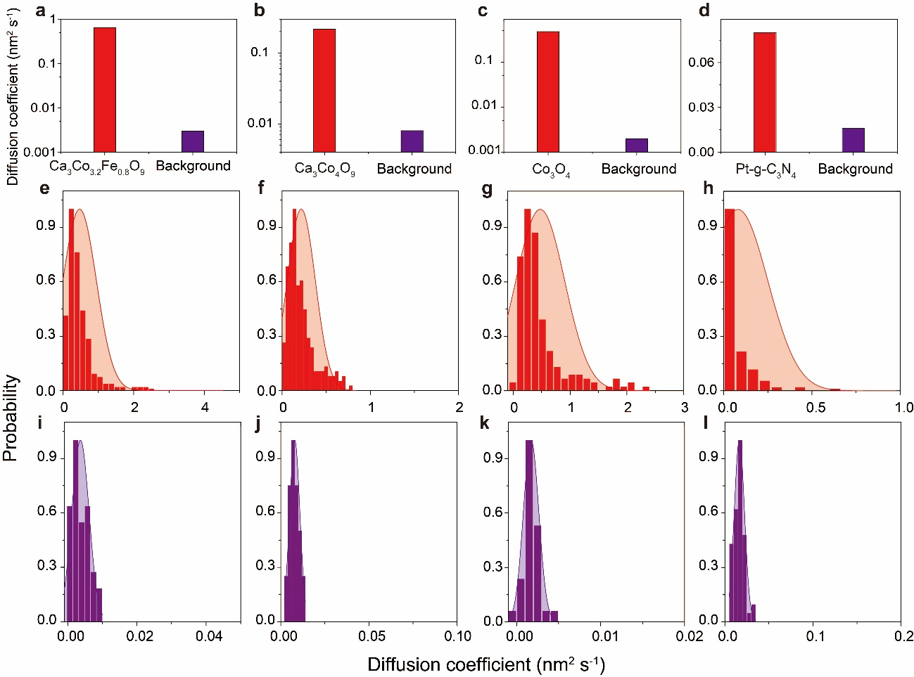
Supplementary Figure 31. (a)-(e) Comparison of averaged one-dimensional diffusion coefficient value of various catalysts including Ca₃Co_{3.2}Fe_{0.8}O₉, Ca₃Co₄O₉, Co₃O₄, and Pt-g-C₃N₄ and relative background signal. The diffusivity distribution (D) under polarization (e-h) and relative background signal (i-l), determined from the fitting function f(t) = 2Dt^{α} where α is set as 1 corresponding to Brownian movement (e, i Ca₃Co_{3.2}Fe_{0.8}O₉; f, j Ca₃Co₄O₉; g, k Co₃O₄; h, l Pt-g-C₃N₄).

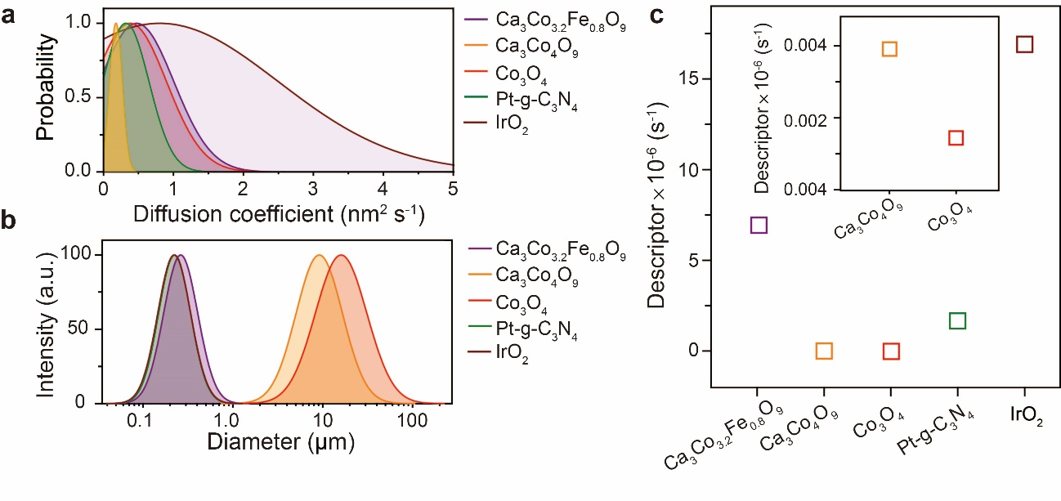
Supplementary Figure 32. (a) The diffusion coefficient distribution for various particles extracted from single particle hopping model. (b) The hydraulic diameter distribution for various particles. (c) The specific indicator calculated for various catalysts. The proposed indicator (f = <D>/A) was calculated by average diffusion coefficient (<D>) and projected area (A = π(d/2)^2) of various particles by eliminating the influence of particle size (hydraulic diameter, d) on one-dimensional diffusion coefficient (D).

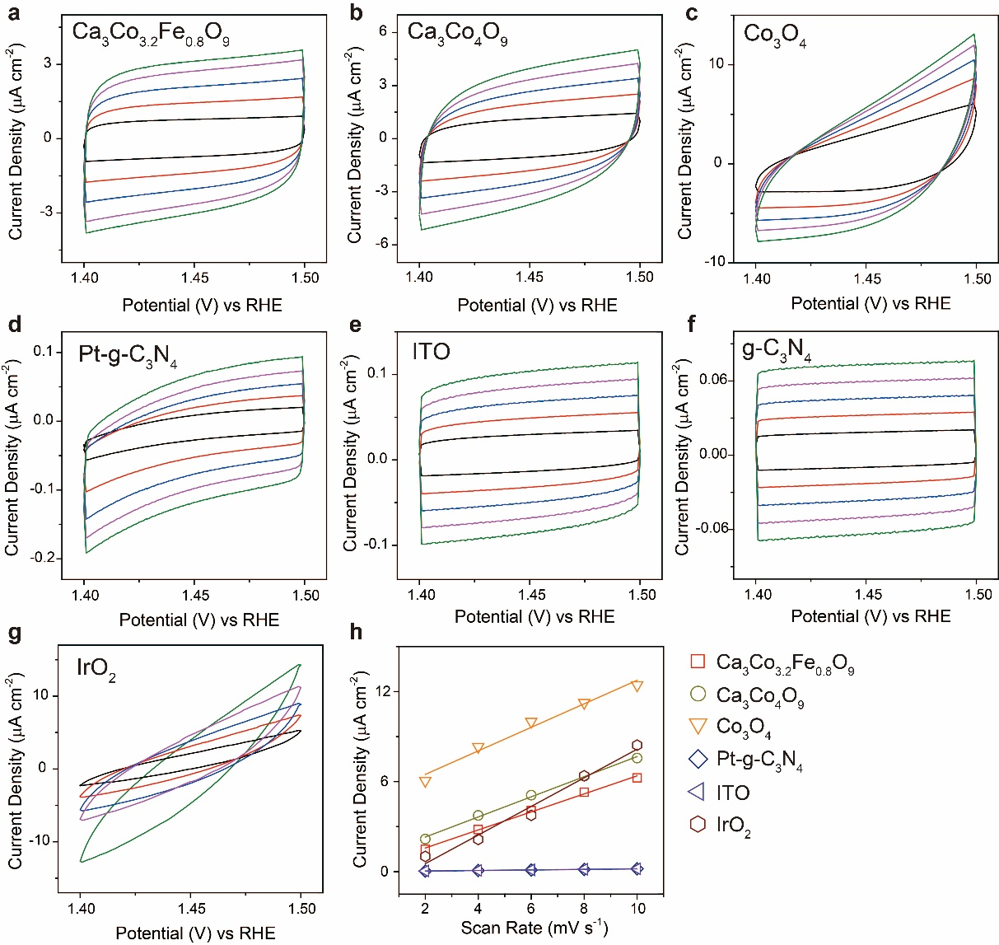
Supplementary Figure 33. CV curves for various electrodes (Ca₃Co_{3.2}Fe_{0.8}O₉, Ca₃Co₄O₉, Co₃O₄, Pt-g-C₃N₄, IrO₂, g-C₃N₄ and bare ITO) in a solution of 0.10 M KOH at different scan rate (2, 4, 6, 8 and 10 mV s⁻¹). The double-layer capacitance C_{dl} is linearly proportional to the electrochemical active surface area (A_{ESCA}). The larger C_{dl} values of the studied doped samples correlate to the larger ESCA, which is a crucial factor for high catalytic activities.

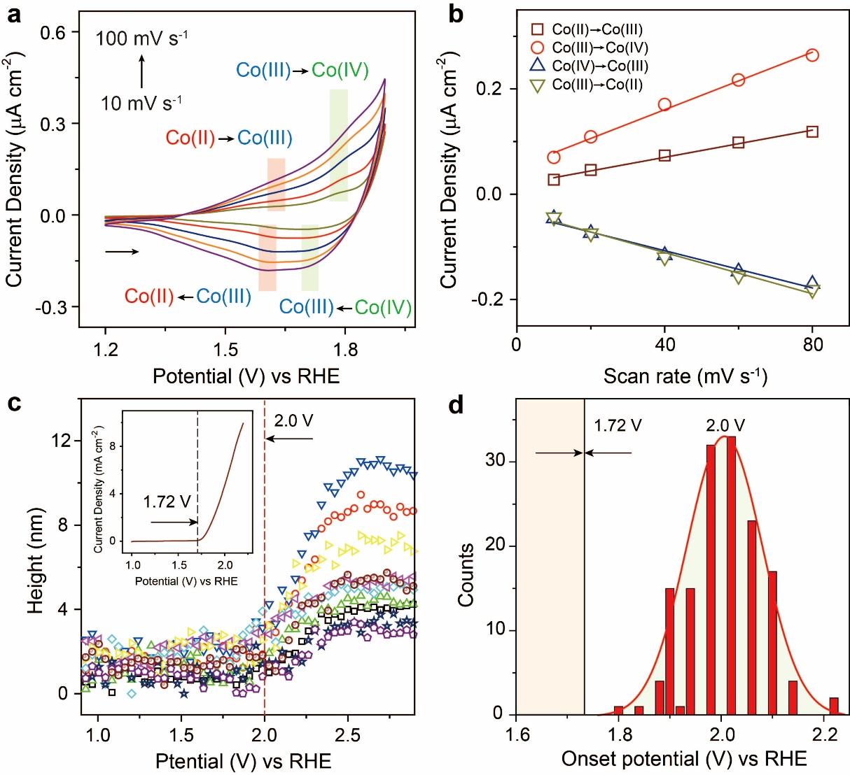
Supplementary Figure 34. (a) CV curves for Co₃O₄/ITO electrode in a solution of 0.10 M KOH at different scan rate (0.01, 0.02, 0.04, 0.06, 0.08, and 0.10 V s⁻¹). (b) The scan rate dependence of anodic and cathodic peak current corresponding to Co redox process. (c) The representative height profiles of Co₃O₄ particles as a function of polarization potential. The red dash line indicatd the onset potential for oxygen evolutioin on Co₃O₄ particles. Inset showed the LSV for Co₃O₄/ITO electrode in a solution of 0.10 M KOH. The black dash line indicated the onset potential for oxygen evolutioin on Co₃O₄ electrode. (d) Histogram distribution of onset potential for OER on individual Co₃O₄ particles. The onset potential of individual particles were collected from Supplementary Figure 29 for statistic analysis.

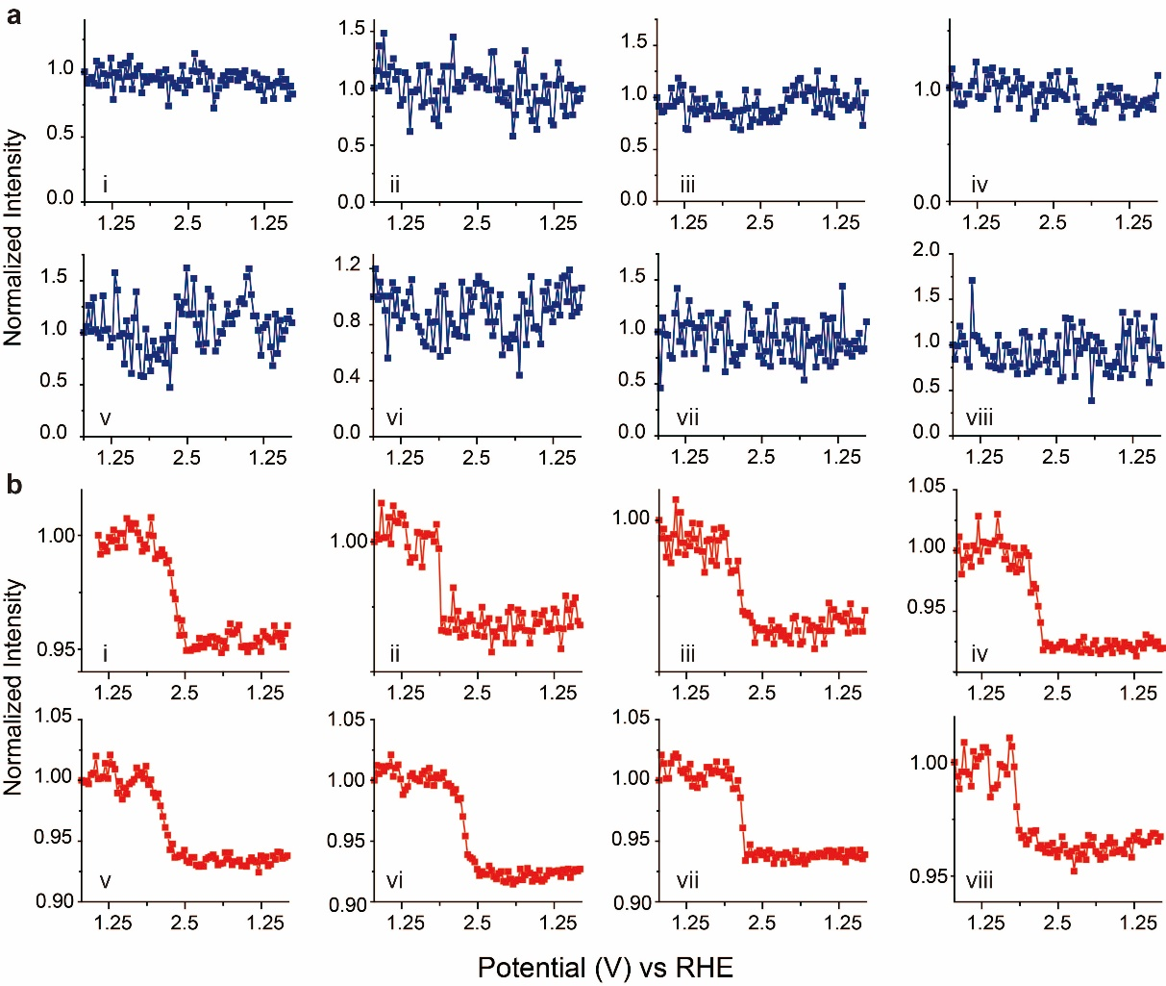
Supplementary Figure 35. Normalized scattering intensity profiles for g-C₃N₄ (a) and Pt-g-C₃N₄ nanosheets (b) during dynamic potential scan from 0.70 to 2.50 then to 0.70 V (vs RHE) at a scan rate 0.10 V s⁻¹. Notably, the scattering intensity decay was only found on Pt-g-C₃N₄ nanosheets and no optical response was identified on g-C₃N₄ structure.

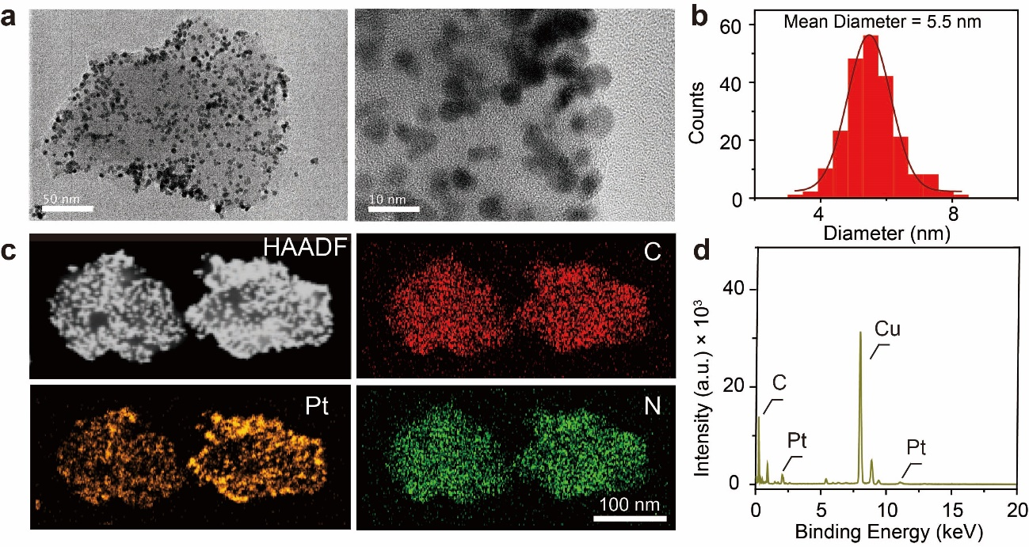
Supplementary Figure 36. (a) TEM image of the Pt-g-C₃N₄ nanosheets (right). HR-TEM image of the Pt nanoparticles modified on Pt-g-C₃N₄ nanosheets (left). (b) The corresponding diameter distribution of the Pt nanoparticles modified on Pt-g-C₃N₄ nanosheets. It exhibits a mean diameter ca. 5.5 nm. (c) High-angle annular dark-field imaging image (HAADF) of adjacent Pt-g-C₃N₄ nanosheets. The EDX elements mapping of C, Pt and N in adjacent Pt-g-C₃N₄ nanosheets.

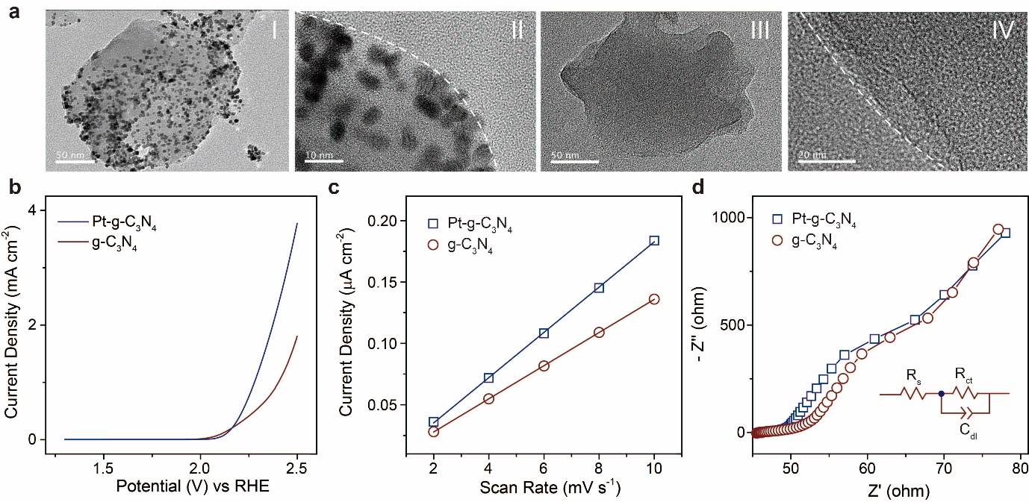
Supplementary Figure 37. (a) TEM images of Pt-g-C₃N₄ nanosheet (I and II) and bare g-C₃N₄ nanosheet (III and IV). The white dash line indicates the boundary of Pt-g-C₃N₄ and g-C₃N₄ nanosheets, respectively. Note that Pt nanoparticle was homogeneously dispersed on g-C₃N₄ surface. (b) LSV and (c) potential scan rate dependent current density and (d) EIS of Pt-g-C₃N₄ and g-C₃N₄ nanosheets modified ITO electrode in Nyquist plot. Inset in (d) shows the corresponding equivalent circuit.

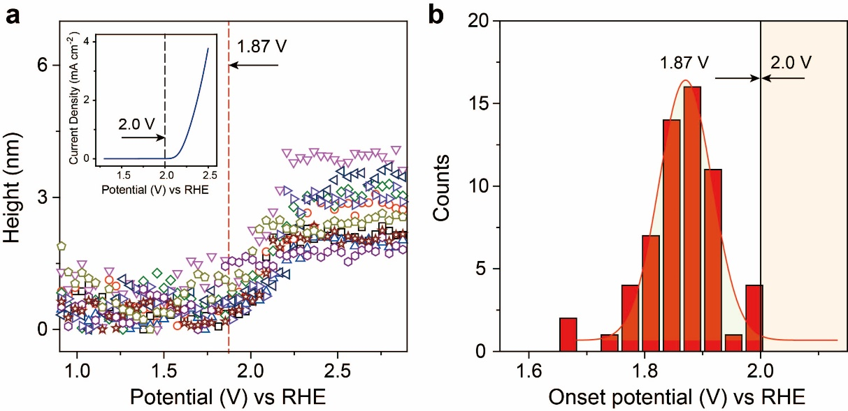
Supplementary Figure 38. (a) Representative height profiles of Pt-g-C₃N₄ nanosheets as a function of polarization potential. The red dash line indicats the onset potential for oxygen evolutioin on Pt-g-C₃N₄ nanosheets. Inset showed the potential linear scan for a Pt-g-C₃N₄/ITO electrode in a solution of 0.10 M KOH. The black dash line indicated the onset potential for oxygen evolutioin on a Pt-g-C₃N₄ bulk electrode. (b) Histogram distribution of onset potential for OER on individual Pt-g-C₃N₄ nanosheets. The onset potential of individual particles were collected from Supplementary Figure 29 for statistic analysis.

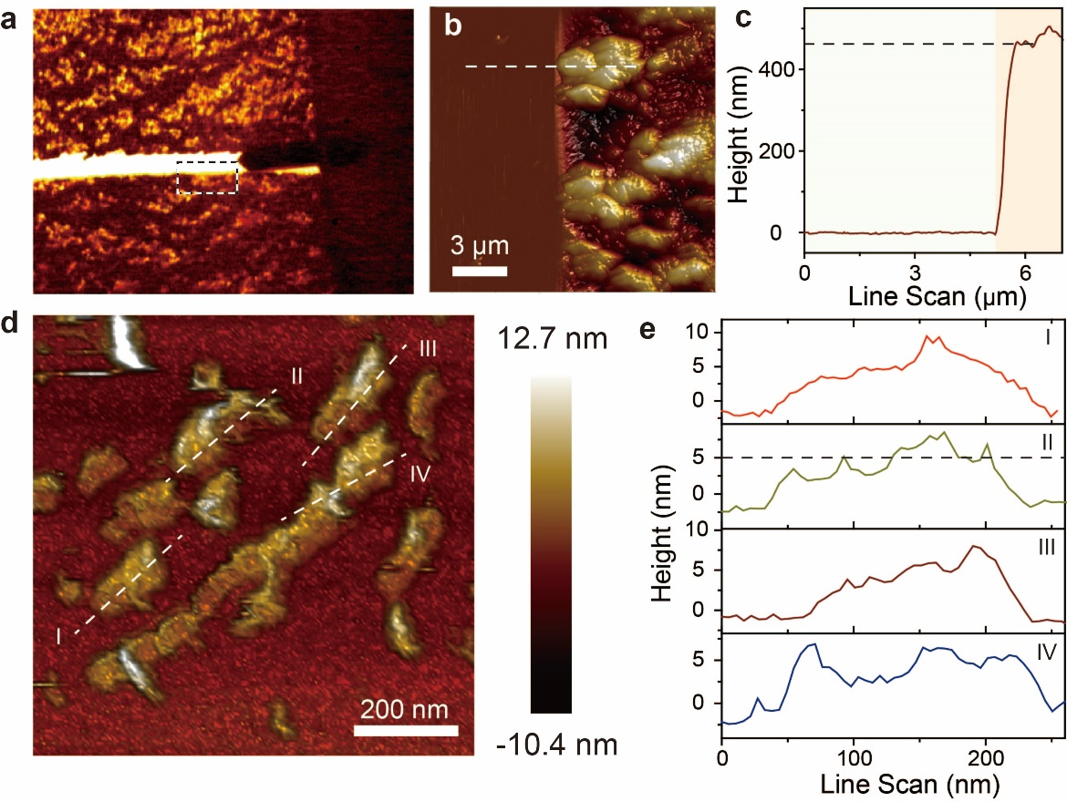
Supplementary Figure 39. (a) Topographic characteristics of line scan location on electrode where Pt-g-C₃N₄ nanosheets were piled on bare ITO electrode (Pt-g-C₃N₄/ITO). (b) AFM image of the line scan location of the Pt-g-C₃N₄ film cross section. (c) The corresponding height line scan of Pt-g-C₃N₄ film. (d) AFM image of as-prepared Pt-g-C₃N₄ nanosheets and (e) the corresponding measured dimensions of individual Pt-g-C₃N₄ nanosheets (I-IV).

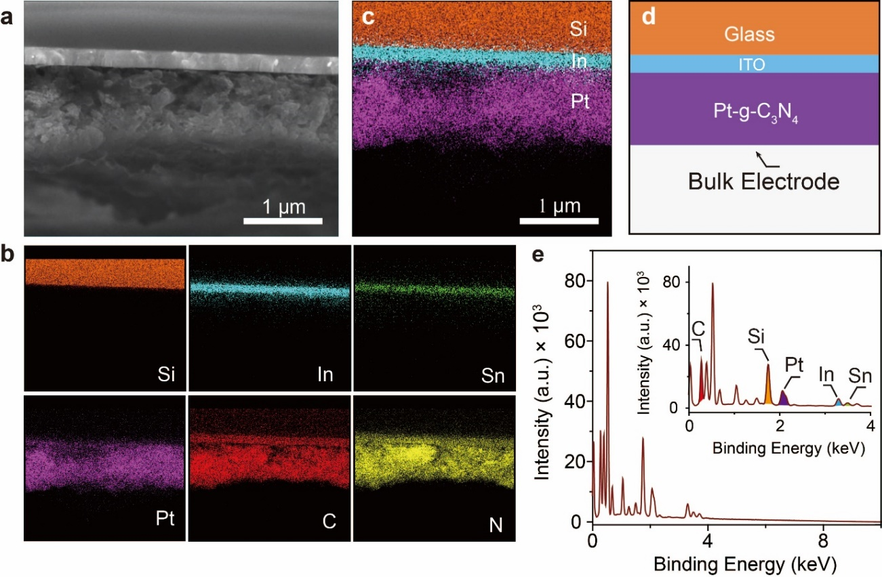
Supplementary Figure 40. (a) FE-SEM image of Pt-g-C₃N₄/ITO electrode. (b) Corresponding EDS elements imaging of Si, In, Sn, Pt, C and N elements. (c) The overlap of various elements shown in (b). (d) Schematic illustration of the depth composition distribution in Pt-g-C₃N₄/ITO electrode. (e) The EDS spectrum achieved form Pt-g-C₃N₄/ITO electrode surface.

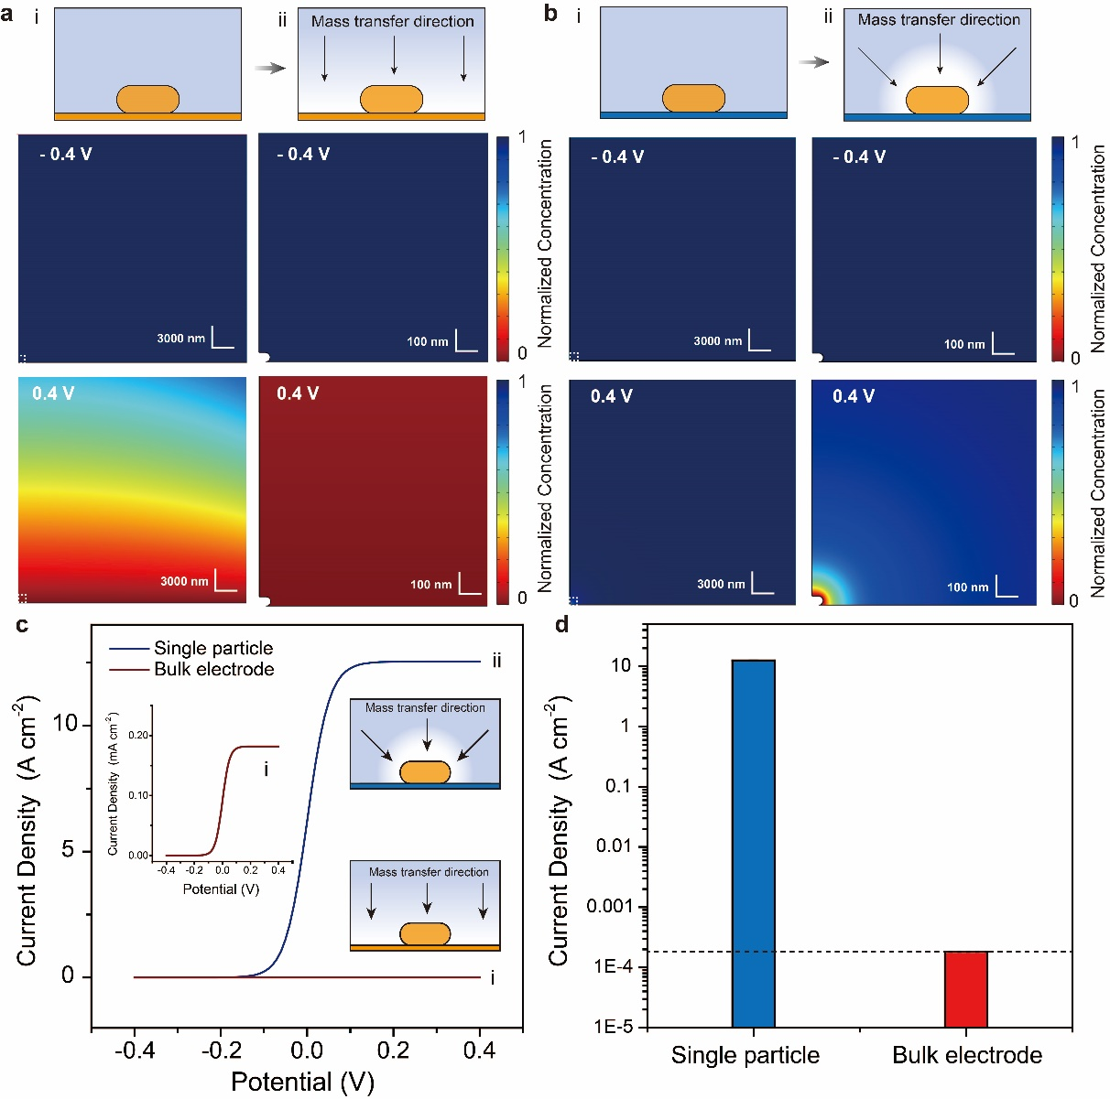
Supplementary Figure 41. The reduced reactant concentration field for a bulk electrode system (a) and single particle electrode case (b) at initial cathodic polarization (- 0.4 V) and followed anodic polarization (0.4 V). The right column is the magnified view of white dash square in left column. At 0.4 V, the depletion of reactants at the electrode-electrolyte interface was obviously observed. Note that the quasi-linear concentration distribution of reactant indicates a quasi-planar diffusion pattern on the electrode-electrolyte interface in (a); radical diffusion mode was clearly identified around single nanoparticle in (b). Upper panel shows the mass diffusion direction along the electrode surface to the bulk electrolyte. (c) CV curves for bulk electrode and single particle electrode. With increasing anodic polarization from - 0.4 to + 0.4 V, the reduced reactant was gradually oxidized by the anodic polarized electrode leading to the decrease of its concentration near the electrode-electrolyte interface. Inset shows the magnified CV curve for a bulk electrode. The cartoon illustrates the diversity mass transfer patterns on the electrode surface. (d) The comparison of limiting current density for a bulk electrode and single particle electrode.

Supplementary References
(1) Steinhauer, C.; Jungmann, R.; Sobey, T. L.; Simmel, F. C.; Tinnefeld, P., DNA Origami as a Nanoscopic Ruler for Super-Resolution Microscopy. Angew. Chem., Int. Ed. 2009, 48, 8870-8873.
(2) Wang, J.-G.; Hua, X.; Li, M.; Long, Y.-T., Mussel-Inspired Polydopamine Functionalized Plasmonic Nanocomposites for Single-Particle Catalysis. ACS Appl. Mater. Interfaces 2017, 9, 3016-3023.
(3) Wang, J.-G.; Shi, L.; Su, Y.; Liu, L.; Yang, Z.; Huang, R.; Xie, J.; Tian, Y.; Li, D., In-situ Plasmonic Tracking Oxygen Evolution Reveals Multistage Oxygen Diffusion and Accumulating Inhibition. Nat. Commun. 2021, 12, 2164.
(4) Lin, X.; Bao, H.; Zheng, D.; Zhou, J.; Xiao, G.; Guan, C.; Zhang, L.; Wang, J.-Q., An Efficient Family of Misfit-Layered Calcium Cobalt Oxide Catalyst for Oxygen Evolution Reaction. Adv. Mater. Interfaces 2018, 5, 1801281.
(5) Fu, J.; Yu, J.; Jiang, C.; Cheng, B., g-C₃N₄-Based Heterostructured Photocatalysts. Adv. Energy Mater. 2018, 8, 1701503.
(6) McCrory, C. C. L.; Jung, S.; Peters, J. C.; Jaramillo, T. F., Benchmarking Heterogeneous Electrocatalysts for the Oxygen Evolution Reaction. J. Am. Chem. Soc. 2013, 135, 16977-16987.
(7) Dickinson, E. J. F.; Limon-Petersen, J. G.; Rees, N. V.; Compton, R. G., How Much Supporting Electrolyte Is Required to Make a Cyclic Voltammetry Experiment Quantitatively “Diffusional”? A Theoretical and Experimental Investigation. J. Phys. Chem. C 2009, 113, 11157-11171.
(8) Compton, R. G., Banks, C. E, Understanding voltammetry. World Scientific: London 2018.
(9) Bard, A. J., Faulkner, L. R., Electrochemical Methods, Foundamentals and Applications. John wiley and Sons Inc: New York, 2001; Vol. 482.
(10) Alobaid, A.; Wang, C.; Adomaitis, R. A., Mechanism and Kinetics of HER and OER on NiFe LDH Films in an Alkaline Electrolyte. J. Electrochem. Soc. 2018, 165, J3395-J3404.
(11) Wang, J.-G.; Zhang, Y.; Yu, X.; Hua, X.; Wang, F.; Long, Y.-T.; Zhu, Z., Direct Molecular Evidence of Proton Transfer and Mass Dynamics at the Electrode–Electrolyte Interface. J. Phys. Chem. Lett. 2019, 10, 251-258.
(12) Wang, J.-G.; Hua, X.; Xia, H.-L.; Long, Y.-T., Pore Confined Liquid–Vacuum Interface for Charge Transfer Study in an Electrochemical Process. Anal. Chem. 2019, 91, 3195-3198.
(13) Zhou, Y.; Su, M.; Yu, X.; Zhang, Y.; Wang, J.-G.; Ren, X.; Cao, R.; Xu, W.; Baer, D. R.; Du, Y.; Borodin, O.; Wang, Y.; Wang, X.-L.; Xu, K.; Xu, Z.; Wang, C.; Zhu, Z., Real-Time Mass Spectrometric Characterization of the Solid–Electrolyte Interphase of a Lithium-Ion Battery. Nat. Nanotechnol. 2020, 15, 224-230.
(14) He, Y.; Jiang, L.; Chen, T.; Xu, Y.; Jia, H.; Yi, R.; Xue, D.; Song, M.; Genc, A.; Bouchet-Marquis, C.; Pullan, L.; Tessner, T.; Yoo, J.; Li, X.; Zhang, J.-G.; Zhang, S.; Wang, C., Progressive Growth of the Solid–Electrolyte Interphase Towards the Si Anode Interior Causes Capacity Fading. Nat. Nanotechnol. 2021, 16, 1113–1120.
(15) Dionigi, F.; Zeng, Z.; Sinev, I.; Merzdorf, T.; Deshpande, S.; Lopez, M. B.; Kunze, S.; Zegkinoglou, I.; Sarodnik, H.; Fan, D.; Bergmann, A.; Drnec, J.; Araujo, J. F. d.; Gliech, M.; Teschner, D.; Zhu, J.; Li, W.-X.; Greeley, J.; Cuenya, B. R.; Strasser, P., In-situ Structure and Catalytic Mechanism of NiFe and CoFe Layered Double Hydroxides during Oxygen Evolution. Nat. Commun. 2020, 11, 2522.
(16) Cho, K. H.; Park, S.; Seo, H.; Choi, S.; Lee, M. Y.; Ko, C.; Nam, K. T., Capturing Manganese Oxide Intermediates in Electrochemical Water Oxidation at Neutral pH by In Situ Raman Spectroscopy. Angew. Chem., Int. Ed. 2021, 60, 4673-4681.
(17) Aoki, H.; Ogawa, H.; Takenaka, M., Neutron Reflectometry Tomography for Imaging and Depth Structure Analysis of Thin Films with In-Plane Inhomogeneity. Langmuir 2021, 37, 196-203.
(18) Jerliu, B.; Dörrer, L.; Hüger, E.; Borchardt, G.; Steitz, R.; Geckle, U.; Oberst, V.; Bruns, M.; Schneider, O.; Schmidt, H., Neutron Reflectometry Studies on the Lithiation of Amorphous Silicon Electrodes in Lithium-Ion Batteries. Phys. Chem. Chem. Phys. 2013, 15, 7777-7784.
(19) Beati, A. A. G. F.; Reis, R. M.; Rocha, R. S.; Lanza, M. R. V., Development and Evaluation of a Pseudoreference Pt//Ag/AgCl Electrode for Electrochemical Systems. Ind. Eng. Chem. Res. 2012, 51, 5367-5371.
(20) Oldham, K. B.; Stevens, N. P. C., Uncompensated Resistance. 2. The Effect of Reference Electrode Nonideality. Anal. Chem. 2000, 72, 3981-3988.
(21) Tarnev, T.; Aiyappa, H. B.; Botz, A.; Erichsen, T.; Ernst, A.; Andronescu, C.; Schuhmann, W., Scanning Electrochemical Cell Microscopy Investigation of Single ZIF-Derived Nanocomposite Particles as Electrocatalysts for Oxygen Evolution in Alkaline Media. Angew. Chem., Int. Ed. 2019, 58, 14265-14269.
(22) Zhang, Y.; Lucas, J. M.; Song, P.; Beberwyck, B.; Fu, Q.; Xu, W.; Alivisatos, A. P., Superresolution Fluorescence Mapping of Single-Nanoparticle Catalysts Reveals Spatiotemporal Variations in Surface Reactivity. Proc. Natl. Acad. Sci. U. S. A. 2015, 112, 8959.
(23) Kang, M.; Perry, D.; Kim, Y.-R.; Colburn, A. W.; Lazenby, R. A.; Unwin, P. R., Time-Resolved Detection and Analysis of Single Nanoparticle Electrocatalytic Impacts. J. Am. Chem. Soc. 2015, 137, 10902-10905.
(24) Xiang, Z.-P.; Deng, H.-Q.; Peljo, P.; Fu, Z.-Y.; Wang, S.-L.; Mandler, D.; Sun, G.-Q.; Liang, Z.-X., Electrochemical Dynamics of a Single Platinum Nanoparticle Collision Event for the Hydrogen Evolution Reaction. Angew. Chem., Int. Ed. 2018, 57, 3464-3468.
(25) Edwards, M. A.; White, H. S.; Ren, H., Voltammetric Determination of the Stochastic Formation Rate and Geometry of Individual H2, N2, and O2 Bubble Nuclei. ACS Nano 2019, 13, 6330-6340.
(26) Taqieddin, A.; Allshouse, M. R.; Alshawabkeh, A. N., Review—Mathematical Formulations of Electrochemically Gas-Evolving Systems. J. Electrochem. Soc. 2018, 165, E694-E711.
(27) Oheim, M.; Salomon, A.; Weissman, A.; Brunstein, M.; Becherer, U., Calibrating Evanescent-Wave Penetration Depths for Biological TIRF Microscopy. Biophys. J. 2019, 117, 795-809.
(28) Epstein, P. S.; Plesset, M. S., On the Stability of Gas Bubbles in Liquid‐Gas Solutions. J. Chem. Phys. 1950, 18, 1505-1509.
(29) Lohse, D.; Zhang, X., Pinning and Gas Oversaturation Imply Stable Single Surface Nanobubbles. Phys. Rev. E 2015, 91, 031003.
(30) Popov, Y. O., Evaporative Deposition Patterns: Spatial Dimensions of the Deposit. Phys. Rev. E 2005, 71, 036313.
(31) Eloul, S.; Kätelhön, E.; Batchelor-McAuley, C.; Tschulik, K.; Compton, R. G., Diffusional Nanoimpacts: The Stochastic Limit. J. Phys. Chem. C 2015, 119, 14400-14410.
(32) Wang, W., Imaging the Chemical Activity of Single Nanoparticles with Optical Microscopy. Chem. Soc. Rev. 2018, 47, 2485-2508.
(33) Xu, S.; Yu, X.; Chen, Z.; Zeng, Y.; Guo, L.; Li, L.; Luo, F.; Wang, J.; Qiu, B.; Lin, Z., Real-Time Visualization of the Single-Nanoparticle Electrocatalytic Hydrogen Generation Process and Activity under Dark Field Microscopy. Anal. Chem. 2020, 92, 9016-9023.
(34) Huang, T.-X.; Dong, B.; Filbrun Seth, L.; Okmi Aisha, A.; Cheng, X.; Yang, M.; Mansour, N.; Lei, S.; Fang, N., Single-Molecule Photocatalytic Dynamics at Individual Defects in Two-Dimensional Layered Materials. Sci. Adv. 7, eabj4452.
(35) Skaug, M. J.; Mabry, J.; Schwartz, D. K., Intermittent Molecular Hopping at the Solid-Liquid Interface. Phys. Rev. Lett. 2013, 110, 256101.
(36) Walder, R.; Nelson, N.; Schwartz, D. K., Single Molecule Observations of Desorption-Mediated Diffusion at the Solid-Liquid Interface. Phys. Rev. Lett. 2011, 107, 156102.
(37) Wei, W.; Yuan, T.; Jiang, W.; Gao, J.; Chen, H.-Y.; Wang, W., Accessing the Electrochemical Activity of Single Nanoparticles by Eliminating the Heterogeneous Electrical Contacts. J. Am. Chem. Soc. 2020, 142, 14307-14313.
(38) Guo, Z.; Manser, J. S.; Wan, Y.; Kamat, P. V.; Huang, L., Spatial and Temporal Imaging of Long-Range Charge Transport in Perovskite Thin Films by Ultrafast Microscopy. Nat. Commun. 2015, 6, 7471.
(39) Lin, C.; Zhao, Y.; Zhang, H.; Xie, S.; Li, Y.-F.; Li, X.; Jiang, Z.; Liu, Z.-P., Accelerated Active Phase Transformation of NiO Powered by Pt Single Atoms for Enhanced Oxygen Evolution Reaction. Chem. Sci. 2018, 9, 6803-6812.
(40) Zheng, Y.; Jiao, Y.; Zhu, Y.; Cai, Q.; Vasileff, A.; Li, L. H.; Han, Y.; Chen, Y.; Qiao, S.-Z., Molecule-Level g-C3N4 Coordinated Transition Metals as a New Class of Electrocatalysts for Oxygen Electrode Reactions. J. Am. Chem. Soc. 2017, 139, 3336-3339.
(41) Quast, T.; Varhade, S.; Saddeler, S.; Chen, Y.-T.; Andronescu, C.; Schulz, S.; Schuhmann, W., Single Particle Nanoelectrochemistry Reveals the Catalytic Oxygen Evolution Reaction Activity of Co₃O₄ Nanocubes. Angew. Chem., Int. Ed. 2021, 60, 23444-23450.

