Supplementary figures

Figure S1. Flowchart of bioinformatics analysis of whole exome sequence data

Figure S2. Variants distribution of DNAH10 and clinical features of patients carrying DNAH10 variations.
(A) Lollipop plot for mapping deleterious variants on the linear protein and its domains of DNAH10.
(B) Cobb angles in patients with or without DNAH10 variants (mean ± SD).
(C) Total tilted vertebrae number in patients with or without DNAH10 variants (mean ± SD).
(D) Curve direction and curve type (C shape or S shape) distribution in patients with or without DNAH10 variants.

Figure S3. Zebrafish dnah10 c.10304_10307del (p. N3435SfsX20) mutation
(A) Schematic of dnah10 protein and location of dnah10 c.10304_10307del allele lead to scoliosis phenotype in this study. Each box represents a conserved domain. MT, microtubule binding domain.
(B) Sanger sequence result of wildtype and dnah10 c.10304_10307del mutant. Base and amino change of dnah10 mutation demonstrate a 4 bp deletion on exon 60 with frameshift of dnah10.

Figure S4. Ciliary movement and beat frequency analyses
(A, B) Time projection of 10 seconds at 33 Hz is recorded. Left panel is inverted grayscale images of single frames from 10 s time-lapse confocal datasets from Tg(Foxj:Arl13b-GFP) or Tg (Foxj:Arl13b-GFP); dnah10 ^{ut28/ut28} mutant zebrafish. Red line represents the recording range of kymograph analysis in right panel. The wave diagram or straight line in right panel are kymograph results for motile cilia or immobile cilia.
(C) Inverted grayscale images of four frames from 10 s time-lapse confocal dataset of Tg(Foxj:Arl13b-GFP). Different positions of the same cilia were presented. Red line represents the recording range of kymograph analysis. The wave diagram in bottom panel is kymograph result for cilia frequency analysis.
(D) Time projection of 10 seconds at 33 Hz is recorded by confocal from Tg(Foxj:Arl13b-GFP). Cilia beat frequency of cilia in head, vent and tail are quantified (n = 9; mean ± SD) and compared.

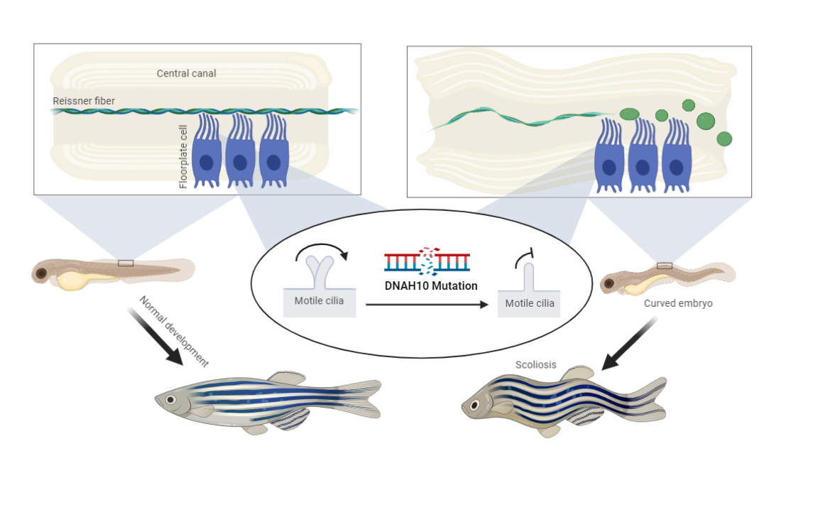
Figure S5. Schematic of pathogenesis of dnah10 ^{ut28} mutation

Supplementary videos
See slide
Video S1, Confocal time-lapse imaging of motile cilia in Tg(Foxj1:Arl13b-GFP).
Video S2, Confocal time-lapse imaging of motile cilia in Tg(Foxj1:Arl13b-GFP);dnah10^{ut28/ut28}.
Video S3, Confocal time-lapse imaging of “immobile cilia” and “motile cilia” in the same Tg(Foxj1:Arl13b-GFP);dnah10^{ut28/ut28} mutant fish.
Video S4, Time-lapse confocal imaging showed that RF continually moved from rostral to caudal in an orderly manner in scospondin-GFP^{ut24} and moved in a disorganized manner in and scospondin-GFP^{ut24}; dnah10 ^{ut28/ut28} mutant zebrafish.
Video S5, Confocal time-lapse imaging of RF phenotypes in scospondin-GFP^{ut24};dnah10 ^{ut28/ut28} mutant zebrafish.

Supplementary tables
Table S1. Clinical data of AIS cohort
Table S2. Gene specific oligos sequences using in this study and gRNA target sequences
Table S3. Primer sequences for amplification of dnah10 DNA segments around Cas9 guideRNAs and dnah10 transcript (ENSDART00000087708.6) from cDNA of AB wild-type.
Table S4. 246 candidate genes associated with AIS after gene-burden analysis.
Table S5. Gene family enrichment analysis.
Table S6. The most significantly enriched protein class by PANTHER orthogonal enrichment analysis
Table S7. KEGG pathway enrichment analysis.
Table S8. GO enrichment analysis.
Table S9. Variants in IS families.
Table S10. Zebrafish counting of post injection for each gene.
Table S11. Deleterious variants in DNAH10 gene detected in AIS cohort.

