Information Supplementary
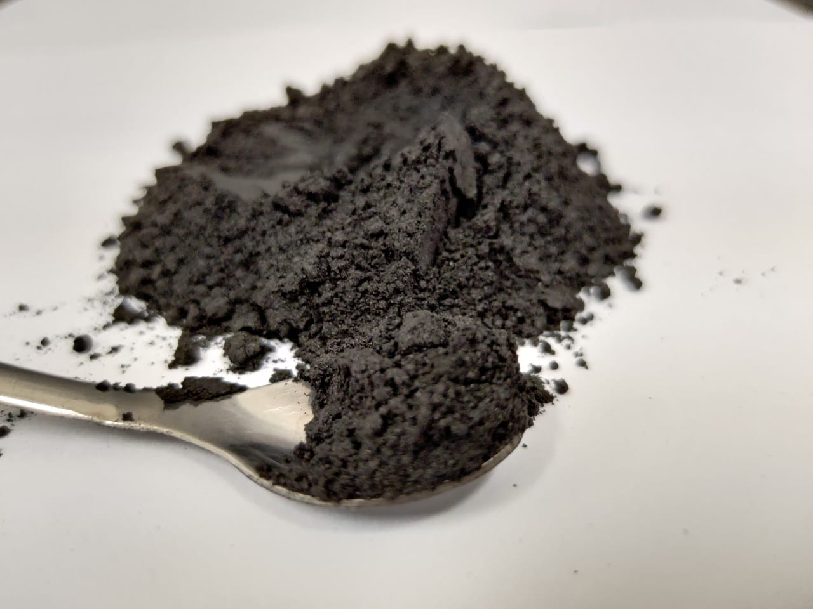
Supplementary figure A: Demonstration of the charcoal fines produced.

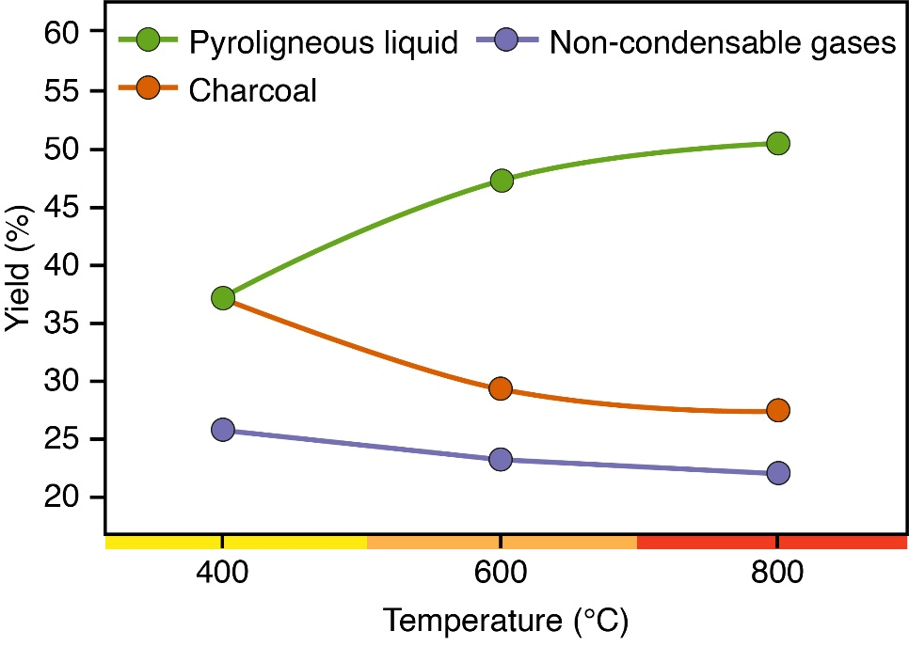
Supplementary figure B: Yield of charcoal fines.

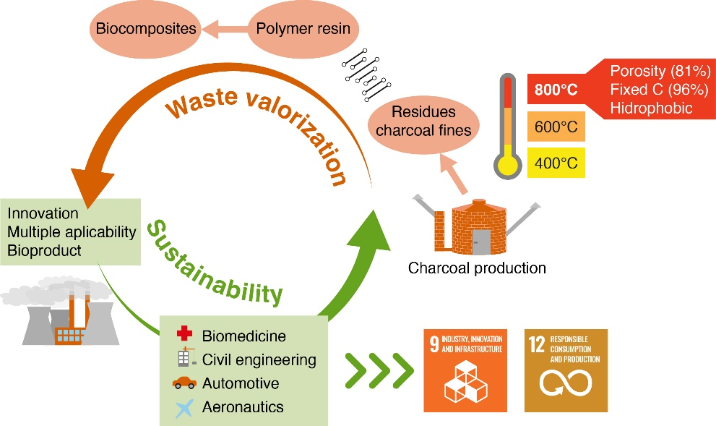
Supplementary figure C: Graphic abstract.

