Supplementary File

Methods

Figure S1. Schoenfeld’s residuals for the continuous predictor age (top) and the categorized predictor PRS (bottom)

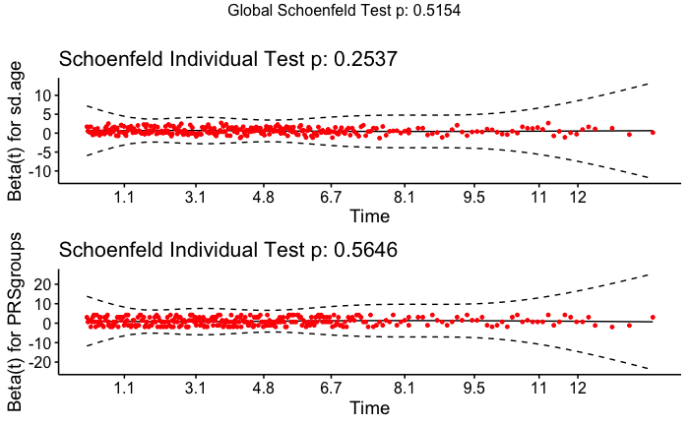

Results

Table S1. Demographic and clinical characteristics of PRS groups
PRS group | 0-25% | 25-50% | 50-75% | 75-85% | 85-95% | Top 5%
Number of women | 7584 | 7584 | 7575 | 3022 | 3031 | 1516
age (mean) | 45.74 | 46.05 | 45.95 | 45.76 | 45.90 | 45.65
BMI (mean) | 26.50 | 26.38 | 26.50 | 26.29 | 26.45 | 26.48
PRS* (mean) | -0.76 | -0.20 | 0.19 | 0.51 | 0.78 | 1.26
Number of comorbidities (mean) | 0.24 | 0.24 | 0.23 | 0.24 | 0.22 | 0.23
Education: less than secondary (count) | 1001 | 1014 | 1040 | 410 | 414 | 198
Education: secondary (count) | 4448 | 4458 | 4517 | 1828 | 1798 | 930
Education: university degree (count) | 2135 | 2112 | 2018 | 784 | 819 | 388
Smoking currently (count) | 1653 | 1691 | 1734 | 732 | 733 | 341
Smoking former (count) | 750 | 824 | 771 | 297 | 283 | 162
Smoking never (count) | 5181 | 5069 | 5070 | 1993 | 2015 | 1013
*Standardized

Table S2. Demographic and clinical characteristics of age groups
Age group | Younger than 50 |  | 50-62 years | Older than 62
Number of women | 17937 |  | 6891 | 5484
age (mean) | 34.39 |  | 55.59 | 71.27
BMI (mean) | 24.82 |  | 28.63 | 29.02
PRS* (mean) | 0.00 |  | 0.00 | 0.00
Number of comorbidities (mean) | 0.04 |  | 0.29 | 0.79
Education: less than secondary (count) |  | 1419 | 816 | 1842
Education: secondary (count) | 11111 |  | 4277 | 2591
Education: university degree (count) | 5407 |  | 1798 | 1051
Smoking currently (count) | 5147 |  | 1435 | 302
Smoking former (count) | 1854 |  | 814 | 419
Smoking never (count) | 10936 |  | 4642 | 4763
Breast cancer events in 3 years | 34 |  | 33 | 34
Breast cancer events in 5 years | 66 |  | 58 | 61
*Standardized

Figure S2. Age density distribution in PRS subgroups
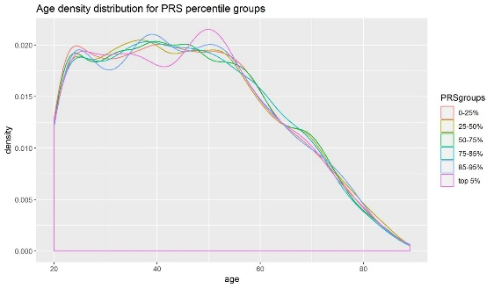

Table S3. Descriptive statistics for 3- and 5-year PRSage_mInc and age_mInc distributions
Statistics | 3-year PRSage_mInc  (mean %) | 3-year age_mInc  (mean %) | 5-year PRSage_mInc  (mean %) | 5-year age_mInc  (mean %)
Min. | 0.05 | 0.1 | 0.09 | 0.19
1st Qu. | 0.14 | 0.17 | 0.26 | 0.32
Median | 0.24 | 0.27 | 0.44 | 0.5
Mean | 0.33 | 0.33 | 0.6 | 0.6
3rd Qu. | 0.42 | 0.43 | 0.76 | 0.79
Max. | 2.78 | 1.16 | 4.48 | 1.85

Table S4. Three-year PRSage-mInc: number (proportions) above 0.5%, 1%, and 1.5% thresholds
PRS group | No. of women (n) | No. of women above 0.5% PRSage_mInc (%) | No. of women above 1% PRSage_mInc (%) | No. of women above 1.5% PRSage_mInc (%)
0-25% | 7584 | 147 (1.94) | 0 | 0
25-50% | 7584 | 462 (6.09) | 0 | 0
50-75% | 7575 | 1544 (20.38) | 85 (1.12) | 0
75-85% | 3022 | 890 (29.45) | 116 (3.84) | 0
85-95% | 3031 | 1537 (50.71) | 491 (16.2) | 135 (4.45)
top 5% | 1516 | 1015 (66.95) | 423 (27.9) | 187 (12.34)
Total | 30312 | 5595 (18.46) | 1115 (3.68) | 322 (1.06)

Table S5. Three-year age_mInc: number (proportions) above 0.5%, 1%, and 1.5% thresholds
PRS group | No. of women (n) | No. of women above 0.5% age_mInc (%) | No. of women above 1% age_mInc (%) | No. of women above 1.5% age_mInc (%)
0-25% | 7584 | 1406 (18.54) | 55 (0.73) | 0
25-50% | 7584 | 1484 (19.57) | 63 (0.83) | 0
50-75% | 7575 | 1445 (19.08) | 57 (0.75) | 0
75-85% | 3022 | 567 (18.76) | 17 (0.56) | 0
85-95% | 3031 | 573 (18.9) | 25 (0.82) | 0
top 5% | 1516 | 276 (18.21) | 11 (0.73) | 0
Total | 30312 | 5751 (18.97) | 228 (0.75) | 0

Table S6. Five-year PRSage-mInc: number (proportions) above 0.5%, 1%, and 1.5% thresholds
PRS group | No. of women (n) | No. of women above 0.5% PRSage_mInc (%) | No. of women above 1% PRSage_mInc (%) | No. of women above 1.5% PRSage_mInc (%)
0-25% | 7584 | 1389 (18.31) | 9 (0.12) | 0
25-50% | 7584 | 2115 (27.89) | 245 (3.23) | 0
50-75% | 7575 | 3925 (51.82) | 1271 (16.78) | 252 (3.33)
75-85% | 3022 | 1904 (63) | 778 (25.74) | 260 (8.6)
85-95% | 3031 | 2524 (83.27) | 1412 (46.59) | 739 (24.38)
top 5% | 1516 | 1490 (98.28) | 929 (61.28) | 597 (39.38)
Total | 30312 | 13347 (44.03) | 4644 (15.32) | 1848 (6.1)

Table S7. Five-year age_mInc: number (proportions) above 0.5%, 1%, and 1.5% thresholds
PRS group | No. of women (n) | No. of women above 0.5% age_mInc (%) | No. of women above 1% age_mInc (%) | No. of women above 1.5% age_mInc (%)
0-25% | 7584 | 3732 (49.21) | 1130 (14.9) | 204 (2.69)
25-50% | 7584 | 3770 (49.71) | 1209 (15.94) | 237 (3.12)
50-75% | 7575 | 3778 (49.87) | 1198 (15.82) | 196 (2.59)
75-85% | 3022 | 1498 (49.57) | 456 (15.09) | 76 (2.51)
85-95% | 3031 | 1502 (49.55) | 458 (15.11) | 80 (2.64)
top 5% | 1516 | 771 (50.86) | 228 (15.04) | 40 (2.64)
Total | 30312 | 15051 (49.65) | 4679 (15.44) | 833 (2.75)

Figure S3. Three- and 5-years PRSage_mInc as a function of age at biobank entry

a) 3-year PRSage_mInc b) 5-year PRSage_mInc
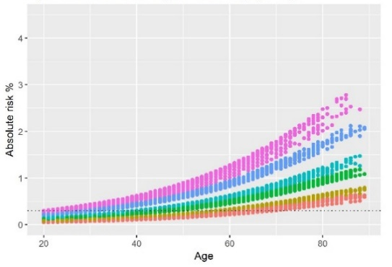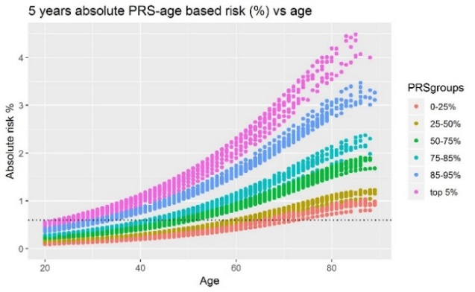
Legend: The dotted horizontal lines show the age-based 3- and 5 years incidence for a 50-year-old woman (non-cross validated).
Table S8. Five-year observed cumulative incidence and PRSage_mInc per 1000 women
PRS-age-group | Number of women (n) | Number of breast cancers in 5 years (n) | 5-year observed incidence (95% CI) | 5-year mean PRSage_mInc | Difference | Ratio
0-25% PRS; 18-49 years | 4499 | 14 | 3.11 (1.85 - 5.22) | 1.96 | 1.15 | 1.59
25-50% PRS; 18-49 years | 4466 | 6 | 1.34 (0.62 - 2.93) | 2.39 | -1.05 | 0.56
50-75% PRS; 18-49 years | 4494 | 16 | 3.56 (2.19 - 5.78) | 3.7 | -0.14 | 0.96
75-85% PRS; 18-49 years | 1794 | 11 | 6.13 (3.43 - 10.95) | 4.54 | 1.59 | 1.35
85-95% PRS; 18-49 years | 1789 | 11 | 6.15 (3.44 - 10.98) | 6.75 | -0.6 | 0.91
Top 5% PRS; 18-49 years | 895 | 8 | 8.94 (4.54 - 17.54) | 8.95 | -0.01 | 1
Sub-total; 18-49 years | 17937 | 66 | 3.68 (2.08 - 6.55) | 3.59 | 0.09 | 1.03
0-25% PRS; 50-62 years | 1750 | 6 | 3.43 (1.57 - 7.46) | 4.04 | -0.61 | 0.85
25-50% PRS; 50-62 years | 1701 | 13 | 7.64 (4.47 - 13.03) | 4.9 | 2.74 | 1.56
50-75% PRS; 50-62 years | 1704 | 15 | 8.8 (5.34 - 14.47) | 7.64 | 1.16 | 1.15
75-85% PRS; 50-62 years | 683 | 6 | 8.78 (4.03 - 19.03) | 9.32 | -0.54 | 0.94
85-95% PRS; 50-62 years | 697 | 11 | 15.78 (8.83 - 28.04) | 13.75 | 2.03 | 1.15
Top 5% PRS; 50-62 years | 356 | 7 | 19.66 (9.56 - 40.02) | 18.22 | 1.44 | 1.08
Sub-total; 50-62 years | 6891 | 58 | 8.42 (4.61 - 15.48) | 7.38 | 1.04 | 1.14
0-25% PRS; 63-89 years | 1335 | 10 | 7.49 (4.07 - 13.73) | 6.79 | 0.7 | 1.1
25-50% PRS; 63-89 years | 1417 | 12 | 8.47 (4.85 - 14.74) | 8.32 | 0.15 | 1.02
50-75% PRS; 63-89 years | 1377 | 13 | 9.44 (5.53 - 16.09) | 12.75 | -3.31 | 0.74
75-85% PRS; 63-89 years | 545 | 10 | 18.35 (10 - 33.44) | 15.41 | 2.94 | 1.19
85-95% PRS; 63-89 years | 545 | 11 | 20.18 (11.31 - 35.78) | 23.25 | -3.07 | 0.87
Top 5% PRS; 63-89 years | 265 | 5 | 18.87 (8.09 - 43.4) | 30.85 | -11.78 | 0.61
Sub-total; 63-89 years | 5484 | 61 | 11.12 (6.14 - 20.17) | 12.34 | -1.22 | 0.90
Total (entire cohort) | 30312 | 185 | 6.10 (3.39 - 11.04) | 6.03 | 0.07 | 1.01
Legend: The table shows the 5-year observed cumulative incidence and mean PRSage_mInc, for each PRSage subgroup, per 1000 women. The difference is observed incidence minus the mean PRSage_mInc. The ratio expresses observed incidence over mean PRSage_mInc.

Table S9. Three-year observed cumulative incidence and PRSage_mInc per 1000 women for the lowest 0-25%, highest 75-100%, and top 5% PRS groups
PRS-age-group | No. women (n) | Number of events in 3 years (n) | 3-year observed incidence (95% CI) | 3 year mean PRSage_mInc | Difference | Ratio
0-25% PRS group
0-25% PRS; 18-49 years | 4499 | 10 | 2.22 (1.21-4.09) | 1.06 | 1.16 | 2.09
0-25% PRS; 50-62 years | 1750 | 1 | 0.57 (0.03-3.23) | 2.20 | -1.63 | 0.26
0-25% PRS; 63-89 years | 1335 | 6 | 4.49 (2.06-9.77) | 3.83 | 0.66 | 1.17
Total | 7584 | 17 | 2.24 (1.09-4.89) | 1.81 | 0.43 | 1.24
75-100% PRS group
75-100%;18-49 years | 4478 | 15 | 3.36 (1.44-7.81) | 3.43 | -0.08 | 0.98
75-100%;50-62 years | 1736 | 15 | 8.64 (3.77-19.97) | 7.06 | 1.58 | 1.22
75-100%;50-62 years | 1355 | 13 | 9.59 (4.19-23.19) | 12.20 | -2.60 | 0.79
Total | 7569 | 43 | 5.68 (2.46-13.35) | 5.83 | -0.15 | 0.97
Top 5% PRS group
Top 5% PRS; 18-49 years | 895 | 4 | 4.47 (1.74 - 11.43) | 4.87 | -0.4 | 0.92
Top 5% PRS; 50-62 years | 356 | 5 | 14.04 (6.01 - 32.45) | 9.96 | 4.08 | 1.41
Top 5% PRS; 63-89 years | 265 | 1 | 3.77 (0.19 - 21.06) | 17.46 | -13.69 | 0.22
Total | 1516 | 10 | 6.60 (2.47-18.05) | 8.27 | -1.67 | 0.80

Table S10. Five-year observed cumulative incidence and PRSage_mInc per 1000 women for the lowest 0-25%, highest 75-100%, and top 5% PRS groups
PRS-age group | No. women (n) | Number of events in 5 years (n) | 5-year observed incidence (95% CI) | 5-year mean PRSage_mInc | Difference | Ratio
0-25% PRS group
0-25% PRS; 18-49 years | 4499 | 14 | 3.11 (1.85-5.22) | 1.96 | 1.15 | 1.59
0-25% PRS; 50-62 years | 1750 | 6 | 3.43 (1.57-7.46) | 4.04 | -0.61 | 0.85
0-25% PRS; 63-89 years | 1335 | 10 | 7.49 (4.07-13.73) | 6.79 | 0.7 | 1.1
Total | 7584 | 30 | 3.96 (2.18-7.23) | 3.29 | 0.67 | 1.20
75-100% PRS group
75-100%;18-49 years | 4478 | 30 | 6.70 (3.66-12.28) | 6.30 | 0.40 | 1.06
75-100%;50-62 years | 1736 | 24 | 13.82 (7.09-26.95) | 12.92 | 0.90 | 1.07
75-100%;63-89 years | 1355 | 26 | 19.19 (10.15-36.33) | 21.58 | -2.36 | 0.89
Total | 7569 | 80 | 10.57 (6.61-19.95) | 10.56 | 0.01 | 1
Top 5% PRS group
Top 5% PRS; 18-49 years | 895 | 8 | 8.94 (4.54- 17.54) | 8.95 | -0.01 | 1
Top 5% PRS; 50-62 years | 356 | 7 | 19.66 (9.56 - 40.02) | 18.22 | 1.44 | 1.08
Top 5% PRS; 63-89 years | 265 | 5 | 18.87 (8.09- 43.4) | 30.85 | -11.98 | 0.61
Total | 1516 | 20 | 13.19 (6.34-27.34) | 14.96 | -1.76 | 0.88

