SUPPLEMENTARY INFORMATION (SI)

Figure SI-1 NGS run summary depicting loading density (A), performance parameters (B), and read length (C) of Ion Torrent sequencing run, carried out using a 520 chip

Figure SI-2 Relative abundance of major 5 bacterial phyla in microbiota of CRC and AN

Figure SI-3 Bar graph represents total microbiome data of colorectal cancer/adjacent normal tissues classified as phyla, class, order, family, genus, and species

A.
B.

Figure SI-4 The pie chart represents an absolute abundance of phyla within each bacterial community in (a) CRC and (b) adjacent normal

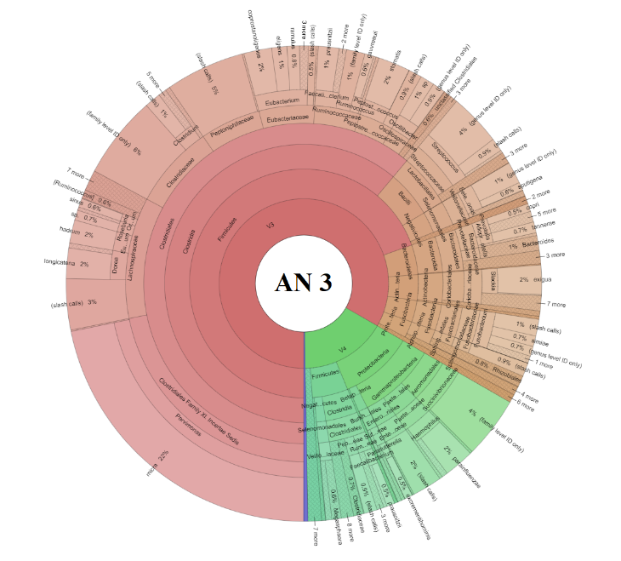

Figure SI-5 Krona graph depicting relative abundance of different taxa at species level

Table SI-1 Laboratory parameters of CRC patients

S. No. | Test Items | Reference Range | 1 | 2 | 3 | 4 | 5 | Mean + SD
1 | CBC
a | Haemoglobin | 13-17 g/dl | 11.6 | 10.3 | 6.6 | 8 | 6.9 | 8.7+2.2
b | PCV | 36 - 46% | 37.1 | 32.1 | 20.3 | 25.9 | 23 | 27.7+ 6.9
c | TLC | 4 - 10 thous/ul | 4.2 | 9.9 | 12.8 | 17.7 | 7.7 | 10.5+ 5.1
d | Platelet Count | 150 - 450 thous /ul | 287 | 220 | 446 | 370 | 238 | 312.2+94.7
2 | Bilirubin (T) | 0.2 - 1mg/dL | 0.5 | 0.54 | 0.33 | 0.45 | 1 | 0.6+0.3
3 | Bilirubin (D) | 0 - 0.20 mg/dL | 0.07 | 0.09 | 0.13 | 0.06 | 0.2 | 0.1+0.1
4 | SGOT | 0- 42 IU/L | 25 | 13 | 33 | 18 | 28 | 23.4+8
5 | SGPT | 0- 60IU/L | 15 | 14 | 18 | 10 | 12 | 13.8+3
6 | ALP | 39- 117IU/L | 86 | 92 | 85 | 63 | 67 | 76.8+14
7 | Total protein | 6.6 - 8.7gm/dL | 6.96 | 7.09 | 5.82 | 5.95 | 5.36 | 6.2+0.8
8 | Albumin | 3.5- 5gm/dL | 4.02 | 4.04 | 1.65 | 2.77 | 2.86 | 3.1+1
9 | Globulin | 1.8 - 3.6gm/dL | 2.97 | 3.05 | 4.17 | 3.18 | 2.5 | 3.2+0.6
10 | BUN | 5-23.00mg/dL | 8.17 | 7.2 | 16.99 | 5.18 | 9.54 | 9.4+4.5
11 | Creatinine | 0.6 - 1.3mg/dL | 0.81 | 0.76 | 1.19 | 1.03 | 1.88 | 1.1+0.5
12 | Sodium | 132 – 148 mmol/L | 139 | 140 | 129 | 141 | 143 | 118.4+44.2
13 | Potassium | 3.5 - 5.5mmol/L | 4.2 | 4.28 | 5.72 | 3.87 | 3.67 | 4.3+0.8
14 | Calcium | 8.2- 10.4 mg/dL | 8.91 | 8.06 | 7.7 | 8.61 | 8.05 | 8.2+0.5
15 | Phosphorous | 2.5 - 4.6mg/dL | 3.81 | 4.58 | 3.82 | 3.4 | 4.07 | 3.9+0.4
16 | CEA | 0- 3ng/ml | 3.7 | 12.03 | 8.01 | 3.08 | 4.85 | 6.3+3.7

Note: T denotes Total; D denotes Direct; CBC – complete blood count; PCV – packed cell volume; TLC – total leukocyte count; SGOT - serum glutamic oxaloacetic transaminase; SGPT - serum glutamic pyruvic transaminase; ALP – alkaline phosphatase; BUN - blood urea nitrogen; CEA - carcinoembryonic antigen

Table SI-2 RNA-Seq and reads counts by data processing and filtering for each samples

 | CRC |  |  |  |  | AN
Samples | 1 | 2 | 3 | 4 | 5 | 1 | 2 | 3 | 4 | 5
Total number of reads | 721190 | 531234 | 560022 | 727869 | 630654 | 680763 | 686380 | 536280 | 366050 | 659349
Number of valid reads | 576007 | 436085 | 458268 | 537808 | 514811 | 557099 | 568560 | 449018 | 213594 | 522560
Number of reads ignored (due to low number of copies <10) | 143925 | 105203 | 126144 | 132002 | 134843 | 116587 | 133829 | 105606 | 65963 | 139393
Mapped reads in sample | 417263 | 318030 | 327737 | 404494 | 373425 | 438536 | 410161 | 342491 | 146413 | 375418
Un-Mapped reads in sample | 14819 | 12852 | 4387 | 1312 | 6543 | 1976 | 24570 | 921 | 1218 | 7749

Table SI-3 Normalized data by DESeq2 algorithm at Genus-species level (p<0.005)

S.NO | OTU | Base Mean | log2Fold Change | lfcSE | stat | P value
1 | Corynebacterium appendicis | 81.22813 | -5.611018791 | 1.285815 | -4.36378 | 1.28E-05
2 | Blautia producta | 100.0408 | -4.543035481 | 1.15389 | -3.93715 | 8.25E-05
3 | Bacteroides massiliensis | 17.25052 | -4.424091067 | 1.204667 | -3.67246 | 0.00024
4 | Pasteurella pneumotropica | 36.80195 | 4.657202107 | 1.277819 | 3.644651 | 0.000268
5 | Oribacterium sp. | 27.18253 | 4.793518463 | 1.318179 | 3.636471 | 0.000276
6 | Paracoccus sphaerophysae | 18.8982 | 4.567452136 | 1.270429 | 3.595205 | 0.000324
7 | Bacteroides intestinalis | 44.30029 | 4.142737936 | 1.16079 | 3.568895 | 0.000358
8 | Alistipes sp. | 31.95772 | -4.525231864 | 1.27097 | -3.56046 | 0.00037
9 | Acidiphilium sp. | 20.42042 | -4.196608287 | 1.202532 | -3.48981 | 0.000483
10 | Campylobacter gracilis | 17.55286 | 4.457998589 | 1.283939 | 3.472127 | 0.000516
11 | Enterobacter mori | 10.28607 | 3.812129125 | 1.127468 | 3.381141 | 0.000722
12 | Bacillus sp. | 13.23504 | 4.109486786 | 1.229123 | 3.34343 | 0.000827
13 | Bifidobacterium pseudocatenulatum | 14.47823 | -4.145956918 | 1.250581 | -3.31523 | 0.000916
14 | Megasphaera micronuciformis | 10.04738 | -3.708246499 | 1.120739 | -3.30875 | 0.000937
15 | Streptococcus intermedius | 139.8204 | 4.477302753 | 1.380733 | 3.242701 | 0.001184
16 | Veillonella atypica | 21.99591 | 4.142436734 | 1.299938 | 3.186643 | 0.001439
17 | Fusobacterium sp. | 11.44314 | -3.668889082 | 1.152405 | -3.18368 | 0.001454
18 | Alistipes onderdonkii | 11.28056 | -3.818451068 | 1.212677 | -3.14878 | 0.00164
19 | Treponema berlinense | 13.21875 | -3.793761391 | 1.206542 | -3.14433 | 0.001665
20 | Kocuria marina | 9.973847 | -3.653620561 | 1.196907 | -3.05255 | 0.002269
21 | Clostridium butyricum | 8.534663 | 3.520207323 | 1.168187 | 3.013393 | 0.002583
22 | Ruminococcus flavefaciens | 7.854566 | 3.410078115 | 1.146111 | 2.975347 | 0.002927
23 | Turicella otitidis | 11.19541 | -3.600709501 | 1.214291 | -2.96528 | 0.003024
24 | Bacteroides ovatus | 128.3392 | 3.226849754 | 1.098402 | 2.937769 | 0.003306
25 | Lactococcus piscium | 7.383484 | -3.238917975 | 1.146033 | -2.8262 | 0.00471
26 | Neisseria subflava | 7.311751 | -3.224864645 | 1.143688 | -2.81971 | 0.004807
27 | Clostridium bolteae | 5.755936 | -2.87513808 | 1.106323 | -2.59882 | 0.009354
28 | Neisseria flavescens | 5.412136 | -2.784852713 | 1.091213 | -2.55207 | 0.010708
29 | Finegoldia magna | 19.49476 | -3.278887429 | 1.286543 | -2.5486 | 0.010816
30 | Corynebacterium tuberculostearicum | 75.98056 | -3.190479796 | 1.284659 | -2.48352 | 0.013009
31 | Ruminococcus callidus | 48.46309 | -3.072716313 | 1.24167 | -2.47467 | 0.013336
32 | Holdemania filiformis | 4.27622 | -2.413748484 | 1.04666 | -2.30614 | 0.021103
33 | Bifidobacterium bombi | 4.410325 | 2.532215259 | 1.107926 | 2.285546 | 0.022281
34 | Fusobacterium periodonticum | 4.410325 | 2.532215259 | 1.107926 | 2.285546 | 0.022281
35 | Acinetobacter calcoaceticus | 4.381479 | 2.523436938 | 1.106374 | 2.280817 | 0.022559
36 | Ralstonia insidiosa | 4.138681 | -2.362456811 | 1.039614 | -2.27244 | 0.02306
37 | Deinococcus ficus | 4.385803 | 2.491403474 | 1.110498 | 2.243502 | 0.024864
38 | Capnocytophaga granulosa | 4.172139 | 2.446019365 | 1.096258 | 2.231244 | 0.025665
39 | Micrococcus lylae | 203.8975 | -2.917523444 | 1.314417 | -2.21963 | 0.026444
40 | Eschericia/Shigella coli/dysenteriae | 4.046912 | 2.398538122 | 1.089706 | 2.201088 | 0.02773
41 | Cloacibacterium normanense | 4.389254 | -2.439495264 | 1.11126 | -2.19525 | 0.028145
42 | Corynebacterium glutamicum | 4.389254 | -2.439495264 | 1.11126 | -2.19525 | 0.028145
43 | Holdemania massiliensis | 3.959962 | 2.362216436 | 1.08531 | 2.176536 | 0.029515
44 | Corynebacterium macginleyi | 4.297734 | -2.399724786 | 1.107701 | -2.1664 | 0.030281
45 | Alishewanella jeotgali | 3.823867 | 2.307509411 | 1.077614 | 2.141314 | 0.032249
46 | Pseudoxanthomonas kaohsiungensis | 4.136249 | -2.341298037 | 1.099269 | -2.12987 | 0.033183
47 | Lactococcus chungangensis | 4.065803 | -2.317830601 | 1.095106 | -2.11654 | 0.034299
48 | Lactococcus plantarum | 3.712345 | 2.259317732 | 1.071222 | 2.109103 | 0.034936
49 | Bifidobacterium catenulatum | 3.837544 | 2.273076013 | 1.082219 | 2.100385 | 0.035695
50 | Bifidobacterium sp. | 3.837544 | 2.273076013 | 1.082219 | 2.100385 | 0.035695
51 | Butyrivibrio crossotus | 356.5488 | -1.894980534 | 0.906625 | -2.09015 | 0.036605
52 | Blautia faecis | 17.27015 | -2.356279322 | 1.137571 | -2.07132 | 0.038328
53 | Clostridium citroniae | 3.914979 | -2.252242766 | 1.087509 | -2.07101 | 0.038358
54 | Raoultella ornithinolytica | 3.914979 | -2.252242766 | 1.087509 | -2.07101 | 0.038358
55 | Amaricoccus macauensis | 3.850169 | -2.229394492 | 1.083389 | -2.0578 | 0.03961
56 | Brevibacterium casei | 3.536559 | 2.174852645 | 1.061086 | 2.049648 | 0.040399
57 | Plesiomonas shigelloides | 20.73695 | -2.226625454 | 1.094545 | -2.03429 | 0.041922
58 | Eubacterium biforme | 25.72398 | -2.471397671 | 1.218557 | -2.02813 | 0.042547
59 | Luteococcus peritonei | 3.734781 | -2.171349118 | 1.077578 | -2.01503 | 0.043902
60 | Veillonella alcalescens | 25.94901 | 2.648972004 | 1.321787 | 2.004084 | 0.045061
61 | Veillonella rogosae | 3.387646 | 2.106080105 | 1.051327 | 2.003259 | 0.045149
62 | Shigella boydii | 4.865707 | -2.133578415 | 1.070248 | -1.99354 | 0.046203
63 | Porphyromonas somerae | 3.634535 | -2.134047842 | 1.070854 | -1.99285 | 0.046278
64 | Actinomyces bowdenii | 3.659223 | -2.133985588 | 1.073478 | -1.98792 | 0.046821
65 | Lelliottia amnigena | 3.570492 | -2.100354318 | 1.067323 | -1.96787 | 0.049083
66 | Enterococcus sp. | 3.42635 | 2.079373896 | 1.057484 | 1.966341 | 0.049259
67 | Atopobium parvulum | 3.284418 | 2.052350555 | 1.0447 | 1.964537 | 0.049468
68 | Cryptobacterium curtum | 3.284418 | 2.052350555 | 1.0447 | 1.964537 | 0.049468
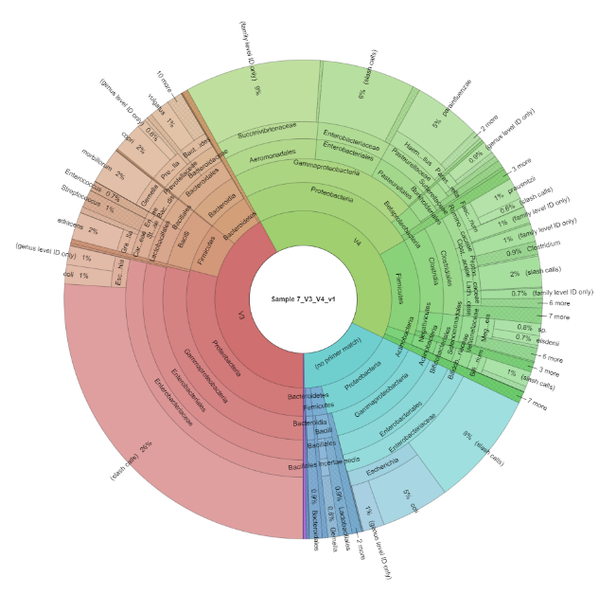
CRC 4

