MO59K vs. MO59J glioblastoma cell lines

Supplementary Materials

The primary antibodies used for Western blot were: rabbit monoclonal anti-PI3K p110α (C73F8), mouse monoclonal anti-phospho-Akt (Ser473) (D9E), rabbit monoclonal anti-phospho-mTOR (Ser2448) (D9C2), rabbit polyclonal anti-phospho-S6 ribosomal protein (Ser240/244), mouse monoclonal anti-phospho-4E-BP1 (Thr37/46) (236B4), rabbit monoclonal anti-phospho-MEK1/2 (Ser217/221) (41G9), rabbit monoclonal anti-HDAC5 (D1J7V), rabbit monoclonal anti-phospho-p44/42 MAPK (ERK1/2) (Thr202/Tyr204) (D13.14.4E), rabbit monoclonal anti-Rad51 (D4B10), rabbit polyclonal anti-PARP, mouse monoclonal anti caspase-3 (3G2mouse monoclonal anti-phospho-p53 (Ser15)(16G8), rabbit monoclonal anti-Bax (D2E11), rabbit monoclonal anti-ATM (D2E2), Homologous Recombination (HR) DNA repair antibody sampler kit (99891), rabbit polyclonal anti-LC3B, rabbit monoclonal anti-SQSTM1/p62 (D5E2), rabbit monoclonal DNA-PKcs (E6U3A) rabbit polyclonal anti-Ku80 (all from Cell Signaling, Danvers, MA), mouse monoclonal anti-Rad50 (13B3/2C6), mouse monoclonal anti-p53 (DO-1), rabbit polyclonal anti-Raf-1 (C12) (Santa Cruz, Dallas, TX), mouse monoclonal anti-Ku70 (p70)Ab-4 (N3H10) (ThermoFisher Scientific, Wiesbaden, Germany), mouse monoclonal anti-β-actin (Sigma, Deisenhofen, Germany), mouse monoclonal anti-phospho-histone H2AX (Ser139) (Millipore, Schwalbach, Germany). Secondary species-specific antibodies for western blot were labelled with horseradish-peroxidase (DAKO, Hamburg, Germany). Secondary antibodies used for microscopy were: Alexa Fluor 532-conjugated goat anti-mouse IgG (ThermoFisher Scientific, Wiesbaden, Germany).

Comet assay and staining for HDAC5 and DAPI
In order to characterize the tested cell lines preliminary experiments were done by means of the Comet assay. Comet assay was performed under alkaline conditions following the protocol reported elsewhere [17]. Just before irradiation, cells were imbedded in a thin layer of agarose spread on glass microscope slides. The slides were placed on ice, subjected to irradiation and transferred immediately either into ice-cold lysis buffer or in CGM for the indicated times. DNA fragmentation was quantified from the "Tail Moment" (TM, given in arbitrary units, a.u.) defined as the product of the percentage of DNA in the comet tail and the tail length. Supplementary Fig. S1 shows the induction and repair of DNA damage measured by the Comet assay in the cells of both cell lines immediately and up to 40 min after irradiation with 5 Gy. As seen in Supplementary Fig. S1, the initial TM was higher in the MO59J cells, however, the residual DNA damage was almost the same in both cell lines as well as the kinetics of its disappearance was similar in both cell lines. Supplementary Fig. S2 shows the distribution of TM in both cell lines measured immediately after IR. As seen in Fig. S2, the histogram of TM values in intrinsically radiosensitive MO59J line were shifted towards the higher DNA damage. It is worth to be mentioned that DNA damage measured by the alkaline Comet assay includes single-strand breaks and alkali-labile sites and base exchanges.
Another preliminary test to characterize intrinsically radioresistant MO59K and radiosensitive MO59J cell lines was staining for HDAC5 protein and subsequent HDAC5 foci counting (Supplementary Fig. S3). To this end, cells were cultured on microscope glass slides for at least 24 h and stained with anti-HDAC5 (1:200) primary antibodies essentially as described elsewhere [Djuzenova et al., 2004] with the exception of primary antibodies. For each experiment or cell line, at least 100 nuclei were examined and HDAC5 foci were scored by eye at a magnification of 1000x. Probes were then quantified by counting the number of foci per nucleus. As seen in Supplementary Fig. S3, the HDAC5 foci were much more expressed in radioresistant MO59K cell line. Simultaneously slides were counterstained with DAPI.

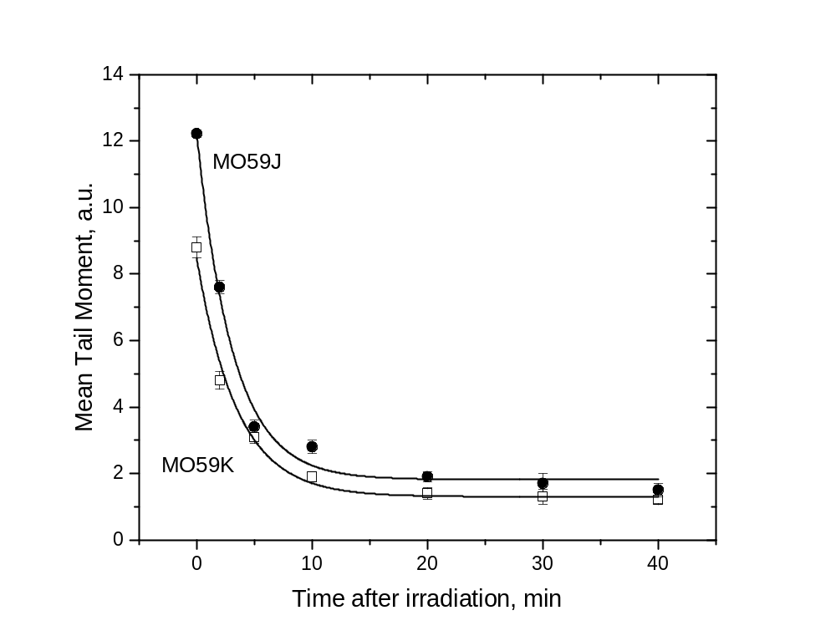
Figure S1. DNA damage (Tail Moment, TM) induction and repair measured by the comet assay in human GBM cell lines irradiated with 5 Gy of X-rays in vitro. Immediately after irradiation the samples were placed at 37°C in a 5% CO₂ incubator. The cells taken at the indicated time intervals after X-ray exposure were lysed and subjected to the alkaline comet assay. Up to 75 cells were analyzed for each slide. Each point (bar) represents the mean value (± S.E.) of TM for the respective time point. The curves are best least-square fits of exponential decay function to the datapoints.

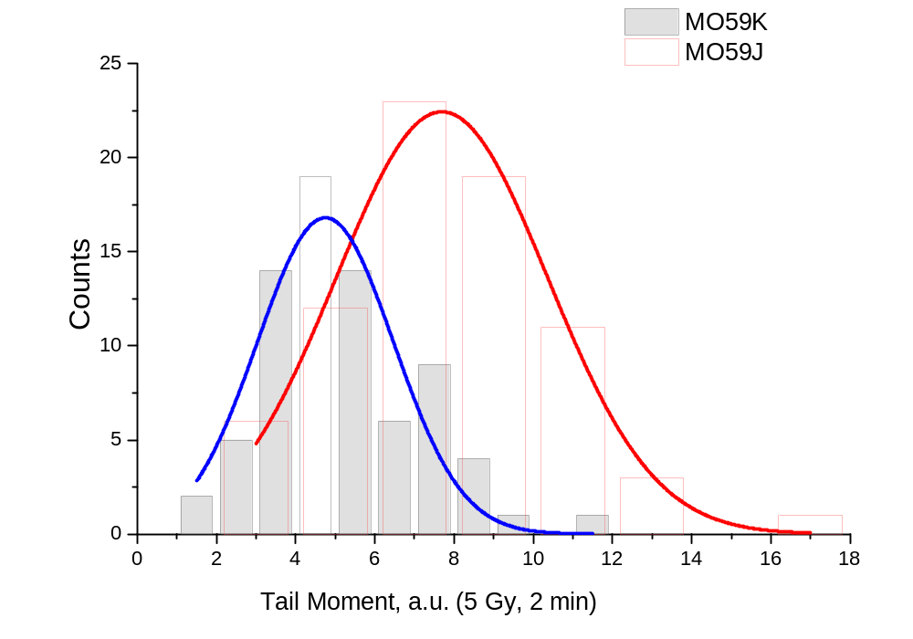
Figure S2. DNA damage (Tail Moment) induction measured by the comet assay in human GBM cell lines MO59K and MO59J irradiated with 5 Gy of X-rays in vitro. The cells taken at the indicated time (2 min) after X-ray exposure were lysed and subjected to the alkaline comet assay. Up to 75 cells were analyzed for each slide. The curves are best least-square fits of normal distribution to the datapoints.

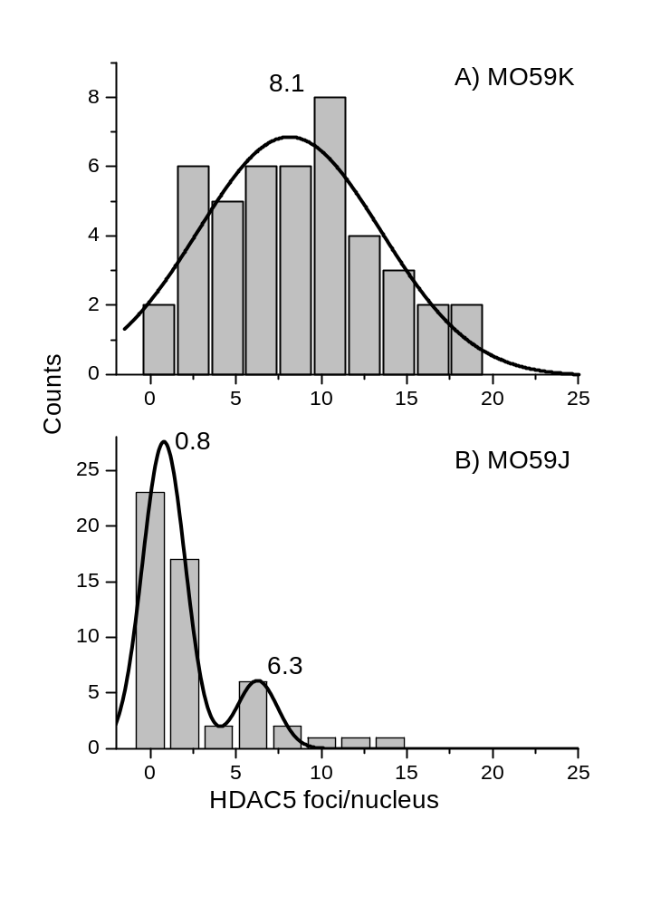
Figure S3. Representative histograms depicting the HDAC5 focus formation in control non-irradiated MO59K and MO59J cells. Cells were analyzed for HDAC5 focus formation 24 h after seeding. About 100 nuclei were counted per each cell line and experiment (n=3).

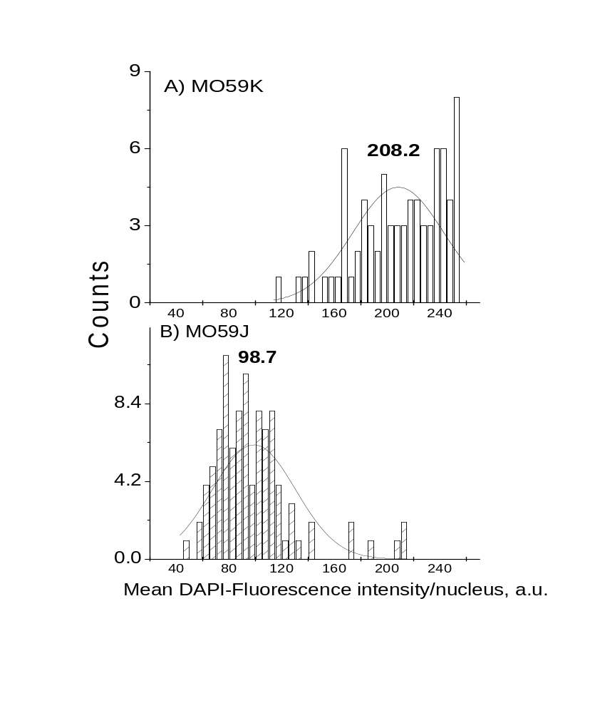
Figure S4. Representative histograms depicting the mean DAPI fluorescence intensity per nucleus in control non-irradiated MO59K and MO59J cells. Cells were cultured on the slides and 24 h after seeding stained with DAPI. Fluorescence intensity was quantitated with the ImageJ program in about 100 nuclei counted per each cell line and experiment (n=3).

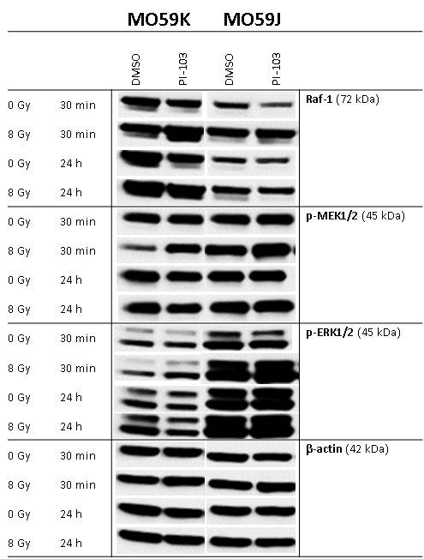
Figure S5. Representative Western blot analysis of expression levels of several marker proteins of MAPK-pathway in MO59K and MO59J tumor cells treated with DMSO (control) or PI-103 for 3 h prior to IR with 8 Gy and detected 30 min and 24 h thereafter. β-actin was used as loading control.The experiment was repeated at least three times. For details, see legend to Figure 2.

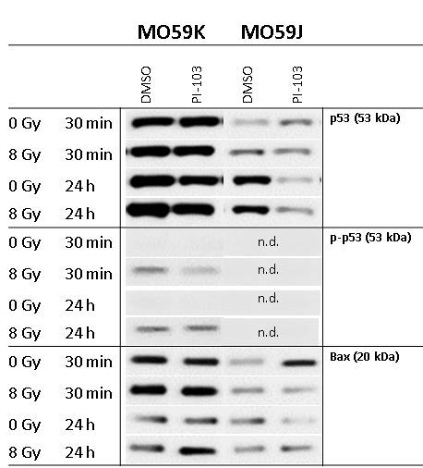
Figure S6. Western blot analysis of p53, p-53 and Bax proteins in MO59K and MO59J cells treated with DMSO (control) or PI-103. The experiments were repeated at least three times. For details, see legend to Figure 2.

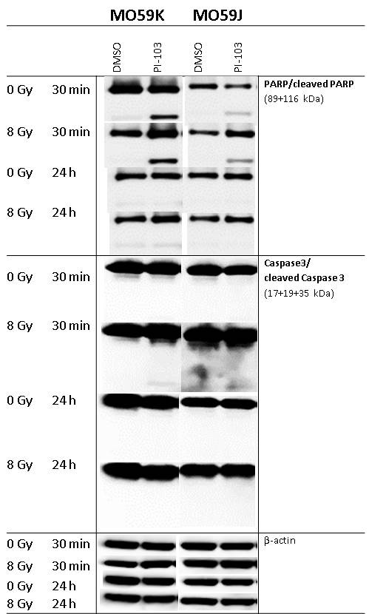
Figure S7. Western blot analysis of PARP and cleaved PARP proteins in MO59K and MO59J cells treated with DMSO (control) or PI-103. β-actin was used as loading control. The experiments were repeated at least three times. For details, see legend to Figure 2.

Table S1
Cloning efficiencies and radiosensitivity parametersª of in vitro irradiated tumor cell lines untreated and pretreated (3 h) prior to IR with the PI-103 and re-plated 24 h post-IR
Cell line | Plating efficiency | SF2 ^{b} | D₁₀ (Gy)^{c} | IF₁₀^{d}  (D₁₀ control)/  (D₁₀+inh.)
MO59K – contr. | 0.15±0.04 | 0.55±0.04 | 6.1±0.4 | 1.0
PI-103 | 0.17±0.07 | 0.43±0.04 | 4.8±0.2 | 1.3±0.1
MO59J – contr. | 0.20±0.07 | 0.14±0.02 | 2.3±0.15 | 1.0
PI-103 | 0.21±0.08 | 0.24±0.04 | 3.2±0.16 | 0.7±0.1

ªMean (± SE) from at least three independent experiments;
^{b}SF2 is the colony-forming ability at 2 Gy;
^{c}D₁₀ is the radiation dose required to reduce colony-forming ability by 10%;
^{d}The growth inhibition factor IF₁₀ was calculated as (D₁₀ control)/(D₁₀+inh.).

