The positive effects of arbuscular mycorrhizal fungi inoculation and/or additional aeration on the purification efficiency of combined heavy metals in vertical flow constructed wetlands
Zhouying Xuª, Kaiguo Liª, Wenxuan Li^{b}, Chen Wuª, Xi Chenª, Jun Huangª, Xiangling Zhangª, Yihui Ban^{b}*
ª School of Civil Engineering and Architecture, Wuhan University of Technology, Wuhan 430070, Hubei, China
^{b} School of Chemistry, Chemical Engineering and Life Sciences, Wuhan University of Technology, Wuhan 430070, Hubei, China
* banyihui@whut.edu.cn

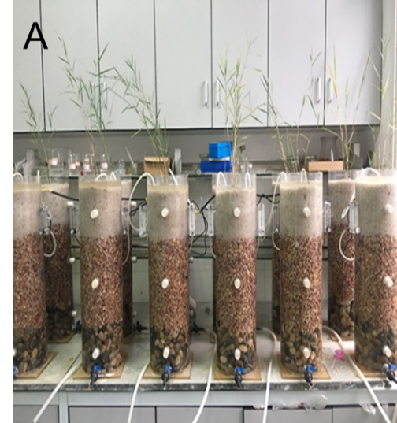
Fig.S1 The picture (A) of vertical flow constructed wetlands

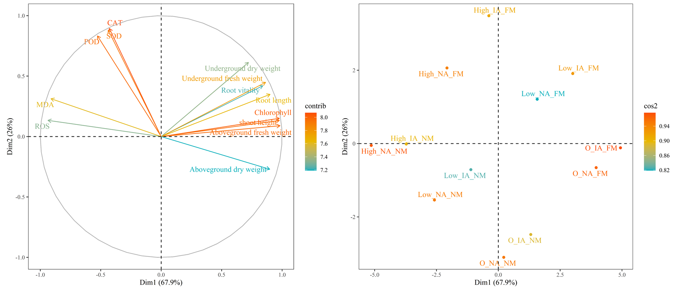
Fig. S2: Principle component analysis of plant growth (shoot height, root length, aboveground fresh weight, underground fresh weight, aboveground dry weight, underground dry weight, chlorophyll, and root vitality) and physiological indexes (MDA, SOD, POD, CAT, and ROS).
IA: intermittent aeration; NA: no aeration; FM: inoculation with F. mosseae; NM: inoculation with autoclaved F. mosseae.

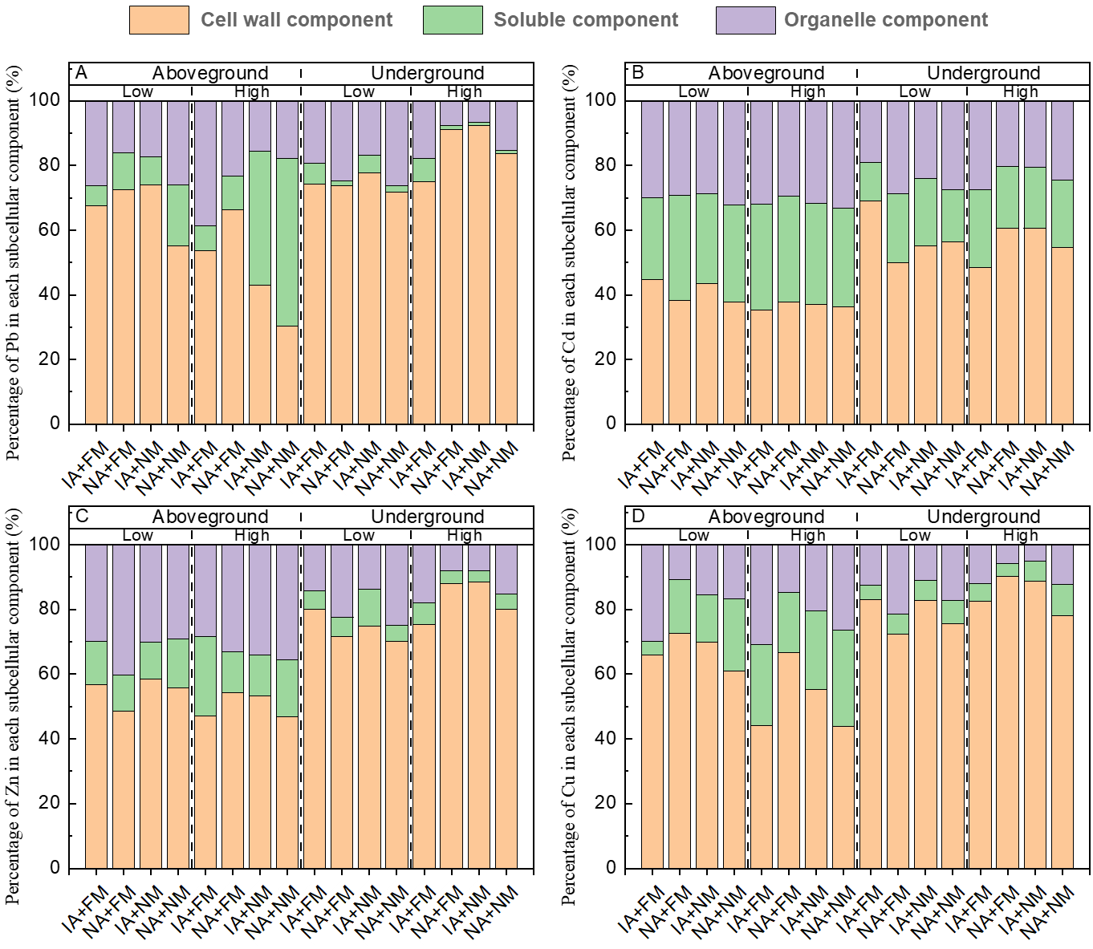
Fig. S3. Distribution of HMs in the subcellular components of the aboveground and underground parts of reeds at two combined heavy metals pollution levels. A, B, C, D represented Pb, Cd, Zn, Cu, respectively. IA: intermittent aeration; NA: no aeration; FM: inoculation with F. mosseae; NM: inoculation with autoclaved F. mosseae.

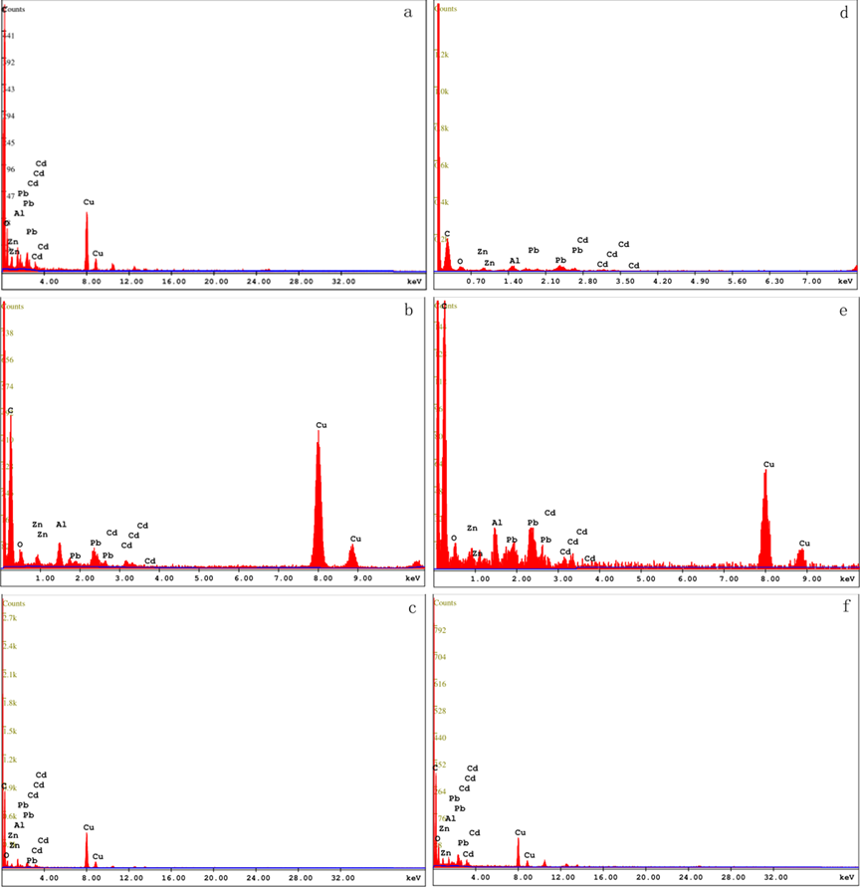
Fig. S4: The energy-dispersive spectroscopy pictures at arrows of a, b, c, d, e, f in Fig. 5.
Table S1 Effects of F. mosseae inoculation and/or additional aeration on growth indexes, root vitality and chlorophyll content of reeds at different combined heavy metals pollution levels.
IA: intermittent aeration; NA: no aeration; FM: inoculation with F. mosseae; NM: inoculation with autoclaved F. mosseae. Different letters show the significant difference (P<0.05).
HMs  concentration | Treatment |  | Shoot height（cm） | Root length（cm） | Aboveground fresh weight（g） | Underground fresh weight（g） | Aboveground dry weight（g） | Underground dry weight（g） | Root vitality  (mg/g*h) | Chlorophyll  content
0 |  | IA+FM | 90.15±0.94a | 93.99±1.69a | 7.13±0.03a | 53.88±0.69a | 2.09±0.01a | 8.48±0.04b | 58.84±0.01b | 50.77±0.15a
 |  | NA+FM | 87.15±1.00b | 88.36±1.26b | 6.51±0.08ab | 46.86±1.51b | 2.03±0.02a | 8.04±0.03c | 44.54±0.02d | 43.47±0.35c
 |  | IA+NM | 74.22±1.08d | 61.33±1.13ef | 4.96±0.13c | 26.16±0.93f | 1.70±0.01b | 5.37±0.10g | 24.46±0.01h | 35.40±0.36e
 |  | NA+NM | 66.39±1.35f | 60.37±1.51ef | 4.42±0.06c | 24.53±1.19f | 1.52±0.01c | 2.94±0.04j | 20.68±0.02j | 25.93±0.15g
Low |  | IA+FM | 83.99±1.11c | 95.26±1.65a | 6.33±1.15b | 47.50±0.76b | 1.64±0.02b | 7.06±0.05e | 66.27±0.01a | 45.67±0.74b
 |  | NA+FM | 70.76±0.57e | 81.53±1.22c | 4.79±0.1c | 42.01±0.42c | 1.52±0.01c | 7.45±0.04d | 57.68±0.01c | 41.76±1.13d
 |  | IA+NM | 64.05±1.11g | 60.24±1.97f | 3.71±0.15d | 24.25±1.11f | 1.30±0.01e | 4.94±0.04h | 32.75±0.01f | 23.87±1.02h
 |  | NA+NM | 54.15±1.38i | 53.98±2.08g | 3.24±0.08d | 20.96±0.67g | 1.10±0.10f | 2.47±0.07l | 21.56±0.01i | 11.90±0.79j
High |  | IA+FM | 73.62±0.94d | 70.64±0.50d | 4.74±0.11c | 38.06±1.45d | 1.14±0.02f | 9.35±0.13a | 38.36±0.01e | 29.93±0.15f
 |  | NA+FM | 61.19±0.48h | 63.44±1.03e | 3.60±0.09d | 34.20±0.82e | 0.89±0.01g | 5.94±0.03f | 28.48±0.03g | 21.67±0.15i
 |  | IA+NM | 51.57±1.15j | 51.59±2.31g | 3.10±0.03d | 19.75±0.41g | 1.38±0.03d | 3.55±0.01i | 10.81±0.01k | 8.47±0.35k
 |  | NA+NM | 47.14±0.52k | 51.52±0.37g | 1.76±0.08e | 19.35±0.64g | 0.72±0.03h | 2.76±0.07k | 6.97±0.43l | 4.83±0.42l

Table S2 Effects of F. mosseae inoculation and/or additional aeration on the content of MDA, ROS and antioxidant enzymes of reeds at different combined heavy metals pollution levels.
HMs  concentration | Treatment | SOD  （U g⁻¹ FW h⁻¹） | CAT  （U g⁻¹ FW min⁻¹） | POD  （U g⁻¹ FW min⁻¹） | MDA  （nmol g⁻¹ FW） | ROS  （µg g⁻¹ FW）
0 | IA+FM | 35.29±1.47h | 16.98±0.08j | 129.07±1.22h | 4.10±0.05i | 13.57±2.15g
0 | NA+FM | 29.90±0.85i | 17.96±0.16i | 117.33±2.01i | 4.30±0.16i | 15.00±1.24fg
0 | IA+NM | 26.47±1.47j | 10.65±0.12k | 110.93±2.57ij | 5.19±0.19h | 15.72±3.73ef
0 | NA+NM | 12.75±0.85k | 10.27±0.04l | 106.93±1.67j | 5.42±0.28h | 22.18±2.15e
Low | IA+FM | 112.75±0.85d | 29.11±0.13e | 365.07±5.14d | 8.20±0.15g | 21.46±1.24ef
Low | NA+FM | 90.69±1.70e | 27.29±0.08f | 352.53±4.41e | 9.45±0.22f | 31.51±3.29d
Low | IA+NM | 63.73±0.85f | 23.18±0.04g | 271.73±7.21g | 14.94±0.12e | 45.87±3.31c
Low | NA+NM | 50.49±0.85g | 21.03±0.07h | 295.47±3.61f | 15.16±0.19e | 52.33±3.73c
High | IA+FM | 180.88±1.47a | 43.12±0.05a | 540.27±3.23a | 16.22±0.26d | 35.10±2.15d
High | NA+FM | 149.51±2.25b | 39.85±0.04b | 478.13±4.03b | 17.26±0.22c | 47.30±2.49c
High | IA+NM | 122.06±1.47c | 32.47±0.05c | 368.27±4.03d | 23.54±0.14b | 68.12±1.24b
High | NA+NM | 113.73±0.85d | 30.22±0.12d | 383.47±3.78c | 26.78±0.28a | 80.32±6.46a

IA: intermittent aeration; NA: no aeration; FM: inoculation with F. mosseae; NM: inoculation with autoclaved F. mosseae. Different letters show the significant difference (P<0.05).

Table S3
Fig. S4: The energy-dispersive spectroscopy pictures at arrows of a, b, c, d, e, and f in Fig. 6.

Effects of AMF inoculation and/or additional aeration on the accumulation and transport of Pb, Zn, Cu, Cd in reeds.

Combined HMs  pollution level | Treatments | BCF |  |  |  |  | TF
Combined HMs  pollution level | Treatments | Pb | Zn | Cu | Cd | Total | Pb | Zn | Cu | Cd | Total
Low | IA+FM | 46.86 | 11.49 | 73.43 | 10.38 | 33.99 | 0.02 | 0.18 | 0.03 | 0.02 | 0.05
Low | NA+FM | 39.72 | 8.41 | 75.75 | 8.63 | 31.52 | 0.12 | 0.26 | 0.15 | 0.06 | 0.15
Low | IA+NM | 26.68 | 12.16 | 79.20 | 12.10 | 31.82 | 0.28 | 0.52 | 0.31 | 0.45 | 0.34
Low | NA+NM | 25.13 | 7.86 | 72.66 | 8.34 | 27.54 | 0.47 | 0.75 | 0.41 | 0.19 | 0.45
High | IA+FM | 19.01 | 1.56 | 18.33 | 1.74 | 9.44 | 0.03 | 0.13 | 0.08 | 0.04 | 0.06
High | NA+FM | 11.11 | 1.56 | 12.61 | 1.57 | 6.35 | 0.08 | 0.23 | 0.18 | 0.12 | 0.15
High | IA+NM | 9.24 | 2.90 | 16.51 | 3.05 | 7.70 | 0.40 | 1.37 | 0.87 | 1.00 | 0.80
High | NA+NM | 4.45 | 1.37 | 11.38 | 1.37 | 4.57 | 0.42 | 0.43 | 0.46 | 0.27 | 0.44
Note: IA: intermittent aeration; NA: no aeration; FM: inoculation with F. mosseae; NM: inoculation with autoclaved F. mosseae. Low: Pb: 2 mg/L, Zn: 5 mg/L, Cu: 2.5 mg/L, Cd: 0.5 mg/L; High: Pb: 20 mg/L, Zn: 50 mg/L, Cu: 25 mg/L, Cd: 2.5 mg/L;

