Supplementary Data
An initial investigation of accuracy required for the identification of small molecules in complex samples using quantum chemical calculated NMR chemical shifts

Authors:
Yasemin Yesiltepe^{1,2}, Niri Govind², Thomas O. Metz¹, Ryan S. Renslow^{1,2}*
1 The Gene and Linda Voiland School of Chemical Engineering and Bioengineering, Washington State University, Pullman, WA, USA.
2 Earth and Biological Sciences Division, Pacific Northwest National Laboratory, Richland, WA, USA
*Corresponding author: Ryan Renslow (ryan.renslow@pnnl.gov)

S1. Results of Case I

Table 1. Averaged percent of molecules being identified with respect to Gaussian standard deviation values.
Percentile (%) | σ (ppm) - ¹³C |  | σ (ppm) - ¹H
Percentile (%) | Set I | Set II | Set I | Set II
100 | 0 | 0 | 0 | 0
99.99 | - | - | - | -
99.9 | 0.04 | 0.08 | 0.01 | 0.01
99 | 1.1 | 1.2 | 0.16 | 0.17
95 | 2.3 | 2.6 | 0.31 | 0.31
90 | 3.2 | 3.6 | 0.38 | 0.38
85 | 3.9 | 4.4 | 0.44 | 0.45
80 | 4.6 | 5.1 | 0.49 | 0.5
75 | 5.4 | 5.8 | 0.54 | 0.55
70 | 6.1 | 6.5 | 0.59 | 0.59
65 | 7 | 7.1 | 0.64 | 0.64
60 | 7.9 | 7.9 | 0.69 | 0.69
55 | 8.8 | 8.6 | 0.74 | 0.75
50 | 10 | 9.3 | 0.8 | 0.8
45 | 11 | 10.2 | 0.86 | 0.86
40 | 12.3 | 11.1 | 0.93 | 0.94
35 | 13.7 | 12.1 | 1.01 | 1.01
30 | 15.6 | 13.3 | 1.1 | 1.11
25 | 17.8 | 14.9 | 1.22 | 1.22
20 | 20.8 | 16.9 | 1.36 | 1.38
15 | 25.9 | 19.7 | 1.57 | 1.59
10 | 32.2 | 24.5 | 1.92 | 1.94
5 | 48.4 | 36.3 | 2.7 | 2.78

Table 2 Averaged percent of molecules of Set I identified in Top 1 to 10 with respect to different Gaussian standard deviation values (ppm) when ¹³C chemical shifts are used alone for identification.
Percentile (%) | Top 1 | Top 2 | Top 3 | Top 4 | Top 5 | Top 6 | Top 7 | Top 8 | Top 9 | Top 10
100 | 0 | 0.53 | 0.94 | 1.35 | 1.95 | 1.95 | 2 | 2.25 | 2.55 | 2.95
99.99 | 0 | 0.58 | 1.15 | 1.4 | 1.95 | 2.3 | 2.55 | 2.75 | 3 | 3.7
99.9 | 0.04 | 1.3 | 1.9 | 2.55 | 3 | 3.4 | 3.7 | 4.15 | 4.3 | 4.45
99 | 1.1 | 2.5 | 3.25 | 4 | 4.5 | 4.95 | 5.45 | 5.7 | 6.15 | 6.55
95 | 2.3 | 4 | 5 | 5.9 | 6.6 | 7.3 | 7.95 | 8.45 | 90.5 | 9.7
90 | 3.2 | 5.1 | 6.35 | 7.45 | 8.4 | 9.3 | 10 | 10.9 | 11.6 | 12.3
85 | 3.9 | 6.15 | 7.65 | 8.83 | 9.95 | 10.95 | 11.9 | 12.75 | 13.55 | 14.4
80 | 4.6 | 7.15 | 8.8 | 10.25 | 11.45 | 12.6 | 13.6 | 14.55 | 15.45 | 16.25
75 | 5.4 | 8.15 | 10 | 11.6 | 12.9 | 14.05 | 15.2 | 16.2 | 17.2 | 18.2
70 | 6.1 | 9.1 | 11.25 | 12.9 | 14.3 | 15.6 | 16.8 | 17.95 | 19.05 | 20.05
65 | 7 | 10.2 | 12.4 | 14.25 | 15.75 | 17.15 | 18.5 | 19.65 | 20.8 | 21.95
60 | 7.9 | 11.3 | 13.7 | 15.6 | 17.3 | 18.75 | 20.35 | 21.55 | 22.85 | 23.95
55 | 8.8 | 12.5 | 15.05 | 17.05 | 19 | 20.6 | 22.25 | 23.65 | 25 | 26.3
50 | 10 | 13.8 | 16.55 | 18.75 | 20.75 | 22.6 | 24.3 | 26 | 27.5 | 28.75

Table 3 Averaged percent of molecules of Set I identified in Top 1 to 10 with respect to different Gaussian standard deviation values (ppm) when ¹H chemical shifts are used alone for identification.
Percentile (%) | Top 1 | Top 2 | Top 3 | Top 4 | Top 5 | Top 6 | Top 7 | Top 8 | Top 9 | Top 10
100 | 0 | 0.14 | 0.2 | 0.26 | 0.28 | 0.32 | 0.32 | 0.33 | 0.4 | 0.4
99.99 | - | 0.18 | 0.22 | 0.3 | 0.31 | 0.33 | 0.38 | 0.38 | 0.42 | 0.42
99.9 | 0.01 | 0.23 | 0.3 | 0.35 | 0.38 | 0.42 | 0.45 | 0.47 | 0.48 | 0.51
99 | 0.16 | 0.32 | 0.41 | 0.46 | 0.51 | 0.53 | 0.57 | 0.6 | 0.63 | 0.66
95 | 0.31 | 0.46 | 0.53 | 0.6 | 0.64 | 0.69 | 0.74 | 0.77 | 0.8 | 0.84
90 | 0.38 | 0.54 | 0.63 | 0.69 | 0.75 | 0.8 | 0.85 | 0.89 | 0.93 | 0.97
85 | 0.44 | 0.6 | 0.7 | 0.77 | 0.84 | 0.89 | 0.94 | 0.99 | 1.04 | 1.08
80 | 0.49 | 0.66 | 0.77 | 0.85 | 0.91 | 0.97 | 1.03 | 1.08 | 1.13 | 1.18
75 | 0.54 | 0.72 | 0.83 | 0.91 | 0.98 | 1.05 | 1.12 | 1.17 | 1.22 | 1.27
70 | 0.59 | 0.77 | 0.89 | 0.98 | 1.06 | 1.14 | 1.21 | 1.26 | 1.32 | 1.38
65 | 0.64 | 0.83 | 0.95 | 1.06 | 1.15 | 1.22 | 1.29 | 1.36 | 1.42 | 1.48
60 | 0.69 | 0.89 | 1.03 | 1.13 | 1.22 | 1.31 | 1.38 | 1.46 | 1.53 | 1.59
55 | 0.74 | 0.95 | 1.09 | 1.22 | 1.32 | 1.41 | 1.49 | 1.57 | 1.65 | 1.73
50 | 0.8 | 1.02 | 1.17 | 1.3 | 1.41 | 1.52 | 1.61 | 1.7 | 1.78 | 1.87

Table 4 Averaged percent of molecules of Set II identified in Top 1 to 10 with respect to different Gaussian standard deviation values (ppm) when ¹³C chemical shifts are used alone for identification.
Percentile (%) | Top 1 | Top 2 | Top 3 | Top 4 | Top 5 | Top 6 | Top 7 | Top 8 | Top 9 | Top 10
100 | 0 | 0.21 | 0.51 | 0.73 | 1.35 | 1.85 | 1.85 | 2.1 | 2.25 | 2.35
99.99 | - | 0.46 | 0.98 | 1.75 | 2.05 | 2.35 | 2.6 | 2.75 | 2.8 | 3.1
99.9 | 0.08 | 1.35 | 2.2 | 2.6 | 2.9 | 3.2 | 3.45 | 3.75 | 3.9 | 4.25
99 | 1.2 | 2.7 | 3.5 | 4.05 | 4.55 | 4.95 | 5.35 | 5.7 | 6.1 | 6.4
95 | 2.6 | 4.3 | 5.35 | 6.1 | 6.75 | 7.35 | 7.8 | 8.35 | 8.75 | 9.2
90 | 3.6 | 5.5 | 6.65 | 7.55 | 8.3 | 8.95 | 9.55 | 10.05 | 10.55 | 11.05
85 | 4.4 | 6.4 | 7.75 | 8.7 | 9.55 | 10.25 | 10.85 | 11.45 | 12 | 12.45
80 | 5.1 | 7.3 | 8.65 | 9.7 | 10.6 | 11.35 | 12.05 | 12.6 | 13.2 | 13.75
75 | 5.8 | 8.1 | 9.55 | 10.7 | 11.6 | 12.4 | 13.05 | 13.75 | 14.4 | 14.95
70 | 6.5 | 8.85 | 10.4 | 11.6 | 12.55 | 13.4 | 14.15 | 14.9 | 15.55 | 16.15
65 | 7.1 | 9.6 | 11.25 | 12.5 | 13.55 | 14.5 | 15.3 | 16 | 16.75 | 17.45
60 | 7.9 | 10.45 | 12.1 | 13.5 | 14.55 | 15.55 | 16.45 | 17.25 | 18 | 18.7
55 | 8.6 | 11.3 | 13.1 | 14.5 | 15.65 | 16.75 | 17.7 | 18.55 | 19.4 | 20.2
50 | 9.3 | 12.25 | 14.05 | 15.6 | 16.9 | 18.05 | 19.05 | 20.05 | 20.9 | 21.85

Table 5 Averaged percent of molecules of Set II identified in Top 1 to 10 with respect to different Gaussian standard deviation values (ppm) when ¹H chemical shifts are used alone for identification.
Percentile (%) | Top 1 | Top 2 | Top 3 | Top 4 | Top 5 | Top 6 | Top 7 | Top 8 | Top 9 | Top 10
100 | - | 0.02 | 0.03 | 0.03 | 0.09 | 0.1 | 0.13 | 0.13 | 0.16 | 0.18
99.99 | - | 0.03 | 0.04 | 0.08 | 0.12 | 0.14 | 0.16 | 0.18 | 0.2 | 0.2
99.9 | 0.01 | 0.08 | 0.11 | 0.14 | 0.17 | 0.19 | 0.22 | 0.23 | 0.25 | 0.26
99 | 0.17 | 0.16 | 0.19 | 0.24 | 0.36 | 0.28 | 0.31 | 0.32 | 0.34 | 0.35
95 | 0.31 | 0.25 | 0.3 | 0.34 | 0.37 | 0.39 | 0.41 | 0.43 | 0.45 | 0.47
90 | 0.38 | 0.31 | 0.37 | 0.41 | 0.44 | 0.46 | 0.49 | 0.51 | 0.53 | 0.55
85 | 0.45 | 0.36 | 0.42 | 0.46 | 0.49 | 0.52 | 0.55 | 0.57 | 0.6 | 0.61
80 | 0.5 | 0.4 | 0.46 | 0.51 | 0.64 | 0.57 | 0.61 | 0.63 | 0.65 | 0.68
75 | 0.55 | 0.44 | 0.5 | 0.55 | 0.59 | 0.62 | 0.66 | 0.69 | 0.71 | 0.74
70 | 0.59 | 0.48 | 0.54 | 0.59 | 0.64 | 0.68 | 0.71 | 0.74 | 0.77 | 0.8
65 | 0.64 | 0.52 | 0.59 | 0.64 | 0.69 | 0.73 | 0.76 | 0.8 | 0.83 | 0.86
60 | 0.69 | 0.55 | 0.63 | 0.69 | 0.74 | 0.78 | 0.82 | 0.86 | 0.89 | 0.92
55 | 0.75 | 0.6 | 0.68 | 0.74 | 0.79 | 0.84 | 0.88 | 0.92 | 0.95 | 0.99
50 | 0.8 | 0.64 | 0.73 | 0.79 | 0.85 | 0.9 | 0.95 | 0.99 | 1.03 | 1.07

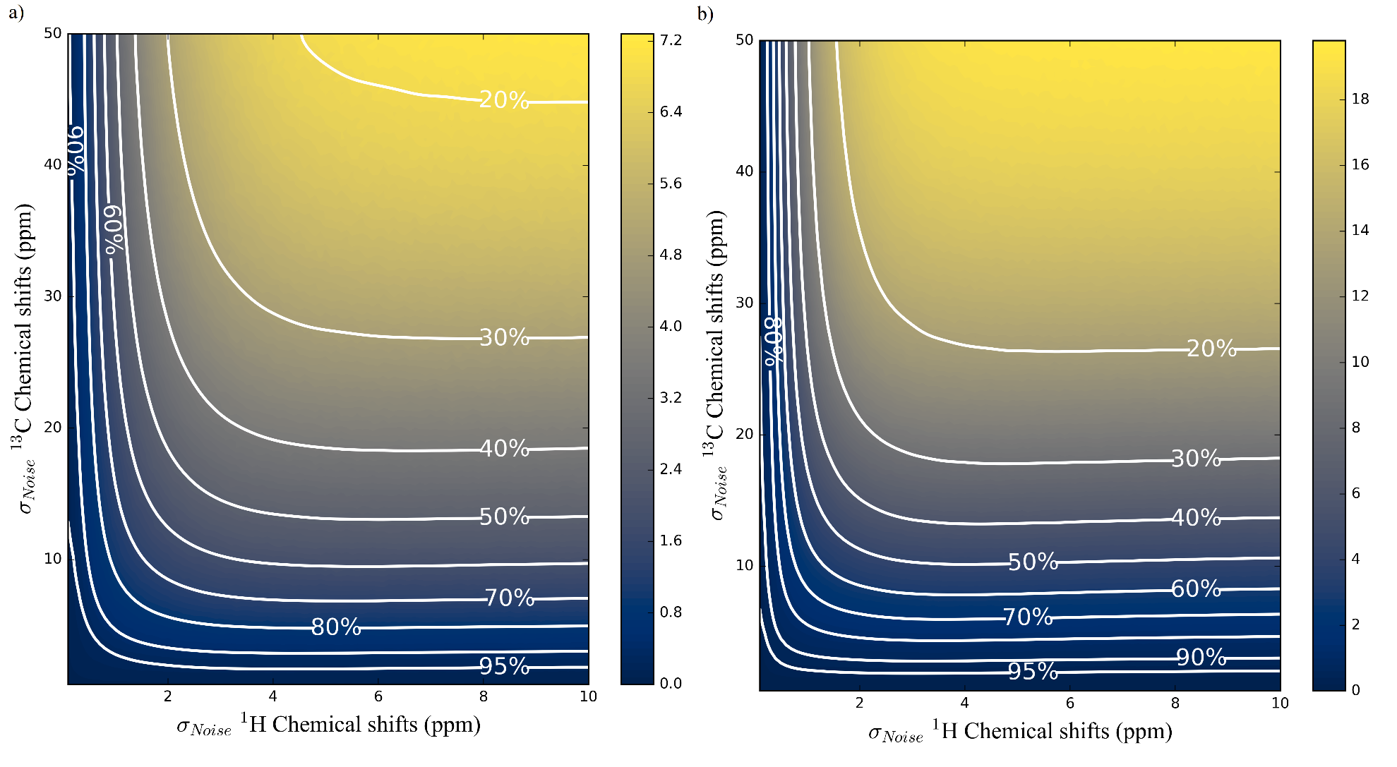
Figure 1 Standard deviations of ranks with respect to the carbon and proton errors and contour lines for the different level of identification ratios when carbons and protons are used together for a-b) Set I (water soluble molecules) and c-d) Set II (chloroform soluble molecules)
The relationship (i.e. trade-off) between ¹³C and ¹H chemical shift errors given by the white contour lines are predicted by using Eqn S1, Eqn S2, and Eqn S3 as showed by red dashed lines in Figure 1 and Figure 2 for Set I and Set II, respectively.

 | $$MAE\left(13C\right)=a+b\exp^{(-cx)}$$ | Eqn S1
 | $$MAE\left(13C\right)=a/\left(MAE\left(1H\right)-b\right)+c$$ | Eqn S2
 | $$MAE\left(13C\right)=a+b\exp^{(-cx)}+d\exp^{(-ex)}$$ | Eqn S3

The fitting parameters predicted for Eqn S1, Eqn S2, and Eqn S3 for Set I and Set II are given in Table 6-8, respectively along with Coefficient of Determination (R²) and Sum of Squared Difference (SSD) values.

% identification | Set I |  |  |  |  | Set II
% identification | R2 | SSD | a | b | c | R2 | SSD | a | b | c
95 | 0.99 | 17.84 | 68.20 | 7.55 | 2.35 | 1.00 | 0.27 | 7.80 | 4.92 | 1.90
90 | 0.99 | 17.38 | 104.49 | 5.66 | 3.42 | 1.00 | 6.47 | 47.63 | 8.11 | 3.02
85 | 0.99 | 15.06 | 106.06 | 4.33 | 4.34 | 0.99 | 12.98 | 103.02 | 7.81 | 3.92
80 | 0.99 | 11.26 | 99.12 | 3.42 | 5.24 | 0.99 | 14.21 | 117.15 | 6.42 | 4.71
75 | 0.99 | 7.44 | 89.37 | 2.76 | 6.18 | 0.99 | 12.42 | 110.30 | 5.20 | 5.50
70 | 1.00 | 4.53 | 83.65 | 2.30 | 7.22 | 0.99 | 10.15 | 98.81 | 4.25 | 6.31
65 | 1.00 | 2.39 | 81.60 | 1.99 | 8.40 | 0.99 | 7.70 | 87.77 | 3.53 | 7.17
60 | 1.00 | 1.30 | 81.41 | 1.75 | 9.75 | 0.99 | 5.43 | 78.92 | 2.98 | 8.10
55 | 1.00 | 0.49 | 81.64 | 1.55 | 11.29 | 0.99 | 3.37 | 72.19 | 2.55 | 9.12
50 | 1.00 | 0.16 | 86.41 | 1.41 | 13.17 | 1.00 | 1.71 | 67.64 | 2.23 | 10.29

% identification | Set I |  |  |  |  | Set II
% identification | R2 | SSD | a | b | c | R2 | SSD | a | b | c
95 | 1.00 | 0.81 | 1.33 | 0.12 | 1.43 | 1.00 | 2.23 | 0.35 | 0.11 | 1.83
90 | 1.00 | 1.13 | 1.95 | 0.23 | 2.21 | 1.00 | 1.49 | 0.66 | 0.16 | 2.52
85 | 1.00 | 0.55 | 2.50 | 0.31 | 2.97 | 1.00 | 1.00 | 1.01 | 0.20 | 3.16
80 | 1.00 | 0.46 | 3.16 | 0.38 | 3.68 | 1.00 | 0.55 | 1.36 | 0.24 | 3.79
75 | 1.00 | 0.42 | 3.92 | 0.45 | 4.45 | 1.00 | 0.83 | 1.80 | 0.28 | 4.40
70 | 1.00 | 0.39 | 4.71 | 0.52 | 5.31 | 1.00 | 0.73 | 2.20 | 0.32 | 5.10
65 | 1.00 | 0.32 | 5.44 | 0.61 | 6.34 | 1.00 | 0.58 | 2.62 | 0.36 | 5.84
60 | 1.00 | 0.21 | 6.03 | 0.73 | 7.61 | 1.00 | 0.58 | 3.02 | 0.41 | 6.69
55 | 1.00 | 0.15 | 6.64 | 0.86 | 9.09 | 1.00 | 0.60 | 3.49 | 0.46 | 7.62
50 | 1.00 | 0.09 | 6.51 | 1.08 | 11.10 | 1.00 | 0.62 | 3.88 | 0.53 | 8.71

Table 8 Fitting parameters for Eqn S3 predicted for Set I and Set II
Percentages  (%) | Set I |  |  |  |  |  |  | Set II
Percentages  (%) | R² | SSD | a | b | c | d | e | R² | SSD | a | b | c | d | e
95 | 1.00 | 1.05 | 8.51 | 2.32 | 134.40 | 12.85 | 1.98 | 1.00 | 0.27 | 3.90 | 4.92 | 3.90 | 4.92 | 1.90
90 | 1.00 | 0.30 | 12.45 | 2.02 | 425.88 | 10.98 | 3.00 | 1.00 | 1.00 | 4.08 | 2.12 | 56.18 | 10.62 | 2.78
85 | 1.00 | 0.21 | 15.57 | 1.78 | 628.58 | 9.26 | 3.88 | 1.00 | 0.53 | 10.58 | 2.67 | 329.56 | 13.97 | 3.61
80 | 1.00 | 0.15 | 18.26 | 1.60 | 656.57 | 7.70 | 4.77 | 1.00 | 0.46 | 13.78 | 2.45 | 713.93 | 13.24 | 4.38
75 | 1.00 | 0.09 | 22.25 | 1.49 | 713.67 | 6.73 | 5.73 | 1.00 | 0.28 | 14.90 | 2.13 | 781.78 | 11.21 | 5.15
70 | 1.00 | 0.09 | 26.53 | 1.40 | 804.17 | 6.03 | 6.80 | 1.00 | 0.25 | 16.05 | 1.90 | 726.53 | 9.50 | 5.95
65 | 1.00 | 0.08 | 33.73 | 1.38 | 1424.80 | 5.95 | 8.03 | 0.99 | 7.70 | -17.24 | 3.53 | 105.00 | 3.53 | 7.17
60 | 1.00 | 0.07 | 41.99 | 1.33 | 7848.66 | 6.72 | 9.43 | 1.00 | 0.18 | 22.11 | 1.73 | 1073.85 | 8.14 | 7.79
55 | 1.00 | 0.05 | 55.06 | 1.33 | 1.16E+06 | 9.45 | 11.08 | 1.00 | 0.13 | 26.11 | 1.67 | 1456.72 | 7.75 | 8.86
50 | 1.00 | 0.01 | 70.07 | 1.31 | 4.30E+18 | 23.88 | 13.06 | 1.00 | 0.05 | 31.91 | 1.64 | 3212.26 | 7.92 | 10.08

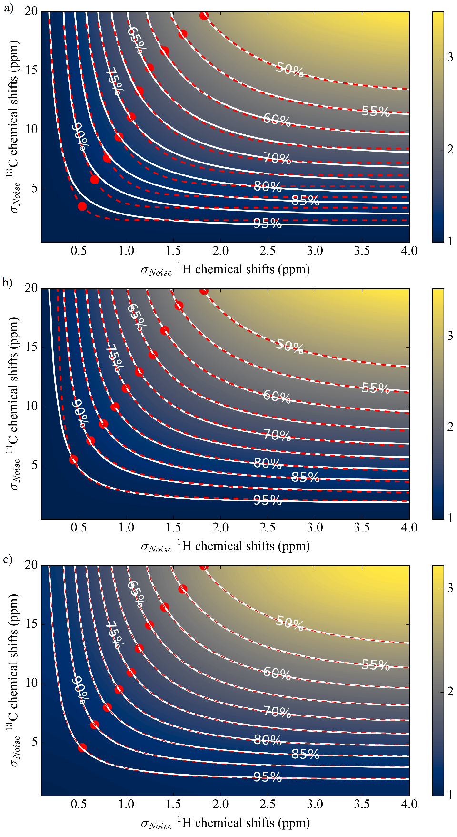
Figure 2 Mean of ranks changing with the ¹³C and ¹H NMR chemical shifts errors when used together for identification for Set I using a) Eqn S1, b) Eqn S2, and c) Eqn S3. White (actual data) and red dashed (predicted data) contour lines represent the same level of identification with changing errors with respect to one another.
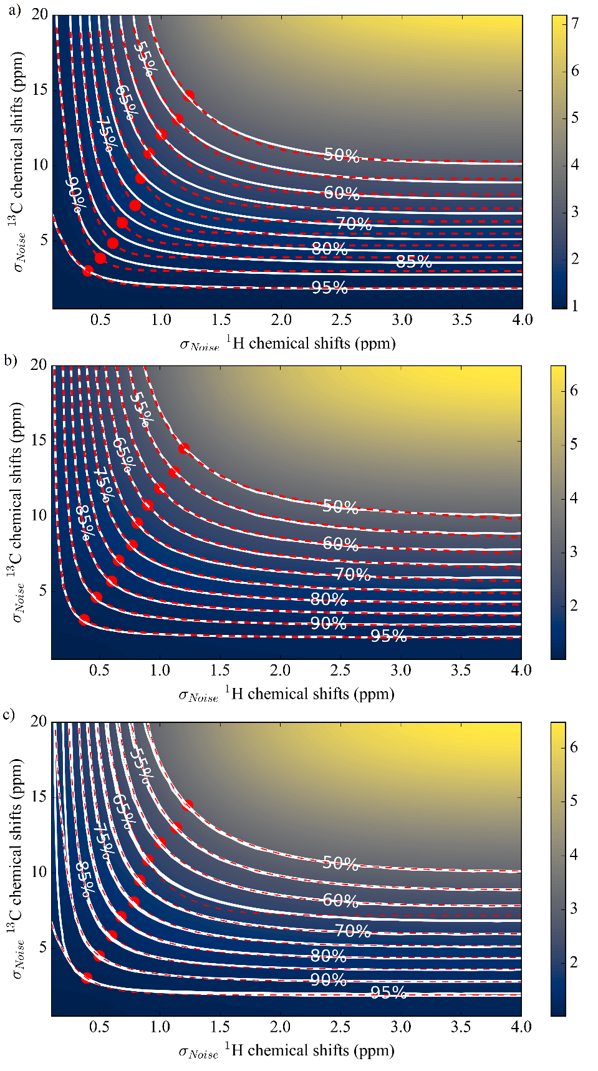
Figure 3 Mean of ranks changing with the ¹³C and ¹H NMR chemical shifts errors when used together for identification for Set II using a) Eqn S1, b) Eqn S2, and c) Eqn S3. White (actual data) and red dashed (predicted data) contour lines represent the same level of identification with changing errors with respect to one another.

Table 9 Optimum MAEs at different Gaussian standard deviation (σ) values (ppm) for Set I and Set II when ¹³C and ¹H NMR chemical shifts are used alone and together for identification
Percentages  (%) | σ (ppm) - Set I |  |  |  | σ (ppm) - Set II
Percentages  (%) | ¹³C alone | ¹H alone | Both ¹³C & ¹H |  | ¹³C alone | ¹H alone | Both ¹³C & ¹H
100 | 0 | 0 | 0 | 0 | 0 | 0 | 0 | 0
99.99 | 0.002 | - |  |  | -
99.9 | 0.04 | 0.01 | - | - | 0.08 | 0.01 | - | -
99 | 1.1 | 0.16 | - | - | 1.2 | 0.17 | - | -
95 | 2.3 | 0.31 | 4.41 | 0.73 | 2.6 | 0.31 | 3.13 | 0.37
90 | 3.2 | 0.38 | 6.12 | 0.85 | 3.6 | 0.38 | 4.57 | 0.48
85 | 3.9 | 0.44 | 7.57 | 0.97 | 4.4 | 0.45 | 5.76 | 0.59
80 | 4.6 | 0.49 | 9.09 | 1.07 | 5.1 | 0.5 | 6.92 | 0.68
75 | 5.4 | 0.54 | 10.73 | 1.19 | 5.8 | 0.55 | 8.09 | 0.77
70 | 6.1 | 0.59 | 12.34 | 1.30 | 6.5 | 0.59 | 9.30 | 0.84
65 | 7 | 0.64 | 14.23 | 1.42 | 7.1 | 0.64 | 10.41 | 0.94
60 | 7.9 | 0.69 | 16.28 | 1.56 | 7.9 | 0.69 | 11.68 | 1.02
55 | 8.8 | 0.74 | 18.55 | 1.71 | 8.6 | 0.75 | 12.90 | 1.13
50 | 10 | 0.8 | 21.41 | 0.60 | 9.3 | 0.8 | 14.27 | 1.23

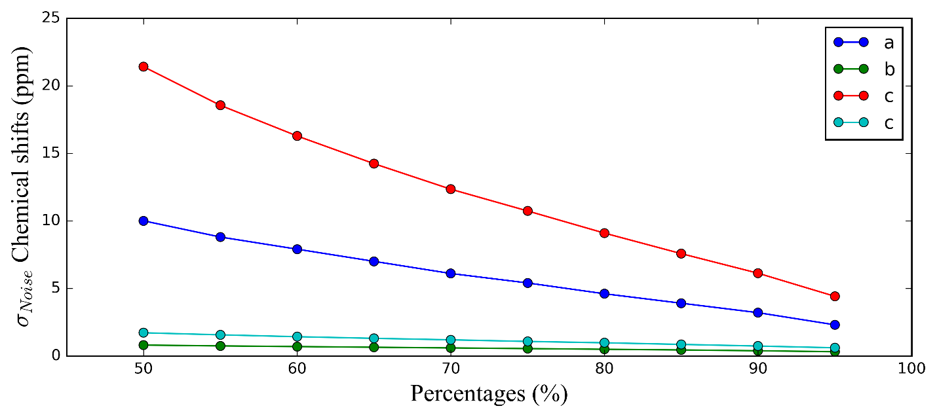
Figure 4 Optimum points obtained when a) ¹³C alone, b) ¹H alone, c) ¹³C together, and d) ¹H together are used with respect to level of identifications for Set I

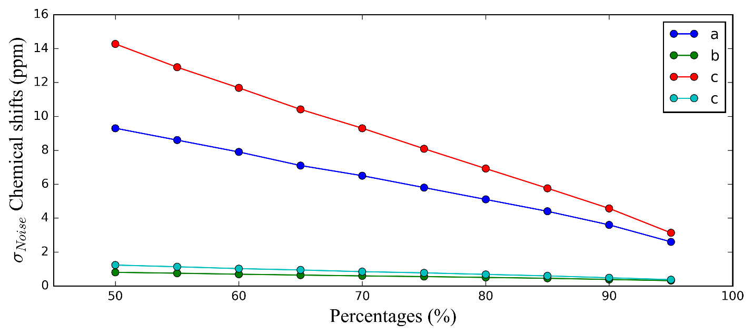
Figure 5 Optimum points obtained when a) ¹³C alone, b) ¹H alone, c) ¹³C together, and d) ¹H together are used with respect to level of identifications for Set II

S2. Results of Case II

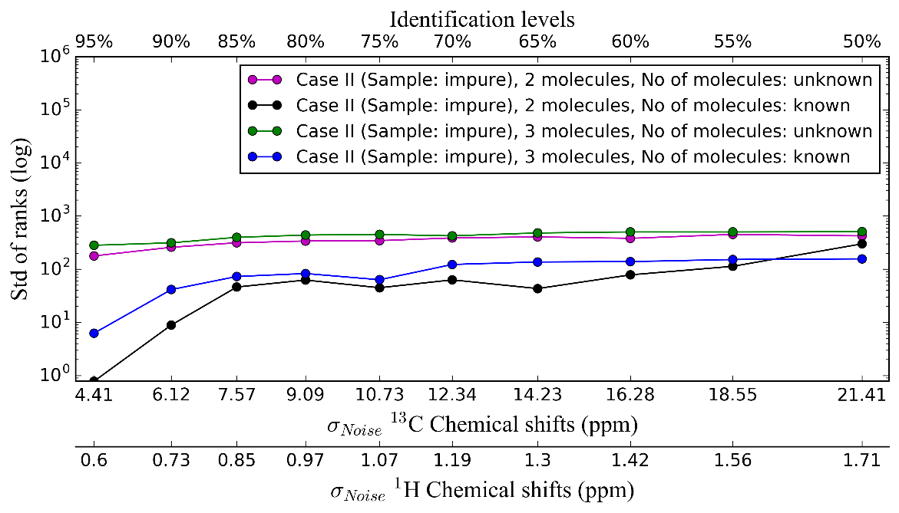
Figure 6 Standard deviation of ranks (at logarithmic scale) of Case II for pairs and triplets when number of molecules in samples are known and unknown at optimum points for Set I
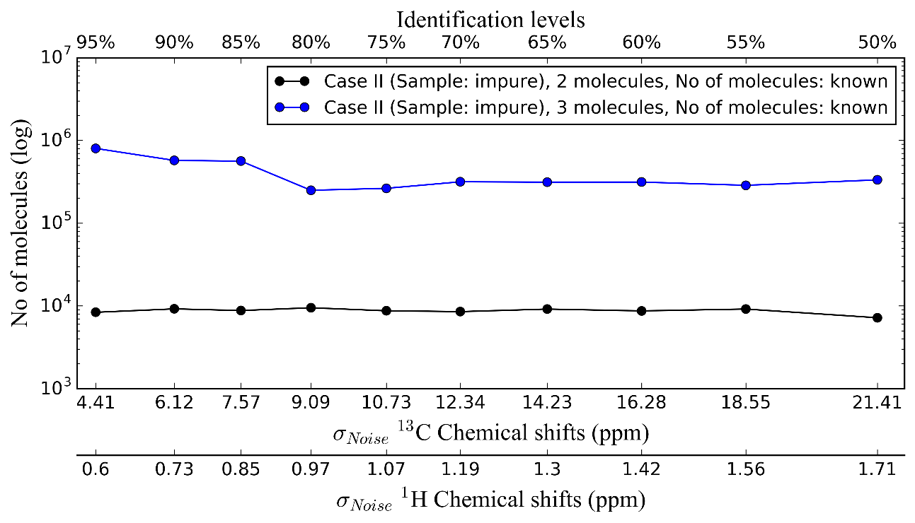
Figure 7 Average number of molecules (at logarithmic scale) used to be matched with the molecule set of interest in runs of Case II for pairs and triplets when number of molecules in samples are known at optimum points for Set I

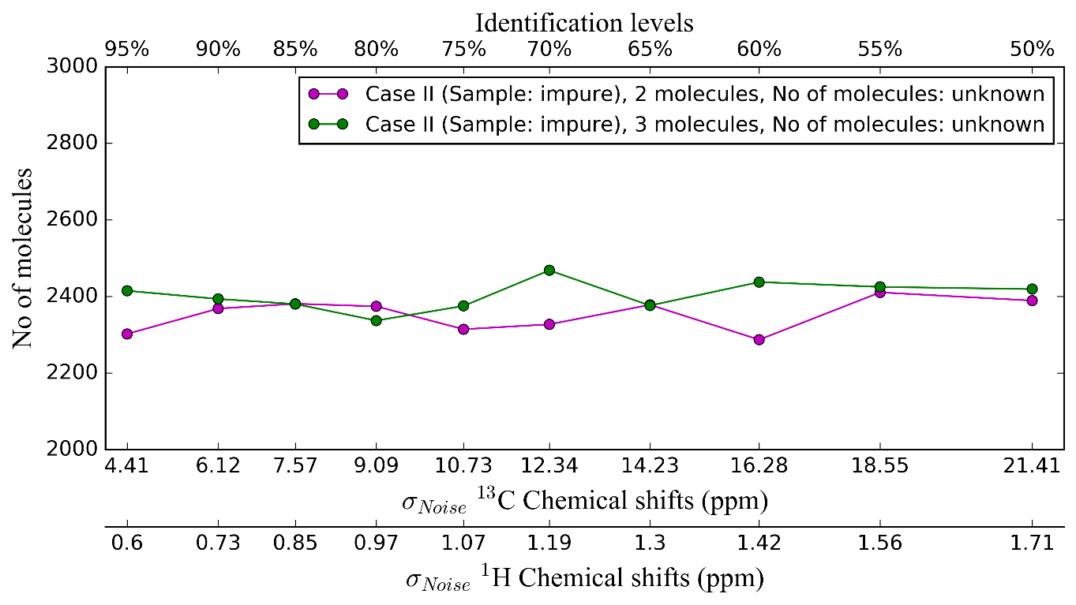
Figure 8 Average number of molecules (at logarithmic scale) used to be matched with the molecule set of interest in runs of Case II for pairs and triplets when number of molecules in samples are unknown at optimum points for Set I

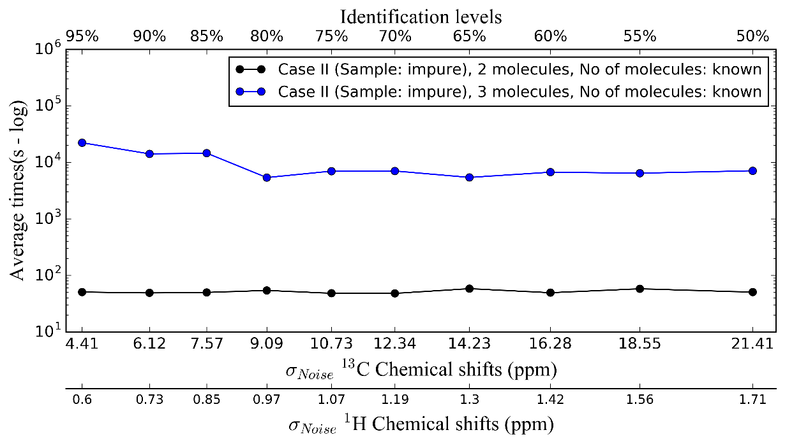
Figure 9 Average computational times (s) (at logarithmic scale) spent for runs of Case II for pairs and triplets when number of molecules in samples are known at optimum points for Set I

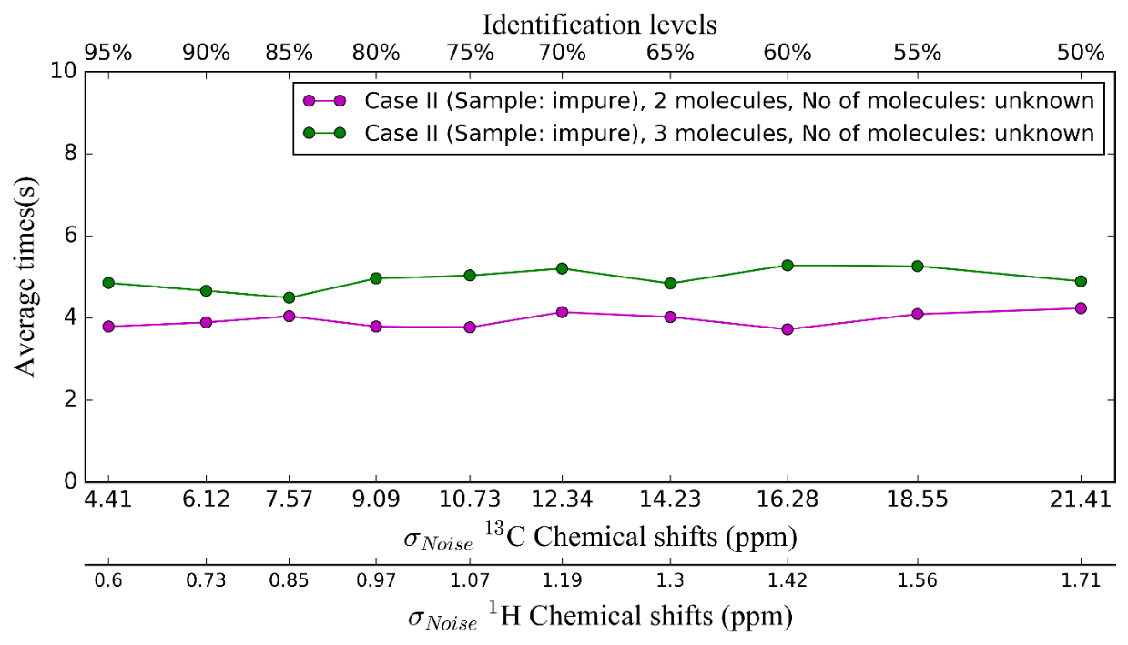
Figure 10 Average computational times (s) (at logarithmic scale) spent for runs of Case II for pairs and triplets when number of molecules in samples are unknown at optimum points for Set I

S3. Results of the comparisons of different DFT methods over NMR spectrum

Isotropic shielding values are compared using ISiCLE for the following 3 different following DFT methods:
- Method 1: B3LYP/cc-pVDZ//B3LYP/3-21G
- Method 2: B3LYP/cc-pVDZ//B3LYP/6-31G*
- Method 3: B3LYP/cc-pVTZ//B3LYP/6-31G*
The comparisons are performed over randomly chosen 5 molecules from Set I (water-solvated molecules) and Set II (chloroform-solvated molecules). Molecules are in different shapes and sizes. The images of the molecules taken from Set I and Set II are given in Figure 11 and Figure 12, and the details of the molecules are given in Table 10 and Table 11, respectively.

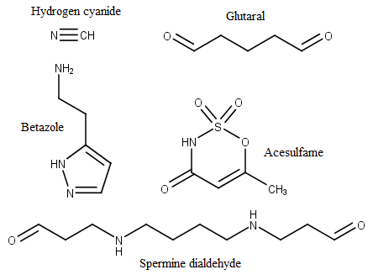
Figure 11 Molecules chosen from the Set I (water-solvated)

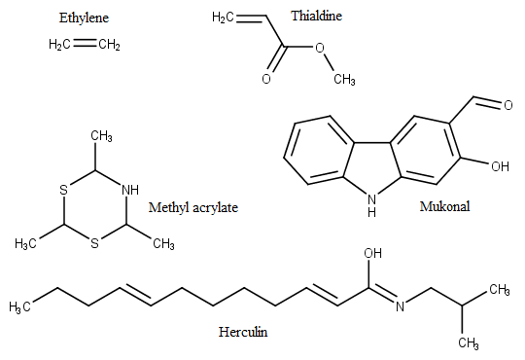
Figure 12 Molecules chosen from the Set II (chloroform-solvated)
Table 10 Features of the 5 molecules randomly chosen from the Set I (water-solvated)
Common Name | Hydrogen cyanide | Glutaral | Betazole | Acesulfame | Spermine dialdehyde
IUPAC Name | Formonitrile | Pentanedial | 2-(1H-pyrazol-5-yl)ethan-1-amine | 6-methyl-3,4-dihydro-1,2,3-oxathiazine-2,2,4-trione | 3-4-3-oxopropylamino]butyl}amino)propanal
InChI | InChI=1S/CHN/c1-2/h1H | InChI=1S/C5H8O2/c6-4-2-1-3-5-7/h4-5H,1-3H2 | InChI=1S/C5H9N3/c6-3-1-5-2-4-7-8-5/h2,4H,1,3,6H2,(H,7,8) | InChI=1S/C4H5NO4S/c1-3-2-4(6)5-10(7,8)9-3/h2H,1H3,(H,5,6) | InChI=1S/C10H20N2O2/c13-9-3-7-11-5-1-2-6-12-8-4-10-14/h9-12H,1-8H2
InChIKey | LELOWRISYMNNSU-UHFFFAOYSA-N | SXRSQZLOMIGNAQ-UHFFFAOYSA-N | JXDFEQONERDKSS-UHFFFAOYSA-N | YGCFIWIQZPHFLU-UHFFFAOYSA-N | WPBJCXUUUSDQJO-UHFFFAOYSA-N
SMILES | C#N | O=CCCCC=O | NCCC1=CC=NN1 | CC1=CC(=O)NS(=O)(=O)O1 | O=CCCNCCCCNCCC=O
Chemical Formula | CHN | C5H8O2 | C5H9N3 | C4H5NO4S | C10H20N2O2
Molecular Weight | 27.0253 | 100.1158 | 111.1451 | 163.152 | 200.278
LogP | -0.65 | 0.93 | -0.64 | -0.1 | 0.45
LogS | -0.92 | -0.19 | 0.15 | -1.15 | -2.39
Solubility | 3.26 g/L | 64 g/L | 156 g/L | 11.4 g/L | 0.81 g/L
LogP | -0.35 | -0.27 | -0.62 | -0.55 | -0.87
Pka (Acidic) | 9.5 | 14.48 | 14.52 | 3.02 | 13.85
Pka (Basic) |  | -6.6 | 9.79 | -6 | 10.23
Rotatable Bond Count | 0 | 4 | 2 | 0 | 11
Direct Parent | Nitriles | Alpha-hydrogen aldehydes | 2-arylethylamines | Organic sulfuric acids and derivatives | Alpha-hydrogen aldehydes
Kingdom Class | Chemical entities | Organic compounds | Chemical entities | Chemical entities | Chemical entities
Super Class | Organic compounds | Organic oxygen compounds | Organic compounds | Organic compounds | Organic compounds
Class | Organic nitrogen compounds | Organooxygen compounds | Organic nitrogen compounds | Organic acids and derivatives | Organic oxygen compounds
Sub Class | Organonitrogen compounds | Carbonyl compounds | Organonitrogen compounds | Organic sulfuric acids and derivatives | Organooxygen compounds
Harary Index | 1 | 11.15 | 15.57 | 23.42 | 31.52
Balaban Index | 1 | 2.45 | 2.06 | 2.51 | 2.78
Ring Bond % | 0 | 0 | 0.294118 | 0.4 | 0

Table 11 Features of the 5 molecules randomly chosen from the Set II (chloroform-solvated)
Common Name | Ethylene | Methyl acrylate | Thialdine | Mukonal | Herculin
IUPAC Name | ethene | methyl prop-2-enoate | 2,4,6-trimethyl-1,3,5-dithiazinane | 2-hydroxy-9H-carbazole-3-carbaldehyde | (Z,2E,8E)-N-(2-methylpropyl)dodeca-2,8-dienimidic acid
InChI | InChI=1S/C2H4/c1-2/h1-2H2 | InChI=1S/C4H6O2/c1-3-4(5)6-2/h3H,1H2,2H3 | InChI=1S/C6H13NS2/c1-4-7-5(2)9-6(3)8-4/h4-7H,1-3H3 | InChI=1S/C13H9NO2/c15-7-8-5-10-9-3-1-2-4-11(9)14-12(10)6-13(8)16/h1-7,14,16H | InChI=1S/C16H29NO/c1-4-5-6-7-8-9-10-11-12-13-16(18)17-14-15(2)3/h6-7,12-13,15H,4-5,8-11,14H2,1-3H3,(H,17,18)/b7-6+,13-12+
InChIKey | VGGSQFUCUMXWEO-UHFFFAOYSA-N | BAPJBEWLBFYGME-UHFFFAOYSA-N | FBMVFHKKLDGLJA-UHFFFAOYSA-N | NEAHWGSQUXSRNW-UHFFFAOYSA-N | JNPRQUIWDVDHIT-GYIPPJPDSA-N
SMILES | C=C | COC(=O)C=C | CC1NC(C)SC(C)S1 | OC1=C(C=O)C=C2C(NC3=CC=CC=C23)=C1 | CCC\C=C\CCCC\C=C\C(\O)=N\CC(C)C
Chemical Formula | C2H4 | C4H6O2 | C6H13NS2 | C13H9NO2 | C16H29NO
Molecular Weight | 28.0532 | 86.0892 | 163.304 | 211.2161 | 251.4076
LogP | 0.9 | 0.67 | 1.3 | 2.86 | 5.85
LogS | -0.94 | -0.13 | -1.72 | -3.47 | -5.47
Solubility | 3.25 g/L | 64.2 g/L | 3.12 g/L | 0.072 g/L | 8.500E-04 g/L
LogP | 1.11 | 0.91 | 1.39 | 3.15 | 5.59
Pka (Acidic) |  |  |  | 8.07 | 8.69
Pka (Basic) |  | -6.8 | 5.87 | -6 | 6.02
Rotatable Bond Count | 0 | 2 | 0 | 1 | 10
Direct Parent | Acyclic olefins | Enoate esters | 1,3,5-dithiazinanes | Carbazoles | N-acyl amines
Kingdom Class | Organic compounds | Organic compounds | Chemical entities | Chemical entities | Chemical entities
Super Class | Hydrocarbons | Organic acids and derivatives | Organic compounds | Organic compounds | Organic compounds
Class | Olefins | Carboxylic acids and derivatives | Organoheterocyclic compounds | Organoheterocyclic compounds | Lipids and lipid-like molecules
Sub Class | Acyclic olefins | Carboxylic acid derivatives | Azacyclic compounds | Indoles and derivatives | Fatty Acyls
Harary Index | 1 | 9.08 | 19.5 | 49.97 | 46.5
Balaban Index | 1 | 2.75 | 2.08 | 1.54 | 3.1
Ring Bond % | 0 | 0 | 0.272727 | 0.555556 | 0

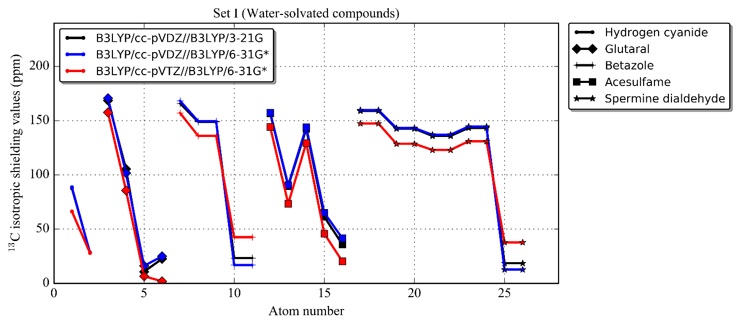
Figure 13 ¹³C isotropic shielding values of the water-solvated molecules (Set I), hydrogen cyanide, glutaral, betazole, acesulfame, spermine dialdehyde, for the DFT methods of B3LYP/cc-pVDZ//B3LYP/3-21G (black), B3LYP/cc-pVDZ//B3LYP/6-31G* (blue), B3LYP/cc-pVTZ//B3LYP/6-31G* (red)

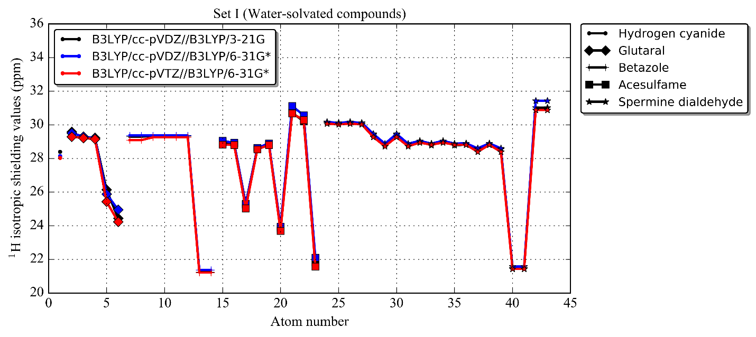
Figure 14 ¹H isotropic shielding values of the water-solvated molecules (Set I), hydrogen cyanide, glutaral, betazole, acesulfame, spermine dialdehyde, for the DFT methods of B3LYP/cc-pVDZ//B3LYP/3-21G (black), B3LYP/cc-pVDZ//B3LYP/6-31G* (blue), B3LYP/cc-pVTZ//B3LYP/6-31G* (red)

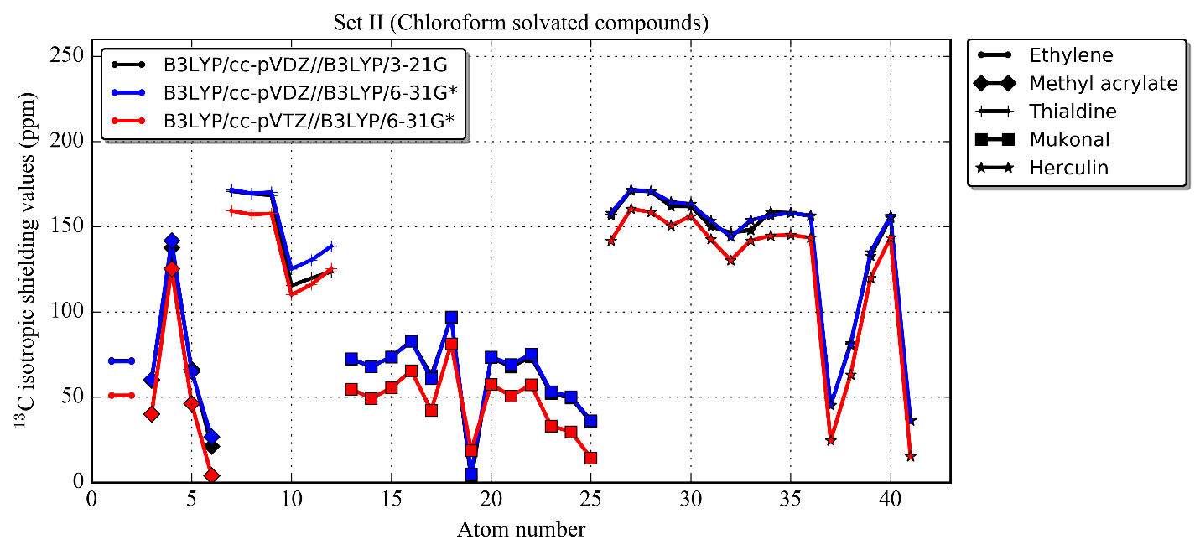
Figure 15 ¹³C isotropic shielding values of the chloroform-solvated molecules (Set II), ethylene, methyl acrylate, thialdine, Mukonal, herculin, for the DFT methods of B3LYP/cc-pVDZ//B3LYP/3-21G (black), B3LYP/cc-pVDZ//B3LYP/6-31G* (blue), B3LYP/cc-pVTZ//B3LYP/6-31G* (red)

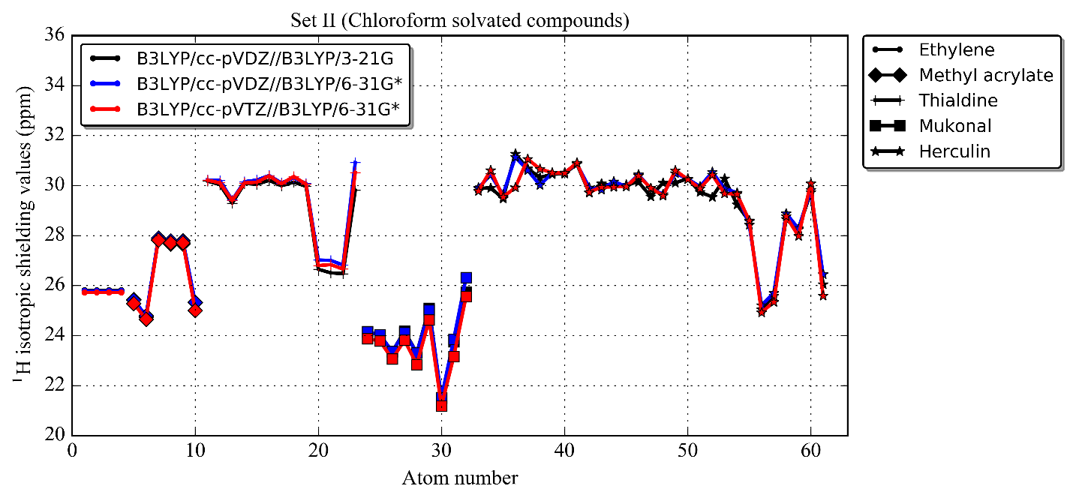
Figure 16 ¹H isotropic shielding values of the chloroform-solvated molecules (Set II), ethylene, methyl acrylate, thialdine, Mukonal, herculin, for the DFT methods of B3LYP/cc-pVDZ//B3LYP/3-21G (black), B3LYP/cc-pVDZ//B3LYP/6-31G* (blue), B3LYP/cc-pVTZ//B3LYP/6-31G* (red)

S4. DP4 Calculations

CP3 and DP4 are valuable methods to determine the candidate molecule with which the structure matches the experimental data the best, particularly in computational NMR structure elucidations and determination of relative stereochemistry of compounds. CP3 [1] is used when two or more sets of experimental NMR data are available and DP4 [2] is used when one set of experimental NMR data is available to many candidate structures.
In our study, molecule identification refers the process of matching of a set of sample NMR signals (¹³C and/or ¹H chemical shifts) to the sets of NMR signals of candidates in a library or database. We assume to have one set of experimental NMR data (i.e. each set belongs to one molecule) to match to those of several candidate molecules. DP4 is more suitable to decide which candidate structure is the most likely to be correct than CP3.
We could have used MAE, CMAE, Pearson’s r or any other parameter to quantify the agreement between two sets. However, we believe that an indication of how confident a matching set is can be expressed better in terms of RMSE and probability. Formerly, we found RMSE to be a more appropriate measure of error than the MAE or others since each error does not contribute to RMSE in proportion to the absolute value of the error. Instead, the effects of squaring the error give more weight to errors further away from the mean, driving the error estimate towards the odd outlier. Latterly, the observation of weighted errors happens for DP4 in a similar way that standard cumulative normal distribution function yields more weight to larger errors than smaller ones, enabling to eliminate incorrect assignments in structure elucidations. Also, Smith et al. [2] shows how DP4 is more successful at assigning stereochemistry than probabilities based on MAE and R. This is because DP4 is based on conditional probability and/or Bayes’ theorem--the key factor increasing the certainty of results. When we compared the results of two exact simulations, one with RMSE and the other with DP4, we found that DP4 gives slightly better rankings for pure samples while taking more computational time than RMSE. On the other hand, we believe DP4 is not convenient for ranking matches in impure/complex samples and computationally more intense than RMSE. Therefore, we use RMSE in this study.
In Case I, we have a pure sample where NMR signals (¹³C and/or ¹H chemical shifts) belong to only one compound. We use the equation 1 for each matching of which candidates have equal number of ¹³C and/or ¹H chemical shifts.
 | $$P\left(i|δ_{1},δ_{2},…,δ_{M}\right)=\frac{\prod_{k=1}^{N}{(1-Φ(\left|\left(δ_{calc,k}^{i}-δ_{exp,k}^{i}\right)-μ\right|/σ))}}{\sum_{j=1}^{M}{[\prod_{k=1}^{N}{(1-Φ(\left|\left(δ_{calc,k}^{i}-δ_{exp,k}^{i}\right)-μ\right|/σ))}]}}$$ | (1)
where i is the candidate structure out of M possible candidates, $Φ$(x) is the standard cumulative normal distribution function and k is the ¹³C or ¹H nucleus (from 1 to N).
We performed a comparison study, DP4 versus RMSE, to decide whether DP4 is superior in predicting the best candidate correctly. We applied 100 different Gaussian noise ranging from 1.0 to 5.0 ppm and 0.2 to 4.0 ppm for ¹³C and/or ¹H NMR chemical shifts of Set I, respectively. We repeated this procedure twice with the same dataset and conditions using DP4 and RMSE. DP4 could predict the molecule correctly for 93% of the runs and RMSE could do so for 92% of those while DP4 is 17% slower on average.
In Case II and Case III, we have an impure sample where NMR signals (¹³C and/or ¹H chemical shifts) belong to many compounds. We use the equation 2, a slightly different version of equation 1, for each matching of which candidates have equal or less number of ¹³C and/or ¹H chemical shifts.
 | $$P\left(i|{RMSD}_{1},{RMSD}_{2},…,{RMSD}_{M}\right)=\frac{(1-Φ(\left|{RMSD}_{i}-μ_{r}\right|/σ_{r}))\prod_{j≠i}{(1-Φ(\left|{RMSD}_{i}-μ_{w}\right|/σ_{w}))}}{\sum_{k=1}^{M}{[(1-Φ(\left|{RMSD}_{i}-μ_{r}\right|/σ_{r}))\prod_{j≠i}{(1-Φ(\left|{RMSD}_{i}-μ_{w}\right|/σ_{w}))}]}}$$ | (2)
where $μ_{r}$ and $μ_{w}$ , and $σ_{r}$and $σ_{w}$ stand for right and wrong assignment.
What is different herein is RMSE of whole nuclei is used instead of errors of individual nucleus. It is necessary due to the fact that a parameter is needed to normalize the products in the nominator since sizes of candidate structures are different. Any parameter could be used here such as MAE, R and etc. As we stated in the paper, we have preferred RMSE since it is better at giving a relatively high weight to undesired large errors than MAE. The use of standard cumulative normal distribution function yields less weight to smaller RMSEs and higher probability to them, but it does not affect the order of RMSEs (smallest to largest) or probabilities (largest to smallest), instead takes more computational time. Therefore, it is definitely better to use RMSE for Case II and Case III.
We could use DP4 for Case I for the sake of better identification, but we prefer RMSE instead since it provides better efficiency in computational time and effort, and to be consistent with the calculations for Case II.
Note that Smith et al recommends to empirically scale all the predicted NMR chemical shifts to remove any systematic errors in a DP4 analysis. Since a surrogate data is used in this study, the NMR data was not scaled. It is also assumed that calculated chemical shifts’ errors obey normal (Gaussian) distribution.

References
1. Smith, S.G. and J.M. Goodman, Assigning the stereochemistry of pairs of diastereoisomers using GIAO NMR shift calculation. J Org Chem, 2009. 74(12): p. 4597-607.
2. Smith, S.G. and J.M. Goodman, Assigning stereochemistry to single diastereoisomers by GIAO NMR calculation: the DP4 probability. J Am Chem Soc, 2010. 132(37): p. 12946-59.

