Supplemental Material
Association between Blood Pressure and Lung Function in Chinese Children: The Seven Northeastern Cities Study
Da Huo, Mo Yang, Qi-Zhen Wu, Caroline J Lodge, Jennifer L Perret, Dinh S Bui, Shyamali C Dharmage, Pasi Jalava, Qiang Hu, Guang-Hui Dong

Table of Contents
eMethods 1: Description of the Study Design and Random Sampling Strategy
eMethods 2: Description of the Anthropometry and Questionnaire Data Collection
Table S1 Correlation between Blood pressure and Lung function
Table S2 Odds ratios of Lung function Impairment due to effect of blood pressure on Boys and Girls
Table S3 Absolute estimated change of lung function due to effect of blood pressure on Boys and Girls
Figure S1 Correlation between Systolic Blood Pressure and Lung Function.

eMethods 1: Description of the Study Design and Random Sampling Strategy
The Seven Northeastern Cities (SNEC) study is a cross-sectional study of children's health outcomes based on exposure to ambient air pollution. This area encompasses more than 20 million people residing in 14 cities in Liaoning province in Northeastern China. To maximize the inter- and intra-city gradients of the pollutants of interest and also to minimize the correlation between district-specific ambient pollutants, in April 2012 the seven cities of Shenyang, Dalian, Anshan, Fushun, Benxi, Liaoyang, and Dandong in Liaoning province were selected as study sites, based on air pollution measurements taken between 2009 and 2011 (Map1). In each city, we selected all urban districts for the study (Map1).
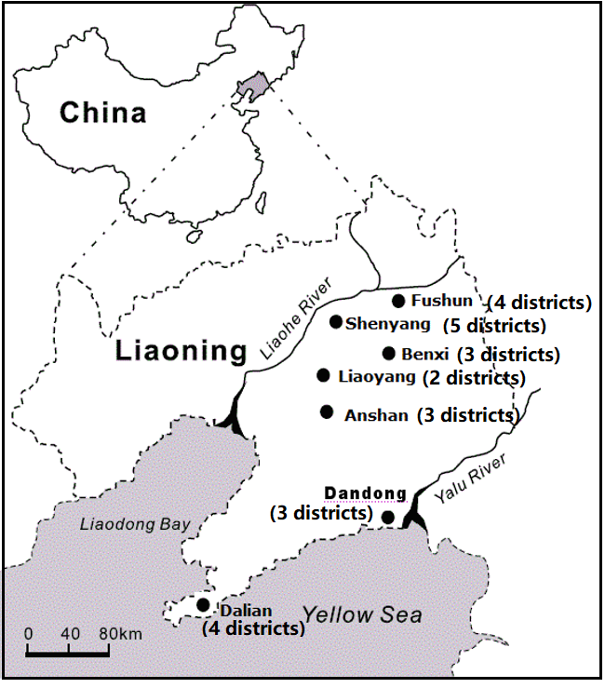
Map 1: Locations of the study cities in Liaoning province, northeast of China
In each of the 24 study districts, there was only one available municipal air monitoring station. To generate a representative sample, we randomly selected one or two primary schools and middle schools, located within 2 km of the monitoring station. If the number of students in the first selected school was below 500, we included a second school. Total 62 schools were included. Within each school, we randomly selected one or two classrooms depending on the class size from each grade level to enroll study participants.

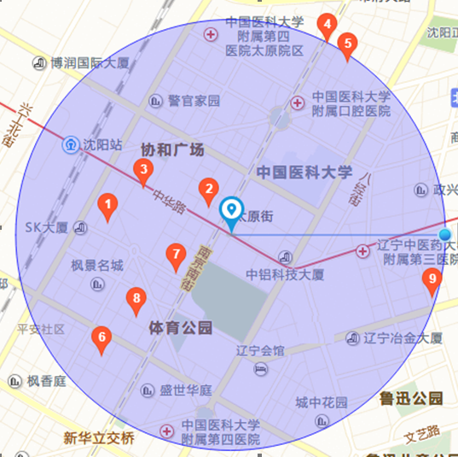
Map 2: The area including 2 km radius around a monitoring station, indicated by a small, blue circle in the center of the map. Primary schools, marked 1-9, fell within this radius. We randomly selected school from 1 to 9.
The Map 2 shows an area including up to 2 km radius around one of our monitoring stations, as indicated by a small, brown circle in the center of the map. As shown in the map2, 9 primary schools (marked 1-9) were within 2 km radius of that particular station. We randomly selected one or two primary schools from the 9 by using a random number table.
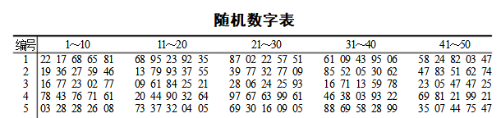
Random Number Table
In China, each district of a city has an administrative code. We selected the last two non-zero valid digits of the administrative code as the number of the district and randomly selected two schools based on a random number table. For example, the administrative code of the Heping district in Shenyang is “210102000000.” We identified “02” as the number of the Heping district. According to a random number table, as shown below, the random numbers “1” and “9” were selected in this survey. So, schools with label 1 and 9 in the figure were included. These randomization procedures ensure that the schools selected are representative of the region.
In China, primary schools admit students restrictively basing the criteria on geographical boundaries, and the policy forbids selecting trans-regionally schools for children. Therefore, the monitoring station, which was the only station in the selected children’s school district, was the nearest station to the child’s home. Furthermore, in the present study, the average time walking from home to school was only 11.9 minutes for the study school children, indicating the children’s PM exposure assessment may represent both school and home exposure levels. For these reasons, our results may have reduced exposure uncertainty.

eMethods 2: Description of the Anthropometry and Questionnaire Data Collection
The study questionnaire included queries about demographics, lifestyle factors in the home, family medical history, health-related behaviors in the home, and household environmental factors such as home coal use, house pet, home renovation in the past 2 years, area of residence per person. The trainees and investigators in the study were required to complete a training program on a standardized protocol for the physical examination. Following training, each trainee had to take a mandatory qualifying examination to ensure proper administration of the study questionnaire and adherence to the standardized protocol, and those who passed were awarded a Physical Observer Certificate. Each of the participating children completed a physical examination in school from April 2012 to May 2013. Trained nurses followed the standardized World Health Organization protocol for measuring children’s height (at 0.1cm) and weight (at 0.1kg), and used them to calculate the body mass index (BMI) in kg/m². Children’s age was from birth to the time we do research. We dichotomized parents’ education as having a high school education or not, and categorized annual family income (≤4999, 5000-9999, 10000-29999, 30000-100000, >100000 RMB). Children’s passive tobacco smoke exposure was defined as cohabitation with a daily cigarette smoker, and home coal use was assessed as household use for cooking or space heating. Area of residence per person (m²) was calculated by dividing the housing area by the number of household residents. We also queried the ‘ever’ presence of a house pet (i.e., dog, cat, bird, farm animals, and others). We defined family history of atopy as a clinical diagnosis of allergies (e.g., allergic dermatitis): hay fever, asthma, or bronchial asthma in a biologic parent or grandparent. Doctor-diagnosed asthma was defined as an affirmative answer to the question “Has a doctor ever diagnosed asthma in this child?” Current asthma among previously asthma-diagnosed children was defined by an affirmative answer to the question ‘‘Has this child had an asthma attack in the last two years?’’ or an affirmative answer to the question ‘‘Does this child take medicine or treatment for asthma or asthmatic bronchitis?’’ We determined home renovation as a positive response to the question “Have you made any renovations in your home within the past 2 years?” We determined low birth weight as the birth weight is less than 2500 g, premature birth as the age of less than 37 weeks at birth. We defined breastfeeding as having been mainly breastfed for more than three months.

Table S1 Correlation between Blood pressure and Lung function
 | FVC | FEV1 | PEF | MMEF
SBP  P-value | 0.4314  <.0001 | 0.4344  <.0001 | 0.3749  <.0001 | 0.3667  <.0001
DBP  P-value | 0.0805  <.0001 | 0.0883  <.0001 | 0.0568  <.0001 | 0.0879  <.0001
Abbreviations: CI, confidence interval; FEV1, forced expiratory volume in 1 second; FVC, forced vital capacity; MMEF, maximum mid expiratory flow rate; PEF, peak expiratory flow rate; SBP, systolic blood pressure; DBP, diastolic blood pressure.

Table S2 Odds ratios of Lung function Impairment due to effect of blood pressure on Boys and Girls
 | FVC <85%  OR (95%CI) | FEV1<85%  OR (95%CI) | PEF<75%  OR (95%CI) | MMEF <75%  OR (95%CI)
Boys
Normotensive | 1.00 | 1.00 | 1.00 | 1.00
Hypotensive | 1.38(0.71, 2.68) | 2.08 (1.11, 3.90) | 2.24 (1.08, 4.64) | 0.74 (0.32, 1.74)
Hypertensive | 0.83(0.59, 1.17) | 0.84 (0.57, 1.22) | 1.14 (0.75, 1.74) | 0.81 (0.55, 1.19)
Girls
Normotensive | 1.00 | 1.00 | 1.00 | 1.00
Hypotensive | 1.00 (0.54, 1.88) | 1.02 (0.48, 2.19) | 1.62 (0.84, 3.15) | 1.15 (0.60, 2.22)
Hypertensive | 1.15 (0.84, 1.56) | 1.14 (0.78, 1.67) | 0.93 (0.62, 1.39) | 1.33 (0.96, 1.85)
Abbreviations: CI, confidence interval; FEV1, forced expiratory volume in 1 second; FVC, forced vital capacity; MMEF, maximum mid expiratory flow rate; PEF, peak expiratory flow rate.
*Adjusting for age, parental education, breast feeding, low birth weight, premature birth, exercise per week, family income, home renovation, use of domestic cooking and heating fuels, environmental tobacco smoke exposure, family history of asthma and study districts.

Table S3 Absolute estimated change of lung function due to effect of blood pressure on Boys and Girls
 | FVC  β (95% CI) | FEV1  β (95% CI) | PEF  β (95% CI) | MMEF  β (95% CI)
Boys
Normotensive | 0.00 | 0.00 | 0.00 | 0.00
Hypotensive | -330.87  (-455.49, -206.25) | -268.16  (-373.86, -162.45) | -373.91  (-605.17, -142.65) | -186.38  (-361.36, -11.39)
Hypertensive | 47.65  (-11.51, 106.81) | 62.69  (12.51, 112.87) | 39.32  (-70.46, 149.10) | 77.05  (-6.03, 160.12)
Girls
Normotensive | 0.00 | 0.00 | 0.00 | 0.00
Hypotensive | -139.12  (-231.33, -46.91) | -128.24  (-210.54, -45.95) | -162.47  (-357.38, 32.44) | -113.67  (-260.81, 33.46)
Hypertensive | 0.75  (-46.42, 47.93) | -2.63  (-44.74, 39.47) | -22.48  (-122.19, 77.25) | -15.33  (-90.60 , 59.94)
Abbreviations: CI, confidence interval; FEV1, forced expiratory volume in 1 second; FVC, forced vital capacity; MMEF, maximum mid expiratory flow rate; PEF, peak expiratory flow rate.
*Adjusting for age, parental education, breast feeding, low birth weight, premature birth, exercise per week, family income, home renovation, use of domestic cooking and heating fuels, environmental tobacco smoke exposure, family history of asthma and study districts.

Figure S1 Correlation between Systolic Blood Pressure and Lung Function. CI, confidence interval; FEV1, forced expiratory volume in 1 second; FVC, forced vital capacity; MMEF, maximum mid expiratory flow rate; PEF, peak expiratory flow rate; SBP, systolic blood pressure. A: correlation between systolic blood pressure and FVC, B: correlation between systolic blood pressure and FEV1, C: correlation between systolic blood pressure and PEF, D: correlation between systolic blood pressure and MMEF.

