A fluorescence system composed of nitrogen-doped graphene quantum dots and gold nanoparticles coated with phenylalanine for selective and sensitive quantification of piroxicam in biological samples
Maryam Moallemi Bahmani, Ali Mohammad Haji Shabani*, Shayessteh Dadfarnia*, Roya Afsharipour
Department of Chemistry, Faculty of Science, Yazd University, Yazd, Iran

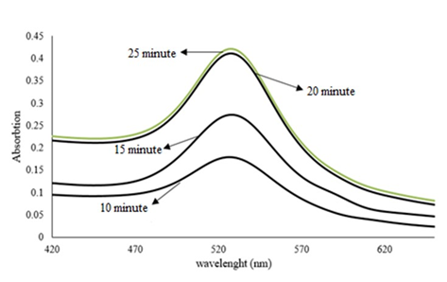
Fig. S1. UV-Visible spectrum of AuNPs in different time.

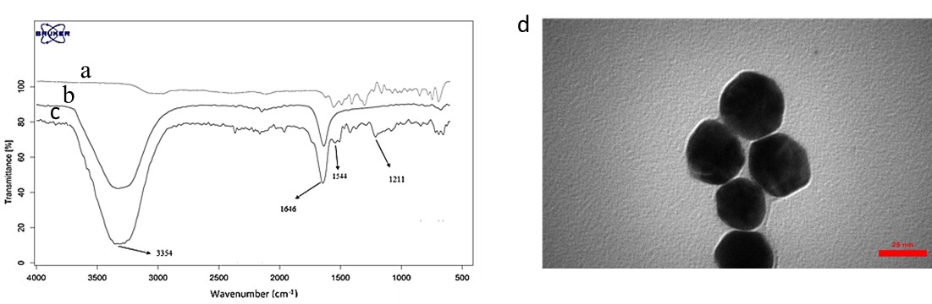
Fig. S2. )a) FT-IR Spectra of phenylalanine; (b) gold nanoparticles; (c) gold nanoparticles coated with phenylalanine; and (d) TEM image of gold nanoparticles coated with phenylalanine.

Fig. S3. Selectivity of designed nanoprobe towards piroxicam (11.0 nmol L⁻¹) and other species.

