Supplement Table 1 Components in Target Network of YXTMG
Compound | Degree | BetweennessCentrality | ClosenessCentrality | Classification
Quercetin | 236 | 0.0529 | 0.4272 | Flavonoids
Kaempferol | 88 | 0.0078 | 0.3757 | Flavonoids
Beta-sitosterol | 84 | 0.0046 | 0.3633 | Steroids
Gomisin B | 66 | 0.0126 | 0.3782 | Lignans
(3R)-3-(2-hydroxy-3,4-dimethoxyphenyl)chroman-7-ol | 63 | 0.0100 | 0.3751 | Flavonoids
Isoflavanone | 59 | 0.0087 | 0.3691 | Flavonoids
Celabenzine | 56 | 0.0108 | 0.3739 | Alkaloids
(E)-1,7-Diphenyl-3-hydroxy-1-hepten-5-one | 56 | 0.0103 | 0.3788 | Lignans
(E)-5-Hydroxy-7-(4-hydroxyphenyl)-1-phenyl-1-heptene | 56 | 0.0128 | 0.3838 | Lignans
Oxycurcumenol | 55 | 0.0082 | 0.3656 | Terpenoid

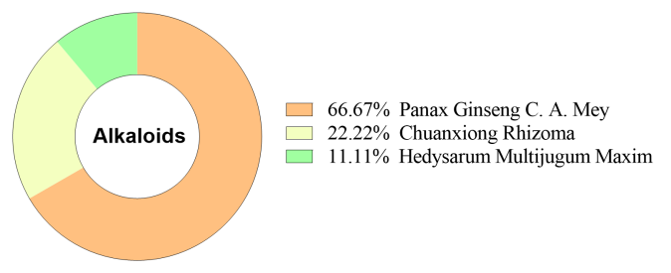
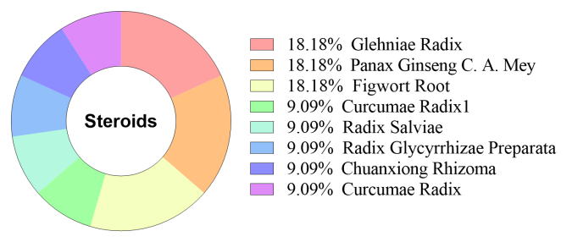
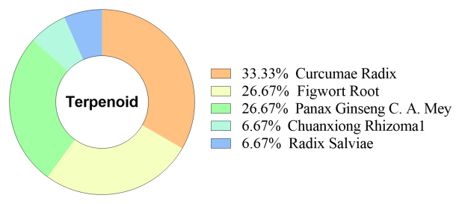
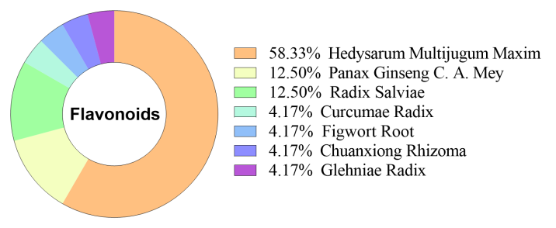
Supplement FIGURE1| Pie Chart of Composition Distribution of Flavonoids, Terpenoid, Steroids and Alkaloids

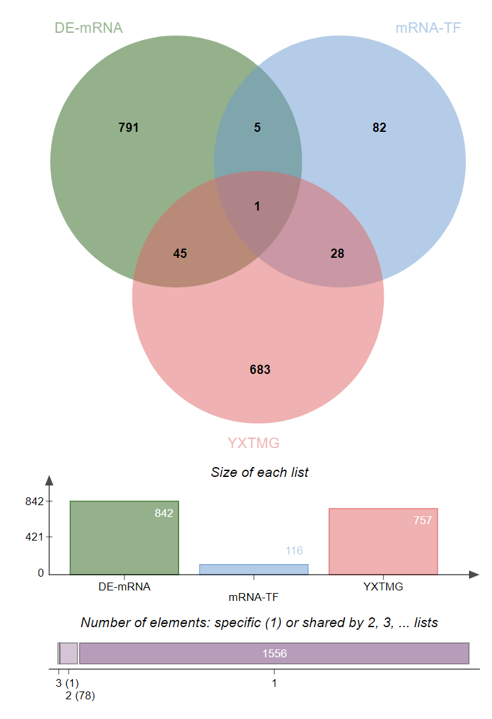
Supplement FIGURE2| Intervention Mechanism of YXTMG on Differentially Expressed mRNA and Transcription Factors in Critical Patients. a, intersection Venn diagram, b, biological process enrichment bubble diagram, c, signal pathway enrichment entry diagram.
a
c
b

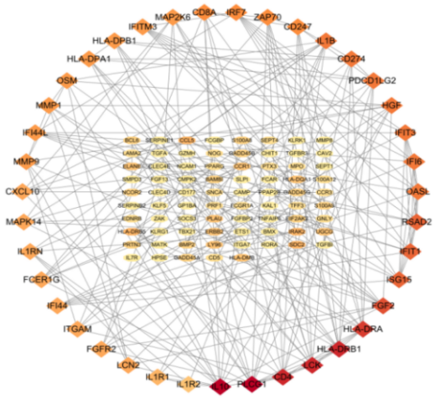
Supplement FIGURE3| Key genes of differential mRNA in severe COVID-19 patients(a),GO(b) and KEGG(c) analysis of differential genes
a
c
b

Supplement table 2 Inhibition of miRNA-mediated PLAU and SERPINE1 by YXTMG compound
Compound | Target | Binding-Energy(kj·mol⁻¹) | H-bond Residue | Ki（μM）
Stigmasterol | PLAU | -34.11 | CYS58 | 1.04
Stigmasterol | SERPINE1 | -24.45 | THR214 | 17.92
Quercetin | PLAU | -19.14 | TYR149 | 440.60
Quercetin | SERPINE1 | -17.76 | GLN303、SER310、GLU313 | 760.89
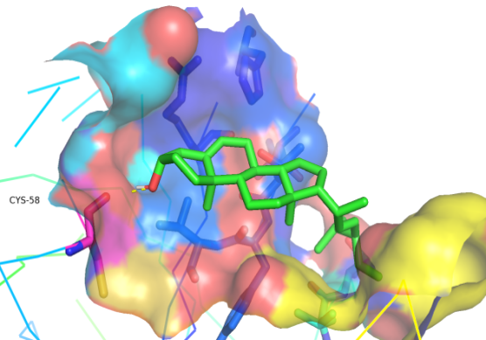
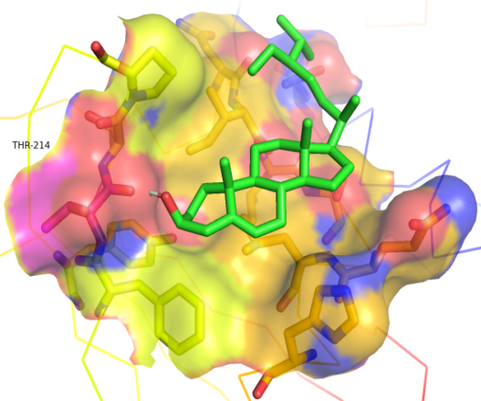
Supplement FIGURE4| Docking mode diagram of stigmasterol with PLAU and SERPINE1

