Supplementary
Optimality principles explaining divergent responses of alpine vegetation to environmental change: Supplementary Information

Ziqi Zhu¹, Han Wang^{1,*}, Sandy P. Harrison^{1,3}, I. Colin Prentice^{1,4,5}, Shengchao Qiao¹, Shen Tan¹

1 Department of Earth System Science, Ministry of Education Key Laboratory for Earth System Modeling, Institute for Global Change Studies, Tsinghua University, Beijing 100084, China
2 School of Archaeology, Geography and Environmental Sciences (SAGES), University of Reading, Reading RG6 6AH, United Kingdom
3 Department of Life Sciences, Imperial College London, Silwood Park Campus, Buckhurst Road, Ascot SL5 7PY, United Kingdom
4 Department of Biological Sciences, Macquarie University, North Ryde, NSW 2109, Australia
The Supplementary Information file contain the following figures:
Supplementary Figure 1. Changes of climate, environmental factors and maximum fAPAR on the Tibetan Plateau.
Supplementary Figure 2. Spatial pattern of climate change on the Tibetan Plateau.
Supplementary Figure 3. Climate change in the climate space of precipitation and SWI_{0.}
Supplementary Figure 4. Number of grid cells in climate space of precipitation and SWI₀.
Supplementary Figure 5. Relationship between maximum fAPAR and climate.
Supplementary Figure 6. Distribution of predicted water and energy limited areas on the Tibetan Plateau.
Supplementary Figure 7. Flowchart of the prediction of maximum fAPAR.
Supplementary Figure 8. Comparison of estimated peak vegetation cover against satellite observations within a single year.
Supplementary Figure 9. Comparison of estimated peak vegetation cover against observed aboveground biomass at site level.
Supplementary Figure 10. Trends of fitted parameters.
Supplementary Figure 11. Attribution of trends in precipitation and temperature sensitivity.
Supplementary Figure 12. Changes in areas of water and energy limited regions on the Tibetan Plateau.
Supplementary Figure 13. Sensitivity of estimated peak vegetation cover to various factors.
Supplementary Figure 14. Comparison of climate change on the Tibetan Plateau derived from CRU-NCEP and CMFD datasets.
Supplementary Figure 15. Spatial distributions of climate on the Tibetan Plateau based on the CMFD and CRU-NCEP data sets.

Supplementary Figure 1. Changes of climate, environmental factors and maximum fAPAR on the Tibetan Plateau. Panels (a-g) represent changes in annual total precipitation, summer warmth index (SWI₀), growing season length, growing season cumulative photosynthetic photon flux density (PPFD), growing season mean vapour pressure deficit (VPD), atmospheric carbon dioxide (CO₂) concentration and maximum fAPAR (F_{max}) over 1982–2016. Solid and dashed regression lines indicate statistically significant and non-significant trends at the 0.05 level, respectively.

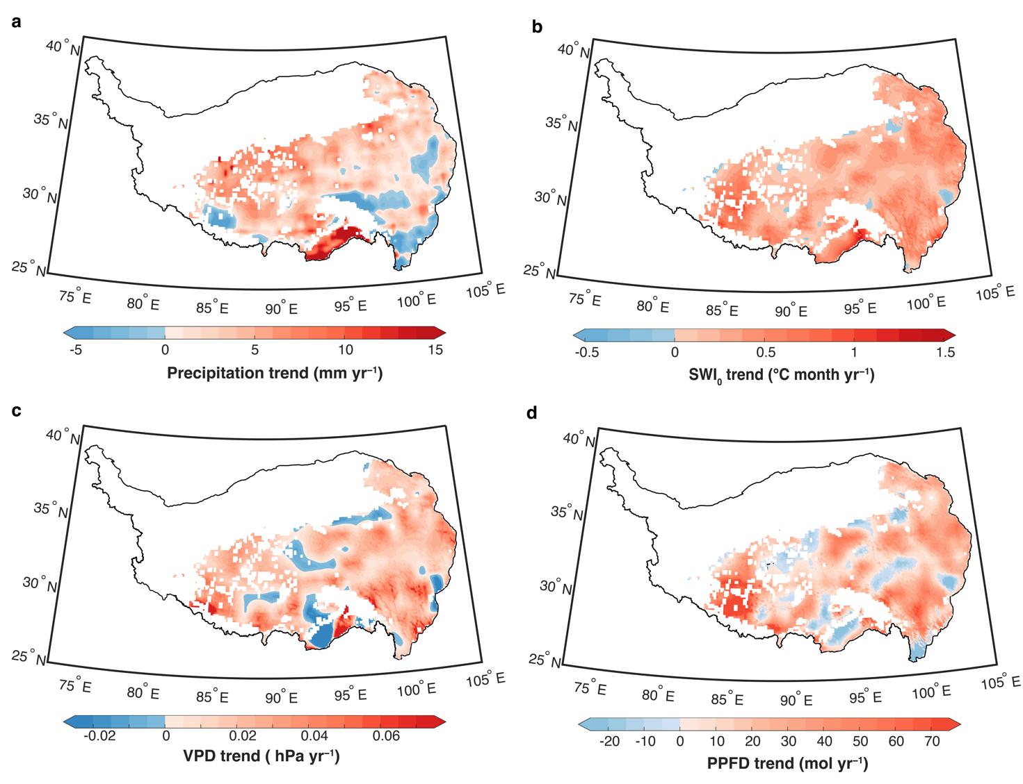
Supplementary Figure 2. Spatial pattern of climate change on the Tibetan Plateau. a-d, Spatial pattern of change trend of annual total precipitation (Precipitation, a), summer warmth index temperature (SWI₀, b), vapour pressure deficit (VPD, c), and growing season accumulated photosynthetic photon flux density (PPFD, d) over 1982–2016.

Supplementary Figure 3. Climate change in the climate space of precipitation and SWI_{0.} Panels (a-d) represent change trend of annual total precipitation, summer warmth index (SWI₀), vapour pressure deficit (VPD) and growing season accumulated photosynthetic photon flux density (PPFD) over 1982–2016. The climate space of SWI₀ and precipitation is subdivided into different bins of equal intervals with bin widths arbitrarily set to 5 °C month for SWI₀ and 50 mm for precipitation. Trends for each bin are calculated by averaging the subset of all pixels falling within that bin. Bins containing less than 5 pixels are not included in these plots. Statically significant trends are marked with black dots (P<0.05).

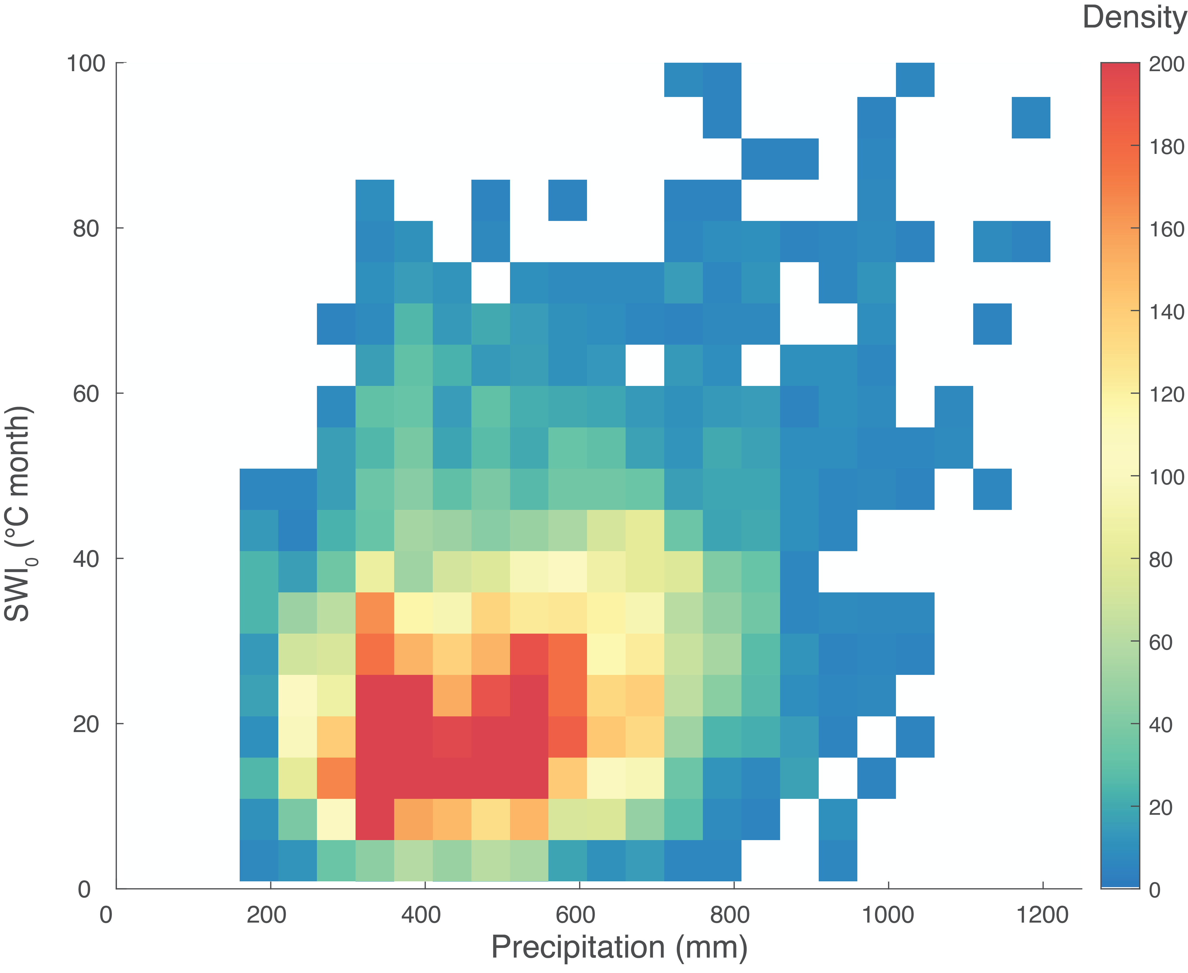

Supplementary Figure 4. Number of grid cells in climate space of precipitation and SWI₀. The climate space is subdivided into different bins of equal intervals, with bin widths arbitrarily set to 5 °C month for SWI₀ and 50 mm for precipitation. Number of grids for each bin are calculated by accumulating the subset of all grids falling within that bin. Bins containing less than 5 pixels are not included in these plots.

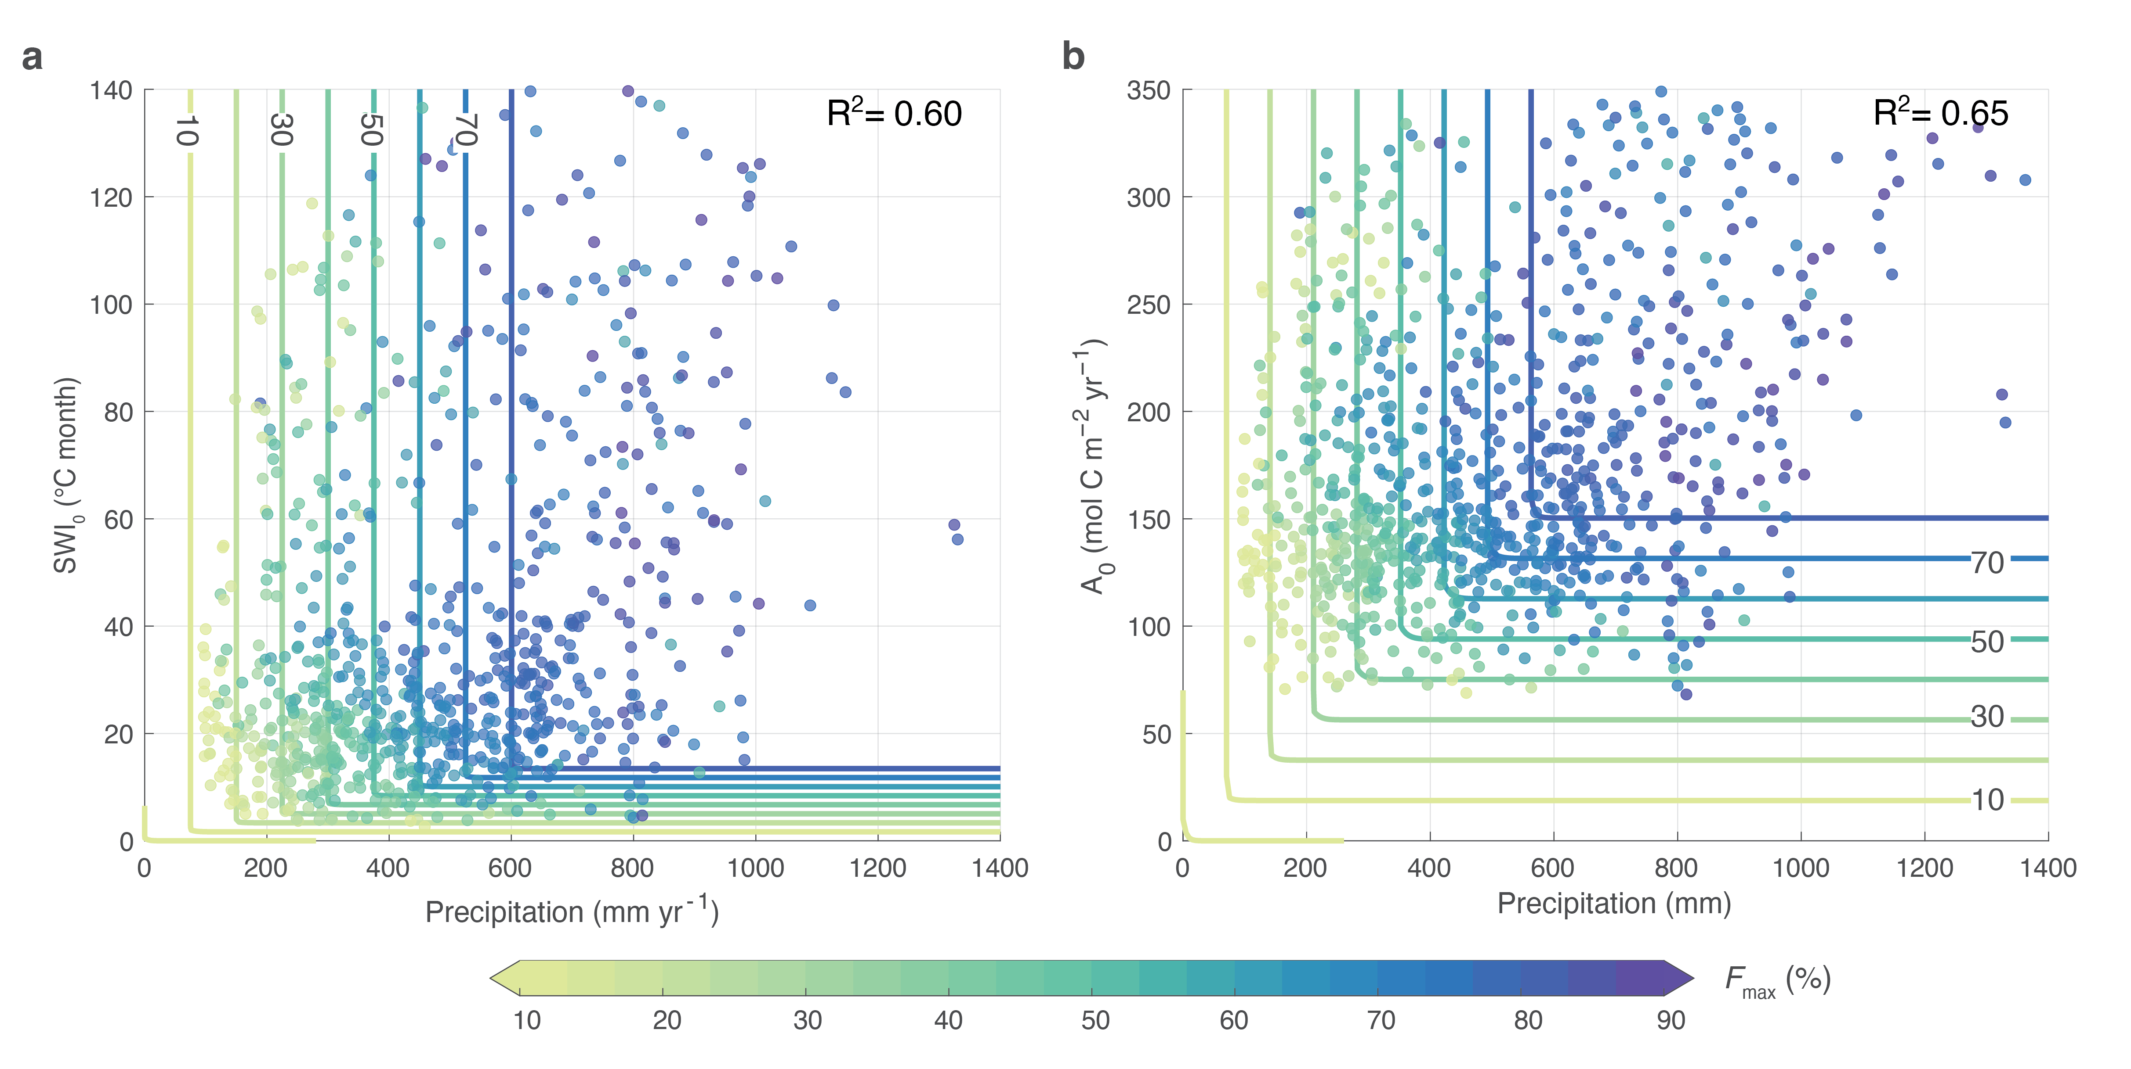
Supplementary Figure 5. Relationship between maximum fAPAR and climate. Same as Fig. 2, but including climate bins containing less than 5 pixels. a, Relationship between F_{max} and total precipitation and summer warmth index (SWI₀) in 1982. b, Relationship between F_{max} and total precipitation and potential gross primary production (A₀) in 1982. F_{max} selected in each 50 mm and 5 °C month (50 mm and 100 g C m⁻²) bin represents the maximum attainable vegetation cover for a given annual precipitation and SWI₀ (A₀). Coloured lines represent the fitted contour of F_{max}, ranging from 0 to 80% with an interval of 10%.

Supplementary Figure 6. Distribution of predicted water and energy limited areas on the Tibetan Plateau. a, Spatial distribution of the predicted water and energy limited areas. Blue colour indicates that the grid is limited by water, while orange colour indicates that the area is limited by energy. The colour gradients represent the proportion of the time limited by water or energy over the period of 1982–2016. b, Distribution of predicted water- and energy-limited areas in climate space defined by summer warmth index (SWI₀) and total precipitation. Climate bins containing less than 5 grid cells are not included. The climate space is subdivided into different bins of equal intervals. The bin widths are set to 5 °C month for SWI₀ and 50 mm for precipitation. Limitation factor for each bin is calculated by averaging the subset of all pixels falling within that bin.

Supplementary Figure 7. Flowchart of the prediction of maximum fAPAR. The model is based on the principle that the carbon allocation to leaves results from the maximisation of net profit, subject to the constraint that water is available to allow optimal function of the leaves. Inputs of the model are atmospheric carbon dioxide concentration (CO₂), growing season cumulative photosynthetic photon flux density (PPFD), growing season mean air pressure, growing season mean vapour pressure deficit (VPD), growing season mean air temperature, and annual total precipitation (Precipitation). Output of the model is the annual maximum fAPAR.

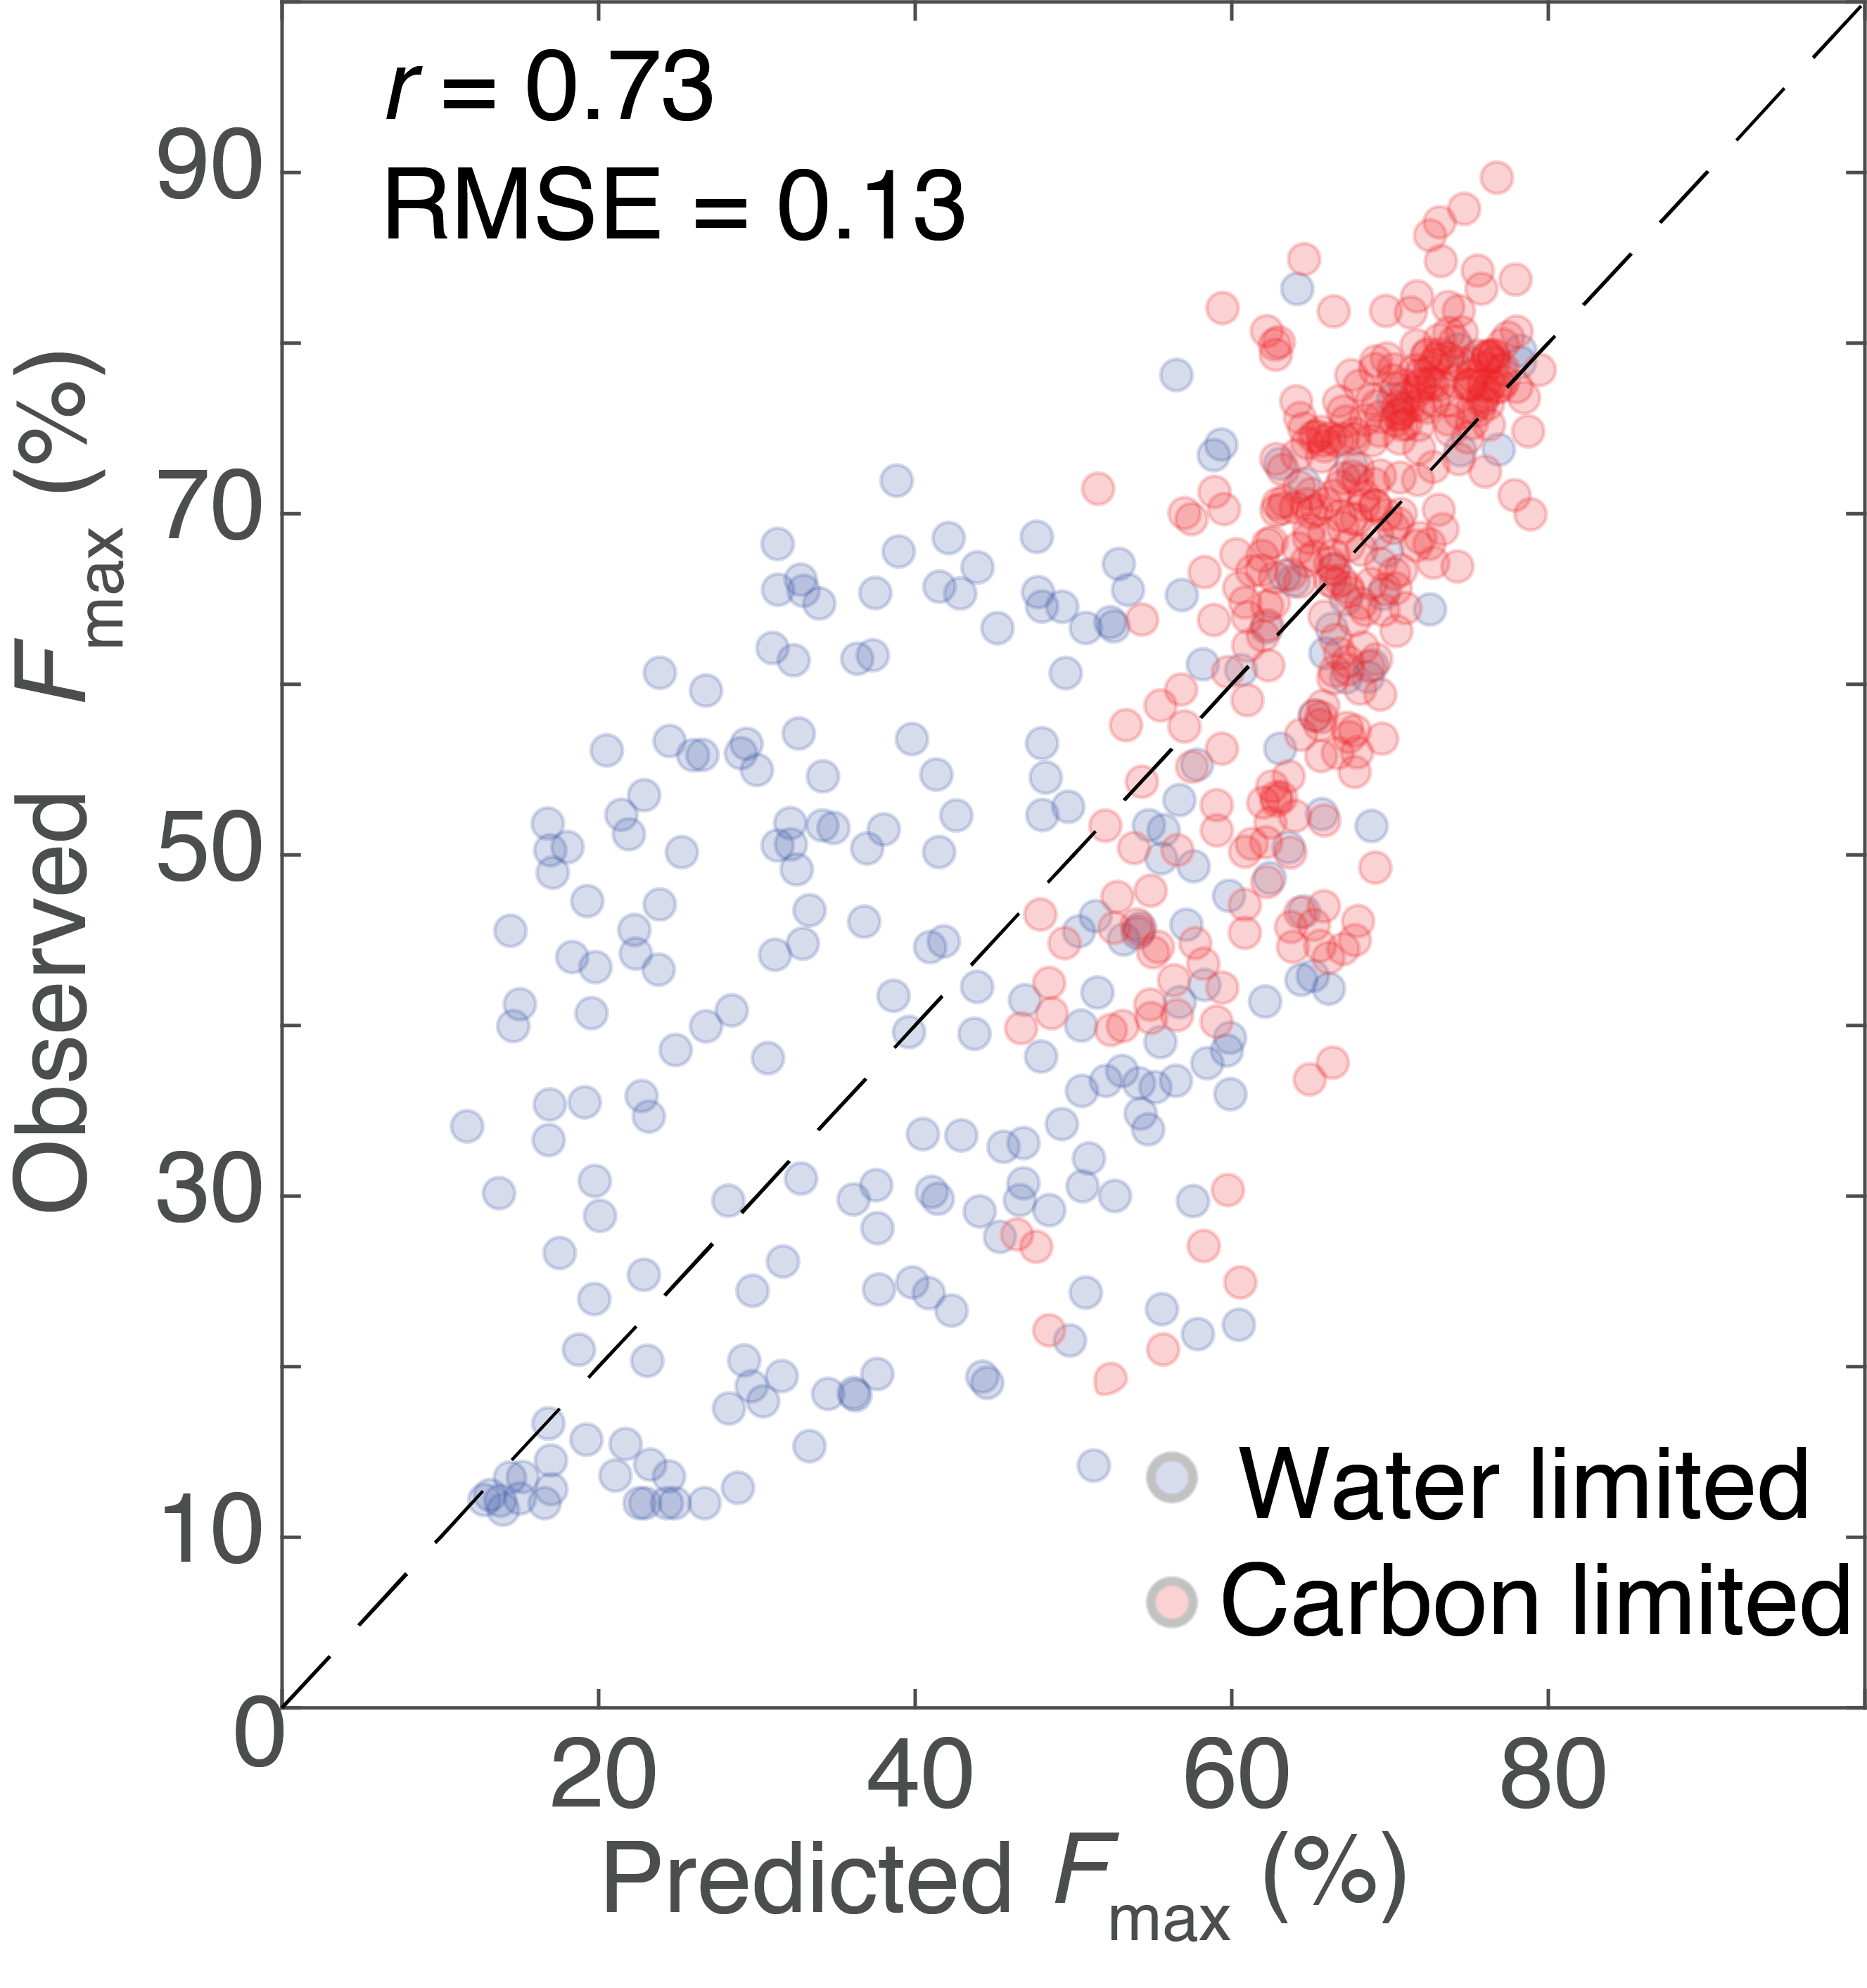
Supplementary Figure 8. Comparison of estimated peak vegetation cover against satellite observations within a single year. Predictions are from the theoretical model driven by environmental predictors and observations are from the GIMMS 3g fAPAR dataset in 1982. Blue grid cells are limited by water and orange grid cells are limited by energy. The black dashed line is the 1:1 line.

Supplementary Figure 9. Comparison of estimated peak vegetation cover against observed aboveground biomass at site level. a, Linear regression between estimated F_{max} and observed aboveground biomass data. Predictions are from the theoretical model driven by environmental predictors, while observations are from the field measurements on the Tibetan Plateau. The black solid line represents the fitted line. Grey colour represents 95% confidence intervals. b, The geographic distribution of the sample sites.

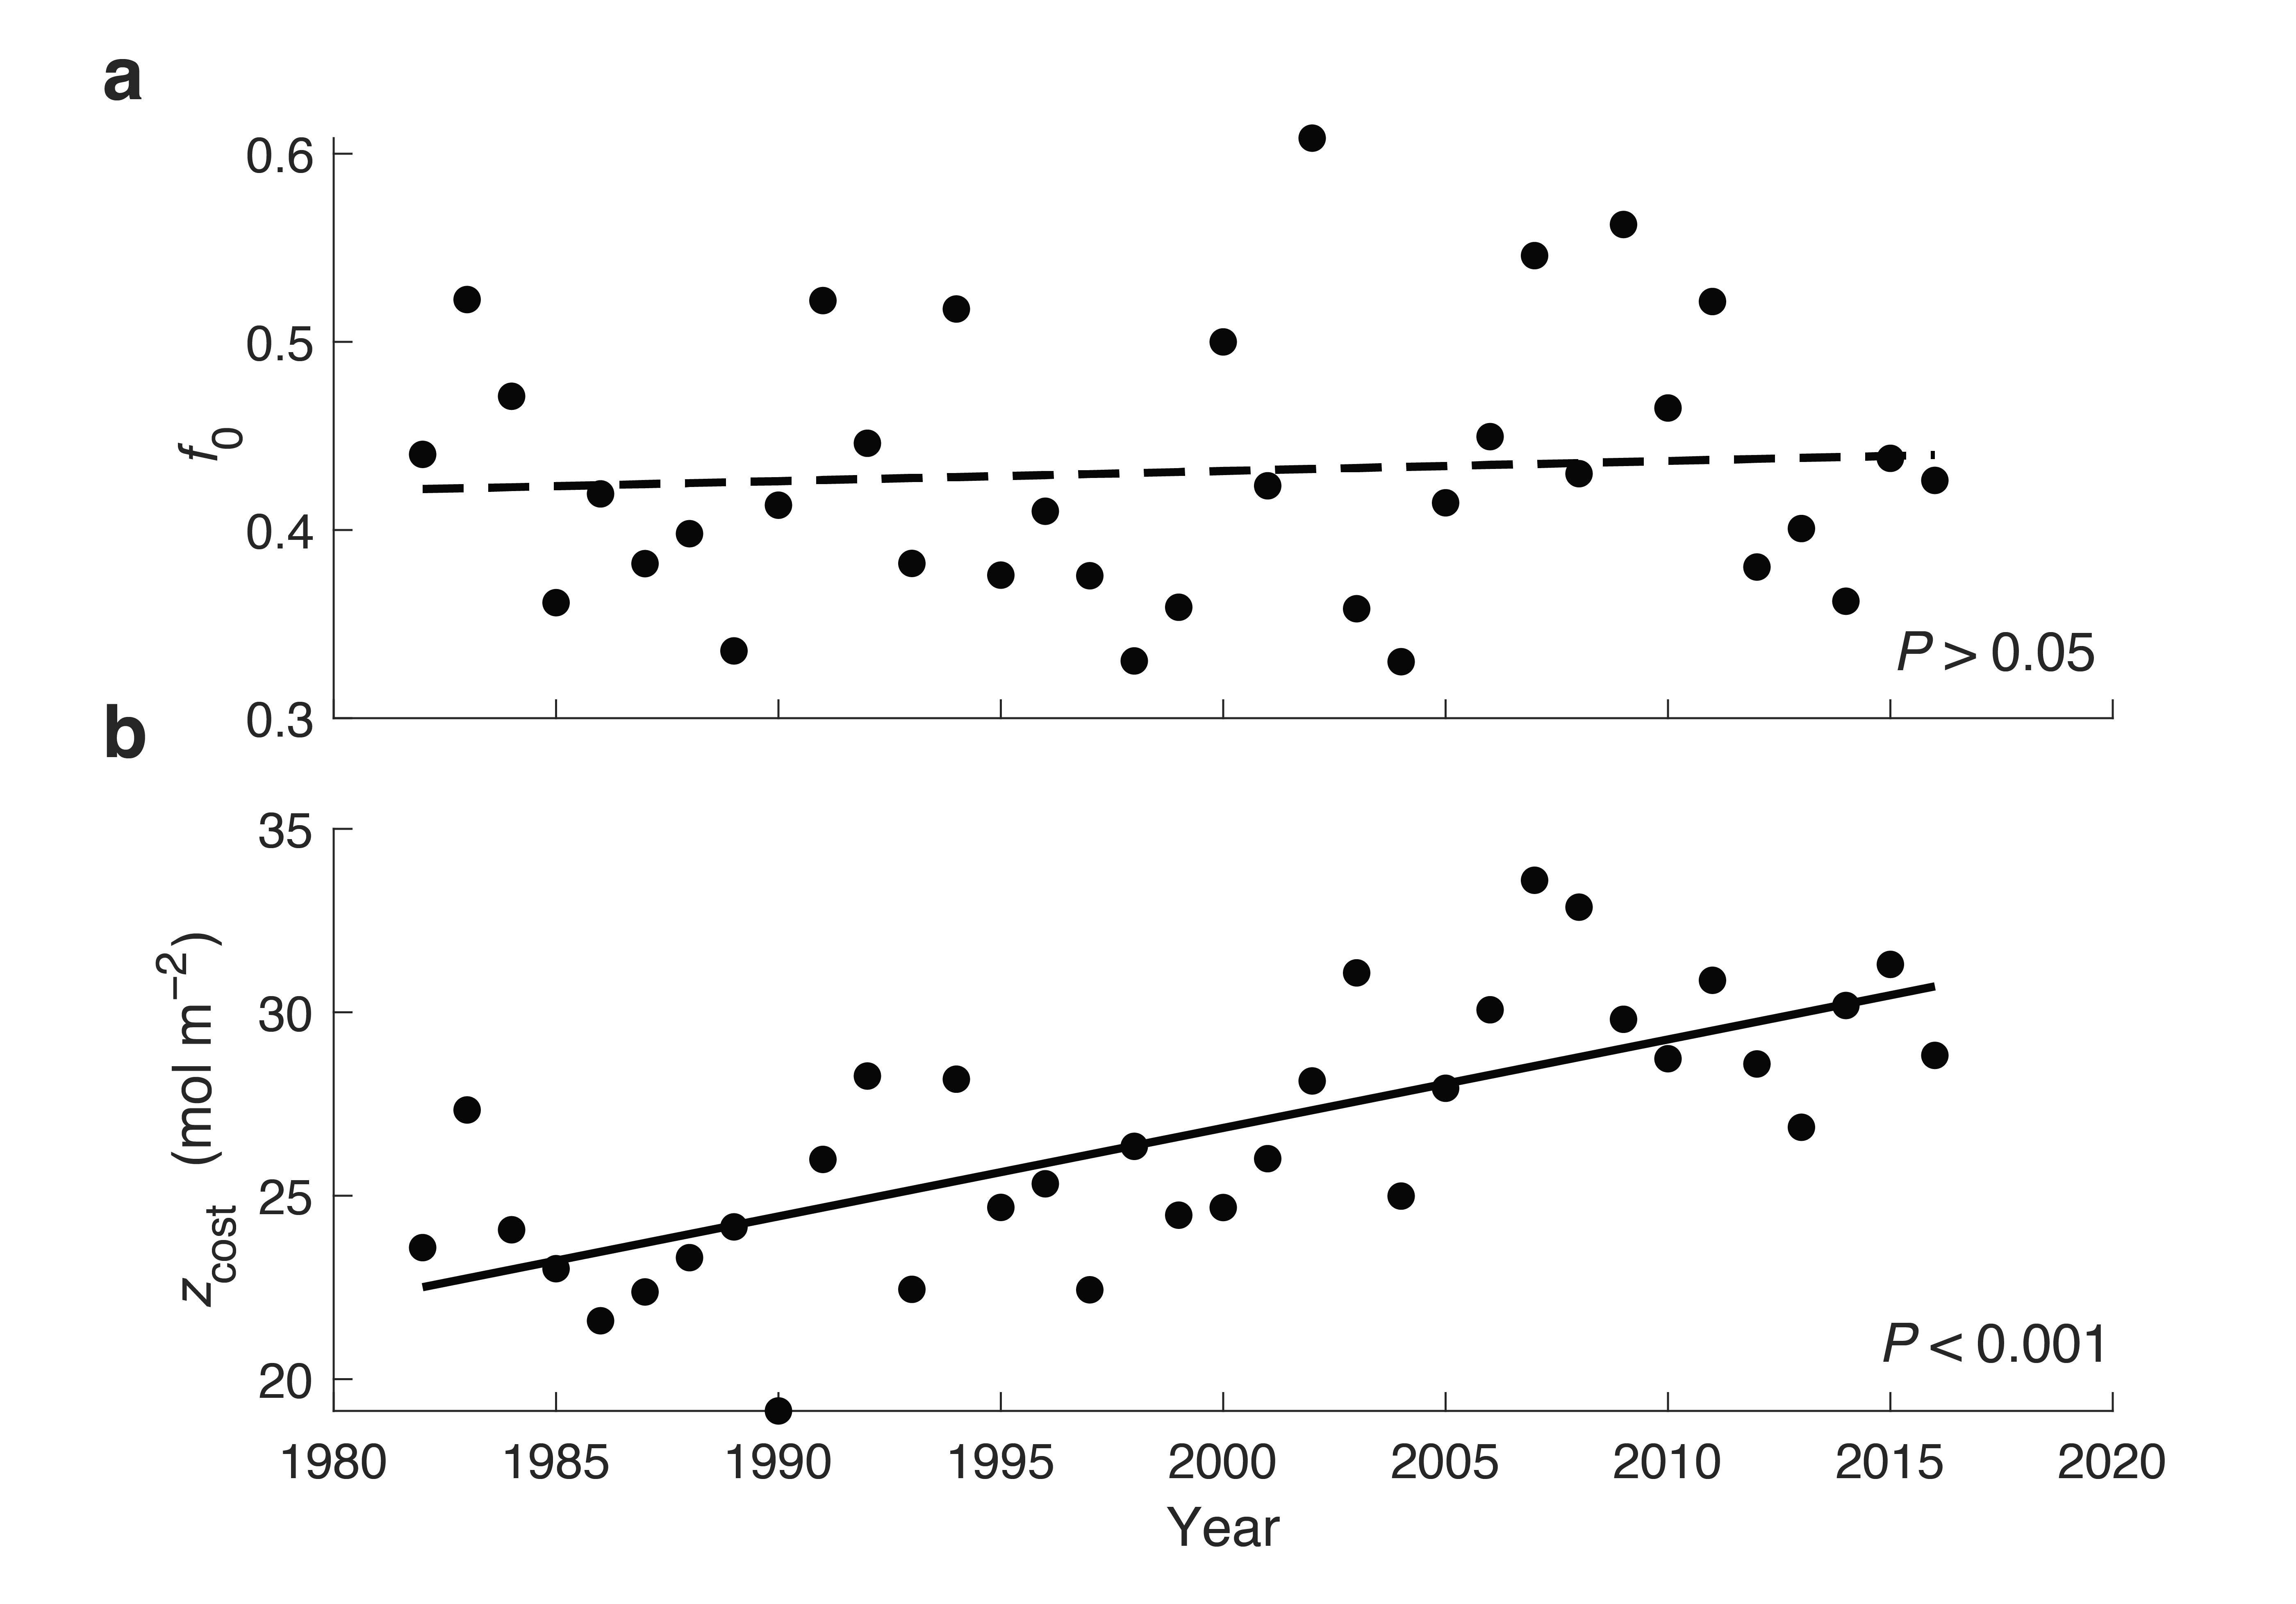
Supplementary Figure 10. Trends of fitted parameters. a, Trend of the ratio of transpiration and precipitation (f₀, dimensionless) over 1982–2016. b, Trend of cost of constructing and maintaining leaves (z_{cost}, mol C m⁻² yr⁻¹) over 1982–2016. Solid and dashed regression lines indicate statistically significant and non-significant trends at the 0.05 level, respectively.

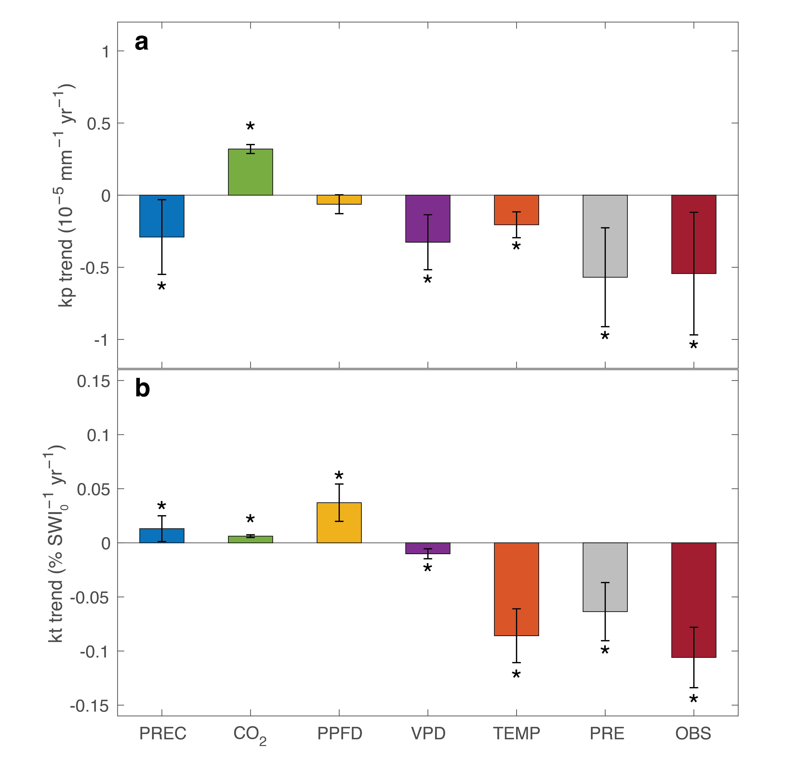
Supplementary Figure 11. Attribution of trends in precipitation and temperature sensitivity. a, b, Trends in precipitation sensitivity (kp, a) and temperature sensitivity (kt, b) for the period 1982–2016 derived from observation (OBS) and modelled trends driven by precipitation (PREC), rising CO₂ (CO₂), photosynthetic photon flux density (PPFD), vapour pressure deficit (VPD), temperature (TEMP) and all environmental factors (PRE) using the Mann-Kendall test. Error bars show the 95% confidence intervals of the regression. Statistically significant trends (P<0.05) are marked by one asterisk.

Supplementary Figure 12. Changes in areas of water and energy limited regions on the Tibetan Plateau. a, Comparison of the areas of water limited regions over the period of 1982-1998 and 1999-2016. b, Comparison of the areas of energy limited regions over the period of 1982-1998 and 1999-2016. Histograms (left y axes) show the distributions of the areas of different years and lines (right y axes) show the kernel density. The blue colour represents data of 1982-1998 while the orange colour represents data of 1999-2016. c, Average areas of water limited regions and energy limited regions over the different time periods, in which categories with significant differences are labelled with different letters (P<0.05). Error bars represent ±SE.

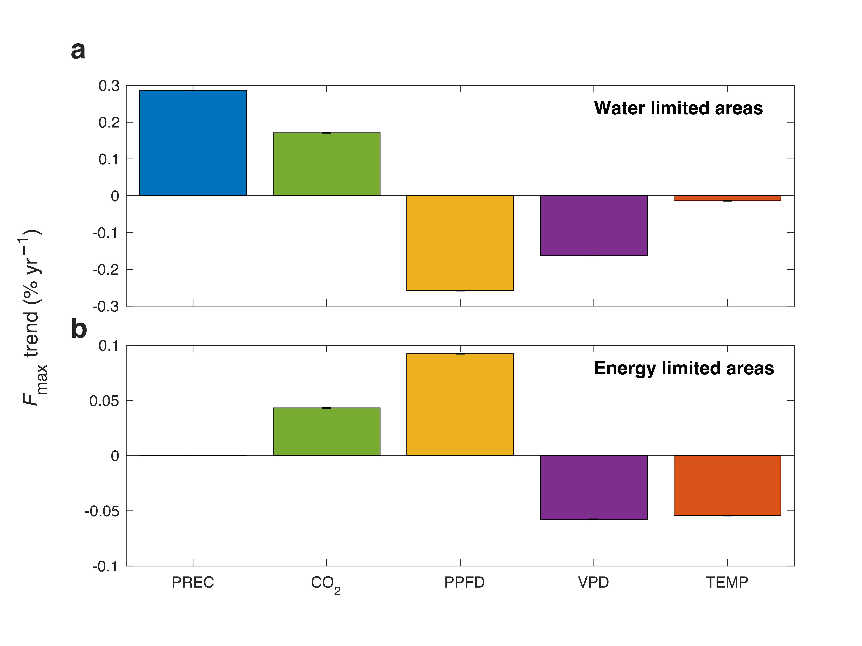
Supplementary Figure 13. Sensitivity of estimated peak vegetation cover to various factors. a, b, Modelled F_{max} trends driven by a 10% increase in precipitation (PREC), 10% increase in CO₂ (CO₂), 10% increase in photosynthetic photon flux density (PPFD), 10% increase in vapor pressure deficit (VPD) and 1 °C increase in temperature (TEMP) in water limited areas (a) and in energy limited areas (b).

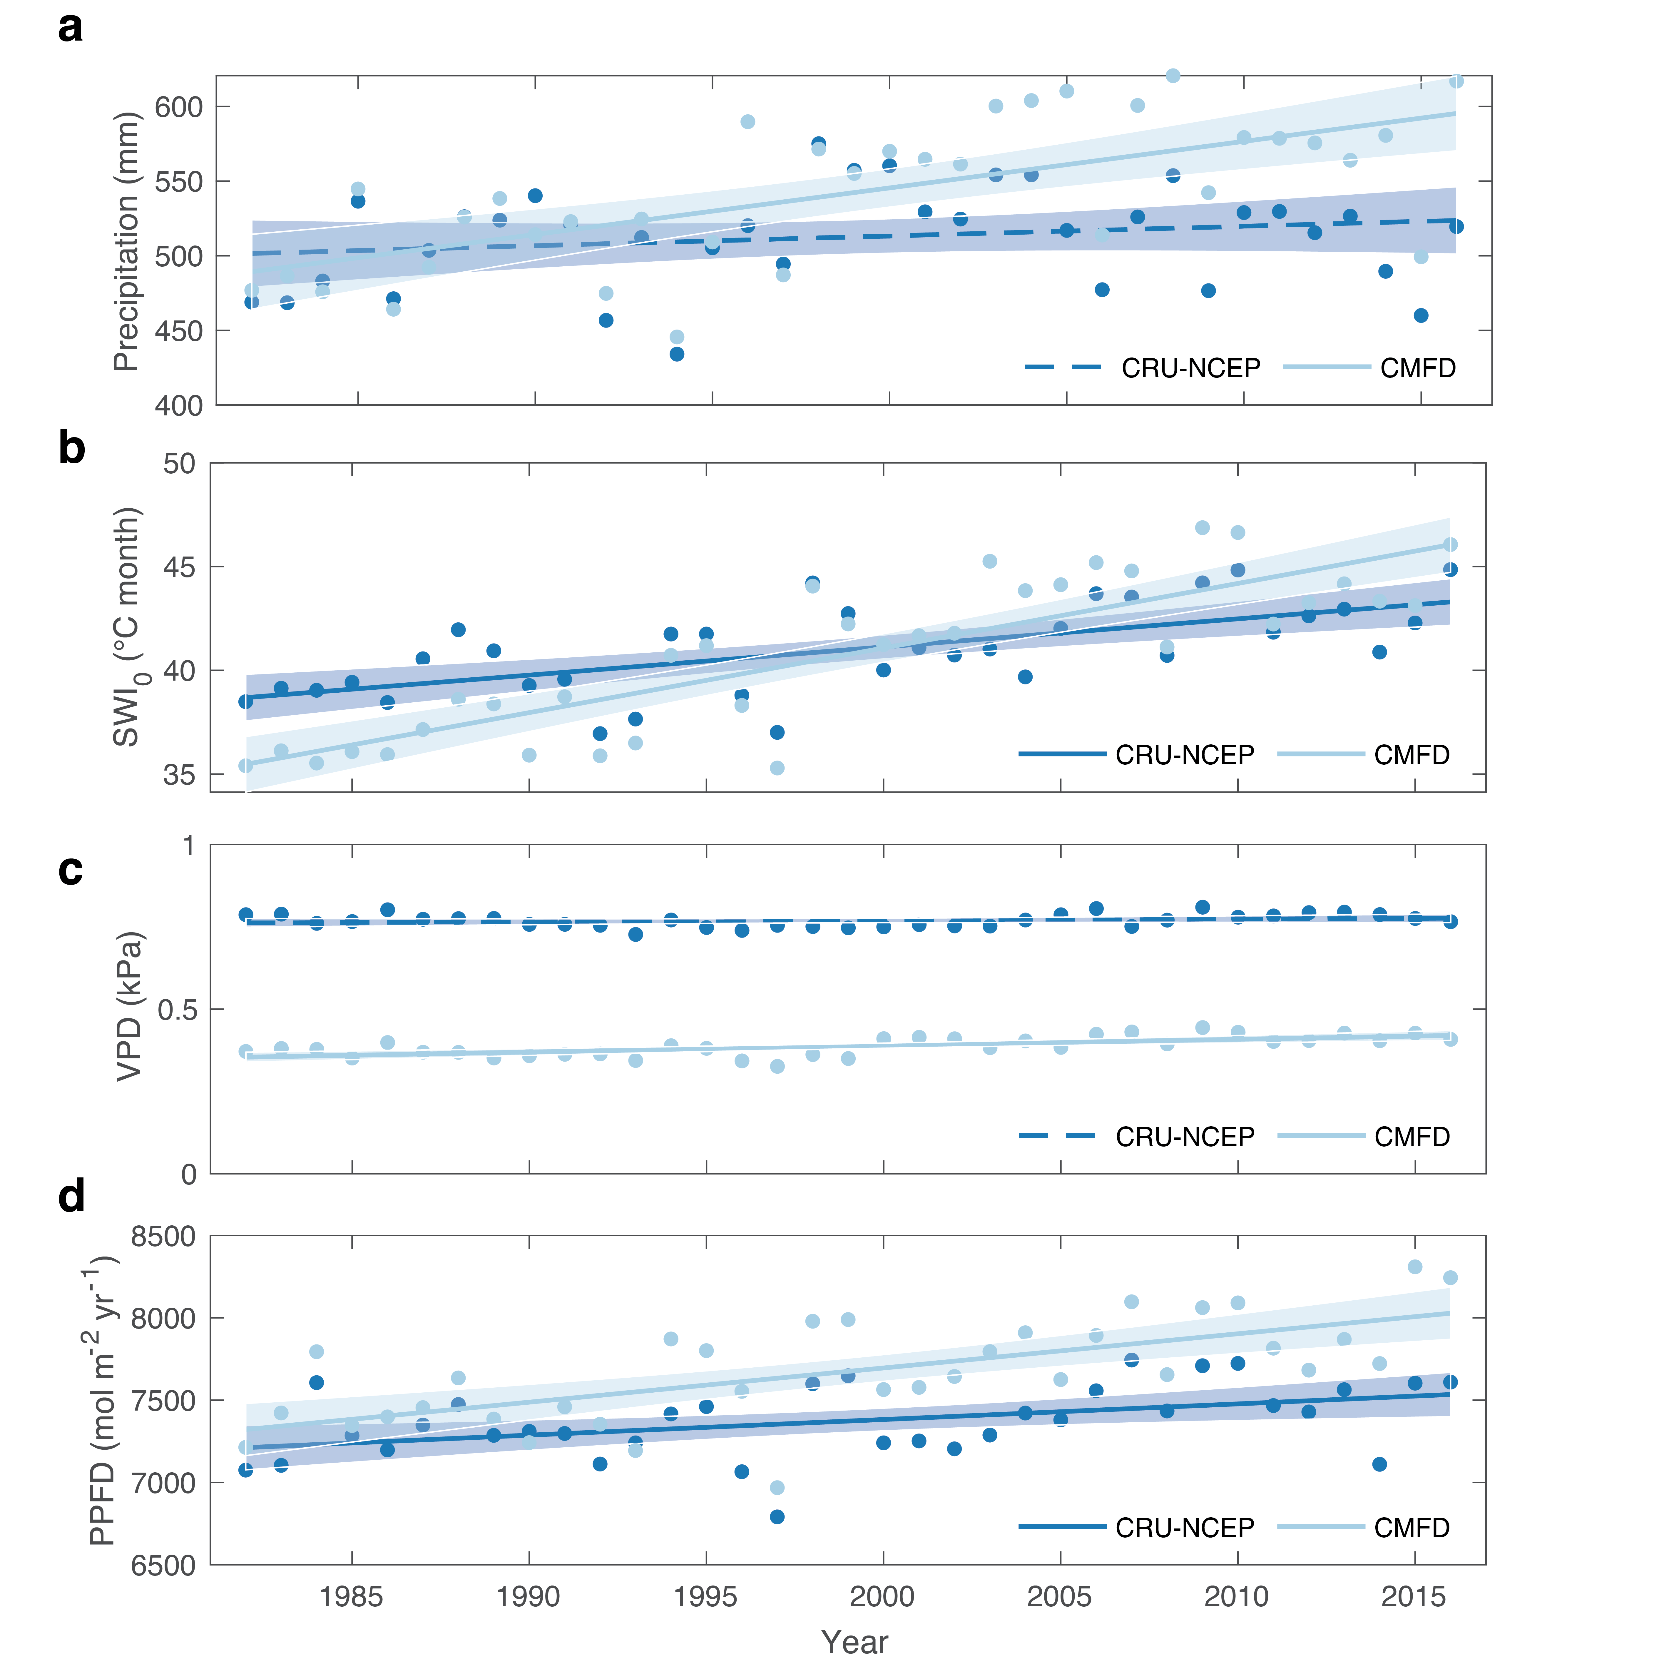
Supplementary Figure 14. Comparison of climate change on the Tibetan Plateau derived from CRU-NCEP and CMFD datasets. Panels (a-d) represent changes in annual total precipitation (Precipitation), summer warmth index (SWI₀), growing season mean vapour pressure deficit (VPD), and growing season cumulative photosynthetic photon flux density (PPFD) over 1982‒2016, derived from CRU-NCEP (inputs of TRENDY) and CMFD datasets (this study). Solid and dashed regression lines indicate statistically significant and non-significant trends at the 0.05 level, respectively.

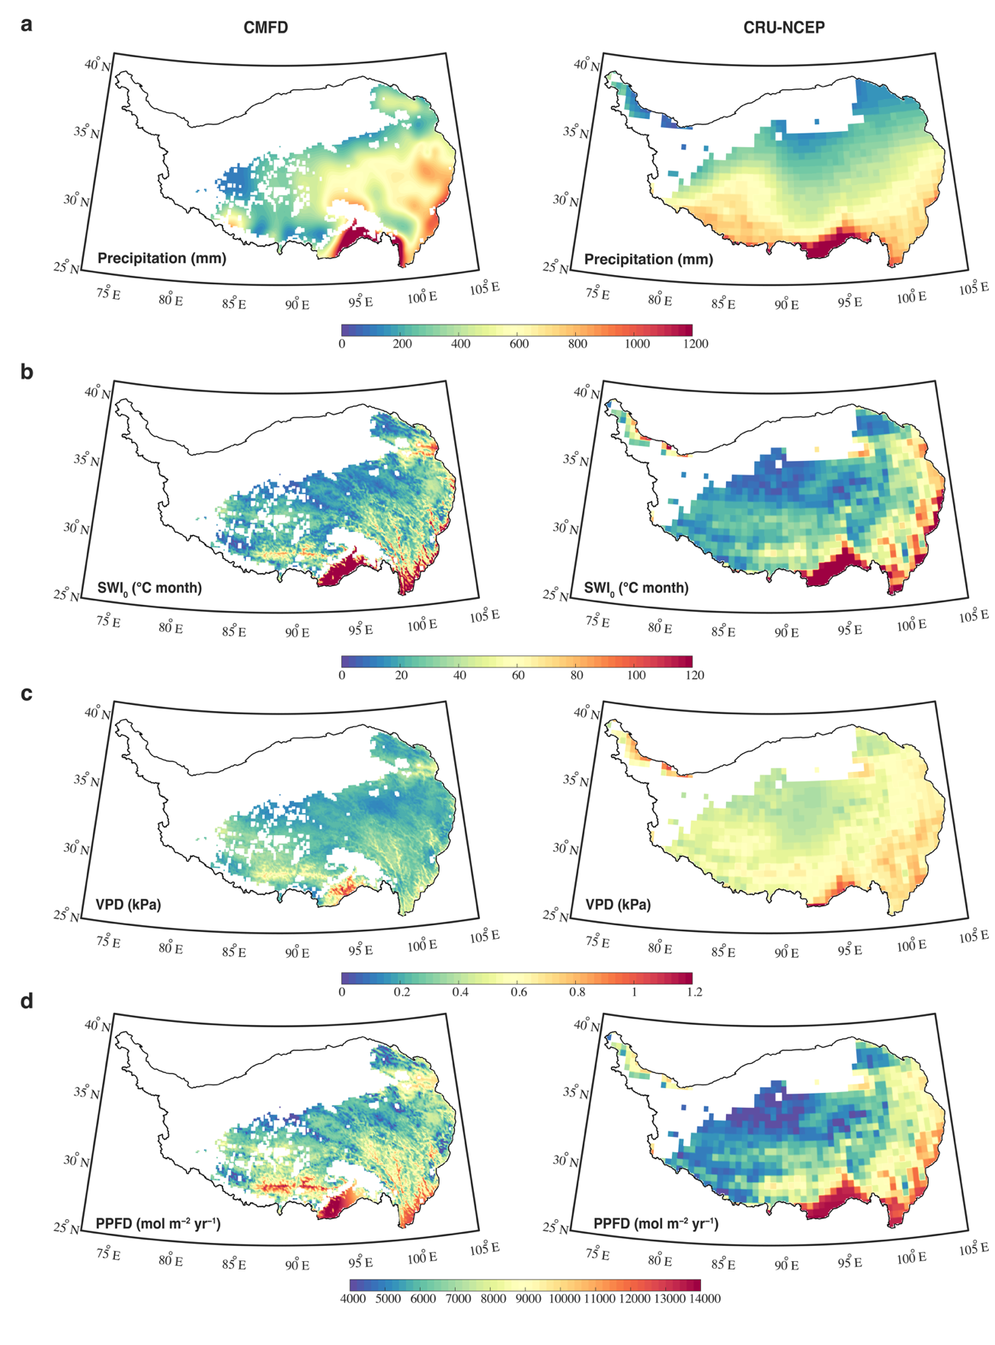
Supplementary Figure 15. Spatial distributions of climate on the Tibetan Plateau based on the CMFD and CRU-NCEP data sets. a-d, Spatial patterns of annual total precipitation (Precipitation, a), summer warmth index temperature (SWI₀, b), vapour pressure deficit (VPD, c) and growing season accumulated photosynthetic photon flux density (PPFD, d) in 1982, derived from CRU-NCEP (inputs of TRENDY) and CMFD datasets (this study).

