Supporting information for “Climate vulnerability scenario of the agricultural sector in the Bicol River Basin, Philippines”
Ricky P. Laureta^{1*}, Ric Ryan H. Regalado¹, Ermar B. De La Cruz²

¹Partido State University, Goa, Camarines Sur 4422, Philippines
²Planning, Monitoring and Evaluation Division, Department of Agriculture Regional Field Office 5,
Pili, Camarines Sur 4418, Philippines

*Correspondence:
Ricky P. Laureta: Partido State University College of Arts and Sciences, Goa, Camarines Sur 4422, Philippines, Email address: da5.bicolriverproject@parsu.edu.ph

Figures:
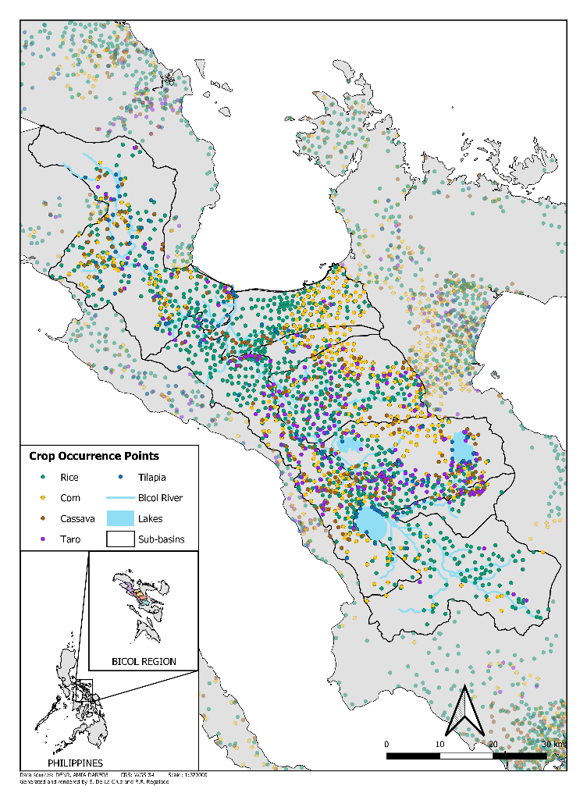

Figure S1. Species occurrence points of priority commodities that are principally cultivated within the Bicol River Basin. Each crop is given corresponding color for visualization. Crop occurrences outside the BRB border was also depicted to facilitate comparison of the vegetation cover within the area.

 |  | Typhoon | Flooding | Drought | Pestilence | Saltwater Intrusion
Major Livelihoods | Rice  cultivation
Major Livelihoods | High-value crops cultivation
Major Livelihoods | Livestock and poultry rearing
Major Livelihoods | Fishing and aquaculture
Major Livelihoods | Wage labor
 |  | 
 |  | Significant | Magnitude of Impact |  | No Impact

Figure S2. Vulnerability matrix representing stakeholders’ (N=330) perception towards vulnerability of the agriculture sector in terms of rural livelihoods versus the major hazards that is widely experienced in the Bicol River Basin area. Results are expressed across a color gradient that represents the perceived magnitude of impact from crimson (significant), light red (moderate), orange (minimal) to light yellow (no impact) following the Likert scale.

Tables:

Table S1. Summary of the descriptive information in relation to the components and indicators used for the vulnerability assessment including its data sources and geospatial resolutions.
Scale | Vulnerability component | Indicator | Description /  Sub-indicator | Data Sources | Resolution
Global | Sensitivity | Current climatic data | Current temperature and precipitation dating from 1950 to 2000 | WorldClim | 30 arc seconds  (~1km)
Global | Sensitivity | GCM projected climatic data | Long term projection of climate (2040–2069 representing 2050 decadal time period) | Global Circulation Model (GCM) | 30 arc seconds  (~1km)
Global | Natural Hazards | Tropical cyclone | Estimate of tropical cyclone frequency based on Saffir-Simpson Category 5 and higher from year 1990-2009 | ESCAP & UNISDR | 1km
National | Natural Hazards | Flood | Susceptibility of flood risk for Philippines from the past 10 years | AMIA Multi-hazard map  Mines and Geo-sciences Bureau | 1:10,000 scale vector
National | Natural Hazards | Drought | Groundwater potential from the past 10 years | AMIA Multi-hazard map  National Water Resources Board  National Color-Coded Guide Map | ~100 meters
National | Natural Hazards | Saltwater intrusion | Ground water potential from the past 10 years | AMIA Multi-hazard map  National Water Resources Board  National Color-Coded Guide Map | ~100 meters
National | Natural Hazards | Erosion | Soil erosion classified from low to high susceptibility | AMIA Multi-hazard map  Bureau of Soils and Water Management | 1:10,000 scale vector
National | Natural Hazards | Landslide | Landslide classified from low to high susceptibility | AMIA Multi-hazard map  Mines and Geo-sciences Bureau | 1:10,000 scale vector
National | Natural Hazards | Storm surge | Total water levels, changes in tidal levels, wave/surge height and direction | AMIA Multi-hazard map  Disaster Risk and Exposure Assessment for Mitigation (DREAM-DOST) | ~100 meters
National | Natural Hazards | Sea level rise | Assumption based on 5m sea level rise | AMIA Multi-hazard map | ~100 meters
Sub national | Adaptive Capacity | Economic capital | Cost of living, capacity to generate employment, cost of doing business, presence of business and professional organizations | Philippine Statistics Authority - Information Services Division (PSA)  National Competitiveness Council (NCC)  National Wages and Productivity Council (NWPC)  Bureau of Internal Revenue (BIR)  Philippine Chamber of Commerce and Industry (PCCI)  Regional Offices of the Department of Labor and Employment (DOLE) | Province shapefile
Sub national | Adaptive Capacity |  | Size and growth of the local economy, capacity to generate employment, cost of doing business, number of banks and financial institutions, productivity based on gross sales and number of employments, presence of business and professional organizations, access to agricultural insurance | Municipal/City Treasurer’s Office (M/CTO)  Business Permits and Licensing Office (BPLO)  Office of Building Official (OBO)  City or Municipal Engineer's Office  Municipal/City Agriculture Office (M/CAO)  Cooperative Development Authority (CDA)  Local financial institutions  Local utility service providers  Other accredited business organizations | District shapefile
Sub national | Adaptive Capacity | Health capital | Capacity of health services (public & private), presence of health infrastructures or facilities | Department of Health (DOH)  Philippine Medical Association (PMA) | Province shapefile
Sub national | Adaptive Capacity |  | Number of health manpower, presence of health infrastructures or facilities, access to water and sanitation, nutrition sufficiency | LGU Health Office  City or Municipal Engineer's Office | District shapefile
Sub national | Adaptive Capacity | Human capital | Population, number of households, literacy rate, educational infrastructures, school enrolment, student-to-teacher ratio | Philippine Statistics Authority (PSA)  National Competitiveness Council (NCC)  Department of Education (DepEd) Division and Regional Offices  Commission on Higher Education (CHED) Regional Office | Province shapefile
Sub national | Adaptive Capacity | Institutional capital | Civil society organization programs, government response to calamities, presence of agricultural workers, conduct of climate resiliency field schools | National Competitiveness Council (NCC)  Municipal/City Agriculture Office (M/CAO)  Municipal/City DRRM Council (M/CDRRMC) | District shapefile
Sub national | Adaptive Capacity | Natural capital | Forest cover, access to irrigation systems and facilities, groundwater availability, presence of Marine Protected Area (MPA) | National Irrigation Authority (NIA)  Department of Environment and Natural Resources (DENR) | Province shapefile
Sub national | Adaptive Capacity | Social capital | Social protection | Department of Social Welfare and Development (DSWD) | Province shapefile
Sub national | Adaptive Capacity |  | Existence of farmer unions, membership in cooperatives, inclusion of ethnic minorities, presence of employed and elected local government unit staff and officials | Municipal/City Planning and Development Office (M/CPDO)  Municipal/City Agriculture Office (M/CAO)  Cooperative Development Authority (CDA) | District shapefile
Sub national | Adaptive Capacity | Physical capital | Area vulnerable to hazards | Mines and Geo-sciences Bureau (MGB-DOST) | Province shapefile
Sub national | Adaptive Capacity |  | Infrastructure investment, access to services (% of households with access to electricity services, % of households with access to water services), number of public transports | National Competitiveness Council - Regional Competitiveness Committee (NCC-RCC) | Province shapefile
Sub national | Adaptive Capacity |  | Land area, farm size, land tenure, value of livestock, poultry and aquaculture, number of farmers and fisherfolks, access to seeds, farm equipment, fertilizers and biologics, number of local farm machineries/facilities, access to post-harvest infrastructure and machineries, access to market outlets and facilities, access to fishing equipment | Municipal/City Agriculture Office (M/CAO)  City or Municipal Engineer's Office | District shapefile
Sub national | Adaptive Capacity | Anticipatory capital | Presence of functional MDRRMC, early warning systems, radio/TV stations, and telecommunications, access to communication technologies, presence of trainings or seminars related to DRRM, presence of Barangay Disaster Risk Reduction and Management Council (BDRRMC) | Barangay LGU  Municipal/City DRRM Council (M/CDRRMC) | District shapefile

Table S2. Global Circulation Models (GCMs) used in the study to assess future (year 2050) climate suitability.
Model | Modeling Center | Institution
bcc_csm1_1 | BCC | Beijing Climate Center, China Meteorological Administration
bcc_csm1_1_m | BCC | Beijing Climate Center, China Meteorological Administration
bnu_esm | GCESS | College of Global Change and Earth System Science, Beijing Normal University
cccma_canesm2 | CCCMA | Canadian Centre for Climate Modelling and Analysis
cesm1_bgc | NSF-DOE-NCAR | National Science Foundation, Department of Energy, National Center for Atmospheric Research
cesm1_cam5 | NCAR | National Center for Atmospheric Research
cnrm_cm5 | CNRM-CERFACS | Centre National de Recherches Météorologiques / Centre Européen de Recherche et de Formation Avancée en Calcul Scientifique
csiro_access1_0 | CSIRO-BOM | CSIRO (Commonwealth Scientific and Industrial Research Organisation, Australia), and BOM (Bureau of Meteorology, Australia)
csiro_access1_3 | CSIRO-BOM | CSIRO (Commonwealth Scientific and Industrial Research Organisation, Australia), and BOM (Bureau of Meteorology, Australia)
csiro_mk3_6_0 | CSIRO-QCCCE | Commonwealth Scientific and Industrial Research Organization in Collaboration with the Queensland Climate Change Centre of Excellence
ec_earth | EC-EARTH | EC-EARTH Consortium
fio_esm | FIO | The First Institute of Oceanography, SOA, China
gfdl_cm3 | NOAA GFDL | Geophysical Fluid Dynamics Laboratory
gfdl_esm2g | NOAA GFDL | Geophysical Fluid Dynamics Laboratory
gfdl_esm2m | NOAA GFDL | Geophysical Fluid Dynamics Laboratory
giss_e2_h | NASA GISS | NASA Goddard Institute for Space Studies
giss_e2_r | NASA GISS | NASA Goddard Institute for Space Studies
inm_cm4 | INM | Institute for Numerical Mathematics
ipsl_cm5a_lr | IPSL | Institut Pierre-Simon Laplace
ipsl_cm5a_mr | IPSL | Institut Pierre-Simon Laplace
ipsl_cm5b_lr | IPSL | Institut Pierre-Simon Laplace
lasg_fgoals_g2 | LASG-CESS | LASG, Institute of Atmospheric Physics, Chinese Academy of Sciences; and CESS, Tsinghua University
miroc_esm | MIROC | Japan Agency for Marine-Earth Science and Technology, Atmosphere and Ocean  Research Institute (The University of Tokyo), and National Institute for Environmental  Studies
miroc_esm_chem | MIROC | Japan Agency for Marine-Earth Science and Technology, Atmosphere and Ocean  Research Institute (The University of Tokyo), and National Institute for Environmental  Studies
miroc_miroc5 | MIROC | Atmosphere and Ocean Research Institute (The University of Tokyo), National  Institute for Environmental Studies, and Japan Agency for Marine-Earth Science and Technology
mohc_hadgem2_cc | MOHC (additional realizations by INPE) | Met Office Hadley Centre (additional HadGEM2-ES realizations contributed by Instituto Nacional de Pesquisas Espaciais)
mohc_hadgem2_es | MOHC (additional realizations by INPE) | Met Office Hadley Centre (additional HadGEM2-ES realizations contributed by Instituto Nacional de Pesquisas Espaciais)
mpi_esm_lr | MPI-M | Max Planck Institute for Meteorology (MPI-M)
mpi_esm_mr | MPI-M | Max Planck Institute for Meteorology (MPI-M)
mri_cgcm3 | MRI | Meteorological Research Institute
ncar_ccsm4 | NCAR | National Center for Atmospheric Research
ncc_noresm1_m | NCC | Norwegian Climate Centre
nimr_hadgem2_ao | NIMR/KMA | National Institute of Meteorological Research / Korea Meteorological Administration

Table S3. Bioclimatic variables used in crop distribution modeling for the current/baseline conditions.
Parameters | Description (O’Donnell and Ignizio, 2012)
Temperature Related
Bio_1 - Annual mean temperature | Annual mean temperature derived from the average monthly temperature.
Bio_2 - Mean diurnal range | The mean of the monthly temperature ranges (monthly maximum minus monthly minimum).
Bio_3 - Isothermality | Oscillation in day-to-night temperatures.
Bio_4 - Temperature seasonality | The amount of temperature variation over a given year based on standard deviation of monthly temperature averages.
Bio_5 - Maximum temperature of warmest month | The maximum monthly temperature occurrence over a given year (time-series) or averaged span of years (normal).
Bio_6 - Minimum temperature of coldest month | The minimum monthly temperature occurrence over a given year (time-series) or averaged span of years (normal).
Bio_7 - Temperature annual range | A measure of temperature variation over a given period.
Bio_8 - Mean temperature of wettest quarter | This quarterly index approximates mean temperatures that prevail during the wettest season.
Bio_9 - Mean temperature of driest quarter | This quarterly index approximates mean temperatures that prevail during the driest quarter.
Bio_10 - Mean temperature of warmest quarter | This quarterly index approximates mean temperatures that prevail during the warmest quarter.
Bio_11 - Mean temperature of coldest quarter | This quarterly index approximates mean temperatures that prevail during the coldest quarter.
Precipitation Related
Bio_12 - Annual precipitation | This is the sum of all total monthly precipitation values.
Bio_13 - Precipitation of wettest month | This index identifies the total precipitation that prevails during the wettest month.
Bio_14 - Precipitation of driest month | This index identifies the total precipitation that prevails during the driest month.
Bio_15 - Precipitation seasonality | This is a measure of the variation in monthly precipitation totals over the course of the year. This index is the ratio of the standard deviation of the monthly total precipitation to the mean monthly total precipitation and is expressed as percentage.
Bio_16 - Precipitation of wettest quarter | This quarterly index approximates total precipitation that prevails during the wettest quarter.
Bio_17 - Precipitation of driest quarter | This quarterly index approximates total precipitation that prevails during the driest quarter.
Bio_18 - Precipitation of warmest quarter | This quarterly index approximates total precipitation that prevails during the warmest quarter.
Bio_19 - Precipitation of coldest quarter | This quarterly index approximates total precipitation that prevails during the coldest quarter.
Bio_20 - Number of consecutive dry days | Consistent number considered as dry days.

Table S4. Hazard weights per Philippine island groups based from consultations with experts.
Hazards | Luzon (%), (Benguet) | Visayas (%) | Mindanao (%)
Typhoon | 20.00, (19.20) | 18.21 | 16.95
Flood | 19.05, (16.81) | 16.40 | 15.25
Drought | 14.25, (12.80) | 16.17 | 16.95
Erosion | 11.43, (12.80) | 12.57 | 12.71
Landslide | 8.57, (13.24) | 10.72 | 14.41
Storm Surge | 9.52, (4.41) | 10.39 | 8.47
Sea Level Rise | 5.71, (4.41) | 8.33 | 5.08
Saltwater Intrusion | 11.43, (4.41) | 7.21 | 10.17
Frost | (11.92) | - | -

