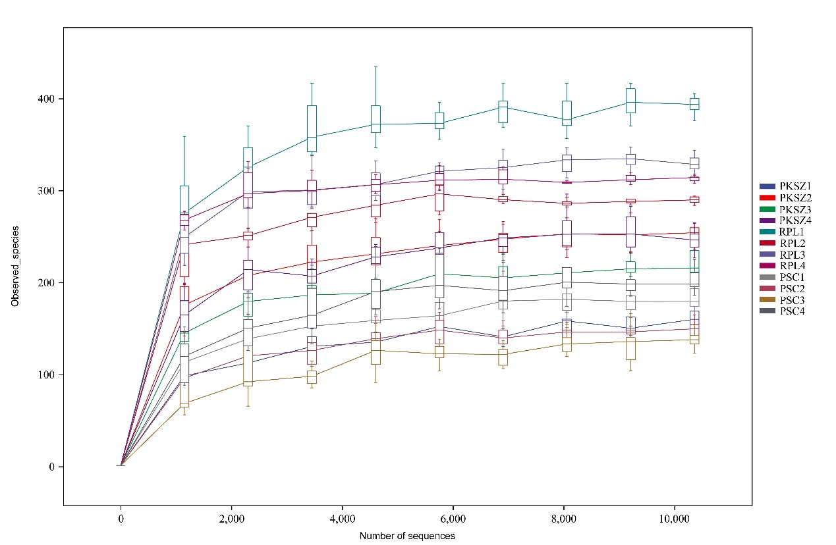
Figure S1 rarefaction curves. PKSZ: Pinus koraiensis Sieb. et Zucc., RPL: Robinia pseudoacacia L., PSC: Populus simonii Carr.

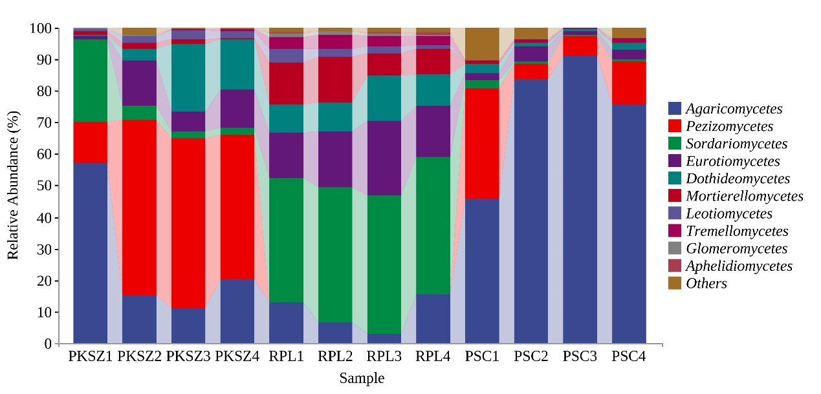
A
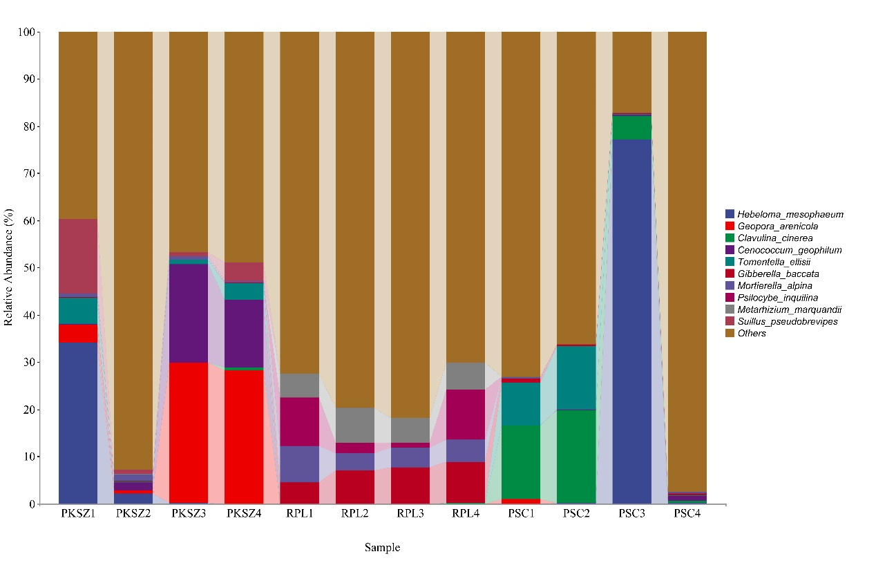
B
Figure S2The relative abundance of ectomycorrhizal fungi at the class (A) and species (B) levels. PKSZ: Pinus koraiensis Sieb. et Zucc., RPL: Robinia pseudoacacia L., PSC: Populus simonii Carr.

