V1/V2
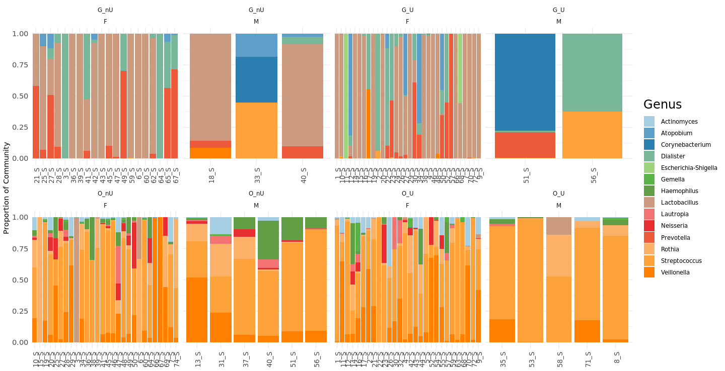

V3/V4
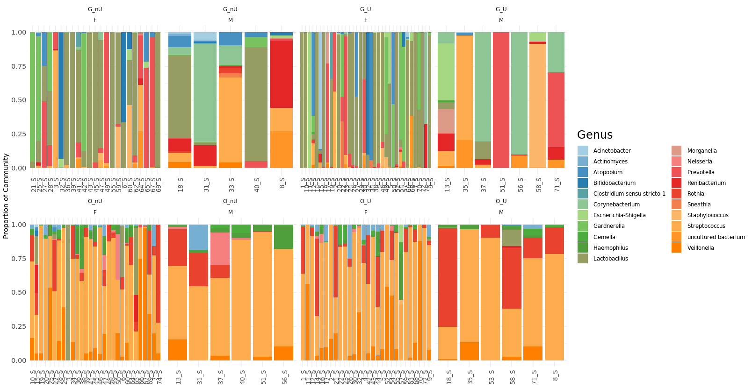
Figure S1: gender and bacteria relevant abundance in oral and genital area of BD patients.

