Supplementary Information

Co-integration of single transistor neurons and synapses by nanoscale CMOS fabrication for highly scalable neuromorphic hardware

Joon-Kyu Han,¹ Jungyeop Oh,¹ Gyeong-Jun Yun,¹ Dongeun Yoo,² Myung-Su Kim,¹ Ji-Man Yu,¹ Sung-Yool Choi¹ and Yang-Kyu Choi¹*

¹ School of Electrical Engineering, Korea Advanced Institute of Science and Technology (KAIST), 291 Daehak-ro, Yuseong-gu, Daejeon 34141, Republic of Korea
² National Nanofab Center (NNFC), 291 Daehak-ro, Yuseong-gu, Daejeon 34141, Republic of Korea

*Authors to whom correspondence should be addressed.
Email address: ykchoi@ee.kaist.ac.kr
1. Fabrication procedure for co-integration of single transistor neuron and synapse
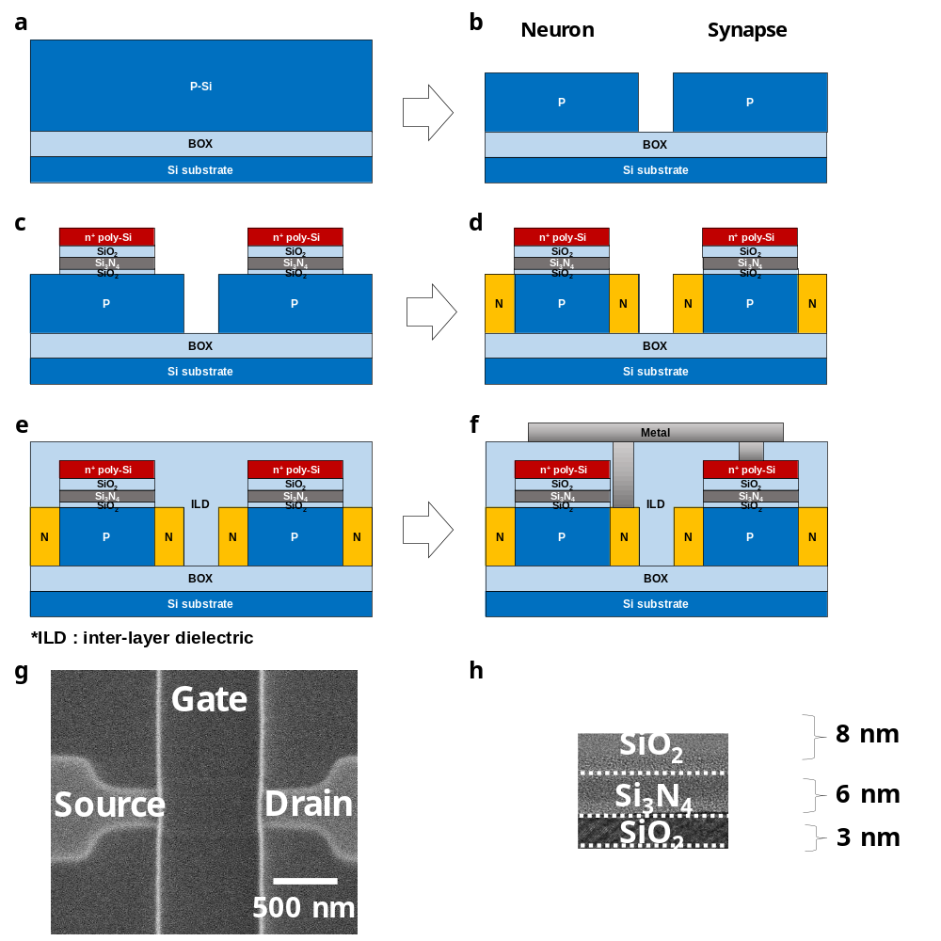
Fig. S1| Fabrication procedure for co-integration of single transistor neuron and synapse. a-f, Schematics of the fabrication procedure for the co-integration of single transistor neuron and synapse. g, SEM image and h, TEM image of the fabricated neuron-synapse device. Gate dielectrics are composed of SiO₂/Si₃N₄/SiO₂.

A p-type (100) SOI wafer (8 inch) with a buried-oxide thickness of 140 nm was used as a starting substrate (Fig. S1a). First, the silicon was thinned to a thickness of 50 nm by sacrificial oxidation and removal. After active area patterning (Fig. S1b), p-type body doping was performed with boron implantation for the n-channel MOSFETs (NMOSFETs) including neuron-synapse. Next, n-type counter body doping was carried out with arsenic for the p-channel MOSFETs (PMOSFETs). It is necessary to fabricate the current mirror and inverter. Afterwards, rapid thermal annealing (RTA) for dopant activation at 1000 °C for 5 sec was performed. Gate dielectrics composed of tunneling SiO₂ (3 nm), charge trapping Si₃N₄ (6 nm), blocking SiO₂ (8 nm), and gate electrode composed of in-situ doped n⁺ poly-Si (100 nm) were then sequentially stacked. The tunneling oxide was thermally grown, and silicon nitride and blocking oxide were deposited by low pressure chemical vapor deposition (LPCVD). After the gate patterning (Fig. S1c), n⁺ S/D implantation was carried out with arsenic for the NMOSFETs including neuron-synapse, and p⁺ S/D implantation was carried out with boron for the PMOSFETs (Fig. S1d). Afterwards, another RTA at 1000 °C for 3 sec was conducted. As a result, the single transistor neuron and synapse, the current mirror, and the inverter were fabricated on the same plane by the same process. Tetraethyl orthosilicate (TEOS) of 300 nm was then deposited for the inter-layer dielectric (ILD) (Fig. S1e). After the contact etch, metallization for connecting the neuron and the synapse was performed with Ti/TiN/Al (10 nm/20 nm/500 nm) (Fig. S1f). Fig. S1g shows a scanning electron microscope (SEM) image of the fabricated neuron-synapse device before the ILD deposition, and Fig. S1h shows a transmission electron microscope (TEM) image of the gate stack in the fabricated neuron-synapse device.

2. Transient energy band diagram of single transistor neuron during LIF operation
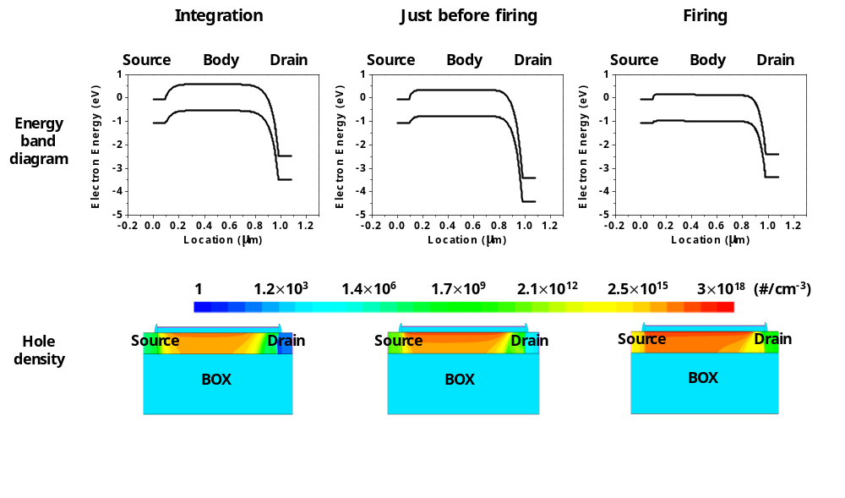
Fig. S2| Transient energy band diagram of single transistor neuron during LIF operation. The potential barrier between the n⁺ source and the p-type body was reduced at the moment of neuronal firing.

In order to confirm the energy band diagram during LIF operation, device simulations were performed with the aid of Synopsys Sentaurus TCAD P-2019.03-SP1. To describe the spiking characteristics of the single transistor neuron, the drift-diffusion transportation model with the Philips unified mobility model including interfacial mobility degradation and high-field velocity saturation was adopted. The Shockley-Read-Hall recombination model with doping concentration dependency, the Auger recombination model, the van Overstraeten – de Man avalanche generation model, and the Hurkx band-to-band tunneling model were also included.^{S1} A transient simulation, which reflects the transient neuron state, was performed to observe the output voltage (V_{out}) while applying constant current (I_{in}). The transient energy band diagram and the hole density of the channel (p-type body) were captured (1) at the moment of the integration, (2) just before firing, and (3) during the firing. As a result, the built-in potential barrier between the n⁺ source and the p-type body that existed during the integration was reduced by the accumulated holes generated by impact ionization. In addition, the built-in potential barrier was flattened at the moment of firing. This allows the integrated charges to escape toward the source.

3. Leaky characteristic of single transistor neuron
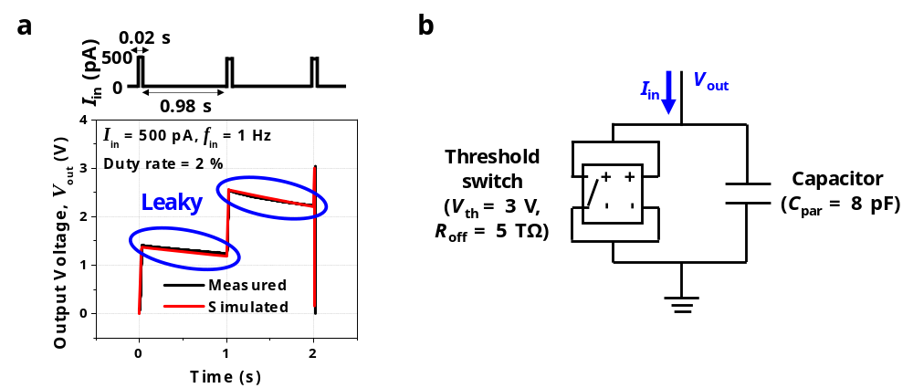 Fig. S3| Measured leaky characteristic of single transistor neuron and its modeling. a, Current pulse measurement results to confirm the leaky characteristic of the single transistor neuron. b, Equivalent circuit composed of the threshold switch and the parasitic capacitor was modeled to mimic the spiking characteristics of the single transistor neuron. The similar spiking characteristics were achieved by the SPICE simulation.

A leaky characteristic by diffusion of ions through a membrane is important in a biological neuron. This is because if there is no leaky characteristic, the previous signal below threshold will retain the voltage until another upcoming input induces firing even after a long time. This is known as a memory problem.^{S2,S3} We performed current pulse measurements to confirm the leaky integrate-and-fire (LIF) characteristic of the fabricated single transistor neuron. An AC current source was utilized, and the V_{out} was measured using the voltage measurement unit (VMU) of a B1500 parameter analyzer. A square pulse of 1 Hz frequency with a peak of 500 pA and a duty rate of 2 % was applied to the drain electrode and the V_{out} was measured at the same drain electrode. As shown in Fig. S3a, it was confirmed that the V_{out} was decreased when no input current was applied. This represents the leaky property. Based on the measured data, the LIF behavior of the single transistor neuron was modeled with a SPICE simulation using a threshold switch (left) and a parasitic capacitor (right), as shown in Fig. S3b. Note that nodes for voltage sensing and nodes for switching are equal in a voltage controlled threshold switch. The parasitic capacitance (C_{par}), firing threshold voltage (V_{T,firing}), and resistance at HRS (R_{off}) were set as 8 pF, 3 V, and 5 TΩ, respectively. As a consequence, there was good agreement between the simulated and the measured spiking characteristic (Fig. S3a).

4. Multi-firing threshold property of single transistor neuron
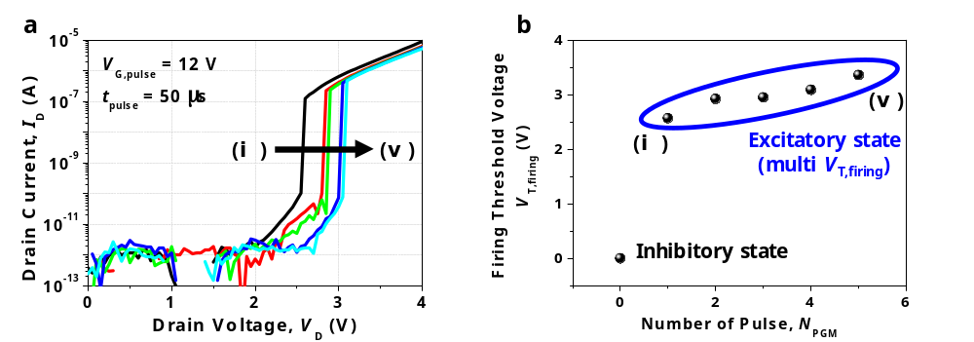 Fig. S4| Multi-firing threshold property of single transistor neuron. a, Output characteristics (I_{D}-V_{D}) depending on the number of applied program pulse (N_{PGM}). As the N_{PGM} is increased in the order of (i) < (ii) < … < (v), more electrons are trapped in the Si₃N₄. The latch-up voltage (V_{latch}) is increased as the trapped charge density in the Si₃N₄ is increased. b, The firing threshold voltage (V_{T,firing}) depending on the N_{PGM}. V_{T,firing} is increased as the trapped charge density in the Si₃N₄ is increased.

V_{T,firing} is tunable by controlling the trapped charge density in the nitride. As shown in Fig. S4a, the latch-up voltage (V_{latch}) was increased by the applied program pulse. This is because the number of carriers supplied from the source to the body was reduced owing to the lowered body potential (i.e., the increased built-in potential at the n⁺ source and the p-type body) by the trapped electrons. As a result, V_{T,firing} of the spiking was increased, as shown in Fig. S4b. This multi-firing threshold property can be a great benefit for a reliable neural network, and this will be discussed in Supplementary Information 13.

5. Gate length dependency of single transistor neuron
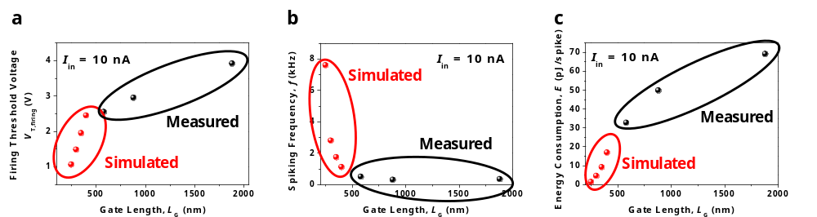 Fig. S5| Neuron characteristics depending on the gate length (L_{G}) of a single transistor neuron obtained from measurements and TCAD device simulations. a, Firing threshold voltage (V_{T,firing}), b, spiking frequency (f), and c, energy consumption per spike (E/spike) depending on the L_{G} of a single transistor neuron. By reducing L_{G}, both the computational speed and the energy consumption can be enhanced.

V_{T,firing} is one of the important parameters in a neuron because it is related to the spiking frequency and energy consumption. From the viewpoint of computational speed, low V_{T,firing}, which makes firing occur at a low output voltage is preferred for high spiking frequency (f). From the viewpoint of energy consumption, the reduced V_{T,firing} decreases the energy consumption per spike (E/spike) for driving the connected neuron and synapses. Therefore, it is better to reduce the V_{T,firing} of the neuron for computational speed and energy consumption in the neuromorphic system. The V_{T,firing} is the same as the V_{latch}, the drain voltage to trigger the single transistor latch (STL). It is determined by the gate length (L_{G}). As the L_{G} increases, the V_{latch} and V_{T,firing} are increased because it requires higher drain voltage to enable the latch-up owing to a reduced lateral electric field (E_{lateral}). Note that the E_{lateral} can be approximated to (V_{D}-V_{S})/L_{G}. Fig. S5a shows the V_{T,firing} as a function of the L_{G}. In addition to the measurements, we performed device simulations to confirm the similar tendency between the V_{T,firing} and the L_{G} shorter than the fabricated L_{G} with the aid of a Synopsys Sentaurus TCAD Transient simulation. As expected, as the L_{G} was decreased, V_{T,firing} was decreased by the reduction of V_{latch}. When the L_{G} is shortened to 250 nm, the V_{T,firing} can be decreased to 1.1 V. Figs. S5b and c show the frequency (f) and the energy per spike (E/spike) as a function of the L_{G}, respectively. As the L_{G} was decreased, the f was increased and the E/spike was decreased by the reduced V_{T,firing}. When the L_{G} is reduced to 250 nm, the f can be increased to 7.6 kHz and the E/spike can be reduced to 1.3 pJ/spike at the I_{in} of 10 nA. On the other hand, when the L_{G} is smaller than 250 nm, the STL does not occur owing to the leakage caused by punchthrough current directly flowing via n⁺ drain-to-n⁺ source. Thus, neuron operation may not be enabled. Further down-scaling of L_{G} will be possible with the aid of junction engineering such as pocket (or halo) implantation via suppression of punchthrough leakage to disable the STL.^{S4}
6. Parasitic capacitance dependency of single transistor neuron
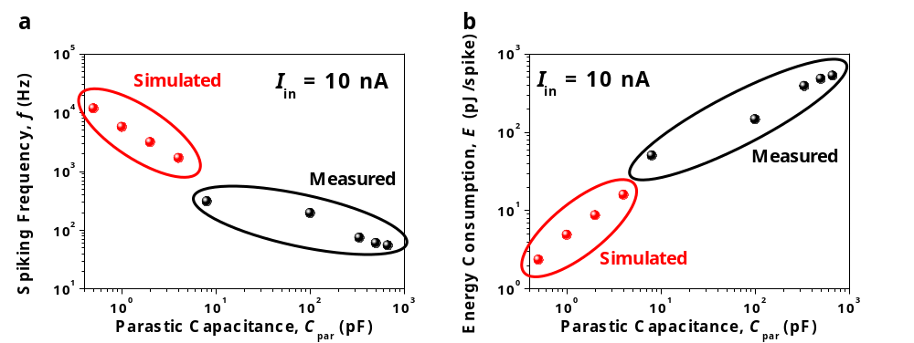
Fig. S6| Neuron characteristics depending on the parasitic capacitance (C_{par}) of the single transistor neuron obtained from measurements and TCAD device simulations. a, Spiking frequency (f) and b, energy consumption per spike (E/spike) depending on the C_{par} of the single transistor neuron. By reducing C_{par}, the computational speed can be faster and energy consumption can be reduced.

C_{par} of the single transistor neuron plays an important role in neuron operation because the operation speed is determined by C_{par}. To confirm the effect of the C_{par}, we measured the f and extracted the E/spike by connecting the external capacitor parallel to the single transistor neuron. L_{G} was fixed as 880 nm. Figs. S6a and b show that the f was increased and E/spike was decreased as the C_{par} was decreased. This is because the time for charging was reduced. In order to confirm the neuron characteristics with a smaller C_{par} than the measured C_{par}, we performed device simulations with the aid of Synopsys Sentaurus TCAD. Notably, it is very difficult to characterize the capacitance of a sub-pF level owing to pad capacitance of the device and coaxial cable capacitance of the parameter analyzer. Note that a pad size larger than 100 μm $×$ 100 μm is huge for direct probing compared to a single transistor neuron size. Therefore, an incremental trend of the f below the sub-pF level can be indirectly estimated by simulations or extrapolation of the measured data. According to the simulation data, when the C_{par} was 0.5 pF, the f could be increased to 11.7 kHz and the E/spike could be reduced to 0.7 pJ/spike at an I_{in} of 10 nA. Therefore, it is better to reduce the C_{par} of the single transistor neuron to enhance the computational speed and energy efficiency. This means that miniaturization of the single transistor neuron is favorable to enhance neuron performance; i.e., they are scalable to each other.

7. Power consumption of single transistor neuron
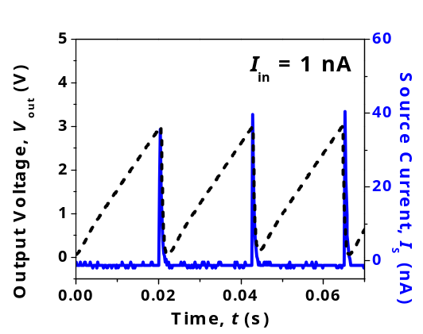
Fig. S7| Source current (I_{S}) during the spiking operation to extract peak power consumption. Peak current is detected at the moment of firing.

To compare the peak power consumption with previously reported neuron devices, the current that flowed out from the source (I_{s}) of the single transistor neuron was measured during the spiking operation when constant input current (I_{in}) was applied to the drain. Due to integrate-and-fire operation, a large current flowed out at the moment of firing, as shown in Fig. S7. Peak power consumption can be calculated with P = I_{peak}V_{peak}, where I_{peak} is the peak current measured at the source and V_{peak} is the peak output voltage (V_{out}) measured at the drain. As a result, P was calculated as 120 nW, which is 10~10³ fold smaller than diffusive memristor based neurons and 10²~10⁴ fold smaller than metal-to-insulator transition (MIT) memristor based neurons.^{S5,S7} This low power consumption compared to the memristor based neurons is attributed to a small cross-sectional channel area for current flowing due to the high scalability of the nano-CMOS fabrication. Its fabricated area was extracted from the product of the channel thickness (50 nm, i.e., channel height) and the channel width (280 nm).

8. Bidirectional characteristic of single transistor neuron
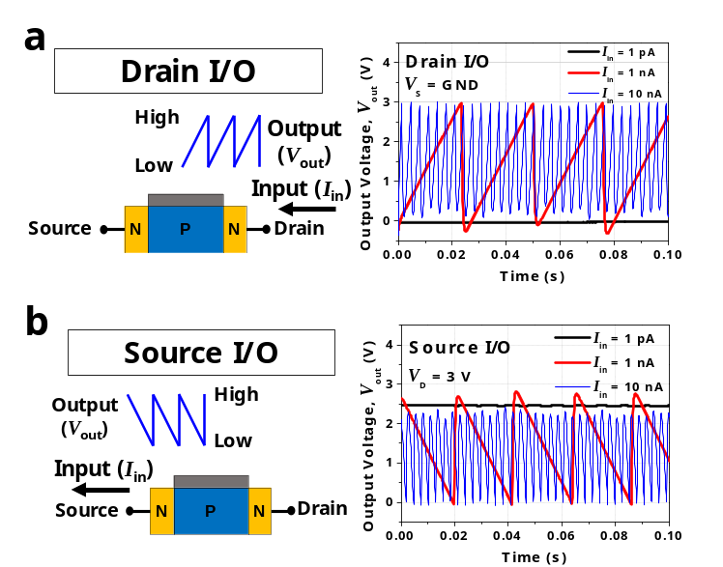
Fig. S8| Bidirectional characteristic of single transistor neuron. a, Measured spiking characteristics for the drain input/output (I/O) scheme. b, Measured spiking characteristics for the source I/O scheme.

The single transistor neuron has a bidirectional characteristic, in which the spiking operation is possible in both the drain input/output (I/O) scheme and the source I/O scheme. When the current is forced to the drain electrode (drain I/O), the positive charges are integrated in the drain-side parasitic capacitor. Accordingly, the level of the V_{out} is low at the resting state and high at the integration state, as shown in Fig. S8a. On the contrary, when the current is pulled out from the source (source I/O), negative charges are integrated at the source-side parasitic capacitor. In other words, a level of the V_{out} is high at the resting state and low at the integration state, as shown in Fig. S8b. This bidirectional characteristic can provide a wide degree of freedom in designing a neuromorphic system. Thus, we utilized both schemes in this work.

9. Co-integration of pre-synaptic neurons and transmitted synapses with high density
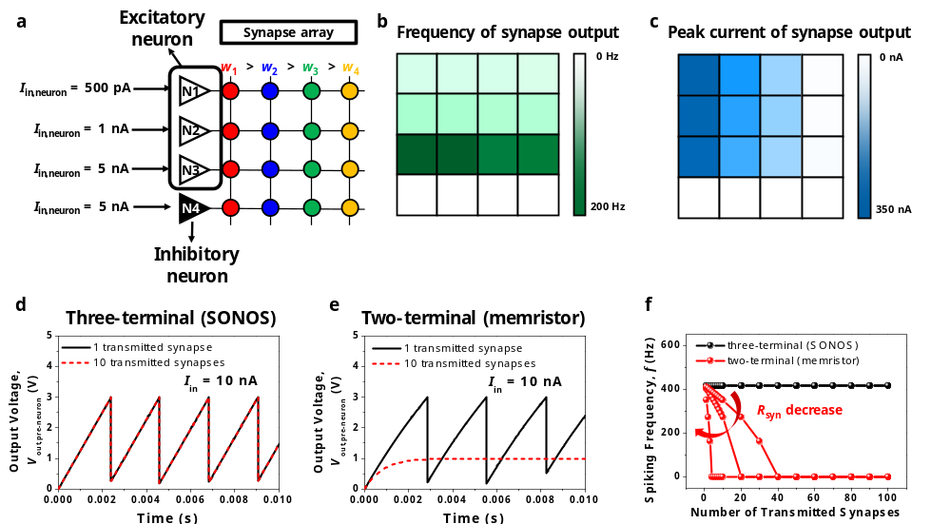 Fig. S9| Co-integration of pre-synaptic neurons and transmitted synapses with high density. a, Array configuration in which pre-synaptic excitatory/inhibitory neurons with different input currents (I_{in,neuron}) and transmitted synapses with different weights (w₁>w₂>w₃>w₄) were connected. b, The spiking frequency (f) of the synapse output current (I_{out,syn}) for each synapse in the array. c, The peak current of I_{out,syn} for each synapse in the array. d, Circuit simulation for comparison of the output voltage of pre-synaptic neuron (V_{out,pre-neuron}) connected with a single-transmitted synapse and deca-transmitted synapses, respectively. All the synapses were composed of a SONOS based three-terminal MOSFET. e, Circuit simulation for comparison of the V_{out,pre-neuron} connected with a single-transmitted synapse and deca-transmitted synapses, respectively. All the synapses were composed of a two-terminal memristor. f, Circuit simulation to confirm the f of the pre-synaptic neuron depending on the number of transmitted synapses in the case of three-terminal synapses (SONOS) and two-terminal synapses (memristor). When the SONOS is used, there is no limit in the number of synapses for the connection with a single neuron, unlike memristors. It assures that there is no loading effect in the proposed configuration of the co-integrated neuron-synapses.

In the main text, Figs. 3(a)-(c) show the analysis of one pre-synaptic neuron and one transmitted synapse connection, when the input current to the excited post-synaptic neuron (I_{in,neuron}) was fixed. In order to show the effect of I_{in,neuron} with excitatory/inhibitory function in the single transistor neuron, we constructed an array structure for co-integration with high density. Fig. S9 shows the array structure in which both pre-synaptic excitatory and inhibitory neurons with different I_{in,neuron} values and transmitted synapses with different conductance (weight) were connected. As shown in Fig. S9a, each neuron was connected to four synapses with different weight, and different I_{in,neuron} were applied to each neuron. Synapses have four different weights (w₁>w₂>w₃>w₄). As an example, the 1st neuron to the 3rd neuron were in the excitatory state in which electrons were trapped in the charge trap layer, and the 4th neuron was in the inhibitory state in which electrons were not trapped in the charge trap layer. For each excitatory neuron, a different I_{in,neuron} was applied. In more detail, 500 pA, 1 nA, and 5 nA were applied for the 1st, 2nd, and 3rd neuron, respectively. Finally, the output current of the transmitted synapse (I_{out,syn}) was measured in each synapse. Fig. S9b shows a color map to represent the spiking frequency (f) of the I_{out,syn} of each synapse in the array. The f of the I_{out,syn} was expressed with brightness. A dark colored pixel indicates a synapse with a high f and a white colored pixel indicates a synapse with a low f. As the I_{in,neuron} applied to the pre-synaptic neuron was increased, the spiking frequency of the I_{out,syn} was increased. Fig. S9c shows a color map to represent the peak current of the I_{in,neuron} of each synapse in the array. The peak current of the I_{in,neuron} was expressed with brightness. A dark colored pixel indicated a synapse with high peak current and a white colored pixel indicated a synapse with low peak current. As the synaptic weight was increased from w₄ to w₁, the peak current of I_{in,neuron} was increased. It should be noted that the synapses connected to the inhibitory state neuron did not show output current regardless of the weights and the I_{in,neuron}.
On the other hand, it is curious how many transmitted synapses can be co-integrated with a single pre-synaptic neuron. Theoretically, it is possible to drive a number of the transmitted synapses that are connected to the single pre-synaptic neuron. As an example, we simulated the architecture composed of one pre-synaptic neuron and 100 synapses with the aid of the SPICE circuit simulator. The current flowing from the neuron to the synapses is negligibly small because the gate of the synapse has very high input resistance due to a low level of gate leakage current. It should be noted that the gate leakage current of the fabricated synapses was less than 1 pA. Because there is no direct current flowing from the neuron to the synapses, the number of transmitted synapses that can be driven by the output voltage of the pre-synaptic neuron (V_{out,pre-neuron}) is not limited. As a result, V_{out,pre-neuron} was invariant even though 100 synapses were connected to the single pre-synaptic neuron, as shown in Figs. S9d and f. Furthermore, the V_{out,pre-neuron} was not varied even when the weight of each synapse was changed. This is an important advantage of co-integration with a MOSFET based three-terminal synapse such as SONOS compared to co-integration with a resistor based two-terminal synapse such as a memristor. Because of the loading effect, the number of synapses inevitably affect the neuronal output when two-terminal synapses are connected. For example, neuron oscillation was impossible when the number of two-terminal synapses with resistance (R_{syn}) of 1 GΩ was more than 10. This is because the current is flown out to the synapses by reduced resistance, as shown in Fig. S9e. This problem was exacerbated for the smaller R_{syn}, as shown in Fig. S9f, because larger current is flown out to the synapses. Referring to Fig. S9f, as the number of the transmitted synapses was increased, the leakage current toward the synapses was increased and the spiking frequency (f) of the pre-synaptic neuron was decreased. Then, when the number of synapses exceeded a certain level, spiking did not occur. To solve this problem of two-terminal synapses, a 1T1R configuration composed of an extra transistor (1T) and a memristor (1R) or a buffer circuit is required. However, such configurations sacrifice layout efficiency, worsen fabrication complexity, and increase hardware cost.

10. Thickness effect of tunneling oxide in single transistor synapse
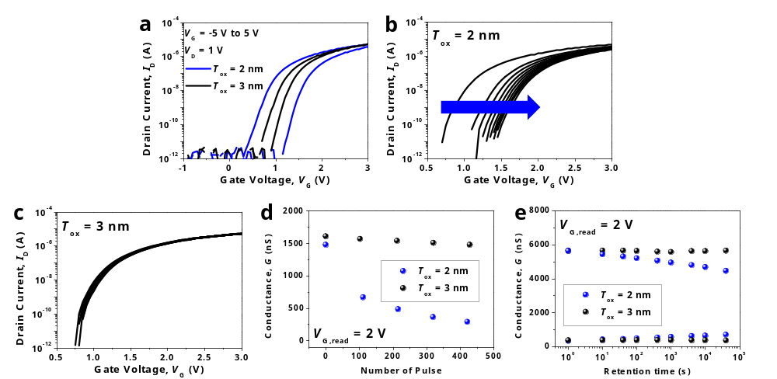 Fig. S10| Thickness effect of the tunneling oxide in the single transistor synapse for on-chip learning application. a, Transfer characteristics (I_{D}-V_{G}) of the SONOS-type synapse for a tunneling oxide thickness (T_{ox}) of 2 nm and 3 nm. The synapse with T_{ox} of 2 nm showed wider hysteresis. b,c, Threshold voltage (V_{T}) shift of the synapse when the neuron output voltage was continuously applied. The V_{T} shift of the synapse with T_{ox} of 2 nm was larger than that of 3 nm. d, Conductance change of the synapse as a function of the number of pulses provided from the neuron. Notable conductance change was observed for T_{ox} of 2 nm. e, Retention characteristics of the synapse. The synapse with T_{ox} of 3 nm showed better retention characteristic than that of 2 nm.

Since V_{T,firing} of the neuron is much smaller than the voltage of the synaptic potentiation/depression, the weight cannot be changed unless additional pulse modulation circuits are used. Therefore, it is suitable for off-chip learning application, where learning is not necessary in the hardware. However, by engineering the V_{T,firing} of the neuron and the thickness of the tunneling oxide (T_{ox}) in the synapse, the weight of the transmitted synapse can be changed by the output voltage of the pre-synaptic neuron without extra pulse modulation circuits. This means that it is also applicable to on-chip learning applications. There are two ways to increase the V_{T,firing} of the neuron. First, by increasing the L_{G}, the V_{T,firing} of the neuron is increased because the V_{latch} is increased by the reduced lateral electric field, as already shown in Fig. S5. Second, by increasing the body doping concentration (N_{body}), the V_{T,firing} of the neuron is increased because the V_{latch} is also increased by the suppressed carrier injection from the source to body, which is attributed to the increased built-in potential at the n⁺ source and the p-type body. We increased the V_{T,firing} of the neuron to 5.5 V by adopting two methods, e.g., increasing the N_{body} to 1$×$10¹⁸ cm⁻³ and increasing the L_{G} to 1.9 μm. At the same time, when the T_{ox} of the synapse is reduced, the weight of the synapse can be further changed by the lower voltage. As shown in Fig. S10a, the hysteresis was increased under the same voltage condition when T_{ox} of the synapse was reduced from 3 nm to 2 nm. This implies that a larger threshold voltage (V_{T}) shift and conductance change can be made under the same potentiation/depression voltage. Fig. S10b shows that when the T_{ox} of the synapse was 2 nm, the V_{T} of the synapse was gradually shifted by the spike of the neuron. On the other hand, when the T_{ox} is 3 nm, the V_{T} shift was not significant, as shown in Fig. S10c. The depression where the conductance gradually decreases occurred by neuron spiking for the T_{ox} of 2 nm, as shown in Fig. S10d. However, the conductance was not changed significantly for the T_{ox} of 3 nm. From the viewpoint of retention characteristics, a T_{ox} of 3 nm was better than a T_{ox} of 2 nm, as shown in Fig. S10e. Therefore, a T_{ox} of 3 nm is suitable for off-chip learning applications that requires good retention characteristics without weight change, and a T_{ox} of 2 nm is suitable for on-chip learning applications that require a weight change with lower potentiation/depression voltage. It should be noted that the formation of various gate oxide thicknesses has already been used for a commercial logic chip. The abovementioned features are readily realized by CMOS fabrications.

11. Co-integrated current mirror for the connection of transmitting synapse and post-synaptic neuron
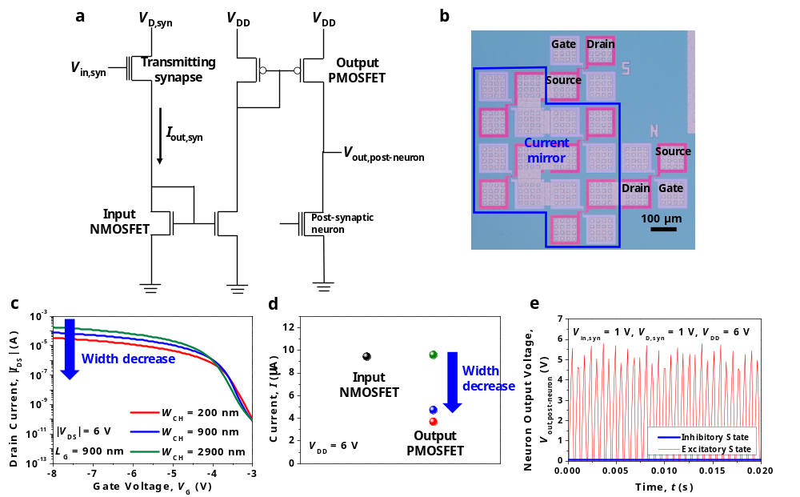 Fig. S11| Co-integrated current mirror for the connection of transmitting synapse and post-synaptic neuron. a, Circuit diagram of connected transmitting synapse, current mirror, and post-synaptic neuron. The current mirror was used to reverse the direction of current flow for the drain I/O scheme and to reduce the current level for ultra large scale integration (ULSI) with high density. b, The fabricated transmitting synapse, current mirror, and post-synaptic neuron interconnected through metallization. c, Measured transfer characteristic of the fabricated PMOSFET. d, The current flowing through the input NMOSFET and output PMOSFET. The output current was reduced by narrowing the channel width of the output PMOSFET. e, The spiking characteristics of the post-synaptic neuron. The spiking was observed only when the neuron was in the excitatory state.

In the main text, for the connection of the transmitting synapse and the post-synaptic neuron, the drain of the transmitting synapse was connected to the source of the post-synaptic neuron in order to fix the source voltage of the synapse. This was the source I/O scheme of the neuron. However, when the output voltage (V_{out,post-neuron}) of the post-synaptic neuron is the source, V_{out,post-neuron} is ‘high’ during resting and at ‘low’ during spiking. If the V_{out,post-neuron} is transferred to the next transmitted synapses, the current is flown not at the spiking state but at the resting state, which is a reverse operation. Therefore, the drain I/O scheme of the neuron is preferred for a neural network with more than three layers of neuron. Furthermore, reduction of the output current from the transmitting synapse (I_{out,syn}) is important to realize ultra large scale integration (ULSI) of a neuromorphic system where the post-synaptic neuron is connected to numerous synapses. A low level of input current (I_{in}) smaller than 10 μA, which is below the current range where the latch-up occurred in Fig. 2b of the main text, is preferred for nominal operation of the single transistor neuron. When the I_{in} is higher than 10 μA, the current flows out to the source without charge integration. Therefore, the post-synaptic neuron does not operate when a number of synapses are connected. The two aforementioned concerns can be resolved by co-integrating a current mirror between the transmitting synapse and the post-synaptic neuron, as shown in the circuit diagram of Fig. S11a. The current mirror is composed of two NMOSFETs and two PMOSFETs in order to change the direction of current flow and to reduce the magnitude of the I_{out,syn}. Fig. S11b shows the co-integrated transmitting synapse, current mirror, and post-synaptic neuron interconnected through metallization.
In the current mirror, scaling of the I_{out,syn} is available by controlling the channel width (W_{CH}) of the output PMOSFET connected to the post-synaptic neuron. Fig. S11c shows the measured transfer characteristics of the fabricated PMOSFET and Fig. S11d shows the output current depending on the W_{CH} of the output PMOSFET. The on-state current (I_{on}) was decreased as the W_{CH} was narrowed from 2900 nm to 200 nm. Accordingly, the output current was reduced. As a result, spiking of the post-synaptic neuron was achieved when it was in the excitatory state, as shown in Fig. S11e. Otherwise, when it was in the inhibitory state, no spiking was observed.

12. Co-integrated inverter
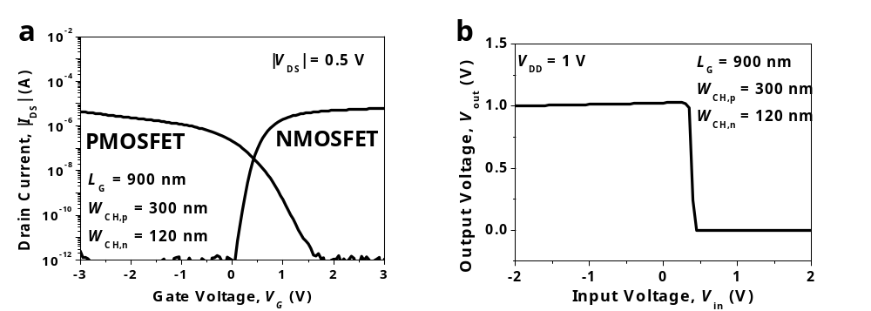 Fig. S12| Co-integrated inverter. a, Measured transfer characteristics of fabricated NMOSFET and PMOSFET constituting an inverter. b, Measured voltage transfer characteristics (V_{out}-V_{in}) of the co-integrated inverter.

In Supplementary Information 11, we showed that the current mirror was co-integrated with the neurons and synapses on the same plane with the same process. In addition to the current mirror, we also fabricated an inverter to show that other logic circuits can also be co-integrated. Fig. S12a shows the measured transfer characteristics of the fabricated NMOSFET and PMOSFET. The W_{CH} of the PMOSFET was designed to be 2.5 times larger than that of the NMOSFET for symmetric inverter operation. Using NMOSFET and PMOSFET, normal inverter operation was confirmed, as shown in the voltage transfer curve of Fig. S12b. The current mirror and inverter are examples to show the feasibility of co-integration with analog circuits and digital circuits, unlike memristor based neurons and synapses.^{S5-S7}

13. SPICE circuit simulation for classifier
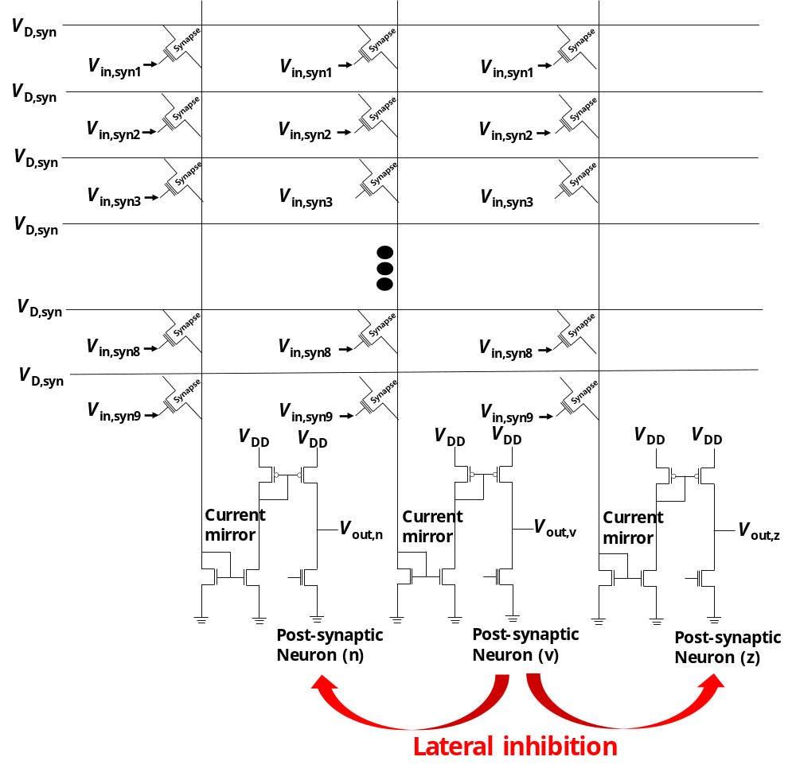 Fig. S13| SPICE circuit simulation for classifier. Circuit diagram of a classifier. 9×3 array of transmitting synapses, three current mirrors, and three post-synaptic neurons were co-integrated to construct the classifier for recognition of letter patterns.

A neural network for a classifier was constructed to classify the letters ‘n’, ‘v’, and ‘z’, which were respectively composed of 3×3 black-and-white pixels. The network comprised of nine input layers corresponding to each pixel and three output layers responding to each letter. Therefore, 9×3 array of synapses are connected to the neuron, as shown in the circuit diagram of Fig. S13. The spiking characteristic of the neuron was modeled with a threshold switch and a parasitic capacitor, which were connected in parallel, as shown in Fig. S3b. A synapse was implemented with a three-terminal MOSFET, which had the same gate length (L_{G}) and channel width (W_{CH}) as the fabricated device (L_{G} = 1880 nm and W_{CH} = 160 nm). The weight of the synapse was adjusted by modifying the threshold voltage (V_{T}) of the MOSFET. A current mirror was connected between the transmitting synapses and each post-synaptic neuron. Through the current mirror, the output current from the transmitting synapses was summed, and it was 400-fold scaled down for transferring reduced current to the post-synaptic neuron.
The input gate voltage applied to the synapse (V_{in,syn}) was differently determined for a black or white pixel. For example, a high V_{in,syn} (1 V) was applied to a synapse connected to an input layer corresponding to a black pixel, and a low V_{in,syn} (0 V) was applied to a synapse connected to an input layer corresponding to a white pixel. The synapse was set to have a binary value, in which the V_{T} values of the low weight synapse and high weight synapse were set as 1 V and 0 V, respectively. The drain voltage of the synapses (V_{D,syn}) was set as 1 V, and supply voltage of the current mirror (V_{DD}) was set as 6 V. For the lateral inhibition, output neurons were connected to each other. When one of the output neurons reached the firing threshold voltage (V_{T,firing} = 3 V), other neurons were changed to the inhibitory state (low resistance state). The energy consumption for one letter pattern recognition was extracted as 6.02 nJ/pattern, until the first output neuron was fired and other neurons were inhibited. In detail, a 4.58 nJ/pattern was consumed in the synapses, a 1.38 nJ/pattern was consumed in the current mirror, and 0.064 nJ was consumed in the neurons.

14. Reliable neural network using characteristic of multi-firing threshold
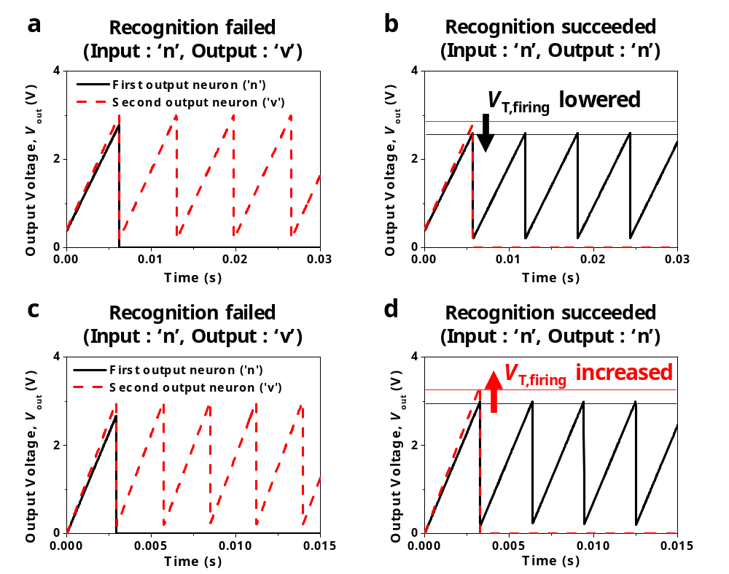
Fig. S14| SPICE circuit simulation to show reliable neural network using property of multi-firing threshold in the single transistor neuron. a, Output voltage (V_{out}) of output neurons when the threshold voltage (V_{T}) of high weight synapses connected to the first output neuron abnormally increased in the case of the input letter pattern ‘n’. Thus, the letter pattern ‘n’ is misidentified as ‘v’. b, V_{out} of output neurons when the firing threshold voltage (V_{T,firing}) of the first neuron is lowered. The letter pattern ‘n’ is successfully recognized as ‘n’. c, V_{out} of output neurons when the threshold voltage (V_{T}) of the low weight synapses connected to the second output neuron abnormally decreased in the case of the input letter pattern ‘n’. Thus, the letter pattern ‘n’ is misidentified as ‘v’. d, V_{out} of output neurons when the V_{T,firing} of the second neuron is increased. The letter pattern ‘n’ is successfully recognized as ‘n’.

In Supplementary Information 4, we showed that V_{T,firing} of the single transistor neuron is tunable by controlling the trapped charge density in the nitride. This can greatly enhance the reliability and reproducibility of the neural network. If the weight of the synapse is unsuitably low or high owing to process-induced variability and endurance problems, the neuron cannot be fired with the targeted number. For instance, the V_{T,firing} should be lowered if the current input to the neuron is too small because the weight of the synapse is abnormally low. In the reverse case, if the weight of the synapse is too high, the V_{T,firing} must be increased. This allows the number of neuron firings to be stably maintained regardless of the non-ideal synapse operations. ^{S8-S10} In order to show the benefit of the multi-firing threshold property, we performed SPICE circuit simulations.
Consider a situation where an input pattern is ‘n’. The first output neuron should be fired and other neurons should be inhibited before the firing. However, when the threshold voltage (V_{T}) of the high weight synapses connected to the first output neuron were abnormally increased to 0.35 V from 0 V, the current from the synapses to the first output neuron decreased. As a result, the first output neuron could not be fired and instead, another output neuron was fired, as shown in Fig. S14a. Therefore, the pattern recognition failed. At this time, normal pattern recognition could be achieved by lowering the V_{T,firing} of the first neuron to 2.6 V, as shown in Fig. S14b.
Otherwise, when the V_{T} of the low weight synapses connected to the second output neuron was abnormally decreased to -0.1 V from 1 V, the current from the synapses to the second output neuron increased. As a consequence, the second output neuron was fired in advance to the first output neuron and the first output neuron was inhibited, as shown in Fig. S14c. Therefore, the pattern recognition failed. At this time, normal pattern recognition could be achieved by increasing the V_{T,firing} of the second neuron to 3.4 V, as shown in Fig. S14d. In summary, reliable pattern recognition was performed by tuning the V_{T,firing} of the single transistor neuron when the weight of the synapses was abnormally changed.
15. SPICE circuit simulation for auto-encoder
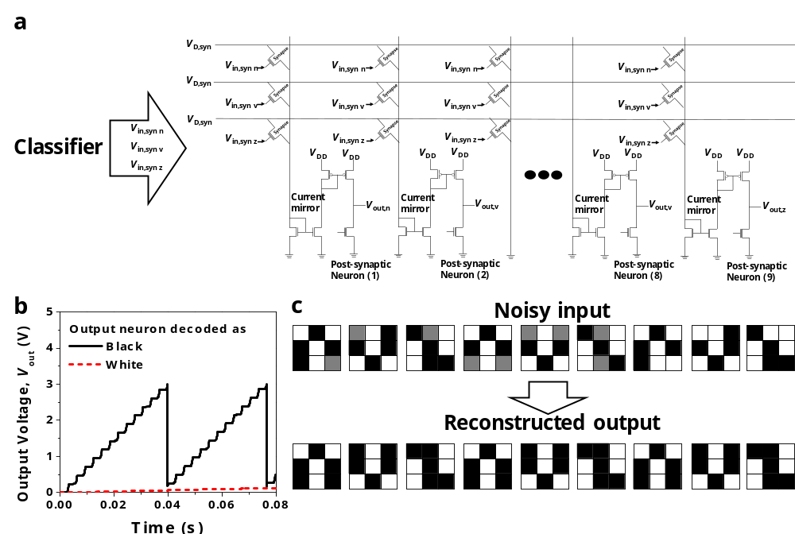
Fig. S15| SPICE circuit simulation for auto-encoder. a, Circuit diagram of an auto-encoder. It was composed of a classifier, 3×9 array of synapses, nine current mirrors, and nine post-synaptic neurons, which is a multi-layer perceptron (MLP) network. b, Output voltage (V_{out}) of the output neuron. When spiking of output neuron was observed, the corresponding pixel was decoded as a black pixel, and otherwise, it was decoded as a white pixel. c, A clean image was reconstructed from the noisy input image using an auto-encoder.

In previous Supplementary Information 13, a classifier was demonstrated using a single-layer perceptron (SLP) network. Meanwhile, a multi-layer perceptron (MLP) can also be implemented with co-integration of single transistor neurons and synapses for low hardware cost and high packing density. As an example of the MLP, we implemented an auto-encoder. By encoding information of 3×3 black-and-white pixels using the classifier and by inputting the output to the neural network composed of 3×9 array of synapses and nine output neurons, pixel information was decoded. The circuit diagram of the auto-encoder is depicted in Fig. S15a. As in the case of the classifier, the current mirror was connected between the transmitting synapses and each post-synaptic neuron. At this time, some middle neurons were disabled by lateral inhibition, which could not deliver sufficient signals for output neuron firing. Through this, information of pixels could be decoded according to which output neuron was excited. As a result, inference of the auto-encoder could be implemented using the MLP, which could obtain the reconstructed clean image from the noisy input image.
The input voltage applied to the synapse (V_{in,syn}) was determined according to the brightness of the pixel. A high gate voltage (1 V), a middle gate voltage (0.5 V), and a low gate voltage (0 V) were applied to a synapse connected to an input layer corresponding to a black, gray, and white pixel, respectively. The synapse was set to have a binary value, in which the V_{T} of the high weight synapse and low weight synapse in the first layer were set as 0 V and 1 V, respectively. The V_{T} of the high weight synapse and low weight synapse in the second layer were set as 2 V and 3 V, respectively. The drain voltage of the synapses (V_{D,syn}) was set as 1 V, and the supply voltage of the current mirror (V_{DD}) was set as 6 V. For lateral inhibition of the middle layer, middle neurons were connected to each other. As a result, the firing of the output neurons was determined according to the signal transferred from the middle neurons. Referring to Fig. S15b, when spiking of the output neuron was observed, the corresponding pixel was newly decoded as a black pixel. Otherwise, when spiking of output neuron was not observed, the corresponding pixel was newly decoded as a white pixel. As a result, various noisy input images were reconstructed as clean images, as shown in Fig. S15c.

16. Software simulation for face recognition
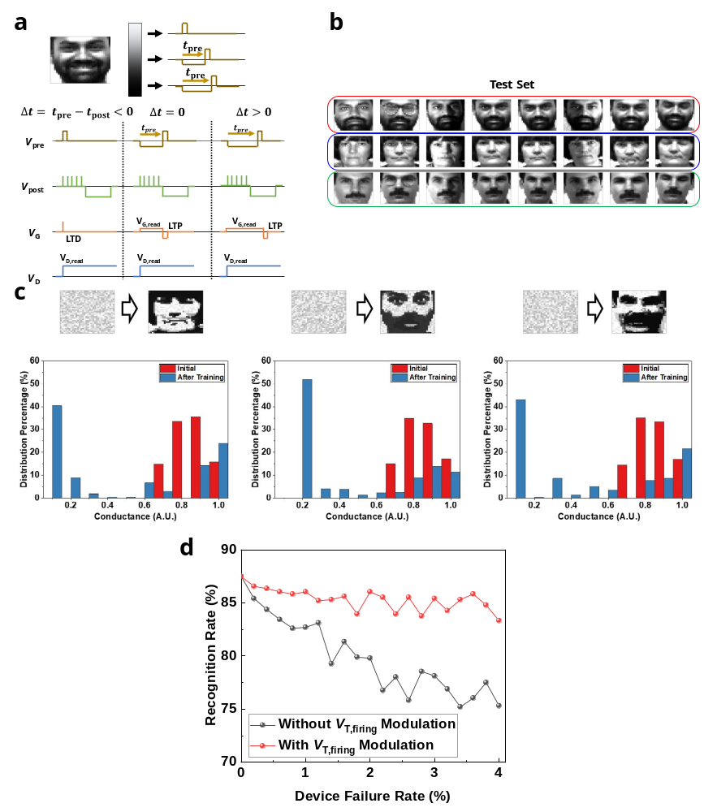 Fig. S16| Software simulation for face recognition. a, Designed pulse scheme for face recognition. The input neuron generates pre-synaptic spikes with the timing proportional to the pixel intensity of the training image. The output neuron generates post-synaptic spikes to update the weight of the synapses according to the simplified STDP learning rule. b, 24 test set images for face recognition. c, Conductance distribution and visual map diagram of the synapse array before and after training. d, Recognition rate without and with the V_{T,firing} modulation, when the conductance of the synapse is abnormally changed. Recognition failure can be prevented by the V_{T,firing} modulation.

For the simulations of face recognition, the measured characteristics of the single transistor neuron and synapse were reflected. Based on the modeled spiking characteristics of the single transistor neuron (Fig. S3b), the capacitance (C_{par}), the resistance at HRS (R_{off}), and the firing threshold voltage (V_{T,firing}) of the LIF neuron were set as 8 pF, 5 TΩ, and 3 V, respectively. For the synapse, based on the experimental results of the P-D characteristics of the single transistor synapse, we modeled the conductance modulation as a function of the pulse number using the following equation:
$G=\left\{\begin{aligned}{((G_{max}^{α}-G_{min}^{α})×w+G_{min}^{α})}^{1/α} if α≠0, \\ G_{min}^{α}×{{(G}_{max}/G_{min})}^{w} if α=0.\end{aligned}\right.$ (1),
, where G_{max} is the maximum conductance, G_{min} is the minimum conductance, α is a parameter that controls potentiation or depression, and w is an internal variable that ranges from 0 to 1.^{S11}
Synapses and neurons were then connected based on the circuit diagram of Fig. 6b. Training images were fed to the input neurons in which each input neuron corresponded to one pixel of the image. The input neurons generated pre-synaptic spikes with the timing proportional to the pixel intensity of the training image, as depicted in Fig. S16a. Synapses that received pre-synaptic spikes transmitted current to the post-synaptic neurons according to the weight. The current mirror was used as an interface circuit in order to reduce the current level from the synapses to the post-synaptic neurons. The post-synaptic neuron that received the highest current caused post-synaptic spikes to be fired for updating the synaptic weights of the synapses, which were connected with the fired post-synaptic neuron. A proper shape of the post-synaptic spike was generated by a waveform generator, which was composed of a pulse voltage with sequential negative and positive polarities. Referring to the pulse scheme illustrated in Fig. S16a, when the pre-synaptic spike was fired earlier than the post-synaptic spike (t_{pre} – t_{post} = Δt < 0), positive long-term depression voltage (V_{LTD}) was applied to the gate of the synapse, which decreased the conductance of the synapse. On the other hand, the conductance of the synapse was increased by negative long-term potentiation voltage (V_{LTP}) applied to the gate of the synapse, if the pre-synaptic spike was fired later than the postsynaptic spike (t_{pre} – t_{post} = Δt > 0).^{S12} A simplified STDP learning rule scheme was used for the synaptic weight update.^{S9} After the learning process, the face recognition was evaluated with 24 test set images, containing eight images of each person (Fig. S16b). Fig. S16c shows the final conductance distribution and the visual map diagram of the synapse array for the three people. Fig. S16d shows the extracted recognition rate by inference operation without the V_{T,firing} modulation and with the V_{T,firing} modulation, when the conductance of the synapses (G) was abnormally changed by process-induced variability or endurance problems. For example, it can be assumed that G is randomly and abnormally changed to 2G_{min}. The recognition rate was decreased as the device failure rate was increased, unless the V_{T,firing} modulation is applied. Otherwise, the recognition failure would be prevented when the V_{T,firing} was modulated. It implies that the reliable neural network can be constructed by the V_{T,firing} modulation.

17. Comparison with previous works for neuron-synapse co-integration
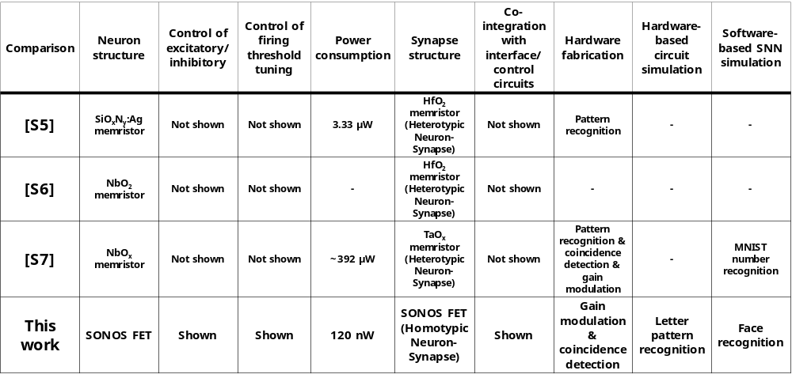
Fig. S17| Comparison table with previous works that showed co-integration of neuron devices and synapse devices. Inhibitory function and multi-threshold property that were not available in memristor based neurons were accomplished in the neuron device itself. Neurons and synapses were implemented with the same device (SONOS) and materials. Co-integration with interface and control circuits was accomplished.

There were three representative works that showed co-integration of neuron devices and synapse devices. First, Wang et al. demonstrated a fully memristive neural network using a SiO_{x}N_{y}:Ag diffusive memristor neurons and HfO₂ memristor synapses.^{S5} Second, Woo et al. demonstrated an integrated crossbar array with NbO₂ memristor neurons and HfO₂ memristor synapses.^{S6} Third, Duan et al. demonstrated a monolithically integrated memristive neural network based on NbO_{x} memristor neurons and TaO_{x} memristor synapses.^{S7} In our work, two neuron properties, control of excitatory/inhibitory function and control of firing threshold, were newly implemented to the single transistor neuron for an energy efficient and reliable neural network. However, they were not accomplished in the memristor neurons owing to the lack of controllability. The power consumption was 10-fold reduced relative to the SiO_{x}N_{y}:Ag diffusive memristor neuron and 10³-fold reduced compared to the NbO_{x} metal-insulator transition memristor neuron.
Compared to previous works, neurons and synapses were implemented with the same device (SONOS) structure and materials, which can reduce the fabrication complexity. Since we used standard Si CMOS fabrication, the interface and control circuits could be co-integrated. In addition, direct transmission without an additional circuit was experimentally demonstrated with co-integration of a pre-synaptic neuron and a transmitted synapse, owing to the nature that the neuron output is a voltage, not a current.
Using the co-integrated neurons and synapses, gain modulation and co-incidence detection were demonstrated with hardware fabrication, inspired by the work of Duan et al. Letter pattern recognition was shown using a hardware-based circuit simulation. Furthermore, complex image recognition such as face recognition was achieved using a software-based simulation.

References
S1. T. Sentaurus, User Manual, Synopsys, Inc., Mt. View, CA (2010).
S2. Hodgkin, A. L. & Huxley, A. F. A quantitative description of membrane current and application to conduction and excitation in nerve. J. Physiol. 21, 500–544 (1954).
S3. Izhikevich, E. M. Which model to use for cortical spiking neurons. IEEE Trans. Neural Netw. 15, 1063–1070 (2004).
S4. Ogura, S., Codella, C. F., Rovedo, N., Shepard, J. F. & Riseman, J. A half-micron MOSFET using double-implanted LDD, IEEE Int. Electron Devices Meeting (IEDM), 718-721 (1982).
S5. Wang, Z. et al. Fully memristive neural networks for pattern classification with unsupervised learning. Nat. Electron 1, 137–145 (2018).
S6. Woo, J., Wang, P. & Yu, S. Integrated crossbar array with resistive synapses and oscillation neurons. IEEE Electron Device Lett. 40, 1313–1316 (2019).
S7. Duan, Q. et al. Spiking neurons with spatiotemporal dynamics and gain modulation for monolithically integrated memristive neural networks, Nat. Commun 11, 1-13 (2020).
S8. Woo, S. Y. et al. Implementation of homeostasis functionality in neuron circuit using double-gate device for spiking neural network. Solid-State Electron. 165, 107741 (2020).
S9. Querlioz, D., Bichler, O., Dollfus, P. & Gamrat, C. Immunity to device variations in a spiking neural network with memristive nanodevices. IEEE Trans. Nanotechnol. 12, 288–295 (2013).
S10. Bartolozzi, C., Nikolayeva, O. & Indiveri, G. Implementing homeostatic plasticity in VLSI networks of spiking neurons. Proc. 15th IEEE Int. Conf. Electron. Circuits Syst. ICECS, 682–685 (2008).
S11. Jang, J.-W., Park, S., Burr, G. W., Hwang, H. & Jeong, Y.-H. Optimization of conductance change in Pr_{1−x}Ca_{x}MnO₃-based synaptic devices for neuromorphic systems. IEEE Electron Device Lett. 36, 457–459 (2015).
S12. Kim, S., Choi, B., Lim, M., Yoon, J., Lee, J., Kim, H. D. & Choi, S. J. Pattern recognition using carbon nanotube synaptic transistors with an adjustable weight update protocol. ACS Nano 11, 2814−2822 (2017).

