Supporting information for

Lead isotopic constraints on the provenance of Antarctic dust and relevant atmospheric circulation patterns prior to the Mid-Brunhes Event (~430 kyr ago)

Changhee Han^{1,2}, Laurie J. Burn³, Paul Vallelonga^{3,4}, Soon Do Hur², Claude F. Boutron⁵, Sanghee Lee¹, Sungmin Hong^{1*}
¹Department of Ocean Sciences, Inha University, 100 Inha-ro, Michuhol-gu, Incheon 22212, Korea
²Division of Polar Paleoenvironment, Korea Polar Research Institute, 26 Songdomirea-ro, Yeonsu-gu, Incheon 21990, Korea
³Department of Imaging and Applied Physics, Curtin University of Technology, GPO Box U1987, Perth 6845, Western Australia, Australia
⁴Oceans Graduate School and UWA Oceans Institute, The University of Western Australia, Crawley WA 6009, Australia
⁵Institut des Géosciences de l'Environnement, Université Grenoble Alpes/CNRS, 54 rue Molière, 38400 Saint Martin d'Hères, France

Corresponding author: Email: smhong@inha.ac.kr (Sungmin Hong); Phone: +82-32-860-7708; Fax: +82-32-862-5236

Summary
There are 14 pages in this Supplementary Information including 2 tables and 7 figures.

Table S1. Data obtained from 40 depth intervals from 2,973.9 (age of 572,800 yr B.P.) to 3189.45 m (age of 801,590 yr B.P.). The depths and estimated ages given in the table are the depth and age for the top of the samples. Uncertainties in the isotope ratios are for 95% confidence intervals.
No. | Depth  (m) | Age  (years BP) | δD  (‰) | Concentration (pg/g) |  | ²⁰⁶Pb/²⁰⁷Pb | ± | ²⁰⁸Pb/²⁰⁷Pb | ± | ²⁰⁶Pb/²⁰⁴Pb | ± | Pb/Ba  (by wt.) | dust Pb (%)
 |  |  |  | Pb | Ba
1 | 2973.91 | 572,800 | -403 | 1.01 | 19.7 | 1.1945 | 0.0032 | 2.4674 | 0.0044 | 18.49 | 0.19 | 0.05 | 58.5
2 | 2974.08 | 572,900 | -403 | 0.45 | 8.8 | 1.1945 | 0.0034 | 2.4729 | 0.0057 | 18.43 | 0.23 | 0.05 | 58.1
3 | 2985.07 | 576,765 | -404 | 0.72 | 15.0 | 1.1975 | 0.0028 | 2.4703 | 0.0049 | 18.52 | 0.15 | 0.05 | 62.3
4 | 2990.35 | 578,965 | -398 | 0.83 | 15.4 | 1.1874 | 0.0028 | 2.4618 | 0.0050 | 18.25 | 0.21 | 0.05 | 55.6
5 | 2995.92 | 581,610 | -415 | 1.31 | 39.5 | 1.1995 | 0.0024 | 2.4729 | 0.0041 | 18.73 | 0.14 | 0.03 | 90.3
6 | 3001.41 | 585,975 | -424 | 2.14 | 38.4 | 1.1853 | 0.0027 | 2.4556 | 0.0047 | 18.09 | 0.20 | 0.06 | 53.8
7 | 3001.58 | 586,225 | -424 | 0.97 | 20.5 | 1.1959 | 0.0033 | 2.4744 | 0.0051 | 18.43 | 0.20 | 0.05 | 63.6
8 | 3012.41 | 597,180 | -432 | 6.81 | 122.3 | 1.1975 | 0.0021 | 2.4674 | 0.0032 | 18.51 | 0.13 | 0.06 | 53.9
9 | 3012.58 | 597,510 | -432 | 4.30 | 81.5 | 1.1970 | 0.0022 | 2.4696 | 0.0041 | 18.59 | 0.13 | 0.05 | 56.8
10 | 3023.35 | 610,680 | -401 | 0.46 | 5.0 | 1.1824 | 0.0032 | 2.4663 | 0.0055 | 18.39 | 0.17 | 0.09 | 32.4
11 | 3034.35 | 622,895 | -405 | 2.21 | 72.4 | 1.1958 | 0.0027 | 2.4644 | 0.0047 | 18.47 | 0.12 | 0.03 | 98.1
12 | 3040.13 | 631,365 | -438 | 3.84 | 100.1 | 1.2021 | 0.0022 | 2.4743 | 0.0048 | 18.67 | 0.13 | 0.04 | 78.1
13 | 3045.42 | 644,485 | -433 | 8.63 | 161.9 | 1.1955 | 0.0024 | 2.4686 | 0.0040 | 18.50 | 0.10 | 0.05 | 56.3
14 | 3056.48 | 662,800 | -437 | 19.05 | 297.1 | 1.2041 | 0.0018 | 2.4686 | 0.0037 | 18.68 | 0.08 | 0.06 | 46.8
15 | 3056.61 | 663,290 | -437 | 16.99 | 311.0 | 1.2004 | 0.0020 | 2.4661 | 0.0040 | 18.40 | 0.13 | 0.06 | 54.9
16 | 3072.92 | 682,755 | -425 | 3.54 | 40.4 | 1.1845 | 0.0026 | 2.4576 | 0.0045 | 18.26 | 0.20 | 0.09 | 34.2
17 | 3073.08 | 682,990 | -425 | 2.93 | 48.7 | 1.2011 | 0.0023 | 2.4763 | 0.0037 | 18.68 | 0.13 | 0.06 | 49.9
18 | 3078.35 | 687,730 | -417 | 1.94 | 32.7 | 1.1964 | 0.0019 | 2.4667 | 0.0035 | 18.61 | 0.10 | 0.06 | 50.5
19 | 3083.85 | 691,890 | -411 | 1.23 | 15.0 | 1.2047 | 0.0034 | 2.4636 | 0.0061 | 18.40 | 0.22 | 0.08 | 36.5
20 | 3089.42 | 695,620 | -403 | 3.54 | 11.4 | 1.2332 | 0.0032 | 2.4902 | 0.0047 | 19.10 | 0.17 | 0.31 | 9.7
21 | 3089.59 | 695,785 | -403 | 1.63 | 6.7 | 1.2000 | 0.0030 | 2.4693 | 0.0047 | 18.57 | 0.18 | 0.24 | 12.4
22 | 3094.92 | 699,080 | -405 | 1.33 | 21.0 | 1.2119 | 0.0036 | 2.4748 | 0.0045 | 18.54 | 0.23 | 0.06 | 47.2
23 | 3095.09 | 699,240 | -405 | 2.15 | 9.9 | 1.2086 | 0.0029 | 2.4703 | 0.0043 | 18.71 | 0.18 | 0.22 | 13.8
24 | 3100.42 | 702,580 | -408 | 0.84 | 9.5 | 1.1907 | 0.0023 | 2.4658 | 0.0035 | 18.50 | 0.16 | 0.09 | 33.8
25 | 3100.57 | 702,740 | -408 | 13.21 | 13.0 | 1.1900 | 0.0022 | 2.4579 | 0.0042 | 18.57 | 0.11 | 1.02 | 2.9
26 | 3106.08 | 706,315 | -407 | 0.70 | 14.5 | 1.2044 | 0.0024 | 2.4767 | 0.0046 | 18.75 | 0.13 | 0.05 | 62.1
27 | 3111.35 | 711,860 | -412 | 6.97 | 171.4 | 1.2299 | 0.0020 | 2.4853 | 0.0033 | 19.16 | 0.09 | 0.04 | 73.8
28 | 3122.35 | 721,290 | -438 | 9.90 | 88.3 | 1.2259 | 0.0017 | 2.4751 | 0.0032 | 19.15 | 0.08 | 0.11 | 26.8
29 | 3127.85 | 727,415 | -422 | 4.06 | 36.3 | 1.2307 | 0.0024 | 2.4939 | 0.0037 | 19.20 | 0.13 | 0.11 | 26.9
30 | 3133.45 | 732,980 | -412 | 1.27 | 30.7 | 1.2013 | 0.0020 | 2.4765 | 0.0032 | 18.64 | 0.11 | 0.04 | 72.8
31 | 3133.60 | 733,260 | -412 | 2.11 | 31.9 | 1.2137 | 0.0022 | 2.4766 | 0.0035 | 19.01 | 0.11 | 0.07 | 45.2
32 | 3139.95 | 739,730 | -439 | 17.07 | 453.1 | 1.1965 | 0.0020 | 2.4713 | 0.0034 | 18.67 | 0.09 | 0.04 | 79.6
33 | 3145.45 | 746,495 | -439 | 7.52 | 143.6 | 1.2108 | 0.0022 | 2.4742 | 0.0039 | 18.82 | 0.10 | 0.05 | 57.3
34 | 3149.85 | 751,860 | -439 | 8.64 | 177.8 | 1.1973 | 0.0018 | 2.4704 | 0.0034 | 18.64 | 0.08 | 0.05 | 61.8
35 | 3156.45 | 759,970 | -429 | 1.96 | 37.0 | 1.1990 | 0.0023 | 2.4758 | 0.0038 | 18.72 | 0.12 | 0.05 | 56.8
36 | 3160.85 | 765,820 | -420 | 2.54 | 25.6 | 1.1877 | 0.0021 | 2.4642 | 0.0033 | 18.57 | 0.13 | 0.10 | 30.3
37 | 3165.32 | 771,640 | -415 | 0.89 | 25.9 | 1.1986 | 0.0041 | 2.4725 | 0.0052 | 18.64 | 0.24 | 0.03 | 87.1
38 | 3172.95 | 781,015 | -403 | 0.49 | 10.7 | 1.2110 | 0.0032 | 2.4849 | 0.0053 | 18.83 | 0.16 | 0.05 | 66.3
39 | 3178.52 | 786,950 | -396 | 1.09 | 12.9 | 1.2013 | 0.0067 | 2.4747 | 0.0089 | 18.63 | 0.38 | 0.09 | 35.3
40 | 3189.45 | 801,590 | -441 | 107.98 | 626.8 | 1.2295 | 0.0015 | 2.4749 | 0.0024 | 19.25 | 0.05 | 0.17 | 17.4
All periods |  | Mean |  | 6.9 | 85 | 1.2022 |  | 2.4715 |  | 18.64 |  | 0.10 | 50.3
 |  | Min-Max |  | 0.45-108 | 5.0-627 | 1.1824-1.2332 |  | 2.4556-2.4939 |  | 18.09-19.25 |  | 0.03-1.02 | 2.9-98.1
Glacials  (δD < –405‰) |  | Mean |  | 9.3 | 114 | 1.2025 |  | 2.4712 |  | 18.67 |  | 0.10 | 52.2
 |  | Min-Max |  | 0.70-108 | 9.5-627 | 1.1845-1.2307 |  | 2.4556-2.4939 |  | 18.09-19.25 |  | 0.03-1.02 | 2.9-90.3
Interglacials  (δD > –405‰) |  | Mean |  | 1.3 | 17 | 1.2015 |  | 2.4723 |  | 18.58 |  | 0.11 | 45.8
 |  | Min-Max |  | 0.45-3.54 | 5.0-72.4 | 1.1824-1.2332 |  | 2.4618-2.4902 |  | 18.25-19.10 |  | 0.03-0.31 | 9.7-98.1

Table S2. Statistical summary (mean ± standard deviation, SD) of Pb isotope ratios. The dust dominant and non-dust dominant Pb isotopes are separated according to the glacial and interglacial periods between the post-MBE and pre-MBE intervals. The post-MBE data are from Vallelonga et al. (2010). The number of samples is given in parentheses. Four pre-MBE samples (nos. 20, 28, 29, 40) were excluded in the calculation to avoid bias because they are outside the general trend of the pre-MBE non-dust dominant isotopic compositions (see text).
Samples | ²⁰⁶Pb/²⁰⁷Pb | ²⁰⁸Pb/²⁰⁷Pb
Post-MBE glacial dust-dominant (n=39) | 1.2050 ± 0.0090 | 2.4731 ± 0.0108
Post-MBE interglacial dust-dominant (n=13) | 1.2049 ± 0.0126 | 2.4801 ± 0.0138
Post-MBE glacial non-dust dominant (n=21) | 1.2311 ± 0.0160 | 2.4877 ± 0.0127
Post-MBE interglacial non-dust dominant (n=1) | 1.2240 | 2.4793
Pre-MBE glacial dust dominant (n=9) | 1.2028 ± 0.0105 | 2.4749 ± 0.0045
Pre-MBE interglacial dust dominant (n=3) | 1.2014 ± 0.0083 | 2.4732 ± 0.0105
Pre-MBE glacial non-dust dominant (n=16) | 1.1974 ± 0.0085 | 2.4672 ± 0.0065
Pre-MBE interglacial non-dust dominant (n=8) | 1.1976 ± 0.0100 | 2.4697 ± 0.0045

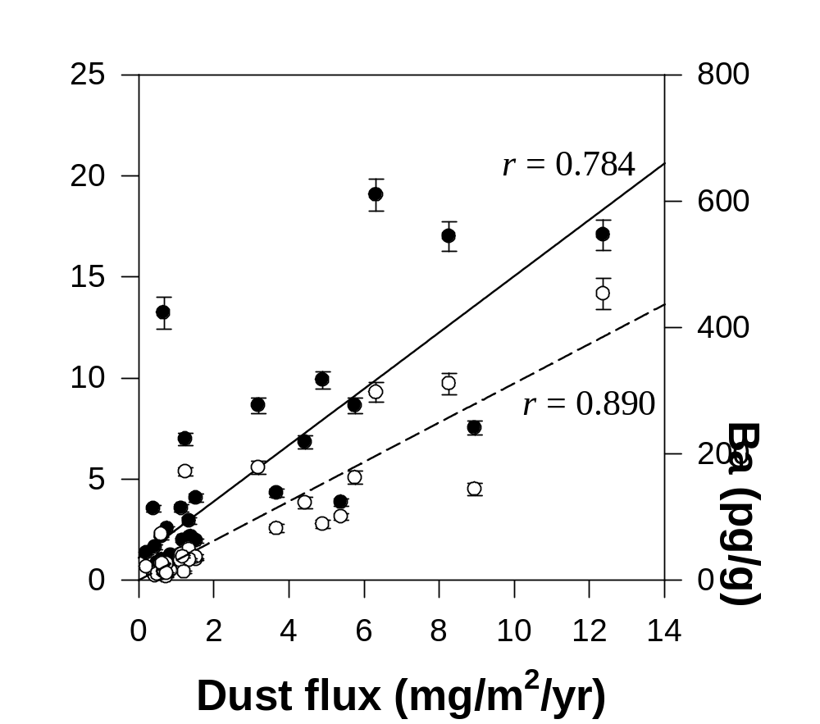
Figure S1. Scatter plots of Pb and Ba concentrations versus dust fluxes (Lambert et al., 2008) in the pre-MBE EDC ice core samples. Two lines with Pearson’s correlation coefficients (r) that are significant at the p < 0.01 level are fit to the data, the solid line being the least squares line for Pb concentrations (solid circles) and the dashed line for Ba concentrations (open circles). The extreme values of Pb and Ba concentration in the deepest ice at 3,189.45 m (sample no. 40, ~801 kyr B.P., MIS 20) was excluded (see text). All uncertainties are 95% confidence intervals.
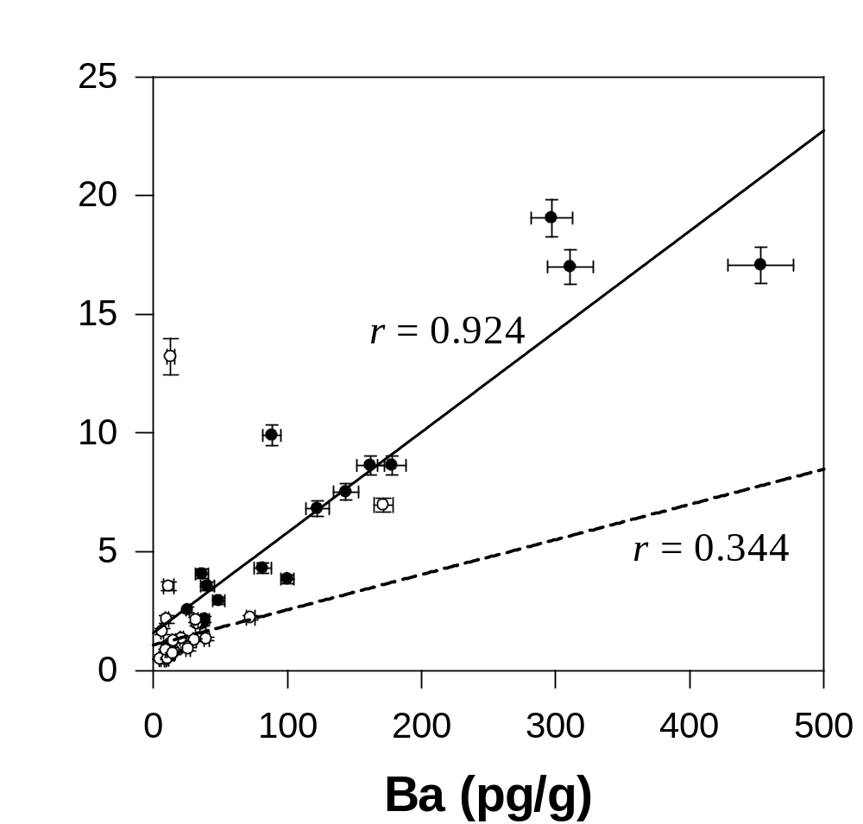
Figure S2. Scatter plots of Pb concentrations versus Ba concentrations in the pre-MBE EDC ice core samples. Two lines with Pearson’s correlation coefficients (r) are fit to the data, the solid line being the least squares line for data with δD values below –420‰ (solid circles) and the dashed line for data with δD values above –420‰ (open circles). The extreme values of Pb and Ba concentrations in the deepest ice at 3,189.45 m (sample no. 40, ~801 kyr B.P., MIS 20) were excluded (see text). All uncertainties are 95% confidence intervals.
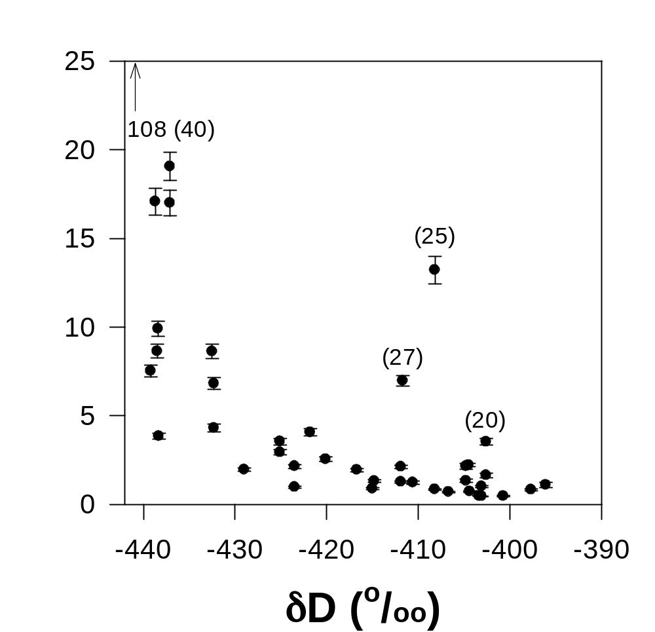
Figure S3. Changes in Pb concentrations as a function of the deuterium content (expressed in delta per mil) in the pre-MBE EDC ice core samples. The numbers in parentheses represent sample numbers in Table S1. All uncertainties are 95% confidence intervals.

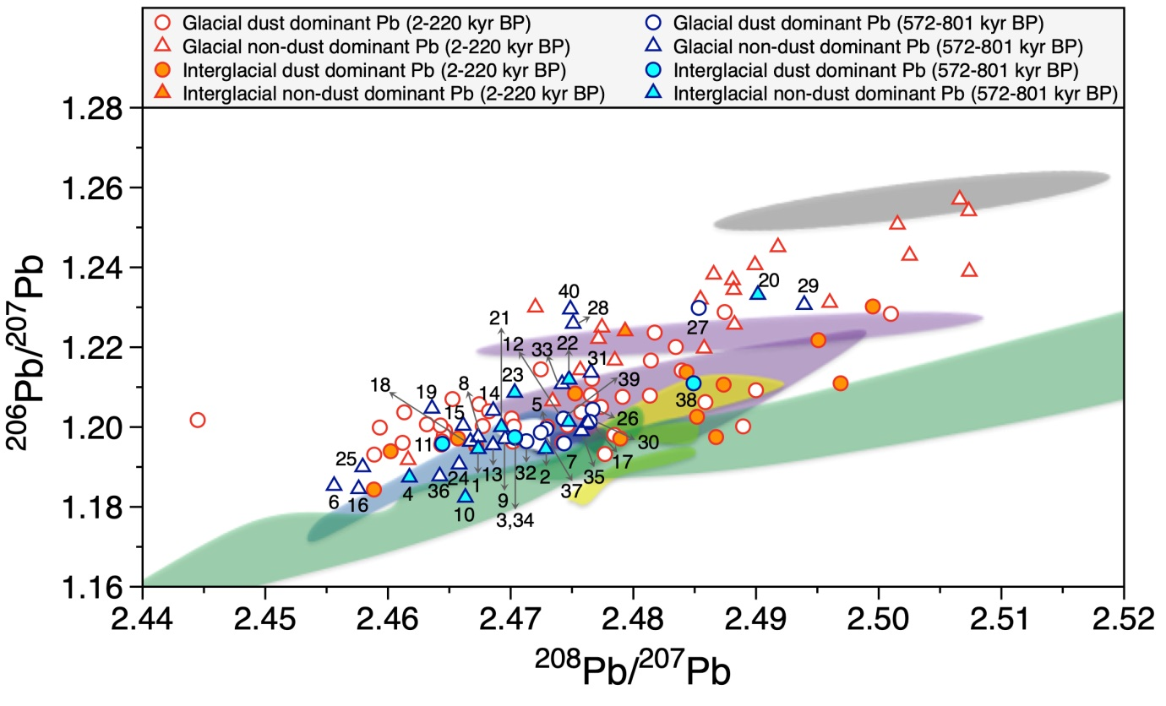

Figure S4. A plot of the ²⁰⁸Pb/²⁰⁷Pb versus ²⁰⁶Pb/²⁰⁷Pb in the EDC ice core samples showing the identification numbers of pre-MBE samples in Table S1. All uncertainties are 95% confidence intervals.

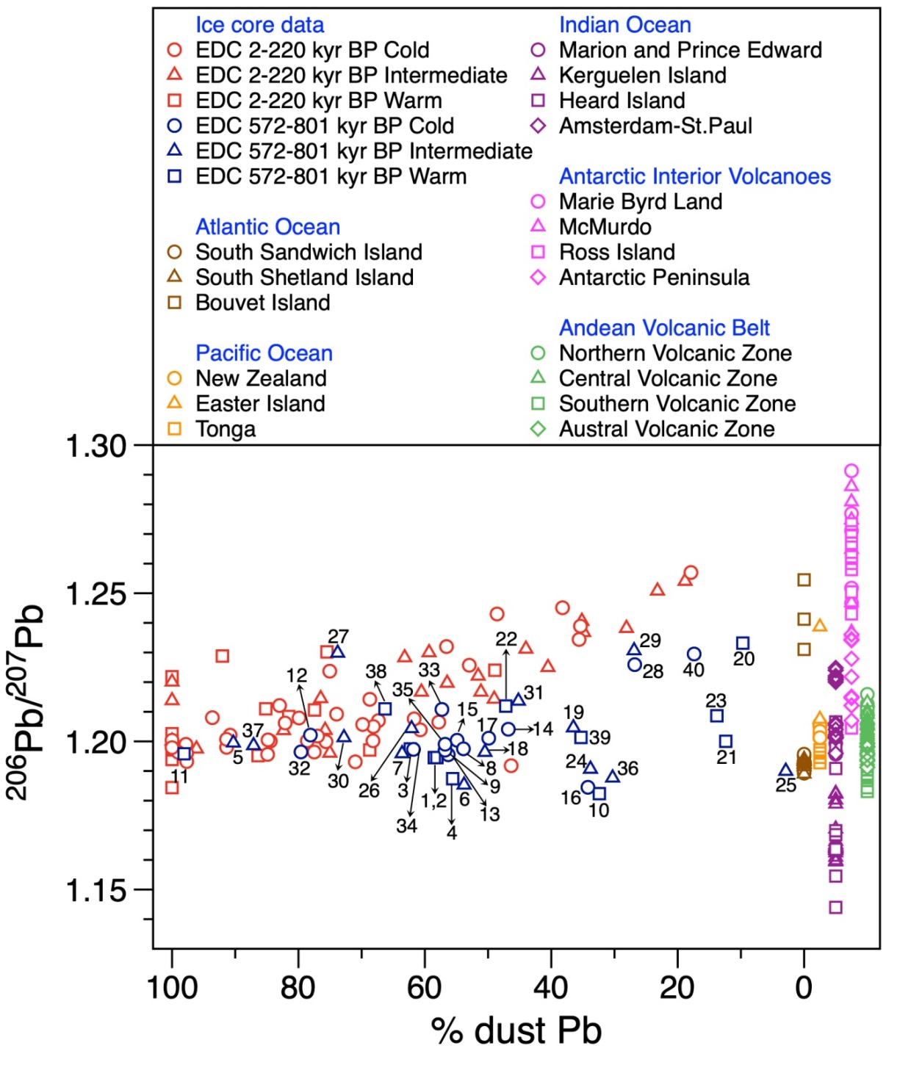
Figure S5. Comparison of ²⁰⁶Pb/²⁰⁷Pb ratios between the pre- MBE and post-MBE intervals as a function of dust fraction of Pb showing the identification numbers of pre-MBE samples in Table S1. The end-members of volcanic ²⁰⁶Pb/²⁰⁷Pb ratios for the potential volcanic sources come from published literature: Marie Byrd Land (Hart et al., 1997), McMurdo volcanics (Rocholl et al., 1995), Ross Island basanitoids (Sun and Hanson, 1975), Antarctic Peninsula basalts (Hole et al., 1993), South American volcanoes (Harmon et al., 1984; Stern and Kilian, 1996), South Sandwich Island (Barreiro, 1983), Bouvet Island (Sun, 1980), South Shetland Island (Lee et al., 2008), Marion and Prince Edward (le Roex et al., 2012), Kerguelen Island (Weis et al., 1998), Heard Island (Barling et al., 1994), Amsterdam-St.Paul (Doucet et al., 2004), New Zealand (McCulloch et al., 1994), and Easter Island and Tonga (Sun, 1980).
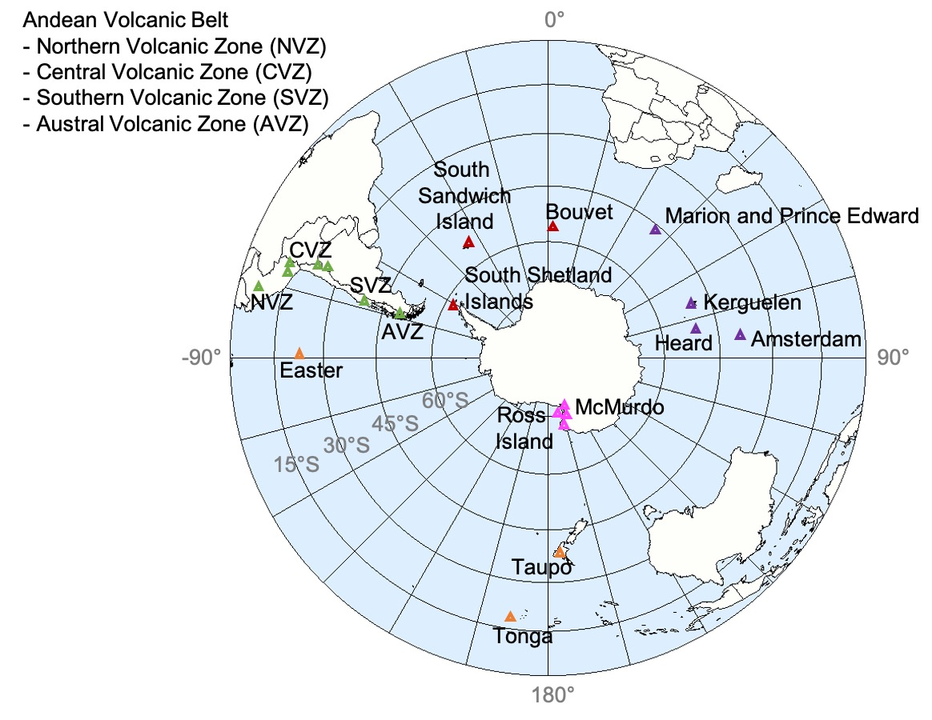
Figure S6. Location map for Antarctic and extra-Antarctic volcanoes mentioned in the text. The base map is ‘Southern Hemisphere of Earth (Lambert Azimuthal projection)’ by Sean Baker licensed under CC BY 2.

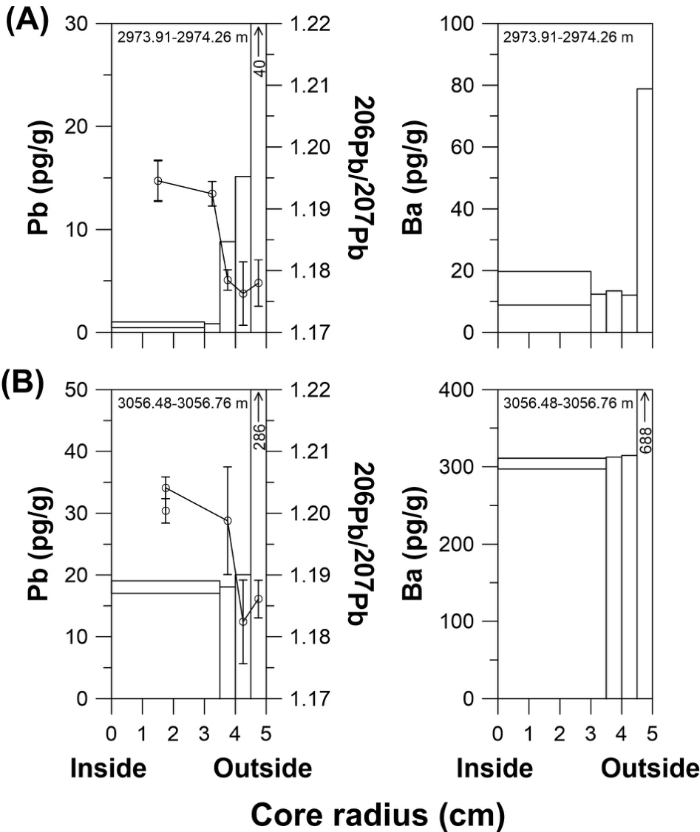
Figure S7. Changes in Pb and Ba concentrations and ²⁰⁶Pb/²⁰⁷Pb ratios (open circles) as a function of radius in two sections: (a) depth of 2973.91 m (572.8 kyr B.P.), MIS 15.1 interglacial; (b) depth of 3056.48 m (662.8 kyr B.P.), MIS 14 glacial. Two different values are given for concentrations and isotope ratios in the innermost part because the inner cores were divided into two consecutive 20 cm long parts. The error bars of the ²⁰⁶Pb/²⁰⁷Pb ratios are 95% confidence intervals.

References
Barling, J., Goldstein, S. L. & Nicholls, I. A. Geochemistry of Heard Island (Southern Indian Ocean): Characterization of an enriched mantle component and implications for enrichment of the sub-Indian ocean mantle. J. Petrol. 35, 1017–1053 (1994).
Barreiro, B. Lead isotopic compositions of South Sandwich Island volcanic rocks and their bearing on magmagenesis in intra-oceanic island arcs. Geochim. Cosmochim. Acta 47, 817–822 (1983).
Doucet, S., Weis, D., Scoates, J. S., Debaille, V. & Giret, A. Geochemical and Hf-Pb-Sr-Nd isotopic constraints on the origin of the Amsterdam-St. Paul (Indian Ocean) hotspot basalts. Earth Planet. Sci. Lett. 218, 179–195 (2004).
Harmon, R. S. et al. Regional O-, Sr-, and Pb-isotope relationships in late Cenozoic calc-alkaline lavas of the Andean Cordillera. J. Geol. Soc. 141, 803–822 (1984).
Hart, S. R., Blusztajn, J., LeMasurier, W. E. & Rex, D. C. Hobbs Coast Cenozoic volcanism: Implications for the West Antarctic rift system. Chem. Geol. 139, 223–248 (1997).
Hole, M. J., Kempton, P. D. & Millar, I. L. Trace-element and isotopic characteristics of small-degree melts of the asthenosphere: Evidence from the alkalic basalts of the Antarctic Peninsula. Chem. Geol. 109, 51–68 (1993).
Lambert, F. et al. Dust-climate couplings over the past 800,000 years from the EPICA Dome C ice core. Nature 452, 616–619 (2008).

le Roex, A. P., Chevallier, L., Verwoerd, W. J. & Barends, R. Petrology and geochemistry of Marion and Prince Edward Islands, Southern Ocean: Magma chamber processes and source region characteristics. J. Volcanol. Geotherm. Res. 223–224, 11–28 (2012).

Lee, M. J., Lee, J. I., Choe, W. H. & Park, C. H. Trace element and isotopic evidence for temporal changes of the mantle sources in the South Shetland Islands, Antarctica. Geochem. J. 42, 207–219 (2008).

McCulloch, M. T., Kyser, T. K., Woodhead, J. D. & Kinsley, L. Pb− Sr− Nd− O isotopic constraints on the origin of rhyolites from the Taupo Volcanic Zone of New Zealand: evidence for assimilation followed by fractionation from basalt. Contrib. Mineral. Petrol. 115, 303–312 (1994).
Rocholl, A., Stein, M., Molzahn, M., Hart, S. R. & Wörner, G. Geochemical evolution of rift magmas by progressive tapping of a stratified mantle source beneath the Ross Sea Rift, Northern Victoria Land, Antarctica. Earth Planet. Sci. Lett. 131, 207–224 (1995).
Stern, C. R. & Kilian, R. Role of the subducted slab, mantle wedge and continental crust in the generation of adakites from the Andean Austral Volcanic Zone. Contrib. Mineral. Petrol. 123, 263–281 (1996).
Sun, S. S. Lead isotopic study of young volcanic rocks from mid-ocean ridges, ocean islands and island arcs. Philos. Trans. Royal Soc. A 297, 409–445 (1980).
Sun, S. S. & Hanson, G. N. Origin of Ross Island basanitoids and limitations upon the heterogeneity of mantle sources for alkali basalts and nephelinites. Contrib. Mineral. Petrol. 52, 77–106 (1975).
Vallelonga, P. et al. Lead isotopic compositions in the EPICA Dome C ice core and Southern Hemisphere Potential Source Areas. Quat. Sci. Rev. 29, 247–255 (2010).

Weis, D., Frey, F. A., Giret, A. & Cantagrel, J. -M. Geochemical characteristics of the youngest volcano (Mount Ross) in the Kerguelen Archipelago: Inferences for magma flux, lithosphere assimilation and composition of the Kerguelen plume. J. Petrol. 39, 73–994 (1998).

