Supplementary
Supplementary Table 1. Region-specific primers
Forward primer | 5′-TCGTCGGCAGCGTCAGATGTGTATAAGAGACAGTCGTCGGCAGCGTCAGATGT  GTATAAGAGACAGCCTACGGGNGGCWGCAG-3′
Reverse primer | 5′-GTCTCGTGGGCTCGGAGATGTGTATAAGAGACAGGTCTCGTGGGCTCGGAGA  TGTGTATAAGAGACAGGACTACHVGGGTATCTAATCC-3′

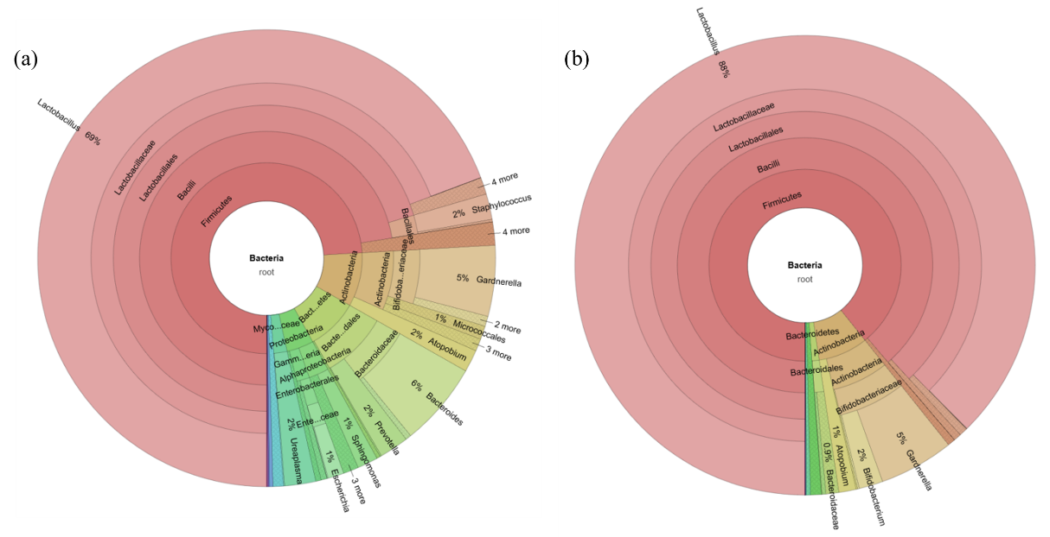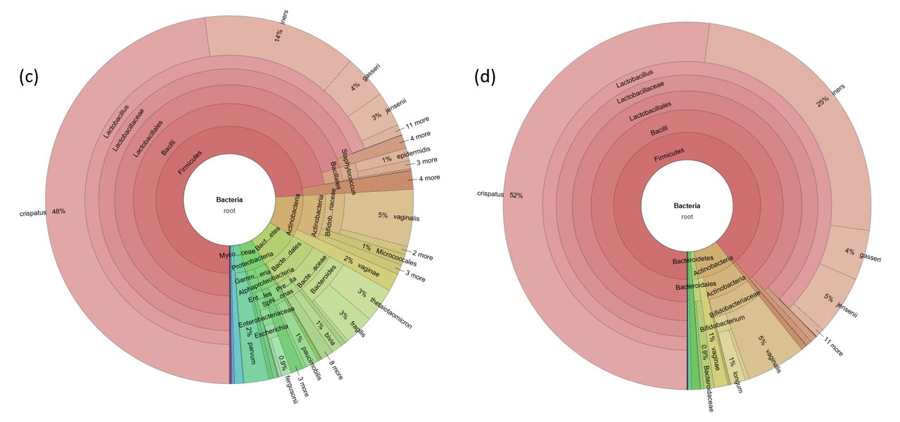
Supplementary Fig 1. Krona chart of bacterial taxa between the preterm birth and term birth groups.
(a), (c) show the preterm birth group (n=102) with genus level and species level. (b), (d) show the term birth group (n=101) with genus level and species level

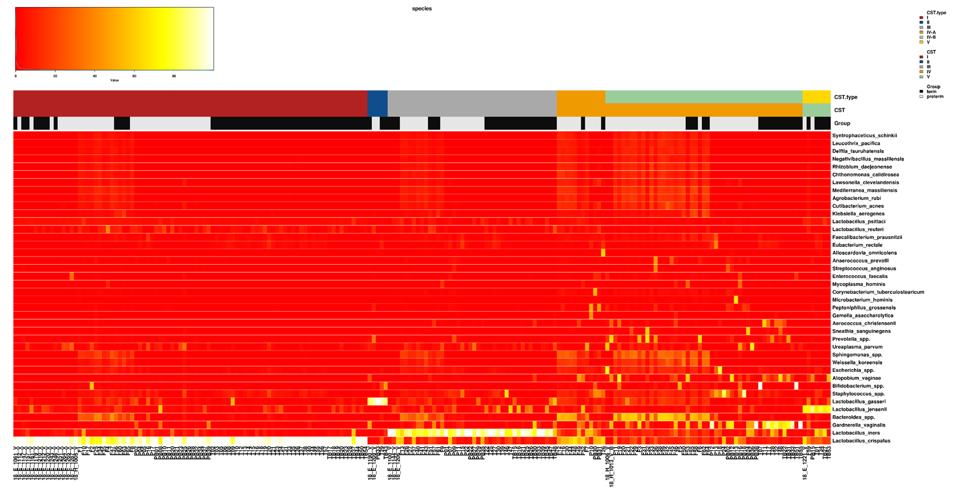
Supplementary Fig 2. Heatmap of microbial taxa of 203 subjects according to the CST type
CST, community-state types; CST-I, Lactobacillus crispatus; CST-II, Lactobacillus gasseri; CST-III, Lactobacillus iners; CST-IV-A, Heterogeneous type, other Lactobacillus spp.; CST-IV-B, fewer lactobacilli and more anaerobic bacterial taxa; CST-V, Lactobacillus jensenii
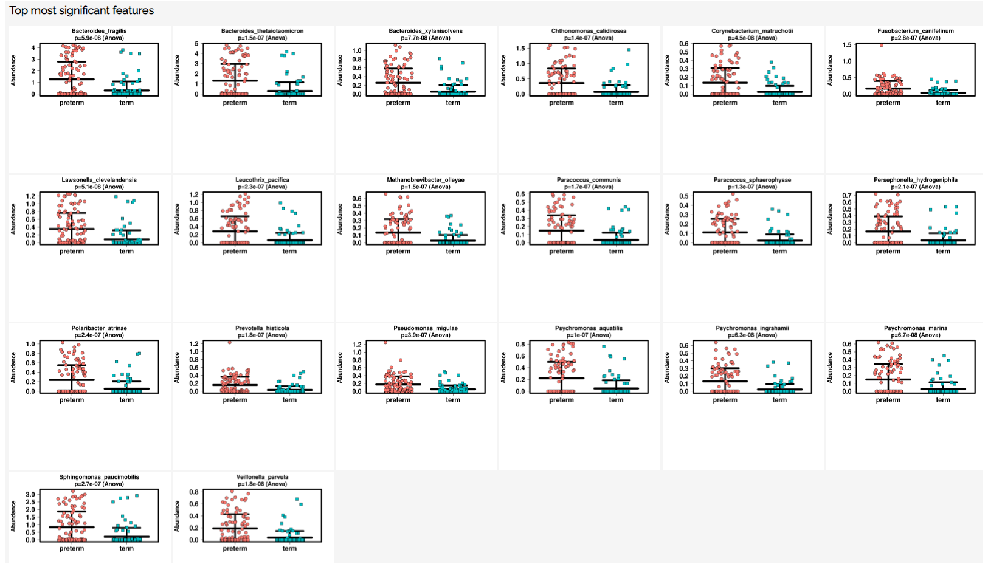
Supplementary Fig 3. Top 20 bacterial communities showing significant features related to preterm birth
The 16s rRNA abundance of the taxa differed significantly between the preterm birth (n=102) and term birth (n=101) groups. Statistical significance was observed using the Mann-Whitney U test, and the adjusted P-value was calculated by adjusting the false positive rate using the false discovery rate.
Whiskers show the median and the interquartile range.
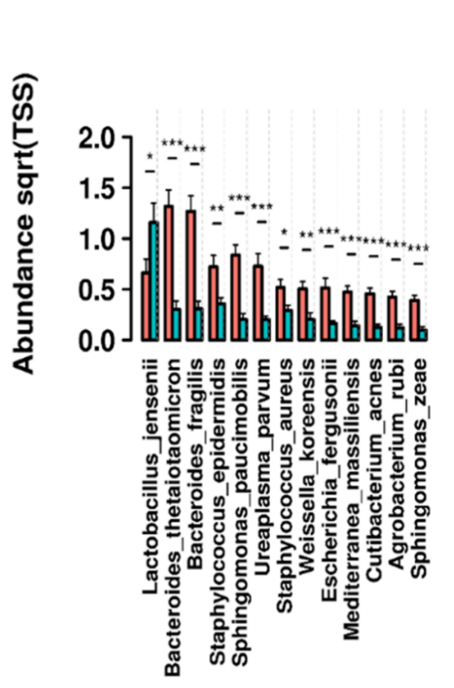

Supplementary Figure 4. Differential dominant relative abundance of bacterial taxa in the PTB and TB groups.
Thirteen bacteria showing significant differential mean relative abundance determined using Mann-Whitney U test (abundance >0.5 %) *Significance between groups (*: P< 0.05 / **: P < 0.02 / ***: P < 0.005),
sqrt, square-root transformed; TSS, Total Sum Scaling.

