Transcriptomics analysis and candidate genes associated with Xinjiang jujubes in response to Alternaria alternata infection
Yingying Fan^{1†} , Ruili Zhang^{2†}, Xiaoqin Liu², Yushan Ma², Yan Wang¹, Fengjuan Liu¹, Weizhong He¹, Aibo Wu³, Cheng Wang^{1,4*}

* Correspondence: wangchengxj321@sina.com
†These authors have contributed equally to this work and share first authorship.

¹ Key Laboratory of Agro-products Quality and Safety of Xinjiang, Laboratory of Quality and Safety Risk Assessment for Agro-Products (Urumqi), Institute of Quality Standards & Testing Technology for Agro-Products, Xinjiang Academy of Agricultural Sciences, Urumqi 830091, PR China
² College of Life Sciences, Tarim University, Alar 843300, China
³ SIBS-UGENT-SJTU Joint Laboratory of Mycotoxin Research, CAS Key Laboratory of Nutrition, Metabolism and Food Safety, Shanghai Institute of Nutrition and Health, University of Chinese Academy of Sciences, Chinese Academy of Sciences, Shanghai 200031, PR China
⁴ Management of Scientific Research, Xinjiang Academy of Agricultural Sciences, Urumqi 830091, PR China

Table S1 Transcriptome sequencing results
Sample ID | Number of bases before filtration (bp) | Number of bases after filtration (bp) | Q20 after filtration(%) | Q30 after filtration (%) | Reads ratio after filtration (%) | Ratio of mapped to reference genome (%) | Ratio of mapped to reference genome uniquely(%)
J_CK_1 | 6141330600 | 5645010600 | 97.87 | 94.38 | 91.91 | 84.44 | 83.98
J_CK_2 | 6083904900 | 5596361100 | 97.96 | 94.64 | 91.98 | 84.49 | 84.85
J_CK_3 | 6286358700 | 5802930300 | 98.00 | 94.69 | 92.30 | 86.70 | 85.25
H_CK_1 | 6671975700 | 6147476700 | 97.83 | 94.47 | 92.13 | 81.68 | 84.06
H_CK_2 | 7420316400 | 6693881700 | 97.29 | 93.44 | 90.21 | 76.95 | 79.50
H_CK_3 | 7085044500 | 6399907500 | 97.14 | 93.16 | 90.32 | 79.17 | 83.92
J_T1_1 | 6692552700 | 6039705600 | 97.43 | 93.62 | 90.24 | 87.17 | 85.56
J_T1_2 | 6060122700 | 5493262200 | 97.39 | 93.60 | 90.64 | 84.52 | 84.81
J_T1_3 | 6201326700 | 5606545500 | 97.30 | 93.35 | 90.40 | 85.03 | 84.90
H_T1_1 | 6257522100 | 5643538200 | 97.24 | 93.31 | 90.18 | 86.67 | 84.72
H_T1_2 | 5858538600 | 5320856100 | 97.15 | 93.17 | 90.82 | 76.30 | 82.81
H_T1_3 | 6784013400 | 6123880800 | 97.19 | 93.22 | 90.26 | 82.60 | 84.37
J_T2_1 | 6440527800 | 5848041000 | 97.15 | 93.21 | 90.8 | 75.57 | 84.18
J_T2_2 | 6382983600 | 5786215200 | 97.41 | 93.53 | 90.65 | 84.80 | 85.14
J_T2_3 | 6130771800 | 5546017500 | 97.47 | 93.63 | 90.46 | 87.50 | 85.52
H_T2_1 | 7326267900 | 6640723200 | 97.20 | 93.29 | 90.64 | 80.97 | 83.75
H_T2_2 | 6088118700 | 5531844600 | 96.88 | 92.63 | 90.86 | 79.47 | 83.55
H_T2_3 | 6346987800 | 5738935800 | 97.16 | 93.15 | 90.41 | 82.80 | 84.24
J_T3_1 | 6123229800 | 5574379500 | 97.28 | 93.35 | 91.03 | 78.72 | 85.61
J_T3_2 | 6415439100 | 5830771800 | 97.32 | 93.43 | 90.88 | 76.60 | 84.07
J_T3_3 | 6305983500 | 5752313100 | 97.36 | 93.47 | 91.21 | 79.54 | 85.36
H_T3_1 | 5976287100 | 5384218800 | 97.14 | 93.19 | 90.09 | 71.09 | 80.66
H_T3_2 | 6160677000 | 5550993000 | 97.28 | 93.24 | 90.10 | 86.19 | 85.10
H_T3_3 | 6440066100 | 5852508600 | 97.03 | 93.00 | 90.87 | 78.21 | 82.86
J_T4_1 | 6910455900 | 6334586100 | 97.45 | 93.63 | 91.66 | 79.07 | 85.09
J_T4_2 | 6070417500 | 5541834600 | 97.37 | 93.46 | 91.29 | 80.08 | 85.09
J_T4_3 | 5894830800 | 5358722700 | 97.60 | 93.89 | 90.90 | 85.50 | 85.65
H_T4_1 | 6737733600 | 6120053400 | 97.14 | 93.21 | 90.83 | 74.40 | 81.36
H_T4_2 | 6623918100 | 6035880000 | 97.17 | 93.00 | 91.12 | 86.45 | 85.56
H_T4_3 | 6512736000 | 5959417500 | 97.44 | 93.55 | 91.50 | 87.53 | 84.54
Note: (J, Jun jujube; H, Hui jujube; CK, clear water control group; T, treatment group; TX (X=1, 2, 3, 4), x days after treatment)

Table S2 Primer information
Name | Gene ID | Primer sequence（F） | Primer sequence（R）
GMP synthase | 107420223 | GACTCTTCGTCAAGCGGTTCTCTG | CTTCGGTGACACAGCCCCAAC
expansin-A1 | 107419239 | GGTGGTGATGCCTCTGGTACAATG | AGGCTGCTGTGTTTGTTCCATACC
Glucose-6-phosphate/phosphate translocator 2 | 107420411 | AGCGAAAGCAACTCCTTCTCTTCC | CCAATGGCTGCGAACGGTCTG
Amino acid permease | 107406430 | GCAGGTCCTCCAGAGAACAAAGC | GCATAACCAACACAGCCGCAAAG
PTR FAMILY 5.4 | 107403855 | CGTGTCGGTGTCGTTGGTTCC | AAACTGGTCCGCCGCAAAGG
Sulfate transporter 3.4 | 107405210 | TGGCTTTCACCGCTACCTTCTTTG | AAACCCAACCAGAGTCGCTTTCG
Internal reference gene | actin | CACGGTGTCGTTACCAACTG | GGCCTGAATGGAGACGTAGA

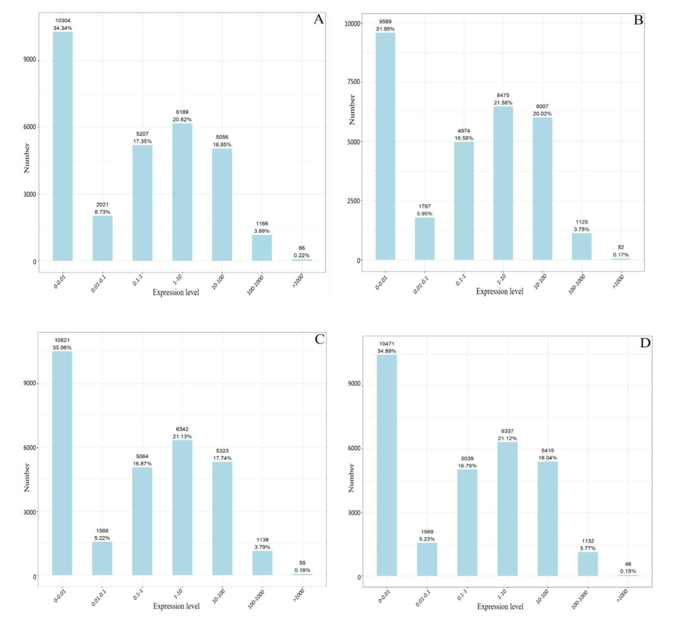
Fig. S1 Distribution of different expression levels in Jun jujube on day 1 (A), 2 (B), 3 (C), and 4 (D)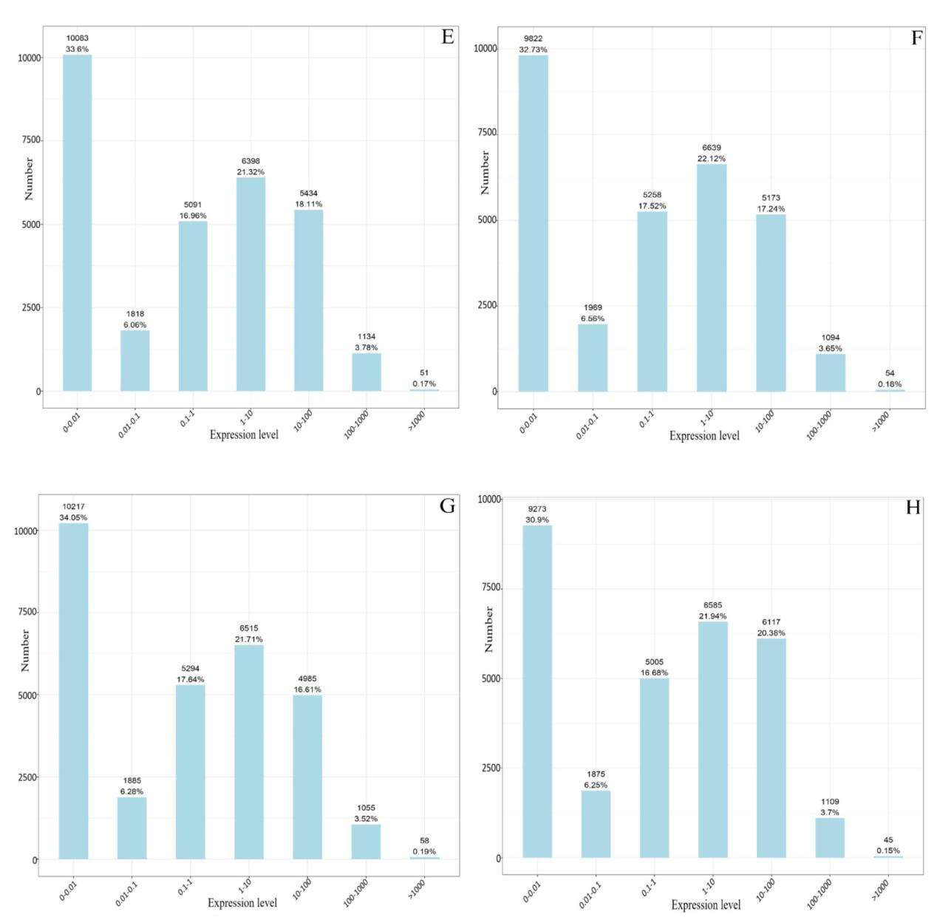
Fig. S2 Distribution of different expression levels in Hui jujube on day 1 (E) , 2 (F) , 3 (G) , and 4(H)
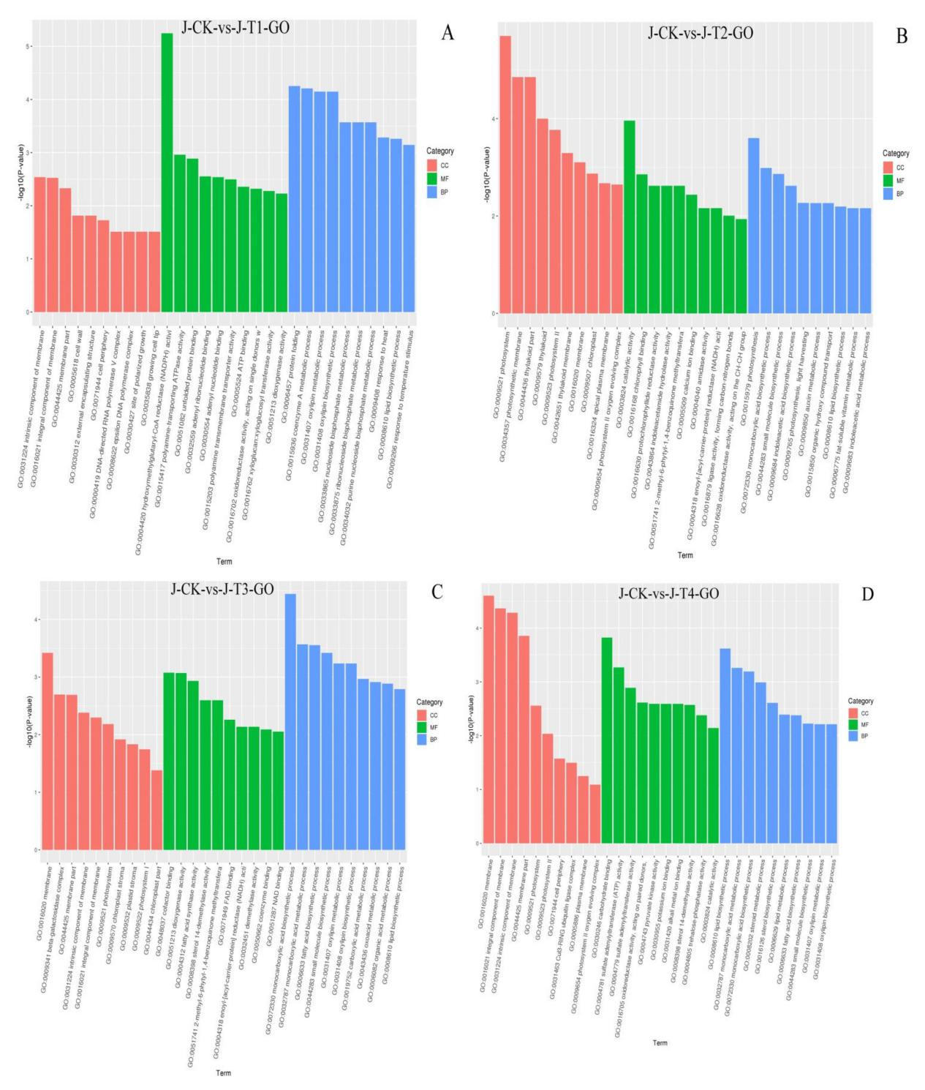
Fig. S3 Statistical map of GO classification of genes with significant differences in Jun jujube (A-D)
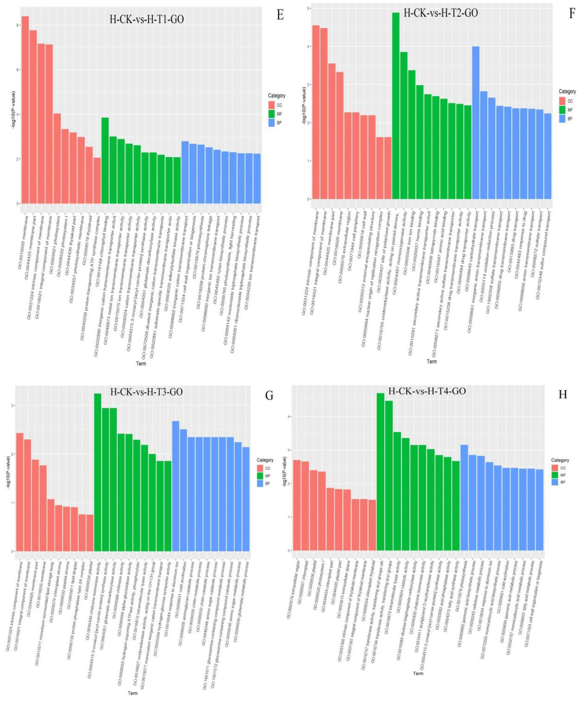
Fig. S4 Statistical map of GO classification of genes with significant differences in Hui jujube (E-H)

