Supplementary Information
“Ultrafast interfacial carrier dynamics and persistent topological surface states in VSe₂/Bi₂Se₃ van der Waals heterojunctions”
Tae Gwan Park¹, Jae Ho Jeon², Seung-Hyun Chun², Sunghun Lee^{2,}*, Fabian Rotermund^{1,}*

¹Department of Physics, Korea Advanced Institute of Science and Technology (KAIST), Daejeon 34141, Republic of Korea
²Department of Physics and Astronomy, Sejong University, Seoul 05006, Korea

*Correspondence to: kshlee@sejong.ac.kr (S.L.) and rotermund@kaist.ac.kr (F.R.)
Note S1: Hall resistance of 10 QL Bi₂Se₃

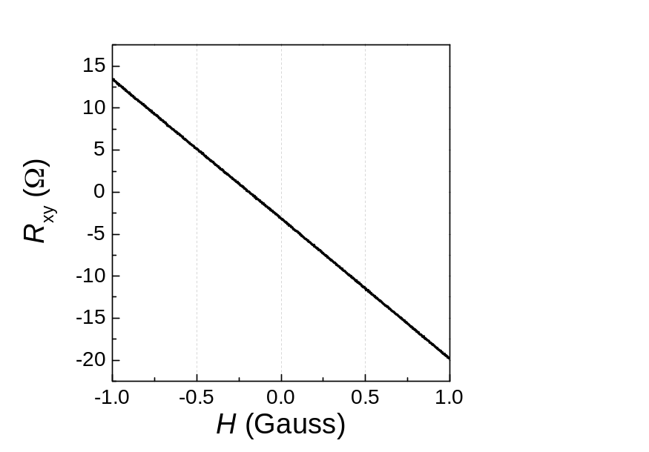
Figure S1. Hall resistance as a function of magnetic field of 10 QL Bi₂Se₃ thin film at room temperature. The slope indicates n-type semiconductor and the estimated three-dimensional carrier density is 3.13×10²⁰ cm⁻³.
Note S2: Coherent phonon dynamics in VSe₂/Bi₂Se₃ heterostructures (VBHs)
As shown in Figure S2, a significant echo signal was observed in VSe₂/Bi₂Se₃ heterostructures (VBHs). The prominent coherent acoustic signal was obtained from the pump-probe data by extracting bi-exponential decays, representing the carrier dynamics as shown in Figure S2a.

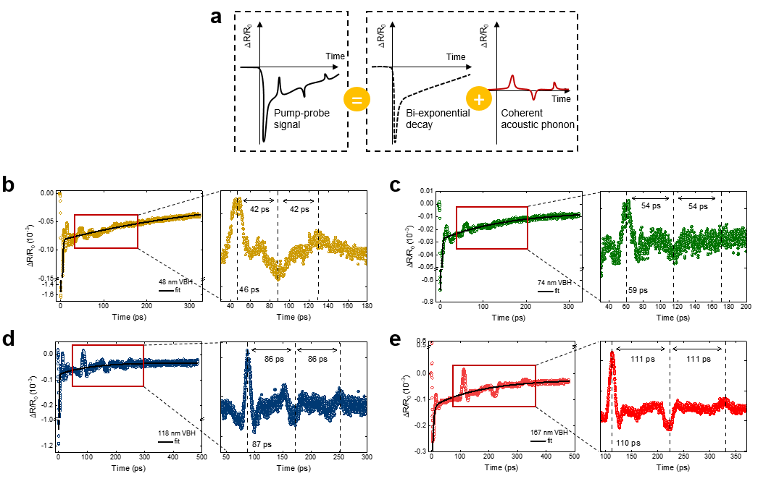
Figure S2. Coherent phonon dynamics in VSe₂/Bi₂Se₃ heterostructures (VBHs). (a) Schematic illustration of coherent phonon propagation signals containing in pump-probe data. (b)-(e) Pump-probe data and the abstracted coherent phonon signals at heterostructures of 48, 74, 118, and 167 nm VSe₂ and Bi₂Se₃, respectively. The black curves indicate the fitting results with bi-exponential decay. The red boxes indicate the interested region and plotted with magnification in each right panel.

Note 3: Transient reflectance (TR) and absorption (TA) spectra in Bi₂Se₃
In the transient reflectance (TR) measurements in Bi₂Se₃, we observed the photobleaching, which leads to a decrease in optical reflectance and absorption at near zero-delay as shown in Figure S3a and S3b. The derivative-like features in Bi₂Se₃ begun to exhibit at 2 ps as indicated by the vertical white lines. This spectral feature showed the dynamics of the blue shift from 0.9 to 0.96 eV over time as indicated by the curved black arrows in Figure S3a and S3b. For the 1.5 eV pump excitation, the energy of excited electrons is higher than the optical transition energy. Consequently, the optical transition was possible at lower energy than that of equilibrium. The excited carriers relaxed toward the conduction band minimum (CBM) for electrons and the valence band maximum (VBM) for holes by efficient electron-phonon coupling during a few ps. Subsequently, the optical transition energy showed the dynamics of blue shift during 5 ps. After this time, the stable derivative-like features were observed by electrons in CBM and holes in VBM for several tens of ps as shown in Figure S3a.

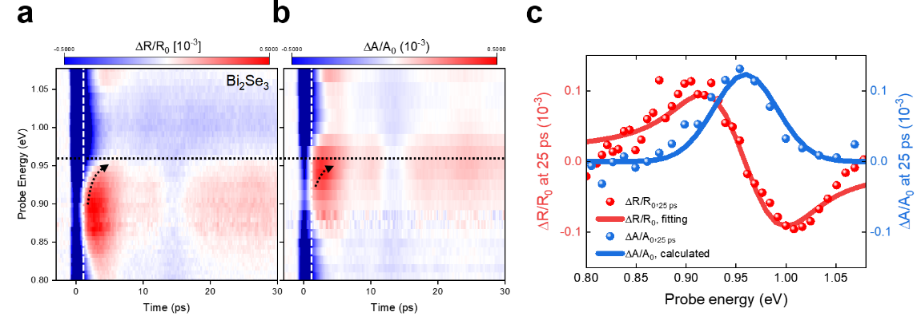

Figure S3. Transient reflectance/absorption (TR/TA) response in Bi₂Se₃. (a) TR response in Bi₂Se₃. (b) TA response in Bi₂Se₃. (c) TR/TA spectra at 25-ps delay time (vertical dashed lines in a). The red line indicates the model fit to the experimental data and the blue line indicates the corresponding calculated absorption change.

Note S4: TR spectroscopy in bare VSe₂

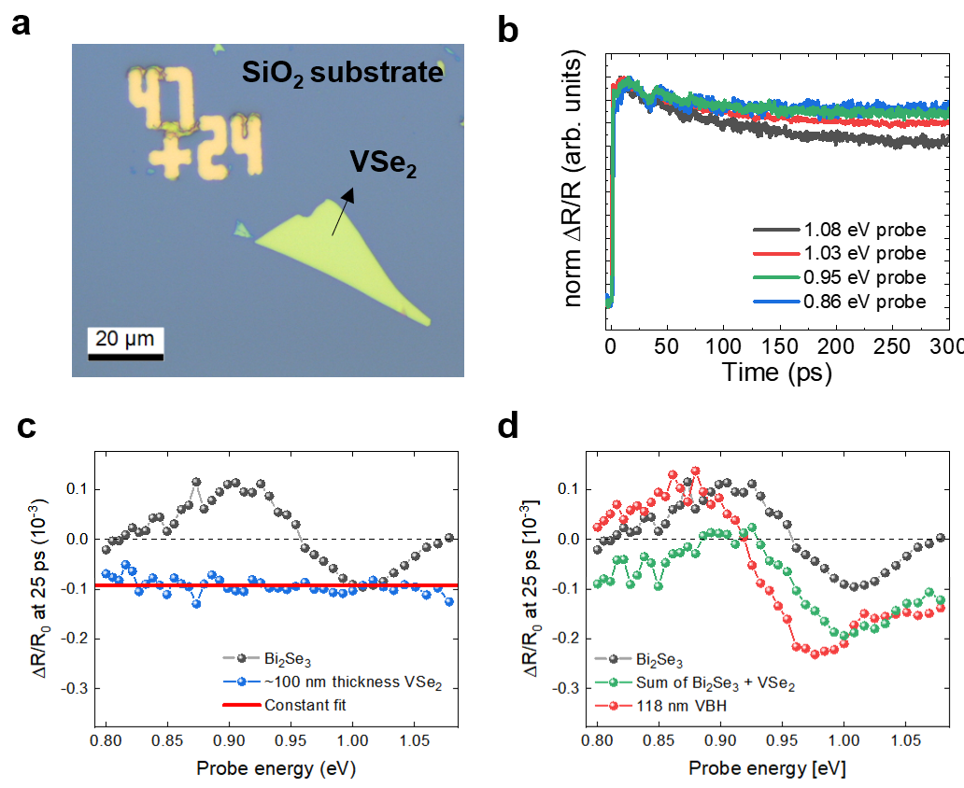
Figure S4. TR response in bare VSe₂. (a) Optical image of bare VSe₂ on SiO₂ with thickness of ~100 nm. (b) Decay kinetics in bare VSe₂ on SiO₂. The normalized differential reflectance measured in bare VSe₂ at various probe energy.. (c) The TR spectra at 25 ps delay time in Bi₂Se₃ and VSe₂. The horizontal red line indicates the constant fit result on VSe₂. (d) Comparison of TR spectra at 25 ps between 118-nm VBH (red), simple TR sum (green) of Bi₂Se_{3,} and ~100-nm thick bare VSe₂.

To confirm whether the observed redshift of the transition energy in VBHs is an interfacial effect or a simple sum of the TR signals of VSe₂ and Bi₂Se₃, the TR measurement was performed in bare VSe₂. We prepared the bare VSe₂ sample by mechanical exfoliation and transferred it onto the SiO₂ substrate (Figure S4a). The expected thickness of the prepared bare VSe₂ was about 100 nm. As shown in Figure S4b, the observed decay characteristics in bare VSe₂ on SiO₂ were significantly slow compared to Bi₂Se₃. It can be seen that the excited electrons in VSe₂ recover relatively quickly at large probe energies, but in our available delay range, the decay constant was difficult to obtain due to the slow decay (~only 10-25% recovery). From this, we concluded that the observed shortened decay times in VBH (Figure 4f) were not originated from decay characteristics in bare VSe₂. The TR response of bare VSe₂ shows a negative signal of decreased reflectance in overall probe energy (Figure S4c). The TR spectra at 25 ps exhibited almost constant differential reflectance $(\frac{∆R}{R_{0}}=-0.9×{10}^{-3})$ as shown in Figure S4c. The comparison between 118-nm VBH and simple summation of Bi₂Se₃ and VSe₂ unambiguously shows that the observed redshift of optical transition in VBH is originated not only from the TR response in VSe₂ but also the interfacial effect as shown in Figure S4d.

Note S5: Decay times in Bi₂Se₃, and VBHs

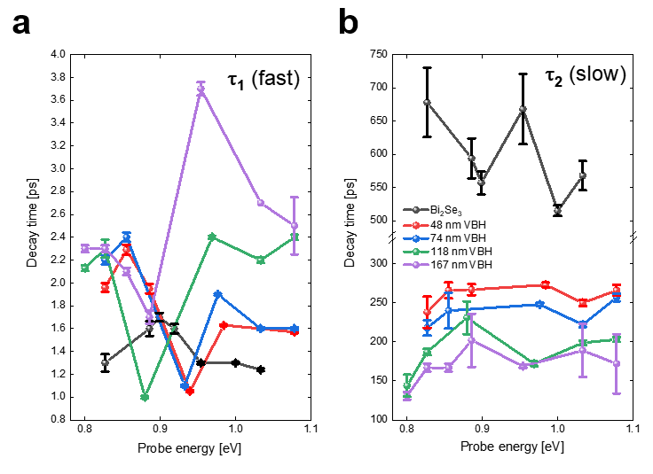
Figure S5. Decay constants in Bi₂Se₃ and VBHs obtained by fitting with bi-exponential decay. (a) Fast decay constant ($τ_{1}$) indicating the hot carrier cooling. (b) Slow decay constant ($τ_{2}$) indicating the carrier recombination time.

