Figures
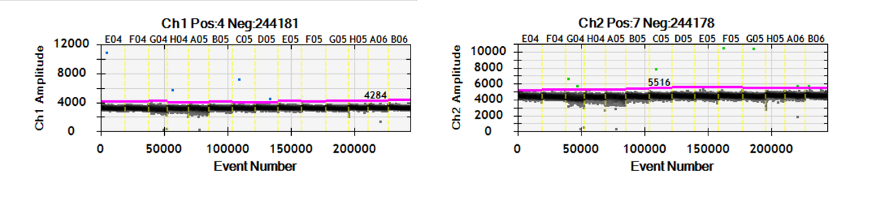Fig. S1 The result of limit of blank (LOB) from 10 NGS-negative CSF samples and 4 no-template controls.

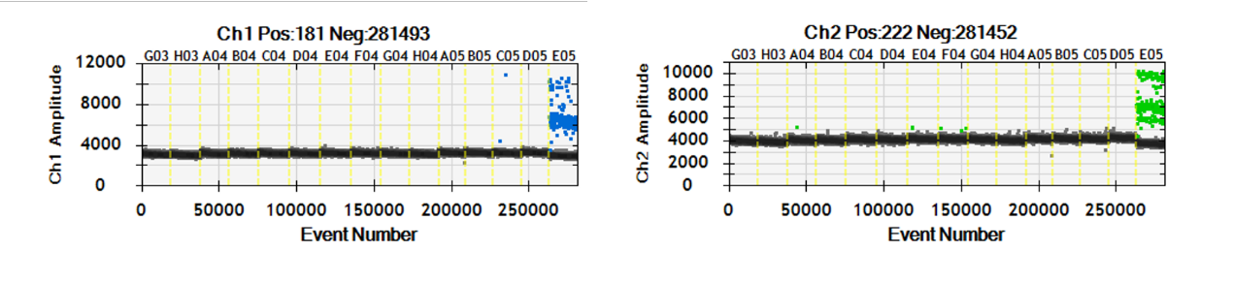
Fig. S2 The result of analytical specificity from 14 pathogens and positive control (E05).

