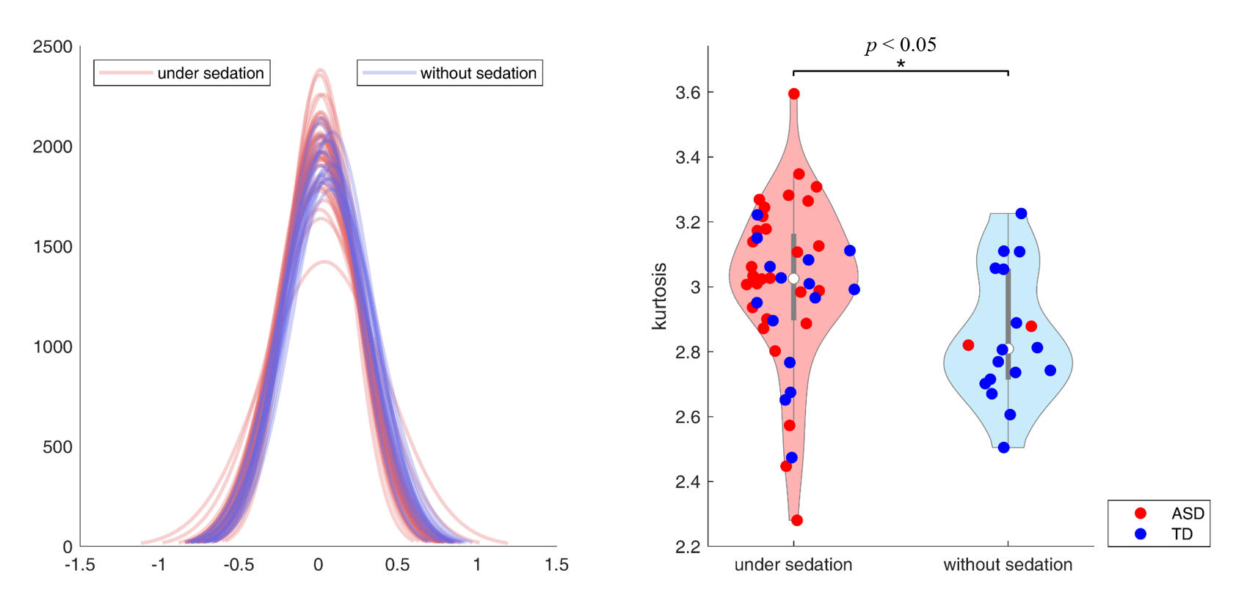
Supplementary Fig. 2 Distribution of the correlation coefficients
The distribution of the correlation coefficients between the groups with and without sedation represented by light pink and light purple colors, respectively, is shown here. To compare the shape of this distribution, the kurtosis of the correlation distribution of each participant was compared between the groups with and without sedation. The mean peakness of the correlation distribution was higher in the group with sedation than in the group without sedation (p < 0.05), indicating that there are more edges with connectivity values closer to zero in the sedation group.
(ASD group, children with autism spectrum disorder; TD group, children with typical development)
*The significant difference of mean peakness was found at p < 0.05.

