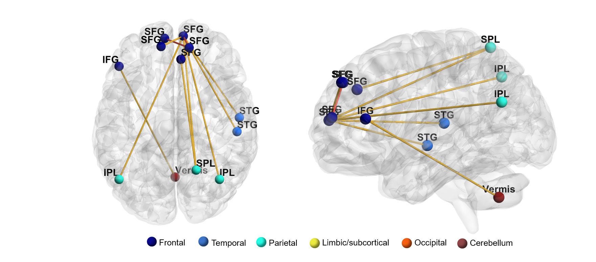
Supplementary Fig. 1 Group differences between the preschool children (age, 2–6 years) of the autism spectrum disorder group and typical development group
The edges show significantly increased SLD in the ASD group (red: p < 0.05, FDR corrected; yellow: p < 0.00005, uncorrected).
(ASD group, children with autism spectrum disorder; TD group, children with typical development; SLD, single linkage distance; FDR, false discovery rate; R, right; L, left; IPL, inferior parietal lobule; IFG, inferior frontal gyrus; SFG, superior frontal gyrus; ITG, inferior temporal gyrus; STG, superior temporal gyrus)

