Figure 1 Original western blot picture shows PSBP-1 or FKBP13 pull-down results. Left four lines stand for the input of GST and GST-PSBP-1 or GST-FKBP13. The next four lines stand for the pull-down results.

Figure 2 Original western blot picture shows 21500F pull-down results.
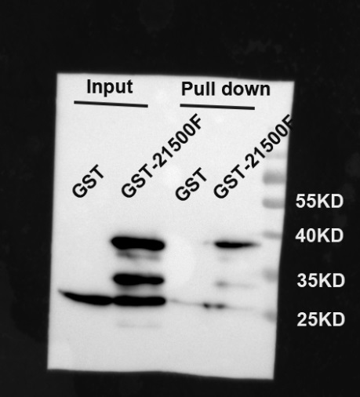
Figure 3 Original western blot picture shows TLP17.9F pull-down results. The dotted box means other samples which are not related in this paper.
