Appendix A. Questions provided to participants for the semi-structured interviews
Question One | You are responsible for the management of a 32 year-old male running athlete with posterior ankle pain. In your clinical practice what assessments (including what would you consider a positive or negative finding) would you use to include or exclude a diagnosis of mid-portion Achilles tendinopathy in this patient?
Question Two | Are there any assessments you do not use clinically but would use more frequently in an “ideal world”? If so, what are the barriers to you using these measures in your clinical practice?
Question Three | Now that we have established what assessments you would use to diagnose tendinopathy which of these following domains (you can choose more than one) would you consider the most important in the diagnosis of mid-portion Achilles tendinopathy; 1) patient rating of the condition, 2) participation in life activities, 3) pain on activity/ loading, 4) function, 5) psychological factors, 6) physical function capacity, 7) disability, 8) quality of life, 9) pain over a specified time, 10) tendon structure, 11) palpation, or 12) range of motion? Why do you feel they are the most important?
Question Four | You have now diagnosed the patient with mid-portion Achilles tendinopathy. In an ideal world where no barriers to what you want to do exist which outcome measures would you use to monitor the progress of this patient over time and how often would you administer these outcome measures?
Question Five | In the last question I wanted to know what you would do in an ideal world, however we know that what happens in the real world is often different to the ideal world due to a number of barriers. What outcome measures do you currently use within your own clinical practice to monitor progress over time, and how often do you assess them?
Question Six | What are the most prominent barriers preventing you from translating your “real world” monitoring to the “ideal world” monitoring?
Question Seven | Now that we have identified the outcome measures that you use clinically in the “real world”, what would you consider a meaningful improvement for these outcome measures?
Question Eight | Now that we have established which outcome measures you think are the most important to monitor the progress of mid-portion Achilles tendinopathy over time which of the following domains (you can choose more than one) would you consider the most important when monitoring progress over time with mid-portion Achilles tendinopathy; 1) patient rating of the condition, 2) participation in life activities, 3) pain on activity/ loading, 4) function, 5) psychological factors, 6) physical function capacity, 7) disability, 8) quality of life, 9) pain over a specified time, 10) tendon structure, 11) palpation, and 12) range of motion? Why do you feel they are the most important?

Appendix B. Personal Characteristics of Interviewers
Interviewer | Credentials | Occupation | Gender | Experience and Training
JD | PT, PhD | University Academic and clinician | Male | Conducted qualitative research including semi-structured interviews. Conducted research with participants with AT. Worked for greater than ten years in clinical practice communicating with patients and managing patients with Achilles tendinopathy.
WG | PT, PhD | University Academic | Male | Conducted qualitative research including semi-structured interviews. Also worked for greater than ten years in clinical practice communicating with patients and managing patients with Achilles tendinopathy.
MM | PT | University Academic and clinician | Male | Has worked for greater than five years in clinical practice communicating with patients and managing patients with Achilles tendinopathy.
MT | PT, PhD | University Academic and clinician | Male | Conducted qualitative research including semi-structured interviews. Also worked for greater than ten years in clinical practice communicating with patients and managing patients with Achilles tendinopathy.
Legend: PT= Physiotherapist, PhD= Doctor of Philosophy
Appendix C. Inclusion Criteria for Sub-groups.
Sub-group | Inclusion Criteria
Junior physiotherapists | - Graduated from undergraduate studies for less than five years.  - No graduate qualifications in sports physiotherapy (Australian Qualifications Framework Level 7)
Senior physiotherapists working in private practice | - Graduated from undergraduate studies for greater than 5 years  - Graduate qualifications in sports physiotherapy of at least a master’s level (Australian Qualifications Framework Level 9 or 10)
Senior physiotherapists working in elite sport | - Graduated from undergraduate studies for greater than 5 years  - Graduate qualifications in sports physiotherapy of at least a master’s level (Australian Qualifications Framework Level 9 or 10)  - Have held a position (either full-time or part-time) with either a national or international sport
Sport and Exercise Medicine Doctors | - Be accredited by the Australasian College of Sport and Exercise Physicians, or  - Be a registrar of the Australasian College of Sport and Exercise Physicians training program for a minimum of two years.

Appendix D. Geographical distribution of participants
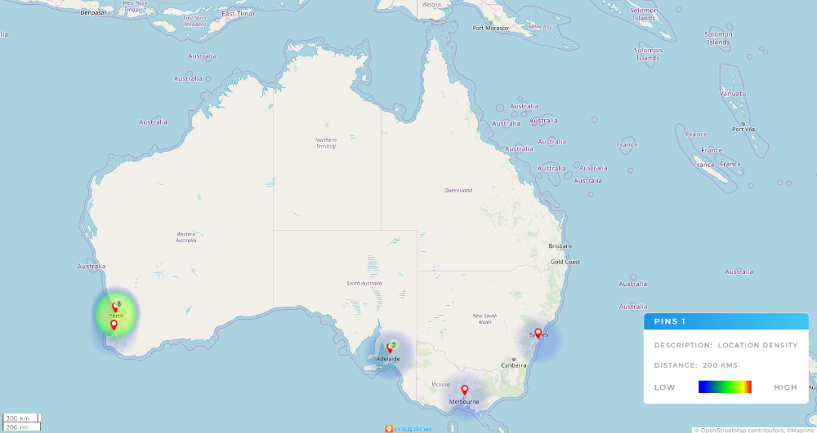

Appendix F. Additional assessments clinicians would perform in an ‘ideal world’ setting to assist diagnosis
Key theme | Description of health domain from ICON 2019¹⁹ | Exemplar Quotes
Physical function capacity | "Quantitative measures of physical tasks performed in clinic (eg, number of hops, timed stair walk, number of single limb squats, including dynamometry (strength) and wearable technology)"¹⁹ | “Jumping, landing strategies and how that could look on a force plate.” (Participant 11)  “Jump test with like a force place or something like that in an ideal world, maybe, working with a professional sporting environment” (Participant 12)
Disability | “Composite scores of a mix of patient-rated pain and disability due to the pain, usually relating to tendon-specific activities/tasks (eg, VISA scales, patient-rated tennis elbow evaluation, disability of the arm, shoulder and hand).”¹⁹ | “So I have absolutely no reason to not use them (self-reported outcome measures) because they're right there. Previously, I probably would have used a lower limb, like functional scale.” (Participant 4)
Tendon structure* | “Tendon tissue characteristics (eg, MRI, US, biopsy).”¹⁹ | “You certainly can get imaging… like if there were no barriers, I suppose, definitely not a bad thing to have a look at.” (Participant 11)  “I have access to ultrasound at both places I work at. But I don't [use it], I think it's beyond my scope of practice or my area of expertise. Would love to learn it.” (Participant 9)
*Tendon structure was not listed as a core health domain of tendinopathy in the ICON statement.

Appendix G. Additional assessments performed by clinicians in an ‘ideal world’ setting to monitor progress
Key theme | Description of health domain from ICON 2019¹⁹ | Exemplar Quote
Tendon structure | “Tendon tissue characteristics (eg, MRI, US, biopsy).”¹⁹ | “Well, if we are talking in an ideal world, if we want it to be really sure we knew what was going on inside there, then I think that UTC (ultrasound tissue characterisation) would be a useful tool if we really want it to be quite clear on that.” (Participant 3)  “10-12 weeks of exercise, or whatever it is, then you can bring imaging and say, is there any physical changes within tendon?” (Participant 6)
Disability | “Composite scores of a mix of patient-rated pain and disability due to the pain, usually relating to tendon-specific activities/tasks (eg, VISA scales, patient-rated tennis elbow evaluation, disability of the arm, shoulder and hand).”¹⁹ | “You may introduce a VISA or a, like I said, I haven't been very good at using… physical outcome measures.” (Participant 5)
Physical function capacity | “Quantitative measures of physical tasks performed in clinic (eg, number of hops, timed stair walk, number of single limb squats, including dynamometry (strength) and wearable technology).”¹⁹ | “Maybe the force plate… [Interviewer - how would you measure that?] No idea.” (Participant 6)

Appendix E. Codebook
Name | Description
Assessment_IdealWorld
Disability
Function
Other
Pain on activity or loading
Pain over a specfied time
Palpation
Participation in life activities
Patient rating of the condition
Physical function capacity
Psychological factors
Quality of life
Range of motion
Tendon structure
Assessment_Least Important Domains
Disability
Function
Other
Pain on activity or loading
Pain over a specficied time
Palpation
Participation in life activities
Patient rating of the condition
Physical function capacity
Psychological factors
Quality of life
Range of motion
Tendon structure
Assessment_Most Important Domains
Disability
Function
Other
Pain on activity or loading
Pain over a specficied time
Palpation
Participation in life activities
Patient rating of the condition
Physical function capacity
Psychological factors
Quality of life
Range of motion
Tendon structure
Assessment_RealWorld
Disability
Function
Other
Pain on activity or loading
Pain over a specficied time
Palpation
Participation in life activities
Patient rating of the condition
Physical function capacity
Psychological factors
Quality of life
Range of motion
Tendon structure
Monitoring_Barriers
Access to equiptment and facilities
Access to Sports Medicine
Decreased monitoring once improving well.
Engagement with management plan
Financial
Good communication between health care practitioners
Knowledge of what to assess and monitor
Motivation to prepare PROMs
Patient compliance to monitoring
Patient symptom severity
Patient understanding of SROMs
Time
Monitoring_Clinically Meaningful
General improvement
Numeric
Monitoring_Ideal World
Disability
Function
Other
Pain on activity or loading
Pain over a specficied time
Palpation
Participation in life activities
Patient rating of the condition
Physical function capacity
Psychological factors
Quality of life
Range of motion
Tendon structure
Monitoring_Least Important Domains
Disability
Function
Other
Pain on activity or loading
Pain over a specficied time
Palpation
Participation in life activities
Patient rating of the condition
Physical function capacity
Psychological factors
Quality of life
Range of motion
Tendon structure
Monitoring_Most Important Domains
Disability
Function
Other
Pain on activity or loading
Pain over a specficied time
Palpation
Participation in life activities
Patient rating of the condition
Physical function capacity
Psychological factors
Quality of life
Range of motion
Tendon structure
Monitoring_Real World
Disability
Function
Other
Pain on activity or loading
Pain over a specficied time
Palpation
Participation in life activities
Patient rating of the condition
Physical function capacity
Psychological factors
Quality of life
Range of motion
Tendon structure

