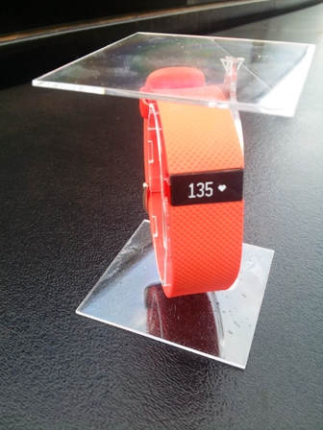
Plate 1. FitbitCharge HR

