Supplementary Material for
Distribution, source apportionment and health risk assessment of phthalate esters in indoor dust samples across China
Xu Li^{1,3}, Wenping Zhang^{1,3}, Jiapei Lv^{1,2,3}, Wenxiu Liu^{1,2,3}, Shanwei Sun^{1,2,3}, Changsheng Guo^{1,2,3*}, Jian Xu^{1,2,3}
* Correspondence: guocs@craes.org.cn

¹ State Key Laboratory of Environmental Criteria and Risk Assessment, Chinese Research Academy of Environmental Sciences, Beijing 100012, China
² State Environmental Protection Key Laboratory of Ecological Effect and Risk Assessment of Chemicals, Chinese Research Academy of Environmental Sciences, Beijing 100012, China
³ Center for Environmental Health Risk Assessment and Research, Chinese Research Academy of Environmental Sciences, Beijing 100012, China

Number of pages: 17
Number of Figures: 5
Number of Tables: 4

List
1. Method of positive matrix factorization model (PMF).
2. Table S1 Molecular structures and select physicochemical properties of target phthalate esters.
3. Table S2 Limits of detection (LODs) and limits of quantitation (LOQs) of individual phthalate esters.
4. Table S3 Parameters used in human exposure estimation and health risk assessments.
5. Table S4 Phthalates median concentrations (μg·g⁻¹) in indoor dust from different countries.
6. Figure S1 The sampling locations in China.
7. Figure S2 Detection frequency of PAEs in indoor dusts from seven regions in China.
8. Figure S3 Principal component analysis results for PAEs in indoor dusts from residences.
9. Figure S4 Principal component analysis results for PAEs in indoor dusts from dormitories.
10. Figure S5 Plots of fit for the predicted Σ⁸PAEs concentrations: (a) PCA/PMF for residence; (b) PCA/PMF for dormitory.

1. Method of positive matrix factorization model (PMF)
The PMF model was proposed by Paatero and Tapper (1994) [1] and recommended by the U.S. Environmental Protection Agency for apportionment of pollution sources. Positive Matrix Factorization (PMF) model is a multivariate analysis which could distinguish different sources in a mixture and calculate their contributions to each species. Concentration matrix of samples was decomposed into factor contribution matrix and factor profile matrix with a residue matrix:
$X_{n×m}=G_{n×p}F_{p×m}+E_{n×m}$ (1)
X is the concentration matrix of sample includes n samples and m chemical species, G is the source contribution matrix, F is the source profiles matrix, E is the residual error matrix, and p is the number of the sources.
PMF determines the optimum number of factors using weighted least square problem in order to minimize an object function ‘Q’. Source contributions and profiles are calculated by minimizing the object function ‘Q’ in the PMF model, which is written as:
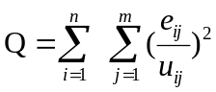 (2)
where m is the number of PAEs investigated, n is the number of indoor dust samples, e_{ij} is the error term and u_{ij} is an estimate of uncertainty of jth PAE for dust sample i. Two values, $Q_{true}$ and $Q_{robust}$ are calculated in the PMF model results which are significant parameters.
The estimation of uncertainties for the measurements was calculated using the formula:
$Unc=\sqrt{{(error fraction×concentration)}^{2}+{(0.5×MDL)}^{2}}$ (3)
where concentration is the measured value of compound and MDL is method detection limit for the measured compound, and error fraction is a percentage of the measurement uncertainty. Missing concentration values were replaced by the geometric mean of the corresponding species and the accompanying uncertainty was replaced by 4 times the geometric mean [2]. In general, chemical spaces are categorized as strong if S/N＞1, weak if 0.1<S/V<1 and bad if S/N <0.5.
In this study, the EPA PMF 5.0 model was used. Datasets with 72 (the number of samples) × 8 (the number of PAEs) elements for residence and 22×8 elements for dormitory were introduced to the model，respectively. The Q value was minimal and stable; most residuals were between +3.0 and -3.0 and basically followed a normal distribution. In this study, the values of $Q_{true}$ approximated the values of $Q_{robust}$, furthermore, the $Q_{true}$ values (392 for residence and 102.7 for dormitory) obtained by this solution were approach the theoretical values (336 for residence and 116 for dormitory) calculated by n×m+p (n×m), which suggesting that the calculated result is reasonable.
Table S1 Molecular structures and select physicochemical properties of target phthalate esters.
Compound | Molecular formula | CAS | MW | Molecular structure
dimethyl phthalate (DMP) | C₁₀H₁₀O₄ | 131-11-3 | 194.19 | 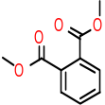
diethyl phthalate (DEP) | C₁₂H₁₄O₄ | 84-66-2 | 222.24 | 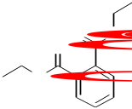
di-iso-butyl phthalate (DIBP) | C₁₆H₂₂O₄ | 84-69-5 | 278.35 | 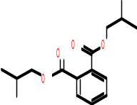
di-n-butyl phthalate (DBP) | C₁₆H₂₂O₄ | 84-74-2 | 278.35 | 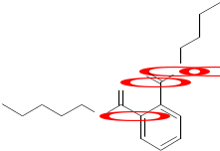
benzyl butyl phthalate (BzBP) | C₁₉H₂₀O₄ | 85-68-7 | 312.37 | 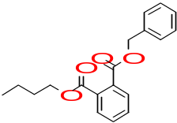
bis(2-ethylhexyl) phthalate (DEHP) | C₂₄H₃₈O₄ | 117-81-7 | 390.56 | 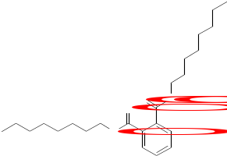
di-n-octyl phthalate (DnOP) | C₂₄H₃₈O₄ | 117-84-0 | 390.56 | 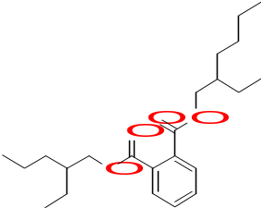
dinonyl phthalate (DNP) | C₂₆H₄₂O₄ | 84-76-4 | 418.61 | 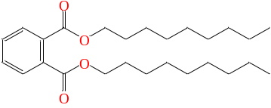

Table S2 Limits of detection (LODs) and limits of quantitation (LOQs) of individual phthalate esters.
 | DMP | DEP | DIBP | DBP | BzBP | DEHP | DnOP | DNP
LODs (μg·g⁻¹) | 0.0013 | 0.0033 | 0.0009 | 0.0008 | 0.0010 | 0.0011 | 0.0048 | 0.0032
LOQs (μg·g⁻¹) | 0.0038 | 0.0098 | 0.0027 | 0.0024 | 0.0029 | 0.0033 | 0.0143 | 0.0095

Table S3 Parameters used in human exposure estimation and health risk assessments.
Parameters | Unit | Children | Adults | men | women | References
IRingestion | mg·d⁻¹ | 72 | 50 | 50 | 50 | [3-5]
IRinhalation | m³·d⁻¹ | 8 | 15.7 | 18 | 14.5 | [3-5]
EF | d·y⁻¹ | 330 | 304 | 300 | 308 | [3-5]
ED | y | 6 | 24 | 24 | 24 | [6]
CF | kg·mg⁻¹ | 1.0×10⁻⁶ | 1.0×10⁻⁶ | 1.0×10⁻⁶ | 1.0×10⁻⁶ | [7]
BW | kg | 15.6 | 60.6 | 65 | 56.8 | [3-5]
average lifetime | y |  | 74.8 | 72.4 | 77.4 | [3-5]
AT (for  non-cancer risk) | d | 2190 | 8760 | 8760 | 8760 | [3-5, 7]
AT (for carcinogenic risk) | d |  | 25550 | 25550 | 25550 | [3-5, 7]
SA | cm² | 1700 | 4000 | 4250 | 3750 | [3-5, 8]
AF | mg·cm⁻²·d⁻¹ | 0.2 | 0.07 | 0.07 | 0.07 | [7]
ABS |  | 0.001 | 0.001 | 0.001 | 0.001 | [7,9]
PEF | m³·kg⁻¹ | 1.36×10⁹ | 1.36×10⁹ | 1.36×10⁹ | 1.36×10⁹ | [6]
RfD | mg·kg⁻¹·d⁻¹ | DMP | 10 |  |  | [10]
RfD | mg·kg⁻¹·d⁻¹ | DEP | 0.8 |  |  | [10]
RfD | mg·kg⁻¹·d⁻¹ | DnBP | 0.1 |  |  | [10]
RfD | mg·kg⁻¹·d⁻¹ | BBP | 0.2 |  |  | [10]
RfD | mg·kg⁻¹·d⁻¹ | DEHP | 0.02 |  |  | [10]
RfD | mg·kg⁻¹·d⁻¹ | DnOP | 0.4 |  |  | [10]
CFS | kg·d·mg⁻¹ | BBP | 1.90E-03 |  |  | [10]
CFS | kg·d·mg⁻¹ | DEHP | 0.014 |  |  | [10]

Table S4 Phthalates median concentrations (μg·g⁻¹) in indoor dust from different countries.

Country | N | DMP | DEP | DIBP | DBP | BBzP | DEHP | DnOP | DNP | Reference
Asia
Chinaª | 22 | 0.124 | 0.092 | 9.017 | 12.168 | 0.052 | 34.651 | 0.134 | 0.137 | This study
China^{b} | 72 | 0.151 | 0.161 | 8.837 | 23.560 | 0.123 | 50.794 | 0.262 | 0.185 | This study
China* | 120 | 0.693 | 0.187 | 17.1 | 26.4 | 0.04 | 105 | 0.342 | — | [7]
Japan | 128 | <LOD | <LOD | 3.1 | — | 2 | 1110 | — | — | [11]
Saudi Arabia | 15 | 0.6 | 1.4 | 22 | 33 | 0.8 | 1022 | 27 | — | [12]
Kuwait | 15 | 0.1 | 2.7 | 17 | 2 | 1 | 240 | 3 | — | [12]
America
Albany/USA | 33 | 0.08 | 2 | 3.8 | 13.1 | 21.1 | 304 | 0.4 | — | [13]
Delaware/USA | 10 | — | 1.8 | — | 12 | — | 339 | — | — | [14]
California/USA* | 39 | — | 1.7 | 10.6 | 18.2 | 68.8 | 179.5 | — | — | [15]
Europe
Sweden | 62 | 0.6 | 5.2 | 7.9 | 38 | — | 538 | 17 | — | [16]
France | 7 | 0.35 | 4.9 | 20 | 9.1 | — | 462 | — | — | [17]
Canada | 126 | 0.12 | 2 | 5.17 | 16.8 | 42.3 | 462 | — | — | [18]
Germany | 30 | 10.8 | 44.6 | — | — | — | 775.5 | — | — | [19]
Belgium | 18 | — | 1.4 | 9.4 | — | — | 62 | — | — | [20]
Netherlands | 9 | <LOD | 0.23 | 4.7 | — | — | 111 | — | — | [20]
Ireland | 6 | — | 0.64 | 7 | — | — | 114 | — | — | [20]
ª : dormitory.
^{b} : residence.
*: Mean concentration.
—: not available.

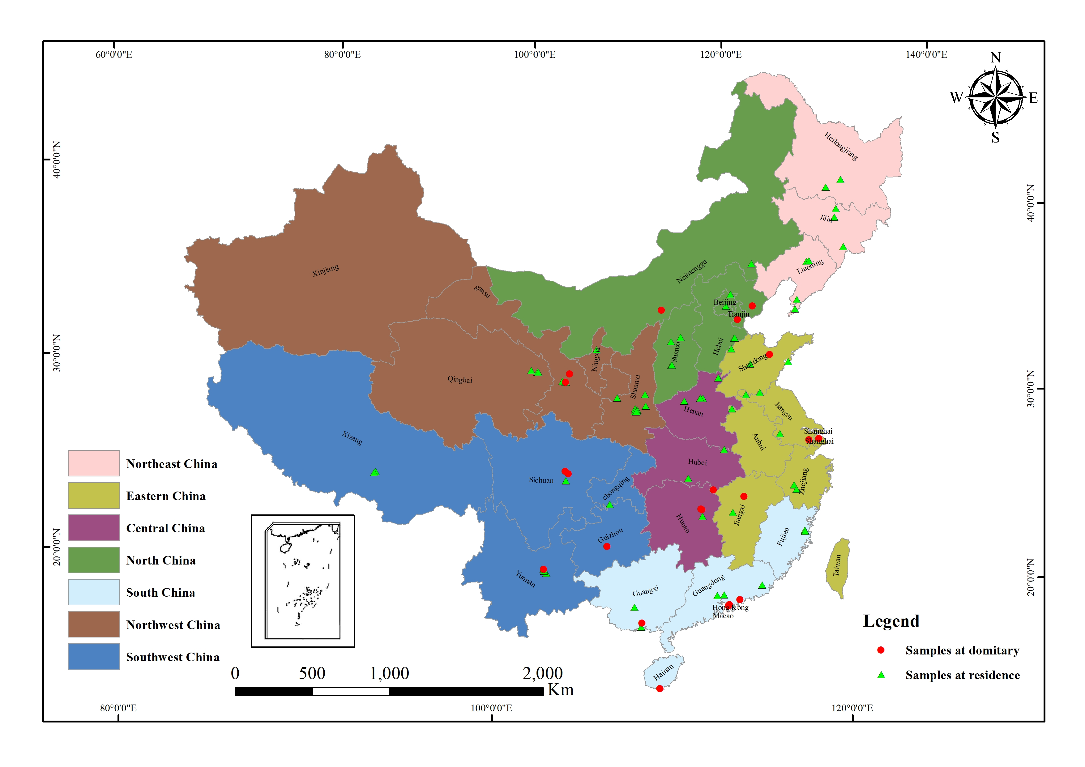
Fig S1 The sampling locations in China.

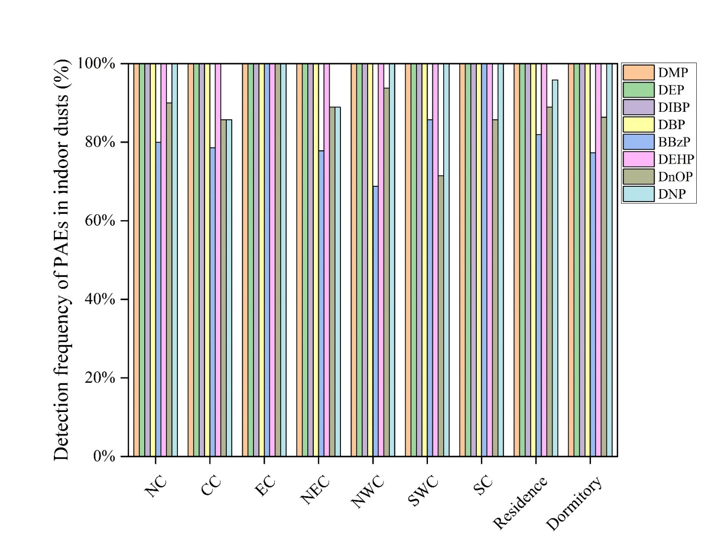
Figure S2 Detection frequency of PAEs in indoor dusts from seven regions in China.

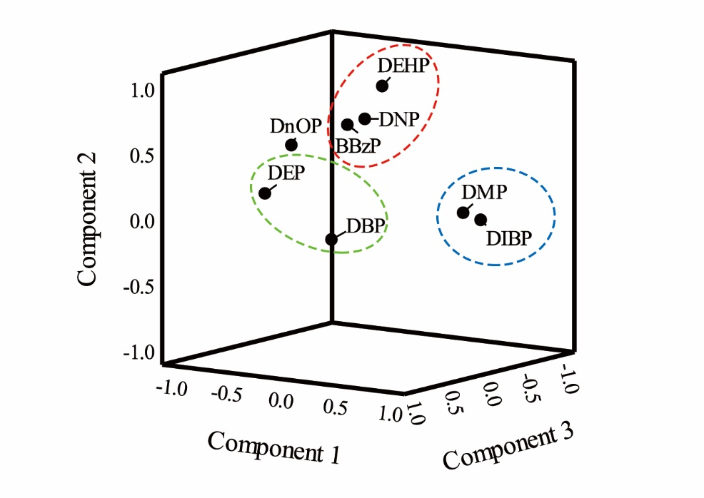
Figure S3 Principal component analysis results for PAEs in indoor dusts from residences.
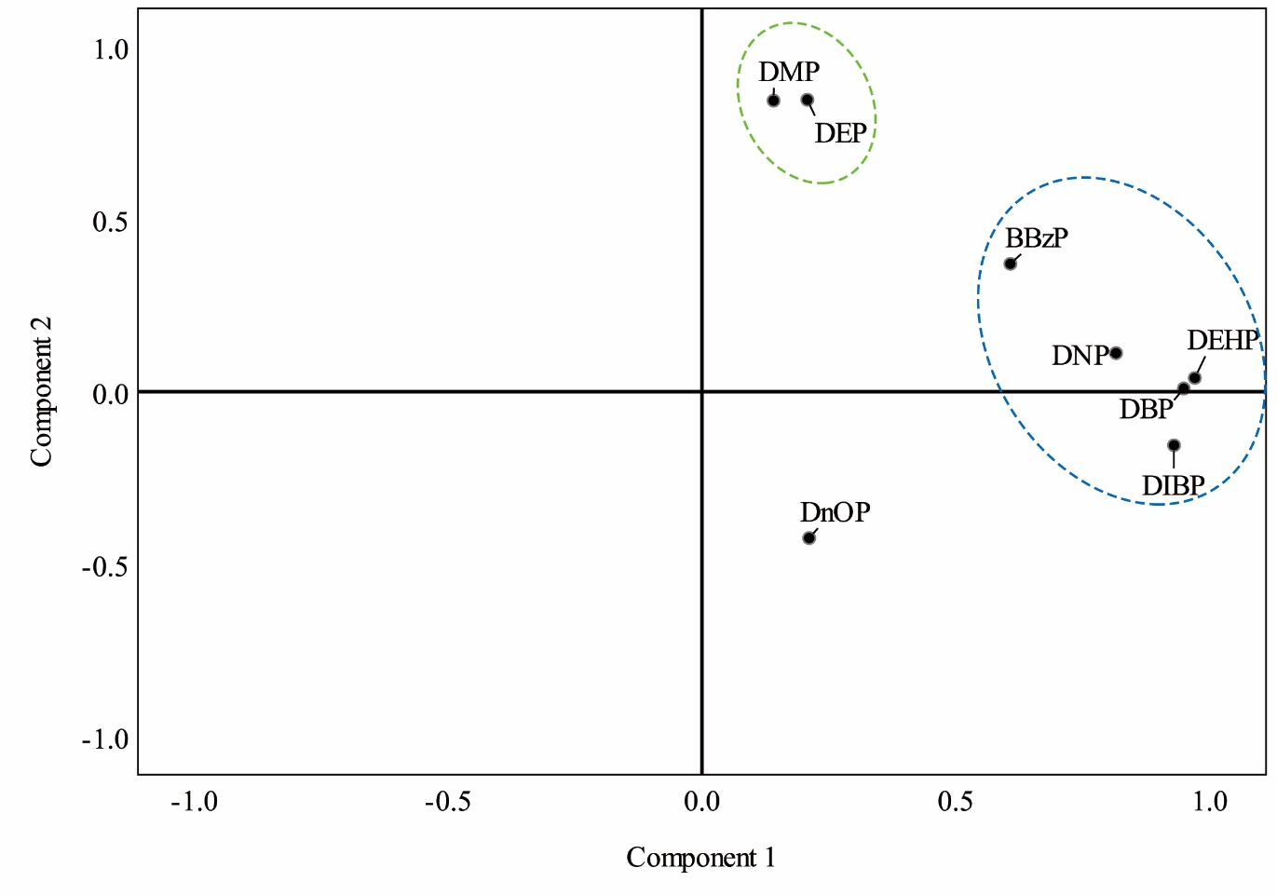
Figure S4 Principal component analysis results for PAEs in indoor dusts from dormitories.

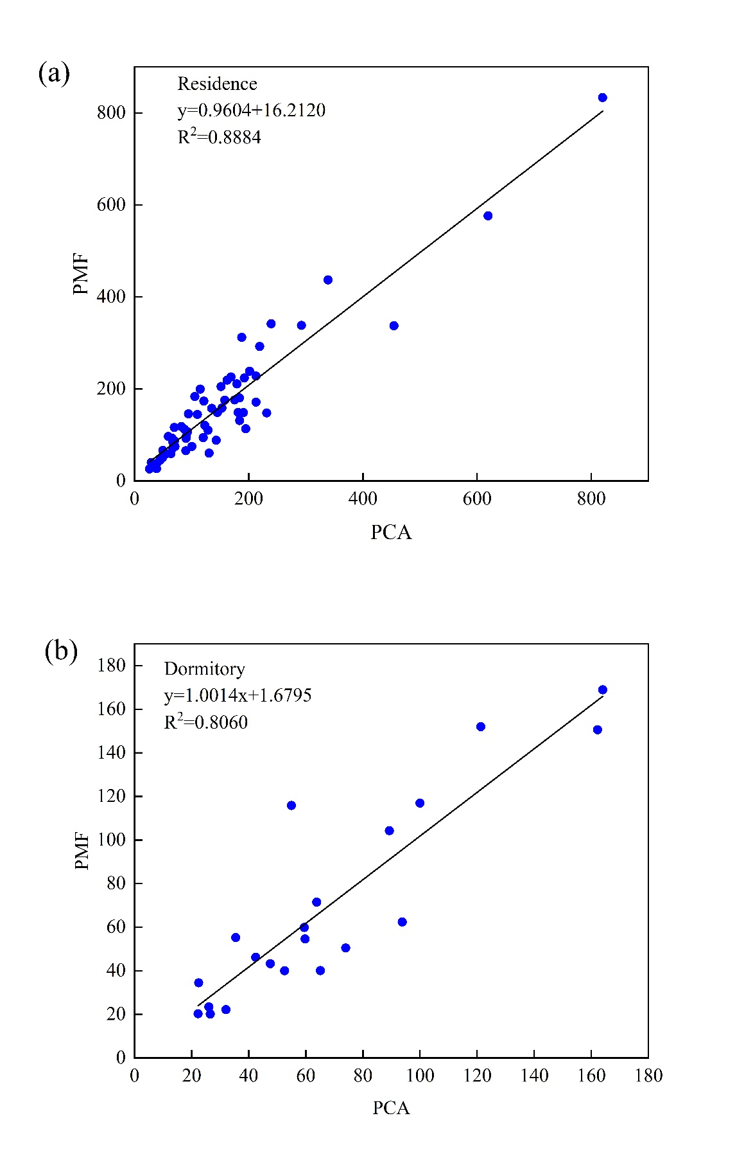
Figure S5. Plots of fit for the predicted Σ₈PAEs concentrations: (a) PCA/PMF for residence; (b) PCA /PMF for dormitory.

Reference
1. Paatero P, Tapper U (1994) Positive matrix factorization: A non-negative factor model with optimal utilization of error estimates of data values. Environmetrics. 5(2): 111-126.
2. Srivastava D, Tomaz S, Favez O, Lanzafame GM, Golly B, Besombes JL, Alleman LY, Jaffrezo JL, Jacob V, Perraudin E, Villenave E, Albinet A (2018) Speciation of organic fraction does matter for source apportionment. Part 1: A one-year campaign in Grenoble (France). Sci Total Environ 624: 1598-1611.
3. Ministry of Ecology and Environment of the People's Republic of China (2016) Exposure Factors Handbook of Chinese Population (0-5years). Beijing: China Environmental Press (in Chinese).
4. Ministry of Ecology and Environment of the People’s Republic of China (2016) Exposure Factors Handbook of Chinese Population (6-17years). Beijing: China Environmental Press (in Chinese).
5. Ministry of Ecology and Environment of the People's Republic of China (2016) Exposure Factors Handbook of Chinese Population (adults). Beijing: China Environmental Press (in Chinese).
6. US EPA (2001) Supplemental Guidance for Developing Soil Screening Level for Superfund Sites. OSWER 9355.4–24. Office of Solid Waste and Emergency Response, Washington.
7. Zhu Q, Jia J, Zhang K, Zhang H, Liao C, Jiang G (2019) Phthalate esters in indoor dust from several regions, China and their implications for human exposure. Science of the Total Environment 652: 1187-1194.
8. Beijing Municipal Research of Environmental Protection (BMREP) (2009) Guidelines for the assessment of the site environment in Beijing (DB11T-656-2009). Beijing: Beijing Bureau of Quality and Technical Supervision (in Chinese).
9. Ferreira-Baptista L, De Miguel E (2005) Geochemistry and risk assessment of street dust in Luanda, Angola: A tropical urban environment. Atmospheric Environment 39(25): 4501-4512.
10. Wang L, Liu M, Tao W, Zhang W, Wang L, Shi X, Lu X, Li X (2018) Pollution characteristics and health risk assessment of phthalate esters in urban soil in the typical semi-arid city of Xi'an, Northwest China. Chemosphere 191: 467-476.
11. Ait Bamai Y, Araki A, Kawai T, Tsuboi T, Saito I, Yoshioka E, Kanazawa A, Tajima S, Shi C, Tamakoshi A, Kishi R (2014) Associations of phthalate concentrations in floor dust and multi-surface dust with the interior materials in Japanese dwellings. Science of the Total Environment 468-469: 147-157.
12. Albar HMSA, Ali N, Shahzad K, Ismail IMI, Rashid MI, Wang W, Ali LN, Eqani SAMAS (2017) Phthalate esters in settled dust of different indoor microenvironments; source of non-dietary human exposure. Microchemical Journal 132: 227-232.
13. Guo Y, Kannan K (2011) Comparative assessment of human exposure to phthalate esters from house dust in China and the United States. Environmental Science & Technology 45(8): 3788-3794.
14. Bi X, Yuan S, Pan X, Winstead C, Wang Q (2015) Comparison, association, and risk assessment of phthalates in floor dust at different indoor environments in Delaware, USA. Journal of Environmental Science and Health, Part A 50(14): 1428-1439.
15. Gaspar FW, Castorina R, Maddalena RL, Nishioka MG, McKone TE, Bradman A (2014) Phthalate Exposure and Risk Assessment in California Child Care Facilities. Environmental Science & Technology 48(13): 7593-7601.
16. Luongo G, Ostman C (2016) Organophosphate and phthalate esters in settled dust from apartment buildings in Stockholm. Indoor Air 26(3): 414-425.
17. Mercier F, Gilles E, Saramito G, Glorennec P, Le Bot B (2014) A multi-residue method for the simultaneous analysis in indoor dust of several classes of semi-volatile organic compounds by pressurized liquid extraction and gas chromatography/tandem mass spectrometry. Journal of Chromatography A 1336: 101-111.
18. Kubwabo C, Rasmussen PE, Fan X, Kosarac I, Wu F, Zidek A, Kuchta SL (2013) Analysis of selected phthalates in Canadian indoor dust collected using household vacuum and standardized sampling techniques. Indoor Air 23(6): 506-514.
19. Fromme H, Lahrz T, Piloty M, Gebhart H, Oddoy A, Ruden H (2004) Occurrence of phthalates and musk fragrances in indoor air and dust from apartments and kindergartens in Berlin (Germany). Indoor Air 14(3): 188-195.
20. Christia C, Poma G, Harrad S, de Wit CA, Sjostrom Y, Leonards P, Lamoree M, Covaci A (2019) Occurrence of legacy and alternative plasticizers in indoor dust from various EU countries and implications for human exposure via dust ingestion and dermal absorption. Environmental Research 171: 204-212.

