Supplementary Materials

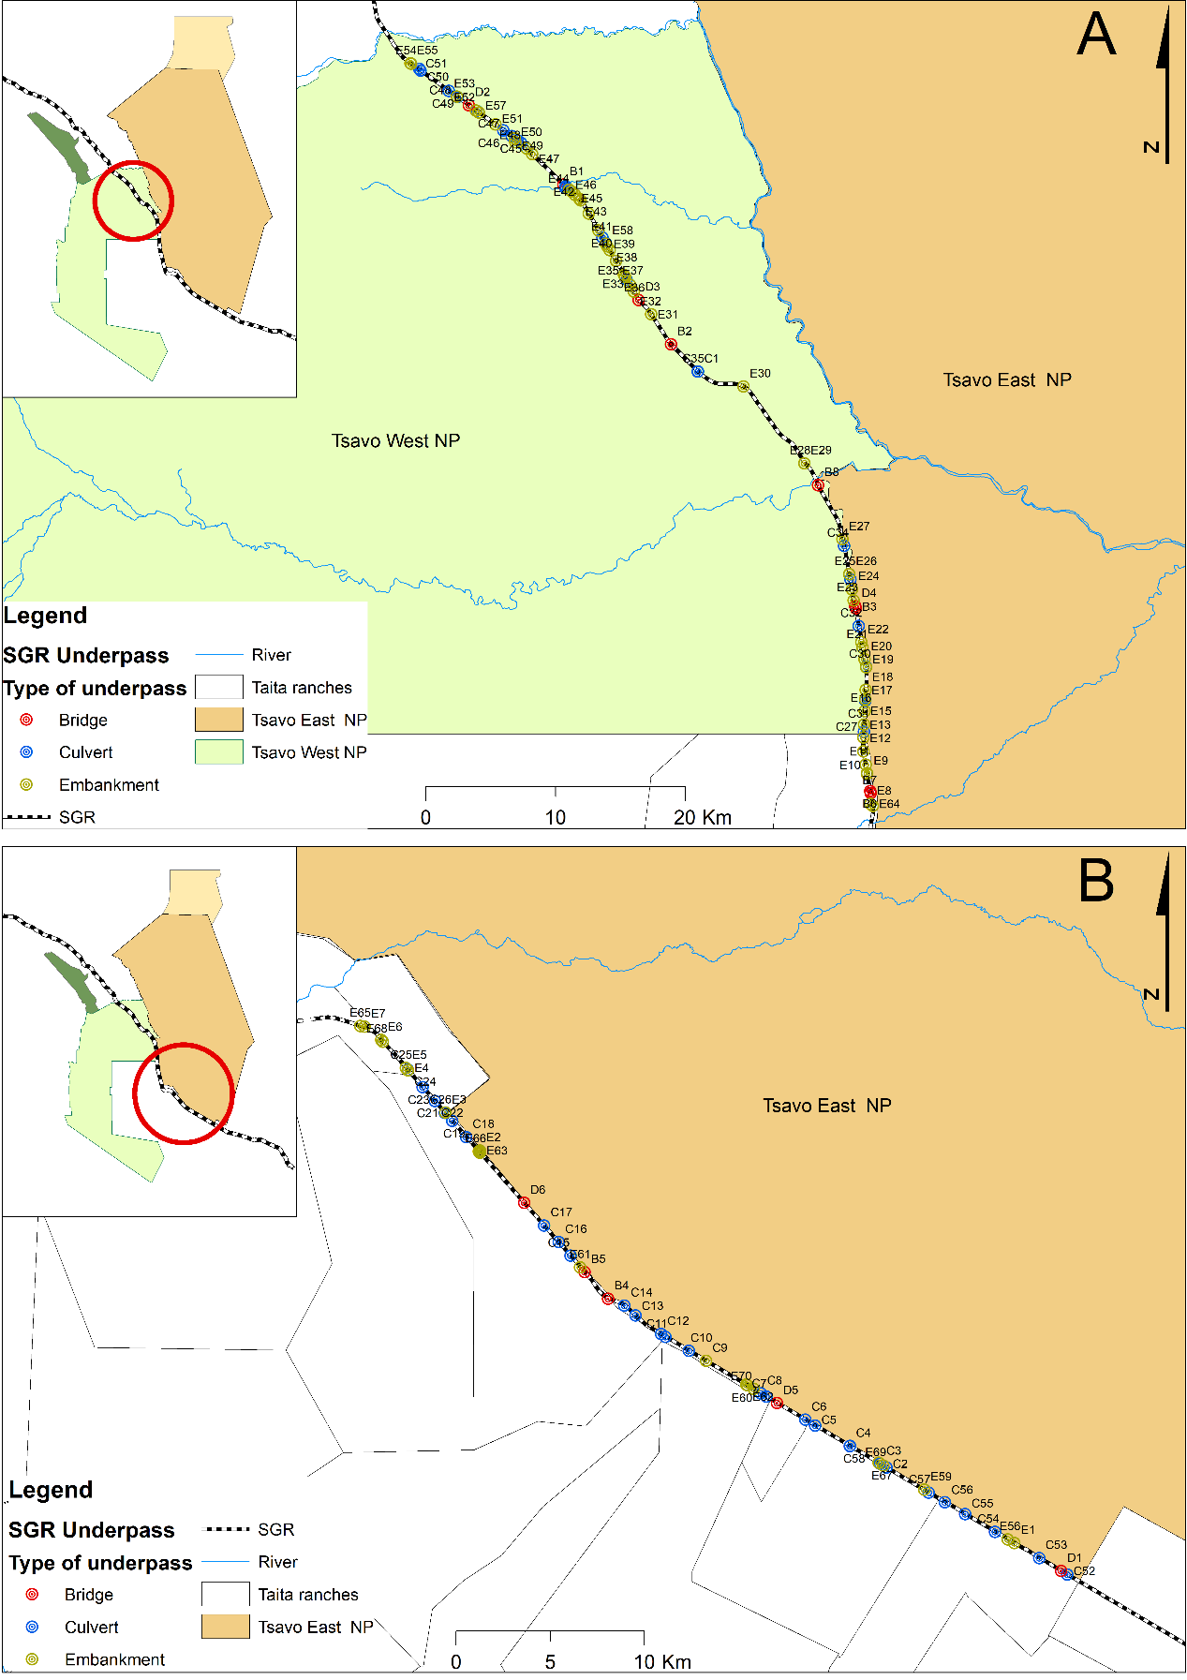

Figure S1: Underpass locations between Voi – Mtito-Andei (A) and Voi – Bachuma (B) along the standard gauge railway in Tsavo Conservation Area located in southeastern Kenya (inset).

Table S1. Location, type and dimensions of underpasses examined during this study

X- coordinate | Y coordinate | Underpass ID | Type of underpass | Road Section | Width meters | Height meters | Size
444273 | 9652304 | C31 | Culvert | VM | 3 | 2 | Medium
417276 | 9695352 | C44 | Culvert | VM | 3 | 2 | Small
443111 | 9661592 | C33 | Culvert | VM | 2 | 2.3 | Small
486140 | 9598800 | C57 | Culvert | VB | 2 | 2.38 | Small
470585 | 9608202 | C13 | Culvert | VB | 3 | 2.4 | Small
442620 | 9664172 | C34 | Culvert | VM | 2 | 2.5 | Small
421115 | 9691604 | C40 | Culvert | VM | 2 | 2.5 | Small
416974 | 9695570 | C45 | Culvert | VM | 2 | 2.5 | Small
416332 | 9696012 | C46 | Culvert | VM | 2 | 2.5 | Small
412121 | 9699034 | C49 | Culvert | VM | 2 | 2.5 | Small
487003 | 9598294 | C56 | Culvert | VB | 2 | 2.58 | Small
461599 | 9617659 | C18 | Culvert | VB | 3 | 3 | Medium
488078 | 9597664 | C55 | Culvert | VB | 6 | 3 | Medium
472172 | 9607062 | C11 | Culvert | VB | 4 | 3.2 | Medium
466513 | 9612090 | C16 | Culvert | VB | 4 | 3.2 | Medium
483905 | 9600126 | C2 | Culvert | VB | 4 | 3.2 | Medium
458404 | 9621328 | C25 | Culvert | VB | 4 | 3.2 | Medium
460495 | 9618961 | C26 | Culvert | VB | 4 | 3.2 | Medium
483566 | 9600336 | C3 | Culvert | VB | 2 | 3.2 | Small
480122 | 9602356 | C5 | Culvert | VB | 3 | 3.3 | Small
431341 | 9677520 | C1 | Culvert | VB | 3 | 3.5 | Small
471936 | 9607214 | C12 | Culvert | VB | 3 | 3.5 | Small
469995 | 9608722 | C14 | Culvert | VB | 3 | 3.5 | Small
460856 | 9618517 | C19 | Culvert | VB | 3 | 3.5 | Small
459942 | 9619567 | C22 | Culvert | VB | 4 | 3.5 | Medium
459283 | 9620313 | C23 | Culvert | VB | 4 | 3.5 | Medium
458514 | 9621231 | C24 | Culvert | VB | 6 | 3.5 | Medium
444334 | 9654896 | C30 | Culvert | VM | 3 | 3.5 | Medium
417426 | 9695248 | C43 | Culvert | VM | 3 | 3.5 | Small
414271 | 9697510 | C47 | Culvert | VM | 3 | 3.5 | Small
412789 | 9698558 | C48 | Culvert | VM | 3 | 3.5 | Small
465736 | 9612968 | C17 | Culvert | VB | 4 | 3.7 | Medium
467890 | 9610500 | B5 | Bridge | VB | 70 | 4 | Large
467142 | 9611366 | C15 | Culvert | VB | 4 | 4 | Medium
460472 | 9618938 | C21 | Culvert | VB | 6 | 4 | Medium
481963 | 9601268 | C4 | Culvert | VB | 6 | 4 | Medium
493493 | 9594462 | C52 | Culvert | VB | 6.8 | 4 | Medium
489667 | 9596716 | C54 | Culvert | VB | 6 | 4 | Medium
481970 | 9601281 | C58 | Culvert | VB | 6 | 4 | Medium
479594 | 9602668 | C6 | Culvert | VB | 6 | 4 | Medium
492016 | 9595328 | C53 | Culvert | VB | 6 | 4.5 | Medium
473414 | 9606324 | C10 | Culvert | VB | 6 | 4.7 | Medium
477244 | 9604060 | C8 | Culvert | VB | 6 | 4.7 | Medium
474334 | 9605790 | C9 | Embankment | VB | 4 | 4.7 | Medium
460485 | 9618949 | C20 | Culvert | VB | 4 | 5 | Medium
477533 | 9603896 | C7 | Culvert | VB | 4 | 5 | Medium
444154 | 9649910 | C27 | Culvert | VM | 6 | 5 | Medium
444274 | 9652288 | C28 | Culvert | VM | 4 | 5 | Medium
444254 | 9652324 | C29 | Culvert | VM | 4 | 5 | Medium
443749 | 9658022 | C32 | Culvert | VM | 4 | 5 | Medium
431348 | 9677528 | C35 | Culvert | VM | 5 | 5 | Medium
424247 | 9687360 | C37 | Culvert | VM | 6 | 5 | Medium
423985 | 9687796 | C38 | Culvert | VM | 6 | 5 | Medium
418131 | 9694624 | C41 | Culvert | VM | 5 | 5 | Medium
417697 | 9695042 | C42 | Culvert | VM | 6 | 5 | Medium
409941 | 9700592 | C50 | Culvert | VM | 4 | 5 | Medium
409835 | 9700722 | C51 | Culvert | VM | 5 | 5 | Medium
493169 | 9594652 | D1 | Bridge | VB | 70 | 5.5 | Large
425844 | 9684556 | C36 | Culvert | VM | 5 | 5.5 | Medium
421151 | 9691706 | C39 | Culvert | VM | 4 | 5.5 | Medium
464682 | 9614172 | D6 | Bridge | VB | 65 | 5.6 | Large
478101 | 9603552 | D5 | Bridge | VB | 70 | 6 | Large
426785 | 9683008 | D3 | Bridge | VM | 70 | 6 | Large
443536 | 9659372 | B3 | Bridge | VM | 20 | 6.5 | Large
443480 | 9659544 | D4 | Bridge | VM | 70 | 6.5 | Large
444661 | 9645378 | B6 | Bridge | VM | 25 | 6.8 | Large
444685 | 9645210 | B7 | Bridge | VM | 60 | 6.8 | Large
413674 | 9697936 | D2 | Bridge | VM | 60 | 7 | Large
469134 | 9609086 | B4 | Bridge | VB | 180 | 7.3 | Large
440619 | 9668820 | B8 | Bridge | VM | 1960 | 9 | Large
429274 | 9679622 | B2 | Bridge | VM | 520 | 10 | Large
420962 | 9691854 | B1 | Bridge | VM | 210 | 12 | Large

Table S2: Large- and medium-sized mammal sightings in the TCA 2008-2015

Species/Taxon | Total sightings | Sighting frequency per month
African elephant | 1677 | 30.491
Grant’s gazelle | 1317 | 23.945
Dik-dik | 1046 | 19.018
Plain’s zebra | 919 | 16.709
Impala | 773 | 14.055
Waterbuck | 497 | 9.036
Gerenuk | 447 | 8.127
Maasai giraffe | 418 | 7.600
Coke's hartebeest | 395 | 7.182
Warthog | 345 | 6.273
Buffalo | 251 | 4.564
Oryx | 186 | 3.382
Kongoni (Hartebeest) | 176 | 3.200
Lesser kudu | 170 | 3.091
Baboon | 117 | 2.127
Hippopotamus | 61 | 1.109
Eland | 54 | 0.982
Black-backed jackal | 31 | 0.564
Vervet monkey | 28 | 0.509
Lion | 24 | 0.436
Common duiker | 19 | 0.345
Banded mongoose | 14 | 0.255
Cheetah | 11 | 0.200
Hirola | 11 | 0.200
Thomson’s gazelle | 9 | 0.164
Topi | 6 | 0.109
Spotted hyena | 4 | 0.073
Klipspringer | 3 | 0.055
Livestock | 2 | 0.036
Bat-eared fox | 2 | 0.036
Rock hyrax | 2 | 0.036
African wild cat | 2 | 0.036
Aardwolf | 1 | 0.018
Bat eared fox | 1 | 0.018
Genet | 1 | 0.018
Grevy’s zebra | 1 | 0.018
Leopard | 1 | 0.018
Reed buck | 1 | 0.018
Rhinoceros | 1 | 0.018
Silver-backed jackal | 1 | 0.018

Table S3. The frequency and proportion of time the underpass was used by all large- and medium-sized mammals in the TCA.

Species/Taxon | Bridge |  | Culvert |  | Embankment |  | Total
Species/Taxon | Count | Ratio | Count | Ratio | Count | Ratio | Count | Ratio
Livestock | 389 | 0.1675 | 1070 | 0.1116 | 0 | 0.0000 | 1459 | 0.06242
African elephant | 708 | 0.3048 | 348 | 0.0363 | 303 | 0.0264 | 1359 | 0.05814
Plains zebra | 470 | 0.2023 | 97 | 0.0101 | 39 | 0.0034 | 606 | 0.02593
Yellow baboon | 287 | 0.1235 | 263 | 0.0274 | 0 | 0.0000 | 550 | 0.02353
Buffalo | 176 | 0.0758 | 135 | 0.0141 | 44 | 0.0038 | 355 | 0.01519
Dik-dik | 179 | 0.0771 | 103 | 0.0107 | 0 | 0.0000 | 282 | 0.01207
Spotted hyena | 129 | 0.0555 | 117 | 0.0122 | 3 | 0.0003 | 249 | 0.01065
Mongoose | 76 | 0.0327 | 164 | 0.0171 | 0 | 0.0000 | 240 | 0.01027
Carnivore | 50 | 0.0215 | 67 | 0.0070 | 0 | 0.0000 | 117 | 0.00501
Antelope | 55 | 0.0237 | 46 | 0.0048 | 0 | 0.0000 | 101 | 0.00432
Impala | 57 | 0.0245 | 8 | 0.0008 | 9 | 0.0008 | 74 | 0.00317
Leopard | 19 | 0.0082 | 40 | 0.0042 | 3 | 0.0003 | 62 | 0.00265
Civet | 36 | 0.0155 | 2 | 0.0002 | 0 | 0.0000 | 38 | 0.00163
Waterbuck | 17 | 0.0073 | 5 | 0.0005 | 13 | 0.0011 | 35 | 0.00150
Lesser kudu | 20 | 0.0086 | 14 | 0.0015 | 0 | 0.0000 | 34 | 0.00145
Lion | 13 | 0.0056 | 9 | 0.0009 | 4 | 0.0003 | 26 | 0.00111
Black-backed jackal | 8 | 0.0034 | 13 | 0.0014 | 1 | 0.0001 | 22 | 0.00094
Vervet monkey | 21 | 0.0090 | 0 | 0.0000 | 0 | 0.0000 | 21 | 0.00090
Warthog | 5 | 0.0022 | 11 | 0.0011 | 4 | 0.0003 | 20 | 0.00086
Grant’s gazelle | 8 | 0.0034 | 4 | 0.0004 | 0 | 0.0000 | 12 | 0.00051
Caracal | 3 | 0.0013 | 8 | 0.0008 | 0 | 0.0000 | 11 | 0.00047
Cape hare | 9 | 0.0039 | 0 | 0.0000 | 1 | 0.0001 | 10 | 0.00043
Eland | 0 | 0.0000 | 0 | 0.0000 | 9 | 0.0008 | 9 | 0.00039
Banded mongoose | 1 | 0.0004 | 5 | 0.0005 | 0 | 0.0000 | 6 | 0.00026
Porcupine | 1 | 0.0004 | 5 | 0.0005 | 0 | 0.0000 | 6 | 0.00026
Cheetah | 2 | 0.0009 | 2 | 0.0002 | 0 | 0.0000 | 4 | 0.00017
Genet | 2 | 0.0009 | 2 | 0.0002 | 0 | 0.0000 | 4 | 0.00017
Grevy’s zebra | 1 | 0.0004 | 0 | 0.0000 | 3 | 0.0003 | 4 | 0.00017
Hippopotamus | 3 | 0.0013 | 1 | 0.0001 | 0 | 0.0000 | 4 | 0.00017
Wild dog | 0 | 0.0000 | 3 | 0.0003 | 0 | 0.0000 | 3 | 0.00013
Aardwolf | 1 | 0.0004 | 1 | 0.0001 | 0 | 0.0000 | 2 | 0.00009
Slender mongoose | 2 | 0.0009 | 0 | 0.0000 | 0 | 0.0000 | 2 | 0.00009
Small spotted genet | 1 | 0.0004 | 1 | 0.0001 | 0 | 0.0000 | 2 | 0.00009
Maasai giraffe | 0 | 0.0000 | 2 | 0.0002 | 0 | 0.0000 | 2 | 0.00009
Honey badger | 0 | 0.0000 | 1 | 0.0001 | 0 | 0.0000 | 1 | 0.00004
African wild cat | 0 | 0.0000 | 1 | 0.0001 | 0 | 0.0000 | 1 | 0.00004
Bush baby | 0 | 0.0000 | 1 | 0.0001 | 0 | 0.0000 | 1 | 0.00004
Common duiker | 1 | 0.0004 | 0 | 0.0000 | 0 | 0.0000 | 1 | 0.00004

Table S4. The influence of electric fencing on the use of SGR underpasses by wildlife in the TCA.
Type of underpass | Underpass |  | Embankment |  | Underpass |  | Embankment
Fencing Present | N | Y | N | Y | N | Y | N | Y
Livestock | 504 | 955 | 0 | 0 | 0.0806 | 0.1688 | 0.0000 | 0.0000
African elephant | 643 | 413 | 298 | 5 | 0.1028 | 0.0730 | 0.0489 | 0.0009
Baboon | 151 | 399 | 0 | 0 | 0.0242 | 0.0705 | 0.0000 | 0.0000
Plain’s zebra | 231 | 336 | 39 | 0 | 0.0369 | 0.0594 | 0.0064 | 0.0000
Mongoose | 17 | 223 | 0 | 0 | 0.0027 | 0.0394 | 0.0000 | 0.0000
Buffalo | 100 | 211 | 44 | 0 | 0.0160 | 0.0373 | 0.0072 | 0.0000
Dik-dik | 76 | 206 | 0 | 0 | 0.0122 | 0.0364 | 0.0000 | 0.0000
Spotted hyena | 71 | 175 | 3 | 0 | 0.0114 | 0.0309 | 0.0005 | 0.0000
Antelope | 14 | 87 | 0 | 0 | 0.0022 | 0.0154 | 0.0000 | 0.0000
Carnivore | 42 | 75 | 0 | 0 | 0.0067 | 0.0133 | 0.0000 | 0.0000
Impala | 19 | 46 | 9 | 0 | 0.0030 | 0.0081 | 0.0015 | 0.0000
Leopard | 33 | 26 | 2 | 1 | 0.0053 | 0.0046 | 0.0003 | 0.0002
Lesser kudu | 13 | 21 | 0 | 0 | 0.0021 | 0.0037 | 0.0000 | 0.0000
Vervet monkey | 2 | 19 | 0 | 0 | 0.0003 | 0.0034 | 0.0000 | 0.0000
Civet | 20 | 18 | 0 | 0 | 0.0032 | 0.0032 | 0.0000 | 0.0000
Lion | 6 | 16 | 4 | 0 | 0.0010 | 0.0028 | 0.0007 | 0.0000
Warthog | 5 | 11 | 4 | 0 | 0.0008 | 0.0019 | 0.0007 | 0.0000
Cape hare | 1 | 8 | 1 | 0 | 0.0002 | 0.0014 | 0.0002 | 0.0000
Porcupine | 0 | 6 | 0 | 0 | 0.0000 | 0.0011 | 0.0000 | 0.0000
Waterbuck | 17 | 5 | 13 | 0 | 0.0027 | 0.0009 | 0.0021 | 0.0000
Black-backed Jackal | 17 | 4 | 1 | 0 | 0.0027 | 0.0007 | 0.0002 | 0.0000
Caracal | 8 | 3 | 0 | 0 | 0.0013 | 0.0005 | 0.0000 | 0.0000
Wild dog | 1 | 2 | 0 | 0 | 0.0002 | 0.0004 | 0.0000 | 0.0000
Hippopotamus | 2 | 2 | 0 | 0 | 0.0003 | 0.0004 | 0.0000 | 0.0000
Honey badger | 0 | 1 | 0 | 0 | 0.0000 | 0.0002 | 0.0000 | 0.0000
Slender mongoose | 1 | 1 | 0 | 0 | 0.0002 | 0.0002 | 0.0000 | 0.0000
African wild cat | 0 | 1 | 0 | 0 | 0.0000 | 0.0002 | 0.0000 | 0.0000
Grevy’s zebra | 0 | 1 | 3 | 0 | 0.0000 | 0.0002 | 0.0005 | 0.0000
Hedgehog | 0 | 1 | 0 | 0 | 0.0000 | 0.0002 | 0.0000 | 0.0000
Aardwolf | 2 | 0 | 0 | 0 | 0.0003 | 0.0000 | 0.0000 | 0.0000
Banded mongoose | 6 | 0 | 0 | 0 | 0.0010 | 0.0000 | 0.0000 | 0.0000
Cheetah | 4 | 0 | 0 | 0 | 0.0006 | 0.0000 | 0.0000 | 0.0000
Genet | 4 | 0 | 0 | 0 | 0.0006 | 0.0000 | 0.0000 | 0.0000
Small-spotted genet | 2 | 0 | 0 | 0 | 0.0003 | 0.0000 | 0.0000 | 0.0000
Bush baby | 1 | 0 | 0 | 0 | 0.0002 | 0.0000 | 0.0000 | 0.0000
Common duiker | 1 | 0 | 0 | 0 | 0.0002 | 0.0000 | 0.0000 | 0.0000
Eland | 0 | 0 | 9 | 0 | 0.0000 | 0.0000 | 0.0015 | 0.0000
Grant’s gazelle | 12 | 0 | 0 | 0 | 0.0019 | 0.0000 | 0.0000 | 0.0000
Maasai giraffe | 2 | 0 | 0 | 0 | 0.0003 | 0.0000 | 0.0000 | 0.0000

