Supplementary Information for

Controlling potential landscape of heterostructured nanocrystals with interfacial polarization

Byeong Guk Jeong¹†, Jun Hyuk Chang¹†, Donghyo Hahm¹†, Seunghyun Rhee¹, Myeongjin Park², Sooho Lee², Youngdu Kim¹, Doyoon Shin¹, Jeong Woo Park¹, Changhee Lee², Doh C. Lee³*, Kyoungwon Park⁴, Euyheon Hwang¹*, and Wan Ki Bae¹*

¹SKKU Advanced Institute of Nanotechnology and Department of Nano Engineering, Sungkyunkwan University, Suwon 16419, Republic of Korea.
²Samsung Display Research Center, Samsung Display, Yongin 17113, Republic of Korea.
³Department of Chemical and Biomolecular Engineering, KAIST Institute for the Nanocentury, Korea Advanced Institute of Science and Technology (KAIST), Daejeon 34141, Republic of Korea.
⁴Display Research Center, Korea Electronics Technology Institute (KETI), Seongnam 13509, Republic of Korea.

*Correspondence to Wan Ki Bae (wkbae@skku.edu); Euyheon Hwang (euyheon@skku.edu); Doh C. Lee (dclee@kaist.edu)
Supplementary Note 1. Density functional theory (DFT) calculation on the charge density diference of InP/ZnSe h-NCs
To calculate the charge density difference at the interface of InP/ZnSe heterostructures we performed first-principle calculations using the plane-wave DFT software QUANTUM ESPRESSO¹. To obtain ground-state electronic structure we used ultrasoft pseudopotentials (RRKJUS) for the semilocal PBE-GGA. We set plane wave cutoff energy of 60 Ry and charge cutoff energy of 300Ry. Gaussian smearing with broadening factor of 0.04 Ry was applied to models for better convergence performance. We consider three surfaces of the InP core, (001), (011) and (111) surface by repeated slab model. All three models were fully relaxed to get most stable atomic positions. For (001) surface, the relaxed cell is a tetragonal with cell dimension (a,b,c) = (5.792 $Å$, 5.792 $Å$, 22.31 $Å$). In calculation we use two unit cells of InP and ZnSe including 32 atoms. For (011) surface, the relaxed cell is an orthorhombic structure with the dimension (5.742 $Å$, 4.075 $Å$, 32.53 $Å$). In calculation we use four unit cells of each materials including 32 atoms. For (111) surface, the relaxed cell is a hexagonal structure with the dimension (4.150 $Å$, 4.150 $Å$, 40.47 $Å$). We use two unit cells of each materials including 24 atoms in the calculation.
For charge density difference calculation, we subtracted the charge density of each subsystem from the charge density of h-NC, i.e., $ρ_{diff}=ρ_{hNC}-ρ_{InP}-ρ_{ZnSe}$. The whole operation results in the sum of charge densities of free surfaces placed in the same supercell as the interface and reproducing its geometry to make possible the direct comparison.

Supplementary Note 2. Calculation of the interfacial dipole density (ρ) in h-NCs.
We calculate the areal density of interfacial dipoles (ρ) in core/shell h-NCs based on the stoichiometry of core and its dimension. The model used in the calculation features faceted InP core NCs with a radius of 1.2, 1.3, 1.6, 1.9 and 2.6 nm. We approximate the number of cations and anions at the surface to calculate the interfacial dipole densities. InP NCs with In-rich surfaces have excess indium surface atoms at the polar surfaces (e.g., {111} and {100}), and thus the surface indium atoms at the polar surface bind Se atoms in the ZnSe shell to create net outward dipole moments that are linearly proportional to the number density of excess indium atoms. On the neutral {110} surfaces where indium and phosphorus coexist with a stoichiometric ratio of 1:1 (In:P), the In-Se outward bond dipole moments are compensated by the Zn-P inward bond dipole moments. For example, InP/ZnSe h-NCs with InP core radius of 1.9 nm and In:P ratio of 1.12 hold 68 In-Se outward dipole moments at the total interfacial area of 45.36 nm², yielding the net outward dipole density (ρ) of 1.50 nm⁻². The same procedures apply to the calculation of the interfacial dipole densities in other III-V/II-VI h-NCs. The detailed information is summarized in the Supplementary Table 2.

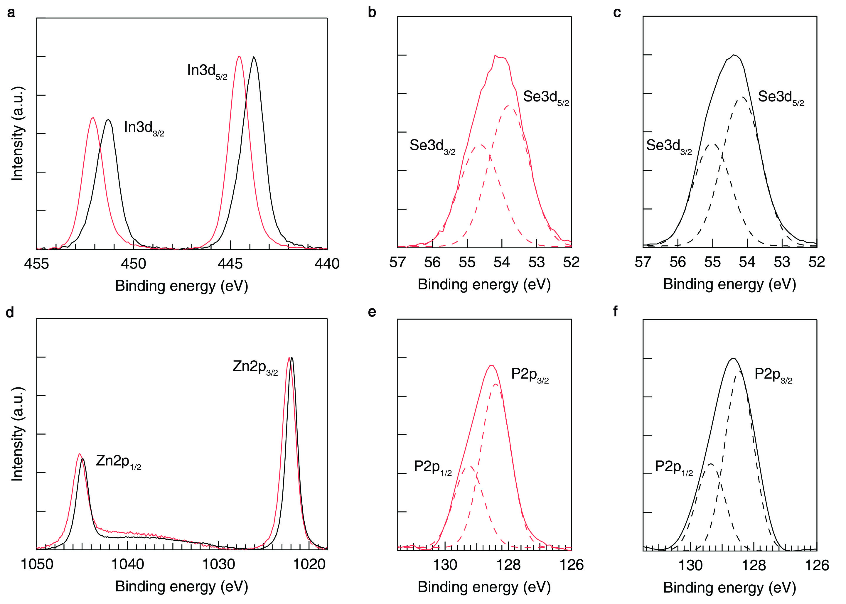
Supplementary Fig. 1. X-ray photoemission spectra of (a) In3d, (b, c) Se3d, (d) Zn2p, and (e, f) P2p obtained from InP/ZnSe h-NCs (red solid lines), and InP and ZnSe NCs (black solid lines). The Se3d and P2p spectra are fitted into the characteristic peaks (broken lines) of the spin-orbit splitting of each atom.

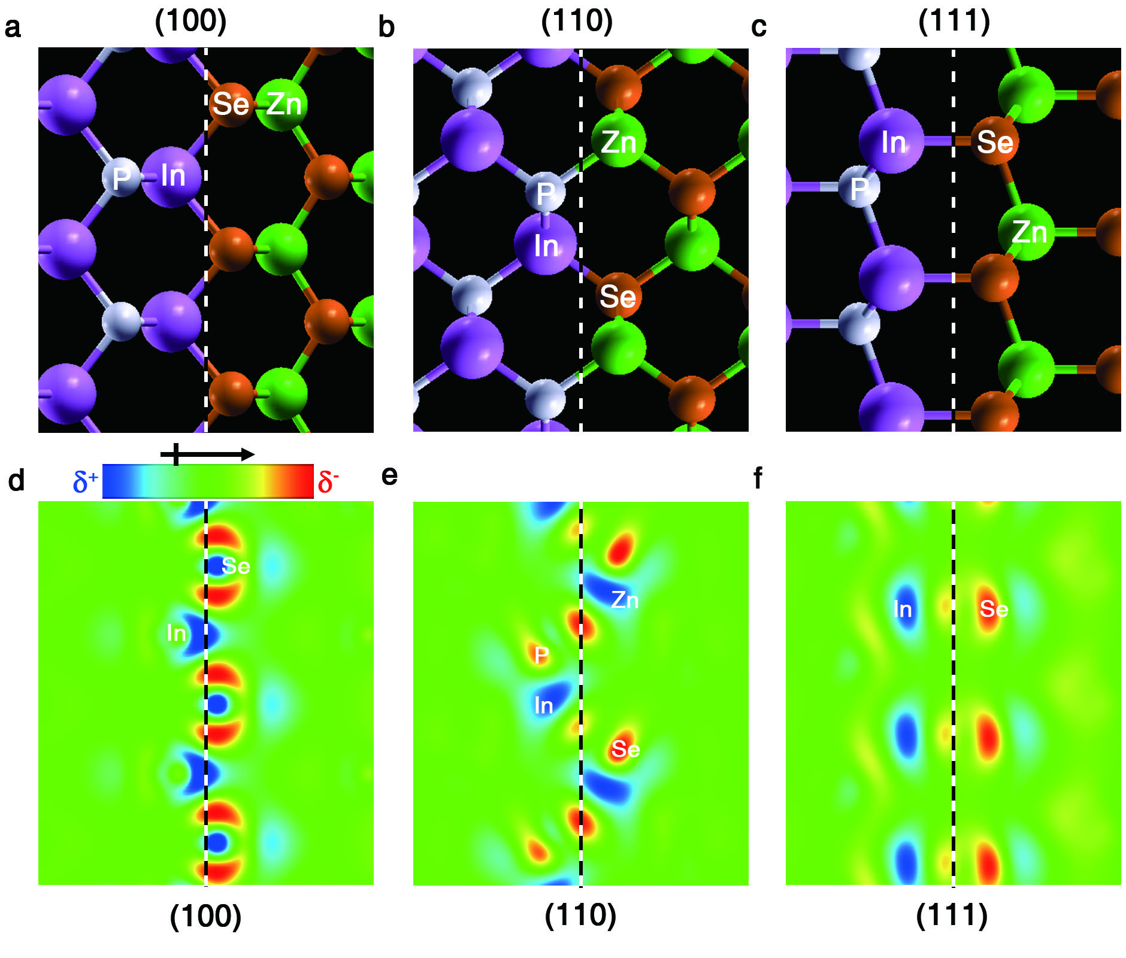
Supplementary Fig. 2. (a-c) Atomic structures and (d-f) charge density difference plots at (a, d) (100), (b, e) (110) and (c, f) (111) interfaces of InP/ZnSe h-NCs. Dashed lines indicate the interface of InP/ZnSe at each plane.

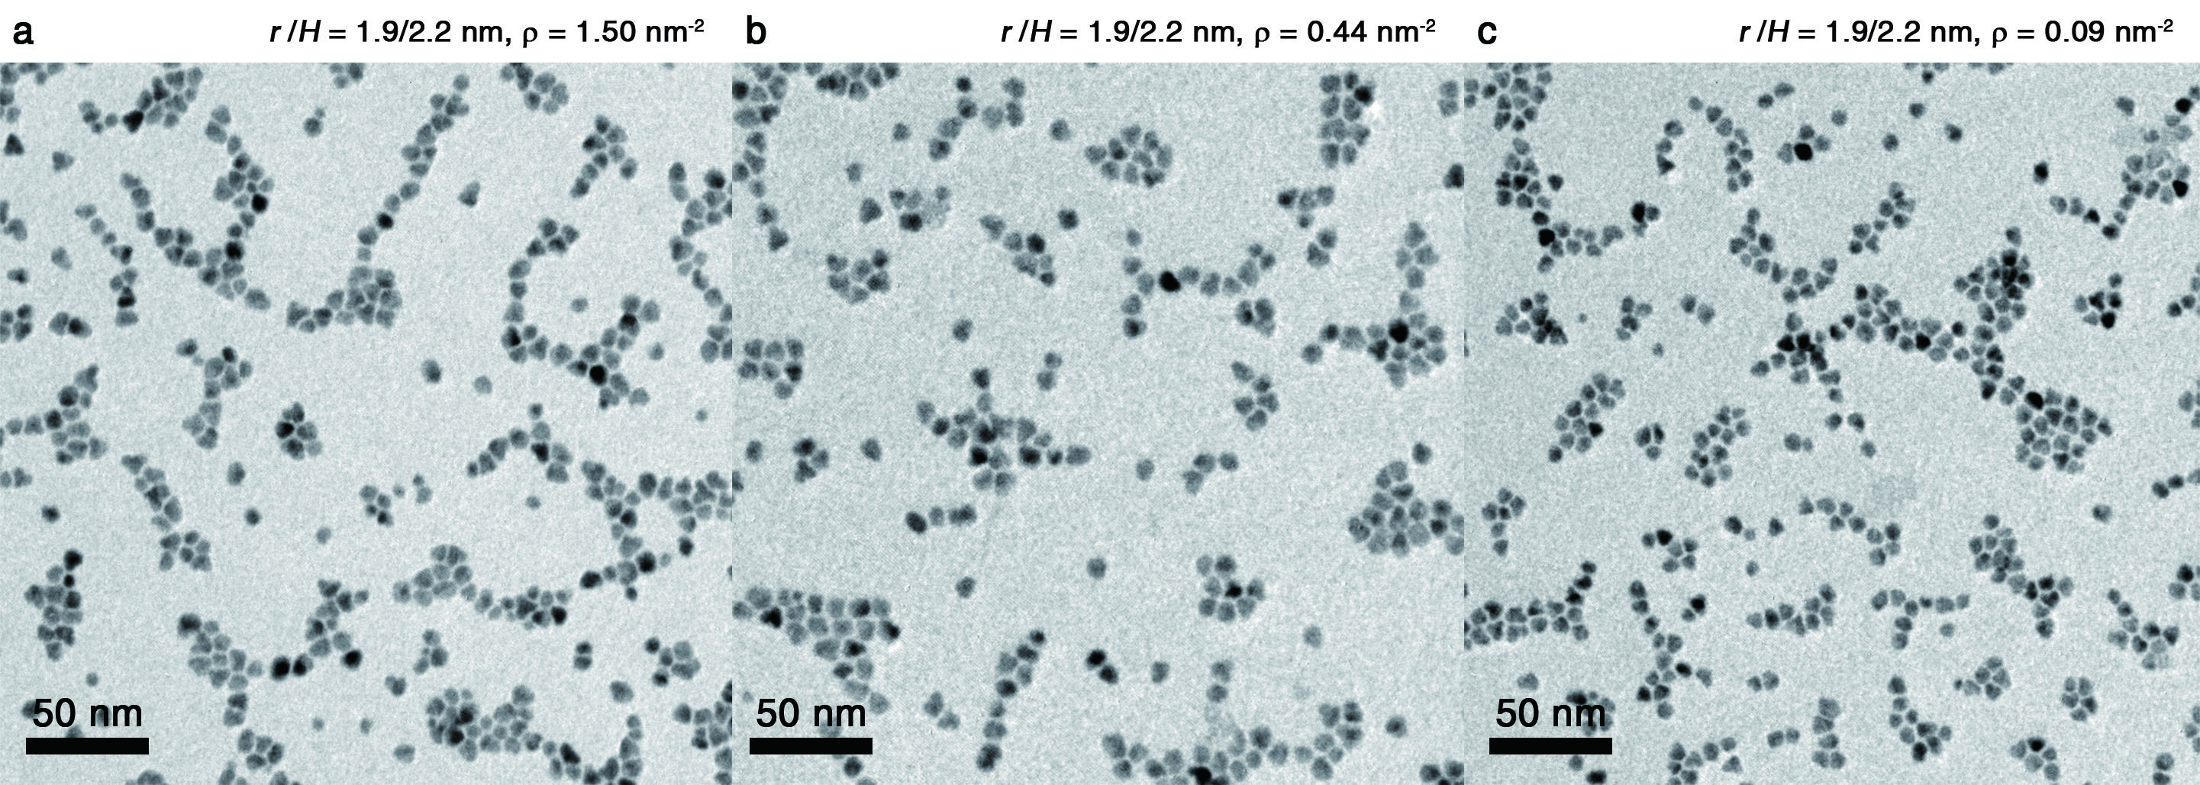
Supplementary Fig. 3. TEM images of InP (r = 1.9 nm)/ZnSe (H = 2.2 nm) h-NCs with interfacial dipole densities, ρ = (a) 1.50, (b) 0.44, and (c) 0.09 nm⁻². Noticeable difference is not observed among chosen variations.

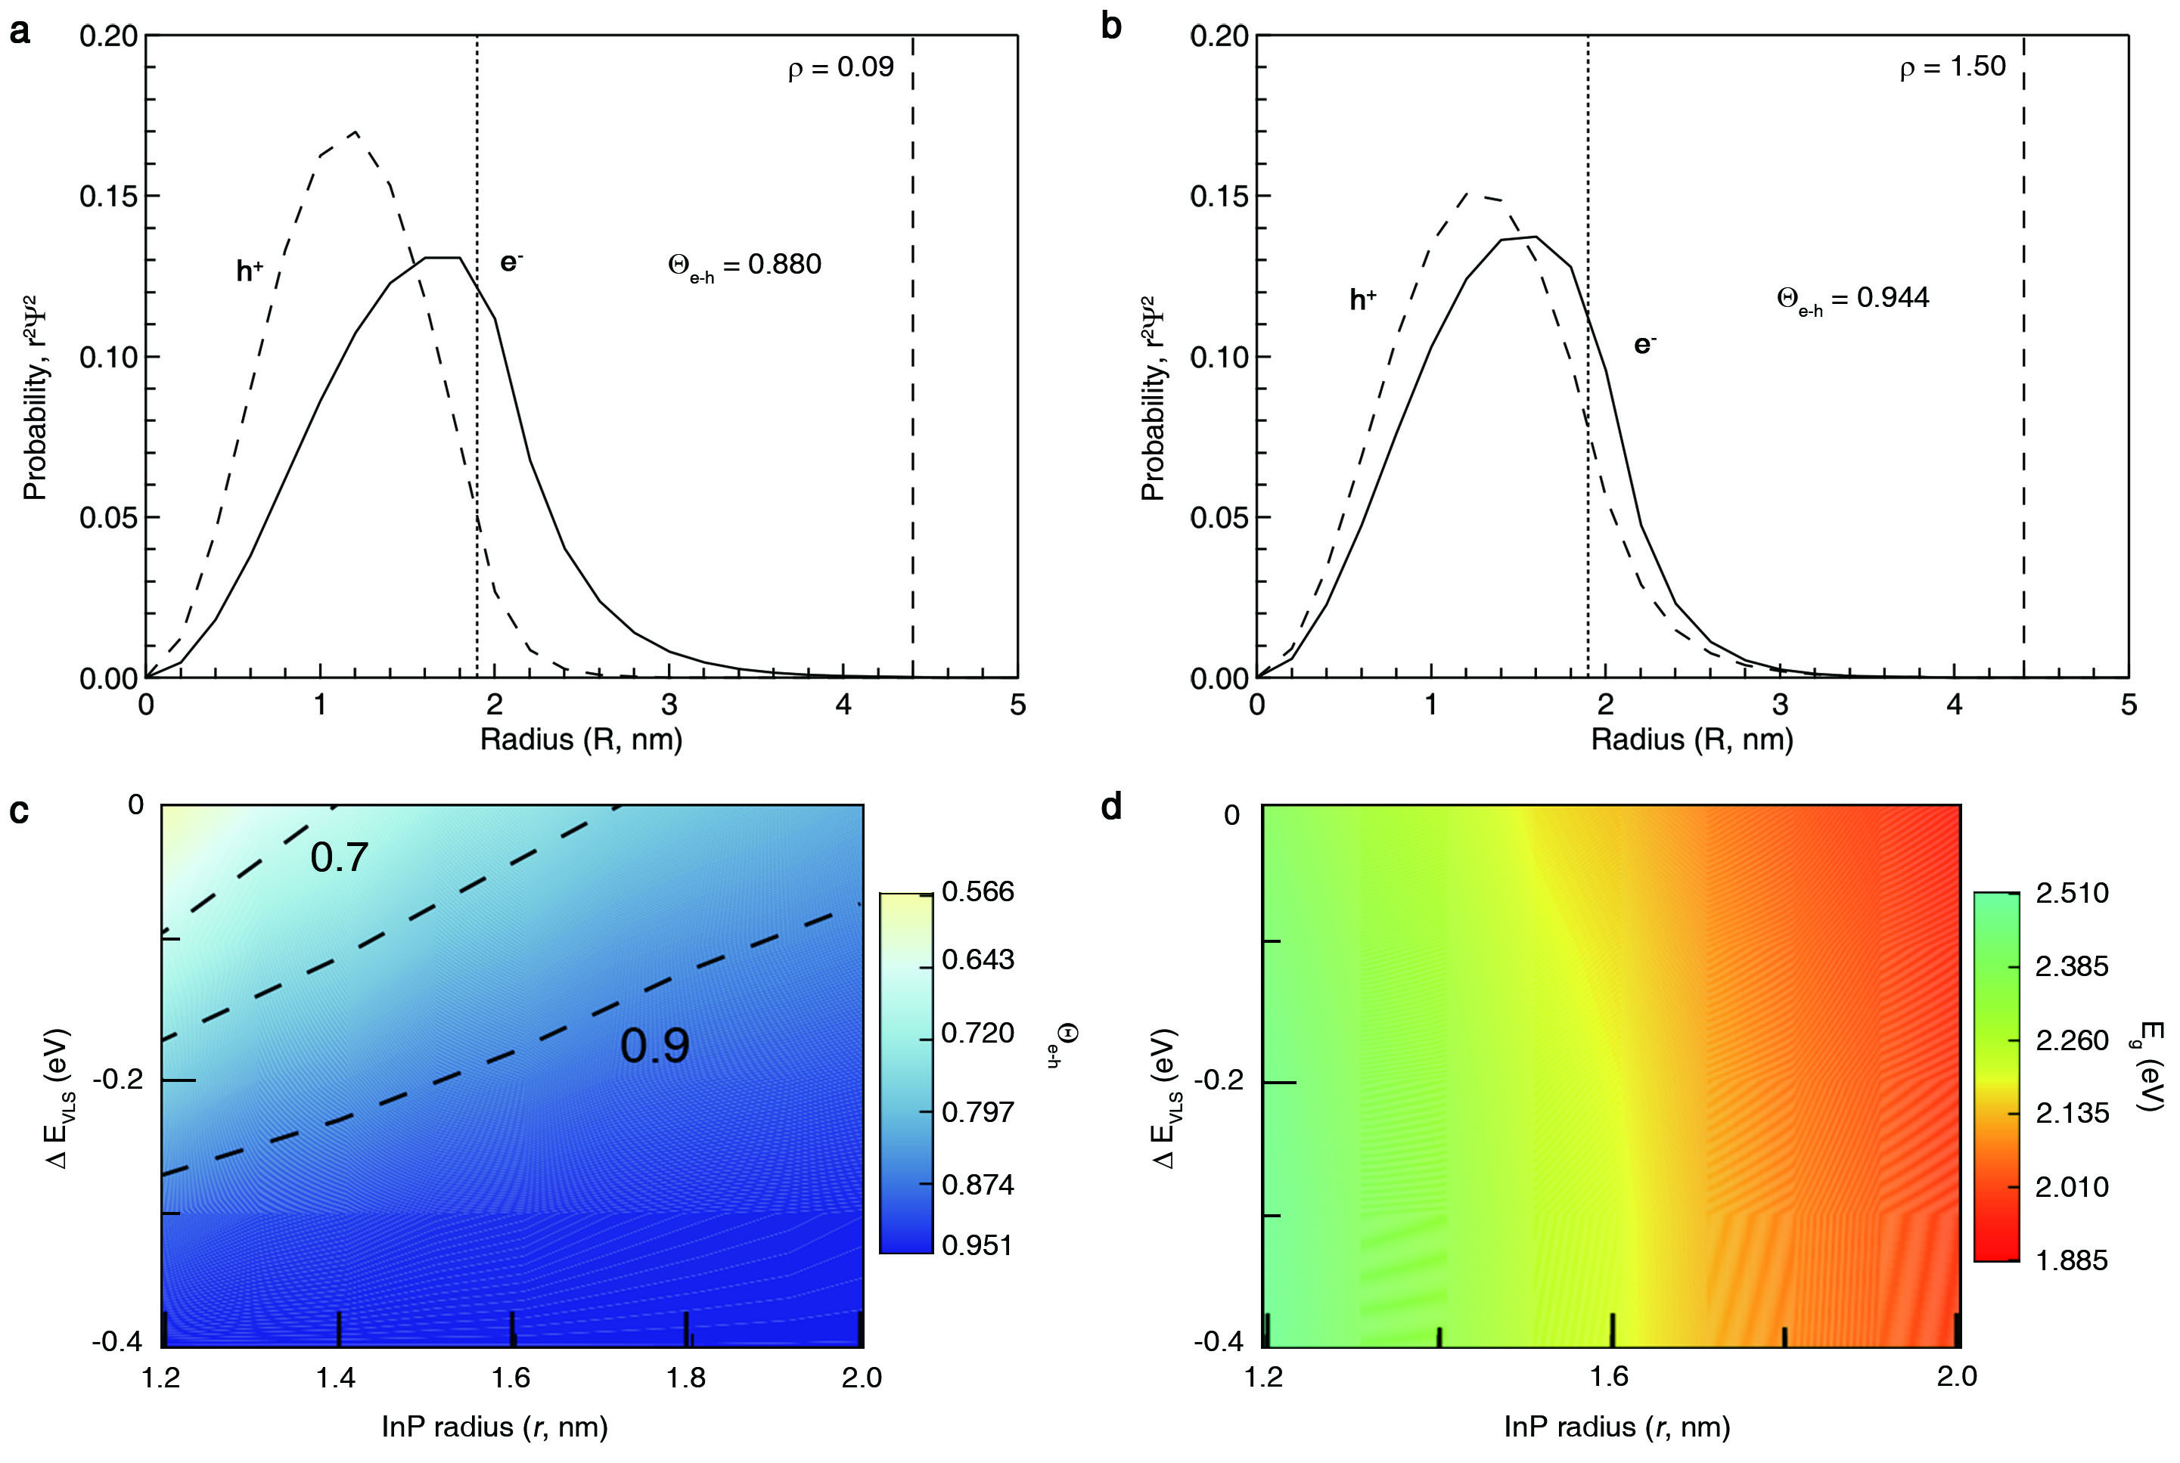
Supplementary Fig. 4. Calculated radial probability of electrons (solid line) and holes (dashed line) in InP (r = 1.9 nm)/ZnSe (H = 2.2 nm) h-NCs with ρ = (a) 0.09 and (b) 1.50 nm⁻². Two-dimensional contour plots of (c) calculated electron-hole overlap integral (Θ_{e-h}), and (d) bandgap energy (E_{g}) upon variations in the extent of vacuum level shift (ΔE_{VLS}) and InP core radius (r).

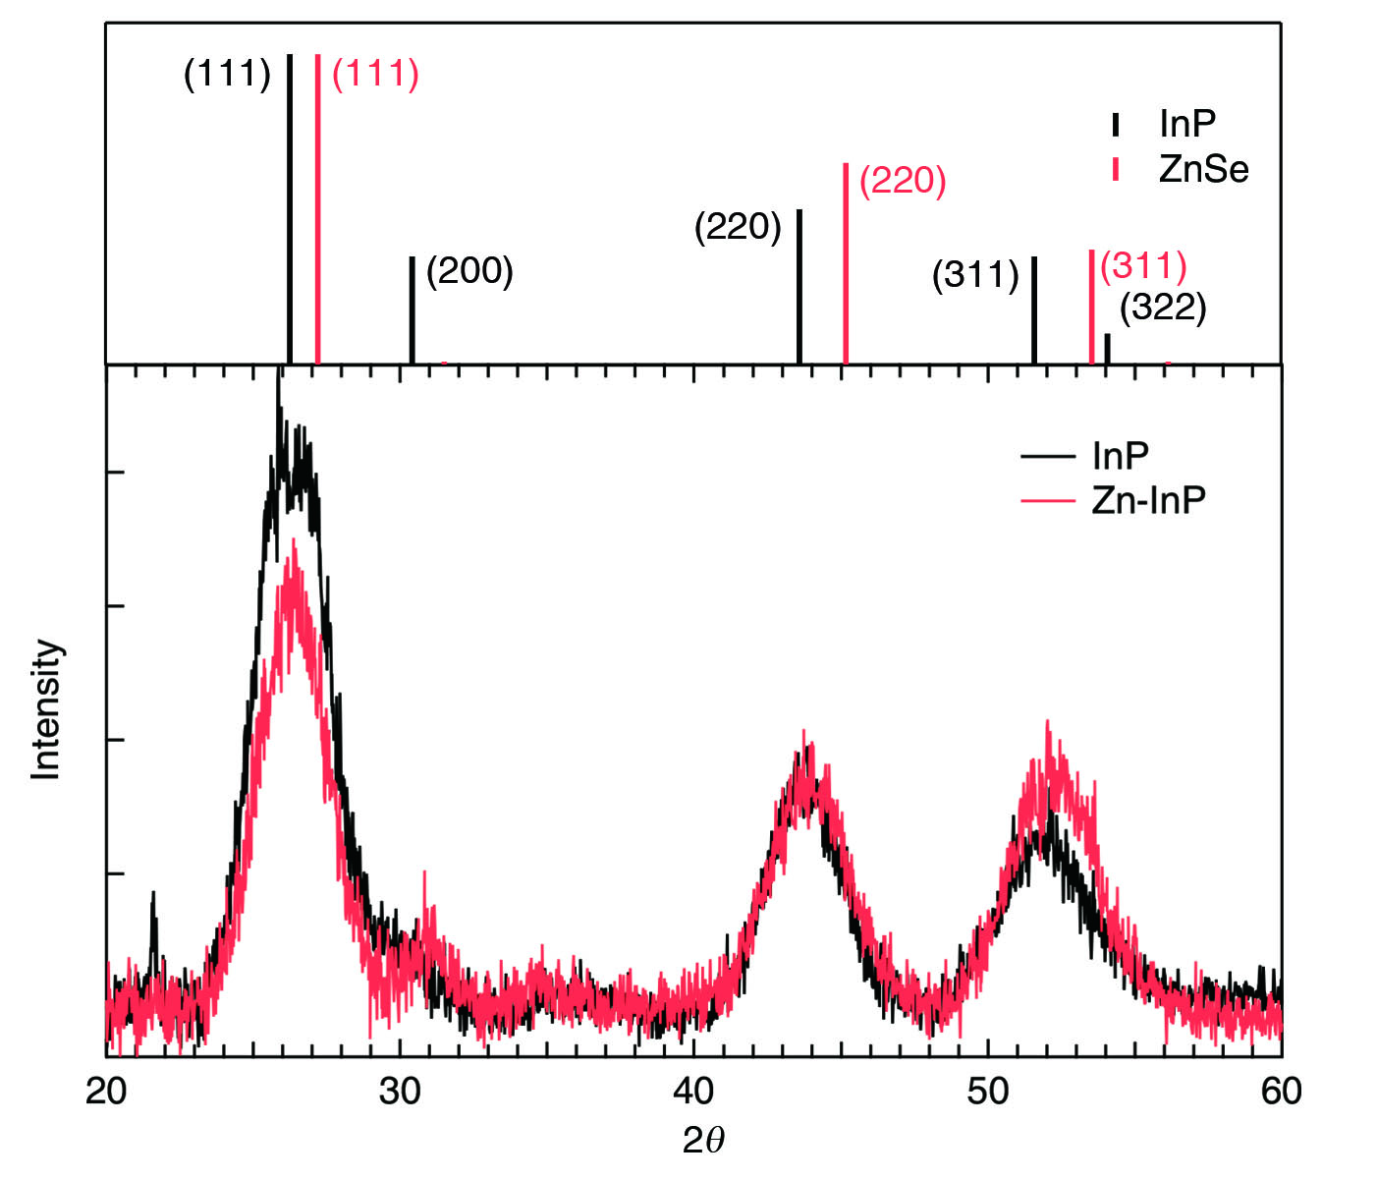
Supplementary Fig. 5. Changes in XRD patterns of InP NCs (r = 1.9 nm) upon cation exchange processes. In:P ratios vary from 1.12:1.00 (black) to 1.07:1.00 (red) as a result of the In to Zn exchange at the {111} planes. The vertical bars indicate the characteristic peaks of bulk zincblende InP (black, JCPDS No. 32-0452) and ZnSe (red, JCPDS No. 37-1463).

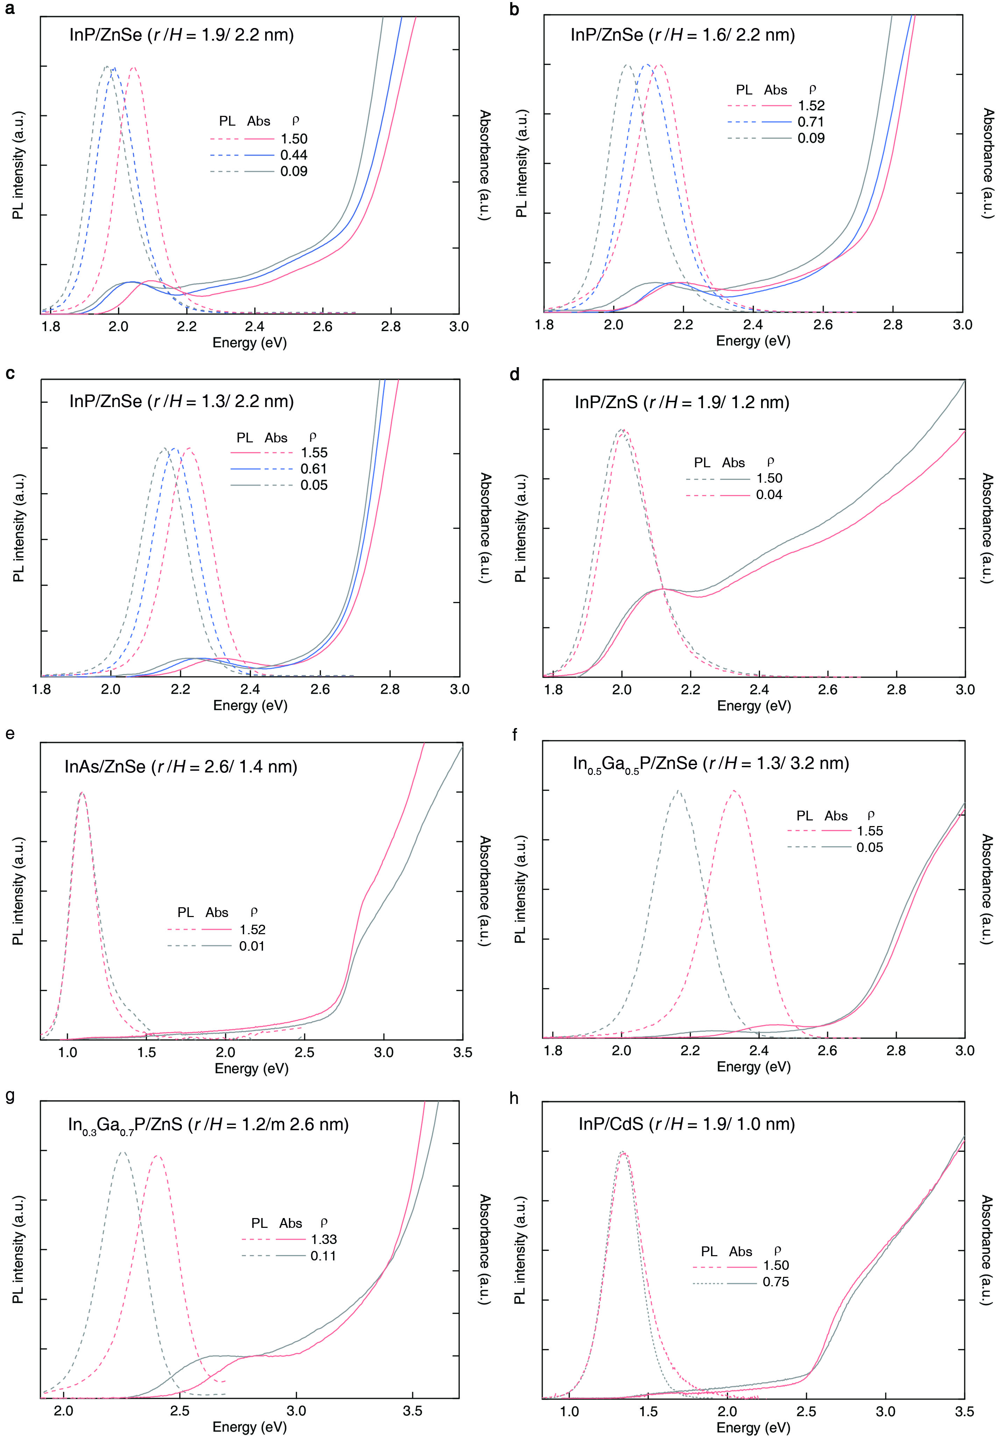
Supplementary Fig. 6. Absorption (solid lines) and photoluminescence (PL) spectra (dashed lines) of (a) InP (r = 1.9 nm)/ZnSe (H = 2.2 nm), (b) InP (r = 1.6 nm)/ZnSe (H = 2.2 nm), (c) InP (r = 1.3 nm)/ZnSe (H = 2.2 nm), (d) InP (r = 1.9 nm)/ZnS (H = 1.2 nm), (e) InAs (r = 2.6 nm)/ZnSe (H = 1.4 nm), (f) In_{0.5}Ga_{0.5}P (r = 1.3 nm)/ZnSe (H = 3.2 nm), (g) In_{0.3}Ga_{0.7}P (r = 1.2 nm)/ZnS (H = 2.6 nm) and (h) InP (r = 1.9 nm)/CdS (H = 1.0 nm) h-NCs with varying interfacial dipole densities (ρ).

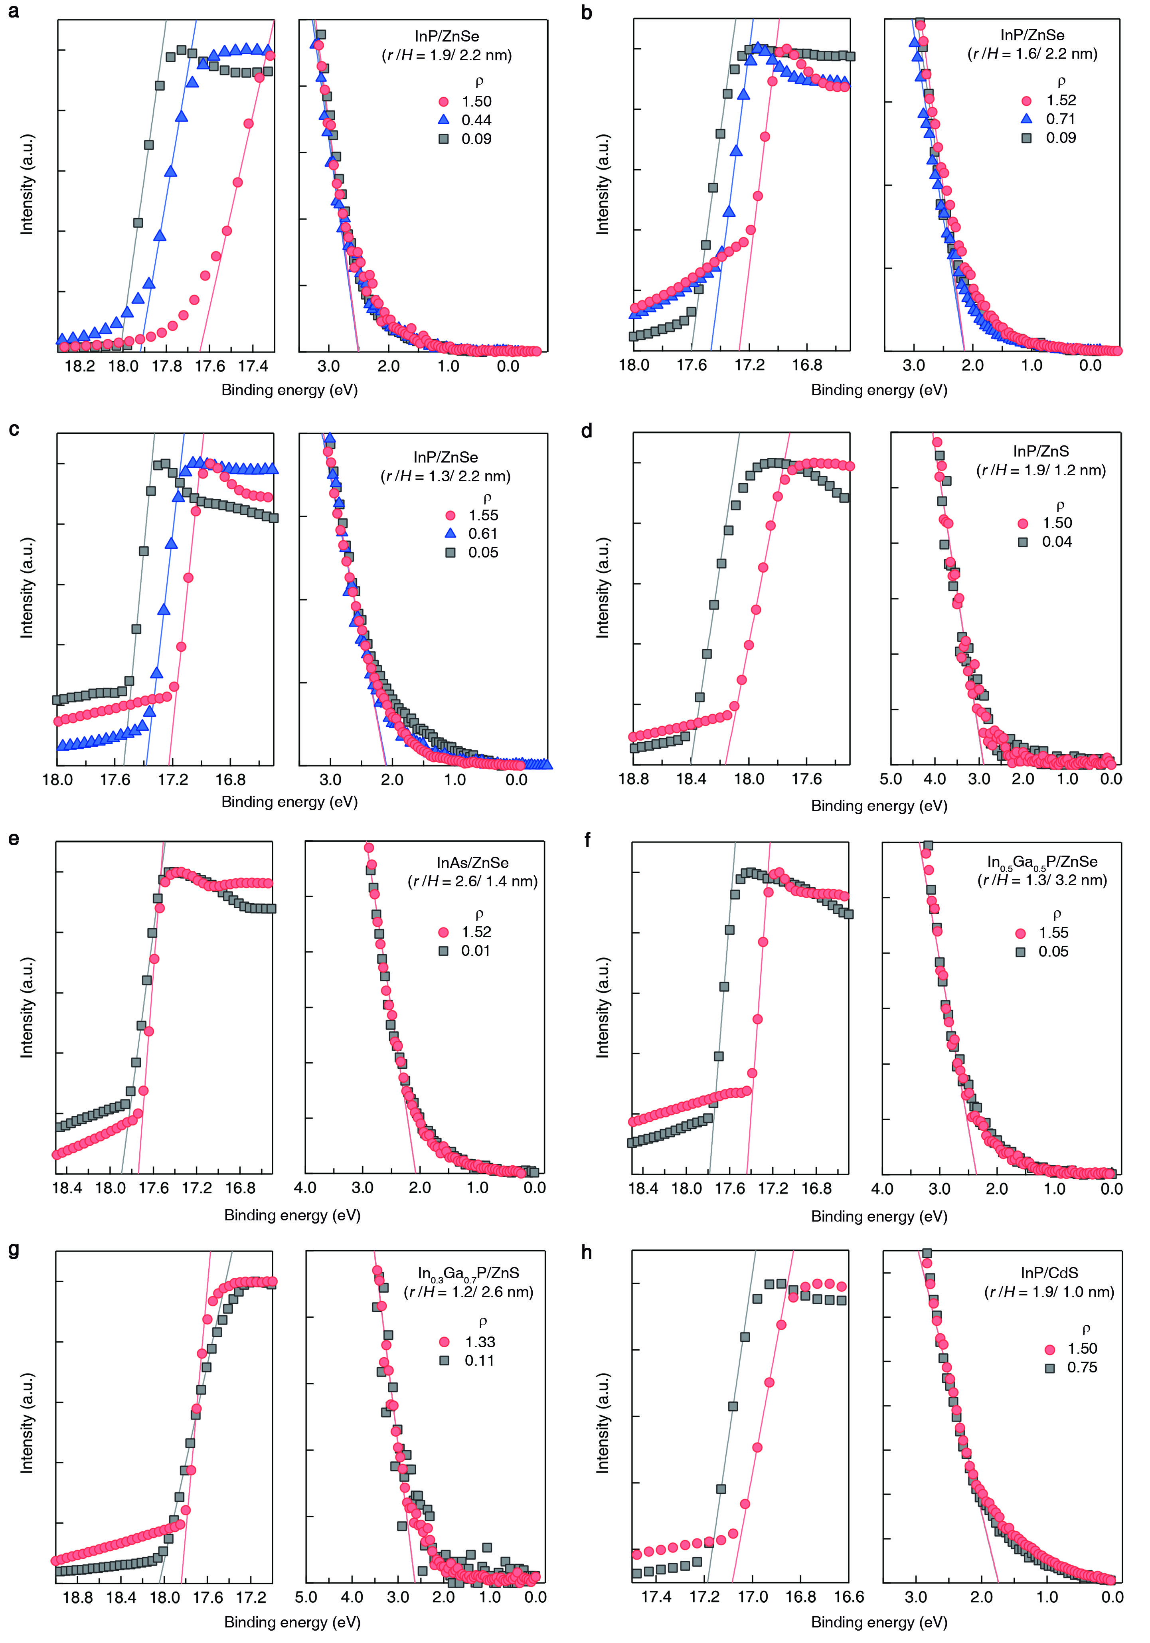
Supplementary Fig. 7. UPS spectra of (a) InP (r = 1.9 nm)/ZnSe (H = 2.2 nm), (b) InP (r = 1.6 nm)/ZnSe (H = 2.2 nm), (c) InP (r = 1.3 nm)/ZnSe (H = 2.2 nm), (d) InP (r = 1.9 nm)/ZnS (H = 1.2 nm), (e) InAs (r = 2.6 nm)/ZnSe (H = 1.4 nm), (f) In_{0.5}Ga_{0.5}P (r = 1.3 nm)/ZnSe (H = 3.2 nm), (g) In_{0.3}Ga_{0.7}P (r = 1.2 nm)/ZnS (H = 2.6 nm) and (h) InP (r = 1.9 nm)/CdS (H = 1.0 nm) h-NCs with varying interfacial dipole densities (ρ).

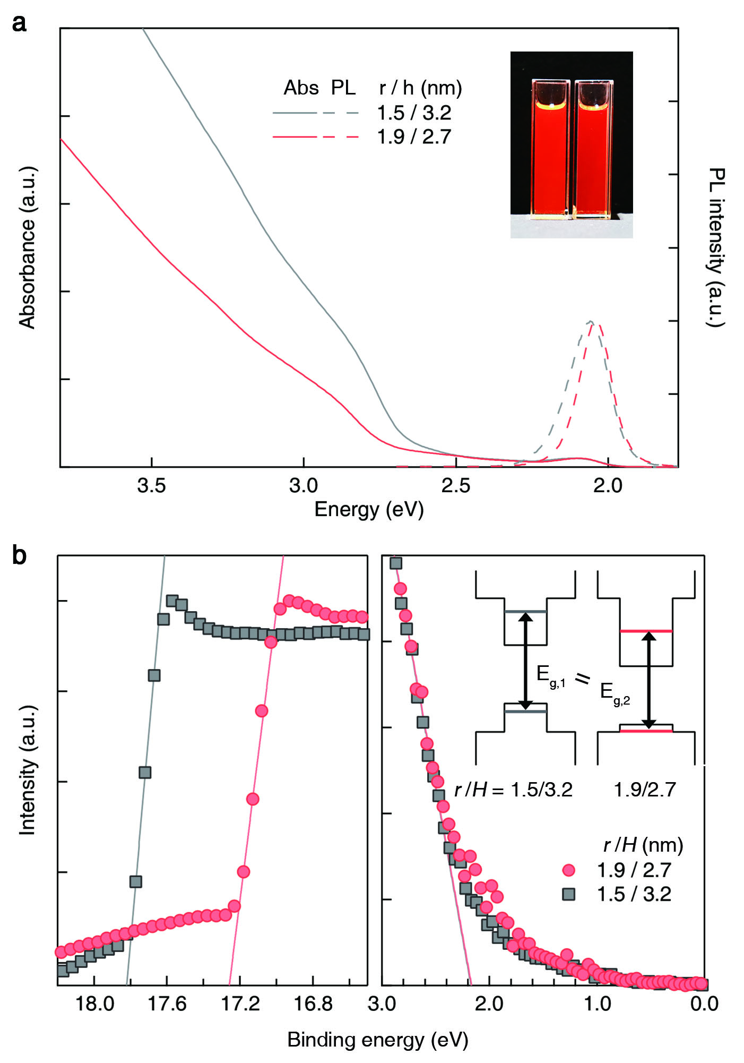
Supplementary Fig. 8. (a) Absorption and PL spectra and (b) UPS spectra of InP (r = 1.5 nm (gray) and 1.9 nm (red))/ZnSe (H = 3.2 nm (gray) and 2.7 nm (red)) h-NCs having the same optical band gap, but different interfacial dipole densities, ρ = 0.05 (gray) and 1.50 (red) nm⁻². Insets illustrate electronic structures and the lowest quantized states (dotted lines) for each InP/ZnSe h-NCs.

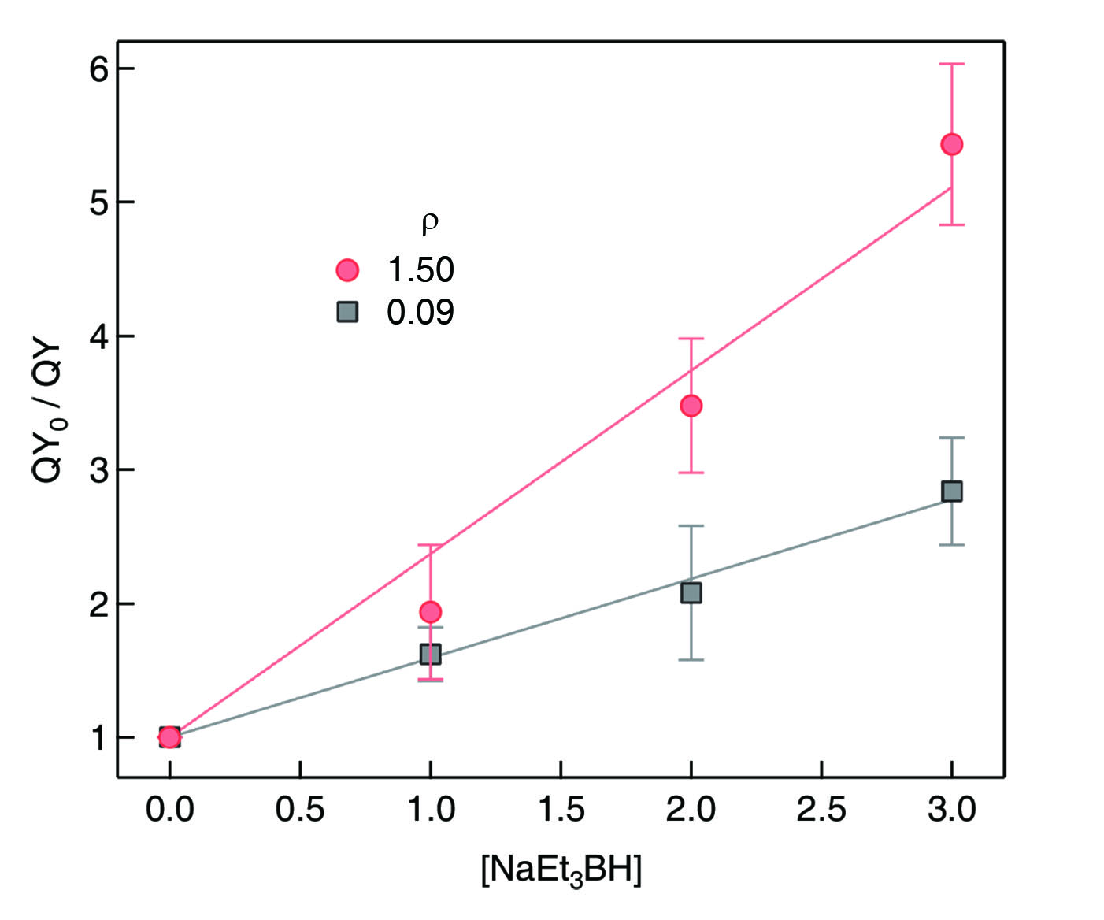
Supplementary Fig. 9. Stern-Volmer plots of InP (r = 1.9 nm)/ZnSe (H = 2.2 nm) h-NCs with interfacial dipole densities, ρ = 1.50 (red) and 0.09 (gray) nm⁻².

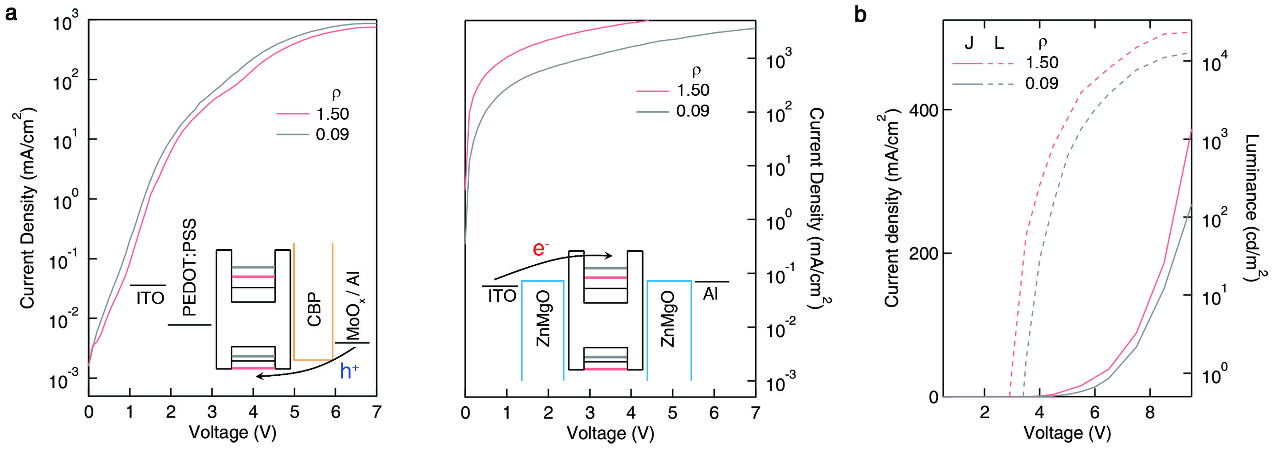
Supplementary Fig. 10. (a) J-V curves of hole only devices (HODs, left) and electron only devices (EODs, right) employing InP (r = 1.9 nm)/ZnSe (H = 3.2 nm) h-NCs with interfacial dipole densities, ρ = 1.50 (red) and 0.09 (gray) nm⁻². Insets illustrate the energy band diagram of each device. (b) J-V-L characteristics of NC-LEDs employing InP (r = 1.9 nm)/ZnSe (H = 3.2nm) h-NCs with ρ = 1.50 (red) and 0.09 (gray) nm⁻². HODs are constructed in a multilayer architecture of ITO//PEDOT:PSS//h-NCs//CBP//MoO_{x}//Al. EODs are constructed in a multilayer architecture of ITO//ZnMgO//h-NCs//ZnMgO//Al. NC-LEDs are constructed in a multilayer architecture of ITO//ZnMgO//h-NCs//CBP//MoO_{x}//Al.

Supplementary Table 1. Structural and optical characteristics of InP (r = 1.9 nm)/ZnSe (H = 2.2 nm) h-NCs with varying interfacial dipole density (ρ)
r/H (nm) | In/P | ρ (nm⁻²) | E_{g} (eV) | Peak PL (eV) | Ѳ_{e-h} | τ (ns) | PL QY (%)
1.9 / 2.2 | 1.12 | 1.50 | 2.077 | 2.036 | 0.944 | 25.2 | 92.7
1.9 / 2.2 | 1.07 | 0.44 | 2.040 | 1.975 | 0.918 | 32.1 | 93.0
1.9 / 2.2 | 1.06 | 0.09 | 2.033 | 1.950 | 0.880 | 41.8 | 93.1

Supplementary Table 2. Structural information of faceted NC models with varying radius (r)
NC radius (r, nm) | III/V | Total atoms | # of atoms in NC |  | # of atoms on surface
NC radius (r, nm) | III/V | Total atoms | In | P | In | P
1.2 | 1.87 | 387 | 252 | 135 | 61 | 37
1.3 | 1.56 | 492 | 300 | 192 | 85 | 52
1.6 | 1.40 | 917 | 535 | 382 | 128 | 79
1.9 | 1.12 | 1535 | 811 | 724 | 180 | 112
2.6 | 1.07 | 3933 | 2031 | 1902 | 338 | 209

Supplementary Table 3. Structural and optical characteristics of various III-V/II-VI h-NCs with varying interfacial dipole density (ρ)
Composition, Core/shell | r/H (nm) | III/V ratio | ρ  (nm⁻²) | ΔE_{VLS} (meV) | E_{g} (eV)
InP/ZnS | 1.9/ 1.2 | 1.17 | 1.50 | 200 | 2.127
InP/ZnS | 1.9/ 1.2 | 1.07 | 0.04 | 10 | 2.120
InAs/ZnSe | 2.6/ 1.4 | 1.07 | 1.52 | 180 | 1.134
InAs/ZnSe | 2.6/ 1.4 | 1.03 | 0.01 | 20 | 1.124
In_{0.5}Ga_{0.5}P/ZnSe | 1.3/ 3.2 | 1.56 | 1.55 | 350 | 2.455
In_{0.5}Ga_{0.5}P/ZnSe | 1.3/ 3.2 | 1.48 | 0.05 | 10 | 2.263
In_{0.3}Ga_{0.7}P/ZnS | 1.2/ 2.6 | 1.88 | 1.33 | 230 | 2.831
In_{0.3}Ga_{0.7}P/ZnS | 1.2/ 2.6 | 1.79 | 0.11 | 20 | 2.667
InP/CdS | 1.9/ 1.0 | 1.13 | 1.50 | 140 | 1.801
InP/CdS | 1.9/ 1.0 | 1.08 | 0.75 | 60 | 1.771

Supplementary Table 4. Structural and optical characteristics of InP (r = 1.3 nm)/ZnSe (H = 2.2 nm) and InP (r = 1.6 nm)/ZnSe (H = 2.2 nm) h-NCs with varying interfacial dipole density (ρ)
r/H (nm) | In/P | ρ (nm⁻²) | ΔE_{VLS} (meV) | E_{g} (eV)
1.3 / 2.2 | 1.56 | 1.55 | 430 | 2.263
1.3 / 2.2 | 1.52 | 0.61 | 200 | 2.279
1.3 / 2.2 | 1.48 | 0.05 | 10 | 2.366
1.6/ 2.2 | 1.41 | 1.52 | 450 | 2.123
1.6/ 2.2 | 1.37 | 0.71 | 200 | 2.191
1.6/ 2.2 | 1.33 | 0.09 | 40 | 2.222

Supplementary Table 5. Optical and electrical characteristics of NC-LEDs employing InP (r = 1.9 nm)/ZnSe (H = 3.2 nm) h-NCs with varying interfacial dipoles density (ρ)
r/H (nm) | ρ  (nm⁻²) | Peak EQE (%) | Max. Lum. Efficiency (cd/A) | V_{on} (V, @ 1 cd/m²) | Max Lum. (cd/m²) | Peak λ_{EL} (nm) | Sol. PL QY (%)
1.9/ 3.2 | 1.50 | 18.30 | 19.26 | 3.0 | 23,451 | 613 | 90.9
1.9/ 3.2 | 0.09 | 13.07 | 13.76 | 3.5 | 14,161 | 637 | 90.4

References
1. Giannozzi, P. et al. QUANTUM ESPRESSO: a modular and open-source software project for quantum simulations of materials. J. Phys. Condens. Matter 21, 395502 (2009).

